Investigation Land Banking Approaches in USA

Seyed Jamaleddin Dryabari¹, Seyed Mostafa Eshaghi Deravi², Rezgar Salimi³

^{1.} Assistant Professor in Islamic Azad University, Tehran Branch, Tehran, Iran
^{2.} PHD Student of Urbanization, Edalat University, Tehran, Iran
^{3.} BSc in Architecture, Shomal Unversity, Amol, Mazandaran, Iran

Abstract: The main purpose of this paper is investigation land banking situation and some innovations applied in USA. Land banks are public or community-owned entities created for a single purpose: to acquire, manage, maintain and repurpose vacant, abandoned, and foreclosed properties-the word abandoned houses, forgotten buildings and empty lots. This empirical study evaluates the effectiveness of the land bank by estimating spatially models. Land banks help to have socioeconomic integration in any communities. Vacant and abandoned properties are a challenging problem for any community. By viewing these properties as potential assets, rather than barriers to revitalization, smart growth advocates are finding new ways to reinvest in once-neglected neighborhoods. This pape represents the findings of the research and identifies those practices in land bank operation in the United States that currently define the models of operation and point to the best policies and practices in use today.
[Seyed Jamaleddin Dryabari, Seyed Mostafa Eshaghi Deravi, Rezgar Salimi. Investigation Land Banking Approaches in USA. Nat Sci 2015;13(10):51-56]. (ISSN: 1545-0740). http://www.sciencepub.net/nature. 7

Keywords: Land banks, Land information, property values

1. Introduction
Land banking is the practice of aggregating parcels of land for future sale or development. Land Banks are quasi-governmental entities created by counties or municipalities to effectively manage and repurpose an inventory of underused, abandoned, or foreclosed property. They are often chartered to have powers that allow them to accomplish these goals in ways that existing government agencies cannot. While the land bank "model" has gained broad support and has been implemented in a number of cities, they are implemented differently so as to best address both municipal needs and the state and local legal context in which they were created.
To understand why it is important to have a land bank, it is necessary to assess the costly impact of vacant and abandoned land in communities. When there are vacant and abandoned properties in communities, neighboring property owners and the municipalities incur significant costs.
With few exceptions, most large metropolitan areas have experienced decades of declining home values and abandonment of properties in central city neighborhoods and some inner suburbs. The foreclosure crisis and accompanying recession created an unprecedented wave of blighted properties in low-income neighborhoods of older US cities. Foreclosures, abandoned homes, and vacant lots have long been present in these neighborhoods, but the rapid.
In modern production processes, “just-in-time” systems – where inputs into the production process are received/acquired just prior to use – are favored because they reduce the amount of capital ‘tied-up’ in inventory and maximize returns.
While in many countries land banking may refer to various private real-estate investment schemes, in the United States it refers to the establishment of quasi-governmental county or municipal authorities purposed with managing an inventory of surplus land.
Unwinding of subprime mortgages caused a surge in distressed properties. Today there are over 80 land banks or land bank initiatives across the country, with more forming every year. They can be found in all types of communities and in every region of the nation.
Land banks take temporary ownership of vacant, abandoned properties in order to make them available for productive use. Land banking is emerging as an important addition to smart growth strategies for community development. By helping communities manage vacant properties and put them back into productive use, land banks help achieve a range of smart growth goals – facilitating infill development, spurring economic investment, and preserving open space.
Land banks encourage people with choices to move into neighborhoods beset by abandonment and poverty. Land banks, often through state legislation, are generally granted special powers to overcome many of the legal and financial barriers—clouded titles, years of back taxes, and costly repairs—that might discourage responsible, private investment in neglected properties. Land banks aim to turn these properties from neighborhood liabilities into assets by transferring them to responsible ownership.
A land bank program has different purposes which we present it as a schematic figure (Fig. 1).

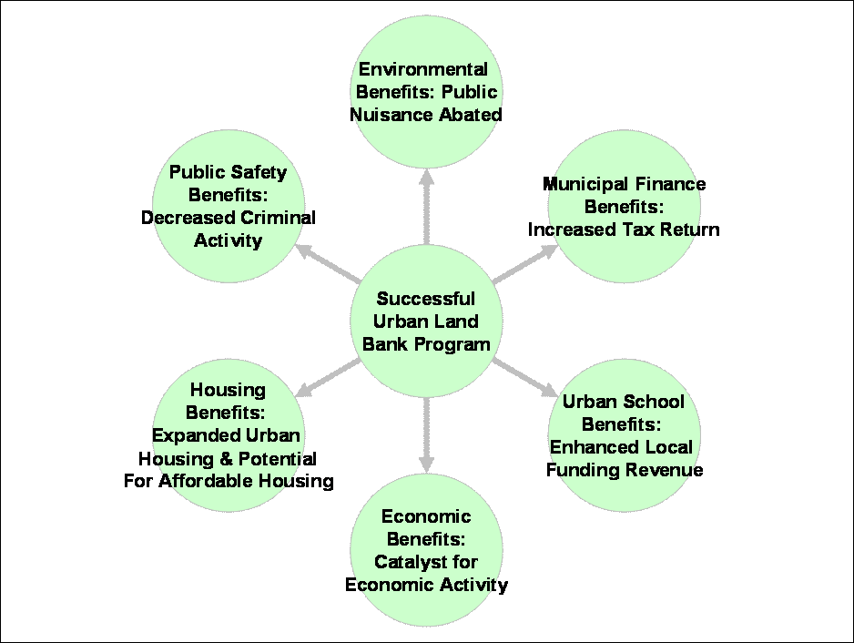
Fig. 1: various goals of land bank program

By transferring vacant and abandoned properties to responsible land owners through a land bank program, local governments benefit because they avoid the significant cost burden of property maintenance, like mowing and snow removal, as part of their nuisance abatement responsibilities. In addition, local governments benefit from increased revenue because the new property owners pay taxes on the property. Also, the local schools benefit because they receive more funding when there is an increase in property owners in their school districts. Land bank programs can increase the variety of mixed-income housing offered and provide more opportunities for affordable housing. Also, land bank properties, which become owner-occupied, discourage criminal activity thereby benefiting public safety and decreasing the cost burden on the local police and fire departments. Finally, the more residents and businesses that occupy property in a neighborhood, the more services and amenities will be needed, which boosts local economic activity.
Land banking as an investment, is nothing new to America. One notable strategy being used nationwide to contest property abandonment is lank banking. Land banks are public authorities created to acquire, hold, manage and develop vacant properties. Land banks aim to convert vacant properties that have been neglected by the open market into productive use, thereby transforming neighborhood liabilities into assets. A land bank: Acquires title to vacant and abandoned properties;
- Eliminates barriers to redevelopment; and
- Transfers property to a new owner in a way that supports community needs and priorities
As such, land banks often provide marketable title to properties previously impossible to develop.
Land is one of the most important factors in local economic development today and must be managed well to improve existing land use practices, enhance livability of communities, and support local community development. In recent surveys, the Brookings Institute found that on average 15% of the land in major American cities is vacant. Vacant and abandoned land does not produce sufficient property tax revenue for cities, which generally is their main revenue source. This lack of funds impedes a city's ability to sustain its operations, programs, and services. In addition, vacant and abandoned land discourages property ownership, depresses property values, attracts crime and creates health hazards.
New York State passed a land bank statute authorizing the establishment of nonprofits in each county to take title to vacant abandoned homes so they can be rehabilitated, sold or demolished in an orderly fashion. Several self-made billionaires started by purchasing large tracts in California where the development opportunities had not yet arisen. Many Florida Counties have traces of these land scams today. Polk County Florida in particular has been devastated with land banking scams. Polk County, being the land that lies between the city of Tampa, in Hillsborough County Florida and the city of Orlando, in Orange County Florida has been a hot bed for speculative land development. North Polk County falls within the lower Green Swamp. The State of Florida has declared the Green Swamp "land of critical state concern". The development of Disney World and the attraction it received was the sales tool to persuade individuals to buy one acre lots at high speculative prices. The Florida land banking scams continue today and are mostly operated outside of the United States. Unwary foreign customers are sold Florida land from outside the U.S. borders through contracts for deed arrangements.
Literature review:
Upon synthesizing the findings of the literature review and survey, the following best practices emerged:
• Land banks should have a narrow focus in the goals and objectives for vacant land reutilization;
• City departments need to be closely coordinated and cooperative with external partners;
• An expedited judicial foreclosure process provides key maintenance for acquisition of marketable titles;
• Independently established land banks with a corporate structure allowing control and flexibility over property distribution;
• An integrated management information system containing parcel-specific information;
• City-wide strategic vision integrated with land bank planning;
• Streamlined eminent domain process;
• Ability to determine the terms and conditions for sale of properties; and
• Funding streams that are diverse, innovative and flexible.
Cities across the country have long perceived abandoned residential housing as a problem (Accordino and Johnson, 2000).
Land banks will very likely proliferate in the coming years in most cities in the industrial Midwest and Northeast. This is because they are one of the few vehicles for policy makers to address the consequences of excess housing stock. Excess housing arises when the number of households is stagnant or declining, but new housing construction continues. If growth of a region’s housing stock exceeds the growth of its population, prices will adjust until the most desirable homes are filled (Bier and Post, 2003; Glaeser and Gyourko, 2005).
Most new housing in the US is built on the periphery of urbanized areas, and the oldest homes are concentrated in the center of the central cities. The innermost census tracts often have declining populations even when the metropolitan population is growing (Rappaport, 2003).
In 2007, a study from Michigan State’s Land Policy Institute found that residential properties that could be acquired by its land bank had much larger negative impacts on surrounding property values than vacant lots (Griswold and Norris, 2007).
Home values are important to homeowners, property investors, mortgage holders, and all local governments that are supported by property taxes. In our literature review, we only identified one previous empirical evaluation of a land bank (Griswold and Norris, 2007).
Mikelbank demonstrated that there is a negative externality from homes that are identified as abandoned, even if those homes had not been through a recent foreclosure (2008).
As foreclosures surged in Cuyahoga County in 2007 and 2008, mortgage lenders took possession of thousands of houses. They resold them, often in bulk, to speculators who intended to resell them quickly at a profit (Kotlowitz, 2009).
Most of the results clustered around a one percent lower sale price for each nearby foreclosure (Immergluck and Smith, 2006; Schuetz et al., 2008; Leonard and Murdoch, 2009; Harding et al., 2009; Rogers and Winter, 2009; Hartley, 2010; Rogers, 2010; Campbell et al., 2011; Groves and Rogers, 2011). One study by Lin, Rosenblatt, and Yao (2009) estimated that each foreclosure liquidation can depress short-run property values of homes within a half mile as much as 8.7 percent in down markets and 5 percent in up markets.
One of the tools being used to mitigate blighted residential properties is modern land banking. Ohio’s modern land banks are government-incorporated nonprofit entities with statutorily defined missions to acquire nonproductive real property and return it to productive use (Fitzpatrick IV, 2010). In 2009, Ohio’s General Assembly passed modern land bank enabling legislation. This law authorizes some counties to create not-for-profit land reutilization corporations, commonly referred to as land banks.
The problem is particularly acute in older industrial cities that have lost population in and around their urban cores (Mallach, 2012).
A few studies look more broadly at indicators of property distress including vacancy and abandonment. These analyses find that vacant or abandoned homes have disamenity effects larger than 1 percent (Mikelbank, 2008; Whitaker and Fitzpatrick, 2013).

The literature review as well as the survey revealed several commonalities among land banks and those redevelopment authorities that are not land banks per se, but operate to return vacant or abandoned property to productive reuse. The majority of land banks operating today were established to promote neighborhood revitalization of properties, particularly for housing reuses. Few examples are available that point to an industrial/commercial application of current land bank powers or direction. In addition, a variety of legislation exists to authorize land bank powers, but none as sweeping as the most recent changes made available in Michigan, which enable local jurisdictions to create land bank authorities with broad powers. Most land banks rely upon tax foreclosure as the primary means of acquiring property, including the use of eminent domain.
Data:
Our data on the land bank properties is derived directly from the comprehensive administrative database. Every property is tracked by parcel number from its initial review before acquisition through its acquisition and rehabilitation or demolition.
The land bank data cover all properties touched from the inception of the land bank through September 2013. When we estimate models incorporating counts of properties that will be acquired by the land bank, we have to exclude sales within the last six months because they may have future land bank properties nearby that we cannot yet identify.
To supplement our data on land bank activities, we sought data on all other demolitions in the county since the land bank began operations. We contacted all 60 municipalities in the county and requested the parcel number and dates of demolitions since 2011. (Fig. 2).

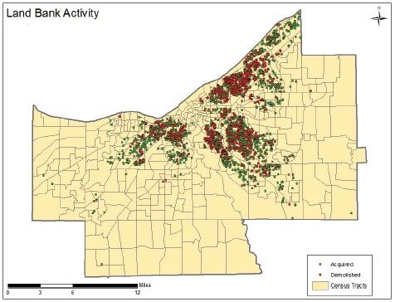
Fig. 2: Land Bank Activity

Unlike the land bank records, which record the specific day a demolition is complete, the city records sometimes do not have the exact date of the demolition. If that date was not available, we used an inspection date, which is the day the city inspector visits the site to confirm the demolition was safely completed. We created an indicator for the parcel being empty if the tax assessors’ record shows that the parcel is zoned residential.
The records include a rich set of property characteristics which are used in property tax assessments and are updated triennially and with permit data. The vacancy data originates with the US Postal Service.
Findings:
The set of models reported in table 1 estimates the negative externalities of land bank homes using a variety of spatial corrections. The last specification, a GMM estimate with both a spatial lag and spatial error, will be our preferred estimate for several reasons. Given the unobserved amenities and disamenities, some type of spatial correction is needed. This specification delivers a more precise spatial control than fixed effects models. It corrects the bias introduced by heteroskedastic errors. Moran’s I and Lagrange Multiplier tests confirm that there is spatial dependence in both the log sale prices and in the error terms of a linear model.
- Connect the Land Bank to the tax collection and foreclosure system. Tax collection is the principal interaction with abandoned properties –as owners typically do not pay taxes on abandoned property. The effective use of the governments’ superior tax lien can be the primary mechanism of acquisition of the properties. Further, connecting the economics of tax collection to the management and disposition of properties coming through the process is a critical element. Most tax systems privatize profits through penalties and interest earned by tax lien investors, or from equity derived from more valuable properties that are foreclosed. The land bank model captures that revenue stream and utilizes those financial resources to manage the properties held by the land bank.
- Scale the land bank at the metropolitan level, or around the most diverse real estate market possible. Land banks are most effective when they are not relegated to ownership of only the worst of the foreclosed or abandoned properties. A common fallacy of tax foreclosure – or property abandonment – is that it is all “junk” property. While most of the properties titled to land banks would meet that definition, it is the case that a small percentage of tax-foreclosed properties have some market value – occasionally significant value. By scaling the land bank around a diverse market, the possibility is increased that more valuable properties conveyed to private ownership through a land bank will generate revenues to be used in managing and improving the most difficult properties.
- Ensure a Land Bank is policy driven – and transparent in policies and transactions. The public –for good reason – is often suspicious of any government role in the real estate market. In the case of these properties, of course, the government already owns the property as a result of tax foreclosure. Still, it is critical that the operation of a land bank be fair and predictable. To build public confidence in a Land Bank, the adoption of well-considered policies and priorities that govern to whom –and for what purpose – properties are sold or transferred. Terms and pricing policy must be clear and uniform, as well.
- Emphasize community engagement and participation. The land held by Land Banks is typically scattered among neighborhoods throughout the community. So, the Land Bank has neighbors, sometimes thousands of them. The most successful Land Banks engage those neighbors on the policies and practices that determine the outcomes for those neighborhoods. Public acceptance of the hard choices that will inevitably need to be made regarding property held by a Land Bank is much more likely when those neighbors have a voice – a formal voice – in policy and operations.

Conclusion:
Land bank is a public authority created to efficiently handle acquisition, maintenance, and sale of vacant properties. Land banks have clear streamlined procedures to clear title, transfer properties to responsible owners, and acquire tax delinquent properties without risking their sale to speculators. Land banks are a best practice that more than 75 governments have adopted, including Cleveland, Louisville, Atlanta, and Genesee County, MI.
The Land Bank will give communities a voice to decide the fate of tax-foreclosed property in their neighborhood, guarding against vacant parcels of land falling into the hands of speculators, allowing neighborhoods to drive development at the grassroots level. By viewing vacant and abandoned properties as potential assets—rather than barriers—communities can reinvest in their neighborhoods from the ground up.
A land bank will remove blight by making it faster, easier and cheaper for neighbors, builders, community groups and investors to return vacant land to productive reuse. At the same time, a land bank will make it harder for speculators to gain ownership of vacant land. A land bank also will encourage owners to pay taxes and maintain their vacant property under threat of foreclosure. Finally, land banks help to:
- Make neighborhoods healthy and more sustainable by transforming blight into new uses;
- Open up land for urban gardens and farming;
- Create a user-friendly process for owners to obtain a sideward;
- Improve storm water management on currently vacant land; and
- Allow for innovative use of land for alternative energy, fruit orchards and other sustainable uses.

References:
- Accordino, J. and G. T. Johnson (2000). Addressing the vacant and abandoned property problem. Journal of Urban Affairs 22 (3), 301–315.
- Anselin, L. (1988). Spatial econometrics: methods and models. Studies in operational regional science, 4. Dordrecht: Kluwer Academic Publishers.
- Bier, T. and C. Post (2003). Vacating the city: An analysis of new homes vs. Household growth. Technical report, Brookings Institution Center on Urban and Metropolitan Policy.
- Campbell, J. Y., S. Giglio, and P. Pathak (2011). Forced sales and house prices. American Economic Review 101, 2108–2132.
- Brooks, Amy; Collins, Demetria; Eichmuller, Barbara; Tintocalis, Melissa; van Leeuwen, Simon. 2004. Harnessing Community Assets: A Detroit Land Bank Authority. Taubman College of Architecture & Urban Planning, University of Michigan, April.
- Drukker, D. M., I. R. Prucha, and R. Raciborski (2011). Maximum-likelihood and generalized spatial two-stage least-squares estimators for a spatial-autoregressive model with spatialautoregressive disturbances. Technical report, StataCorp.
- Fitzpatrick IV, T. (2010). Ohio’s land bank legislation: Modernizing an aged model. Journal on Affordable Housing and Community Development Law 19 (3), 127–147.
- Glaeser, E. L. and J. Gyourko (2005). Urban decline and durable housing. Journal of Political Economy (2), 345–375.
- Griswold, N. and P. Norris (2007). Economic impacts of residential property abandonment and the Genesee County Land Bank in Flint, Michigan. Land Policy Institute Report No. 2007-5.
- Groves, J. R. and W. H. Rogers (2011). Effectiveness of RCA institutions to limit local externalities: Using foreclosure data to test covenant effectiveness. Land Economics 87 (4), 559–581.
- Harding, J. P., E. Rosenblatt, and V. W. Yao (2009). The contagion effect of foreclosed properties. Journal of Urban Economics 66 (3), 164–178.
- Hartley, D. (2010). The effect of foreclosures on nearby housing prices: Supply or disamenity? Federal Reserve Bank of Cleveland Working Paper (10-11).
- Immergluck, D. and G. Smith (2006). The external costs of foreclosure: The impact of single-family mortgage foreclosures on property values. Housing Policy Debate 17 (1), 57–79.
- Kelejian, H. H. and I. R. Prucha (1999). A generalized moments estimator for the autoregressive parameter in a spatial model. International Economic Review 40, pp. 509–533.
- Kotlowitz, A. (2009, 4 March). All boarded up. The New York Times Magazine.
- Leonard, T. and J. C. Murdoch (2009). The neighborhood effects of foreclosure. Journal of Geographic Systems 11, pp. 317–332.
- Lin, Z., E. Rosenblatt, and V. W. Yao (2009). Spillover effects of foreclosures on neighborhood property values. Journal of Real Estate Finance and Economics 38, 387–407.
- Lowry, I. (1960). Filtering and housing standards: A conceptual analysis. Land Economics 36 (4), 362–370.
- Mallach, A. (2012). Laying the groundwork for change: Demolition, urban strategy, and policy reform. Technical report, Brookings Metropolitan Policy Program Paper.
- Mikelbank, B. A. (2008, November). Spatial analysis of the impact of vacant, abandoned and foreclosed properties. http://www.clevelandfed.org/Community Development/publications/ Spatial Analysis Impact Vacant Abandoned Foreclosed Properties.pdf. Rappaport, J. (2003). U.S. urban decline and growth, 1950 to 2000. Federal Reserve Bank of Kansas City Economic Review 88 (3), 15 – 44.
- Rogers, W. H. (2010). Declining foreclosure neighborhood effects over time. Housing Policy Debate 20 (4), 687–706.
- Rogers, W. H. and W. Winter (2009). The impact of foreclosures on neighboring housing sales. Journal of Real Estate Research 31 (4), 455–479.
- Rosen, S. (1974). Hedonic prices and implicit markets: Product differentiation in pure competition. The Journal of Political Economy 82 (1), pp. 34–55.
- Rosenthal, S. S. and R. W. Helsley (1993). Redevelopment and the urban land price gradient. Journal of Urban Economics 35 (2), 182–200.
- Schuetz, J., V. Been, and I. G. Ellen (2008). Neighboring effects of concentrated mortgage foreclosures. Journal of Housing Economics 17 (4), 306–319.
- Whitaker, S. and I. Fitzpatrick, Thomas J. (2013). Deconstructing distressed-property spillovers: The effects of vacant, tax-delinquent, and foreclosed properties in housing submarkets. Journal of Housing Economics 22 (2), 79 – 91.
- Smart Growth Tactics. 2005. Michigan Society of Planning, January.

9/13/2015

