The Impact of Diabetes on Early and Midterm Outcome of Patients Undergoing Coronary Artery Bypass Grafting Surgery in Egyptians

Yasser Abdelgaleel¹, Mostafa Ismael¹, Islam shawky¹, Mohamed Elbaz¹, Mohamed Wael², Ashraf abdelsalam³

¹Cardiology department, Faculty of Medicine, Al Azhar University, Cairo, Egypt.
²Cardiothoracic surgical department, Faculty of Medicine, Al Azhar University, Cairo, Egypt.
³Cardiothoracic surgical department, Faculty of Medicine, zagazig university, Egypt
y_abdelgaleel@yahoo.com

Abstract: Background: Diabetes is a well-known risk factor for coronary artery disease and cardiovascular death. The reported prevalence of diabetes among patients undergoing coronary artery bypass surgery (CABG) has been estimated to be 12-38%. Patient and Methods: The impact of diabetes on early and midterm follow-up after coronary artery bypass grafting was studied by comparing the outcomes between 50 patients without diabetes mellitus and 50 patients with type II Diabetes Mellitus from March 2013 till December 2014. Results: Compared with nondiabetic patients, the group with diabetes hada greater incidence of hypertension (70% in diabeticsvs 42% in non-diabetics, P=0.004) and hyperlipidemia, showed a higher incidence of ECG changes (previous myocardial infarction, ST‐T changes and conduction defects) (72% in diabetics vs. 44% in non-diabetics, P=0.005). Early mortality was not significantly different between two groups (2% in diabetics vs. 2% in non-diabetics, P=0.661). No significant differences were found regarding postoperative complications; except sternal wound infection (12% in diabetics vs. 2% in non-diabetics, P=0.049). However, in midterm follow up of diabetic patients had significantly higher MACCE (16.4% in diabetics vs. 4% in nondiabetics, P= 0.04). Conclusion: Except for sternal wound infection, DM was not associated with the in- hospital adverse outcomes in the patients undergoing isolated CABG. Diabetes mellitus is an independent predictor of adverse cardiac and cerebrovascular events after isolated coronary artery bypass graft surgery (CABG).
[Yasser Abdelgaleel, Mostafa Ismael, Islam shawky, Mohamed Elbaz, Mohamed Wael, and Ashraf abdelsalam. The Impact of Diabetes on Early and Midterm Outcome of Patients Undergoing Coronary Artery Bypass Grafting Surgery in Egyptians. Nat Sci 2015;13(10):29-34]. (ISSN: 1545-0740). http://www.sciencepub.net/nature. 4

Key Words: Coronary Artery Bypass, Diabetes Mellitus, Outcome

1. Introduction:
The incidence of diabetes is increasing markedly and the World Health Organization estimates that by 2025, about 5.4% of the world population (300 million people) will be diabetic (1). Diabetes is a well-known risk factor for coronary artery disease and cardiovascular death (2). The reported prevalence of diabetes among patients undergoing coronary artery bypass surgery (CABG) has been estimated to be 12-38% (3). Coronary artery disease is more extensive, diffuse and distal with a rapidly progressive nature in diabetic compared with non-diabetic patients(4). Patients with type 2 diabetes mellitus (DM) represent 25% of those requiring myocardial revascularization, choice of treatment in diabetic patients is much more controversial than in non-diabetics, this is because coronary artery disease is more often complex and diffuse, left ventricular function is depressed, and concomitant multiple risk factors are present. This subset of patients experience worse outcomes than non-diabetic patients undergoing either coronary artery bypass grafting (CABG) or percutaneous coronary interventions(5). Traditionally, it has been accepted that patients with diabetes have poorer outcome than non-diabetics following CABG. There is less controversy about the role of diabetes in increasing long term mortality of patients undergoing CABG (6). Diabetes may not be an independent risk factor for early death following CABG. However, it is an important predictor of midterm mortality (7). However, there are conflicting data about the early and midterm result of CABG in diabetic patients (6).

2. Patients and Methods:
The study included two main groups; the first group included patients with type II Diabetes Mellitus, the second group included non-diabetic Patients as control.
Inclusion criteria
The study population consisted of One hundred patients with coronary artery disease indicated for CABG (By the use of cardiopulmonary bypass), were studied at the Cardiology and cardiothoracic surgery departments of Mahalla Cardiac Center, from March 2013 till December 2014 and they were divided into two groups:
- First group: included fifty non-diabetic patients (non-diabetic group).
- Second group: included fifty typeII diabetic patients (diabetic group).
Exclusion criteria
- Patients with history of previous CABG.
- Patients with emergency CABG.
- Patients with significant valvular heart disease needing intervention.
- Ischemic heart disease associated with co-morbidity:
  - Renal failure.
  - Liver cell failure.
  - Respiratory failure.
  - Thyroid dysfunction.
All patients will be subjected to the following:
I-Preoperative Evaluation in the form of:
- Full history taking.
- Thorough medical examination.
- Routine laboratory investigations (in the form of):
- Complete Blood Picture (CBC).
- Serum electrolytes (Na & K).
- Hemoglobin A1C.
- Total Lipid profile.
- Liver function tests.
- Kidney function tests.
- Carotid duplex.
- Electrocardiogram.
Electrocardiogram was carefully interpreted for presence of previous myocardial infarction (pathological Q), ST‐T changes, conduction defects, right or left bundle branch block.
- Echocardiography.
The following parameters were estimated:
• Left ventricular ejection fraction (LVEF).
• Regional wall motion score index (RWMSI).
- Coronary angiography:
Number of vessels diseased
II-Intra-Operative course: (All patients will be submitted to Coronary artery bypass grafting with cardio pulmonary bypass).
- Number of grafts per patient.
- Use of internal mammary artery (IMA).
III- Short term Post-operative evaluation for detection of:
- Post-operative myocardial infarction.
- Arrhythmias: Atrial fibrillation, ventricular arrhythmias.
- Low cardiac output symptoms.
- Peripheral arterial disease.
- Neurological complications.
- Chest complications.
- Renal impairment.
- Sternal wound infection.
- Mortality.
IV- Six months Post-operative evaluation for detection of:
- Major adverse cardiac and cerebrovascular events (MAACE):
- Mortality.
- Myocardial infarction.
- Unstable angina.
- Heart failure (NYHA class II or more).
- Fatal ventricular arrhythmia.
- Cerebrovascular accident.

3. Results:

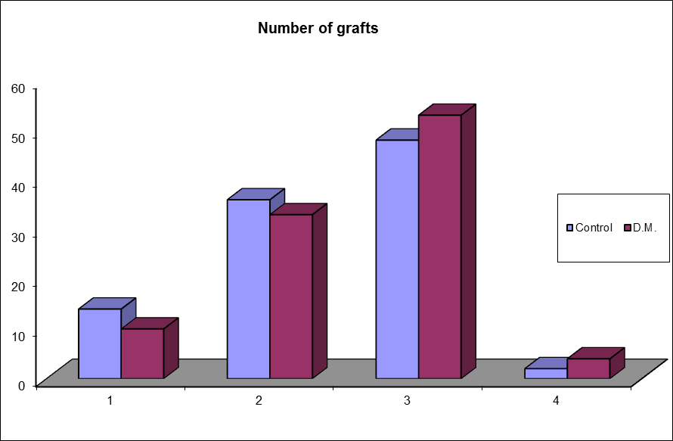
Figure (1):Comparison between both groups regarding number of grafts

The study included 100 patients scheduled for CABG operation. Fifty patients were diabetics. The majority of patients were overweight. (Table 1) shows the preoperative characteristics of the diabetic (n = 50) and the nondiabetic (n = 50) groups. The diabetic and non‐diabetic groups were comparable as regards age (p= 0.948). Hypertension was significantly more frequent in the diabetic group (p=0.004). The diabetic group patients are more hyperlipidemic. The diabetic group also showed significantly more preoperative ECG changes (p= 0.005). Both studied groups had comparable echocardiographic measurements including left ventricular ejection fraction and wall motion score index, as well as comparable coronary angiographic data (Table1). There was no significant difference between both groups as regarding the use of the left internal mammary artery (LIMA) as a graft, the total number of vessels bypassed. (Table2). Post‐operatively, there were no significant differences between both studied groups regarding postoperative morbidities and mortality except sternal wound infection (p= 0.049) as shown in (Table 3). Regarding the Six months follow up for total (MACCE), there was a significant difference between the 2 groups (16.4% in diabetics vs. 4% in nondiabetics, p= 0.04)(Table 4).

Table 1: Preoperative characteristics of the two studied groups
Variable | The studied groups |  | P value
 | Diabetic  No = 50 | Non diabetic  No = 50
Age(mean±SD) | 55.78 ± 6.12 | 55.86 ± 6.05 | 0.948
Male gender, No. (%) | 42 (82) | 39(78) | 0.306
Smoking, No. (%) | 18(36) | 21(42) | 0.295
BMI(mean ± SD) | 26.90 ± 2.39 | 26.46 ± 3.32 | 0.446
Hypertension, No. (%) | 35(70) | 21(42) | 0.004(S)
Hyperlipidemia  -Cholesterol (Mean+SD)  -Triglycerides(Mean+SD)  -LDL(Mean+SD) | 238.24+23.36  175.56+19.38  128.44+19.05 | 207.72+25.70  158.76+22.93  102.66+14.63 | 0.001(S)  0.001(S)  0.001(S)
Pre-operative carotid lesion, No. (%) | 3(6) | 1(2) | 0.307
Pre-operative ECG changes, No. (%) | 36(72) | 22(44) | 0.005 (S)
Pre-operative ECHO  LVEF(mean ± SD) | 56.96 ± 4.34 | 56.94 ± 4.36 | 0.982
Pre-operative ECHOWMSI(mean ± SD) | 1.4± 0.164 | 1.39 ± 0.166 | 0.904
Extent of CAD  - Single vessel disease  - Two vessel disease  - Multi vessel disease | 3(6)  13(26)  34(68) | 6(12)  16(32)  28(56) | 0.294  0.508  0.216

Table (2): Operative characteristics of both groups:
Variable | The studied groups |  | P value
 | Diabetic  No = 50 | Non diabetic  No = 50
Use of LIMA, No.(%) | 50(100) | 50(100)
Number of grafts  - Single graftNo. (%)  - Two graftsNo. (%)  - Three graftsNo. (%)  - Four graftsNo. (%) | 3(6)  15(30)  29(58)  3(6) | 7(14)  18(36)  24(48)  1(2) | 0.344
Table (3): Early postoperative mortality and morbidity
Variable | The studied groups |  | P value
 | Diabetic  No = 50 | Non diabetic  No = 50
Mortality, No. (%) | 1(2) | 1(2) | 0.661
Sternal wound infection, No. (%) | 6(12) | 1(2) | 0.049 (S)

Table (4): Six months follow up for total (MACCE)
Variable | The studied groups |  | P value
 | Diabetic  No = 49 | Non diabetic  No = 49
MACCE, No. (%) | 8(16.4) | 2(4) | 0.044(S)

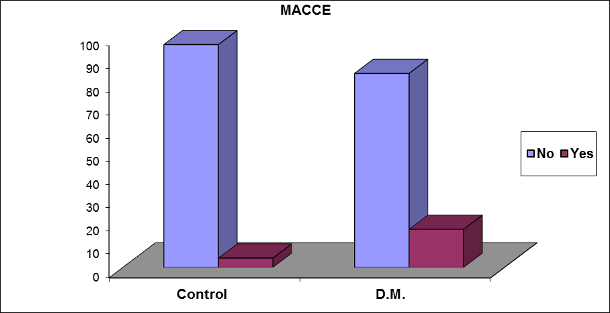
Figure (2): Comparison between both groups regarding six months MACCE

Study limitation:
The study followed one hundred patients, while other studies addressed this subject were multicenter studies which compromised more number of patients. The study followed the patients after six months postoperative, while the long term outcome at five and ten years was not addressed.

4. Discussion:
Diabetes has long been described as an independent risk factor for the development of coronary artery disease after adjusting for other risk factors such as age, hypertension, hypercholesterolemia, and smoking. It is common in adult patients requiring cardiac operations, and the proportion of diabetic patients undergoing coronary artery bypass grafting (CABG) is steadily increasing(8). Diabetes is recognized as a risk factor for adverse outcomes after CABG, especially with regard to long-term survival. However, the impact of diabetes on in-hospital mortality has been changing over time according to the Society of Cardiothoracic Surgeons of Great Britain and Ireland(9).
Several studies suggested that patients with DM are at 2 to 5 folds increased risk of postoperative complications (10). Other studies suggested that diabetic patients can pass the post-operative period with low morbidity and mortality owing to improved peri‐operative management (6).
As regards hypertension, there was a statistically significant difference between diabetic and non-diabetic groups (P=0.004) diabetic patients are more hypertensive than non-diabetics and this agreed with results of Koochemeshki et al.(11).
Regarding preoperative Electrocardiogram (previous myocardial infarction, ST‐T changes and conduction defects) there was statistically significant difference between diabetic and non-diabetic groups (P=0.005). These results agree with the results of Rajakaruna, et al.(12).
In our study regarding the results of preoperative carotid duplex showed no statistically significant difference between diabetic and non-diabetic groups (P=0.307), and this was similar to results of WK et al.(13) and disagree with the results of Calafior et al.(14) a study which reveal a significant difference between diabetic and non-diabetic group.
Regarding the results of preoperative Coronary angiography (Extent of coronary artery disease) Our study showed that multivessel disease was more with the diabetic group 68% versus 56% in the non-diabetic group, but this was not statistically significant (P=0.216), and the overall extent of coronary artery disease showed no statistically significant difference between diabetic and non-diabetic groups (P=0.388), and this was similar to the results of Zhuang et al.(15) and Qiang et al.(16) and disagree with the results of Kubal, et al.(17) Charvát et al.(18), there results show the patients with diabetes mellitus had more extensive coronary artery disease and there was a significant difference between both group regarding number of diseased coronary vessel.
Our results showed that, there was a statisticallysignificant difference between diabetic and non-diabetic groups regarding dyslipidemia, these results agreed with Sohrabi et al.(7) and Moshtaghi et al.(19) but disagreed with Rajakaruna et al.(12), Woods et al.(20) and Kubal et al.(17) as their results werenot significantly different regarding total serum cholesterol in both groups.
Our results regarding postoperative mortality showed nostatistically significant difference between diabetic and non-diabetic group. This was similar to results of Koochemeshki et al. (11) and WK, et al.(13), in which the diabetes mellitus was not found to be an independent risk for in-hospital mortality. But was against the results of Ergüne et al.(21) and Woods et al.(20) as there was a significant difference regarding postoperative mortality in both groups.
Our results regarding sternal wound infection show statistically significant difference between diabetic and non-diabetic group (P=0.049) and this was in agree with Moshtaghi et al.(19) and Brandt et al.(22) study which predict the occurrence of sternal wound infection in diabetic patients. And disagree with the study by Rajakaruna, et al.(12) in which the diabetes mellitus was not found to be an independent risk for in-hospital mortality and post-operative complications even postoperative infection.
The follow up for Major Adverse Cardiac and Cerebro-vascular Events (MACCE) between the diabetic and non-diabetic group after six months, revealed a statistically significant difference (P=0.044), as 16.4% in the diabetic group developed (MACCE) versus 4.0% in the non-diabetic group. This was similar to the results of Gitman et al.(23) study which showed that diabetic patients have a higher rate of adverse events compared with non-diabetic patients.
Our results regarding six months follow up for mortality showed no significant difference between diabetic and non-diabetic group. This was similar to the results of WK et al.(13) and Ergüneş et al.(21) but was against the results of Szabo´ Z, et al (3) and Rajakaruna, et al.(12) study which showed that diabetes mellitus remained an independent predictor of 5-year mortality as there was a significant difference regarding mortality in both groups.

Conclusion:
Except for sternal wound infection, DM was not associated with the in- hospital adverse outcomes in the patients undergoing isolated CABG. The in-hospital mortality and morbidity is equivalent between non diabetic and diabetic patients.
Diabetic patients are more likely to experience adverse cardiac and cerebral events, during six months follow up after CABG. Diabetes mellitus is an independent predictor of adverse cardiac and cerebrovascular events after isolated coronary artery bypass graft surgery (CABG).

Corresponding author:
Yasser Abdelgaleel,
Cardiology department, Al Azhar University, Al Husseien university hospital, Cairo, Egypt. Tel; +201005268765, e-maily_abdelgaleel@yahoo.com

References:
- Monteiro P, Goncalves L, Providencia LA. (2005) Diabetes and cardiovascular disease: the road to cardioprotection. Heart. 2005;91:1621-5.
- Raman M, Nesto RW. Heart disease in diabetes mellitus. Endocrinol Metab Clin North Am 1996; 25:425-38.
- Szabo´ Z, Håkanson E, Svedjeholm R. et al.(2002) Early Postoperative Outcome and Medium-Term Survival in 540 Diabetic and 2239 Non diabetic Patients Undergoing Coronary Artery Bypass Grafting. Ann Thorac Surg; 74:712-719.
- Flaherty JD, Davidson CJ. (2005) Diabetes and coronary revascularization. JAMA; 293:1501.
- Mohammadi S, Dagenais F, Mathieu P, et al.(2007) Long-term impact of diabetes and its comorbidities in patients undergoing isolated primary coronary artery bypass graft surgery. Circulation; 116 (11 Suppl):I220-5.
- Filsoufi F, Rahamanian PB, Castillo JG, et al.(2007) Diabetes is not a risk factor for hospital mortality following contemporary coronary artery bypass grafting. Interact Cardiovasc Thorac Surg; 6:753‐ 758.
- Sohrabi B, Yaghoubi AR, Ghaffari S.(2010) The Impact of Diabetes on Early and Midterm Outcome of Patients Undergoing Coronary Artery Bypass Grafting Surgery. Iranian Cardiovascular Research Journal: Vol.4, No.2.
- Ferguson TB Jr, Hammill BG, Peterson ED, et al.(2002) A decade of change— risk profiles and outcomes for isolated coronary artery bypass grafting procedures, 1990–1999. Ann Thorac Surg; 73:480 –90.
- Eagle KA, Guyton RA, Davidoff R, et al.(1999) ACC/AHA guidelines for coronary artery bypass graft surgery: a report of the American College of Cardiology/American Heart Association Task Force on Practice Guidelines (Committee to Revise the 1991 Guidelines for Coronary Artery Bypass Graft Surgery). Circulation; 100:1464–80.
- Hoogwerf BJ. (2006) Perioperative management of diabetes mellitus: How should we act on the limited evidence? Cleve Clin J Med; 73 (suppl 1):S95‐9.
- Koochemeshki V, Salmanzadeh HR, Sayyadi H, et al. (2013) The Effect of Diabetes Mellitus on Short Term Mortality and Morbidity after Isolated Coronary Artery Bypass Grafting Surgery. Int Cardiovasc Res J.; 7(2): 41-5.8732
- Rajakaruna C, Chris A. Rogers, Chinthaki Suranimala, et al. (2006) The effect of diabetes mellitus on patients undergoing coronary surgery: A risk-adjusted analysis. J Thorac Cardio vasc Surg;132:802-10.
- WK Au,KTLam,LC Cheng, SW Chiu,et al. (2009) Impact of diabetes on early and mid-term survival after coronary artery bypass graft surgery in the Hong Kong Chinese population. Hong Kong Med J; 15:173-8.
- Calafiore, Michele Di Mauro, Gabriele Di Giammarco, et al.(2003) Effect of diabetes on early and late survival after isolated first coronary bypass surgery in multivessel disease. J Thorac Cardiovasc Surg;125:144-154.
- Zhuang Yu, Ming-Di Xiao, Zhong-Xiang Yuan, et al.(2009) Early outcomes of isolated coronary artery bypass grafting in Chinese aged patients with diabetes mellitus. Saudi Med J; Vol. 30 (9): 1202-1207.
- Qiang JI, Yunqing MEI, Xisheng WANG, et al.(2009) Impact of diabetes mellitus on old patients undergoing coronary artery bypass grafting. Int Heart J 2009 ;50: 693-700.
- Kubal, Arun K. Srinivasan, Antony D. Grayson, et al.(2005) Effect of Risk-Adjusted Diabetes on Mortality and Morbidity after Coronary Artery Bypass Surgery. Ann Thorac Surg; 79:1570–6.
- Charvát J, Stríteský M, Semrád M, et al.(2004) Comparison of short-term and long-term results after aortocoronary bypass in ischemic heart disease in diabetics and non-diabetics. Vnitr Lek; 48(4): 279-84.
- Moshtaghi N, Shirzad M, Karimi A, et al.(2010) Outcome of coronary artery bypass surgery in diabetic and non-diabetic patients: A comparative, retrospective study. Journal of Diabetology; 3:2.
- Woods SE, Smith JM, Sohail S, et al.(2004) The Influence of Type 2 Diabetes Mellitus in Patients Undergoing Coronary Artery Bypass Graft Surgery Chest; 126:1789-1795.
- Ergüneş K, Yilik L, Yurekli I, et al.(2014) Coronary surgery in patients with diabetes and mid-term follow-up Chirurgia (Turin), Volume 27, Issue 1, Pages 5-9.
- Brandt M, Harder K, Walluscheck KP, et al.(2004) Coronary artery bypass surgery in diabetic patients. Journal of cardiac surgery; 19(1):36-40.
- Gitman MR, Okrainec K, Nguyen H, et al.(2005) ROSETTA-CABG Impact of diabetes on 12-month outcomes following CABG; Can J Cardiol. 2005 Nov;21(13):1169-74.

9/8/2015

