Mechanical Stabilization of a Migmatitic - Gneiss Derived Soil from Shao near Ilorin

Olubunmi Oluwadare OWOYEMI and Gabriel Oladapo ADEYEMI

Department of Geology university of Ibadan, Ibadan, Nigeria
E mail,: lade.owoyemi@gmail.com, adedapodrngus@yahoo.com

Abstract: Samples of a migmatitic-gneiss derived lateritic soil taken from Shao were stabilized with the soil developed over sandstone from Mokwa with a view to assessing the effectiveness, or otherwise, of the mechanical stabilization. Geological mapping and sampling of rock and soil were executed to confirm the names of the rocks. Classification and California Bearing (CBR) tests were carried out by following standard procedures which were modified to take care of peculiar characteristics of lateritic soils. Grain size distribution and plasticity of the two sets of soils confirmed that the soil developed over sandstone had better geotechnical properties than migmatitic-gneiss derived soil. Sandstone - derived soil samples were thus utilized for stabilization of the soil developed over migmatitic-gneiss using percentage by volume. Equation y=0.59x + 42 was established from the plot of unsoaked CBR(y) against volume of stabiliser (x). The optimum amount of the stabilizer was found to be 30% by volume. The stabilized soil samples were adjudged to be good as highway sub-base material.
[Olubunmi Oluwadare OWOYEMI and Gabriel Oladapo ADEYEMI. Mechanical Stabilization of a Migmatitic - Gneiss Derived Soil from Shao near Ilorin. Nat Sci 2015;13(9):96-101]. (ISSN: 1545-0740). http://www.sciencepub.net/nature. 15

Key words: California Bearing Ratio, Compaction, Lateritic soil, Mechanical stabilization, Migmatitic gneiss, Plasticity Index, Grain size distribution, Stabilizer

1. Introduction
Lateritic soils which are the most frequently used soil for construction in North - Central Nigeria. They also form the foundation for most roads in Nigeria. Long term performance of pavement structures often depends on the stability of the underlying soils. Engineering design of these constructed facilities relies on the assumption that each layer in the pavement has the minimum specified structural quality to support and distribute the super imposed loads. Often times, lateritic soil in their natural states hardly possess characteristics suitable for the desired engineering applications, particularly for road works. This necessitates their improvement by stabilization so as to ensure they meet up with the required standards.
Mechanical stabilization is the blending of different grades of soils to obtain a required grade. Amadi (2010) reported significant changes in index properties of a residually derived lateritic soil from Zaria by stabilizing them with up to 20% fly ash. Several other workers including Ola (1974), Alhassan (2008), Amu et. al. (2011), Oyediran, and Okosun (2013), and Adeyemi and Afolagboye (2013), Mustapha et. al., (2014), have stabilized lateritic soils using various methods. Most of the methods used by these researchers are neither economically visible nor easy to execute especially on large scales. There is therefore the need for more research on mechanical stabilization of lateritic soils which forms the foundation and construction materials of most of our roads at cheaper cost and by easier methods. Although, mechanical stabilization using percentage by volume is easier, it is rarely executed worldwide. This work investigates the effectiveness of mechanical stabilization using percentage by volume which is not a conventional method of mechanical soil stabilization.

2. Study Area
The study area lies between Latitude 9⁰21’and 8⁰56’ North and Longitude 4⁰51’ and 4⁰.88’ East. These two locations are two different geological terrains along the Ilorin –
Mokwa road. Location one is in the sedimentary terrain, underlain by Cretaceous sedimentary rocks of the Northern Bida basin, outskirts of Mokwa town while location two is in Basement Complex terrain underlain by the Migmatitic - gneiss outskirt of Shao township. The two locations are abandoned borrow pits from which materials for road construction have been previously won.

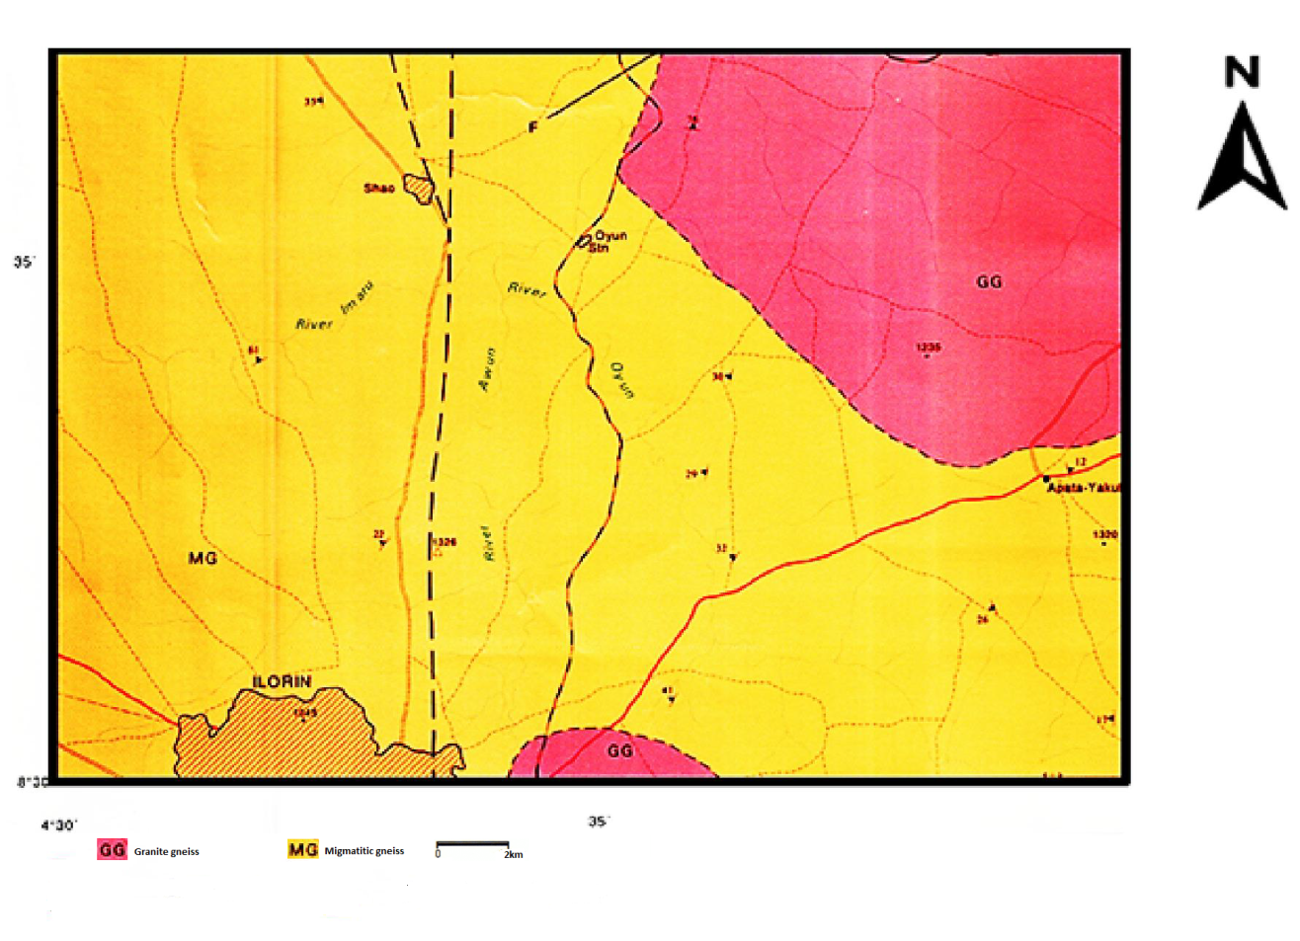
Fig 1: Geological map showing location of study area.

3. Methodology
Two sets of ten genetically different bulk disturbed samples were obtained from borrow pits at sampling intervals of 5m and air dried for two weeks. Laboratory tests were carried out in accordance with the specification of British Standard 1337 of 1975 with some minor modifications where necessary.
Preliminary classification tests, were carried out on the two sets of soils to determine the soil samples with better engineering properties. These tests include grain size analysis, consistency limits, specific gravity and linear shrinkage. Sand stone derived soil has better engineering properties when compared with their migmatite derived counterparts. The migmatitic - gneiss derived soil samples which had higher amount of fines and plasticity were then mixed with 10%, 20%, 30% and 40% of sandstone derived soil respectively. These mixtures were compacted at modified AASHTO level. Regression plots and equations were used to determine the effectiveness of the stabilizer on the compaction characteristics and strength of the stabilized soils.

4. Results And Discussion
Preliminary Classification
The amount of fine grained materials present in the migmatite derived soil range between 20% and 54%, while the fine content of the sand stone derived soil range between 11% and 35%, however the Federal Ministry of Work Specifies an amount of fines not more than 15% sub base material. The sandstone derived soil classify as sandy silty clay while the migmatite derived samples classify as silty clay. The migmatite gneiss derived samples rated as fair to poor subgrade materials (group A-6 - A-7-6 according to AASHTO classification), they also have group index higher than 20. The sandstone derived samples rated as excellent to good sub grade material (A-2-6 according to AASHTO classification). They have group index between zero and one. Figure 2. shows the plasticity chart that compares the plasticity of both the migmatite derived lateritic soils and the sandstone derived ones. The migmatite derived soil exhibit higher plasticity therefore, higher compressibility compared to their sandstone derived counterpart. This variation is due to the differences in mineralogical characteristics of the parent materials. However, the average liquid limit and plasticity index for soils from both parent materials are averagely more than the recommended values for good highway sub base material.

TABLE I. Summary of the index properties of the studied soils
Parent  rock | Sample number | Liquid Limit | Plasticity Index | Plastic Limit | Flow Index | Toughness Index | Specific Gravity | NMC | Amount of fines | Linear shrinkage
Migmatitic gneiss | BMB1 | 44.0 | 18.2 | 25.8 | 20.1 | 1.3 | 2.6 | 22.0 | 50.3 | 9.2
 | BMB2 | 38.4 | 16.3 | 22.1 | 21.0 | 1.1 | 2.7 | 24.1 | 38.1 | 5.9
 | BMB3 | 45.0 | 18.4 | 26.7 | 17.2 | 1.6 | 2.6 | 24.1 | 53.1 | 8.9
 | BMB4 | 42.3 | 18.5 | 23.8 | 24.3 | 1.0 | 2.6 | 22.8 | 51.6 | 9.1
 | BMB5 | 37.3 | 17.0 | 20.3 | 18.4 | 1.1 | 2.7 | 21.0 | 43.9 | 6.2
 | BMB6 | 47.3 | 19.1 | 28.2 | 19.8 | 1.4 | 2.7 | 24.6 | 53.8 | 9.8
 | BMB7 | 48.8 | 18.4 | 29.6 | 17.8 | 1.7 | 2.7 | 23.4 | 53.9 | 9.1
 | BMB8 | 40.1 | 17.3 | 22.8 | 17.8 | 1.3 | 2.7 | 23.3 | 42.3 | 7.0
 | BMB9 | 39.0 | 17.5 | 21.6 | 21.7 | 1.0 | 2.7 | 22.8 | 42.7 | 6.8
 | BMB10 | 43.7 | 18.0 | 25.2 | 18.2 | 1.4 | 2.6 | 25.2 | 47.3 | 7.6
Sand stone | BMS1 | 31.2 | 9.8 | 21.5 | 13.9 | 1.5 | 2.6 | 21.5 | 15.4 | 1.5
 | BMS2 | 25.3 | 8.3 | 17.0 | 17.8 | 1.0 | 2.6 | 19.1 | 11.3 | 1.5
 | BMS3 | 36.2 | 11.8 | 24.4 | 7.4 | 3.3 | 2.6 | 17.2 | 23.6 | 2.5
 | BMS4 | 42.1 | 15.7 | 26.4 | 23.3 | 1.1 | 2.6 | 19.0 | 27.4 | 6.0
 | BMS5 | 33.0 | 15.2 | 17.8 | 24.9 | 0.7 | 2.7 | 15.2 | 18.0 | 6.2
 | BMS6 | 28.1 | 10.1 | 18.0 | 20.5 | 0.9 | 2.6 | 15.2 | 20.2 | 2.1
 | BMS7 | 22.3 | 10.2 | 12.1 | 10.2 | 1.2 | 2.7 | 17.2 | 21.3 | 2.1
 | BMS8 | 20.8 | 9.8 | 10.9 | 8.5 | 1.3 | 2.7 | 14.0 | 21.1 | 1.8
 | BMS9 | 34.0 | 10.6 | 23.4 | 20.6 | 1.1 | 2.7 | 16.2 | 26.3 | 1.5
 | BMS10 | 34.0 | 15.7 | 18.3 | 18.3 | 1.0 | 2.6 | 16.6 | 10.5 | 5.9

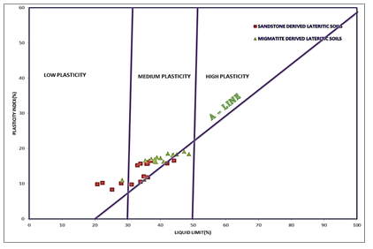
Fig 2: Casagrande Chart Classification of the soil samples

Fig. 3:Grading curve of Migmatite derived soil

Fig. 4: Grading curve of Sandstone derived soil

5. Influence of stabilization on the compaction characteristics of the stabilized soil.
Table III shows the relationship between amount of stabilizer and the Maximum dry density of the stabilized soil. The equation that yields the strongest correlation between percentage by volume stabilizer and Maximum dry density is y= 2.5% x+ 1780 with a strong correlation coefficient of 0.999. y and x are MDD and % stabilizer respectively. Statistics show that there is a significant difference between the maximum dry density of the stabilized soil before and after stabilization with 40% by volume of the stabilizer. (Fig 5)
As the Maximum dry density of the stabilized samples increases with increasing stabilizer content, the Optimum moisture content reduced up to 11%. This amount of reduction in OMC was found to be significant when treated with the Student Statistical t- test. (Table III and IV).

TABLE II: Regression analysis of the Maximum dry density relationship between amounts of stabilizer
MDD | Regression equation | R² (coefficient of determination) | r (correlation coefficient)
BMB1 | MDD = 2.5% Stabilizer + 1780 | 0.997 | 0.999
BMB2 | MDD = 0.8% stabilizer + 1866 | 0.279 | 0.528
BMB3 | MDD= 0.4% stabilizer + 1762 | 0.040 | 0.200
BMB4 | MDD = 2.2% Stabilizer + 1788 | 0.991 | 0.996
BMB5 | MDD= 0.2%Sstbilizer + 1870 | 0.153 | 0.391
BMB6 | MDD = 2.0% Stabilizer + 1828 | 0.996 | 0.998
BMB7 | MDD = 3.0% Stabilzer + 1806 | 0.992 | 0.996
BMB8 | MDD = -0.1% Stabilizer+ 1891 | 0.014 | 0.117
BMB9 | MDD = 1.4 %Stabilizer% + 1843 | 0.720 | 0.849
BMB10 | MDD= 1.4 %Stabilzer + 1843 | 0.720 | 0.849

Fig 5: Regression plot of %Stabilizer and Maximum Dry Density (MDD) of the studied soil

TABLE III: Relationship between Maximum dry density and Amount of stabilizer
S/N | MDD before stabilization (kg/m³) | MDD after stabilization (kg/m³) | Cumulative % increase in MDD | optimum % stabilizer
BMS1 | 1780.0 | 1880.0 | 5.6 | 40
BMB2 | 1890.0 | 1910.0 | 3.2 | 40
BMB3 | 1770.1 | 1810.0 | 4.5 | 40
BMB4 | 1790.0 | 1880.4 | 5 | 40
BMB5 | 1860.1 | 1880.0 | 1.9 | 40
BMB6 | 1830.1 | 1910.0 | 4.4 | 40
BMB7 | 1810.0 | 1930.0 | 6.6 | 40
BMB8 | 1885.3 | 1890.0 | 2 | 20
BMB9 | 1890.2 | 1880.0 | 3.2 | 40
BMB10 | 1860.1 | 1905.3 | 3.5 | 40

TABLE IV: Relationship between Optimum Moisture Content and Amount of stabilizer
S/N | OMC before stabilization(%) | OMC after stabilization (%) | Cumulative % decrease in OMC | optimum % stabilizer
BMB1 | 17.6 | 16.8 | 11.4 | 30
BMB2 | 16 | 15.2 | 7.5 | 40
BMB3 | 19.2 | 17.2 | 10.4 | 40
BMB4 | 18 | 16.4 | 8.8 | 40
BMB5 | 16.4 | 16.8 | 3.7 | 40
BMB6 | 18.4 | 18.4 | 3.3 | 40
BMB7 | 18 | 18.4 | 4.4 | 30
BMB8 | 17.2 | 15.6 | 9.3 | 40
BMB9 | 16.8 | 16 | 5.6 | 40
BMB10 | 18.2 | 16 | 12.1 | 40

6. Influence of stabilization on the California Bearing ratio (CBR) of the stabilized samples
Table VI shows the influence of amount of stabilizer on the unsoaked CBR of the migmatite derived soil samples. Increment in CBR as a result of stabilization range between 38% and 108 %. As a result of mixing the migmatite derived soil samples with up to 40% by volume of the sandstone derived soil, almost 100% CBR increment can be achieved. The optimum percentage of stabilizer that yields significant increment in CBR is 30%. Beyond this, the increment in CBR becomes marginal. From table IV, it can be seen that the equation, y = 0.59x+ 42. yields the best correlation between percentage by volume stabilizer and CBR. Where y and x are the CBR and percentage by volume of stabilizer respectively.
The statistics also show that there is a significant difference between the average CBR values before and after stabilization. The unsoaked CBR values which range between 34.1% and 88.7% before stabilization increased to (71.6%-127.5%) after stabilization. Also the soaked CBR increased from a range of (20.1%-26.1%) to (36.6%-54.4%) after stabilization. This implies that the stabilized soil which did not meet the 30% soaked CBR, and 80% unsaoked CBR stipulated by FMWH 1997 for sub-base and base course of roads before stabilization, has been improved to meet up with this specification after stabilization.

TABLE V: Influence of amount of stabilizer on the unsoaked California Bearing Ratio of stabilized samples
Sample number | CBR of Unstabilized Samples | CBR after Stabilization | Ratio | Cumulative percentage increase in CBR
BMB1 | 62.5 | 111.2 | 1.8 | 105.1
BMB2 | 74.8 | 91.4 | 1.2 | 37.9
BMB3 | 34.1 | 71.6 | 2.1 | 107.7
BMB4 | 52.6 | 75.5 | 1.4 | 41.3
BMB5 | 69.4 | 103.7 | 1.5 | 51.6
BMB6 | 88.7 | 120.2 | 1.4 | 37.6
BMB7 | 65.8 | 115.7 | 1.8 | 79.8
BMB8 | 65.8 | 127.5 | 1.9 | 100.3
BMB9 | 66.4 | 115.7 | 1.7 | 86.8
BMB10 | 70.94 | 79.4 | 1.1 | 41.8

TABLE VI: Nature of relationship between amount of stabilizer and the CBR of the stabilized sample
NOTE : Y = CBR, % by volume stabilizer = X
Sample | Regression equation | Coefficient of determination (R2) | correlation coefficient (r)
BMB1 | Y =1.45X + 40 | 0.96 | 0.98
BMB2 | y = 0.59X + 42 | 0.99 | 0.99
BMB3 | Y = 0.65X + 20 | 0.93 | 0.97
BMB4 | Y = 0.34X + 31 | 0.94 | 0.97
BMB5 | Y 1.06X + 64 | 0.87 | 0.93
BMB6 | Y = 0.77X +82 | 0.65 | 0.81
BMB7 | Y = 1.4X + 66 | 0.88 | 0.94
BMB8 | Y = 1.8X + 57 | 0.86 | 0.93
BMB9 | Y = 1.34X +51 | 0.92 | 0.96
BMB10 | Y = 0.88X + 47 | 0.34 | 0.59

Fig 6: A regression plot of unsoaked CBR against amount of stabilizer.

Conclusion
Most stabilization methods used by researchers are neither economically visible nor easy to execute especially on large scales. Mechanical stabilization involving blending of soils together by percentage volume is easier to execute and cheap. The stabilization of the migmatitic - gneiss derived soil with up to 40% of the sandstone derived soil is significantly effective. Increment in California Bearing Ratio as a result of stabilization range between 38% and 108 %. This implies that as a result of mixing the migmatite derived soil samples with up to 40% by volume of the sandstone derived soil, almost 100% CBR increment can be achieved. Statistical T – Test also indicate that there is a significant difference between the average CBR values, Maximum dry density and Optimum moisture content before and after stabilization. The optimum percentage of stabilizer that yields significant increment in CBR is 30%. Beyond this, the increment in CBR becomes marginal. As a result of stabilization, the migmatite derived soil has been made suitable as highway sub grade materials.

Correspondence to:
Olubunmi Owoyemi
Lecturer, Department of Geology and Mineral Sciences, Kwara State University Malete, P. M. B. 1530, Ilorin, Nigeria.
Telephone: +234-703-676-1892
Email: lade.owoyemi@gmail.com

References
- Adeyemi, G.O. and Afolagboye, L.O. 2013., Mechanical Stabilization of a Migmatite Gneiss-Derived Lateritic Soil from Southwestern Nigeria. Electronic Journal of Geotechnical Engineering.Vol. 18 [2013].pp 1847- 1858.
- Amadi, A., 2010 Evaluation of Changes in Index Properties of Lateritic Soil Stabilized with Fly Ash. Leonardo Electronic Journal of Practices and Technologies ISSN 1583-1078 Issue 17, July December 2010 p. 69-78.
- Alhassan, M. 2008. Potentials of rice husk ash for soil stabilization. Assumption University Journal of Technology 114: 246-50.
- Amu, O.O.et al., 2011 Geotechnical properties of lateritic soil stabilized with sugarcane straw ash American journal of scientific and industrial research ISSN: 2153-649x doi:10.
- British Standard (BS) 1377 (1975): Methods of testing of soils for civil engineering purposes. British Standard Institute.
- FMW (Federal Ministry of Works) 1997. General specifications (roads and bridges), Vol. II, Federal Ministry of Works and Housing, Lagos, Nigeria.
- Ladipo K.O., (1986) Tidal shelf depositional model for the Ajali Sandstone, Anambra Geology and Mineral Resources of Nigeria.
- Mustapha, A. M., Jibrin R., Etsuworo, N. M., Alhassan M., 2014., Stabilization of A-6 Lateritic Soil using Cold Reclaimed Asphalt Pavement International Journal of Engineering and Technology Volume 4 No 1, January, 2014 ISSN: 2049 - 3444.
- Ola, S.A. 1974. “Need for estimated cement requirement for stabilizing lateritic soils”.Proc. Transportation. Engineering Division. Journal of the American Society of Civil.
- Oyediran, I. A., and Okosun, J., 2013. An attempt to improve geotechnical properties of some highway lateritic soils with lime 292 RMZ – M&G. 60pp. 287–296.

8/23/2015

