Clinical evaluation of Direct Aperture Optimization in Head&Neck and Prostate IMRT treatment

Mohamed ElGohary¹, Gehan Kamal², Mohamed Galal³, Mahmoud Hosini⁴

^{1.} Biophysics department, Faculty of science, AlAzhar University
^{2.} Biophysics department, Faculty of science, AlAzhar University (Girls), Cairo, Egypt
^{3.} Radiation oncology department (NEMROK), Faculty of Medicine, Cairo University, Cairo, Egypt
^{4.} Radiation oncology department, Faculty of Medicine, Zagazig University, Zagazig, Egypt
mhosini@ksu.edu.sa

Abstract: this study aims To investigate the planning and dosimetric advantages of direct aperture optimization (DAO) over beamlet optimization in IMRT treatment of head and neck (H/N) and prostate cancers. Five H/N as well as five prostate patients were planned using the beamlet optimizer in Elekta-Xio© ver 4.6 IMRT treatment planning system. Based on our experience in beamlet IMRT optimization, PTVs in H/N plans were prescribed to 70 Gy delivered by 7 fields. While prostate PTVs were prescribed to 76 Gy with 9 fields. In all plans, fields were set to be equally spaced. All cases were re-planed using Direct Aperture optimizer (DAO) in Prowess Panther© ver 5.01 IMRT planning system at same configurations and dose constraints. Plans were evaluated according to ICRU criteria, number of segments, number of monitor units and planning time. Results showed that; For H/N plans, the near maximum dose (D2) and the dose that covers 95% (D95) of PTV has improved by 4% in DAO. For organs at risk (OAR), DAO reduced the volume covered by 30% (V30) inspinal cord, right parotid, and left parotid by 60%, 54%, and 53% respectively. This considerable dosimetric quality improvement achieved using 25% less planning time and lower number of segments and monitor units by 46% and 51% respectively. In DAO prostate plans, Both D2 and D95 for the PTV were improved by only 2%. The V30 of right femur, left femur and bladder were improved by 35%, 15% and 3% respectively. On the contrary, the rectum V30 got even worse by 9%. However, number of monitor units, and number of segments decreased by 20% and 25% respectively. Moreover the planning time reduced significantly too.
[El Gohary M, Kamal G, Gala M, Hosini M. Clinical evaluation of Direct Aperture Optimization in Head&Neck and Prostate IMRT treatment. Nat Sci 2015;13(9):63-68]. (ISSN: 1545-0740). http://www.sciencepub.net/nature. 11

Key words: DAO, IMRT, Optimization, Prostate, Head & neck

I. Introduction
Intensity-modulated radiotherapy (IMRT) can achieve conformal dose distributions to concave tumor shape while sparing nearby normal tissues. Step-and-shoot IMRT plans can be created using a fluence-based optimization (beam-let optimization) involving two steps: a fluence optimization and a delivery optimization (or a leaf-sequencing process).
Beamlet intensity modulated radiation treatment (IMRT) methods rely on optimizing dose distributions using intensity maps; subsequent to optimization, the maps are converted into sequences of deliverable MLC apertures. Converting the ideal intensity map into a deliverable one can require modification of the ideal map; this can result in a suboptimal plan being delivered
Another type of optimization is one-step optimization (direct aperture optimization), where the step of fluence optimization in two-step optimization algorithms is eliminated.¹⁻⁹ There is renewed interest in rotational radiotherapy techniques to achieve improvement of dose distribution, MU efficiency and treatment throughput for IMRT delivery.¹⁰
The main idea of Direct Aperture Optimization (DAO) can be described that the shapes of the multileaf collimator (MLC) apertures and their beam weighting are optimized, so, the treatment plan is optimized using a deliverable treatment solution and therefore the optimized distribution is the one that will be delivered.
Shepard et al.² introduced the concept of DAO and showed that when applied to several patient cases, it resulted in highly conformal dose distributions with significantly fewer segments and monitor units (MUs) than conventional optimization methods. The DAO plans were generated using a noncommercial planning system with a Monte Carlo-based dose calculation.
Bergman et al.⁷ introduced a Monte Carlo-based DAO algorithm. For a nasopharynx case, they found approximately 33% improvement in MU efficiency when the optimization engine was changed from two-step optimization to one-step optimization.
Several studies reported clinical comparisons of one-step and two-step optimization in the Pinnacle TPS. In this TPS, the one-step optimization is referred to as the Direct Machine Parameter Optimization (DMPO), and the two-step method is referred to as the Intensity Modulation (IM). From a study of 11 head-and-neck plans, Jones and Williams 13 found that fewer segments were used in DMPO plans than corresponding IM plans.
Ludlum and Xia¹¹ showed that a significant MU reduction was achieved when changing from IM to DMPO for five prostate cases, but no significant MU reduction for five nasopharynx cases. DMPO and IM IMRT plans were also compared by van Asselen et al.¹² for twelve breast cancer patients. They found no significant reduction in MUs, but a reduction in the number of segments. As well, Ahunbay et al.13 compared the DAO method in the Panther TPS and the two-step optimization in the XiO CMS TPS for ten cases of whole breast treatment. They observed that the total number of MUs for DAO plans were approximately 60% less than those of two-step optimization IMRT plans.

II. Materials And Methods
Intensity modulated treatment plans were generated for 5 head-and-neck 5 prostate cancer patients using XiO Planning system (CMS, Elekta Inc.) and Prowess Panther Planning system (Prowess Inc.). For each patient, 2 plans were constructed, 1 using beamlet optimization and the other using DAO. A 4-mm dose grid was used in conjunction with the adaptive convolution algorithm for all calculations.
Treatment plans were designed for delivery on a Siemens Oncor linear accelerator equipped with a80-leaf double focused MLC (Siemens Healthcare USA, Inc) using 6-MV photons delivered at 400 MU/min with a step-and-shoot IMRT method. At our institution, all head-and-neck patients are positioned during treatment using a thermoplastic immobilization system, and prostate cases are positioned using vacuum cautions with daily online corrections performed using an amorphous silicon electronic portal imager and a 3-mm positional tolerance.
For each patient, a plan was generated firstly using the beamlet optimization method and then using DAO, wherever possible, identical parameters were used. These parameters included the number and direction of beams; which was determined experimentally by making plans for each patient on Xio TPS with different beam numbers and directions, then select the optimum plan (results not shown here). Also, the dose objectives and their relative weights were kept constant. The convolution dose calculation took place between the 5th and the 8th iteration.
For the segmentation, a minimum segment size of 1 cm² and minimum MUs of 2 MU were specified. These parameters had been derived from previously published values and independently confirmed for use at our institution.¹⁴
7 intensity levels per beam were used for the beamlet intensity based optimization. This was consistent with the findings of Keller-Reichenbecher et al.,¹⁵ which established that using between 5 to 7 intensity levels was sufficient for most IMRT treatments. For the plans using DAO value of segments per beam was determined experimentally (results not shown) by the repeated optimization of multiple plans with different numbers of segments and observing the convergence of the COV to a stable minimum.16, 17 In DAO, the convolution dose iteration is also the point at which the optimized intensity map is converted into MLC segments for the first time.
Plans were evaluated based on ICRU 83¹⁸ criteria (D98, D95, D50, D2, and V30), number of segments, number of monitor units and planning time. The results for 5 headandneck 5 prostate cases have been summarized.

Results
For H/N plans, the optimum plans done using beamlet optimizer was compared with those done using DAO based on criteria defined by ICRU 83, where doses delivered to target volumes and OAR were measured, and also comparing the number of segments and total number of monitor units should be delivered from clinical linear accelerator.
As shown from the results, for GTV the average percentage difference for all cases in 95% isodose coverage was 1% plans done using DAO more than that done using beamlet optimizer, the average difference in volume which was covered by the prescribed dose was 12% in plans done using DAO more than those done using beamlet optimizer, and the hot area was 4% more in beamlet plan than DAO plan. For PTV the average difference in 95% isodose coverage was 3% plans done using beamlet optimizer more than that done using DAO, the average difference in volume which was covered by the prescribed dose was 4% in plans done using beam optimizer more than those done using DAO, and the hot area was 4% more in beamlet plan than DAO plan. Figure (1) showed GTV and PTV average dose difference between DAO and beamlet optimizer.
For OAR, results showed an improvement in OAR sparing up to more than 27%, 22%, and 29% on average in rt. Parotid and lt. parotid and spinal cord respectively in plans done using DAO, Figure (2) showed the dose difference between DAO and beamlet plans for OAR.

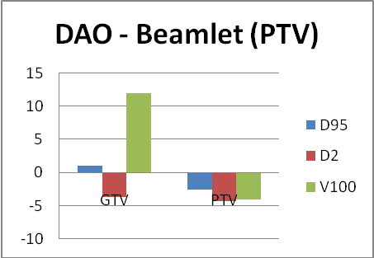
Fig. 1. The graph of GTVs and PTVs dose coverage difference between DAO and beamlet optimizer plans.

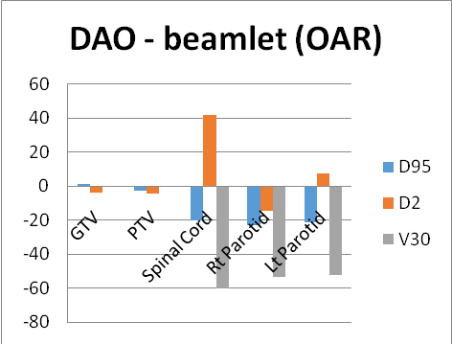
Fig. 2. The graph of OAR dose coverage difference between DAO and beamlet optimizer plans.

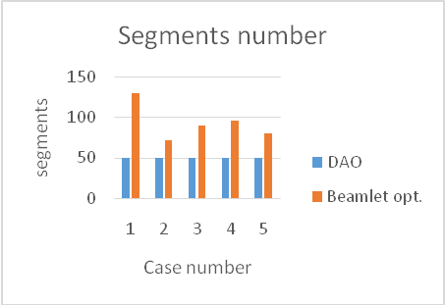
Fig. 3. The graph of segments number for DAO and beamlet optimizer plans.

The number of segments in plan using DAO was constant at 49 because the planner determine it by himself, while it was varies from 71 up to 129 segments in plan using beamlet optimizer as shown in figure (3). And the number of total monitor units should be delivered from linear accelerator was lower in DAO plans than those for beamlet plans by about 55% on average as shown in figure (4).

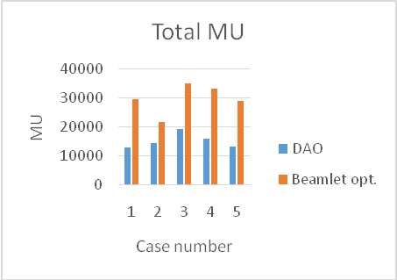
Fig. 4. The graph of total monitor units’ number for DAO and beamlet optimizer plans.

For prostate plans, optimum plans done using beamlet optimizer were compared with those done using DAO, where doses delivered to target volumes and OAR were measured, and also comparing the number of segments and total number of monitor units should be delivered from clinical linear accelerator.
The results showed, for GTV, there was no significant differences between DAO and beamlet in all plans in 95% isodose coverage, while for the same isodose line in PTV, and seminal vesicles, the difference was 6.3% and 2.6% on average for plans done using beamlet optimizer more than that done using DAO. The average difference in GTV, PTV, and seminal vesicles volume which was covered by the prescribed dose was 15%, 34%, and 37% respectively in plans done using beamlet optimizer more than those done using DAO, and also D2% was higher in beamlet optimizer plans than in DAO optimizer by about 2.5%, 2.6%, and 3.4 % respectively. Figure (5) showed GTV, PTV, seminal vesicles average dose differences between DAO and beamlet optimizer.
For OAR, results showed an improvement in rectum and bladder sparing in plans done using beamlet optimizer where D50%, D2%, and V30 were lower by 9.5%, 2.8%, and 12.4% respectively in rectum and were 4.6%, 1.3%, and 4.5% respectively in bladder. While DAO improved lt. femur and rt. femur sparing than beamlet optimizer as D50%, D2%, and V20 were lower by 3.6%, 5.9%, and 14% respectively in lt. femur, and were 18.4%, 13.6%, and 35% respectively in rt. femur. Figure (6) showed the dose difference between DAO and beamlet plans for OAR.

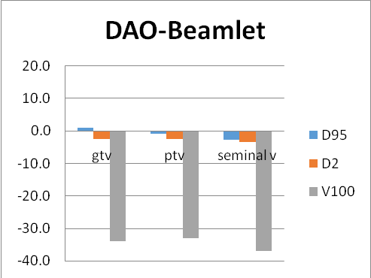
Fig. 5. The graph of GTV, PTV, and seminal vesicles dose coverage difference between DAO and beamlet optimizer plans.

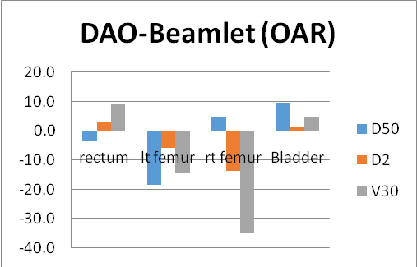
Fig. 6. The graph of OAR dose coverage difference between DAO and beamlet optimizer plans.

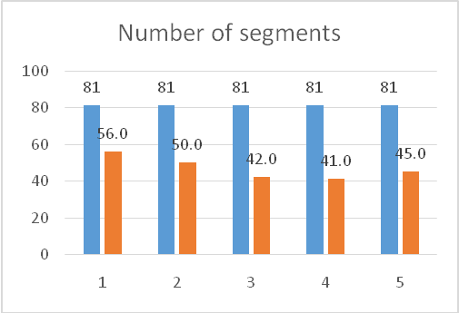
Fig. 7. The graph of segments number for prostate cases planned using DAO and beamlet optimizer plans.

The number of segments in plan using DAO was constant at 81 because the planner determine it by himself, while it was varies from 100 up to 130 segments in plans using beamlet optimizer as shown in figure (7).
Total monitor units should be delivered from linear accelerator was lower in DAO plans than those for beamlet plans by about 15% on average as shown in figure (8).

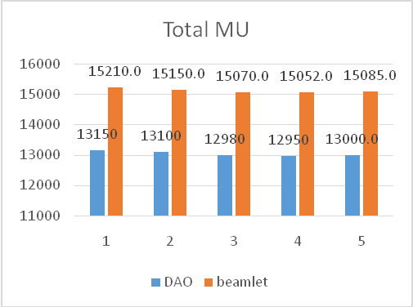
Fig. 8. The graph of total number of monitor units for prostate cases planned using DAO and beamlet optimizer plans.

IV. Discussion
Direct Aperture optimization (DAO), sometime termed Direct Machine Parameter Optimization, is an inverse planning where the apertures are identified during the planning process, however the apertures are not selected by considering the anatomical relationship between the target and critical structures. The planner inputs the dose constraints, beam angles, energies and number of apertures. With DAO, the planner can also put a constraint on the minimum size of each aperture and place a lower bound on the weight². The apertures are selected based on a few initial iterations and then the dose distribution is calculated for all fields. A large number of candidate apertures are sampled and either accepted or rejected depending on whether the plan is improved by adding the new aperture.
In beamlet based optimization a large beam is divided into many small beamlets of about 1 cm², then dose constraints are assigned to the targets and sensitive structures. Computerized inverse optimization must be performed to find the individual weights of this large number of beamlets. The computer adjusts the intensities of these beamlets according to the required planning dose objectives. Plans frequently fail to achieve the desired dose constraints and so clinical decisions have to be made as to which are most important and which can be relaxed. Once the optimal fluence map is decided upon, there is a further leaf sequencing step. The optimized intensity patterns are decomposed into a series of deliverable MLC shapes made up of a number of basic beamlets with mathematically related weights/intensities¹¹.
There are many dosimetric concerns associated with IMRT such as low MU per segment, high overall MU, and dosimetric uncertainties can be improved by controlling plan complexity. Direct aperture optimization is a method of controlling complexity that provides a significant reduction in the number of beam segments and MU required.
In beamlet optimization when converting the plan from the computer generated solution to deliverable segments, the dose distribution will degrade from that originally decided upon. DAO differs from beamlet optimization in that it does not rely on the use of a segmentation routine (sequencing step) to select the initial leaf sequence as this step is incorporated into the original optimization resulting in avoidance of the plan degradation which can occur.
Head and neck the dose coverage has improved by 4% in DAO. For organs at risk (OAR), DAO reduced the volume covered by 30% (V30) in spinal cord, right parotid, and left parotid by 60%, 54%, and 53% respectively. DAO required lower number of segments and monitor units by 46% and 51% respectively. In another study of 10 hypopharyngeal patients, no statistically significant difference was found for compliance to the dose volume constraints although the mean dose to the parotid was lower with the beamlet based plans compared to the DAO plans. Dose homogeneity within the PTV was superior for the DAO plans and they also required significantly less MU to deliver¹⁹.
In prostate plans, PTV dose coverage was improved by only 2% when planned using DAO. The right femur, left femur and bladder were improved by 35%, 15% and 3% respectively also. On the contrary, the rectum V30 got even worse by 9%. However, number of monitor units, and number of segments decreased by 20% and 25% respectively. Ludlum et al¹¹ compared DAO to beamlet based optimization in 5 prostate. Their results showed that DAO could create plans of similar quality yet with a significant reduction in the number of segments, requiring 3–5 times fewer segments reducing the delivery time for MLC. With DAO, clinical requirements could be met for prostate patients with as fewer segments compared to beamlet based optimization.
Calculation time for all cases were also calculated in this study and it was found that the DAO IMRT treatments would easily fit into the about 18 - 25 min but the beamlet based IMRT treatments would require slightly longer treatment slots of 30 - 40 min depending on target volume and the complexity of plan. the difference in calculation time arises from that beamlet perform calculations twice as it calculates the map intensity first and then recalculate to translate the map to deliverable segments while DAO perform the calculation once as discussed earlier.

V. Conclusion:
DAO introduces considerable advantages over beamlet optimization in regards to organ at risk sparing. While no significant improvement occurred in the PTV ICRU reporting dose. The main advantage for using DAO was decreasing the number of segments to be used during treatment as well as decreasing the total number of monitor units should be delivered from linear accelerator which is reflecting on the treatment time and scattered radiation to the patients.

References
- De Gersem W, Claus F, De Wagter C, De Neve W. An anatomy-based beam segmentation tool for intensity-modulated radiation therapy and its application to head-and-neck cancer. Int J Radiat Oncol Biol Phys. 2001;51(3):849–59. 4.
- Shepard DM, Earl MA, Li XA, Naqvi S, Yu C. Direct aperture optimization: a turnkey solution for step-and-shoot IMRT. Med Phys. 2002;29(6):1007–18. 5.
- Siebers JV, Lauterbach M, Keall PJ, Mohan R. Incorporating multi-leaf collimator leaf sequencing into iterative IMRT optimization. Med Phys. 2002;29(6):952–59. 6.
- Cotrutz C and Xing L. Segment-based dose optimization using a genetic algorithm. Phys Med Biol. 2003;48(18):2987–98. 7.
- Y. Li, Yao J, Yao D. Genetic algorithm based deliverable segments optimization for static intensity-modulated radiotherapy. Phys Med Biol. 2003;48(20):3353–74. 8.
- Bedford JL and Webb S. Constrained segment shapes in direct-aperture optimization for step-and-shoot IMRT. Med Phys. 2006;33(4):944–58. 9.
- Bergman AM, Bush K, Milette MP, Popescu IA, Otto K, Duzenli C. Direct aperture optimization for IMRT using Monte Carlo generated beamlets. Med Phys. 2006;33(10):3666–79. 10.
- Bedford JL and Webb S. Direct-aperture optimization applied to selection of beam orientations in intensity-modulated radiation therapy. Phys Med Biol. 2007;52(2):479–98. 11.
- Mestrovic A, Milette MP, Nichol A, Clark BG, Otto K. Direct aperture optimization for online adaptive radiation therapy. Med Phys. 2007;34(5):1631–46. 12.
- Jones S and Williams M. Clinical evaluation of direct aperture optimization when applied to head-and-neck IMRT. Med Dosim. 2008;33(1):86–92. 13.
- Ludlum E and Xia P. Comparison of IMRT planning with two-step and one-step optimization: a way to simplify IMRT. Phys Med Biol. 2008;53 (3):807
- Van Asselen B, Schwarz M, van Vliet-Vroegindeweij C, Lebesque JV, Mijnheer BJ, Damen EM. Intensity-modulated radiotherapy of breast cancer using direct aperture optimization. Radiother Oncol. 2006;79(2):162–69. 14.
- Ahunbay EE, Chen GP, Thatcher S, et al. Direct aperture optimization-based intensity-modulated radiotherapy for 15. whole breast irradiation. Int J Radiat Oncol Biol Phys. 2007;67(4):1248–58.
- Lydon, J.M. Theoretical and experimental validation of treatment planning for narrow MLC defined photon fields. Phys. Med. Biol. 50:2701–14; 2005.
- Keller-Reichenbecher MA, Bortfeld T, Levegrun S, Stein J, Preiser K, Schlegel W (1999) Intensity modulation with the “step and shoot” technique using a commercial MLC: a planning study. Multileaf collimator. Int J Radiat Oncol Biol Phys 45:1315–1324.
- Bedford, J.L.; Webb, S. Constrained segment shapes in directaperture optimization for step-and-shoot IMRT. Med. Phys. 33: 944–58; 2006.
- Zhu, X.R.; Schultz, C.J.; Gillin, M.T. Planning quality and delivery efficiency of sMLC delivered IMRT treatment of oropharyngeal cancers evaluated by RTOG H-0022 dosimetric criteria. J. Appl. Clin. Med. Phys. 5:80–95; 2004.
- International Commission on Radiation Units and Measurements 2010: “Prescribing, Recording, and Reporting Photon-Beam Intensity-Modulated Radiation Therapy (IMRT)”, Journal of the ICRU Vol 10 No 1 (2010) Report 83.
- Dobler B, Pohl F, Bogner L, Koelb O. Comparison of direct machine parameter optimization versus fluence optimization with sequential sequencing in IMRT of hypopharyngeal cancer. Radiat Oncol (2007), 2:33 [http://www.ro-journal.com/con tent/2/1/33].

8/16/2015

