Arrival Sequence, Abundance and Host Plant Preference of the Apple Leaf Miner Lyonetia clerkella Linn. (Lepidoptera: Lyonetiidae) in Kashmir

Samiullah Rather, Abdul A. Buhroo*

Section of Entomology, Postgraduate Department of Zoology, University of Kashmir, Hazratbal, Srinagar-190006, India
*Corresponding author: abuhroo@yahoo.com

Abstract: Apple leaf miner Lyonetia clerkella is a key pest particularly in the late spring and early summer in Kashmir where it causes severe damage to the apple trees followed by heavy defoliation prior to harvest. This species overwinters in the adult stage from November onwards in the valley of Kashmir and the moths were seen active in April at the time of apple blossom. These moths lay eggs in the third week of April and the first larval mines make their appearance in the last week of April and continue to grow till the second week of May and the first generation was completed up to the 4th week of May. During this period, abundance of mines was seen on the apple foliage. This species then produced five generations in a single year and the adult moths of the final brood overwintered in November. The pest completed its life cycle in about 35-60 days. However, the density of infestation rose to its peak from the first week of May till the 3rd week of June (Mean of individuals per 10 trees, 27.4–78.6). Furthermore, it was observed that abundance of the pest declined steeply from the 3rd week of June till the last week of November (Mean 50.2–4.1) after which no fresh mines were seen. The results also showed that apple was the most favorable host for this species with dominance coefficient of 84.70% as compared to other host trees.
[Rather S, Buhroo AA. Arrival Sequence, Abundance and Host Plant Preference of the Apple Leaf Miner Lyonetia clerkella Linn. (Lepidoptera: Lyonetiidae) in Kashmir. Nat Sci 2015; 13(9):25-31]. (ISSN: 1545-0740). http://www.sciencepub.net/nature.

Keywords: Apple leaf miner; arrival sequence; abundance; host preference

1. Introduction
In Kashmir valley, a wide variety of insect pests occur on apple in varying levels of infestation and accordingly cause damage to the apple fruit, reducing its yield as well as quality. Some of these insect pests are the leaf miner moths that became serious pests in apple and pear orchards around the world by the end of 1940’s (Cross et al., 1999). Feeding inside leaves, these leaf miners have been viewed as an adaptive innovation for consuming foliage. The leaf mine presumably provides its occupant shelter from the detrimental effects of the physical environment, protection from attack by natural enemies, and potentially a means of avoiding plant defenses concentrated in particular layers of the leaf tissue (Connar and Taverner, 1997).
The miner and plant relationship may have arisen 275 million years ago being, probably, a beneficial interaction to the miner, in as much as the host plant offers food and shelter to the miner during the larval period of its life cycle (Labandeira, 1998). The leaf mining habit has been developed by a group of over 10,000 species of holometabolous insects, concentrated in four orders: Diptera, Coleoptera, Hymenoptera, and Lepidoptera (Connor and Taverner, 1997). Among these insect pests, the apple leaf miner, Lyonetia clerkella Linn. (Lepidoptera: Lyonetiidae) is the most common and causes severe damage to the host plants. This leaf miner is considered as a major insect pest in commercial peach orchards in Japan where it causes heavy defoliation prior to harvest (Naruse, 1978; Naruse and Hirano, 1990). This microlepidoptera (L. clerkella) occurs all over Europe, north-western Siberia, the Far East, Northern Africa, the Middle East, Turkey, India and Japan and damages a wide variety of fruits including apple, pear, cherry, plum, peach, quince (Agata et al., 2007). It is considered as one of the most destructive pests in East Asia where it causes defoliation even when the leaves are infested merely by few larvae (Akira and Takehiko, 1989).
The larvae of L. clerkella live and feed inside the leaves, consuming the mesophyll without damaging the leaf epidermis. Their feeding tracts (=mines) are externally visible in leaves as whitish or grey areas with variable lengths that range from narrow linear galleries to wide chambers (Hering, 1951). The galleries excavated by the larvae of L. clerkella can reduce the photosynthetic capacity of leaves, cause premature leaf abscission, and permit pathogen entry into plant tissue (Spencer, 1973; Parrella and Jones, 1987; Minkenberg and Van Lenteren, 1986; Maier, 2001). As the main target of this insect miner is the leaf in the young plant hosts; therefore, leaf selection is also an important aspect of insect-plant interaction because oviposition by the adult moth determines the area where the larva will feed (Faeth et al., 1981).
There is no information available on this insect in the Indian sub-continent except that Ahmad and Bhat (1987) only reported this species in Kashmir but without any details. We, therefore, sought to obtain the arrival sequence, seasonal distribution and abundance, and host plant preference of L. clerkella infesting temperate fruits.

2. Material and Methods

Field Studies
The biological data were obtained mainly from the study area at Hazratbal, district Srinagar consisting mainly apple trees, 15-25 years old and infested with L. clerkella. The orchard had many cultivars of apple but Red Delicious was the predominant one. Besides few trees of pear, plum, peach, apricot and cherry were also scattered in the orchard. These trees were planted at a distance of 4-10 meters from each other.
Apple tree twigs bearing infested leaves were placed inside the five liter transparent plastic bottles which were used as traps. These bottles were cross ventilated so as to allow the free movement of air. The dimensions of the ventilations were made as 10 x 10 cm and were closed with nylon mesh in order to detain the caterpillars (Fig. 1). After the formation of pupae, bottles were removed and the cocoons were collected. The cocoons so collected were placed within the bottles mounted upon the apple plantlets in the rearing room for further study.
Laboratory Studies
For laboratory study, seven liter transparent plastic bottles were used for the rearing of adult moths. Likewise, cross ventilations were made in these bottles for the free circulation of air. The dimensions of the ventilations were made as 10 x 10 cm and were also closed by fine nylon mesh. The bottles were free from parasitism and were mounted upon the apple plantlets (Fig. 2). Leaves bearing cocoons were collected from the apple trees and were placed inside the aforesaid bottles and the latter were sealed perfectly in order to detain the moths. The total life span of the moths was determined by calculating the time from their emergence until their death and for this purpose, cocoons were kept in separate bottles with cross ventilations. The bottles used for this process were transparent and the ventilations were sealed by a fine nylon mesh for the free circulation of air and sunlight. After the death of moths, bottles were detached from their respective apple plantlets and the dead moths were preserved in 80% ethyl alcohol. After the removal of bottles, the leaves of these plantlets were observed carefully for mines with the help of a magnifying glass. However, it is very difficult to recognize a mine at its initial stage because of its extreme narrowness. Therefore, a well lit torch was often used by placing it underside the mined leaves. The mines were marked by drawing tiny, short lines with the help of a marker. Near the end of the larval phase, the bottles were again mounted upon the plantlets in order to study the next cycle and the process was repeated until the end of the season which finally revealed the total number of generations apple leaf miners produce in a year.

Seasonal abundance
In order to know the abundance and the level of infestation of apple trees by apple leaf miner moths in various months of the year, two hundred apple trees with the age of about 2.5 – 3 years were surveyed for mines in the University campus. Ten trees were selected randomly after weekly intervals and the mines these infested leaves contain, were counted and recorded. The mean of the ten trees for each week was calculated throughout the year. The number of mines is equal to the number of attacking individuals and hence represents the abundance of this species throughout the season.
Host plant preference
In order to study the host selection preference of L. clerkella, moths were reared in a rearing box. The dimensions of the box were kept as 2.5 x 2 x 4 feet respectively. One foot from the bottom of the box was completely enclosed by timber planks and was filled with soil. The right and back sides of the box were enclosed by ply wood. Sections were cut so as to facilitate the free circulation of air and sunlight. The dimensions of the ventilations were kept as 3 x 2 feet and closed by a fine nylon mesh. The box was free from parasitism and was kept in the rearing room. Eight temperate fruit plantlets including apple, quince, peach, plum, cherry, apricot, almond and pear along with a non-host plant, pomegranate were planted into the soil of the rearing box. Cocoons of apple leaf miners were collected from the infested apple trees and introduced in the box. The opening of the box was closed perfectly in order to save the moths from escaping. The behavior of the adult moths within the box was monitored continually until their death. The dead moths were then collected from the box and preserved in 80% alcohol. The leaves of the host plantlets and the non-host plantlet within the box were observed carefully for the mines. The total number of mines from each infested plant was recorded and consequently the proportion of mine formation (i.e., dominance coefficient of attack) by L. clerkella was determined.
The host tree preference was also studied in the field at Hazratbal Experimental site. The number of mines on the infested trees which include apple, quince, peach, plum, pear and apricot were counted and recorded. The coefficient of dominance by the pest was also determined.
3. Results and Discussion
Seasonal distribution
Observations recorded in laboratory as well as in the field showed that L. clerkella overwinters in the adult stage from November onwards in the valley of Kashmir. These moths were seen active in April at the time of apple blossom. After mating, the female moths were found to insert their eggs into the leaves of the host plant from 10th of April till 20th of the same month. It was observed (Fig. 3) that the larval period started when the mines first appeared on 25th of April and extended up to the 10th May when mines were found empty. During this period, abundance of mines was seen on the apple foliage. Pupae were first seen from 10th of May onwards and the cocoons were found empty after 25th May. Adult moths appeared on 20th of May and no moth was found alive after 5th June. The moths of the first generation laid their eggs from 1st to 14th of June and the mines appeared on 5th June. However, these mines were found empty after 15th of June. The pupal period of the second generation started when the cocoons first appeared on 10th of June. Nevertheless, these cocoons were found empty after 25th of June and moths appeared but no moth was found alive after 6th July. The moths of the second generation laid eggs in the first week of July and the fresh mines were seen from 2nd week of July onwards. However, these fresh mines were found empty after 15th of July. Fresh pupal cocoons were seen after 15th of July and this period extended until 30th of the same month when cocoons were found empty. The adult moths for the third generation were seen from 25th of July till 10th of August. These moths laid eggs through 1st to 10th of August and the mines appeared from 5th of the same month. These mines were completed up to 20th of August followed by the formation of cocoons until the first week of September. The moths of the 4th generation appeared from first September to 20th of the same month that laid their eggs in the second fortnight of September and the signs of fresh mines were again seen on 24th of September. However, these tiny mines became empty after 25th of October and the pupal cocoons were again found in the second fortnight of October. The adult moths of 5th generation were seen from 25th of October onwards. No moth was seen active through November until 2nd week of April of the following year. This species completed its life cycle in about 35-60 days (Table 1). During the winter season, these moths take shelter in the crevices of bark, underside of the dry fallen leaves and inside the thatch.
Seasonal abundance
The number of attacking individuals and abundance of this species throughout the season is shown in Figure 4. The data reveals that the density of infestation was very low initially in the month of April. However, the density of infestation rose to its peak from the first week of May till the 3rd week of June (Mean of individuals per 10 trees, 27.4–78.6). Furthermore, it was observed that abundance of the pest declined steeply from the 3rd week of June till the last week of November (Mean 50.2–4.1) after which no fresh mines were seen. This clearly indicated that moths of the 5th generation had undergone the process of hibernation. The sudden decline in the population of this pest in the second half of the summer season could be mainly due to the biological control agents like insects, fungi and parasitoids that regulate the population of the leaf miners. Insects like beetles and spiders lay eggs on or into the developing miner caterpillars inside the mines and after hatching, the larvae of these insects consume the miner caterpillars (Kholchenkov, 1974). The weather seems to play no role in the successive reduction of these miner microlepidopterans. However, it was seen that the degree of infestation is less in the insecticide sprayed apple orchards as compared to unsprayed ones.
Host plant preference
The data obtained at the experimental orchard (Table 2) showed the extent of infestation to the host trees and consequently the host preference by L. clerkella. It was seen that apple was the most favorable host for this species with dominance coefficient of 84.70% as compared to other host trees. This was followed by quince, pear and peach with 9.41%, 4.70%, and 1.18% coefficient of dominance respectively. These findings revealed that the female moths of apple leaf miners prefer to deposit their eggs within the apple foliage as compared to other host trees. Therefore, apple trees are usually preferred over the other host trees. The reason for this seems to be the apple foliage that provides maximum resources to the eggs and caterpillars for the completion of larval phase. In case of mass infestation, the other host trees particularly quince and pear, lying nearby are also utilized by the leaf miners for this purpose. This was inferred by surveying the trees like pear, plum and peach at different locations. These trees were situated far away from the apple trees and did not show any signs of such infestation. However, non host trees were never seen infested by these micro moths. In order to know the behavior of apple leaf miners towards these non host trees, ten orchards were surveyed at different sites in the Srinagar city. Many such trees were found merely 5-10 feet apart from the apple trees and did not show any sign of infection. Therefore, it was concluded that such trees must lack the necessary life sustaining resources essential for the larval development.
The results obtained in the laboratory (Table 3) revealed the coefficient of dominance of apple, quince, pear, apricot, peach and plum were 51.61%, 19.35%, 09.68%, 06.45%, 06.45%, and 06.45% respectively. These results indicated the apple plants to be heavily infested where as cherry, almond and pomegranate remained unaffected.

Table 1. Number of generations per year of L. clerkella in Kashmir
No of generations | 1st | 2nd | 3rd | 4th | 5th
Duration (days) | 50 | 35 | 40 | 40 | 60

Table 2. Host tree preference (in field)
Host plant | No. of mines observed | Coefficient of dominance (%)
Malus domestica, Apple | 1800 | 84.70
Cydonia oblonga, Quince | 200 | 9.41
Pyrus communis, Pear | 100 | 4.70
Prunus persica, Peach | 25 | 1.18
Prunus domestica, Plum | 0 | 0.0
Prunus armeniaca, Apricot | 0 | 0.0

Table 3. Host selection preference (in laboratory)
Host plant | No. of mines observed | Coefficient of dominance (%)
Malus domestica, Apple | 16 | 51.61
Cydonia oblonga, Quince | 6 | 19.35
Pyrus communis, Pear | 3 | 9.68
Prunus persica, Peach | 2 | 6.45
Prunus domestica, Plum | 2 | 6.45
Prunus armeniaca, Apricot | 2 | 6.45
Prunus dulcis, Almond | 0 | 0.00
Prunus avium, Cherry | 0 | 0.00
Punica granatum, Pomegranate | 0 | 0.00

Fig. 1. Traps mounted upon infested apple twigs

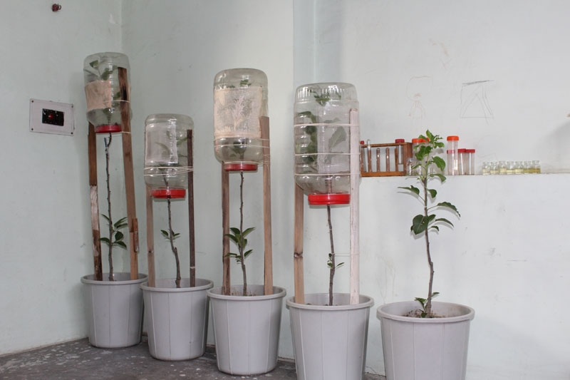
Fig. 2. Experimental apple plantlets in rearing room

 | JAN | FEB | MAR | APR |  |  |  |  | MAY |  |  |  |  |  | JUNE |  |  |  |  |  |  |  | JULY |  |  |  |  |  |  | AUG |  |  |  |  |  | SEP |  |  |  |  | OCT |  |  |  | NOV |  |  | DEC
A
E | 1st generation
L
P
A
E |  | 2nd generation
L
P
A
E |  |  | 3rd generation
L
P
A
E |  |  |  | 4th generation
L
P
A
E |  |  |  |  |  |  |  |  | 5th generation
L
P
A
Fig. 3. Life cycle and seasonal distribution of L. clerkella (E: egg, L: larva, P: pupa & A: adult)

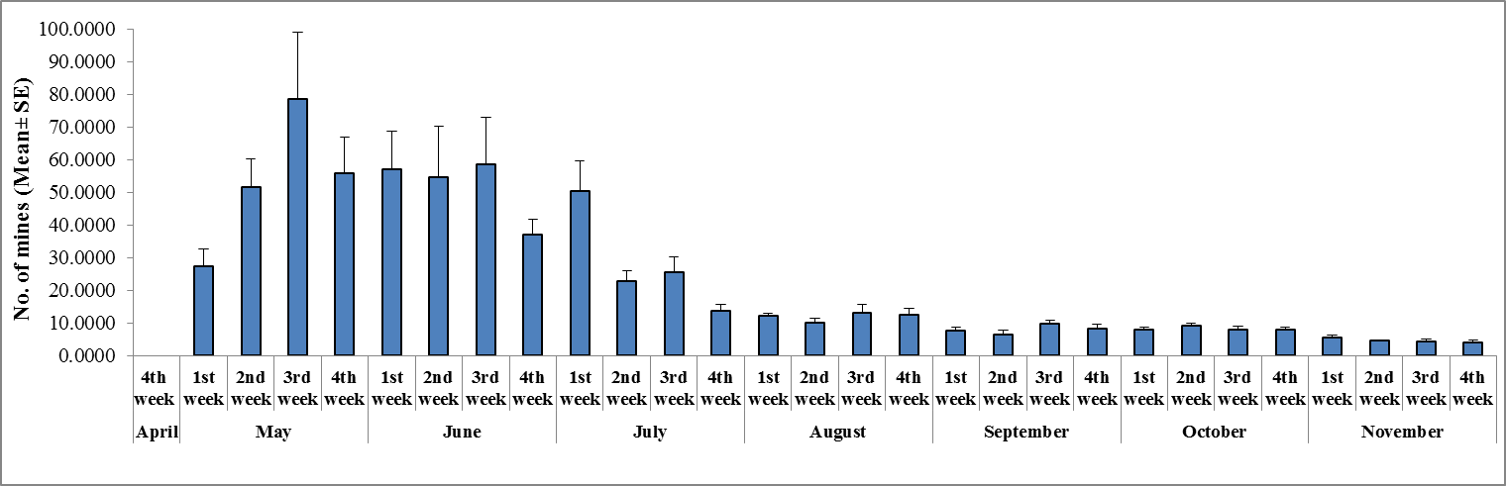
Fig. 4. Population dynamics of L. clerkella

Conclusions
The destructive phase of this microlepidopteran is the larval stage. The larvae form mines in the leaves and these mines often cross the midrib and block the circulation of sap and other vital nutrients. This causes the leaves to dry which ultimately minimizes the process of photosynthesis and, therefore, reduces the yield. After the sudden emergence in the late spring, it becomes very difficult to save the host trees from their infection. However, it is recommended that the bark of the host trees be cleared from these moths and the dry fallen leaves and twigs be burnt. During the field trips, it was observed that the orchards having apple trees when sprayed with insecticides, showed least degree of infestation. However, the unsprayed orchards displayed the abundance of mines and were severely affected. But much needs to be done on its detailed bionomics so as to develop an efficient pest management system in apple orchards.

References
- Agata, Z., Filipescu, C., Georgeseu, T., Talmaciu, N., & Bernardis, R. (2007). Biology, Ecology and integrated control of the species Lyonetia clerkella: Pest in the apple plantation from Neamt County. Neamt County Phytosanitary Board. pp. 1125-1128.
- Ahmed, D., & Bhat, M. R. (1987). Insect pests of apple trees in Kashmir. Geobios new Reports, 6, 60-63.
- Akira, Y., & Takehiko, F. (1989). Convenient synthesis of racemic 14-methy-1- tadecene, sex pheromone of the peach leaf minor Moth. Agric. Biol. Chem., 53, 1183–1184.
- Connor, E. F., & Taverner, M. P. (1997). The evolution and adaptive significance of the leaf-mining habit. Oikos, 79, 6-25.
- Cross, J.V., Solomon, M. G., Babandreier, D., Blommers, L., Easterbrook, M. A., Jay, C. N., Jenser, G., Jolly, R. L., Kuhlmann, U., Lilley, R., Olivella, E., Toepfer, S., & Vidal, S. (1999). Biocontrol of pests of apples and pears in northern and central Europe: 2. Parasitoids. Biocontrol Science and Technology, 9, 277–314.
- Faeth, S. H., Mopper, S., & Simberloff, D. (1981). Abundances and diversity of leaf-mining insects on three oak host species: effects of host-plant phenology and nitrogen content of leaves. Oikos, 37, 238-251.
- Hering, E. M. (1951). Biology of the Leaf Miners. Dr. W. Junk, The Hague. The Netherlands. pp. 420.
- Kholchenkov, V. A. (1974). Family Lyonetiidae. In: Vasil. ev V.P., ed. Pests of agricultural crops and forest plantations. V. 2. Arthropods. Kiev: Urozhai, pp. 230-231.
- Labandeira, C. C. (1998). Early history of arthropod and vascular plant associations. Review of Earth and Planetary Sciences, 26, 329-377.
- Maier, C. T. (2001). Exotic lepidopteran leaf miners in North American apple orchards: rise to prominence, management, and future threats. Biol. Invasions, 3, 283-293.
- Minkenberg, O., & Lanteren, J. V. (1986). The leafminers Liriomyza bryoniae and L. trifolii (Diptera: Agromyzidae), their parasities and host plants: a review. Agricultural University Wagenigen Papers, 86, 1-50.
- Naruse, H. (1978). Defoliation of peach tree caused by the injury of the peach leaf-miner, Lyonetia clerkella: Influence of larval density. Jpn. J. Appl. Entomol. Zool., 22, 1-6 (in Jpanese).
- Naruse, H., & Hirano, M. (1990). Ecological studies on the peach leaf-miner Lyonetia clerkella in the peach field. Bull. Toyama Agric. Res. Ctr., 6, 1-81.
- Parella, M. P., & Jones, V. P. (1987). Development of integrated pest management strategies in floricultural crops. Bull. Entomol. Soc. Am., 33, 28-34.
- Spencer, K. A. (1973). Agromyzidae (Diptera) of economic importance. Series Ent. 9. Dr W Junk. The Hague. The Netherlands. pp. 418.

8/6/2015

