**Effect of Acetazolamide Drug as Corrosion Inhibitor for Carbon Steel in Hydrochloric Acid Solution**

1. S. Fouda1,*, S. H. Etaiw2 and Ahmed wahba3

1Department of Chemistry, Faculty of Science, Mansoura University, Mansoura-35516, Egypt, Fax: +2 050 2202271, Tel: +2 050 2365730

2Department of Chemistry, Faculty of Science, Tanta University, Tanta, Egypt.

3Hight Institute of Engineering and Textile Technology (HIETT), El-Mahalla, Egypt

**Abstract:** The inhibiting effect of acetazolamide on the corrosion of C-steel in 1M HCl was studied by weight loss, potentiodynamic polarization measurements, electrochemical impedance spectroscopy (EIS) and electrochemical frequency modulation (EFM) techniques. The results showed that the inhibition efficiency increases with increasing the drug concentration, while it decreases with raising the temperature. The adsorption of acetazolamide on the carbon steel surface obeys the Temkin adsorption isotherm. Polarization studies indicate that this investigated drug is a mixed type inhibitor. The thermodynamic functions of adsorption processes were calculated from weight loss at different temperatures. The surface morphology of the carbon steel specimens was examined using scanning electron microscope (SEM) and energy dispersive X-ray (EDX) analysis.

**[**A.S. Fouda, S.H. Etaiw and Ahmed wahba. **Effect of Acetazolamide Drug as Corrosion Inhibitor for Carbon Steel in Hydrochloric Acid Solution.** *Nat Sci* 2015;13(9):1-8]. (ISSN: 1545-0740). <http://www.sciencepub.net/nature>. 1

**Keywords**: Carbon steel, Corrosion inhibition, acetazolamide, HCl, Potentiodynamic polarization, EIS, EFM, SEM, EDX.

**1. Introduction**

Corrosion is a fundamental process playing an important role in economics and safety‚ particularly for metals. The use of inhibitors is one of the most practical methods for protection against corrosion‚ especially in acidic media. Most well-known acid inhibitor are organic compounds containing nitrogen ‚ sulfur‚ phosphorus and oxygen atoms. Among them‚ organic inhibitors have many advantages such as high inhibition efficiency‚ low price‚ low toxicity‚ and easy production**.** Organic heterocyclic compounds have been used for the corrosion inhibition of most metals in different corroding media. The adsorption of heterocyclic compounds on the metal surface can markedly change the corrosion- resisting property of the metal and so the study of the relations between the adsorption and corrosion inhibition is of great important. Heterocyclic compounds have shown a high inhibition efficiency for iron in HCl solution.

The objective of this study is to investigate the corrosion behavior of carbon steel in 1M HCl at different temperatures in the presence of acetazolamide using chemical and electrochemical techniques. The surface morphology of the carbon steel specimens was evaluated using SEM and EDX analysis.

**2. Experimental methods**

*2.1. Chemicals and materials*

Hydrochloric acid (37%), ethyl alcohol and acetone were purchased from Al-Gomhoria Company, Egypt, acetazolamide was purchased from Lanett Company. The molecular structure and other detail of this compound is given in Table (1). Bidistilled water was used throughout all the experiments.

**Table 1.** Molecular structure, formula and molecular weight of acetazolamide

|  |  |  |  |
| --- | --- | --- | --- |
| Chemical formula | Active center | IUPAC Name | Structure |
| 222.245 C4H6N4O3S2 | 3O  4N  2S | N-(5-sulfamoyl-1,3,4-thiadiazol-2-yl)acetamide |  |

***2.2 Solutions***

The aggressive solutions, 1M HCl were prepared by dilution of analytical grade (37%) HCl with bi-distilled water. The concentration range of the inhibitor used was 50-300 ppm

**3. Methods**

*3.1. Weight loss method*

Seven parallel C-steel sheets of 2 × 2 × 2 cm2 were abraded with emery paper (grade up to 1200 grit size) and then washed with bi-distilled water and acetone. After accurate weighing, the specimens were immersed in a 250 ml beaker, which contained 100 ml of HCl with and without addition of different concentrations of investigated drug.

All the aggressive acid solutions were open to air. After3h, the specimens were taken out, washed, dried, and weighed accurately. The average weight loss of seven parallel C-steel sheets could be obtained. The inhibition efficiency (%IE) and the degree of surface coverage, θ, of acetazolamide were calculated as follows:

%IE = θ x 100 = [1− (W∕ Wº)]×100 (1)

Where Wº and W are the values of the average weight loss without and with addition of the drug, respectively.

***3.2. Electrochemical measurements***

Electrochemical measurements were conducted in a conventional three electrodes thermostated cell assembly using Gamry Potentiostat/ Galvanostat/ZRA (model PCI300/4). A platinum foil and saturated calomel electrode (SCE) were used as counter and reference electrodes, respectively. The carbon steel electrodes were 1x1 cm and were welded from one side to a copper wire used for electrical connection. The electrodes were abraded, degreased and rinsed as described in weight loss measurements. All experiments were carried out at temperature 25◦C. The potentiodynamic curves were recorded from -500 to 500 mV at a scan rate 1 mVs-1 after the steady state is reached (30 min) and the open circuit potential (OCP) was noted. The %IE and degree of surface coverage were calculated from Eq. (2):

%IE = θ x 100 = [1 – (i°corr/ icorr)] x 100 (2)

Where i°corr and icorr are the corrosion current densities of uninhibited and inhibited solution, respectively.

Electrochemical impedance spectroscopy (EIS) and electrochemical frequency modulation (EFM) experiments were carried out using the same instrument as before with a Gamry framework system based on ESA400. Gamry applications include software EIS300 for EIS measurements and EFM140 for EFM measurements; computer was used for collecting data. Echem Analyst 5.5 Software was used for plotting, graphing and fitting data. EIS measurements were carried out in a frequency range of 100 kHz to 10 mHz with amplitude of 5 mV peak-to-peak using ac signals at respective corrosion potential. EFM carried out using two frequencies 2 and 5 Hz. The base frequency was 1 Hz. In this study, we use a perturbation signal with amplitude of 10 mV for both perturbation frequencies of 2 and 5 Hz.

***3.3. Surface examinations***

The specimens of carbon steel used for surface morphology examination were immersed in 1M HCl in the absence (blank) and presence of 300 ppm of investigated drug at 25°C for 24 hours. The analysis was performed using scanning electron microscope (JEOL JSM-5500, Japan).

Rough elemental analyses for the exposed surface were conducted by EDX technique.

**4. Results and Discussion**

*4.1. Weight loss measurements*

The weight loss-time curve of C-steel with the addition of acetazolamide inhibitor 1M HCl at various concentrations is shown in Figure (1). The curves of Figure(1) show that the weight loss values of C-steel in 1M HCl solution containing investigated drug decrease as the concentration of the drug increases; i.e., the corrosion inhibition strengthens with the drug concentration, this is appear in the data of Table 2.This trend may result from the fact that the adsorption of the drug on the C-steel increases with the drug concentration thus the C-steel surface is efficiently separated from the medium by the formation of a film on its surface**.**

**Table (2):** Variation of inhibition efficiency (%IE) of acetazolamide at 25oC from weight loss measurements at 120 min immersion in 1M HCl

|  |  |  |  |
| --- | --- | --- | --- |
| %IE | C.R. x 10-3  mg cm-2 min-1 | Conc.  ppm | Compound |
| 37.2 | 16.2 | 50 | acetazolamide |
| 52.4 | 12.3 | 100 |
| 57.2 | 11.1 | 150 |
| 71.1 | 7.5 | 200 |
| 78.4 | 5.6 | 250 |
| 86.1 | 3.6 | 300 |

**Figure (1):** Weight loss-time curve for the corrosion of C-steel in 1M HCl in the absence and presence of different concentrations of acetazolamide at 25oC

***4.2. Adsorption isotherms***

Organic molecules inhibit the corrosion process by the adsorption on metal surface. Theoretically, the adsorption process can be regarded as a single substitutional process in which an inhibitor molecule, I, in the aqueous phase substitutes an "x" adsorbed on the metal surface

I(aq) + xH2O(sur) I(sur) + xH2O(aq) (3)

where x is known as the size ratio and simply equals the number of adsorbed water molecules replaced by a single inhibitor molecule. The adsorption depends on the structure of the inhibitor, the type of the metal and the nature of its surface, the nature of the corrosion medium and its pH value, the temperature and the electrochemical potential of the metal-solution interface. Also, the adsorption provides information about the interaction among the adsorbed molecules themselves as well as their interaction with the metal surface. The values of surface coverage, θ, for different concentration of the studied drug at different temperatures have been used to explain the best isotherm to determine the adsorption process. By far the results of investigated inhibitor were best fitted by Temkin adsorption isotherm. Figure 2 shows the plotting of θ against log C at 25oC for investigated drug. This plot gave straight line indicating that the adsorption of investigated acetazolamide on C-steel surface follows Temkin adsorption isotherm:

θ= (1/f) ln KadsC (4)

Where C is the concentration of inhibitor, θ the fractional surface coverage and Kads is the adsorption equilibrium constant related to the free energy of adsorption ∆Gºads as follows:

Kads = 1/ 55.5 exp (-ΔGºads/ RT) (5)

Where R is the universal gas constant, T is the absolute temperature. The value 55.5 is the concentration of water on the metal surface in mol/ l



**Figure (2)**: Temkin adsorption isotherm of acetazolamide on C-steel surface in 1 M HCl at different temperatures

**Table 3:** Adsorption parameters for inhibitor acetazolamide in 1 M HCl obtained from Temkin adsorption isotherm at different temperatures

|  |  |  |  |  |  |
| --- | --- | --- | --- | --- | --- |
| -ΔS˚ads | -ΔG˚ads | R2 | Kads  x 10-6 M-1 | Temp.  oC | Inhibitor |
| 15.5 | 20.9 | 0.993 | 13.88 | 25 | Aceta-zolamide |
| 15.1 | 20.9 | 0.984 | 17.82 | 30 |
| 14.7 | 21.3 | 0.958 | 20.01 | 35 |
| 14.4 | 21.6 | 0.992 | 22.60 | 40 |
| 14.0 | 20.9 | 0.987 | 26.71 | 45 |

***4.3. Effect of temperature***

The effect of temperature on the rate of corrosion of C-steel in 1M HCl containing different concentrations from investigated drug was tested by weight loss measurements over a temperature range from 25 to 45oC.The results revealed that, the rate of corrosion increases as the temperature increases and decreases as the concentration of the drug increases. The activation energy (E*a) of the corrosion process was calculated using Arrhenius equation:

K=A exp (-Ea*/ RT) (6)

Where k is the rate of corrosion, A is the Arrhenius constant. Figure 3 presents the Arrhenius plot in the presence and absence of acetazolamide. E*a values determined from the slopes of these linear plots are shown in Table 4.Table 4 showed that the value of E*a for inhibited solution is higher than that for uninhibited solution, suggesting that dissolution of C-steel is slow in the presence of drug and can be interpreted as due to physical adsorption. The higher E*a values lead to the lower corrosion rate. This is due to the formation of a film on the C-steel surface serving as an energy barrier for the C-steel corrosion..

**Figure (3):** Arrhenius plots for C-steel corrosion rates (kcorr.) after 120 minute of immersion in 1 M HCl in the absence and presence of various concentrations of acetazolamide



**Figure (4):** Transition-state for C-steel corrosion rates (kcorr) in 1 M HCl in the absence and presence of various concentrations of acetazolamide

**Table 4:** Activation parameters for C-steel corrosion in the absence and presence of various concentrations of Acetazolamide in 1M HCl solution

|  |  |  |  |  |
| --- | --- | --- | --- | --- |
| Conc; ppm | Activation parameters | | | |
| Ax10-9  g cm-2 min-1 | E*a  kJ mol-1 | ∆H*  kJ mol-1 | -∆S*  J mol-1 K-1 |
| blank | 0.2 | 64.2 | 45.3 | 115.8 |
| 50 | 0.3 | 67.8 | 51.1 | 99.5 |
| 100 | 0.5 | 68.1 | 55.7 | 90.9 |
| 150 | 0.6 | 68.7 | 54.7 | 85.5 |
| 200 | 0.5 | 74.7 | 65.6 | 57.4 |
| 250 | 0.9 | 75.3 | 67.7 | 52.9 |
| 300 | 0.8 | 77.3 | 68.1 | 47.2 |

***4.4 Potentiodynami*c *polarization measurements***

Figure 5 shows the anodic and cathodic Tafel polarization curves for C-steel in 1M HCl in the absence and presence of varying concentrations of acetazolamide inhibitor at 25oC respectively. From Fig. 5, it is clear that both anodic metal dissolution and cathodic H2 reduction reactions were inhibited when investigated inhibitor were added to 1M HCl and this inhibition was more pronounced with increasing inhibitor concentration. Tafel lines are shifted to more negative and more positive potentials with respect to the blank curve by increasing the concentration of the investigated inhibitor. This behavior indicates that the undertaken additives act as mixed-type inhibitor. The results show that the increase in inhibitor concentration leads to decrease the corrosion current density (icorr), but the Tafel slopes (βa ‚βc)‚ are approximately constant indicating that the retardation of the two reactions (cathodic hydrogen reduction and anodic metal dissolution) were affected without changing the dissolution mechanism**.**

**Table 5:** Effect of acetazolamide concentrations on the free corrosion potential (Ecorr), corrosion current density (icorr), Tafel slopes (βc, βa), corrosion rate , and inhibition efficiency (%I.E) of C- steel in 1 M of HCl at 25 ºC

|  |  |  |  |  |  |  |
| --- | --- | --- | --- | --- | --- | --- |
| % I.E | C.R mpy | βc mV/decade | βa mV/decade | Ecorr mV- | Icorrx 10-4uA cm-2 | Inh;  ppm |
| ------ | 277.6 | 206 | 133 | 443 | 607 | Blank |
| 37.2 | 173.9 | 186 | 136 | 416 | 381 | 50 |
| 48.8 | 142.1 | 180.9 | 122 | 408 | 311 | 100 |
| 52.9 | 130.6 | 187 | 95 | 429 | 286 | 150 |
| 62.1 | 105.1 | 168 | 64 | 442 | 230 | 200 |
| 72.0 | 77.6 | 137 | 60 | 450 | 170 | 250 |
| 75.4 | 76.5 | 136 | 61 | 452 | 167 | 300 |



**Figure (5):** Potentiodynamic polarization curves for the dissolution of C- steel in 1 M HCl in the absence and presence of different concentrations of acetazolamide at 25oC.

***4.5. Electrochemical impedance spectroscopy (EIS) measurements***

The effect of inhibitor concentration on the impedance behavior of C-steel in 1M HCl solution at 25 0C is presented in Figure(6).The curves show a similar type of Nyquist plots for C-steel in the presence of various concentrations of acetazolamide. The existence of single semi-circle showed the single charge transfer process during dissolution which is unaffected by the presence of inhibitor molecule. Deviations from perfect circular shape are often referred to the frequency dispersion of interfacial impedance which arises due to surface roughness, impurities, dislocations, grain boundaries, adsorption of inhibitor, and formation of porous layers and in homogenates of the electrode surface. Inspections of the data reveal that each impedance diagram consists of a large capacitive loop with one capacitive time constant in the Bode–phase plot Figure (7). The electrical equivalent circuit model is shown in Fig.(8). It used to analyze the obtained impedance data. The model consists of the solution resistance (Rs), the charge-transfer resistance of the interfacial corrosion reaction (Rct) and the double layer capacitance (Cdl). Excellent fit with this model was obtained with our experimental data. EIS data (Table 6) show that the Rct values increases and the Cdl values decreases with increasing the inhibitor concentrations. This is due to the gradual replacement of water molecules by the adsorption of the inhibitor molecule on the metal surface, decreasing the extent of dissolution reaction. The higher (Rct) values, are generally associated with slower corroding system.

**Figure (6):** Nyquist plots for carbon steel in 1M HCl at different concentrations of acetazolamide



**Figure (7)**: Bode plot for C-steel in 1 M HCl at different concentrations of acetazolamide

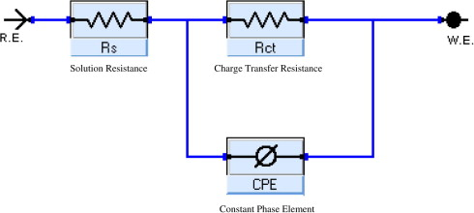

**Figure (8):** Electrical equivalent circuit model used to fit the results of impedance.

**Table (6):** EIS data of carbon steel in 1M HCl and in the presence of different concentrations of inhibitor acetazolamide at 25° C.

|  |  |  |  |  |  |
| --- | --- | --- | --- | --- | --- |
| %IE | Cdl  µF cm−2 | alpha | Y0 x10-4  µΩ−1sncm−2 | Rct  Ω cm2 | Conc., ppm |
| ------ | 24.1 | 1.14 | 3.7 | 17.6 | Blank |
| 34.7 | 7.8 | 0.85 | 7.5 | 27.1 | 50 |
| 42.5 | 5.4 | 0.87 | 9.6 | 30.7 | 100 |
| 56.7 | 5.0 | 0.75 | 7.8 | 40.7 | 150 |
| 71.5 | 3.6 | 0.76 | 7.1 | 61.9 | 200 |
| 76.8 | 3.0 | 0.77 | 6.7 | 76.9 | 250 |
| 79.6 | 2.4 | 0.75 | 7.4 | 86.4 | 300 |

***4.6. Electrochemical frequency modulation (EFM) measurements***

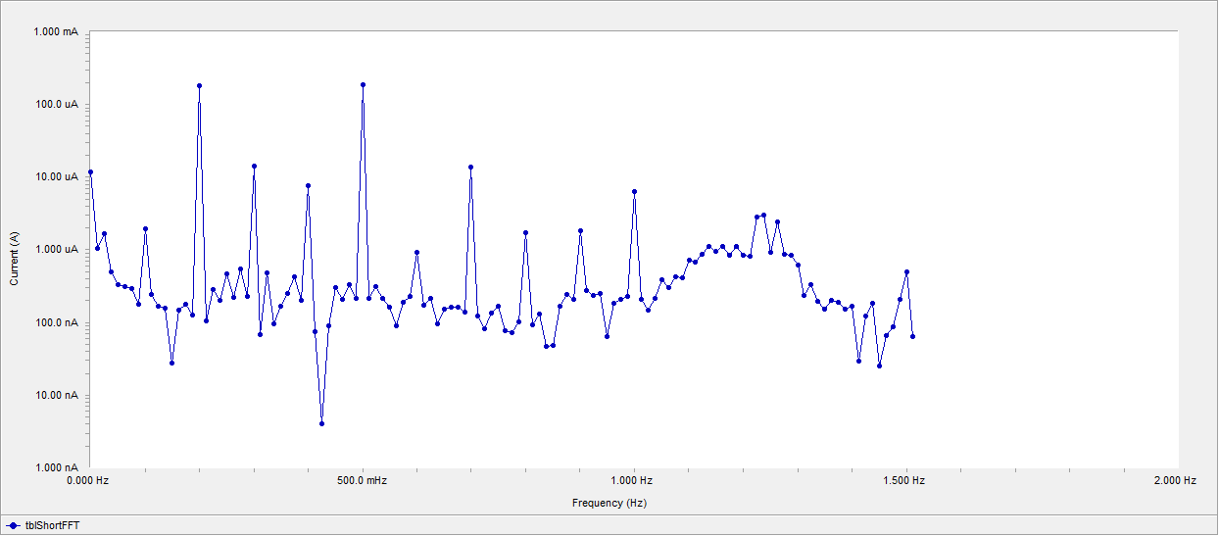

**Figure 9.** EFM spectra for carbon steel in 1M HCl in the presence of 50 ppm acetazolamide

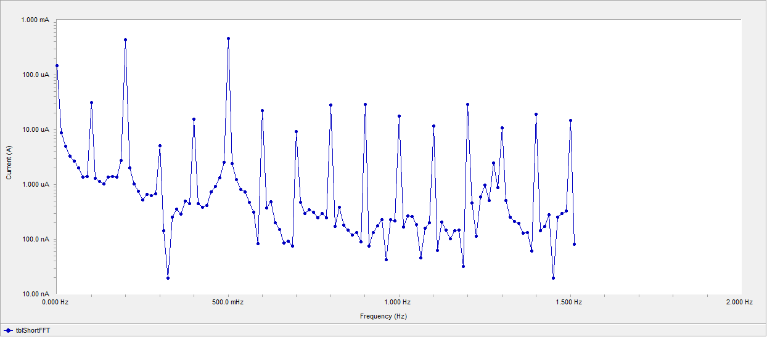

**Figure 10.** EFM spectra for carbon steel in 1M HCl in the presence of 300 ppm acetazolamide

**Table (7):** Electrochemical kinetic parameters obtained by EFM technique for c-steel in the absence and presence of various concentrations of acetazolamide in 1M HCl at 25oC

|  |  |  |  |  |  |  |  |  |
| --- | --- | --- | --- | --- | --- | --- | --- | --- |
| % IE | ϴ | CF-3 | CF-2 | βc  mVdec−1 | βa  mVdec−1 | icorr  µAcm-2 | Conc  ppm | Inhibitor |
| - | - | 3.34 | 1.65 | 96 | 86 | 444.4 | 0 | Blank |
| 36.2 | 0.362 | 3.02 | 1.95 | 92 | 84 | 283.5 | 50 | Acetazolamide |
| 41.6 | 0.416 | 3.29 | 1.94 | 109 | 82 | 259.3 | 100 |
| 57.6 | 0.576 | 2.85 | 1.93 | 104 | 83 | 188.4 | 150 |
| 66.4 | 0.664 | 4.51 | 1.44 | 99 | 85 | 149.3 | 200 |
| 77.1 | 0.771 | 3.27 | 1.87 | 98 | 85 | 101.5 | 250 |
| 80.0 | 0.800 | 2.94 | 1.57 | 96 | 100 | 88.5 | 300 |

***4.7. Surface examinations***

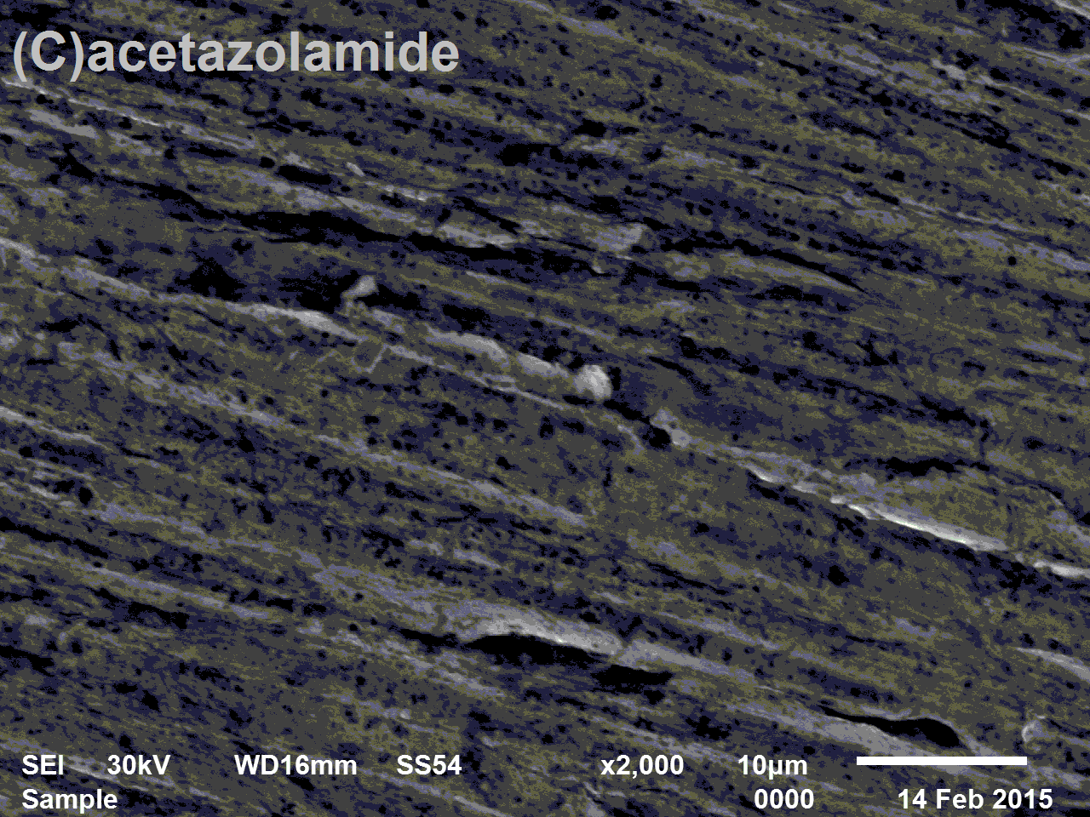

**Figure (11).** SEM of the c- steel surface: (a) polished sample (free), (b) after immersion in 1M HCl and (c) after immersion in 1M HCl in the presence of 300 ppm of acetazolamide.

Fig. (11a) show SEM image of polished carbon steel surface. The micrograph shows a characteristic inclusion, which was probably an oxide inclusion.

Fig. (11,b) show SEM of the surface of carbon steel specimen after immersion in 1M HCl for 1 day in absence of inhibitor, while Fig.(11,c) show SEM of the surface of another carbon steel specimen after immersion in 1M HCl for the same time interval in the presence of 300 ppm of acetazolamide. The resulting scanning electron micrographs reveal that, the surface was strongly damaged in the absence of the inhibitor, but in the presence of 300 ppm of acetazolamide, there is less damage in the surface. This confirms the observed high inhibition efficiency of acetazolamide at this concentration.

It is important to take into consideration the percentage of the elements present on the surface of the carbon steel (Table 8).

**Table 8**. Surface composition (weight %) of carbon steel before and after immersion in 1 M HCl without and with 300 ppm of acetazolamide at 25 °C.

|  |  |  |  |  |  |  |  |
| --- | --- | --- | --- | --- | --- | --- | --- |
| Mass % | Fe | Mn | C | S | O | N | Cr |
| Free | 97.39 | 0.82 | 1.41 | 0.23 | - | - | 0.15 |
| 1M HCl | 69.36 | 0.63 | 1.39 | 0.20 | 11.43 | 7.68 | 0.37 |
| Acetazol-amide | 75.21 | 0.70 | 18.22 | 0.21 | 13.20 | 9.19 | 0.31 |

***4.8. Quantum Chemical Calculations***

The EHOMO indicate the ability of the molecule to donate electrons to an appropriated acceptor with empty molecular orbitals but ELUMO indicate its ability to accept electrons. The lower the value of ELUMO, the more ability of the molecule is to accept electrons. While, the higher is the value of EHOMO of the inhibitor, the easer is its offering electrons to the unoccupied d-orbital of metal surface and the greater is its inhibition efficiency. The HOMO–LUMO energy gap, ΔE approach, which is an important stability index, is applied to develop theoretical models for explaining the structure and conformation barriers in many molecular systems. The smaller is the value of ΔE, the more is the probable inhibition efficiency that the compound has. The dipole moment μ, electric field, was used to discuss and rationalize the structure. The higher is the value of μ, the more is the probable inhibition efficiency that the compound has. The calculations showed that the highest value of μ is assigned for the acetazolamide which has the highest inhibition efficiency. Absolute hardness and softness σ are important properties to measure the molecular stability and reactivity. A hard molecule has a large energy gap and a soft molecule has a small energy gap. Soft molecules are more reactive than hard ones because they could easily offer electrons to an acceptor. For the simplest transfer of electrons, adsorption could occur at the part of the molecule where σ, which is a local property, has the highest value .In a corrosion system, the inhibitor acts as a Lewis base while the metal acts as a Lewis acid. Bulk metals are soft acids and thus soft base inhibitors are most effective for acidic corrosion of those metals. Accordingly, it is concluded that inhibitor with the highest σ value has the highest inhibition efficiency. The relatively good agreement of Pi and ΔN with the inhibition efficiency could be related to the fact that any factor causing an increase in chemical potential would enhance the electronic releasing power of inhibitor molecule Table (9). Analysis to estimate the adsorption centers of acetazolamide has been widely reported and it is mostly used for the calculation of the charge distribution over the whole skeleton of the molecule .There is a general consensus by several authors that the more negatively charged heteroatom is, the more is its ability to adsorb on the metal surface through a donor–acceptor type reaction.

**Figure (12):** frontier molecular orbital density distribution (HOMO and LUMO) for acetazolamide inhibitor.

|  |  |  |
| --- | --- | --- |
| inhibitor | HOMO | LOMO |
| acetazolamide |  |  |

**Table 9.** Calculated quantum chemical properties for acetazolamide inhibitor.

|  |  |  |  |  |  |  |  |  |
| --- | --- | --- | --- | --- | --- | --- | --- | --- |
| inhibitor | -EHOMO | -ELOMO | ΔE | μ | σ | -Pi | -X | Dipole moment |
| Aceta-zolamide | 9.07 | 1.61 | 7.46 | 3.94 | 0.25 | 5.53 | 5.53 | 13.81 |

***4.9. Mechanism of corrosion inhibition***

From the results obtained using electrochemical and weight loss measurements, it was concluded that the investigated pharmaceutical compound inhibits the corrosion of C-steel in 1M HCl by adsorption at carbon steel/solution interface. From the literature, it is known that the adsorption of organic compounds at the metal surface interface is the first step in the mechanism of the inhibition action. The inhibition of the C-steel is due to the adsorption of the drug molecules on the C-steel surface forming a protective film. The drug molecules can be adsorbed onto the C-steel surface through electron transfer from the adsorbed species to the vacant electron orbital of low energy in the C-steel to form a co-ordinate type link. The essential effect of the drug as corrosion inhibitor is due to the presence of free electron pairs in the nitrogen, oxygen and sulfur atoms, dπ-electrons on the aromatic rings, molecular size, heat of hydrogenation and mode of interaction with the metal surface [37]. It is well known that C-steel has co-ordination affinity toward N, O and S bearing ligands [38]. Hence, adsorption on C-steel can be attributed to co-ordination through hetero-atoms and π-electrons of aromatic rings.

By considering the structure of investigated drug we found that there are unshared electron pairs on N, O and S, capable of forming σ-bond with C-steel [39]. Further, the double bonds in the molecule allow back donation of metal d-electrons to the π*-orbital. Another striking feature for high inhibition performance of the studied compound is the presence of S-atom. The presence of S-atom in the drug structure makes the formation of dπ-dπ bond resulting from overlap of 3d-electrons from C-steel atom the 3d vacant orbital of S-atom possible, which enhances the adsorption of the drug on the C-steel surface. Also the greater polarizability of sulfur atoms increases the inhibition efficiency of this compound.

**References**

1. M. S. Yen, I. J. Wang, *Dyes and pigments*, 67 (2005) 183.
2. SS. Abd EL Rehim, MAM. Ibrahim, KF. Khalid, *Mater. Chem. Phys*., 70 (2000) 268.
3. F. Bentiss, M. Bouanis, B. Mernari, M. Traisnel, H. Vezin, M. Lagrennee, *Appl. Surf. Sci*., 253 (2007) 3696.
4. M. Elachouri, M.S. Hajji, S. Kertit, E.M. Essassi, M. Salem, R. Coudert, *Corros. Sci*., 37 (1995) 381.
5. B. Merari, H. Elattar, M. Traisnel, F. Bentiss,M. Larenee, *Corros. Sci.*, 40 (1998) 391.
6. F. Bentiss, M. Traisnel, M. Lagrenee, *Corros. Sci*., 42 (2000) 127.
7. L. Elkadi, B. Mernari, M. Traisnel, F. Bentiss,M. Lagrenee, *Corros. Sci*., 42(2000) 703.
8. F. Bentiss, M. Lagrenee, M. Traisnel, J.C. Lornez, *Corros. Sci*., 41 (1999) 789.
9. F. Bentiss, M. Traisnel, H. Vezin, H.F. Hildebrand, M. Lagrennee, *Corros. Sci*., 46 (2004) 781.
10. F. Zucchi, G. Trabanelli, G. Brunoro, *Corros. Sci*., 36 (1994) 1683.
11. Sk. A. Ali, M.T. Saeed, S.U. Rahman, Corros*. Sci*., 45 (2003) 53.
12. A.S. Fouda, G. Bader, M.N. El-Haddad, *J. Korean Chem. Soc*., 52 (2008) 124.
13. A.A. Al-Sarawy, A.S. Fouda, W.A. Shehab, *Desalination*, 229 (2008) 279.
14. A.S. Fouda, H.A. Mostafa, Y.A. El-Ewady, M.A. El-Hashemy, *J. Chem. Eng. Commun*., 195 (2008) 934.
15. E. Kraka, D. Cremer, Computer design of anticancer drugs, *J. Am. Chem.Soc*., 122 (2000) 8245.
16. F. Touhami, A. Aouniti, Y. Abed, B. Hammouti, S. Kertit, A. Ramdani, K. Elkacemi, *Corros. Sci*., 42 (2000) 929.
17. A.M. Abdel-Gaber, B.A. Abd-El-Nabey, I.M. Sidahmed, A.M. El-Zayady, M. Saadawy, *Corros. Sci*.48 (2006) 2765.
18. A.Y. El-Etre, *Corros. Sci*.45 (2003) 2485.
19. Abiola, J.O.E. Otaigbe, O.J. Kio, *Corros. Sci.*51 (2009) 1879.
20. Abiola, A.O. James, *Corros. Sci.* 52 (2010) 661.
21. J. Halambek, K. Berkovic, J. Vorkapic-Furac, *Corros. Sci*. 52 (2010) 3978.
22. M. Ebadi, Pharmacodynamic Basis of Herbal Medicine, 2nd ed., CRC Press, New York. 2007.
23. A.S. Fouda, Y.A. Elewady, H.K. Abd El-Aziz, A.M. Ahmed, *Int. J. Electrochem. Sci.,* 7 (2012) 10456.
24. Afidah, E. Rahim, J. Rocca, *Corros. Sci*. 49 (2007) 402.
25. A.S. Fouda, A.A. Al-Sharawy, E.E. El-Katori, *Desalination*201 (2006) 1).
26. F.Z .Mylius: Metallic, 14,233 (1992).
27. P. Hancock, and J.E.O Mayne: J. Appl. Chem, 7, 700 (1957).
28. S.F. Khalaf-Alla, A.M. Shams El-Din, and S.A. Marei: Rec. Trav. Chim Trav. Chim., 78,518 (1959).
29. H. Gatos, J. Electrochem. Soc., 101,443(1954).
30. H. Kaesche, and N. Heckerman, J. Electrochem. Soc., 105, 191(1958).
31. M. Stern, and N. Hackerman: J. Electrochem. Soc., 104, 390 (1957).
32. E.S. Snavely, and N. Hackerman: NACE Basic Corrosion Course, (NACE), Houston, Texas. Chapter 9 (1970).
33. E. J. Kelly: J. Electrochem. Soc., 112, 121 (1965).
34. L. I. Antropov: Corros. Sci., 7, 607(1967).
35. L.I. Antropov: Ann. Inst. Polytech. Erevan, 2, 71 (1946).
36. L. I. Antropov: Proc. Electrochem. Congr. Kiev, 138 (1949), J. Phys. Chem., USSR, 24, 1482 (1950).
37. H. Ashassi-Sorkhabi, B. Shaabani and D. Seifzadeh, App. Surf. Sci., 239(2),154 (2005).
38. SS.Abd EL Rehim, MAM. Ibrahim, KF. Khalid, *Mater. Chem. Phys*., 70,268 (2000).
39. B. Merari, H. Elattar, M. Traisnel, F. Bentiss, M. Larenee, *Corros. Sci.*, 40,391 (1998).

8/3/2015