Growth Tolerance Of Horticultural Crops To Gas Flare In Ogba/Egbema/Ndoni Local Government Area Rivers State.

⁺Offor, U. S, ⁺Jane Onwugbuta - Enyi And ⁺⁺Akonye, 1. A.

Department of Agricultural Science Ignatius Ajuru University of Education, Port Harcourt
E-mail: sos2212003@yahoo.com
⁺⁺Department of Plant Science and Biotech University of Port Harcourt
.
Abstract: Studies on the growth tolerance of horticultural crops to gas flare in Ogba/Egbema!Ndoni local government area of Rivers State using T. occidentalis as test crop was carried out. T. occidentalis seeds were planted on plastic containers and allowed to establish for a period of 6 weeks in a nursery. The plants were randomly selected for even growth and placed at varying distances along a straight line from the flare. The distances are, 45, 50, 60 and 65m respectively. A control was set up and kept away from the flare. Growth measurements-leaf area, plant height and pod production were evaluated on weekly basis. Results showed that the growth parameters tested increased with increasing distances from the flare and were less significant (P<0.05) to the control. It was then postulated that gas flare hinders the growth of horticultural crops in general.
[Offor, U. S, Jane Onwugbuta - Enyi And Akonye, 1. A. Growth Tolerance Of Horticultural Crops To Gas Flare In Ogba/Egbema/Ndoni Local Government Area Rivers State. Nat Sci 2015;13(8):94-96]. (ISSN: 1545-0740). http://www.sciencepub.net/nature. 15

Keywords: Horticultural crops, Gas flare and growth tolerance

Introduction
Crude oil exploration and production activities have negatively deplete or reduce in both quantity and quality of our physical environment. Such impacts lead to reduction on the biotic and abiotic components of adjoining ecosystem. In Ogba/Egbema/Ndoni Local Government Area of Rivers State, such activities have been going for over fifty (50) years. Thus, the local government faces escalating challenges involving the balance between the protections of the environment (crop /vegetables).
From Nwankwo 2000, vegetables being classified as horticultural crops are edible products of herbaceous plant eaten whole or in parts, raw or cooked as part of a meal or salad and are good examples of healthy food, which their consumption in totality has proved beneficial. The need to adequately protect these crops becomes necessary. Gas flare as one of the activities resulting from crude oil exploration and production has been claimed by many communities and researchers to have negative impact on its production, terrestrial and aquatic ecosystem.
Abbiw 1990, Isawummi 1993, from their reports, more than 10% of the ozone necessary for life has been depleted by constant gas flaring resulting to high intensity of radiation of sun which is dangerous to human body and our biotic and abiotic environment. In conformity, Willey, and Nortan(1981) identified acid rain damages, on roofing sheets, arable crops and pollution of fishing pods as one of the consequences of gas flaring. Such negative consequence does not argue well in a local government like Onelga, where majority of the inhabitants are increasing aware of the accruing benefits in horticultural crops consumption, i.e.
- Potential in increasing body fat
- Cure maladies
- Provision of gender and age related medicinal needs.
- Improve skeletal strength
- Lower cholesterol or improve the optical vision (Kern 2000)
Ingredients such as lycopene (tomato), allicin (garlic), indo flavors (soyabean) are associated prevention or treatment of cancer, diabetics, hypertension and heart diseases (Norris 1969). The need to study the environmental compatibility of this crop is therefore an important quality parameter for the growth of horticultural
crops hence this research.

Materials And Methods
Telfairia occidentalis seeds were procured from the Omoku market while the plastic containers of even size, performed three to five (3-5) small holes were filled with top soil collected from the Federal College of Education (T) demonstration farm. The soil were evenly weighed (6,600g) leaving a space of 7.0cm from the top to make allowance for addition of water. The seeds were planted on the plastic containers at the rate of four per bag and allowed to establish for a period of six (6) weeks in a nursery. The plants were randomly selected for even growth and placed at varying distances of 45, 50, 60 and 65m along a straight line to the gas flare at OB/OB gas plant in Onelga. A control was set up and kept away from the flare.

Growth Evaluation
The following parameters were used to evaluate the growth of the plants under investigation;
a. Leaf Area (LA): This was achieved by using the formula of Adamson et al.1980.
b. Plant Height: This was measured with a metre rule, from the base of the plant to the tip of the stem.
c. Pod Production: This was achieved by counting the number of pods per treatment on weekly basis, the sum total for each treatment was taken as total for the plant. Pod production in this work was seen as ability of plants to flower. Physiological observations were also made on weekly basis.
Analysis of results was performed on data collected and means separated by least significant difference in conformity with the statistical analysis system (SAS, 1991).

Results And Discussion
Results on the physiological observation shows that yellowing and prolonged leaf twisting apex was observed on T.occidentalis placed at closer distances from the flare than at 60 m, 65 m’ and control.
Telfairia occidentalis placed at close distances to gas flare showed also decrease in height and leaf area of the crop (Fig 1 and 2). The control maintained significant increase in height and leaf area compared to the treatments. At a longer distance (60 and 65m) from the flare, increase in height and leaf area was observed but were less significant compared to the control.

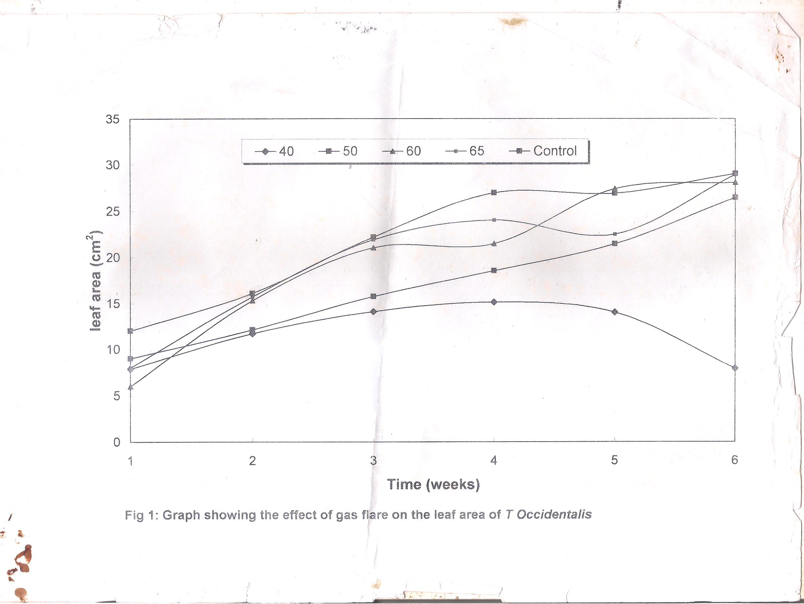

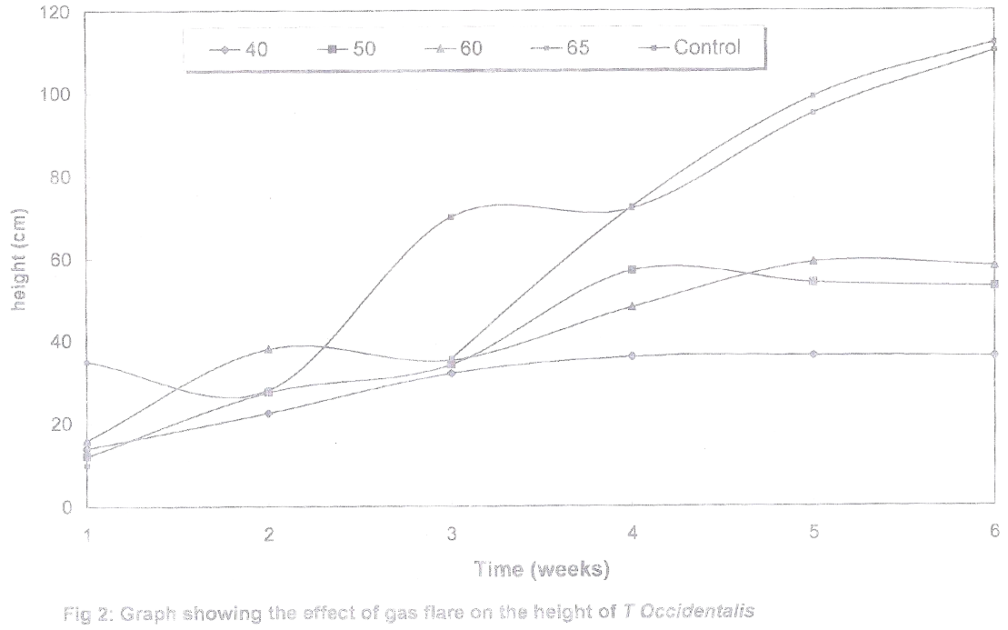

T Occidentalis at such distances showed better growth increase than at 40 and 50m away. The increase in growth promotion slightly comparable to control could be attributed to less inhibitory effects of gas flare.
Pod production was not observed within the experimental period but flowering were seen more in control than at 60 and 65m away respectively. Close distances of 45 and 50m did not flower. Previous studies have revealed the effects of gas flare on crops showing inhibitory responses. Mensah (2005) noted that Zmays at closer distances to gas flare showed decrease in height and leaf area of the crop. Works from Ezekiel (2005), showed significant increase in shoot length of maize when placed at a longer distance from gas flare compared to close distances.
The results of this work therefore, indicate that gas flare has negative effects on horticultural crops.

References
- Abbiw, D. Useful Plants of Botanic Garden. Kew UK. (1990): p 337.
- Ezekiel, P. Effects of Palm Bunch Ash on the Growth of Maize Placed at Close Distance to Gas Flare. (2002): Unpublished.
- Isawumi, MA. The Common Edible Fruits of Nigeria. Part II. The Nigeria Field 58 (1993): p.64.
- Mensah, S. Effects of Gas Flare on Maize. Paper Presented at 32” National Conference on Plant Protection and Environment. Uniport. (2005).
- Norris, PO. Observation on the Production Status of Raw Forest Species in Amezon & Gueyane. Tropical Agriculture 46 (1969): p 145.
- Nwankwo, C. Elements and Practices of Horticultural Molsyfem United Publisher. Omoku (2000).
- Whiteman, PC. and BW. Nortan Uses of Horticultural Crops. In Proceeding of the International Workshop on Hort. Crops. (1981): Vol 21CR: 1 Shi; India.

7/27/2015

