Geotechnical Properties of Different Foundation Beds of Sadat City- Egypt

Mohammed H. Awad¹, Ahmed M. Saad¹, Yousry M. Mowafy² and Abd Allah O. Hashim¹

¹ Geology Department, Faculty of Science, Al Azhar University, Cairo, Egypt.
² Civil Department Faculty of Engineering, Al Azhar University, Cairo, Egypt.
Abdallhomar53@yahoo.com

Abstract: This research involves the geotechnical properties of different foundation beds of Sadat City. The studied area is characterized by very gentle topography and lack of sharp relief and is covered by Quaternary deposits which are mainly composed of sands and gravels intercalated with clay lenses. The investigation results of sands at foundation levels reveal that the values of specific gravity ranged from 2.55 to 2.88 with an average 2.72, effective diameter ranged from 0.16 mm to 0.87 mm, uniformity coefficient ranged from 1.59 to 13.65, and coefficient of curvature ranged from 0.26 to 1.57. According to unified soil classification system the group symbol of the majority of the studied samples are SP. The values of the internal angle of friction obtained from a direct shear test range from 33° to 43°. The investigation results of clays at foundation levels reveal that the values of the initial water content ranged from 7.9 % to 20 %, liquid limit range from 35% to 78 %, plastic limit ranged from 22% to 36%, shrinkage limit ranged from 10.8% to 17%, and the values of free swell ranged from 50 % to 120 %.The results of chemical analysis of the studied samples reveal that the values of pH ranged from 6.1 (moderately aggressive) to 7.9 (non aggressive ),sulfates ranged from 0.001% (non aggressive) to 0.88% (aggressive) and chlorides ranged from 25.89ppm (non aggressive) to 1380ppm (aggressive). According to Egyptian code (2001), more than 50% of the studied samples are non aggressive soil. The ultimate soil bearing capacity values of the studied samples using Terzaghi’s bearing capacity equation for square foundation range from 1182 kN/m² to 5433 kN/m².
[Mohammed H. Awad, Ahmed M. Saad, Yousry M. Mowafy and Abd Allah O. Hashim Geotechnical Properties of Different Foundation Beds of Sadat City- Egypt. Nat Sci 2015;13(8):46-58]. (ISSN: 1545-0740). http://www.sciencepub.net/nature. 8

Keywords: Soil, uniformity coefficient, coefficient of curvature, bearing capacity.

I- Introduction:
Sadat City lies west of the Nile Delta and eastern side of the Cairo – Alexandria desert road from Kilo 85 to 109. It is bounded by longitude 30° 21` 64" - 30° 39` 55" E and latitude 30° 18` 57" - 30° 38` 19" N (Fig. 1). Sadat City covers about 500 Km² and is considered as one of the important urban extension zones. The present research was achieved as an attempt to study the geotechnical properties of different foundation beds of Sadat City. For this purpose, about 86 samples from different boreholes (of depth 10 meters) and from different open cuts (of depth less than 10 meters) that were collected from different localities at the studied area (Fig. 2). These samples have been taken at depth from 0.5 to 10 m. The studied area is characterized by a very gentile topography and lack of sharp relief and is characterized by a long hot summer and a short warm winter, low rainfall rates (50 mm/year) and high evaporation rates.
2. Geologic Setting:
The geology of the studied area and its vicinities had been discussed by several workers such as Shedid 1989, it is concluded that, the rocks of Miocene, Pliocene, and Quaternary times are the most outcropping sediments dominating the investigated area and its vicinities.
In the subsurface, the sedimentary rocks have a thickness of about 4500 m was recorded in Wadi El Natrun area. The sedimentary rocks succession starts from base by Triassic rocks resting on the basement rocks and ends at top with the recent deposits belonging to the Pliocene and Quaternary. The geological map of the studied area and its vicinities are showed in (Fig. 3). Sadat City is covered by Quaternary deposits which are mainly composed of sand,sand with trace of gravel, sand with some gravels, gravely sand and gravels intercalated with some clay lenses. The thickness of these clay lenses ranges from 1 m to 3 m.Some of these lenses are found at boreholes No. 34, 41, 44 and 45 as well as open cuts No.36, 37 and 46.
3. Geotechnical Studies:
The foundation beds of the urban area at Sadat City are the soil (Quaternary deposits) which are mainly composed of sands and gravels intercalated with clay lenses. The laboratory tests on Sands are specific gravity, sieve analysis, direct shear test and chemical analysis but the laboratory tests of clays (fine grained soil) are the initial water content, atterberg limits and free swell test.
3.1. Geotechnical Properties of Sands:
3.1.1. Specific Gravity (Gs):
Specific gravity is the ratio of the weight of the soil solids to the weight of water of equal volume. The values of the specific gravity of the studied samples are given in table (I) and range between 2.55 to 2.88 with an average 2.72.
3.1.2.: Sieve Analysis:
Grain size analysis is used for different purposes, such as textural, description, testing the behavior of sediments during transportation and deposition. It is also used to interpret the depositional environments under which these sediments were deposited and to evaluate the soil for engineering use. The quantitative data depend upon the mechanical properties such as stiffness and strength. Coarse grained soils have good bearing capacities and good drainage qualities, and their strength volume change characteristics are not significantly affected by change in moisture conditions. Fine grained soils have less load bearing capacities compared with coarse grained. Grain size analysis is required for classifying the soil. The results of the mechanical analysis are tabulated in Table (2) and the data are represented by grain size distribution curves to determine D₁₀, D₃₀ and D₆₀.
Where; D₁₀ (effective diameter): is a particle diameter at which 10% of the soil is finer.
D₃₀: is a particle diameter at which 30% of the soil is finer.
D₆₀: is a particle diameter at which 60% of the soil is finer.
Fig. (4) shows grain size distribution curves of samples No 1A, 2A, 3A and 3B.
The values of D₁₀, D₃₀ and D₆₀ are given in table (2). The values of D₁₀ of the studied samples range from 0.16 mm to 0.87 mm while the values of D₃₀ range from 0.18mm to 0.99 mm but the values of D₆₀ range from 0.28 mm to 3.34 mm.

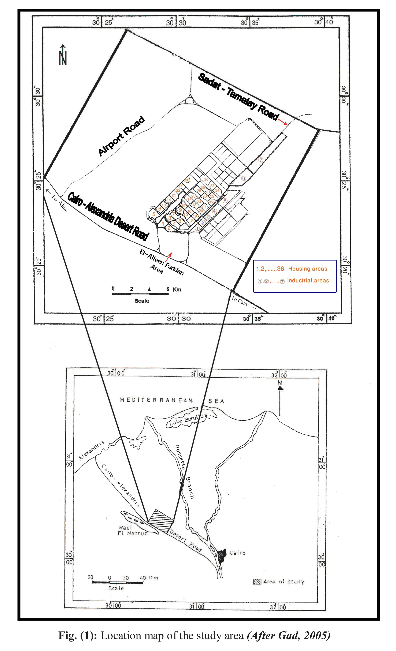
Sadat Tamalay Road

Fig.(2): Location map of examined sections
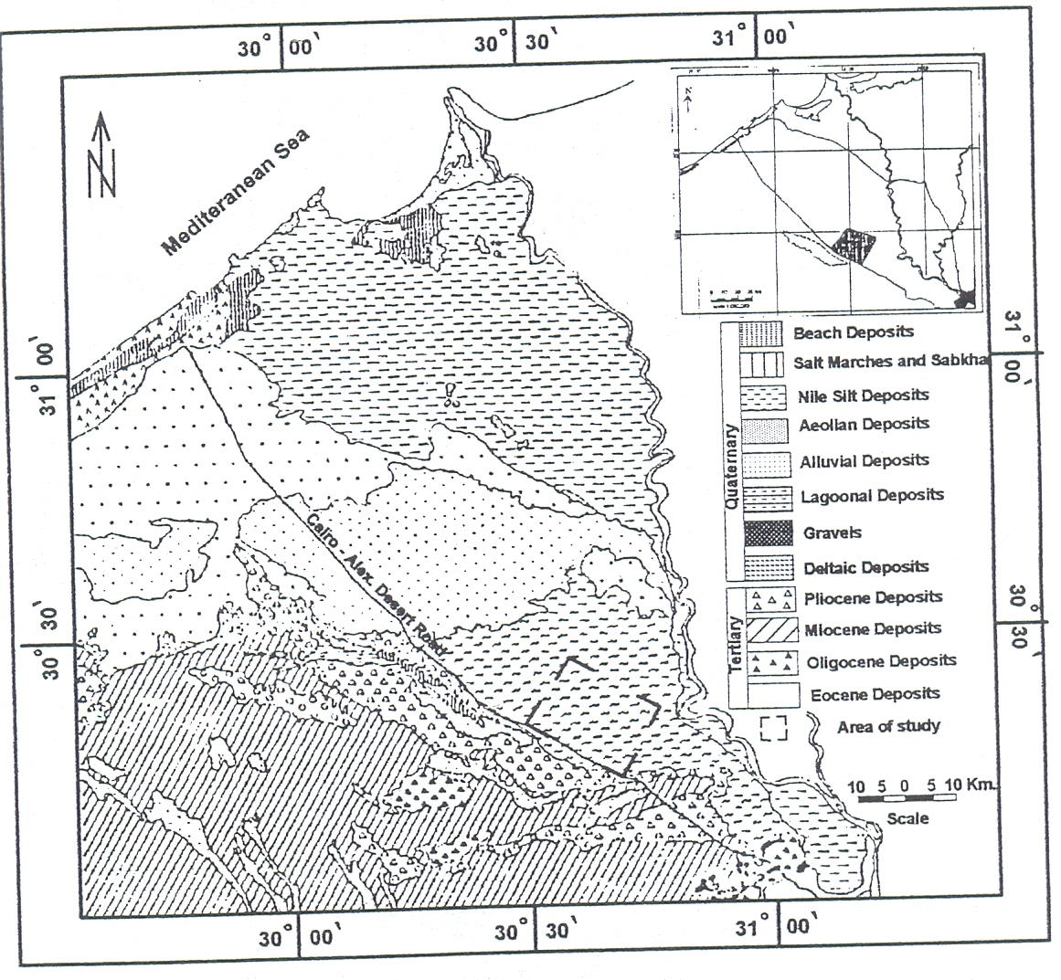
Fig. (3): Geological map of the area under study and its vicinities (After CONCO/EGPC, 1987)
Table (1): Specific gravity of the studied samples
Sample No. | Specific gravity  (g/cc) | Sample No. | Specific gravity (g/cc)
1 A | 2.79 | 31 A | 2.82
3 A | 2.55 | 32 A | 2.71
6 A | 2.61 | 37 A | 2.67
7 A | 2.56 | 40 A | 2.63
8 A | 2.68 | 44 A | 2.56
9 A | 2.87 | 45 A | 2.74
11 A | 2.56 | 45 B | 2.87
11 B | 2.63 | 50 A | 2.88
11 C | 2.81 | 50 B | 2.78
11 D | 2.55 | 50 C | 2.63
13 A | 2.59 | 51 A | 2.87
17 A | 2.87 | 51 B | 2.87
17B | 2.86 | 51 C | 2.56
17 C | 2.75 | 51 D | 2.56
23 A | 2.83 | 51 E | 2.57
24 A | 2.55 | 53 A | 2.57
25 A | 2.55 | 53 B | 2.88
25 B | 2.56 | 53 C | 2.86
26 A | 2.59 | 53 D | 2.69
27 A | 2.55 | 54 A | 2.88
28 A | 2.55 | 54 B | 2.55
29 A | 2.86 | - | -

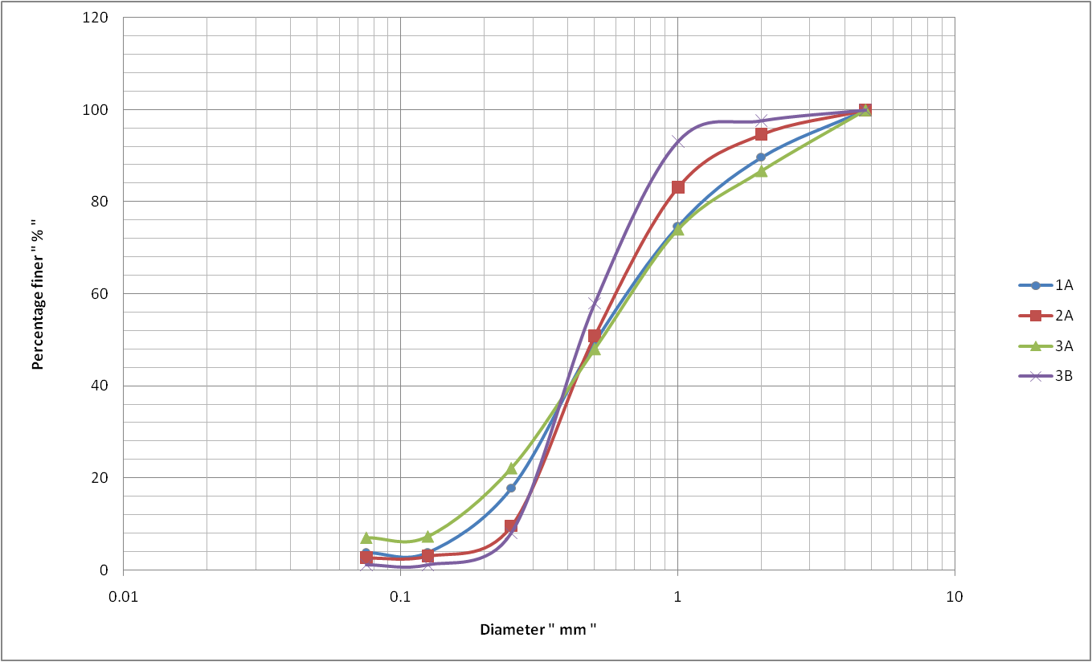
Fig.(4): Grain size distribution curves of samples No. 1A, 2A, 3A and 3B.
Table (5): Sieve analysis of the studied samples
Sieve opening (mm)  Sample No. | Finer (Passing) weight (%) |  |  |  |  |  |  | Statistical parameters
 | 4.75 | 2 | 1 | 0.5 | 0.25 | 0.125 | 0.075 | D₁₀ | D₃₀ | D₆₀ | C_{U} | C_{C} | Group symbol
1A | 100 | 89.7 | 74.76 | 49.5 | 17.84 | 3.88 | 3.88 | 0.18 | 0.34 | 0.66 | 3.67 | 0.97 | SP
2A | 100 | 94.68 | 83.18 | 50.89 | 9.58 | 3.06 | 2.66 | 0.26 | 0.37 | 0.6 | 2.31 | 0.88 | SP
3A | 100 | 86.78 | 74.08 | 48.06 | 22.16 | 7.32 | 7.04 | 0.16 | 0.32 | 0.68 | 4.25 | 0.94 | SP-SM
3B | 100 | 97.68 | 93.18 | 57.94 | 8 | 1.06 | 1.06 | 0.27 | 0.35 | 0.52 | 1.93 | 0.87 | SP
4A | 100 | 88.79 | 74.8 | 46.9 | 14.36 | 4.2 | 4.2 | 0.22 | 0.36 | 0.68 | 3.09 | 0.87 | SP
4C | 100 | 100 | 94.55 | 64.35 | 19.02 | 5.22 | 4.72 | 0.18 | 0.31 | 0.47 | 2.61 | 1.14 | SP
5A | 100 | 92.75 | 77.62 | 37.5 | 20.2 | 3.7 | 3.3 | 0.17 | 0.38 | 0.74 | 4.35 | 1.15 | SP
6A | 100 | 91.13 | 80.14 | 53.25 | 31.09 | 17.51 | 17.51 | - | 0.24 | 0.59 | - | - | SM
7A | 85.48 | 69.83 | 45.18 | 17.8 | 4.8 | 1.6 | 1.6 | 0.37 | 0.7 | 1.62 | 4.38 | 0.82 | SP
8A | 100 | 82.03 | 66.04 | 38.18 | 13.08 | 2.82 | 2.82 | 0.23 | 0.41 | 0.85 | 3.7 | 0.86 | SP
9A | 100 | 73.47 | 61.48 | 44.58 | 18.74 | 4.92 | 4.42 | 0.18 | 0.33 | 0.93 | 5.17 | 0.65 | SP
11A | 91.88 | 77.3 | 57.38 | 31.72 | 7.8 | 1.84 | 1.84 | 0.27 | 0.48 | 1.24 | 4.59 | 0.69 | SP
11B | 89.78 | 41.74 | 30.39 | 16.36 | 6.12 | 1.19 | 0.69 | 0.34 | 0.99 | 2.83 | 8.32 | 1.02 | SW
11C | 100 | 83.66 | 60.72 | 22.6 | 4.58 | 0.82 | 0.82 | 0.34 | 0.59 | 1 | 2.94 | 1.02 | SP
11D | 100 | 98.66 | 95.04 | 75.28 | 8.82 | 0.88 | 0.88 | 0.27 | 0.32 | 0.43 | 1.59 | 0.88 | SP
13A | 93.41 | 69.32 | 51.84 | 30.17 | 9.3 | 2.28 | 2.28 | 0.27 | 0.5 | 1.46 | 5.41 | 0.63 | SP
14A | 100 | 93.53 | 75.33 | 32.31 | 14.21 | 2.49 | 2.11 | 0.21 | 0.48 | 0.79 | 3.76 | 1.39 | SP
15A | 100 | 88.87 | 76.62 | 32.65 | 19.36 | 3.24 | 3.24 | 0.18 | 0.47 | 0.78 | 4.33 | 1.57 | SP
15A | 100 | 82.08 | 79.48 | 55.48 | 17.47 | 4.49 | 4.13 | 0.19 | 0.33 | 0.56 | 2.95 | 1.02 | SP
16A | 100 | 91.54 | 81.78 | 53.38 | 19.79 | 3.66 | 3.16 | 0.18 | 0.33 | 0.58 | 3.22 | 1.04 | SP
16B | 100 | 95.63 | 74.33 | 34.23 | 8.28 | 3.6 | 3.2 | 0.27 | 0.44 | 0.79 | 2.93 | 0.91 | SP
17A | 92.72 | 66.92 | 56.88 | 40.2 | 23.66 | 12.6 | 12.1 | - | 0.34 | 1.35 | - | - | SM
17B | 91.66 | 57.12 | 48.18 | 30.78 | 15.9 | 6.86 | 6.68 | 0.17 | 0.49 | 2.32 | 13.65 | 0.61 | SP-SM
17C | 100 | 84.59 | 53.06 | 24.1 | 8.02 | 2.12 | 2.12 | 0.28 | 0.59 | 1.35 | 4.82 | 0.92 | SP
19A | 90.57 | 67.77 | 54.5 | 18.39 | 4.63 | 3.52 | 3.52 | 0.37 | 0.64 | 1.43 | 3.86 | 0.77 | SP
19B | 100 | 86.17 | 64.07 | 28.63 | 13.49 | 5.2 | 4.7 | 0.21 | 0.52 | 0.91 | 4.33 | 1.41 | SP
20A | 96.24 | 79.85 | 58.74 | 32.19 | 15.3 | 2.99 | 2.99 | 0.19 | 0.47 | 1.21 | 6.37 | 0.96 | SP
23A | 95.38 | 76.54 | 67.7 | 48.86 | 28.64 | 13.72 | 13.4 | - | 0.24 | 0.59 | - | - | SM
24A | 100 | 94.78 | 83.12 | 58.7 | 18.78 | 4.92 | 4.56 | 0.17 | 0.32 | 0.52 | 3.06 | 1.16 | SP
25A | 89.87 | 71.46 | 54.52 | 30.72 | 16.5 | 3.36 | 4.96 | 0.17 | 0.49 | 1.38 | 8.12 | 1.02 | SP
25B | 100 | 88.4 | 69.43 | 24.46 | 8.22 | 2.44 | 2.44 | 0.28 | 0.57 | 0.86 | 3.07 | 1.35 | SP
21A | 100 | 73.67 | 16.32 | 1.21 | 0.52 | 0.25 | 0.25 | 0.87 | 1.41 | 1.81 | 2.08 | 1.26 | SP
21B | 100 | 89.1 | 75.82 | 57.39 | 23.23 | 4.62 | 4.62 | 0.17 | 0.29 | 0.53 | 3.12 | 0.93 | SP
22A | 95.63 | 87.01 | 54.53 | 17.2 | 5.67 | 3.47 | 3.47 | 0.41 | 0.61 | 0.81 | 1.98 | 1.12 | SP
22B | 100 | 86.15 | 74.19 | 54.47 | 30.65 | 3.43 | 3.43 | 0.17 | 0.26 | 0.6 | 3.53 | 0.66 | SP
26A | 100 | 92.71 | 81.95 | 51.98 | 18.09 | 5.2 | 4.7 | 0.18 | 0.34 | 0.6 | 3.33 | 1.07 | SP
27A | 100 | 89.18 | 69.22 | 24.68 | 6.12 | 1.1 | 1.1 | 0.32 | 0.56 | 0.86 | 2.69 | 1.14 | SP
28A | 100 | 95.42 | 73.88 | 24.38 | 4.84 | 1.12 | 1.12 | 0.2 | 0.53 | 0.8 | 2.5 | 1.09 | SP
29A | 94.77 | 80.26 | 56.34 | 16.54 | 3.06 | 0.2 | 0.2 | 0.41 | 0.64 | 1.31 | 3.2 | 0.76 | SP
31A | 100 | 89.08 | 76.92 | 44.88 | 11.04 | 2.43 | 2.43 | 0.25 | 0.38 | 0.7 | 2.8 | 0.83 | SP
32A | 100 | 93.95 | 81.76 | 62.09 | 27.59 | 3.73 | 3.23 | 0.17 | 0.28 | 0.48 | 2.82 | 0.96 | SP
33A | 100 | 92.05 | 80.77 | 38.77 | 3.46 | 0.61 | 0.61 | 0.29 | 0.43 | 0.7 | 2.41 | 0.91 | SP
34A | 100 | 83.5 | 70.08 | 43.25 | 19.44 | 1.69 | 1.69 | 0.18 | 0.34 | 0.76 | 4.22 | 0.85 | SM
35A | 100 | 86.2 | 76.7 | 43.06 | 13.21 | 4.65 | 4.65 | 0.22 | 0.38 | 0.7 | 3.18 | 0.94 | SP
36D | 100 | 84.2 | 67.7 | 50.4 | 22.9 | 2.6 | 2.2 | 0.18 | 0.31 | 0.73 | 4.06 | 0.73 | SP
37A | 100 | 90.56 | 80.41 | 59.63 | 29.13 | 4.29 | 3.89 | 0.17 | 0.26 | 0.51 | 3 | 0.78 | SP
38A | 93.77 | 76.2 | 49.26 | 9.02 | 1.08 | 0.2 | 0.2 | 0.52 | 0.82 | 1.57 | 3.02 | 0.82 | SP
39A | 100 | 85.33 | 70.27 | 41.16 | 18.97 | 5.17 | 4.67 | 0.17 | 0.26 | 0.78 | 4.59 | 0.98 | SP
40A | 100 | 81.53 | 61.17 | 38.86 | 6.48 | 1.37 | 0.87 | 0.28 | 0.42 | 0.98 | 3.5 | 0.64 | SP
41C | 100 | 90.09 | 75.6 | 51.82 | 15.37 | 3.04 | 2.54 | 0.22 | 0.35 | 0.62 | 2.82 | 0.9 | SP
42A | 100 | 79.3 | 55.23 | 27.66 | 13.39 | 0.76 | 0.26 | 0.22 | 0.53 | 1.6 | 6.18 | 0.94 | SW
43A | 100 | 91.79 | 48.09 | 4.75 | 0.76 | 0.4 | 0.4 | 0.57 | 0.77 | 1.35 | 2.37 | 0.77 | SP
46A | 100 | 91.54 | 74.92 | 38.84 | 8.96 | 1.58 | 1.58 | 0.27 | 0.42 | 0.74 | 2.74 | 0.88 | SP
47A | 100 | 81.5 | 66.8 | 37.7 | 9.38 | 1.84 | 1.82 | 0.26 | 0.42 | 0.83 | 3.19 | 0.82 | SP
47B | 100 | 95.08 | 84.32 | 39.1 | 5.84 | 1.16 | 1.16 | 0.28 | 0.43 | 0.68 | 2.43 | 0.97 | SP
44B | 100 | 90.45 | 78.15 | 37.05 | 8.65 | 3.11 | 3.11 | 0.26 | 0.43 | 0.72 | 2.77 | 0.99 | SP
45A | 100 | 90.4 | 35.3 | 57.2 | 30.6 | 0.2 | 0.2 | 0.17 | 0.26 | 0.55 | 3.23 | 0.72 | SP
49A | 100 | 96.7 | 64.41 | 29.2 | 11 | 4.2 | 4.2 | 0.23 | 0.52 | 0.93 | 4.04 | 1.26 | SP
50A | 82.48 | 62.54 | 49.76 | 30.94 | 11.5 | 2.18 | 2.18 | 0.23 | 0.49 | 2.78 | 12.09 | 0.38 | SP
50B | 100 | 98.18 | 95.4 | 87.34 | 51.16 | 4.22 | 4.22 | 0.16 | 0.18 | 0.28 | 1.75 | 0.72 | SP
50C | 100 | 96.33 | 86.77 | 63.1 | 32.84 | 4.4 | 4.4 | 0.27 | 0.35 | 0.52 | 1.93 | 0.87 | SP
51A | 96.89 | 87.58 | 72.6 | 43.38 | 11.86 | 2.98 | 2.98 | 0.23 | 0.38 | 0.72 | 3.13 | 0.87 | SP
51B | 100 | 89.22 | 77.62 | 55.1 | 26.12 | 0.04 | 0.04 | 0.16 | 0.28 | 0.57 | 3.56 | 0.86 | SP-SM
51C | 86.49 | 31.76 | 27.78 | 19.66 | 7.04 | 1.46 | 1.46 | 0.3 | 0.51 | 3.34 | 11.13 | 0.26 | SP
51D | 100 | 88.02 | 68.03 | 39.6 | 10.84 | 1.76 | 1.76 | 0.26 | 0.41 | 0.8 | 3.08 | 0.8 | SP
51E | 100 | 94.56 | 85.3 | 46.94 | 11.3 | 0.94 | 0.94 | 0.24 | 0.37 | 0.62 | 2.58 | 0.92 | SP
52A | 100 | 90.72 | 78.21 | 43.21 | 17.81 | 3.5 | 3.1 | 0.18 | 0.37 | 0.7 | 3.89 | 1.09 | SP
53 A | 100 | 91.21 | 79.22 | 56.5 | 29.48 | 4.84 | 4.48 | 0.17 | 0.26 | 0.56 | 3.29 | 0.71 | SP
53B | 100 | 92.38 | 81.14 | 57.02 | 27.4 | 4.18 | 4.18 | 0.17 | 0.27 | 0.54 | 3.18 | 0.79 | SP
53C | 90.18 | 48.48 | 42.38 | 29.28 | 13.56 | 1.76 | 1.76 | 0.2 | 0.36 | 0.68 | 3.4 | 0.95 | SP
53D | 100 | 92.7 | 78.2 | 45.78 | 16.18 | 2.08 | 2.08 | 0.2 | 0.37 | 0.68 | 3.4 | 1.01 | SP
54A | 100 | 93.88 | 82.1 | 43.52 | 12.46 | 1.9 | 1.9 | 0.23 | 0.38 | 0.68 | 2.96 | 0.92 | SP
54B | 100 | 97.88 | 93.42 | 82.34 | 29.82 | 1.98 | 1.98 | 0.17 | 0.26 | 1.37 | 8.06 | 0.29 | SP

3.1.2.1. Uniformity coefficient (C_{U}):
Uniformity Coefficient is a measure of the particle size range and is given by the relation:

Uniformity coefficient is also called Hazen coefficient The results of C_{U} values of the studied samples are given in table (2). The value of C_{U} range from 1.59 to 13.65. The majority of the studied samples are very uniform.

3.1.2.2. Coefficient of Curvature (C_{C}):
Coefficient of curvature is a measure of the shape of the particle size curve and is given by the relation:
The results of C_{C} values of the studied sample are given in table (2). The values of C_{C} range from 0.26 to 1.57. The majority of the studied samples are poorly graded.
3.1.3. Direct Shear Test (Shear Box):
The importance of shear strength of soil becomes of primary importance in all stability problems such as bearing capacity of shallow foundation, stability of slopes, lateral earth pressure used to design of retaining wall and sheet pile walls. The aim of this experiment is to estimate the shear strength parameters (angle of internal friction (∅) and cohesion (C)). The angle of friction of the studied samples can be determined by plotting peak shear stresses against corresponding normal stresses. The values of (∅) and (C) are given in table (3). The values of friction angle of the studied samples range from 33° to 43° but the value of cohesion (C) is 0.00 KPa. The relationship between shear stress and horizontal displacement at different normal stresses is showed in Fig. 5 to Fig. 8 but Fig. 9 shows shear stress versus normal stress of samples No. 1A and 3B. Normal stress can be determined from the following relation:
Where: σ = Normal stress.
N = Norma load
A = area of the shear box (6 * 6)
Shear stress can be determined from the following relation.
Where: τ = Shear stress.
T = The value of approving ring calibration factor * reading of horizontal dial ring. The internal friction angle can be calculated from the following equation:

Table (3): Friction angle and cohesion of the studied samples.
Sample No. | Normal stress (KPa) | Peak shear stress (KPa) | Friction angle (∅) | Cohesion( C) (KPa)
1A | 220.7  320.7  420.7 | 186.878  249.067  344.233 | 38° | 0.00
3B | 320.7  320.7  420.7 | 170.636  248.243  335.639 | 38° | 0.00
6A | 220.7  320.7  420.7 | 176.242  256.389  350.675 | 39° | 0.00
11D | 220.7  320.7  420.7 | 191.422  239.278  367.617 | 40° | 0.00
17A | 220.7  320.7  420.7 | 197.948  288.221  406.772 | 43° | 0.00
21A | 220.7  320.7  420.7 | 194.141  273.538  363.811 | 41° | 0.00
23A | 220.7  320.7  420.7 | 188.771  259.399  357.985 | 40° | 0.00
28A | 220.7  320.7  420.7 | 185.984  279.52  354.566 | 42° | 0.00
29A | 220.7  320.7  420.7 | 197.948  288.221  398.071 | 43° | 0.00
35A | 220.7  320.7  420.7 | 148.864  216.315  283.766 | 34° | 0.00
36A | 220.7  320.7  420.7 | 143.324  208.265  273.206 | 33° | 0.00
37A | 220.7  320.7  420.7 | 167.242  247.918  319.166 | 37° | 0.00
40A | 220.7  320.7  420.7 | 154.536  224.557  294.577 | 35° | 0.00
46A | 220.7  320.7  420.7 | 167.373  223.772  320.412 | 36° | 0.00
50A | 220.7  320.7  420.7 | 194.998  263.985  365.669 | 40° | 0.00
53D | 220.7  320.7  420.7 | 190.334  258.855  320.849 | 38° | 0.00

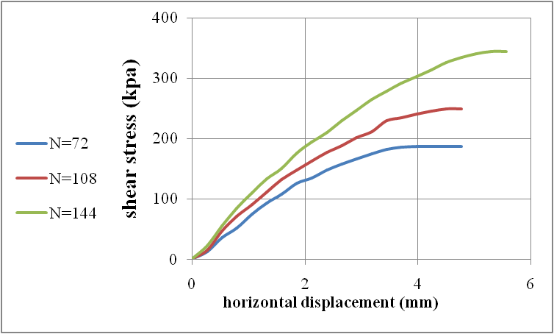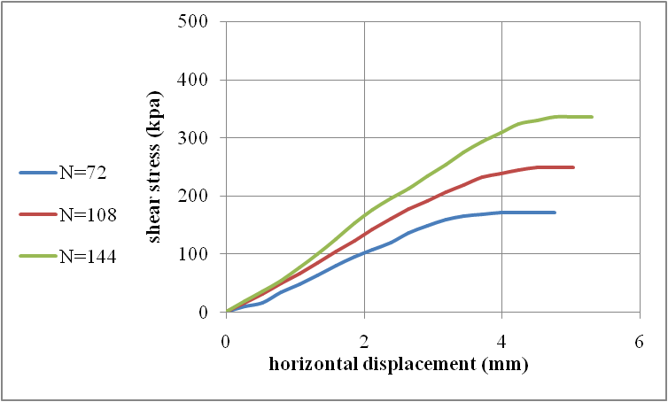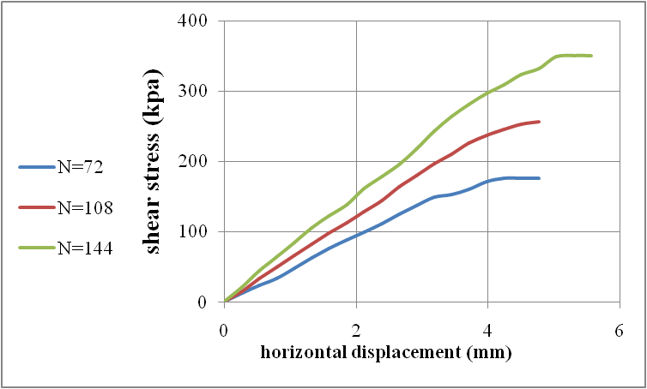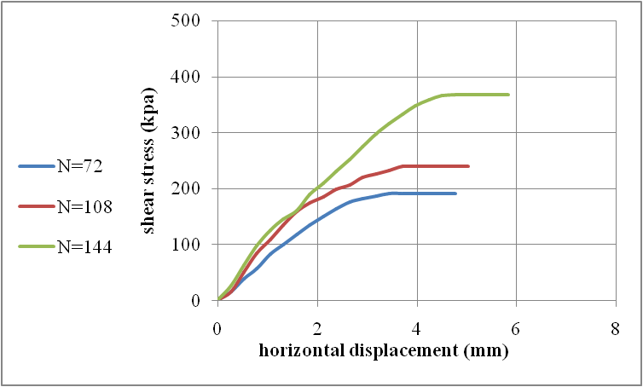
Sample
No. 1A
Sample
No. 3B
Sample
No. 6A
Sample
No11D
Fig. (5): Shear stress and horizontal displacement at different normal stresses of samples No. (1A, 3B, 6A and 11D)

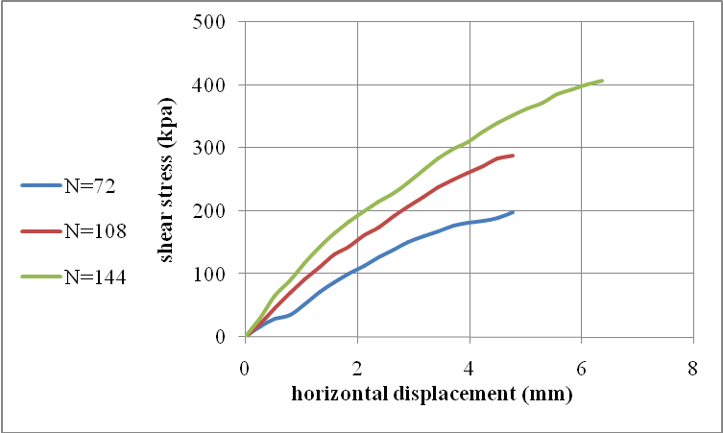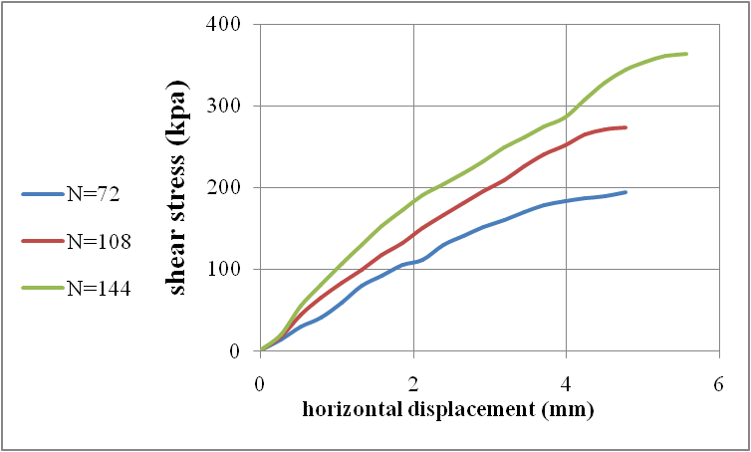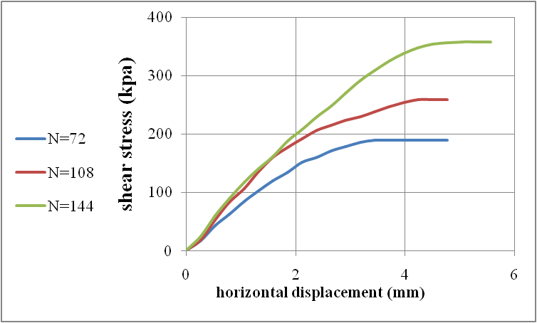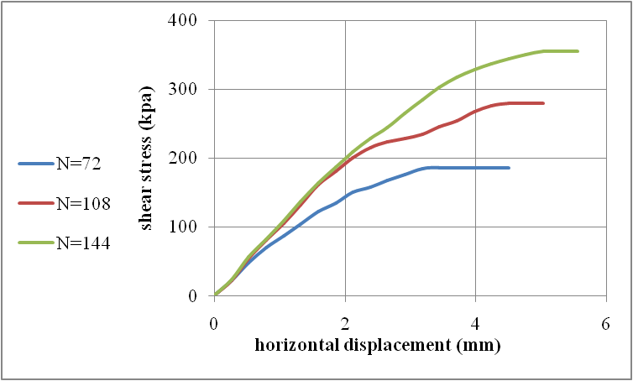
Sample
No. 17A
Sample
No. 21A
Sample
No. 23A
Sample
No. 28A
Fig. (6): Shear stress and horizontal displacement at different normal stresses of samples No. (17A, 21A, 23 A and 28A)
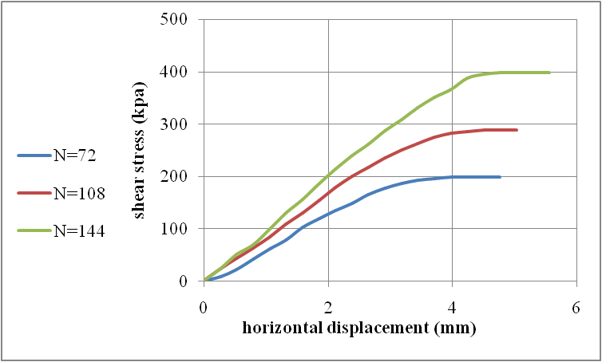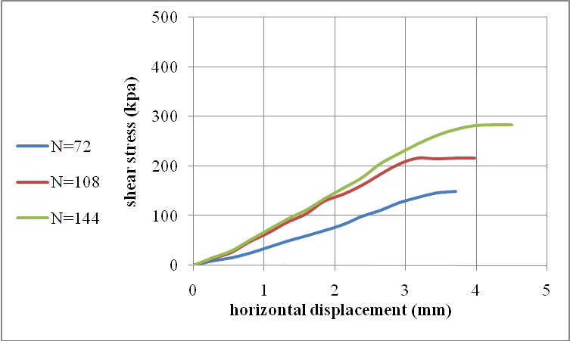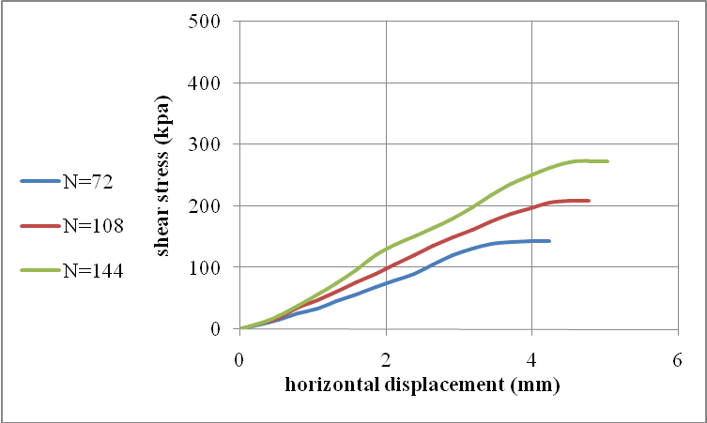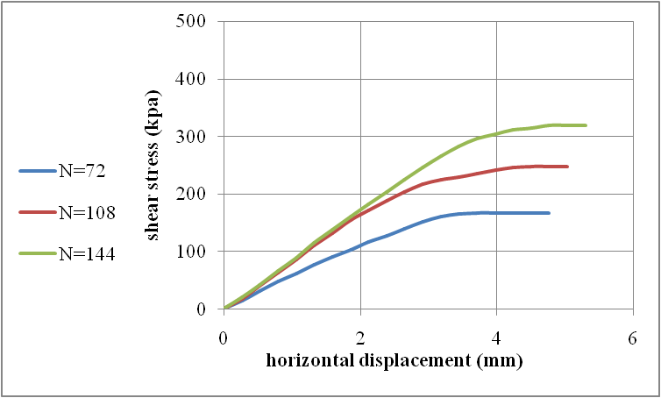
Sample
No. 29A
Sample
No. 35A
Sample
No. 36D
Sample
No. 37A
Fig. (7): Shear stress and horizontal displacement at different normal stresses of samples No. (29A, 36A, 36D and 37A)

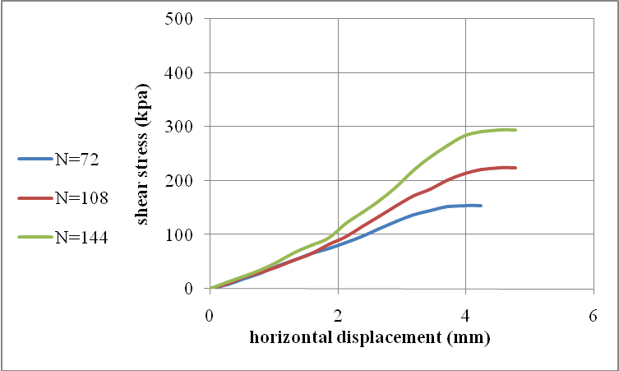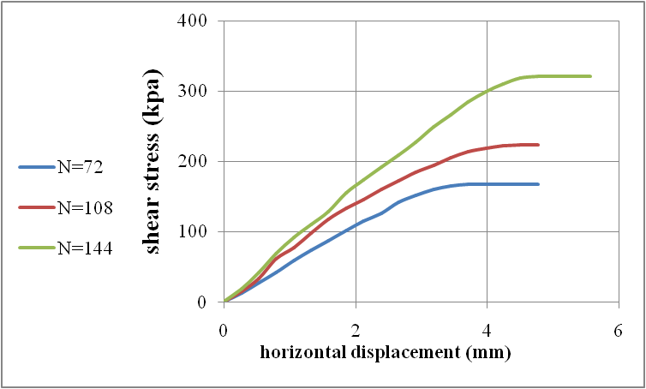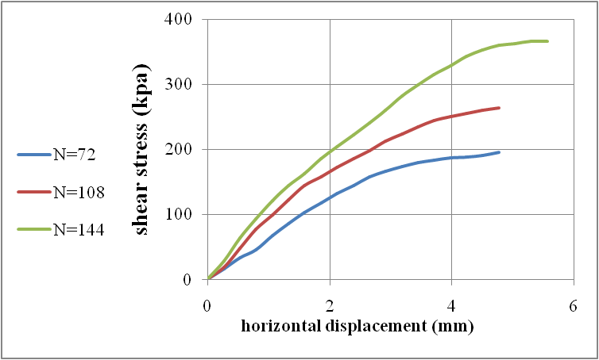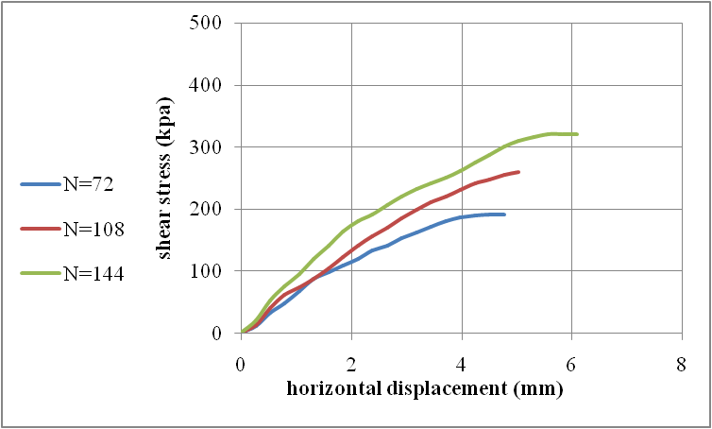
Sample
No. 40A
Sample
No. 46A
Sample
No. 50A
Sample
No. 53D
Fig. (8): Shear stress and horizontal displacement at different normal stresses of samples No. (40A, 46A, 50A and 53D)
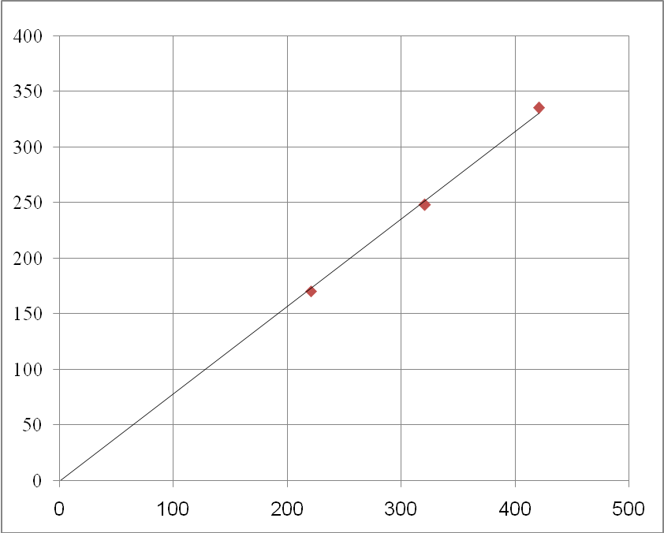
Sample No. 1A
Sample No. 3B
Normal Stress Kpa
Shear stress, Kpa
Normal Stress Kpa
Shear stress, Kpa
Fig. (9): Shear stress versus normal stress of samples No. (1A and 3B)

3.1.4. Chemical Analysis:
The purpose of chemical analysis is to determine the degree of aggressive for soil samples. The water extraction method can be used for determining the sulfates, chlorides contents and pH values. The results of chemical analysis are given in table (4).
The values of pH of the studied samples range from 6.1 (moderately aggressive) to 7.9 (non aggressive), sulfates range from 0.001% (non aggressive) to 0.88% (aggressive) and the values of chlorides range from 25.89ppm (non aggressive) to 1380ppm (aggressive). According to Egyptian code (2001), more than 50% of the studied samples are non aggressive soil.
3.2. Geotechnical Properties of Clays:
3.2.1. Initial Water Content:
The initial water content (moisture content) is defined as the ratio of the weight of water present in a given soil mass to the dry weight of solid soil particles. The results of this test of the studied samples are given in (Table 2). These results range from 7.9% to 20 %.

Table (4): Guide values for some aggressive elements and factors determining aggressive degrees of the soil at Sadat City.
Sample. No | E.C. | T.D.S | Sulfates | Chlorides | pH
2A | 1468 | 938.98 | 0.412 | 330 | 7.2
3A | 1636 | 1047.04 | 0.013 | 299.07 | 7
3B | 572 | 366.08 | 0.003 | 150.14 | 7.1
4B | 1298 | 830.72 | 0.034 | 113.9 | 7
5A | 1321 | 999.81 | 0.48 | 620 | 7
6A | 5130 | 3283.2 | 0.082 | 1113.12 | 7
7A | 3490 | 2233.6 | 0.081 | 657.52 | 6.1
9A | 5240 | 3353.6 | 0.089 | 1190.78 | 6.1
11D | 714 | 456.96 | 0.007 | 160.5 | 7
14A | 832 | 854.81 | 0.139 | 400 | 7
16A | 1211 | 763.21 | 0.037 | 220 | 7.3
17C | 1415 | 905.6 | 0.015 | 295.11 | 7.1
19A | 1642 | 2860 | 0.013 | 1150 | 7.9
20A | 1951 | 4960 | 0.206 | 1380 | 7.6
21A | 948 | 6375 | 0.288 | 864 | 7.2
22A | 1120 | 7013 | 0.445 | 791 | 7.1
24A | 376 | 240.64 | 0.004 | 67.3 | 7
25B | 432 | 276.48 | 0.004 | 108.72 | 7
26A | 196 | 125.44 | 0.002 | 25.89 | 7.1
28A | 558 | 357.12 | 0.005 | 129.43 | 7.3
29A | 1784 | 114176 | 0.078 | 103.55 | 7
32A | 1653 | 1254.22 | 0.45 | 840 | 7.2
34A | 1251 | 871.35 | 0.1 | 490 | 7.5
37A | 999 | 743.56 | 0.88 | 420 | 7.1
44A | 596 | 381.44 | 0.002 | 139.79 | 6.5
45A | 3280 | 2029.2 | 0.052 | 693.76 | 6.4
49A | 994 | 590.18 | 0.03 | 840 | 7.9
50A | 1011 | 647.04 | 0.001 | 269.22 | 7.1
50B | 586 | 375.04 | 0.002 | 142.38 | 7
50D | 394 | 252.16 | 0.001 | 96.6 | 7.1
51E | 757 | 484.48 | 0.007 | 147.55 | 7
53D | 898 | 574.72 | 0.002 | 238.16 | 7

Table (5): Initial water content of the studied samples
Sample No. | Initial water content % | Sample No. | Initial water content %
4B | 12.1 | 41 B | 16
34B | 12 | 42 B | 16.6
36A | 19 | 43 B | 9.6
36B | 20 | 44 A | 11.2
36C | 17 | 46 B | 12.1
37B | 17 | 47 B | 7.9
41A | 17 | - | -

3.2.2. Atterberg Limits and Consistency of Fine Grained Soils:
The aterberg limits are the boundaries between four states of soil. The term consistency of soil means the relative ease which soil can be deformed, this term used for fine grained soil and is related to a large extent to the water content. The soil passes through various states of consistency, these states are liquid, plastic and semisolid states.
3.2.2.1. Liquid limit (L.L):
The liquid limit is the water content corresponding to a limit between liquid and plastic states of consistency. The results of the liquid limit of studied samples are given in Table (5). These results range from 35% to 78 %.
3.2.2.2. Plastic Limit (P.L.):
The plastic limit for the part of soil passing from sieve No. 40 (425 μm) of studied samples are determined by laboratory test. It is depends on the type and amount of clay fraction in soil. The results of the plastic limit are given in table (5). These results range from 22 % to 36 %.
3.2.2.3. Shrinkage Limit (S.L):
According to Arora 1988 the shrinkage limit is the water content below which no appreciable change in volume is observed. This limit is determined in the laboratory. The results of this test are given in table (5). These results range from 10.8 % to 17 %.
3.2.2.4. Plasticity Index (P.I.):
Plasticity index is defined as the numerical difference between the liquid limit and plastic limit. The plasticity index values of the tested soils are shown in table (6).These results range from 10 % to 49 %.
3.2.2.5. Liquidity Index (L.I.):
The liquidity index (L.I) according to Withlow, 1983 can be used to predict the physical state of the soil and its natural moisture content. The values of this liquidity index are given in table(6). These results range from -2.07 % to 0.13 %.
3.2.2.6. Consistency Index (C. I):
The consistency index is defined as the ratio of the difference between the liquid limit and natural water content to the plasticity index. The values of this index are given in table (6). These results range from 1.13 % to 3.07 %.

Table (5): Atterberg limits of the studied samples.
Sample No. | Liquid limit (L.L) | Plastic limit (P.L) | Shrinkage limit (S.L)
3A | 47 | 36 | -
4A | 55 | 22 | 16.8
6A | 36 | 26 | -
17A | 41 | 28 | -
17B | 45 | 33 | -
23A | 40 | 28 | -
34B | 39 | 26 | 16
36A | 45 | 22 | 16
37B | 44 | 29 | 17
41B | 45 | 29 | 14
42B | 44 | 24 | 17
43B | 78 | 34 | 14
44A | 48 | 36 | 17
46A | 72 | 23 | 17
47B | 66 | 26 | 13
51B | 35 | 25 | -

Table(6): Plasticity, liquidity and consistency index of the studied samples:
Sample. No. | Plasticity index% | Liquidity index % | Consistency Index %
4B | 33 | -0.3 | 1.3
34B | 13 | -1.08 | 2.08
36A | 23 | -0.13 | 1.13
37B | 15 | -.08 | 1.8
41B | 16 | -0.81 | 1.81
42B | 20 | -0.37 | 1.37
43B | 44 | -0.55 | 1.55
44A | 12 | -2.07 | 3.07
46A | 49 | -0.22 | 1.22
47B | 40 | -0.45 | 1.45

3.2.3. Free Swell Test:
The free swell test is a qualitative indicator of expansive soil. The values of free swelling of the studied samples are given in table (7) and range between 50 % to 120 %.

Table (7 ): Free swell of the studied samples
Sample. No. | Free swell % | Sample No. | Free swell %
4 B | 120 | 41 B | 50
34 B | 60 | 42 B | 55
36 A | 53 | 43 B | 50
36 B | 60 | 44 A | 60
36 C | 50 | 46 B | 50
37 B | 50 | 47 B | 54
41 A | 70 | - | -

3.3. Classification of Engineering Properties of Soil:
The purpose of soil classification is to arrange various types of soil into groups according their engineering characteristics.
The classification of coarse grained soils (sand and sand with gravel) according to USCS (Unified soil classification system) is showed in table (2). Some samples of coarse grained soil contain more than 12% of finer fractions or contain from 5% to 12% of finer fractions, the liquid limit and plastic limit tests are estimated and plotted on plasticity chart (Fig. 7) to determine the symbol of fine fractions.
The fine grained soils of the studied sample are classified by using plasticity chart according to Casagrand's (1948), (Fig. 10) shows the classification of fine grained soils of the studied samples.

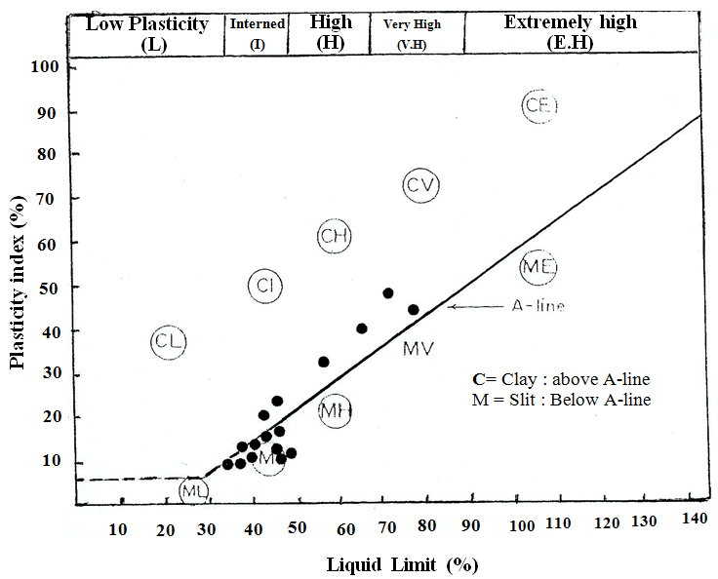
Fig. (10): Classification of fine – grained soil (After Casagrand, 1948)

3.3. Bearing Capacity:
The supporting power of a soil or rock is referred to as its bearing capacity. The term bearing capacity is defined as described below after attaching certain qualifying prefixes.The ultimate soil bearing capacity can be determined by using Terzaghi’s bearing capacity equation for square footing:
Qu = 1.3 c Nc +γD Nq + 0.4γB Nγ
Where: C: Cohesion of soil, γ: unit weight of soil, D: depth of footing, B: width of footing Nc, Nq, Nr: Terzaghi’s bearing capacity factors depend on soil friction angle, φ.
Nc=cotφ(Nq –1)
Nq=e2(3π/4-φ/2)tanφ / [2 cos2(45+φ/2)]
Nγ=(1/2) tanφ( Kpr /cos2 φ -1)
Kpr=passive pressure coefficient.
Also, these factors can be determined from (Fig.11).

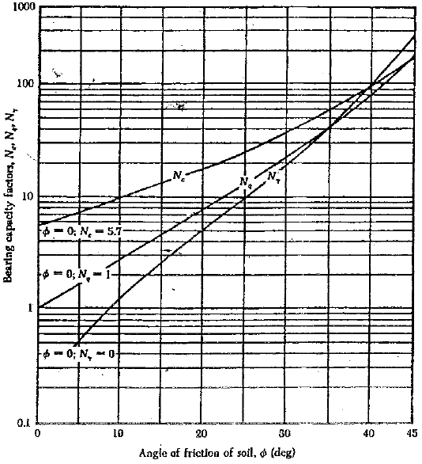
Fig. (11): Terzaghi’s bearing capacity factors for general shear failure

In this research, A square foundation is (1.5 m * 1.5 m ), the unit weight of soil is 18 kN/m³, the depth of the foundation is 1.5 m. The results of the ultimate soil bearing capacity for different friction angles of the studied samples are showed in table (8). The values range from 1182 kN/m² to 5433 kN/m².

Table (8): The ultimate soil bearing capacity of the studied samples.
Sample No. | Friction angle (∅) | Cohesion (C ) (KPa) | Nc | Nq | Nγ | Qu (kN / m²)
1A | 38° | 0.00 | 82.2 | 63.5 | 73.1 | 2504
3B | 38° | 0.00 | 82.2 | 63.5 | 73.1 | 2504
6A | 39° | 0.00 | 95.7 | 73.2 | 89.2 | 2940
11D | 40° | 0.00 | 146.7 | 81.3 | 100.4 | 3279
17A | 43° | 0.00 | 99.5 | 132.3 | 172.3 | 5433
21A | 41° | 0.00 | 95.7 | 85.4 | 116.5 | 3564
23A | 40° | 0.00 | 123.2 | 81.3 | 100.4 | 3279
28A | 42° | 0.00 | 146.7 | 97.5 | 144.5 | 4193
29A | 43° | 0.00 | 52.6 | 132.3 | 172.3 | 5433
35A | 34° | 0.00 | 48.8 | 36.5 | 36 | 1374
36A | 33° | 0.00 | 72.4 | 32.6 | 27.9 | 1182
37A | 37° | 0.00 | 57.8 | 52.7 | 58.9 | 2059
40A | 35° | 0.00 | 68.2 | 41.4 | 42.4 | 1576
46A | 36° | 0.00 | 68.2 | 51.1 | 48.3 | 1901
50A | 40° | 0.00 | 95.7 | 81.3 | 100.4 | 3279
53D | 38° | 0.00 | 82.2 | 63.5 | 73.1 | 2504

Conclusion:
The soil of Sadat City from the foundation point of view is divided into three types: sandy soil, gravel soil and clay soil (clay lenses).From the geotechnical parameters, the first and second types of soils are suitable for direct foundation above them. These two types are classified as coarse grained soils. Which have good load bearing capacities and good drainage qualities, and their strength and volume change characteristics are not significantly affected by changes in moisture conditions. So, it is recommended here to build a lot of buildings.
The third type is not allowed to direct foundation because of its high swelling property, which has a dangerous effect on the buildings that are found there. If it is necessary to use this type of soil for building, this soil should be replaced by a soil of clean sand taken from another spots to be distributed under the foundation. This replacement layer should not be less than 1.5m thick. It is also recommend to create green and open play grounds on this type of soil. If it is needed to build on it, villas and small housings can be constructed.

References:
- Arora, K.P. (1988): Introductory soil engineering, New chand Jain, Delhi, India, 630 p.
- Casagrand, A. (1948): Classification and identification of soils Am. Soc. Civ. Civ. Eng. Trans. Vol., 113, pp. 901 – 930.
- CONCO/EGPC (1987): "Geological map of Egypt, Scale 1:500,000". Map Sheet No. NH36NW, CONCO with cooperation of The Egyptian General Petroleum Corporation, Klitzsch, E.; List, F.K. and poehlman, G. (Editors), Berlin: Cairo, Egypt.
- Egyptian Code. (2001): Fore soil mechanic, design and construction foundation.
- Gad, M.A. (2005): Environmental impacts on the ground water aquifer in El Sadat Area, West of the Nile Delta, Egypt. M. Sc. Thesis, Fac. Sci. El Menoufia Univ; Shibin El Kom, Egypt, 88 pp.
- Hazen, A. (1892): Some physical properties of sands and gravels with special reference.
- Shedid, A.G. (1989): Geological and hydrogeological studies of El Sadat area and its vicinties". M. Sc. Thesis, Fac. Sci. El Menoufia Univ; Shibin El Kom, Egypt, Cairo, 157 p.
- Terzaghi,K. Theoretical Soil Mechanics, John Wiley & Sons, Inc., New York, 1954.
- Whitlow, R. (1983): Basic soil mechanics. Longman Cropu Limited. New York. 439P.

7/21/2015

