Impacts of Water Pollution with Heavy Metal on the Tissue of Egeria radiata (Bivalvia: Tellinacea: Donacidae) (Lammark, 1804) Obtained from Calabar River, Cross River State, Nigeria.

Ekpo, Eyo Antai¹, George, Ubong Uwem², Edet, Mercy²

¹Department of Marine Biology, Institute of Oceanography University of Calabar, Calabar.
²Department of Zoology and Environmental Biology, University of Calabar, Cross River State, Nigeria

talk2georgeubong@gmail.com

Abstract: Heavy metals are natural trace components of the aquatic environment, but their levels have been increased due to human activities which include industrial wastes, agricultural and mining activities. All these sources of pollution affect the physicochemical characteristics of the water, sediments and biological components, thus negatively affecting the quality and quantity of macro fauna stock. Environmental pollution is a worldwide problem threatening extinction of many economic species; heavy metal is one of the most important pollutants that posed a risk to the health status of aquatic system. The progress in technological advancement has led to increased emission of pollutants into the ecosystem. Levels of heavy metal concentrations in the tissue of E. radiata from Calabar River were investigated. The toxic substances in Calabar River showed that their concentration in the water did not exceed acceptable levels during the studied period. There is need for constant monitoring of the levels of heavy metals in the area of study in order to forestall any significant rise in their levels.
[Ekpo, Eyo Antai, George, Ubong Uwem, Edet, Mercy. Impacts of Water Pollution with Heavy Metal on the Tissue of Egeria radiata (Bivalvia: Tellinacea: Donacidae) (Lammark, 1804) Obtained from Calabar River, Cross River State, Nigeria. Nat Sci 2015;13(8):36-39]. (ISSN: 1545-0740). http://www.sciencepub.net/nature. 6

Keywords: Heavy Metals, Impacts, Water Pollution, Tissue, Egeria radiata, Calabar River.

1. Introduction
Over the years, environmentalist have been making efforts in many directions aimed at preserving the human, animal, aquatic fauna and flora from pollution, devastation and extinction due to heavy metal pollution. Our environment is highly polluted and the effects of this pollution have been very devastating. it is therefore not strange to see concerned men and women in different fields of endeavor rising up to fight this monster called environmental pollution, which has turn our society into a battle field where everyone is struggling to survive and to live decently.
It is important to note that the major cause of environmental degradation is as a result of human induced activities which include industrial, mining, agriculture, house hold waste production, road construction and other human related activities that is capable of increasing the concentration of this metals in the environment, thereby altering the status of the aquatic ecosystem which may in turn affects fish stocks, extinction of many economic species and possibly alteration in the quality of water which hampered the use of such system for domestic, farming and tourism purposes.
Metal contamination of the aquatic environment is a long-term issue, since metals accumulate in aquatic organisms, including macro benthic organism, and persist in sediments (Fleeger et..al., 2003). Fish and other macro benthic organism are an important source of metals in human nutrition, and those from metal contaminated sites present a potential risk to human health.
Currently, contamination of aquatic ecosystems is monitored using specific biomarkers. In the case of metal pollution, Egeria radiata has been suggested to be a suitable bio indicator due to their filter feeding habits and contacts with bottom sediments. Heavy metals can therefore bio-accumulate in tissues of benthic organisms such as E. radiata. E. radiata happens to be one of the fishery resources in the area and is consumed by people in the area of study. The aim of this study is to assess the levels of heavy metal contamination in the tissue of Egeria radiata obtained from Calabar River in order to ascertain their suitability and safety for human consumption.

2. Material and Methods
2.1 Study Area
The study area is located in Cross River System which lies geographically between latitude 04°30’13''N and longitude 08°30’06''E; and latitude 04°32’40''N and longitude 08°28’40''E, South Eastern Nigeria (Akpan, 2002) as shown in Fig 1. The river encloses Esuk Nsidung Calabar south, Adiabo bridge in Odukpani Local Government Areas. According to Etim and Enyenihi (1991) Calabar River is known to be the major tributary of the Cross River which originates from Oban hills Nigeria and flows through black shale and siltstone, clay, sand and silts deposits, before emptying into the estuary at Alligator Island. The approximate estimated area of Calabar river is 54,000 square kilometers and stretches about 25km to the south of the river. The Calabar River is hydro-dynamically homogenous. Dissolved particulate materials insitu are transported by surface current from the estuary into Creeks and upper reaches of Calabar River within the industrial area of Esuk Nsidung to Adiabo-Bridge head during semi diurnal tide (Asuquo et al., 1999). The river is a major sink for toxic substances and undesirable materials through agricultural, industrial, and municipal discharges.
2.2 Sample collection
Egeria radiata was purchased from artisanal fishermen from August to october 2014. The samples were placed immediately in poly-ethylene bags, put into isolated container of polystyrene icebox and then brought to the Marine Biology Laboratory of Institute of Oceanography University of Calabar, Calabar for further analysis.
2.3 Determination of Heavy Metals Analysis
In the laboratory samples of Egeria radiata were washed and frozen at -5°C until they were ready for analysis. Later, Egeria radiata were de-shelled and the soft tissues air-dried at room temperature for three weeks and were analyzed at the Department of Chemistry, University of Calabar. Tissues of Egeria radiata were grounded to powder form, sieved, weighed and ash at 77°C for two hours in a furnace. Ten grams of ash Egeria radiata tissues were digested with 20 ml of concentrated HNO3 and heavy metals such as Lead (Pb), Iron (Fe), Cadmium (Cd), Copper (Cu), Zinc (Zn) and Chromium (Cr) were determined using solar model-unicam 969 Atomic Absorption Spectrophotometer.
2.4 Determination of Total Hydrocarbon
The Soxhlet Extraction Gravimetric method was used for determination of petroleum hydrocarbon such as Total Hydrocarbon (THC). Fifty grams of air-dried and ground Egeria radiata tissues were extracted in Soxhlet Extractor for 8 hours using hexane acetone (60:40) cocktail solvent. Soluble metallic soaps were hydrolyzed by acidification. Oils and solids or viscous grease present were separated from liquid samples by filtration. After extraction, the residues after solvent evaporation were weighed to determine the oil and grease content. Compounds volatilized at or below 103°C were lost when filtered and dried.
2.5 Statistical Analysis
Data obtained were subjected to Descriptive Statistics and Simple student t-test, to test whether there is a significant difference between the mean values of the different month.

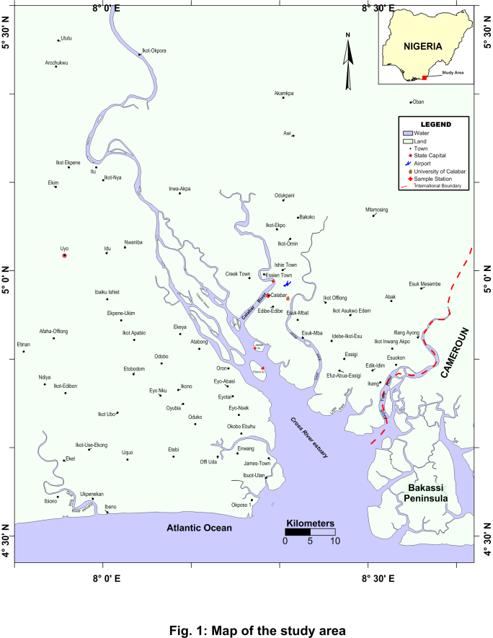

3. Results
The mean Heavy metals and Total hydrocarbon concentrations in the tissues of Egeria radiata obtained from Calabar River are summarize in (Table 1, Fig. 1). Iron ranged between 0.049 - 0.129 mg/l. Iron did not differ significantly between the various months (p > 0.05). Cadmium ranged between 0.000 - 0.006 mg/l. Cadmium was also not significantly different between months (p > 0.05). Copper ranged between 0.030 - 0.045 mg/l. Copper was also not significantly different between months (p> 0.05). Lead ranged between 0.003 - 0.012 mg/l. Lead was also not significantly different between months (p > 0.05). Zinc ranged between 0.016 - 0.057 mg/l. Zinc did not show significant difference between months (p > 0.05). Total hydrocarbon also ranged between 0.047 - 0.050 mg/l and there was no observed significant across the different months of study. However, slight variation in concentrations of Heavy metal and Total hydrocarbon were observed across all the months during the study period.

Table 1: Mean Concentration of Heavy Metals in the tissue of Egeria radiata (August – October, 2014) from Calabar River.
Metal | August | September | October
Fe | 0.129 ± 0.0007 | 0.049 ± 0.0006 | 0.065 ± 0.002
Cd | 0.006 ± 0.0007 | 0.000 ± 0.0000 | 0.000 ± 0.000
Cu | 0.045 ± 0.0006 | 0.030 ± 0.0012 | 0.033 ± 0.007
Pb | 0.003 ± 0.0007 | 0.006 ± 0.0010 | 0.012 ± 0.002
Zn | 0.050 ± 0.0009 | 0.016 ± 0.0006 | 0.057 ± 0.002
Cr | 0.027 ± 0.0006 | 0.000 ± 0.0000 | 0.000 ± 0.000
THC | 0.047 ± 0.001 | 0.050 ± 0.001 | 0.049 ± 0.001

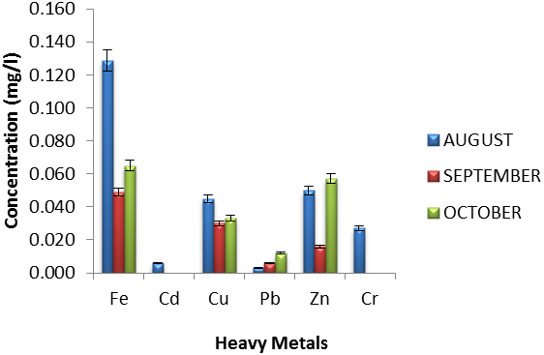
Fig 1: Mean Variation in Heavy Metal in the tissue of Egeria radiata obtained from Calabar River during the studied period (August – October, 2014).

4. Discussion
The results of this investigation (Tables 1) revealed that the mean levels of all the metals in the tissue of Egeria radiata were lower than the permissible limits for heavy metal in aquatic food. The possible explanation for this could be that the source of the samples (Egeria radiata) from artisanal fishermen were collected in area of the river that is relatively unpolluted or the ability of the organism to assimilate these metals during the study period. Duruibe and Egwurugwu (2007) reported that heavy metals are released into the environment by both natural and anthropogenic sources especially mining, industrial activities and automobile exhaust. Ali and Fisher (2005) also reported that some benthic invertebrates accumulate heavy metals from water and sediments and that mollusks and crustaceans have higher concentrations than other invertebrates.
There were variations in levels of heavy metals in E. radiata obtained from Calabar River. This indicated that heavy metal concentration in the River studied varied but not significantly different (p > 0.05). The results of the present study agrees favorably with the work of Etim and Muller, (1991) which also reported low levels of heavy metal concentrations in the tissue of E. radiate from Cross River, Andem et.al, 2013 which during their studies also reported low levels of heavy metal concentration in the tissues of Tympanotonus fuscatus from Qua iboe River. Monthly variation in heavy metal concentration was not significant throughout the study period.
Low concentrations of total hydrocarbon (THC) were found in the test organism. The levels of THC in the organism tissues could have been induced by uptake from the sediment. Similar Finding was also observed by Davies et al., 2006. The differences in the level of heavy metals accumulated in the test organism, Egeria radiata could be attributed to the differences in their metabolic rates, feeding habits, age and sex (Kotze et al., 1999). Levels of heavy metals (Iron, Cadmium, Copper, Lead, Zinc and Chromium) in tissues of E. radiata were found to be below the acceptable limits of heavy metal pollution in shell fish (FAO / WHO, 1984, USEPA, 1986; Sharp, 1987 and Ayenimo et al., 2005). There is need for constant monitoring of the levels of heavy metal in the River system to forestall any significant rise in their levels.

5.0 Conclusion
However, it should be noted that heavy metals have relatively high density and are toxic or poisonous even at low concentrations. In this regards, heavy metal pollution of water bodies especially in the area of study and environs should be reduced to the barest minimum level. This is to minimize shellfish and fish food contamination which in turn will reduce clinical poisoning in human who consume Egeria radiata and other fishery products from Calabar River.
Corresponding Author:
Mr. Ubong George
Department of Zoology & Env. Biology,
University of Calabar,
P.M.B 1115, Calabar.

E-mail: talk2georgeubong@gmail.com.

References
- Akpan, E. R. Heavy Metal trends in The Calabar River, Nigeria. Environ. Geol., 2002: 42: 47-51.
- Ali, M. H. H and Fisher, M. R. A. Accumulation of trace metals in some benthic invertebrates and fish species relevant to their concentration in water and sediment of Lake Quaran, Egypt. Egyptian Journal of Aquatic Research, 2005: 31 (1): 290-301.
- Andem A. B., Udofia U. U., Okorafor K. A. and George U. U. Bioaccumulation of some Heavy Metals and Total Hydrocarbon (THC) in the Tissues of Periwinkle (Tympanotonus Fuscatus Var Radula) in the Intertidal Regions of Qua Iboe River Basin, Ibeno, Akwa Ibom State, Nigeria. Greener Journal of Biological Science, 2013:3(7):253-259.
- Asuquo, F. E., Ogri, O. R. and Bassey, E. S. Distribution of heavy metals and total hydrocarbons in coastal waters and sediments of Cross River, South-eastern Nigeria. International Journal of Tropical Environment, 1999:1 (2): 1 – 19.
- Ayenimo, J. G., Adeyinwo, C. A., Amoo, I. A. and Odukudu, F. I. A preliminary investigation of heavy metals in periwinkles from Warri River, Nigeria. Journal of Applied Science, 2005:5(5): 813 - 815.
- Davies, O. A., Allison M. E. and Uyi, H. S. Bioaccumulation of heavy metals in water, sediment and periwinkle (Tympanotonus fuscatus) from the Elechi Creek, Niger-Delta, Nigeria. African Journal of Biotechnology, 2006: 5:968-973.
- Duruibe, J. O., Ogwuegbu, M. O. C. and Egwurugwu, J. N. Heavy metal pollution and human biotoxic effects, International J. Phys. Sci., 2007:2(5): 112-118.
- Etim, L. and Enyenihi, U.K. Annual cycle of condition and flood season spawning in Galatea Paradoxa (Born, 1977) from the Cross River, Nigeria. Tropical Freshwater Biology, 1991:2: 243 – 248.
- Etim, l., Akpan, E. R and Muller, P. Temporal trends in heavy metal concentrations in the clam Egeria radiata (Bivalvia: Tellinacea: Donacidae) from Cross River, Nigeria. Revue d’ Hydrobiologie Tropicale, 1990:24 (4):327-333.
- FAO / WHO. List of maximum levels recommended for contaminants by the Joint FAO/WHO Codex Alimentarius Commission. Second Series. CAC/FAL, Rome, 1984:3: 1–8.
- Fleeger, J. W., Carman, K. R. and Nisbet, R. M. (2003). Indirect effects of aquatic contaminants in aquatic ecosystem. Sci. Total Environ, 2003:317(1): 207-233
- Kotze, P. Du., Preez, H. H. and J. H. J. Van Vuren. Bio-accumulation of copper and zinc in Oreochromis mossambicus and Clarias gariepinus from the Olitants River, Mpumalanga, South Africa. Water S.A, 1999: 25 (1):99-110.
- United States Environmental Protection Agency (USEPA). Biological indicators of watershed health. Available at http://www.epa.gov/ Last modified January, 1987.
- Sharp, D. S., Becker, C. E. and Smith, A. H. Chronic low-level lend exposure: its role in the pathogenesis of hypertension. Medical Toxicology, 1987: 2: 210-232.

7/17/2015

