Comparison and assessment of monthly drought determined by two drought indices: CZI, SPI

Seyed Vahid Shahoei¹, Jahangir Porhemmat²

^{1.} PhD candidate in Water Resources Engineering, Islamic Azad University, Science and Research Branch, Department of Water Resources Engineering, Tehran, Iran
^{2.} Associate Professor of Soil Conservation and Watershed Management Research Center, Tehran, Iran

Abstract: Drought index by using rainfall data, discharge, snow and etc give an understandable picture of the phenomenon of the drought. The drought index expresses in a number, which this number is the basis of the decision. In this study assesses and compares drought indices in three stations Tehran and Qazvin and Khoramabad. To this end from two drought indices SPI and CZI is used. The data used is monthly rainfall data of selected synoptic stations during the period of 51 years (1960-2010). Determining threshold of start, the continuation and the end of the drought specify by using the Run theory. To evaluate drought indices in order to monitoring the drought from regression analysis is used. Following the number and monthly drought periods have been determined by each index. Finally, with determining distribution of drought (according to the number and Period of time drought) this subject was studied that whether according to previous studies carried out existence of a high correlation between the two drought indices can be indicates this subject that the results of the two indices in calculating drought are the same or not.
[Seyed Vahid Shahoei, Jahangir Porhemmat. Comparison and assessment of monthly drought determined by two drought indices: CZI, SPI. Nat Sci 2015;13(8):1-7]. (ISSN: 1545-0740). http://www.sciencepub.net/nature. 1

Keywords: drought; drought indices; Run theory; regression analysis

1. Introduction
In terms of Richard and Him (2002) Drought is local phenomena, from climatology phenomena that every some years leads a lot of damages. Rainfall is the most important variable that its changes reflect directly in the humidity, surface flows and changes of underground water reservoirs. So rainfall is first factor that can be considered in the review of drought (Lashnizand, 2003). Indices that in own calculations use only rainfall factor in comparison with the complex hydrological indices give more favorable results (Oladipoo, 1985). From drought indices that have been developed based on rainfall data can be pointed to two indexes SPI and CZI. McKee et al. in 1993 developed Standard Precipitation Index (SPI) for the purpose of defining and monitoring drought and determining lack of precipitation in time scales of 3, 6, 12, 24 and 48 months. Hayes et al in 1999 came to the conclusion that the users of the index SPI in the world is increasing. In Iran also the results of studies Yazdani and colleagues show that the standard rainfall index in seasonal scale has better performance than the other indexes (Yazdani et al., 2011). lashniZand and colleagues in 2003 and moghaddasi in 2005 and Akhtari et al in 2006 reached to a common conclusion that the performance of SPI drought index in comparison with other drought index is more appropriate. Wu and colleagues in 2001 evaluated three drought indexes, standardized precipitation (SPI), Z Chinese (CZI) and ZSI in four regions in China where had conditions dry to wet with using 48 years of precipitation Statistics 1998 to 1951 and period 1, 3, 6, 9 and 12 months. In this research SPI index was based and other indices and its reaction in wet and dry years than this index were evaluated. For this study, from linear correlation between amounts of these indices were used by SPI. This correlation between amounts of SPI and CZI suggest that indices SPI and CZI generally show good relations in different time scales, except in time scale 3 month and in conditions very dry of own. In total the results of the study showed that these indices have good ability for monitoring drought in different time scales. Superiority of ZSI and CZI than the SPI is in this respect that the two indices unlike SPI accept statistical deficiencies between data series and have the simpler calculation. On the other hand, CZI than lack of rainfall and drought conditions than two other indices show further reaction and provides negative greater amounts than the rest. While ZSI did not shows a lot of capability for severe drought. In this study to evaluating and comparing the results of two droughts index CZI and SPI in area studying.

Materials and methods
Study area
Iran due to being in geographical dry ring and desert strip is located at 25 to 40 degrees northern latitude, from climatic conditions enjoys that is considered part of the areas with low rain in world. Due to the geographical position of the country in the dry belt, rainfall in Iran is only the equivalent of a third of the world average. In this study three synoptic stations have been studied in Tehran and Qazvin and Khorramabad. In this selective range, has been selected monthly statistics of rainfall 3 synoptic stations in the period of 51 years (1960-2010) that characteristics of selective synoptic stations is shown in Table 1.

Table 1- stations studying in research and their properties
Station Name | Station height (m) | Latitude (m) | Longitude (m) | Number
Tehran | 1191 | ´41 °35 | ´19 °51 | 1
Khorramabad | 1148 | ´26 °33 | ´17 °48 | 2
Qazvin | 1279 | ´15 °36 | ´03 °50 | 3

The selection of these 3 stations has been made with considering proximity of characteristics of height and geographical length and width, all these case can affect rainfall.
Drought indices
As mentioned, in this study is used 2 drought index in order to evaluating and comparing their results in the analysis of the drought in monthly time scale. Each of these indices with relying on rainfall data in different time scales (in this study monthly time scale) provides quantitative numeral which is used in the evaluation of drought. The general characteristics 2 selective drought index based on rainfall data can be summarized in Table 2.

Table 2. Characteristics of drought indices used in the study
Provider Name | Year of providing | Index Title | Symbol
Mckee | 1993 | Standard precipitation Index | SPI
Ju et al | 1997 | Chinese Z Score Index | CZI

Standard Precipitation Index
Standard Precipitation Index was introduced in 1993 by McKee et al. This index obtains based on differences in level of rainfall from the average amount for a specified time scale and then dividing it on standard deviation. The only factor involved in the calculation of the index is Rainfall element. This index can be calculated in time scales of 1, 3, 6, 9, 12, 18, 24 and 48 months and a one-year. Based on this index can be determine drought threshold for any time period. Standard Precipitation Index needs an expectable fixed amount and meaningful variance in order to comparing index mentioned in different stations (McKay et al., 1993). Relation of this index is in relation 1.
(1) 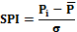
In which:
: The amount of precipitation in the slightly period : long-term average of rainfall for the slightly period and is the standard deviation of the amount rainfall.
Chinese Z Index
This index was created in 1997 by Joe and colleagues. Relations that used to calculate CZI index is the as relations 2 to 4:
(2) 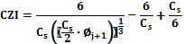
(3) 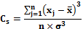
(4)
In which:
- j: slightly month;
- : Coefficient of skewness;
- : Standard variable;
- : Precipitation of month j;
- : Average of rainfall data;
- : The total number of months during the statistical period;
- : Standard deviation of rainfall data
Run theory
From Common methods of drought analysis, is RUN theory. (Yujnovich, 1967) with using RUN theory, three important features of the drought namely continuity, enlargement and intensity of drought defined and explained and concluded that the RUN theory has effective applications in the analysis the process of droughts. This theory determines process of start and ends of the drought, according to high limit and bottom limit of a critical threshold. In all studies of drought that have been done, using of RUN theory have applied as the first step monitoring drought that some of these studies can be refer to studies of (Chung & Salas, 2000), (Morid, 2006, Shiau, 2006), (Lee et al, 2013). For start of drought, every two selective indices of threshold have the same start.

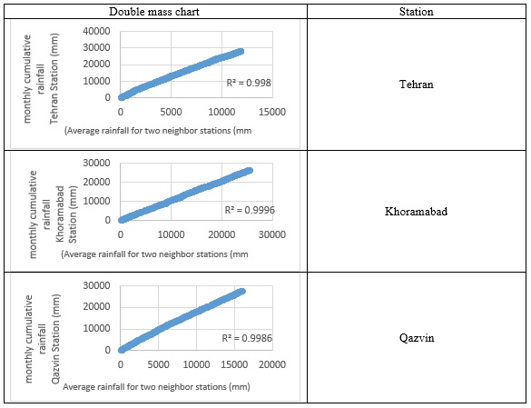
Figure 1- Test homogeneity of Monthly rainfall data in stations studying

Start of drought in SPI index and CZI is when amount of the index is smaller than -1. In RUN theory that is used to define drought, drought begins when that numerical amount of drought indices are under level of threshold of this theory. According to the chart of this theory can be seen that in some cases despite never amounts of drought indexes CZI and SPI do not get to less than -1, but cumulative amount of this Index and therefore the its impact is more than other drought index that amount of index have got to less than -1. On the other side in some cases that drought threshold is -1 and has defined according to this certain limit, has period of time very less than conditions that amounts of Index never are not got to -1 but continuous and prolonged is below the threshold limit. For solving these problems and defining a specific threshold limit for two index of study, the zero amounts of these indices are considered as the boundary of beginning the drought and with regard to this border of drought, start of drought is when numerical amount of the drought indexes studying is being less than zero.
Initial scrutiny of statistical data
The first step in designs and hydrology studies is initial analyzing of statistical data using. When the correctness and accuracy of the data is not reliable, the results obtained can not be reliable. Review and analysis of hydrological data is including completing and correcting data cutoff and incomplete. Checking homogeneity, stability and randomness of data is also including actions that should be examined before analysis and study. In this study in order to testing the homogeneity of the monthly data of rainfall in stations studying from double mass method, in order to studying the randomness of data Run test and to investigate stability of used data was used Spearman rank correlation test (Moghaddam et al., 2012). The results of each these tests are shown below.
Regression analysis
If the two sets of data are being available, the Regression method determines dependence of these two series relative to each other and specifies correlation between the two sets data in quantitative. Also this method specifies equation of the best linear that can be drawn between the two series. A theory that regression uses to obtain the correlation is theory of the least squares, in fact linear regression is a line that the sum of the square of the distance of points from the line than each other line have the minimum amount of its own. In this study in order to evaluating and comparing the results of two drought indices SPI and CZI from linear regression was used.

Results and discussion
Homogeneity of data
As mentioned before, in each hydrological study and research should be sure from randomness, homogeneity and stability of used data in the study until results of the study being reliable. In this study with using mentioned method checked randomness, homogeneity and stability of the monthly rainfall data of selected stations over a statistical period of 51 years that its results have came below.
Charts relating to double mass test to evaluate the homogeneity of the monthly rainfall data 3 stations examining in this study during the Statistical period 51 years have came in Figure 1.
As you can see, all stations examining according to double mass test are homogeneous.
Stability and randomness of data
Results of Spearman rank correlation test and run test to examine stability and randomness of studied rainfall data in stations at the annual time scale, is summarized in Table 3.

Table 3- results of the test the stability and randomness of annual rainfall data at the stations studying
data stability test |  | data Randomness test |  | Station Name
Permitted range | computational amount | Permitted range | computational amount
± 2.01 | - 0.02 | ±1.96 | 1.75 | Tehran
±2.01 | 1.22 | ±1.96 | 0.23 | Khorramabad
±2.01 | -1.85 | ±1.96 | -0.23 | Qazvin

As is clear from the results, all the rainfall data in the study are random and static.
Determining monthly drought happened in the period of 51 years at the stations examining
By using run theory and by using the amounts of critical level for each two drought index considered, droughts occurred will be specified. As before mentioned drought happens when amounts of index CZI and SPI are below of critical level (zero level). Changes of amounts drought index at each station is shown in Figure 2.

Station | SPI drought index changes chart | CZI drought index changes chart
Tehran
Khoramabad
Qazvin
Figure 2- Chart of changes drought indices examining over the 51-year statistical period in the Stations studying

Regression analysis in order to compare the drought index the studied
In this study, after identifying the drought by 2 indexes SPI and CZI, by using regression analysis has been compared two by two results of each index in all the elected stations. .By using test that was mentioned before have specified meaningfulness or non-meaningfulness of correlation between results of indices that the results are shown in Figure 3.

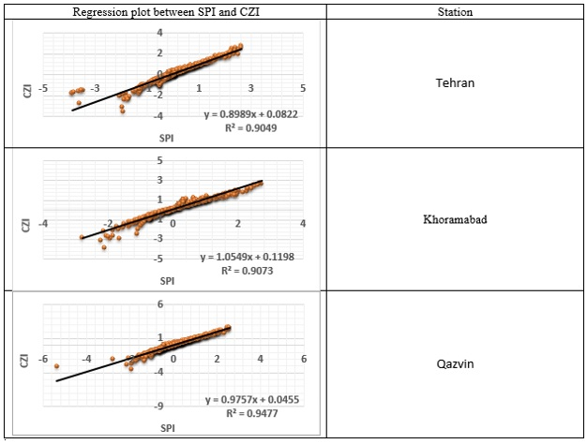
Fig. 3. Linear regression between drought indices studied in selected stations
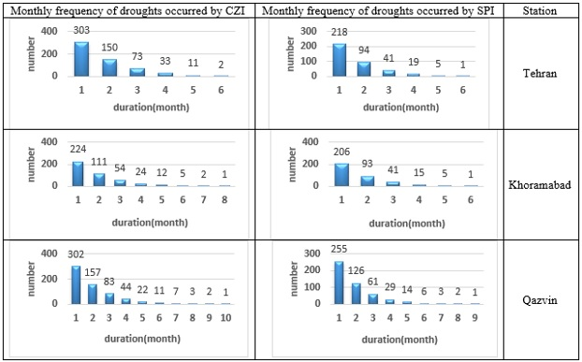
Figure 4- Chart frequency of monthly droughts occurred by drought indexes examining in stations studying.

As the results of the regression analysis show two indices CZI and SPI in the 3 stations examining have very high correlation so we should expect that monitoring drought by these two indices be same. In the rest of this article we will examine whether existence of a high linear correlation between the two indexes indicates equality of determination of droughts in stations examining or not?

Distribution of drought dispersion
In this section, were examined the droughts calculated by each drought indices and considering period of drought. In fact, the number of droughts occurred due to period of drought, by any index in all stations studying have been specified that its charts is in Figure 4.
As is clear from the results, in the three stations examining frequency and period of droughts differs from each other and in none of the stations, the number and duration of monthly droughts determined by two indexes SPI and CZI is not identical.

Conclusion
In this study overall presented assessment and comparison of the results of the drought index CZI and SPI and the relationship these indices together in the analysis of drought. According to the results obtained it was found that in all the stations examining, always two indexes CZI and SPI have high correlation and the amount of this correlation in all stations are up 0.90. According to these results it can be expected that two drought indexes SPI and CZI droughts in monthly scale monitor alike, and concluded that in studies and research projects can be sure from equality of the results of the two indexes. But when monthly droughts determined were determined by two indexes, was found those slightly drought indexes monitors number and periods of monthly drought completely separately. So that none of the stations examining the number and duration of drought, which are determined by the index SPI and CZI, are not the same. Thus, from this research can be concluded such that high linear correlation between drought indices (in this study, SPI and CZI) can not be enough witness for confidence of the equality of results determining drought by these indices and in estimating drought are in monthly scale by these indices should be careful that results of these two indices, despite the high linear correlation can be quite different.

References:
- Akhtari, R.; Mahdian, M. and Morid, S. (2006). Analysis of drought indices SPI and EDI place in Tehran. Water Resources Research 1 (4): 27-38.
- Yazdani, V.; Zare Abyaneh, H.; and Shademani, M. (2011). "Analysis of the frequency of droughts and zoning using Standardized Precipitation Index (SPI). Journal of Water Resources Engineering, Vol. IV, pp. 31-42.
- Samiei, M. and Talouri, A. (2005). "The severity and duration of hydrological drought in the catchment areas of Tehran." Research and development of natural resources, No. 79, pp. 22-27.
- Lashni Zand, M. (2003). "The intensity, duration and frequency of climatic drought." Third Regional Conference and the National Conference on Climate Change, Isfahan.
- Moghadasi, M. and Moridi, S. (2005). "The intensity, duration and frequency of climatic drought." Third Regional Conference and the National Conference on Climate Change, Isfahan.
- Where drought years 1999-2000 to 2000-2001 in Tehran monitoring using indicators DI, SPI and EDI and GIS. Quarterly Journal of, Vol. 9, No. 1, pp. 197-220.
- Moghadam, S.; Khani, Z. and Montaseri, M. (2003). "Effects of climate change on the severity, duration and course of SPI, drought and climate models (case study Urmia Lake basin)." Fifth Conference of Iran Water Resources Management.
- Chung, C.H. and salas, J.D. (2000). Drought occurrence probabilities and risks of dependent hydrologic processes. Journal of Hydrologic Engineering ASCE, 5(3), 259 – 268.
- Hayes, M. J., Svoboda, M. D., Wilhite, D. A., and Vanyarkho, O. V. (1999). Monitoring the 1996 Drought Using the Standardized Precipitation Index. Bulletin of the American Meteorological Society, Vol. 80, NO. 3, 427 – 440.
- Joe, H. (1997). Multivariate Models and Dependence Concepts. Chapman and Hall, Boca Raton, Fla.
- Lee, T. Modarres, R., and Ouarda, T.B.M. J. (2013). Data – based analysis of bivariate copula tail dependence for drought duration and severit, Hydrol. Process. 27: 1454 – 1463.
- McKee, T.B., Doesken, N.Y. and Kleist, Y. (1993). The relationship of drought frequency and duration to time scales. Preprints, 8th conference on Applied Climatology, 17 – 22 January, Anaheim, C.A., 179 – 185.
- Morid, s., Smakhtin, V., Moghaddasi, M. (2006). Comparison of seven Meteorological Indices for Drought Monitoring in Iran. Int. J. Climatol. 26: 971- 985.
- Oladipo, E.O. (1985). A comparative performance analysis of three meteorological drought indices. Journal of Climatology, Vol6, 495 – 514.
- Richard, R. Heim. (2002). A review of twentieth century drought indices used in the United States. American Meteorogical society, 1148 – 1165.
- Shiau, J.T. (2006). Fitting Drought Duration and Severity with Two – Dimensional Copulas. Water Resources Management (2006) 20: 795 – 815.
- Wu, H., hayes, MJ. Welss, A., Hu, Q. (2001). An evaluation the standardized precipitation index, the china – z index and statistical Z – score. International Journal of Climatology 21: 743 – 759.
- Yevjevich, V. (1967). An objective approach to definitions and investigation of continental hydrological droughts, Hydrology paper 23, Colorado State University, Fort Collins, Co, 18.

6/29/2015

