**Correlation between central corneal thickness and intraocular pressure in children with congenital glaucoma**

Hoda M. K.El-Sobky1, Hatem M. Marey1 and Dalia A. A. Nagy1

**1**Ophthalmology Department-Faculty of Medicine-Menoufia University**-**Egypt

[drdalianagy@yahoo.com](mailto:drdalianagy@yahoo.com)

**Abstract: Objectives**: This work aimed to study correlation between central corneal thickness and intraocular pressure in children with congenital glaucoma requiring surgery. **Background:** Central corneal thickness (CCT) has recently been shown to be important risk factor for development and severity of glaucoma. The clinical use of CCT measurement has become so important that it directly affects glaucoma management strategy in 15% of patients. **Patients and methods:** Thirty individuals were enrolled in this study, 18 males and 12 females. All children were diagnosed to have primary congenital glaucoma and underwent combined trabeculotomy-trabeculectomy operation. All patients underwent full history taking, thorough clinical examination and ocular examination was doneunder oral sedation and local anaesthetic eye drops with emphasis on IOP and CCT measurements. The central corneal thickness was measured using (PacScan 300 AP ultrasonic pachymetry, Sonomed, USA). IOP was measured by Perkins hand-held applanation tonometer. **Results:** The mean CCT was 547 μm before operation and decreased to 533.9 μm after operation with *P*-value (< 0.01). Mean IOP was30.7 mmHg before and decreased to 11.8 mmHg after operation with *P*-value (< 0.01).There was no significant dependence of CCT on IOP values measured with local anaesthesia and oral sedation before and after operation with *p*-value (> 0.05). There wasno significant correlation between the decrease of CCT and the decrease of IOP after operation (*p*-value>0.05, r= -0.139) regarding IOP data obtained with local anaesthesia and oral sedation. **Conclusion:** Regarding IOP data obtained with local anaesthesia and oral sedation we cannot depend on central corneal thickness as an independent parameter to monitor the follow up of childhood glaucoma cases after surgery.

**[**Hoda M. K.El-Sobky, Hatem M. Mareyand Dalia A. A. Nagy. **Correlation between central corneal thickness and intraocular pressure in children with congenital glaucoma.** *Nat Sci* 2015;13(7):83-87]. (ISSN: 1545-0740). <http://www.sciencepub.net/nature>. 9

**Keywords:** Congenital glaucoma. Central corneal thickness.Intraocular pressure.Ultrasonic pachymetry.Perkins hand-held applanation tonometry.

**1.Introduction**:

It is true that primary congenital glaucoma is a rare disease but we also know that glaucoma causes progressive and complete blindness. Hence the significance of early diagnosis and prompt treatment as well as parental counseling cannot be overemphasized [1].

Primary congenital glaucoma is characterized by maldevelopment of the angle structures (isolated trabeculodysgenesis) characterized by absence of the cilliary body band due to translucent amorphous material that obscures the trabeculum. Congenital glaucoma is classificated as congenital glaucoma, when IOP becomes elevated during intrauterine life or manifests in first three years of life, or juvenile which manifests between three and sixteen years of age [2].

The diagnosis of glaucoma is based on factors like intra ocular pressure (IOP), optic disc damage (optic nerve fiber layer damage) and specific visual field defects. Increased IOP is the only known causal risk factor that can be therapeutically manipulated [3].

The thickness of cornea influences the eye pressure measurement. It may affect the accuracy of the applanation tension by changing the resistance of the cornea to identification. A thinner cornea may require less force to bend it leading to underestimation of the true intraocular pressure (IOP), while a thicker cornea would need more force to bend it thus giving an artifactually higher IOP reading [4].

Little is known so far about the relation between IOP and CCT in young children with childhood glaucomas [5].

The aim of our study is to detect correlation between central corneal thickness and intraocular pressure in children with congenital glaucoma requiering surgery.

**2.Patients and methods**

This study was done at Ophthalmology department, Menoufia University from January to December 2014, and included 30 patients, 18 males and 12 females. All patients were diagnosed to have primary congenital glaucoma and underwent combined trabeculotomy-trabeculectomy operation.

An informed consent was signed by parents of all patients after explaination of the surgical procedure to them. The study was approved by the Research Ethics Committee of Menoufia University.

**Inclusion criteria:**

1- Primary congenital glaucoma.

**Exclusion criteria:**

1- Any other types of congenital glaucomas or acquired ones.

2- Patients with history of any intraocular or corneal surgery.

3- Corneal opacity.

**All 30 patients were subjected to the following:**

**(A) History taking from parents:**

Age, sex and residence of the patients, family history of glaucoma.

**(B) Preoperative Examination:**

Ocular examination was done under oral sedation (chloral hydrate) and local anaesthetic eye drops as follows: examination of eye lids, corneal examination, assessment of iris, assessment of anterior chamber, assessment of lens, assessment of pupil, funduscopy, IOP assessment and measurement of CCT.

IOP was measured by Perkins hand-held applanation tonometer which is portable and does not require a slitlamp. The patient's cornea was anesthetized by topical anethesia (Benoxinate hydroehloride 0.4%), one drop was placed in the inferior fornix of the eye followed by one drop of fluorescein stain. The patient was placed in supine position then the applanation head was approached until touch the patient's cornea, when the inner boundaries of the two green half circles are in contact the reading was taken from the measuring drum and multiplied by 10 to get the IOP in mmHg.

The central corneal thickness was measured using PacScan 300 AP ultrasonic pachymetry, Sonomed, USA. The probe was applied directly to the corneal surface following the instillation of a topical anaesthetic (Benoxinate hydroehloride 0.4%). The probe was applied at the center of the pupil and held at a 90º angle to the corneal apex. The average of three readings and the time of day were recorded. Measurements were taken after 2 hours of awakening as overnight corneal oedema may still be present and will interfere with the readings.

**C) Operation:**

Combined trabeculotomy-trabeculectomy operation was performed in all children.

**D) Postoperative follow up:**

Follow-up examinations with applanation tonometry for measuring IOP and corneal pachymetry for measuring CCT were scheduled at 2 weeks, 6 weeks, 3 months and 12 months after the operation.

**Statistical analysis**

Results were expressed as mean ± standard deviation (mean ± SD). Linear regression analysis was used to assess the relationship between CCT and IOP values. *P*-values ≤ 0.05 were considered statistically significant. Statistical analysis was done using SPSS statistical package version 13 (SPSS Inc, Chicago, IL, USA).

**3.Results**

This study included 30 patients with primary congenital glaucoma and underwent combined trabeculotomy-trabeculectomy operation.

This study included 18 males and 12 females, with male predominance 60%.

In our study there was statistically significant reduction in CCT after operation. The mean initial CCT was 547 μm before operation and decreased to 533.9 μm after operation with (*P*< 0.01) (Table 1).

There was statistically significant reduction in IOP after operation. The mean initial IOP was 30.7 mmHg before operation and decreased to 11.8 mmHg after operation with (*P*< 0.01) (Table 2).

**Table (1): Comparison between CCT before and 12 months after operation.**

|  |  |  |  |  |
| --- | --- | --- | --- | --- |
|  | **Mean** | **±S. D** | **t.test** | ***p*.value** |
| **CCT pre** | 547 | 42.4 | 1.6 | <0.01 |
| **CCT post** | 533.9 | 38.6 |

**Table (2): Comparison between IOP before and after op**

|  |  |  |  |  |
| --- | --- | --- | --- | --- |
|  | **Mean** | **±S. D** | **t.test** | ***p*.value** |
| **IOP pre** | 30.7 | 3.3 | 1.57 | <0.01 |
| **IOP post** | 11.8 | 1.51 |

**Table (3): Correlation between CCT and IOP before operation.**

|  |  |  |
| --- | --- | --- |
|  | **CCT pre** | |
| r | *p*.value |
| **IOP pre** | -0.105 | >0.05 |

**Table (4): Correlation between CCT and IOP after operation.**

|  |  |  |
| --- | --- | --- |
|  | **CCT post** | |
| r | *p*.value |
| **IOP mmHg post** | 0.079 | >0.05 |

**Table (5): Correlation between the decrease of CCT and the decrease of IOP after operation.**

|  |  |  |
| --- | --- | --- |
|  | **IOP decrease** | |
| r | *p*.value |
| **CCT decrease** | -0.139 | >0.05 |

Our study showed no significant dependence of CCT on IOP values measured with local anaesthesia and sedation before and after operation with (*p*> 0.05) (Tables 3 and 4).

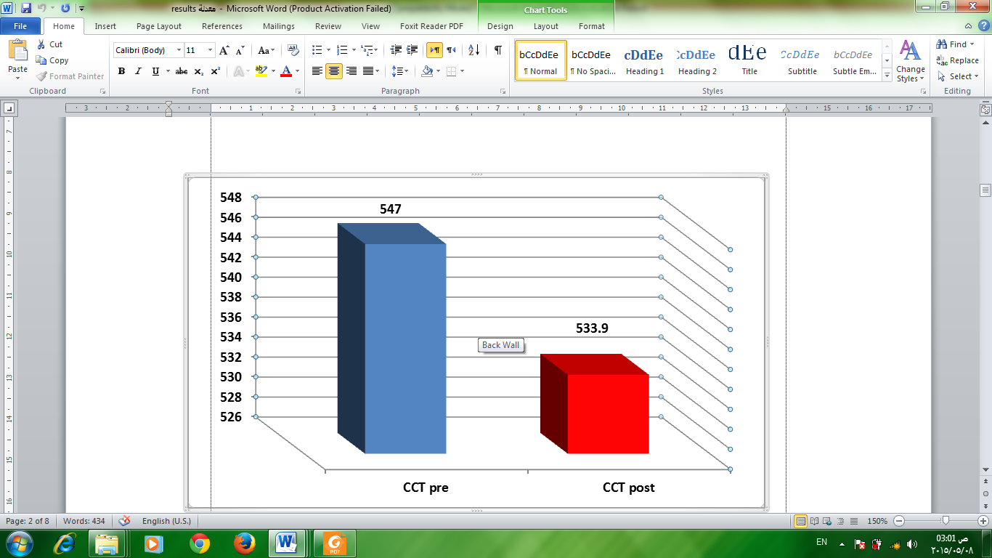

**Figure (1) Comparison between CCT before and after operation.**

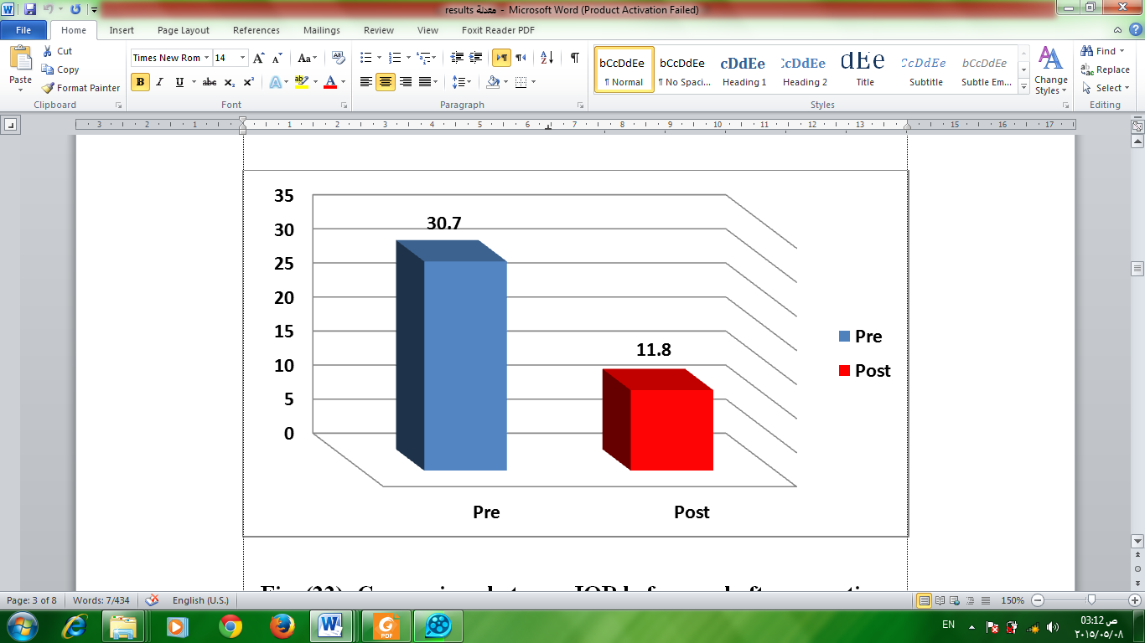

**Figure (2) Comparison between IOP before and after operation.**

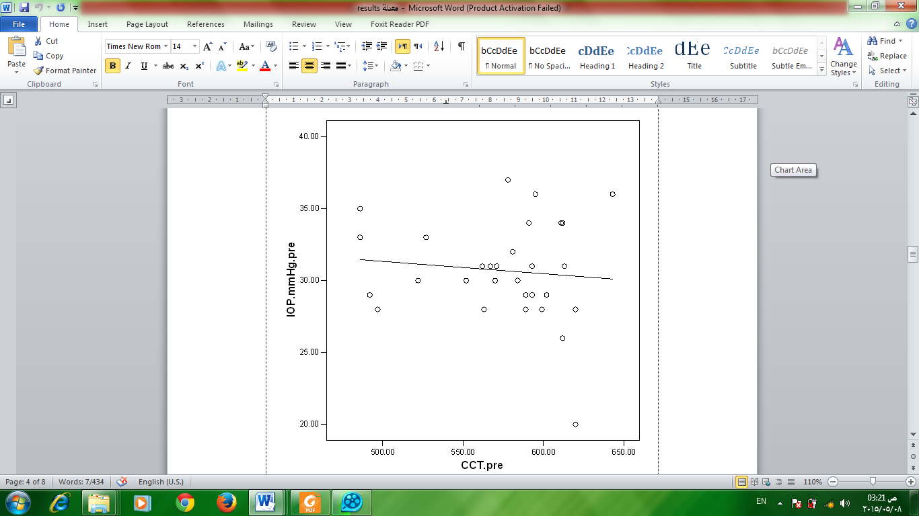

**Figure (3) Correlation between CCT and IOP before operation.**

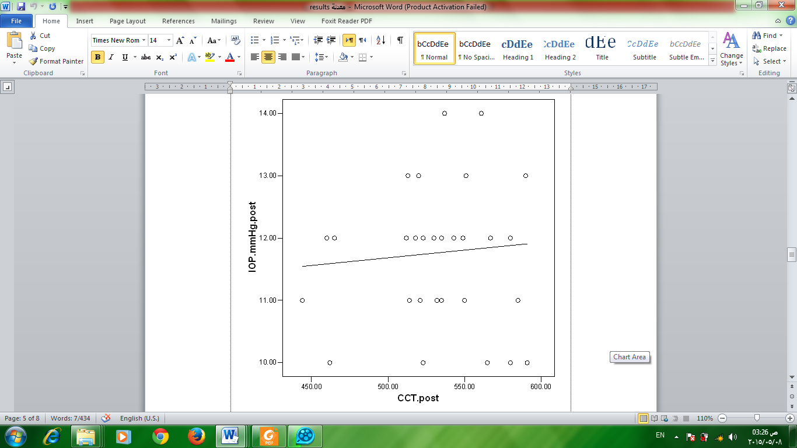

**Figure (4) Correlation between CCT and IOP after operation.**



**Figure (5) Correlation between the decrease of CCT and the decrease of IOP after operation.**

Our study showed that there was no significant correlation between the decrease of CCT and the decrease of IOP after operation (*p*>0.05, r= -0.139) regarding IOP data obtained with local anaesthesia and sedation (Table 5).

In our study the decrease of CCT level after operation showed a positive significant correlation with the preoperative CCT (*p*-value< 0.01, r =0.87).

The decrease of IOP level after operation showed a positive significantcorrelation with the preoperative IOP (*p*<0.05, r=0.43).

**4.Discussion**

Little is known so far about the relation between IOP and CCT in young children with childhood glaucomas. Ultrasound measurements of the CCT mostly can be taken easily without sedation or anaesthesia, even in very young children [5].

This study included 18 males and 12 females, with male predominance 60%. Fung *et al.* (2013) [6] and Oberacher-Velten *et al.* (2008) [5] confirmed that there was a male predominance in primary congenital glaucoma cases.

In our study there was statistically significant reduction in CCT after operation. The mean initial CCT was 547 μm before operation and decreased to 533.9 μm after operation with(*P*< 0.01). These results are in agreement with that of Jordan *et al.* (2005) [7] and Oberacher-Velten *et al.* (2008) [5] who reported that the mean initial CCT was 651.3±138μm before trabeculotomy and decreased to 592.3±119.7 μm after trabeculotomy.

In our study there was statistically significant reduction in IOP after operation. The mean initial IOP was 30.7 mmHg before operation and decreased to 11.8 mmHg after operation with (P< 0.01). Oberacher-Velten *et al.* (2008) [5] reported that Mean IOP was 18.6±7.5 mmHg before and decreased to 14.8±5.8 mmHg after glaucoma surgery. Moreover,Zhang *et al.* (2009) [8]reported thatthe mean IOP in all patients declined dramatically after the procedure (31.70 ±9.16 mmHg preoperatively and 19.22 ±8.67 mmHg postoperatively; ***P*=0.000**).Ross *et al.* (2011) [9] reported that there was a statistically significant reduction in both mean IOP (*p*=0.002) and peak IOP (*p*=0.025) following trabeculectomy.

Our study showed no significant dependence of CCT on IOP values measured with local anaesthesia and sedation before and after operation with *p*-value(> 0.05). These results are in agreement with that of Oberacher-Velten *et al.*(2008) [5]who reported that regarding the IOP data measured without general anaesthesia, a regression analysis showed no significant dependence of CCT on IOP values.

Our study showed that there was no significantcorrelation between the decrease ofCCT and the decrease of IOP after operation (*p*-value >0.05, r= -0.139) regarding IOP data obtained with local anaesthesia and sedation. These results are in agreement with that of Oberacher-Velten *et al.*(2008) [5]who reported that regarding IOP data obtained under general anaesthesia, decrease of CCT was significantly correlated with decrease in IOP.

There is a high variability of IOP measurements taken without sedation or anaesthesia. To exclude errors due to this variability, only IOP values taken under same conditions were included [10].

Muir *et al.* (2006) [11] studied racial differences of CCT in children, and correlated those values with applanatory measured IOP values. They found a positive relationship between increasing measured IOP and CCT among children with normal corneas and anterior segments.

Novak-Stroligo *et al.* (2011) [12] reported that in congenital glaucoma group mean central corneal thickness was 513±23 micrometers. In control group result for mean central corneal thickness was 535±27 micrometers. The mean pachymetry values in group with congenital glaucoma was significantly lower than in control group (*p*<0.05). Thinner cornea may be caused by corneal distension which happens in early stage of congenital glaucoma. Lower central corneal thickness values results in lower tonometrically recorded intraocular pressure so it need to be measured and intraocular pressure has to be corrected according to CCT measurements. Also, lower central corneal thickness values should be taken as a part of examination in congenital glaucoma diagnostics.

Patel *et al.* (2013) [1] reported that CCT should be routinely taken into consideration as part of the comprehensive eye exam while measuring IOP, as knowledge of an individual's CCT provides valuable information about the accuracy of IOP status.

From this study, we cannot conclude whether the non significant relation between the central corneal thickness and intraocular pressure is only caused by equipment measurement errors or because of the variation in the central corneal thickness. The measured intraocular pressure can be underestimated or overestimated than the actual hydrostatic intraocular pressure.

**Conclusion**

Regarding IOP data obtained with local anaesthesia and oral sedation we cannot depend on central corneal thickness as an independent parameter to monitor the follow up of childhood glaucoma cases after surgery. Thus, further studies have to investigate the role of CCT as an additional parameter in congenital glaucoma in more patients at various ages.

**Funds**

No funds from governmental or non-governmental authorities.The authors declared clearly no conflict of interest.

**Corresponding author**

Dalia Abbas Ahmed Nagy,

Address: Ophthalmology Department, Faculty of Medicine, Menoufia University**,** Egypt.

E.mail: [drdalianagy@yahoo.com](mailto:drdalianagy@yahoo.com)

**References**

1. Patel DP, Brahmbhatt JN, Kothari RN, Kumar P, Solanki D, Sharma D. Importance of pachymetry in diagnosis of open angle glaucoma. National Journal Of Medical Research 2013; 3: 216–218.
2. Okorie AY,Madu AA. Diagnosis and treatment of primary congenital glaucoma.Eye Net, American Academy of Ophalmology 2010.
3. Bolivar G, Moreno-Arrones JP, Teus MA. Cornea and Glaucoma. In Tech Journals (Chapter 11) 2013.
4. Touboul D, Roberts C, Kerautret J, Garra C, Maurice-Tison S,Saubusse E. Correlations between corneal hysteresis, intraocular pressure, and corneal central pachymetry. J Cataract Refract Surg 2008;34: 616–22.
5. Oberacher-Velten I, Prasser C, Lorenz B. Evolution of central corneal thickness in children with congenital glaucoma requiring glaucoma surgery. Graefes Arch Clin Exp Ophthalmol 2008; 246: 397–403.
6. Fung DS, Roensch MA, Kooner KS, Cavanagh HD, Whitson JT. Epidemiology and characteristics of childhood glaucoma: results from the Dallas Glaucoma Registry. Clinical Ophthalmology 2013; 7: 1739–1746.
7. Jordan JF, Dietlein TS, Dinslage S,Krieglstein GK. New aspects of corneal pachymetry in congenital glaucoma and pediatric aphakic glaucoma. Klin Monatsbl Augenheilkd 2005; 222: 883–887.
8. Zhang X, Du S, Fan Q, Peng S, Yu M, Ge J. Long-term surgical outcomes of primary congenital glaucoma in China. Clinics 2009; 64: 6.
9. Ross AH, Jackson TE, Wertheim MS, Spry PG, Sparrow JM, Diamond JP. Analysis of the diurnal intraocular pressure profile pre and post trabeculectomy using 24-hour monitoring of intraocular pressure. Eur J Ophthalmol 2011; 21: 400-3.
10. Sator-Katzenschlager S, Deusch E, Dolezal S, Michalek-Sauberer A, Grubmüller R, Heinze G, Wedrich A. Sevoflurane and propofol decrease intraocular pressure equally during non-ophthalmic surgery and recovery. Br J Anaesth 2002; 89: 764–766.
11. Muir KW, Duncan L, Enyedi LB, Freedman SF. Central corneal thickness in children: Racial differences (black vs white) and correlation with measured intraocular pressure. J Glaucoma 2006; 15: 520–523.
12. Novak-Stroligo M, Alpeza-Dunato Z, Kovacevice D, Caljkusic-ManceT. Corneal Thickness in Congenital Glaucoma. Coll Antropol 2011; 35: 305–306.

6/13/2015