**Endometrial Biopsy with Pipelle Versus Diagnostic Dilatation And Curettage In Abnormal Uterine Bleeding**

Mona Al Sayed Elkafrawy1; Shaimaa Sh. Abu Seadah2 and Samah M. Attiah3

1Department of Obstetrics and Gynecology, Faculty of Medicine, Al Azhar University for Girls, Cairo, Egypt

2Department of Pathology, Faculty of Medicine, Al Azhar University for Girls, Cairo, Egypt

[isia992018@yahoo.com](mailto:isia992018@yahoo.com)

**Abstract: Background and Objectives:** This study was done to compare endometrial sampling by pipelle endometrial curette with endometrial sampling by curettage (D& C) in patient with abnormal uterine bleeding. **Methods:**Sampling from the endometrial with pipelle curette was performed on fifty patients followed by D&C endometrial biopsy under general anesthesia both samples were sent to a histopathologest who was blinded as to the method of sampling. The histopathology reports of results of both samples were compared. **Results:**This study was done on fifty patients, six with endometrial hyperplasia (12%), five patients with hyperplasia with atypia (10%) and one of them with endometrial carcenoma (2%). The sensitivity, specificity, positive predictive value and negative predictive value of the samples were taken by pipelle was 100% for diagnosing endometrial carcinoma, hyperplasia and secretory endometrium. For endometrial hyperplasia with atypia the sample had 100% sensitivity, negative predictive value, and 98% specificity. While in endometritis pipelle had low sensitivity and positive predictive value about (57%) but high specificity and negative predictive value (97%). Also similarly for proliferative endometrium, the pipelle device had (94%) and (93%) for sensitivity, specificity respectively. No statistically difference between pipelle and D&C in diagnosis of abnormal uterine bleeding by histopathological examination. **Conclusion**: The pipelle is a safe technique of endometrial biopsy for getting an adequate endometrial sample for histopathology, with high sensitivity and specificity for endometrial hyperplasia and endometrial carcenoma.

**[**Mona Al Sayed Elkafrawy; Shaimaa Sh. Abu Seadah and Samah M. Attiah. **Endometrial Biopsy with Pipelle Versus Diagnostic Dilatation And Curettage In Abnormal Uterine Bleeding.** *Nat Sci* 2015;13(6):69-74]. (ISSN: 1545-0740). <http://www.sciencepub.net/nature>. 11

**Keywords:** abnormal uterine bleeding – curettage, endometrial sampling, pipelle, uterine bleeding.

**1. Introduction**

Abnormal uterine bleeding accounts for more than 70% of all gynecological consultations in the peri and postmenopasual years (1).The bleeding could be a sign of an underlying localized condition including infection, benign and malignancy. Endometrial cancer and premalignant hyperplasia are likely causes of abnormal uterine bleeding

. Main aim of investigations for abnormal uterine bleeding is to exclude intrauterine pathology, particularly endometrial cancer. More than 9% of patients with endometrial carcinoma present with irregular or post menopausal bleeding. However only 20% of patients with postmenopausal bleeding will not have any significant pathology as a cause of their bleeding.(2)

Endometrial carcinoma is the most common malignancy of the female genital tract in U.K. (3). Developing countries and Japan has the incidence rate four to five times lower than western industrialized nations with the lowest being in India and south Asia. Any factor that increases exposure to unopposed oestrogen increases the risk of this cancer. Screening for endomtrial carcinoma or its precursors (hyperplasia) is justified for certain high risk women(4).

Dilatation and curettage (D&C) is the gold standard for endometrial sampling, but 60% of cases less than half of the uterine cavity is curetted, with the added risk of general anesthesia, infection and perforation(3).

This has led to the advent to new and simple methods for endometrial sampling (5). These method are commonly used interfiary gynecological care and more recently have been successfully introduced in primary care a large number of various out patient endometrial sampling procedures are available currently such as accurette, gynoscann, Novak curette, pipelle, Verba aspiration, Z sampler (5). But our focus is on endometrial biopsy by pipelle. The pipelle is a thin plastic tube 3 mm in diameter and is the most convenient, best tolerated and least expensive outpatient endometrial sampling procedure. Pipelle samples only 4% of the endometrial surface and has a sensitivity of 67-97% office endometrial biopsy can often expedite appropriate evaluation and therapy and most cases can be performed instead of D&C. Pipelle is devoid of serrated teeth and because of its flexibility usually does not require a tenaculum or straightening of cervical fundus axis(6). Pipelle does not require a syringe or pump nor require general anesthesia or cervical dilatation and permits almost painless endometrial sampling (7).

**2. Material and Methods**

This study was conducted at Alzahraa University Hospital starting from March 2013 to April 2014, fifty patients 40 years of age and over, presented with abnormal uterine bleeding attending at the hospital were enrolled in this study after providing informed consent to all participant, then personal history, obstetric history and past history in the form of (DM, hypertension or cardiac disease)were taken . Examination in the form of general, abdominal and local examination (vaginal examination to the uterus cervix and vagina). Ultrasound was done to detect uterine size, endometrial thickness, uterine polyp or fibroid and any abnormalities in the cervix or the uterus . Laboratory investigations (CBC, coagulation profile, prolacten thyroid and liver functions tests). Patients with local gynecological cause or possibility of pregnancy or history of contraception ,hormonal treatment or endometrial thickness < 4 mm were excluded from the study 50 patients were included in this study with normal liver function tests, normal activated partial thromboplastin time (APTT) and normal platelet count. The endometrial sampling was performed by pipelle device in the theater room prior to the anesthesia .The patient put in the lithotomy position then complete sterilization, the pipelle was introduced in the uterus without cervical dilatation and with drawn outside the uterus with a rotatory movement to get the sample ,then the sample put in the container with formalin. Then anesthesia was taken and D&C biopsy was taken under general anesthesia the sample put in anther container with formalin .Both samples were sent to the pathologist. The histopathological examination was done as follow, one section five micron thickness was cut and stained by hematoxylin and eosin stain for histopathological examination.

**Tissue processing overview:**

Ideally, fixation by formalin 10% will be carried out as soon as possible after removal of the tissues, thus preventing autolysis. Fixed tissue is too fragile to be sectioned and must be embedded first in paraffin. The tissue must be dehydrated through a series of ethanol solutions (alcohol 70% for 3 hours, alcohol 90% for 3 hours and alcohol 1000% for 6 hours). Ethanol is not miscible with paraffin, so nonpolar solvent (xylene) is used as clearing agent; this also makes the tissue more translucent. Tissue can be sectioned at anywhere from 3 to 10 μm (routine sections are usually cut at 5 μm). The 5 micron section is stained with hematoxylin and eosin stain which allow for differentiation of the nuclear and cytoplasmic component of cells as well as the intercellular structure of the tissue. The stained section on the slide is covered with a thin piece of plastic or glass to protection the tissue from being scarted, to provide better optical quality for viewing under the microscope, and to preserve the tissue section for years. The histopathology reports of the pipelle sample was compared with that of D&C sample.

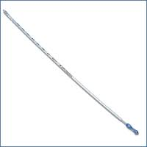

**Figure 1: Pipelle curette shape.**

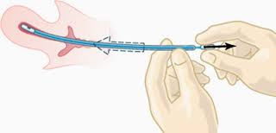

**Figure 2: Route of insertion of pipelle and curettage.**

**3. Results**

The mean age of the studied population was 44.5 years and medium age of menarche was 13.5 years, while the mean parity was 3.5. The median endometrial thickness was 11 cm, (Table 1) the patient in this study presented by menorrhagia (n=15), polymenorrhia (n=5), metrorrhagia or irregular uterine bleeding (n=20) and postmenopousal bleeding (n=10).

The types of endometrial lesion according to pathology reports consisted of secretory (14%) proliferative endometrium (54%), endometrial hyperplasia 12%, hyperplasia with atypia (10%) and endometrial carcinoma (2%) (Table 3).

**Table (1): Descriptive analysis data of the studied groups.**

|  |  |  |
| --- | --- | --- |
|  | **Median** | **Range** |
| **Age** | 44.5 | 40-49 |
| **Age of menarche (years)** | 13.5 | 12-15 |
| **Parity** | 3.5 | 1-6 |
| **BMI** | 28.54 | 24-33 |
| **Endometrial thickness (mm)** | 11 | 10-12 |

**Table (2): Range of medical disorder in the studied groups.**

|  |  |  |
| --- | --- | --- |
|  | **No.** | **Incidence** |
| **Diabetes mellitus** | 10 | 20% |
| **Hypertnesion** | 20 | 40% |
| **Cardiac Disease** | 5 | 10% |

**Table (3): Comparison between endometrial biopsy was taken by D&C and pipelle device as regard histpathology examination.**

|  |  |  |
| --- | --- | --- |
| **Report of histopathology** | **Pipelle biopsy** | **D&C biopsy** |
| **Endometritis** | 3(6%) | 4(8%) |
| **Endometrial polyp** | - | 1(1%) |
| **Endometrial hyperplasia** | 6(12%) | 6(12%) |
| **Secretory endometrium** | 7(14%) | 7(14%) |
| **Proliferative endometrium** | 27(54%) | 27(54%) |
| **Endometrial hyperplasia with atypia** | 5(10%) | 4(8%) |
| **Endometrial carcinoma** | 1(2%) | 1(2%) |
| **Inadequate biopsy** | 1(2%) | - |



**Figure 3: Comparison between endometrial biopsy was taken by D&C and pipelle device as regard histpathology examination.**

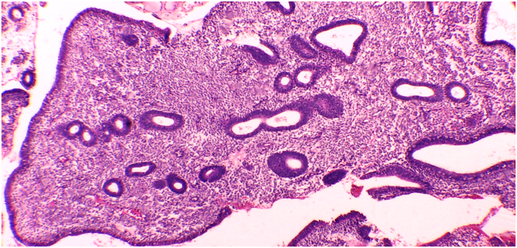

**Figure 4:** Endometrial polyp with glandular epithelium lining. The endometrial glands are lined by low columnar to cuboidal epithelium and surrounded by abundant stroma (Original magnification).

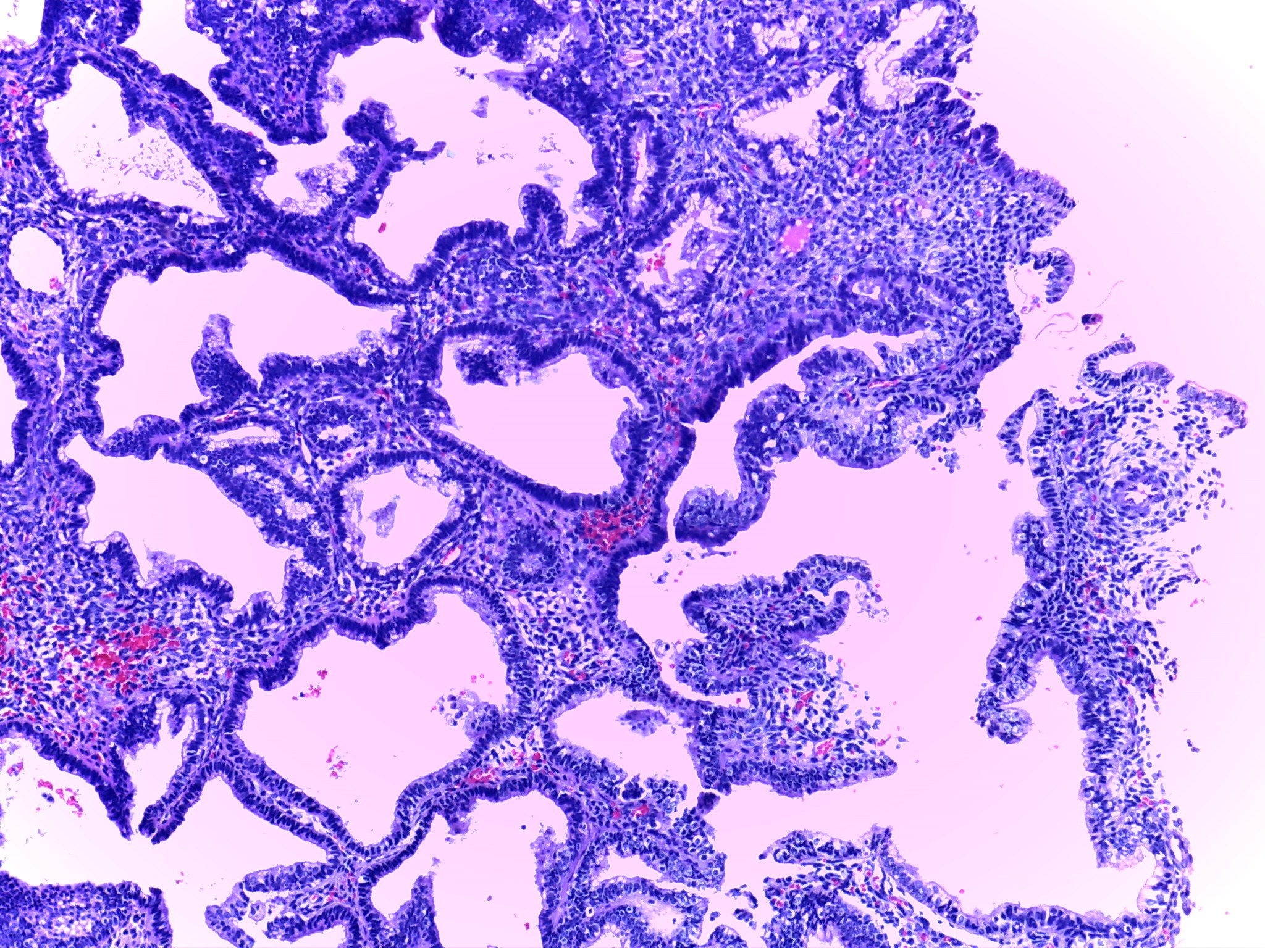

**Figure 5:** Complex endometrial hyperplasia with atypia displaying haphazardly arranged irregular branching glands lined by cells with atypical nuclei surrounded by minimal stroma (Original magnification).

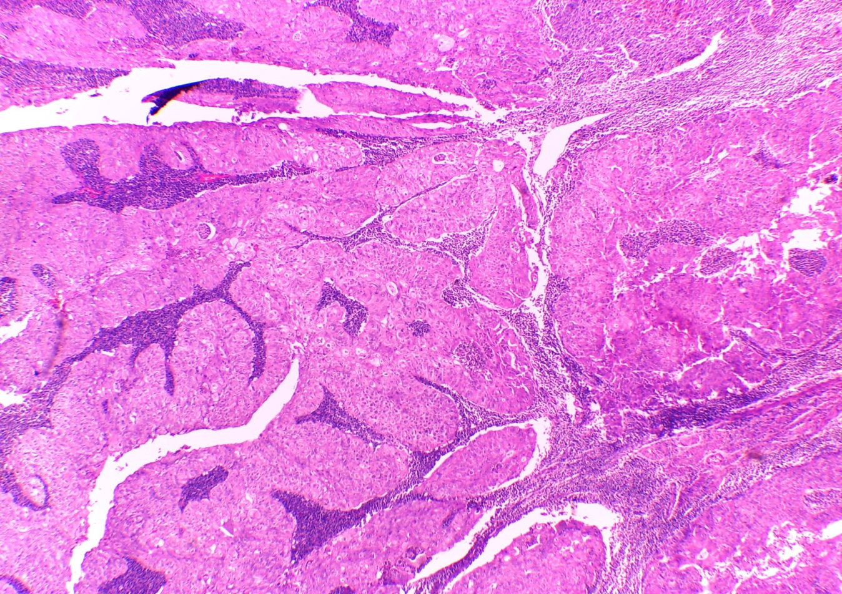

**Figure 6: Endometrial adenocarcinoma endometrioid type GII showing complex papilloglandular growth with cribriform architecture and back-to back glands without intervening stroma. Solid areas could be seen. The cells show moderate cytologic atypia (Original magnification).**

**Table (4): The sensitivity, specificity, predictive values and accuracy of histopathological examination of biopsy taken by pipelle device.**

|  |  |  |  |  |  |
| --- | --- | --- | --- | --- | --- |
| **Variable** | **Proliferative endometrium** | **Secretory endometrium** | **Endometrial hyperplasia** | **Endometritis** | **Endometrial carcinoma** |
| **Sensitivity** | 94% | 100% | 100% | 57% | 100% |
| **Specificity** | 93% | 100% | 100% | 97% | 100% |
| **PPV** | 80% | 100% | 80% | 57% | 100% |
| **NPV** | 93% | 100% | 100% | 97% | 100% |
| **Accuracy** | 100% | 100% | 100% | 93.8% | 100% |

Proliferative endometrium was the most common finding on histopathology (54%) indicating an ovulation as the leading cause of abnormal uterine bleeding.

In this study; the pipelle device had 100% sensitivity, specificity and predictive values for diagnosing endometrial hyperplasia, endometrial carcinoma, proliferative and secretory endometrium, also it had (88.9%) sensitivity 100% specificity, positive predictive value (PPV) and (99.2%) negative predictive value (NPV) for diagnosing endometritis, while, it had 60% sensitivity, 100% specificity, PPV and 89.6% NPV for diagnosing endometrial polyps (Table 4).

This study show that, pipelle device histopathology was 100% accurate for diagnosing endometrial hyperplasia, endometrial carcinoma, proliferative and secretory endometrium, also it was 99.3% accurate for endometritis and 98.6% accurate for endometrial polyps (Table 4).

The inadequate sample when no endometrial tissue was present in the specimen sent to the histopathologist about one sample(2%)in this study by pipelle as in (Table 3).

**4. Discussion**

Abnormal uterine bleeding is a major gynecological problem, accounting 33% of outpatient referrals, including 69% of referrals in the perimenopausal and postmenopausal age groups (8).

The main cause for performing endometrial biopsy is to confirm histopathology of the endometrial sample if benign or malignant nature of the endometrial biopsy, so that medical treatment or conservative surgery can be offered and unnecessary radical surgery can be avoided. Endometrial sampling by means of pipelle biopsy is a minimally invasive comparable to sample performed by dilatation and curettage or by hysteroscopy and curettage. The study was conducted to evaluate the efficacy of pipelle in endometrial biopsy. As the pipelle does not usually require anesthesia or cervical dilatation due to small diameter and flexibility the procedure was well tolerated and was acceptable to the patient and can be done as out patient technique. While D/C is an invasive in patient procedure performed under general anesthesia. Pipelle device is used as out patient non invasive method gives adequate endometrial sample increases when central endometrial thickness is more than 5 mm(9), this why patient with endometrial thickness < 4 mm were excluded from the study. The sample obtained by pipelle device were adequate for histopathological examination in 79.9% for the purpose of maintaining synchronicity in the lining of the sample, the pipelle method was performed at the time of D&C but otherwise it is an outpatient procedure that can be performed without anesthesia, analgesia, or premedication in the same setting and at the same time as pelvic examination.

The result of this study shows that out patient endometrial biopsy was taken by pipelle device had a sensitivity and specificity of 100%of endometrial carcinoma which was confirmed by D/C biopsy so that the sensitivity of the pipelle for detection of malignancy had 100% sensitivity for postmenopausal women with malegnancy. Also positive predictive value 100%, and negative predictive value 100% for endometrial, hyperplasia, proliferative endometrium and secretory endometrium. Other studies have also shown that pipelle and D&C biopsy produced the same results in detection of endometrial pathology (10). According to Bakour *et al.*(11) 95.5% of patients had an adequate sample, 4% had inadequate sample with 1.4% ending as failed sample. In that study the failed samples were in postmenopausal women, heavy vaginal bleeding and cervical stenosis. While in our study only one patient (2%) had inadequate sample in patient with uterine polyp. The case diagnosed by pipelle in our study as endometrial carcinoma were confirmed by D&C and both in postmenopausal women. Sawar and Haque in there study have also 2% detection rate for endometrial carcinoma(12).

So that the pipelle technique is the best technique when compared to other endometrial sampling techniques for detection of endometrial carcinoma and atypical hyperplasia(13).

In this study the case of inadequate biopsy by pipelle was with polyp biopsy and no case of endometrial carcinoma was missed.

This study shows that a low sensitivity (57%) but high specificity (97%) so pipelle is a good device for diagnosing malignant and hyperplasia with or without atypia as compared to benign disease, which was also reported in a study by Clark and colleagues(13).

In this study no procedure failure or operative complication (pre-or postoperative)with pipelle procedure, the cast per case was more in D&C than pipelle device. Thus, in view of this results the reported high sensitivity and specificity of pipelle(14). It is suggested this device should replace the traditional method of endometrial sampling by D&C as it is out patient procedure, avoids general anesthesia and its associated complications, pipelle procedure does not require operative room, staff of anesthesia as less painful and less cost.

**Conclusion**

The pipelle device technique should be replaced by the traditional method of endometrial sampling by D&C. Pipelle technique is an out patient procedure no anesthesia was need and no associated complications, less painful and cost. There is need to bring this procedure at Al Zahraa University Hospital to done to all patient with abnormal uterine bleeding.

**Corresponding author:**

Dr. Mona Al Sayed Elkafrawy

E-mail: [Drsaad53@yahoo.com](mailto:Drsaad53@yahoo.com)

**References**

1. Spencer CP and Whitehead MI (1999): Endometrial assessment re-visited. Br J Obstet Gynecol.; 106(7):623-32.
2. Gorman TO and Holling Growth T (2008): Postmenopausal bleeding. In: Dunlop W, Ledger WL, editor: Recent advances in obstetric and gynecology. 24th ed UK: Royal Society of Medicine Press Ltd, P: 245-58.
3. Behnamfar F, Khamehchian T, Mazoochi T, *et al.* (2004): Diagnostic value of endometrial sampling with pipelle suction curettage for identifying endometrial lesions in patients with abnormal uterine bleeding. J Res Med Sci; 3: 123-5.
4. Berek JS and Hacker NF, editors (2000): Practical gynecologic Oncology. 3rd ed. Philadelphia: Lippincott Williams and Wilkins.
5. Fakhar S, Saeed G, Khan AH, *et al.* (2008): Validity of pipelle endometrial sampling in patients with abnormal uterine bleeding. Ann Saudi Med.; 28(3):188-91.
6. Rock JA, Howard W and Jones HW 3rd, editors (2003): Te Linde’s Operative gynecology. 9th ed. Philadelphia, Pa: Lippcintt Williams & Wilkins.
7. Guido RS and Stovall DW (2008): Endometrail sampling procedure, up to date (online serial). In Wathan MA. Up to date.
8. Goldenstein SR (2010): Modern evaluation of endometrium. Obstet Gynecol; 116: 168-76.
9. Polena V, Mergui JL, Zerat L, *et al.* (2007): The role of Pipelle Mark II sampling in endometrial disease diagnosis. Eur J Obstet Gynecol Reprot Biol.; 134(2):233-7.
10. Chaudry A and Javaid M (2005): clinical usefulness of pipelle endometrial sampling Pak Armed Forces Med J; 55: 122-125.
11. Bakour SH, Khan KS, Gupta JK (2000): Transvaginal ultrasonography and endometrial histology in peri and post menopausal women in hormone replacement therapy. Br J. Obstet Gynecolgy 107:296.
12. Clark TJ, Mann CH, Shah N, *et al.* (2001): Accuracy of outpatient endometrial biopsy in the diagnosis of endometrial hyperplasia. Acta Obstet Gynecol Scand.; 80(9):784-93.
13. Dijkhuizen FP, Mol BW, Brolmann HA, *et al.* (2000): The accuracy of endometrial sampling in the diagnosis of patients with endometrial carcinoma and hyperplasia: a meta-analysis. Cancer. 89(8):1765-72.
14. Huang GS, Gebb JS, Einstein MH, *et al.* (2007): Accuracy of preoperative endometrial sampling for the detection of high-grade endometrial tumors. Am J Obstet Gynecol.; 196(3):243 e1-5.

5/25/2015