Yarsa Gambu: The Changing Business Scenario of Rang Society

Rakesh Singh Phakaliyal¹, Shobha Rawat²*

¹ Department of History, Kumaun University, S.S.J. Campus, Almora
² Department of Botany, Kumaun University, S.S.J. Campus Almora
*Corresponding author e-mail – shobharawat1981@gmail.com
Mob. – 09450369320, 9450675466

Abstract- Animal husbendry, agriculture, trade, manufacture of various crafts, tourism and woolen garments etc have been the major source of livelihood of the tribals of Rang Society. But the one business, which has arisen out of exploitation of the Yarsaa-gambu in the high snow covered areas of Dharchula, has completely changed the situation. This has become alternative to all other for the people of the region. Their conventional source of earnings have become secondary and in fact started depleting. The new business is giving very high returns with much less labor input and hardship. Earlier the people of the area had to struggle hard for 6 months to earn livelihood for the year now this new business is giving them very high returns in 3 months only which is more than adequate for the entire year. On one hand this new business arising out of Yarsaa-gambu exploitation in the region has made their life better and easy but at the same time because of large scale human activities engaged in exploitation of the Yarsaa-gambu in the entire alpine region, has affected the environment adversely. It is, therefore, considered important that the people of the area should realize that they should take all possible measures to protect the nature.
[Rakesh Singh Phakaliyal, Shobha Rawat. Yarsa Gambu: The Changing Business Scenario of Rang Society. Nat Sci 2015;13(6):29-33]. (ISSN: 1545-0740). http://www.sciencepub.net/nature. 4

Keywords: Scheduled Tribe, Rung Society, Yarsa gambu, Uttrakhand

Rang Society
The tribes in the snow covered areas of Himalayan near Indo- Tibbet border of Uttarakhand of India are known as Bhotia tribes. The name Bhotia is derived from Bhot and Bhot is region which falls in the Himalayan region near Tibet border of Uttarakhand Therefore, the tribes of this area are called Bhotia. The entire region is very cold during winters and experience havy snowfall. The Bhotia tribes of Dharchula tehsil of Pithoiragarh district Uttarakhand are also called Shauka. These Shauka are original inhabitant of India (Raypa 2015). Shauka Tribal population is concentrated in three valleys of Dahrchula tehsil of Pithoragarh District namely Darma, Vyas and Chaudas. The habitants of all these three valleys are quite similar socially and culturally. Their living standard, food habits, dresses, profession, traditions and nomadic life style are quite same. The entire areas of these three valleys are covered with snow in the winter season during November to March and therefore living is not possible during this period. They migrate to the relatively much lower altitude during this snow season. Predominantly all the inhabitants migrate to Dharchula area. They return to their habitation (villages) during summer season starting from April to October every year. This is the reason the tribal’s are constrained to live like nomads. The Shaukas have much harder life as compared to the Bhotia tribes of Garhwal region. There are very poor connecting transport facility of the tribal belts of Darma, Vyas and Chaudas. The inhabitants of this region are required to travel on tracking to reach their place and some time they have to travel 2 to 3 days on tracking to reach their destinations. The life they live is quite hard and full of struggle. It is quite strange that on the one hand the road, transport and medical facility has reached every place, on the other hand the scenario has not changed in these tribal belts. These people have to travel long distances on tracking even today and some time it takes 2 to 3 days to reach to the destination. The life of these tribes is full of struggle but even then they are able to live life easily. This is what distinguishes them from the rest and that is what that the society is known for.
The Nomadic Life Style Of Rang Society And Their Business
The people of Rang society have to live a nomadic life because of geographical and climatic condition of the area they habitat. Their source of earning is quite limited because there are poor infrastructures. They generally earn their livelihood from agriculture, trade, animal husbendry with Tibbet and marketing of various goods like the tribal crafts and services including porter services at times.
Marketing:
The marketing in hilly terrain is extremely difficult. The movement of goods and services is very difficult due to valleys and high rising peaks in the hilly terrain, rough road conditions obstructed by deep lakes, ponds, rivers and small streams all over the places. In such conditions and circumstances the marketing of various goods and services becomes quite complex and difficult. Therefore, it necessitated the creation of marketing centers at various convenient locations where people come from various places of the region and trade the various goods and at times through barter system where the goods are exchanged for different goods. The fair at various locations in the districts is the outcome of such a need. The fairs at Jauljeevi, Bageshwar, Gauchar and Thal are favorite fairs for Bhotias. At these places the Bhotias are able to sell and market their woolen and other crafts. These places also provide them opportunity to buy the raw material for their craft business. In addition these fairs also provide them opportunity to buy the articles for their need.
Transportation
As we know that the tourists going to Lipu Lake, Chota Kailash and Kailash Mansarovar use the pedestrian route of this area. For this various animals like horses, mules, yalks, sheeps, goats are used for transportation of goods and carrying passengers/tourists for their various destinations (Pangti 1992). The entire region is full of difficult hilly and huge rocky terrain with high rising snow covered peaks and deep valleys, rivers, lakes ponds, waterfalls and difficult route conditions. All these conditions have made the inhabitants of the area courageous and fearless. The people of this area also work as carrier of goods and services. One can easily find a well built healthy men and women working as porters and coolies. The terrain in this region is so difficult that even the goods being carried by the animals take a journey of six mile a day (Dhir 1992).
Trade With Tibet
The kind of means of transportation used by the Bhotia tribes for the trade is indicative of its type and size of the business. The kind of transportation possible to be used for trading by the Bhotia tribes for trade with Tibet puts limitation on the volume of trade despite the fact that that there is more demand and scope. Various difficulties in the hilly terrain and high altitude locations are major impediments in transportation of goods which ultimate limit and restrict the in trading. Prior to 1962, the Bhotia tribal were actively engaged in trading with Tibet. This has come to an end after Indo-China War in 1962 (Bainjwal 2002, Pangti 1992). As a result the entire tribal population of the area became fully dependent on business arising out of animals and agriculture.
Industry
The men folk of the Bhotia tribes are generally busy with trade with Tibet and sub Himalayan region at the same time the women folk the tribe while staying at home provide good support to the family by engaging them in the woolen craft activities. Every tribal house is a small cottage industry. They have very good skills for spinning wool to make threads and then knit clothes out of that. The women folk are able to make very good woolen clothes while at home. The Goats, sheeps and mules are the major means of transportation of goods in the hilly terrain. The raw material for their woolen craft industry at home is largely taken from the sheeps and goats. Wool is also purchased from the markets in Tibet where they go for trading. The Bhotia people are often found having large number of sheeps and goats. Their life is largely dependent on these animals. These animals are not only the carrier of the goods for their trade but the extra hair taken out of their body is converted to wool which is used to make various clothes and articles of daily use. The long hair of the goat is also used to make long ropes with good strength which can be used for tying the tents and for other purposes. So long these animals are alive they are used for transportation of goods and the extra hair taken out their body are useful making various type of woolen clothes and other useful articles like bags etc. After the death of these animals, their skins and hair are used for making various articles such as floor sheets, bags and various leather articles. In nut shell the animal folk like goats and sheeps and yalks are the basis of their livelihood.
Agriculture – A Secondary Business
Agriculture is based on the geographical and climatic condition of the region. The regions where the Bhotia tribal population exists are not very conducive for agriculture because of the high altitudes, bad soil conditions and extreme cold weather conditions. The pattern of agriculture is quite primitive. One can see small pieces of land for agricultural scattered in the valleys along sides the rivers. These scattered pieces of agriculture land resembles like oasis in the deserts. Only one crop is possible in a year. Potato, mustard, cabbages, turnip, Kotu, faafar, Sau are the main agriculture crops of the region. There is no system of irrigation prevalent in the region. Rain water is the only source of water for the crops (Bainjwal 2002).
Yarsaa gambu-A New Emerging Business
Yarsaa Gambu is a medicinal herb which is found in the soil at alpine region (high hills). This name has been given by the local people of Darma valley. The term has been derived out of combination of four different words of dialect spoken in the region i.e Yar – means high hill, Sa- means earth, Gam- means stone and Bu- means insect. The botanical name of this insect is Cordyceps sinensis (Berk) Saac. It’s a kind of medicinal herb, in fact it a kind of fungi which grows on the body of an insect and found at an altitudes above 3800m from mean sea level. It is very useful for treatment of cancer, respiratory problems, kidney problems and cough.

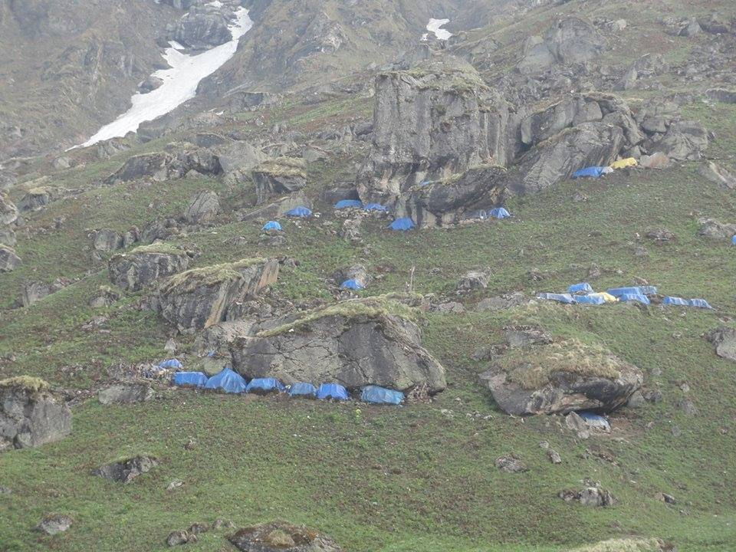
Fig 1 : Camping in alpine region

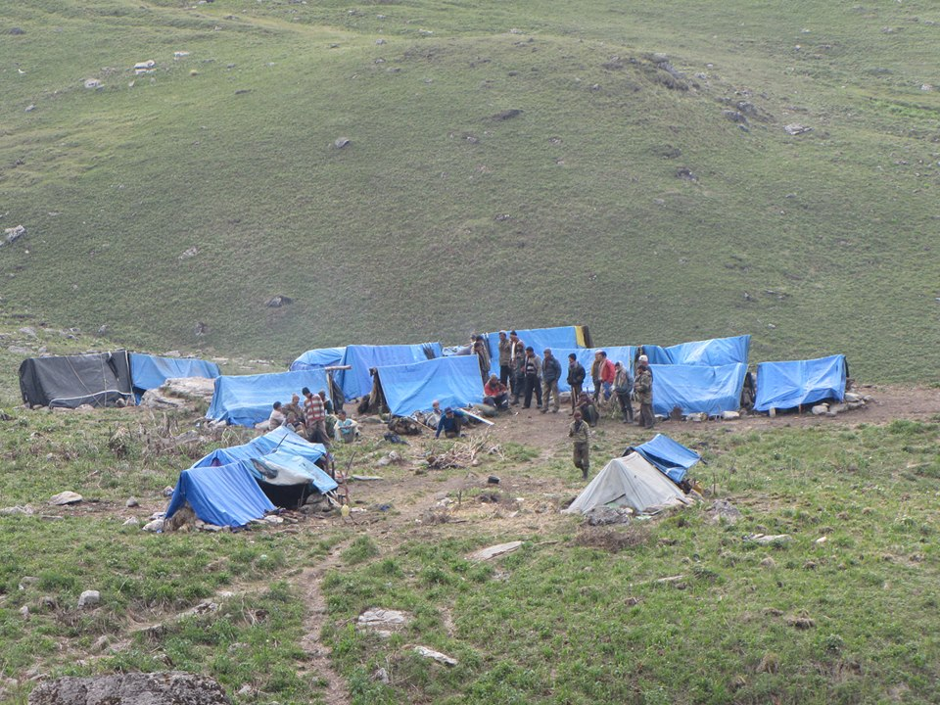
Fig 2: Disturbing to Alpine region

It has very good anti ageing property and increases sex power without any side effects ( Devkota 2006, Mishra and Upadhyay 2011). It is also called Himalayan Viagra. It is brown in clour and has only six months life and after six month it gets mingled with earth. The demand of Yarsaa-gambu is increasing day by day because of its medicinal use. Extensive research work is going on this medicinal herb in our neighboring countries like China, Tibet and Nepal and because of its wide ranging application in pharmaceutical industries, its demand is quite high and the cost is also increasing. This is found in the high altitude snow covered peaks of the hills in Pithoragarh district of Uttarakahand, more prominently in the tribal areas of Dharchula at an altitude of 3800m and above. The tribal’s of Dharchula area of Uttarakhand state have been found engaged in searching and collecting this and in fact it has evolved as their business for earning livelihood. The tribals of the area find it as an opportunity to improve their living standard as it is giving them very high returns as compared to their conventional business. The Dharchula uphill areas are potential source of this medicinal herb called Yarsaa-gambu. It has enormous potential for export to the nearby countries like Nepal, Tibet and China. The researchers of all over the globe are conducting extensive research on this. The tribals of this area from their camps in the high altitude snow covered areas during April to August in search of collection Yarsaa-gambu alongwith all necessary articles for their living food grains, clothings, medicines etc. Some enterprising people have also set up small shops having packed food articles like magi, biscuit, and snacks of different types general medicines at these areas for the benefit of the people. The shop keepers exchange Yarsaa-gambu in lieu of the articles they sell to the people who are engaged in searching and collecting Yarsaa-gambu. A kind of barter trade is in practice. This new business has made the life of tribals of the area easier as they got higher returns in compassion to other conventional business.
In 2014 during 10 day camp, Shri Shekhar Pathak has pointed out that because of collection of Yarsaa-gambu the entire alpine region has become polluted and affecting the environment badly. Seeing the growing demand of Yarsaa-gambu, the people from other areas are also attracted for this business. As a result there is rivalry between the tribals of the area and the people coming from outside the region. The use of various articles like food packets in plastic and other unwanted items in the alpine region has started polluting the environment.
In year of 2007 cost of the yaarsa gambu is 35 Rs per piece now at present per piece cost is almost 65-80 Rs. This increasing price exciting for the explore Yarsa gambu in rung society business. The people of Rang Society have started switching over to this new business of exploitation of Yarsaa-gambu because it is giving them very high return with less labor input as compared to their conventional business. The bad road conditions, lack of proper transport facility, lack of medical and educational facility are the other major reasons which have forced Rang people to switch over this new emerging business called exploitation of Yarsaa-gambu. The rising trend of exploitation of Yarsaa-gambu in the region is getting commercialized in big way. The conventional business of the tribal’s of the region is depleting day by day. In this transformation the environment of the entire alpine area is getting affected adversely. If timely action is not taken by the Government to tackle this situation it would lead to disastrous situation pollution in the entire alpine region.

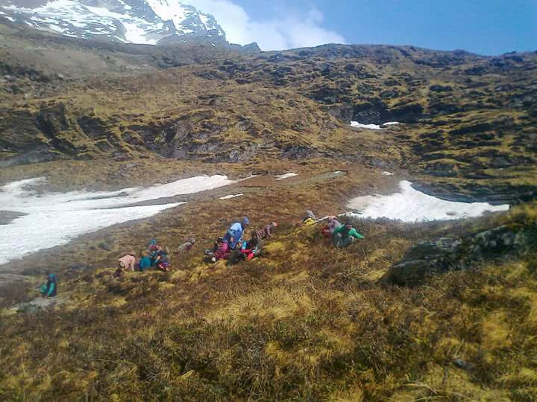
Fig 3: Tribe peoples collecting Yarsa gambu

Conclusion
Animal husbendry, agriculture, trade, manufacture of various crafts, tourism and woolen garments etc have been the major source of livelihood of the tribals of Rang Society. But the one business, which has arisen out of exploitation of the Yarsaa-gambu in the high snow covered areas of Dharchula, has completely changed the situation. This has become alternative to all other for the people of the region. Their conventional source of earnings have become secondary and in fact started depleting. The new business is giving very high returns with much less labor input and hardship. Earlier the people of the area had to struggle hard for 6 months to earn livelihood for the year now this new business is giving them very high returns in 3 months only which is more than adequate for the entire year. On one hand this new business arising out of Yarsaa-gambu exploitation in the region has made their life better and easy but at the same time because of large scale human activities engaged in exploitation of the Yarsaa-gambu in the entire alpine region, has affected the environment adversely. It is, therefore, considered important that the people of the area should realize that they should take all possible measures to protect the nature. The Government should also take all necessary steps in this direction to facilitate the area with good roads, transport facility, medical and educational facilities for the people and also steps to safe guard the nature from ill-effect of this new emerging business arising out of exploitation of Yarsaa-gambu.

References
- Raypa, Ratan Singh (2015) ‘Sauka’ Seemavarti Janjati, pp. 21.
- Pangti, S. S. (1992) ‘Madhya Himalaya ki Bhotia Janjati’ Johar K Sauka’ pp. 39.
- Dheer, K. C. (1947) ‘Kumaun Bhotia Pipuls Fedration’ pp.18-27.
- Bainjwal, Ramakant (2002) ‘Garhwal Himalaya’ pp. 72-73.
- Devkota, S. (2006) Yarsa gambu (Cordisopus cynonsim (Burk) shek: Traditional utilization in Dolpa district Western, Nepal 4:48-52.
- Mishra, R. N. and Upadhyay, Yogesh (2011) Co-disrepairs Cynosan : The Chinese Chemical- Current Research Scenario, International Journal of Research in Pharmaceutical and Biomedical Science 2 (4) 1503-1519.

5/12/2015

