**Study of CD4+CD28 null T cells and its Relation to Atherosclerosis in Chronic Kidney Disease patients (CD4+CD28 null T cells in CKD)**

Ahmed Rabie El Arbagy1, Mahmoud Abd El-Aziz Kora1, Hany Said Elbarbary1, Gehan Abd El-Fatah Tawfeek²and Amera Abd El Hameed Sharaf El Deen1

**1** Department of Internal Medicine, Faculty of Medicine, Menoufia University.

***²*** Department of Clinical Pathology, Faculty of Medicine, Menoufia University.

[Amerasharaf1986@yahoo.com](mailto:Amerasharaf1986@yahoo.com),[HanyElbarbary2004@yahoo.com](mailto:HanyElbarbary2004@yahoo.com)

**Abstract**: **Background:** Chronic kidney disease (CKD), whether starting HD or not is associated with a sharp increase in the risk for cardiovascular disease, which can only be partially explained by known classical risk factors. However, chronic inflammation and endothelial dysfunction are key events in the development of atherosclerosis; both are observed in CKD and HD patients. A unique cytotoxic CD4+T cell population has been identified, which can be recognized by the loss of the costimulatory cell surface marker CD28, hence their name CD4+ CD28null T cells. These cells are highly proinflammatory.**Aims:** The aim of the present study is to determine the prevalence of CD4+CD28 null T Helper cells and its relation to atherosclerosis in CKD patients not starting HD and Patients on regular HD for more than 6 months. **Materials and Methods:**CD4+CD28null T cells were measured in the blood samples of 60 CKD patients (30 CKD patients not start HD (Group ΙΙ) and 30 CKD patients on regular HD more than six months (Group ΙΙΙ) and in comparison with 30 control subjects (Group Ι) (Control Group). ***Results:***The mean value of CD4+CD28null T cells in the control group (1.5±0.49), the mean value in the CKD predialysis group (6.3±1.1) and The mean value in the CKD on HD group (7.5±3.7),thus The mean values of CD4+CD28null T cells in both CKD predialysis and CKD on HD groups were significantly higher than that of the control group (P1<0.001, P2<0.001),and The mean value of CD4+CD28null T cells in the CKD on HD was higher than that of CKD predialysis group, but there was no significant difference between CKD predialysis and CKD on HD groups (P3=0.25).**Conclusions**: CKD patients exhibit an increase in the circulating cytotoxic CD4 +CD28 null T lymphocyte population. CD4+CD28null T cells cell expansion correlated with preclinical atherosclerotic changes. There was an independent association between (CD4+CD28null T cells, age, hsCRP) and IMT in the CKD (predialysis, and on regular HD) groups.

[Ahmed Rabie El Arbagy, Mahmoud Abd El-Aziz Kora, Hany Said Elbarbary, Gehan Abd El-Fatah Tawfeek and Amera Abd El Hameed Sharaf El Deen.**Study of CD4+CD28 null T cells and its relation to atherosclerosis in Chronic Kidney Disease patients (CD4+CD28 null T cells in CKD).***Nat Sci*2015; 13(6):13-21]. (ISSN: 1545-0740).<http://www.sciencepub.net/nature>. 2

**Keywords:** Cardiovascular disease, Atherosclerosis, Inflammation, CIMT, CD4+ CD 28 null T cell, CKD (predialysis or on regular HD).

**Abbreviations**: **CIMT** (carotid intima-media thickness), **CKD** (chronic kidney disease), **CVD** (Cardiovascular Disease), **HD (**hemodialysis), **hsCRP** (highly sensitive C-reactive protein), eGFR (estimated glomerular filtration rate), **TNF-α** (tumour necrosis factor-alpha).

**1. Introduction:**

Cardiovascular diseases (CVD) are the leading cause of death in patients with chronic kidney disease (CKD). The 10- to 30-fold increase in mortality makes CKD patients the ‘highest risk group’ for subsequent cardiovascular events (***Yadav et al., 2012***).Traditional risk factors such as smoking, hypertension, and hypercholesterolemia can be identified, but do not explain the full magnitude of the increment in risk (***Menon et al., 2005***). It has been suggested that mortality and CVD are strongly associated with levels of certain proinflammatory cytokines and acute-phase proteins at the time of initiation of renal replacement therapy as well as on their profiles during dialysis treatment (***Knight et al., 2004***). One possible mechanism is through accelerated atherosclerosis. Chronic inflammation is associated with atherogenesis, and decreased renal function may increase susceptibility to adverse effects of inflammation on the development of coronary plaques and the physical disruption of these plaques ***(Libby, 2002).***Recent studies have shown that a proinflammatory milieu is conductive to the expansion of a subset of circulating CD4 +T cells that do not express CD28 (CD4 +CD28 null T cells) (***Yadav et al., 2012***). In contrast to the classical CD4+CD28 Tcells, these cells show a proinflammatory and cytotoxic profile. The CD4 +CD28 null T cell frequency is increased in patients with unstable angina, and is associated with an increased risk of recurrence of both acute coronary events and ischemic stroke (***Nowik et al., 2007).*** Human CD4 +CD28null T cells can invade and cause apoptosis of the vascular smooth muscle cells in the atherosclerotic plaque of a human carotid artery xenotransplanted in a mouse (***Sato et al., 2006***). Studies have shown that this population can be expanded up to 60% of the total CD4 T cells in ESRD patients and more so in CKD patients with CVD (***Yadav et al.,2012***). Ultrasonic measurement of the thickness of the intima and media layer of the carotid artery is a simple, reliable, and noninvasive method for detecting asymptomatic atherosclerosis. CCA-IMT is increased in CKD patients and may help in predicting patients who have a higher risk of future cardiovascular events (***Hurst et al., 2007).***

We investigated the relationship between the CD4+CD28 null T lymphocyte population and subclinical atherosclerosis as measured by CCA-IMT in CKD patients (predialysis and on regular HD for at least 6 months), as well as the relationship between inflammatory activation and CD4+CD28 null T cell expansion.

**2. Subjects and Methods:**

The protocol for this study followed the ethical standards and was approved by the ethical committee of our institution and all subjects gave informed consent to participate in this study. This study was carried out on a number of 60 CKD patients (24 males and 36 females). In addition, 30 healthy subjects (14males and 16 females) with matched age and gender were involved as a control group. Subjects were divided into three groups: Group Ι (control group) (N=30); apparently normal individuals, group ΙΙ; CKD patients not start HD (predialysis group), and group ΙΙΙ (N=30); CKD Patients on regular HD more than six months.

Patients with active infection, history of autoimmune disease, malignancy, hepatitis c virus infection, patients on immunosuppressant drugs, ischemic heart disease and smokers were excluded from our study. All subjects underwent full history taking and clinical examination including measuring blood pressure, weight, height and body mass index (BMI) was calculated. GFR was estimated using Cockcroft-gault formula: (140-age in years) x weight (kg)/ 72 X plasma creatinine (mg/dl).

**Laboratory assessment**

Blood samples were collected by sterile venipuncture and divided into 3 parts; the first part was collected on dipotassiumethelenediamine tetra-acetic acid (EDTA) tube for CBC. The second part was delivered into a plain tube in which serum was separated by centrifugation on 3000 rpm for 10 minutes and used for assessment of renal function, lipid profiles, serum calcium, Phosphorus, albumin and assay for highly sensitive CRP by ***turbiditimetry***.The third part delivered into EDTA tube for Flow-Cytometric Analysis of T Cell Subsets, using an ***(BECTON DICKINSON***) Cytometer**.**

***Flow-Cytometric Analysis of T cell Subsets***

50 µl of each whole blood sample was mixed together with 20 µl FITC-Conjugated anti CD4 monoclonal antibodies and 20 µlPE conjugated anti CD28 monoclonal antibody incubated in the dark at 4 c for 20 minutes. 2 ml of lysis solution was added to each tube and incubated for 10 minutes. The tubes then were centrifuged at 1800 rpm for 5 minutes and the supernatant was discarded. The tubes then were washed with 2 ml PBS (phosphate buffered saline) at 1800 rpm for 5 minutes. Analysis was performed using the ***BECTON DICKINSON*** software (*BD Biosciences)*.

***Radiological investigations; Measurement*** of common carotid artery intimal media thickness with ultrasound system, 12 leads Electrocardiogram (ECG).

**Statistical analysis**

We used the statistical package of social signs (SPSS, version 16) to perform the analysis. Categorical data were presented as number and percentages and continuous variables as means ± standard deviation (SD). One way ANOVA test or Kruskalwalis test was used as appropriate for comparison of quantitative variables more than two independent groups. Chi-Square test,T-test and Spearman correlation (r) were used.

Multiple stepwise regression analysis was performed to determine the possible predictor for CD4+CD28null T cellsamong potential risk factors including inflammatory markers. P value <0.05 was considered significan

**3. Results**

**1- The clinical and demographic data**

The clinical and demographic data of the study subjects are shown in (**tables 1)**. The gender ratio, age and BMI were comparable in both the control and CKD groups (either predialysis and on regular HD). CKD predialysis group include 16 (53.3%) diabetic patients and 14 (46.7) hypertensive patients and CKD on HD group include 14 (46.7%) non diabetic non hypertensive patients, 1(3.3%) diabetic patient, 14 (46.7) hypertensive patients, 1 (3.3%) diabetic hypertensive patient thus there were highly significant difference between the three studied groups as regard the presence of chronic disease.

**2- Biochemical parameters;**

Biochemical parameters of the 90 subjects (30 control and 60 patients) are reported in (**Table 2**). The mean values of the hemoglobin, serum calcium, HDL in both (CKD predialysis group and on HD) groups were significantly lower than that of the control group. And their mean values in CKD on HD group were significantly lower than that of CKD predialysis group, while the mean values of the serum urea, creatinine, phosphorus, Cholesterol and LDL in both CKD (predialysis group and on HD) groups were significantly higher than that of the control group, and their mean values in the CKD on HD group were significantly higher than that of CKD predialysis group, but there were no significant difference between the three studied groups as regard the mean value of Triglycerides.

**3- Highly sensitive CRP and CIMT values**

Regarding inflammatory marker (hsCRP) **(Table 3),**the mean values of hsCRP in CKD (predialysis, and on HD) groups were significantly higher than that of the control group (P1=<0.001, P2=<0.001), but there was no significant difference between that of CKD predialysis and CKD on HD groups **(**P3=0.11).

The mean values of CIMT in the CKD (predialysis, and on HD) groups were significantly higher than that of the control group (P1<0.001, P2<0.001), and its mean value of in the CKD on HD group was higher than that of CKD predialysis group, but there was no significant difference between CKD predialysis group and CKD on HD group (P3=0.71) **(Table 3).**

**4-Frequency of CD4+CD28null T cells**

CD28 is down-regulated on CD4 T Cells in CKD (either predialysis, and on regular HD) Compared to the control group, The mean value of CD4+CD28null T cells in the control group was (1.5±0.49), the mean value in the CKD predialysis group was (6.3±1.1), and The mean value in the CKD on HD group was (7.5±3.7) ,thus The mean values of CD4+CD28null T cells in the CKD (predialysis, and on HD) groups were significantly higher than that of the control group( P1=<0.001,P2=<0.001), and its mean value in the CKD on HD group was higher than that of CKD predialysis group, but there was no significant difference between its value in the CKD predialysis and CKD on HD groups ( P3=0.25) **(Table 3& figure 1).**

**5- Correlation between CD4+CD28null T cells and other parameters**

There were positive correlation between CD4+CD28null T cells and (Triglycerides, hsCRP and IMT) and negative correlation between CD4+CD28null T cells and both(Calcium and eGFR) in the CKD predialysis group but there was no correlation between CD4+CD28null T cells and( age, phosphorus, HTN, DM ,and other lipid profiles including Cholesterol, LDL and HDL) in this group **(figure 2).**

There were positive correlation between CD4+CD28null T cells and (age, hsCRP and IMT) ,and negative correlation between CD4+CD28null T cells and eGFR, but there was no correlation between CD4+CD28null T cells and (calcium, phosphorus, HTN, DM and lipid profiles including Cholesterol, Triglycerides, LDL and HDL) in this group **(figure3).**

Linear regression analysis showing that, there was independent association between (CD4+CD28null T cells, age, hsCRP) and IMT in the CKD (predialysis, and on regular HD)**(Table 4**).

**Table (1*): Socio-demographic characteristics and Anthropometric Measurements of studied groups***

|  |  |  |  |  |  |  |  |  |  |
| --- | --- | --- | --- | --- | --- | --- | --- | --- | --- |
|  | **Control group**  **(no=30)** | | **CKD predialysis**  **group (no=30)** | | **CKD on HD group**  **(no=30)** | | **Kruskal Wallis Test** | **P value** |  |
| **Mean±SD** | | **Mean±SD** | | **Mean±SD** | |
| **Age** | 47.6±19.8 | | 52.8±15.2 | | 46.5±15.7 | | 1.74 | 0.42 |  |
|  | **No** | **%** | **No** | **%** | **No** | **%** | **X2 test** | **P value** |  |
| **Gender**  Male  Female | 14  16 | 46.7  53.3 | 15  15 | 50.0  50.0 | 9  21 | 30.0  70.0 | 2.82 | 0. 24 |  |
| **Chronic diseases**  No  DM  HTN  Both | 30  0  0  0 | 100  0.0  0.0  0.0 | 0  16  14  0 | 0.0  53.3  46.7  0.0 | 14  1  14  1 | 46.7  3.3  46.7  3.3 | 75.08 | <0.001** |  |
|  | **Mean±SD** | | **Mean±SD** | | **Mean±SD** | | **FTest** | **P value** | **Post Hoc Test** |
| **Height (cm)** | 165.3±7.7 | | 170.2±5.9 | | 161.5±8.6 | | 10.27 | <0.001** | P1=0.01*  P2=0.05  P3=<0.001** |
| **Weight (Kg)** | 74.2±11.4 | | 82.03±11.3 | | 69.5±17.6 | | 6.41 | 0.003* | P1=0.03*  P2=0.19  P3=0.001* |
| **BMI** | 27.02±2.9 | | 28.2±4.01 | | 26.3±5.3 | | 1.58 | 0.21 | P1=0.27  P2=0.53  P3=0.08 |

*Significant difference **Highly significant difference

P1: Comparison between control and CKD predialysis groups. P2: Comparison between control and CKD on HD groups.

P3: Comparison between CKD predialysis and CKD on HD group

**Table (2):Comparison between the three studied groups regarding renal functions, Lipid profile, Ca+2, Po4 and Hemoglobin level**

|  |  |  |  |  |  |  |
| --- | --- | --- | --- | --- | --- | --- |
|  | **Control Group**  **(no=30)** | **CKD predialysis**  **Group (no=30)** | **CKD on HD**  **Group**  **(no=30)** | **Kruskal Wallis**  **Test** | **P value** | **Post Hoc Test** |
| **Mean±SD** | **Mean±SD** | **Mean±SD** |
| **Urea(Mg/dl)** | 25.4±4.9 | 87.8±42.9 | 119.2±34.4 | 55.69 | <0.001** | P1=<0.001**  P2=<0.001**  P3=0.009* |
| **Creatinine**  **(Mg/dl)** | 0.71±0.12 | 3.8±1.7 | 9.9±2.8 | 78.09 | <0.001** | P1=<0.001**  P2=<0.001**  P3=<0.001** |
| **Calcium**  **(Mg/dl)** | 9.4±1.4 | 7.8±0.59 | 8.3±0.49 | 26.71 | <0.001** | P1=<0.001**  P2=<0.001**  P3=0.02* |
| **Phosphorus**  **(Mg/dl)** | 3.03±0.47 | 4.4±0.50 | 4.9±1.2 | 43.81 | <0.001** | P1=<0.001**  P2=<0.001**  P3=0.005* |
| **Hemoglobin**  **(gm/dl)** | 13.1±0.56 | 9.8±1.3 | 9.1±1.8 | 77.62 | <0.001** | P1=<0.001**  P2=<0.001**  P3=0.04* |
| **Cholesterol**  **(Mg/dl)** | 141.3±21.4 | 159.9±34.7 | 187.6±40.4 | 22.52 | <0.001** | P1=0.04*  P2=<0.001**  P3=0.02* |
| **Triglycerids**  **(Mg/dl)** | 119.9±34.8 | 138.03±35.7 | 126.9±50.02 | 3.11# | 0.21 | P1=0.15  P2=0.89  P3=0.69 |
| **LDL(Mg/dl)** | 74.3±9.8 | 97.2±28.9 | 119.2±36.04 | 20.25 | <0.001** | P1=0.002*  P2=<0.001**  P3=0.002* |
| **HDL**  **(Mg/dl)** | 50.8±8.8 | 34.6±8.1 | 27.2±4.9 | 77.90 | <0.001** | P1=<0.001**P2=<0.001**  P3=<0.001** |

*Significant difference ** Highly significant difference

P1: Comparison between control and CKD predialysis groups. P2: Comparison between control and CKD on HD groups.

P3: Comparison between CKD predialysis and CKD on HD groups

**Table (3): Comparison between the three studied groups as regarding hsCRP, IMT and CD4+CD28null T cells**

|  |  |  |  |  |  |  |
| --- | --- | --- | --- | --- | --- | --- |
|  | **Control group**  **(no=30)** | **CKD predialysis**  **group (no=30)** | **CKD on HD group**  **(no=30)** | **F**  **Test** | **P value** | **Post Hoc Test** |
| **Mean±SD** | **Mean±SD** | **Mean±SD** |
| **hsCRP(Mg/dl)** | 6.7±1.6 | 61.0±24.5 | 44.6±34.1 | 54.51 | <0.001** | P1=<0.001**  P2=<0.001**  P3=0.11 |
| **IMT** | 0.56±0.11 | 1.04±0.20 | 1.1±0.48 | 49.99 | <0.001** | P1=<0.001**  P2=<0.001**  P3=0.71 |
| **CD4+CD28null T**  **(% of total lymphocytes)** | 1.5±0.49 | 6.3±1.1 | 7.5±3.7 | 59.59 | <0.001** | P1=<0.001**  P2=<0.001**  P3=0.25 |

*Significant difference **Highly significant difference

P1: Comparison between control and CKD predialysis groups. P2: Comparison between control and CKD on HD groups.

P3: Comparison between CKD predialysis and CKD on HD groups.

**Table (4): Stepwise multiple linear regression analysis showing the independent association of CD4+CD28 null T cells, age, hsCRP and IMT in the CKD**

|  |  |  |  |  |  |  |
| --- | --- | --- | --- | --- | --- | --- |
|  | **Unstandardized B** | **Standardized**  **B** | **CI** | | **t** | **P value** |
| **Lower limit** | **Upper limit** |
| **CD4+CD28null T cells** | 0.066 | 0.494 | 0.035 | 0.096 | 4.323 | <0.001** |
| **Age** | 0.007 | 0.310 | 0.001 | 0.013 | 2.479 | 0.02* |
| **hsCRP** | 0.008 | 0.630 | 0.005 | 0.01 | 6.179 | <0.001** |

*significant difference **highly significant difference



1a

1b



A



**Figure1: flowcytometric analysis of CD4+CD28- in control (1a), predialysis group (1b) and HD group (1c)**

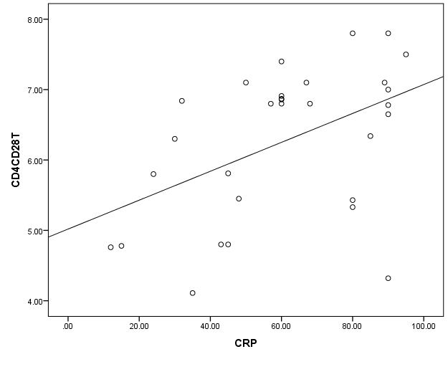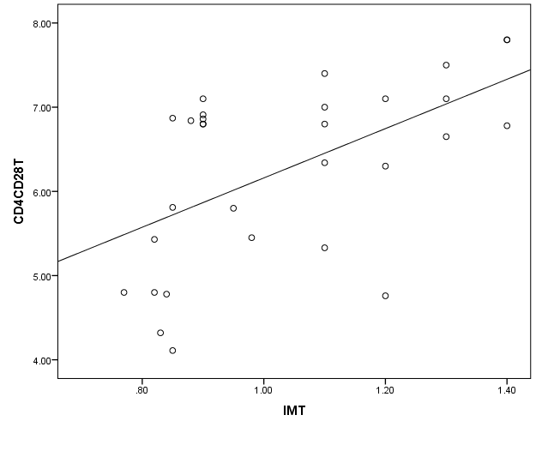

r =-0.583

P= 0.001*

r=0.551

P= 0.02*

r = 0.464

P= 0.01*

ppp

p

pp

p

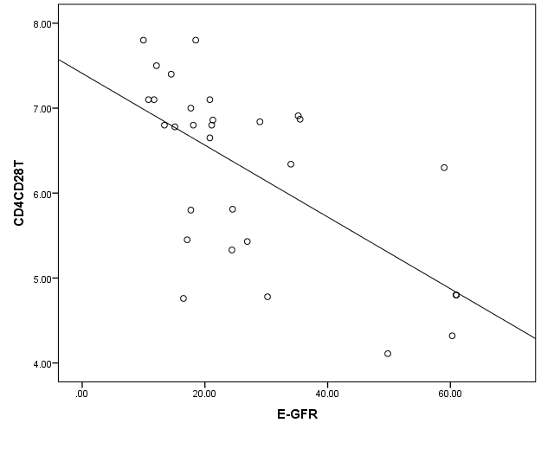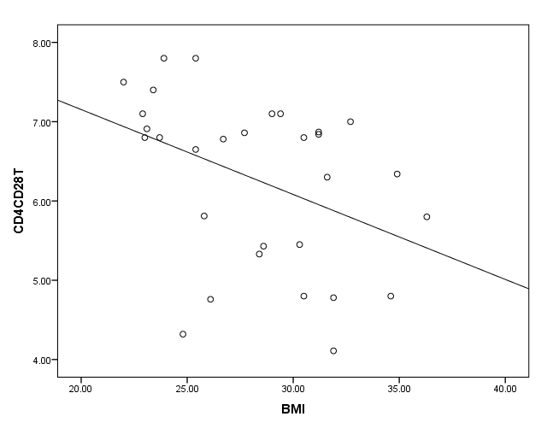

r= -0.436

P= 0.02*

**Figure (2): Correlation between CD4+CD28null Tcells and hsCRP, IMT, eGFR and BMI in the CKD predialysis group**

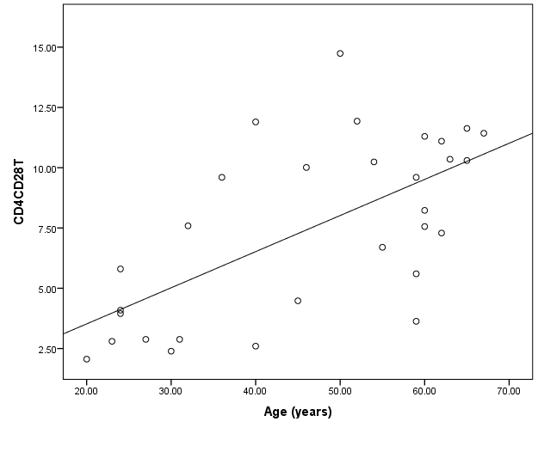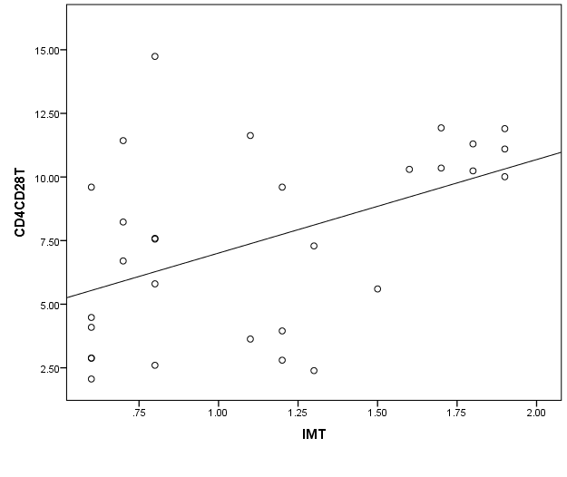

r= 0.449

P= 0.01*

r = 0.475

P= 0.008*

r = 0.631

P< 0.001**

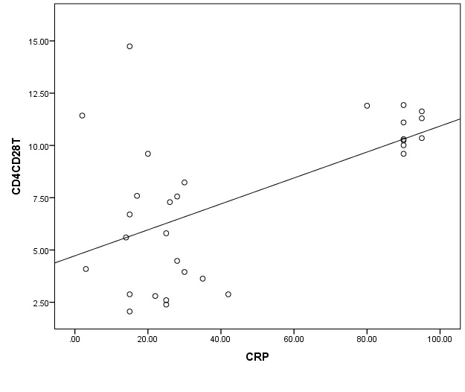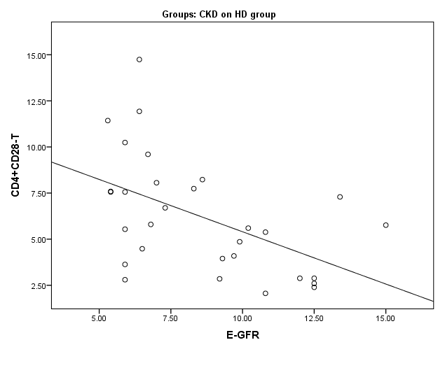

r = -0.510

P= 0.004*

**Figure (3): Correlation between CD4+CD28null T cells and age, IMT, eGFR and hsCRP in the CKD on HD group**

**4. Discussion**

Cardiovascular disease is a principal cause of morbidity and mortality in dialysis patients. The United States Renal Data System reports that cardiovascular disease accounts for 30–40% of all deaths *(****Atlas of CKD & ESRD, 2012****).* There is an important link between chronic inflammation and endothelial dysfunction for the development and progression of atherosclerosis in Hemodialysis (HD) patients *(****El-Banawy et al., 2007****).* CKD is associated with increased inflammation.Which can be measured by the elevated levels of inflammatory markers and CRP is the marker of choice (***Gomez et al., 2011***).Cardiovascular disease (CVD) and infections are directly or indirectly associated with a disturbed immune response and account for the high incidence of morbidity and mortality among patients with kidney dysfunction, and accumulating uremic toxins interfere with the immune defense (***Cohen and Hörl, 2012***).

HD treatment leads to the induction of the complement system and increases transcript levels of several proinflammatory Cytokines, such as tumor necrosis factor-α, interleukin-1b (IL-1b), IL-6, and IL-8 as well as chemokine receptors such as CXCR4 CCR7, and the fractalkine receptor CX3CR1.2 *(****Friedrich et al.,2006****)* Within the last decade, expansion of circulating proinflammatory, cytotoxic CD4+CD28null T cells has been identified as a novel nontraditional risk factor for cardiovascular disease. Particularly, patients with underlying conditions that are associated with an activated and deregulated T cell system, such as ESRD, are prone to expansion of these cells *(****Betjes et al., 2012****).*

Phenotypic and functional studies of CD4+CD28 null T cells showed that these cells wereclosely correlated with impaired flow-mediated vasodilation and increased intima-media thickness in the carotid artery, which are markers of early atherosclerosis. These data suggested that CD4+CD28 null T cells are important effector cells in HD patients, and that these cells may have a critical role in mediating early atherosclerotic damage *(****Sun et al.,2013****).* Carotid intima–media thickness (CIMT) is used as a surrogate marker of early atherosclerosis. *(****Park et al., 2013****).*

So The aim of the present is to determine the prevalence of CD4+CD28null T Helper cells and its relation to atherosclerosis in CKD patients and if hemodialysis is a risk factor for expansion of these cells and then progression of atherosclerosis in these patients.

The present study showed that CD4+CD28null T cells were significantly enriched in the peripheral blood of CKD patients (predialysis and on regular HD) compared with that from the control.

We found that, the mean value of CD4+CD28null T cells in the CKD (predialysis, and on HD) groups were significantly higher than that of the control group, and its mean value in the CKD on HD group was higher than that of CKD predialysis group, but there was no significant difference between its mean value in the CKD predialysis and CKD on HD groups. This is in agreement with the finding of ***(*Yadav *et al., 2012, and* Sun *et al., 2013),***

There were positive correlation between CD4+CD28null T cells and( Triglycerides, hsCRP and IMT), and negative correlation between CD4+CD28null T cells and both( Calcium and eGFR) in the CKD predialysis group**,** but there was no correlation between CD4+ CD28null T cells and( age, phosphorus, HTN, DM, and other lipid profiles including Cholesterol, LDL and HDL) in this group, and ***(*Yadav *et al.,2012)*** confirm that there is direct association between the CD4 + CD28 null T cell population and CCAIMT, , in CKD patients .

There were positive correlation between CD4+CD28null T cells and (age, hsCRP and IMT), and negative correlation between CD4+CD28null T cells and eGFR in the CKD on HD group, but there was no correlation between CD4+ CD28null T cells and (calcium, phosphorus, HTN , DM, Cholesterol, Triglycerides, LDL and HDL) in this group, and this in agreement with ***(Sun et al.,2013)***as regard CIMT and hsCRP, who found that,the percentage of CD4+CD28null T cells showed a positive correlation with CIMT (p = 0.023) and also a positive correlation was observed between CD4+CD28null T cells and hsCRP levelsin HD patients.

Stepwise multiple linear regression analysis showing the independent association between (CD4+CD28null T cells, age, hsCRP) and IMT in the CKD groups (predialysis and on regular HD), and this in agreement with (***Yadav et al., 2012***).

***(*Liuzzo *et al.,2007)***,also found that this expansion of CD4+CD28 null T in CKD subjects was independent of other demographic parameters like age, sex, diabetes, smoking, eGFR and hypertension, and predict coronary events in patients with unstable angina***.***

This Regression analysis demonstrated that the increased levels of CD4+CD28null T cells were positively correlated to serum levels of highly sensitive C-reactive protein, suggesting systemic inflammation. Furthermore, it showed that these cells were closely correlated with impaired flow-mediated vasodilation and increased intima-media thickness in the carotid artery, which are markers of early atherosclerosis, so these data suggested that CD4+CD28 null T cells are important effector cells in CKD patients (predialysis and those on regular HD), and that these cells may have a critical role in mediating early atherosclerotic damage.

CKD is invariably associated with systemic inflammation and oxidative stress which are the main mediators of atherosclerosis and cardiovascular disease as well as cachexia, anemia, among other morbidities ***(*Carrero and Stenvinkel, 2010*).*** The key to improve survival in dialysis patients may lie in interventions that modify the conventional cardiovascular risk factors, mainly inflammation and malnutrition (**Kalantar et al., 2005**). Costimulation of the T cell and IL-12 receptors induced the transcription of CD28 in approximately 50% of CD4+CD28null T cell clones and lines. IL-12 by itself did not restore CD28 expression. Up-regulation of CD28 after IL-12 exposure correlated with the reassembly of the CD28–initiator protein complex. The re expressed CD28 was functional and restored the ability of CD4+CD28null T cells to express CD25 and CD40 ligand (***Kenneth et al., 2003).***

Interestingly, increased TNF levels reduce CD28 expression on CD4 T cells. In vitro treatment with the TNF inhibitor infliximab increases the fraction of CD4+CD28null T cell. (***Betjes et al., 2012***). Therefore, therapeutic reduction of TNF may be a method to restore CD28 expression, reduce the CD28null T cell population, potentially rehabilitate “killers” to “helpers,” and normalize immune function. This possibility warrants further evaluation ***(*Olofsson *et al., 2012)*** .Hopefully, these studies will be of great value for developing innovative immunetherapy approaches for the prevention and early treatment of atherosclerosis and CVD in HD patients.

**5. Conclusion**:

From our work, we showed that not only CD4 + CD28 null T cells are highly expanded in CKD patients, but that this expansion is associated with preclinical atherosclerosis and HD is not independent risk factor for this expansion. There are independent association between CD4+CD28null T cells, age, hsCRP and IMT in the CKD (predialysis and on regular HD) patients, and these findings indicate that circulating CD4 + CD28 null T cells may act as a novel CVD risk factor in CKD patients. Further research is needed to understand the conditions of growth and to address the current therapeutic challenges aimed at reducing an expanded CD4+CD28null T cell population.

**References**

**Atlas of CKD & ESRD (2012):** Available at: <http://www.usrds.org/>2012/pdf/v2_ch5_12.pdf [Date accessed: 16 September 2012.

**Betjes MGH, Ruud W.J. Meijers RWJ, Wit LED and Litjens NHR (2012)**: A killer on the road: circulating CD4+CD28null T cells as cardiovascular risk factor in ESRD patients. *J. Nephrol.* 25:183-191.

**Carrero JJ and Stenvinkel P (2010):** Inflammation in end-stage renal disease--what have we learned in 10years? Semin Dial. 23: 498–509.

**Cohen G and Hörl WH (2012):** Immune Dysfunction in Uremia. Toxins. 4: 962–990.

**El-Banawy S, Emara F ES, Kandil MH, Khalil ES and Maharem D (2007):** Atherosclerosis in Hemodialysis Patients: Relation to Chronic Inflammation and Endothelial Dysfunction. Journal of Medical Research Institute. 28: 131-41.

**Friedrich B, Alexander D, Janessa A,** [**Häring HU**](http://www.ncbi.nlm.nih.gov/pubmed/?term=H%C3%A4ring%20HU%5BAuthor%5D&cauthor=true&cauthor_uid=17063178)**,** [**Lang F**](http://www.ncbi.nlm.nih.gov/pubmed/?term=Lang%20F%5BAuthor%5D&cauthor=true&cauthor_uid=17063178) **and**[**Risler T**](http://www.ncbi.nlm.nih.gov/pubmed/?term=Risler%20T%5BAuthor%5D&cauthor=true&cauthor_uid=17063178) **(2006):** Acute effects of hemodialysis on cytokine transcription profiles: evidence for C-reactive Protein-dependency of mediator induction. Kidney Int. 70: 2124–2130.

**Hurst RT, Ng DW, Kendall C, and Khandheria B (2007):** Clinical use of carotid intima-media thickness: review of the literature. J Am SocEchocardiogr. 20: 907–914.

**Kalantar-Zadeh K (2005):** Recent Advances in Understanding the Malnutrition- Inflammation-Cachexia Syndrome in Chronic Kidney Disease Patients: What is Next. Seminars in Dialysis. 18: 365–369.

**Kenneth J. Warrington, Abbe N and** [**Goronzy JJ**](http://www.ncbi.nlm.nih.gov/pubmed/?term=Goronzy%20JJ%5BAuthor%5D&cauthor=true&cauthor_uid=12506015)**(2003):** CD28 loss in senescent CD4+ T cells: reversal by interleukin-12 stimulation, The American Society of Hematology(Blood;101:3543-3549).

**Knight EL, Rimm EB, Pai JK,**[**Rexrode KM**](http://www.ncbi.nlm.nih.gov/pubmed/?term=Rexrode%20KM%5BAuthor%5D&cauthor=true&cauthor_uid=15213279)**,** [**Cannuscio CC**](http://www.ncbi.nlm.nih.gov/pubmed/?term=Cannuscio%20CC%5BAuthor%5D&cauthor=true&cauthor_uid=15213279)**,** [**Manson JE**](http://www.ncbi.nlm.nih.gov/pubmed/?term=Manson%20JE%5BAuthor%5D&cauthor=true&cauthor_uid=15213279)**et al., (2004**): Kidney dysfunction, inflammation, and coronary events: a prospective study. J Am SocNephrol. 15: 1897–1903.

**Lavin-Gomez BA, Palomar-Fontanet R, Gago-Fraile M,** [**Quintanar-Lartundo JA**](http://www.ncbi.nlm.nih.gov/pubmed/?term=Quintanar-Lartundo%20JA%5BAuthor%5D&cauthor=true&cauthor_uid=22073825)**,** [**Gómez-Palomo E**](http://www.ncbi.nlm.nih.gov/pubmed/?term=G%C3%B3mez-Palomo%20E%5BAuthor%5D&cauthor=true&cauthor_uid=22073825)**,** [**González-Lamuño D**](http://www.ncbi.nlm.nih.gov/pubmed/?term=Gonz%C3%A1lez-Lamu%C3%B1o%20D%5BAuthor%5D&cauthor=true&cauthor_uid=22073825)**et al., (2011):** Inflammation markers, chronic kidney disease, and renal replacement therapy, AdvPerit Dial. 27: 33-7.

**Libby P (2002):** Inflammation in atherosclerosis. Nature. 420: 868–874.

**Liuzzo G, Biasucci LM, Trotta G,**[**Brugaletta S**](http://www.ncbi.nlm.nih.gov/pubmed/?term=Brugaletta%20S%5BAuthor%5D&cauthor=true&cauthor_uid=17919564)**,** [**Pinnelli M**](http://www.ncbi.nlm.nih.gov/pubmed/?term=Pinnelli%20M%5BAuthor%5D&cauthor=true&cauthor_uid=17919564)**,** [**Digianuario G**](http://www.ncbi.nlm.nih.gov/pubmed/?term=Digianuario%20G%5BAuthor%5D&cauthor=true&cauthor_uid=17919564)**et al. (2007):** Unusual CD4+CD28null T lymphocytes and recurrence of acute coronary events. J Am CollCardiol. 50: 1450–1458.

**Menon V, Gaul A, and Sarnak MJ (2005**): Cardiovascular risk factors in chronic kidney disease. Kidney Int. 68: 1413–1418.

**Nowik M, Nowacki P, Grabarek J,** [**Drechsler H**](http://www.ncbi.nlm.nih.gov/pubmed/?term=Drechsler%20H%5BAuthor%5D&cauthor=true&cauthor_uid=17483582)**,** [**Białecka M**](http://www.ncbi.nlm.nih.gov/pubmed/?term=Bia%C5%82ecka%20M%5BAuthor%5D&cauthor=true&cauthor_uid=17483582)**,** [**Widecka K**](http://www.ncbi.nlm.nih.gov/pubmed/?term=Widecka%20K%5BAuthor%5D&cauthor=true&cauthor_uid=17483582)**et al., (2007):** Can we talk about CD4+CD28– lymphocytes as a risk factor for ischemic stroke? EurNeurol; 58: 26–33.

**Olofsson PS (2012):** Targeting T CellCostimulation to Prevent Atherothrombosis. Circ Res. 110: 800-801.

**Park KA**, **Jo HM and Han JS (2013):** Features of atherosclerosis in hemodialysis patients. Kidney Res ClinPract. 32: 177–182.

**Sato K, Niessner A, Kopecky SL, Frye RL, Goronzy JJ, Wey and CM (2006):** Trail-expressing T cells induce apoptosis of vascular smooth muscle cells in the atherosclerotic plaque. J Exp Med. 203: 239–250.

**Sun Z, Ye H, Tang B,**[**Shen X**](http://www.ncbi.nlm.nih.gov/pubmed/?term=Shen%20X%5BAuthor%5D&cauthor=true&cauthor_uid=22902395)**,** [**Wu X**](http://www.ncbi.nlm.nih.gov/pubmed/?term=Wu%20X%5BAuthor%5D&cauthor=true&cauthor_uid=22902395)**,** [**Zhong H**](http://www.ncbi.nlm.nih.gov/pubmed/?term=Zhong%20H%5BAuthor%5D&cauthor=true&cauthor_uid=22902395)**et al., (2013):** Prevalence of Circulating CD4+CD28null T cells is associated with early with end-stage renal disease undergoing hemodialysis. Human Immunology 74: 6-13.

**Yadav AK, Lal A, and Jha V, (2012):** Cytotoxic CD4 + CD28 null T Lymphocytes, Systemic Inflammation and Atherosclerotic Risk in Patients with Chronic Kidney Disease**.** Nephron Clin, Pract. 120: 185–193.