Early changes in the normal appearing white matter by diffusion tractography in patients with acute demyelinating optic neuritis

FathiAfify¹, Nabil Hussein¹, Sayed El-Zayat¹, Mohammed Fouad², SabryFathy¹, Hassan Gad¹, Wael Osman¹, AymanNasef, ³Ahmad Esmat¹

¹Neurology Department, Faculty of Medicine, AlAzhar University, Cairo, Egypt
²Radiology Department, Faculty of Medicine, AlAzhar University, Cairo, Egypt
³Neurology Department, Faculty of Medicine, Ain Shams University, Cairo, Egypt
waelnada72@hotmail.com

Abstract: Objective: Acute optic neuritis is the initial presentation in approximately 20% of cases of multiple sclerosis. Conventional magnetic resonance imaging is sensitive for detecting brain lesions in most, but not all patients. Diffusion tractography provides information about the diffusion properties of water molecules and microstructural tissue changes not visible on conventional MRI. The aim of the study was to assess the early diffusion changes of the normal appearing white matter in patients with optic neuritis. Methods: The present study included 26 patients with acute demyelinating optic neuritis and 10 age and sex matched healthy controls. All patients had normal conventional MRI brain. Diffusion MRI tractography was done to all patients within the first 3 days of onset. Diffusion parameters including apparent diffusion coefficient and fractional anisotropy were measured in different regions of white matter. Results: Compared with controls all patients showed significant decreased mean fractional anisotropy in the normal appearing white matter (P<0.05). We found no significant difference in the ADC values in patients when compared with the control group (P >0.05). The study showed that FA is sensitive than ADC for detection of white matter abnormalities in demyelinating optic neuritis patients. Corpus callosum is an early site for development of white matter anisotropy changes in patients with optic neuritis. Conclusion: DTI tractography seems to provide available means of indirectly detecting subtle changes in the normal appearing white matter not visible on the conventional brain MRI. FA is more sensitive than ADC to detect white matter damage in demyelinating optic neuritis patients.
[Fathi Afify, Nabil Hussein, Sayed El-Zayat, Mohammed Fouad, Sabry Fathy, Hassan Gad, Wael Osman, Ayman Nasef, and Ahmad Esmat. Early changes in the normal appearing white matterby diffusion tractography in patients with acute demyelinating optic neuritis. Nat Sci 2015;13(5):175-180]. (ISSN: 1545-0740). http://www.sciencepub.net/nature. 24

Key words: white matter, Optic neuritis, diffusion tractography

1. Introduction:
Acute demyelinating optic neuritis (ON) is the initial presentation in approximately 20% of cases of multiple sclerosis (MS) and is characterized by unilateral painful visual loss without systemic or neurological symptoms. The presence of white matter lesions on the initial magnetic resonance imaging of the brain has been identified as the strongest predictor for the development of MS ((Kidd et al., 2008;Kidd and plant 2008 &Rizzo et al., 2009).
The real value of MRI in typical demyelinating ON is not to image the optic nerves, but to image the brain as a prognostic indicator for the future development of MS. Periventricular white matter abnormalities on magnetic resonance imaging (MRI) consistent with MS have been reported in 40% to 60% of ON (Christiansen et al., 2008).
There is a strong association between ON and MS. Approximately 30-70% of MS patients develop ON during the course of their disease. Many patients who present with ON as a clinically isolated syndrome (CIS) demonstrate evidence of disseminated central nervous system inflammation and demyelination on their baseline magnetic resonance imaging (MRI) study, which increase their future risk of MS (Brodsky et al., 2008).
Diffusion tractography is a technique based on the directional movement of water, which is determined by the brain microstructure and imaged with diffusion sensitive MRI to generate three-dimensional representations of the white matter tracts. Moreover, by tracking principal diffusion direction, the primary eigenvector of the diffusion tensor, diffusion tensor tractography can reconstruct major white matter fiber tracts, such as the corpus callosum, cingulum, and pyramidal tract (LeBihan et al., 2001; Clark et al; 2010 ).
Tractography is a 3D modeling technique used to represent fibre tracts using data collected by diffusion tensor imaging. It has a potential role in quantifying the degree of axonal loss and demyelination within different types of lesions and normal appearing white matter(Simon et al., 2006; Schmierer et al., 2007; Simon, 2011).Diffusion tensor imaging (DTI) is a non-invasive imaging technique which can measure and quantify microstructural tissue changes not visible on conventional MRI and has the potential to map the white matter integrity and anatomical connectivity of the brain (Basser and Pierpaoli, 1996). The aim of the present study was to assess the early changes of the normal appearing white matter by diffusion tractography in patients with acute demyelinating optic neuritis.

2. Subjects and Methods
This study was carried out on a group of patients recruited from the outpatient clinic (Neurology and Ophthalmology), Al-Azhar University hospitals. The study included two groups: Patients group included 26 patients (10 males & 16 females) from different age groups range from 20-45 years diagnosed as acute demyelinating optic neuritis with normal conventional MRI brain and without any manifestations of other diseases. Control group included ten healthy Egyptian controls were age and sex matching with the patients. Control subjects were volunteers selected from general population through personal communication.
Patients with other causes for optic neuritis were excluded from the study such as acute disseminating encephalomyelitis (ADEM), ischemic optic neuritis, toxic optic neuritis or hysterical. Patients with past history of optic neuritis or with concomitant disease that may affect optic nerve such as diabetes, and hypertension were also excluded from the study.
All patients were subjected to: Clinical assessment including history taking, general and neurological examination according to neurology sheet accepted in neurology department faculty of medicine, Al-Azhar University. Laboratory investigation including complete blood count, erythrocyte sedimentation rate, fasting blood sugar, renal function tests, ANA, ANCA and Anti DNA to exclude other causes of demyelinating optic neuritis. Electrophysiological studies: visual evoked potential (VEP) was done for all patients 1 to 7 days from the onset of the disease. All the patients received the same medication in the form of methylprednisolone 1000 mg per day for five days.
Conventional MRI brain and MRI tractography were done to all patients within 1-3 days after clinical diagnosis. MRI was done at Wadi El-Neel Hospital on Philips panorama high field open MRI 1.0 Tesla. The following protocols were applied: Conventional MRI including T1, T2- weighted image and Fluid attenuated inversion recovery (FLAIR) images. Diffusion Tensor imaging (Tractography) measurement of ADC and FA have been done at the following anatomical sites: Corpus callosum, Internal capsule, Periventricular white matter, Frontal white matter, Frontal gray matter, Thalamus and Middle cerebellar peduncle.
Pulsed-gradient spin-echo echoplanar pulse sequence (interecho spacing 5 0.8, TE 5 123), with diffusion gradients applied in eight noncolinear directions, chosen to cover three-dimensional space uniformly. The duration and maximum amplitude of the diffusion gradients were 25 msec and 21 mTm21, giving a maximum b factor in each direction of 1044 seconds mm22. Fat saturation was performed using a four radiofrequency (RF) pulse binomial pulse train to avoid the chemical shift artifact. A bird-cage head coil of z300 mm diameter was used for RF transmission and for signal reception.
Image analysis and processing: all image post processing was performed on a computer workstation. For diffusion weighted image apparent diffusion Co-efficient (ADC) and fractional anisotropy (FA) were calculated which are the most important commonly used measures of alignment of cellular structures within fiber tracts, as well as their structured integrity. Analysis has been done forADC and FA value from region of interest (ROI) in the NAWM in all patients and the corresponding ROI placed in the control group.
Statistical analysis of the present study was conducted using the mean, standard error and student t- test by SPSS V17. Unpaired Student T-test was used to compare between two groups in quantitative data. P < 0.05 is significant

3. Results:
The study included 26 patients presented with acute demyelinating optic neuritis they were 16 females (61.5%) and 10 males (38.5%). The age of patients ranged from 20 to 45 with a mean of 27.75+6.648 (Table 1).There were 16 patients (53.33%) have ophthalmoscopic changes. Visual evoked potentials showed prolonged P 100 latencyin all patients.
Radiological findings in the Normal Appearing White Matter (NAWM):
(a) Corpus Callosum:
ADC value for corpus callosum in patients ranged from 0.313 to 1.315, while ADC value for controls ranged from 0.662 to 0.999 with a mean of 0.812±0.122 (Table 2). There was no statistically significant differences in ADC value of corpus callosum for both patients and controls (P>0.05).
FA value for corpus callosum in patients ranged from 0.578 to 0.910 with a mean of 0.705±0.138, while FA value for controls ranged from 0.605 to 0.978 with a mean of 0.820±0.106 (Table 3). There was statistically significant difference between patients and control groups as regard FA in corpus callosum (P<0.05).
(b) Internal Capsule:
ADC value for internal capsule in patients ranged from 0.304 to 0.949 with a mean of 0.715±0.156 while ADC value for controls ranged from 0.652 to 0.790 with a mean of 0.712±0.050 (Table 2). There was no statistically significant difference of ADC value of internal capsule for both patients and controls (P>0.05).
FA value for internal capsule in patients ranged from 0.153 to 0.836 with a mean of 0.447±0.238 while FA value for controls ranged from 0.453 to 0.844 with a mean of 0.611±0.146 (Table 3). There was statistically significant difference between patients and controls as regard FA of internal capsule (P<0.05).
(c) Periventricular White Matter (PVWM):
ADC value for PVWM in patients ranged from 0.125 to 2.266 with a mean of 1.141±0.504 while ADC value controls ranged from 0.768 to 1.617 with a mean of 1.068±0.330 (Table 2). There was no statistically significant difference between patients and controls as regard ADC of PVWM (P>0.05).
FA value for PVWM in patient ranged from 0.240 to 0.464 with a mean of 0.302±0.091, while FA value for controls ranged from 0.215 to 2.331 with a mean of 0.703±0.502 (Table 3). There was a statistically significant difference in FA value as regard PVWM in patients when compared with the control group (P>0.05).
(d) Frontal White Matter:
ADC value for frontal white matter in patients ranged from 0.457 to 1.184 with a mean of 0.843±0.186 while ADC value for controls ranged from 0.696±1.034 with a mean of 0.862±0.120 (Table 2). There was no statistically difference in ADC value as regard frontal white matter for both patient and control group (P>0.05).
FA value for frontal white matter in patients ranged from 0.380 to 0.575 with a mean of 0.405±0.075, while FA value for controls ranged from 0.237 to 0.804 with a mean of 0.511±0.132 (Table 3). There was a statistically significant difference in FA value as regard frontal white matter for both patients and controls (P<0.05).
(e) Middle Cerebellar Peduncle (MCP):
ADC value for MCP in patients ranged from 0.562 to 1.609 with a mean of 0.899±0.272 while ADC for controls ranged from 0.579 to 1.471 with a mean of 0.894±0.339 (Table 2). There was no statistically significant difference in ADC value as regard MCP for patients and controls (P>0.05).
FA value for MCP in patients ranged from 0.406 to 0.889 with a mean of 0.611±0.136 while FA for controls ranged from 0.695±0.831 with a mean of 0.754±0.053 (Table 3). There was a significant statistically differences in FA value as regard MCP for patient and control group (P<0.05).

Table (1): Demographic Data of the study groups
 | Patients | Controls | P - value
Number | 26 | 10
Age (mean±SD) | 27.75±6.64 | 27.90±7.41 | 0.952
Male/Female (N & %) | 10 (38.5%)/16 (61.5%) | 5(50%)/5 (50%) | 0.571

Table (2): The mean values of ADC in the normal appearing white matter in patients and control groups
Regions of interest | Patients  (N=26) | Controls  (N=10) | T- test | P- value
Corpus callosum | 0.787±1.189 | 0.812±0.122 | 0.390 | 0.698
Inernal capsule | 0.715±0.156 | 0.712±0.050 | 0.059 | 0.953
PVWM | 1.141±0.504 | 1.068±0.330 | 0.427 | 0.672
Frontal white matter | 0.843±0.186 | 0.862±0.120 | 0.301 | 0.764
Middle cerebellar peduncle | 0.899±0.272 | 0.894±0.339 | 0.047 | 0.962

Table (3): The mean values of FA in the normal appearing white matter in patients and control groups
Regions of interest | Patients  (N=26) |  | Controls  (N=10) | T- test | P-value
Corpus callosum | 0.705±0.138 |  | 0.820±0.106 | 2.753 | 0.009
Inernal capsule | 0.447±0.238 |  | 0.611±0.146 | 2.044 | 0.047
PVWM | 0.302±0.091 |  | 0.703±0.502 | 2.491 | 0.017
Frontal white matter | 0.405±0.075 |  | 0.511±0.132 | 2.400 | 0.021
Middle cerebellar peduncle | 0.611±0.136 |  | 0.754±0.053 | 3.221 | 0.002
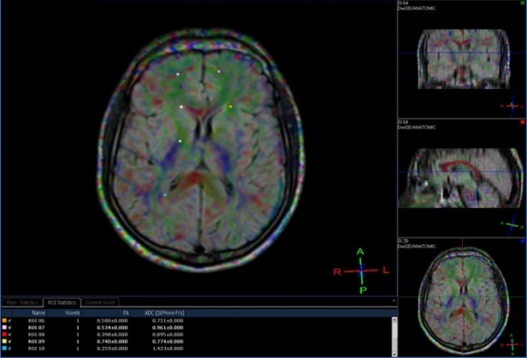 |  | 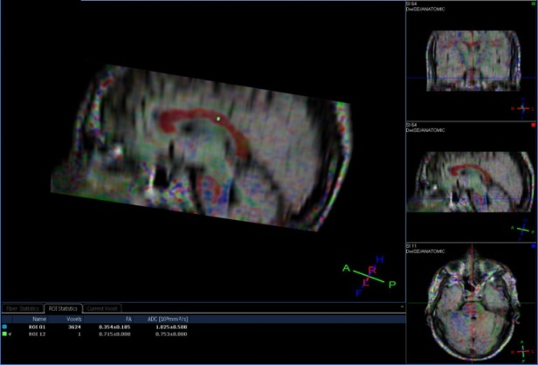
Figure (1): Axial T1 conventional MRI brain showed no abnormality |  | Figure (2): Sagittal T1 conventional MRI brain showed no abnormality

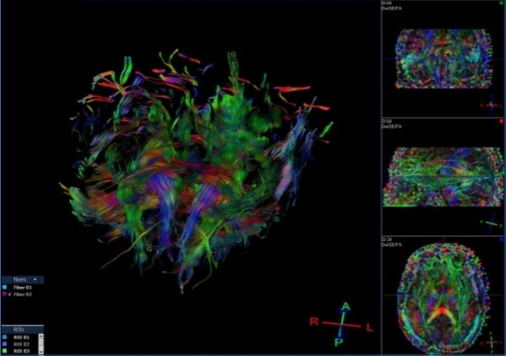
Figure (3): Three dimensional MRI tractography that reconstruct brain white matter bundles. The different colors represent different direction of fibers.
•Red indicates directions in the X axis: right to left or left to right.
•Green indicates directions in the Y axis: posterior to anterior or from anterior to posterior.
•Blue indicates directions in the Z axis: foot-to-head direction or vice versa.

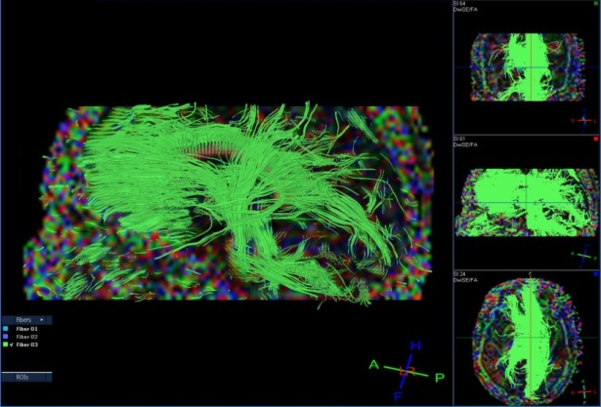 | 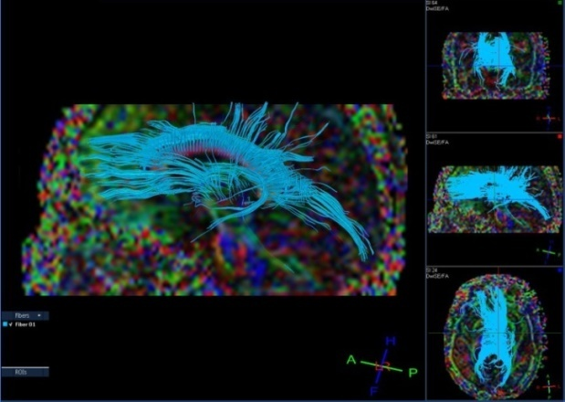
Figure (4): Sagittal view three dimensional MRI tractography that reconstruct brain white matter bundles. | Figure (5): Sagittal view three dimensional MRI tractography that reconstruct brain white matter bundles.

4. Discussion:
A relationship between optic neuritis and MS has been well recognized for many years. The risk for developing MS is 35 - 50%, the risk was strongly related to MRI evidence of prior demyelination in the white matter of brain at the time of optic neuritis onset (Brodsky et al., 2008).
Diffusion imaging is sensitive to diffusion of free water. This is useful for imaging of brain anatomy because, within white matter, diffusion is orientation dependent; there is greater hindrance to diffusion across a fiber bundle than along it. By acquiring multiple images, each sensitive to diffusion at a different orientation, the diffusion tensor measurements, the mean diffusion quantification and its orientation dependence (fractional anisotropy) at each brain voxel (three-dimensional pixel), can be done. Previous studies confirm the sensitivity of these measures to microstructural changes(Hickman et al., 2005).
In multiple sclerosis (MS), nonconventional magnetic resonance imaging (MRI) techniques have demonstrated a high degree of specificity and sensitivity in detecting pathological tissue damage. These techniques play an important role in high-lighting brain microstructural damage not visible when conventional MRI sequences are used (Assaf et al., 2008).
Our study consisted of 26 patients with optic neuritis and included more females than males, with a male to female ratio 1:1.6. This ratio is less than the ratio encountered in the previous studies where females were more than twice as much as males (Kantarci et al., 2005 & Robertson et al., 1996). This difference may be due to the difference in sampling procedure and methodology, where most of these studies included definite multiple sclerosis.
The mean age of patients in the present study was 27 years which is consistent with the finding of Brass et al. (2008) who reported that demyelinating optic neuritis affect young adult patients less than 45 years old.
In the present study, DTI tractography was applied to patients at early stage of optic neuritis in order to characterize the change in diffusion of white matter. Two indices (FA and ADC) derived from the diffusion tensor imaging were used to investigate the presence of abnormal diffusion indices. Fractional anisotropy is a scalar value between zero and one that describes the degree of anisotropy ofthe diffusion process. A value of zero means that diffusion is isotropic, i.e. it is unrestricted in all directions. A value of one means, that diffusion occurs only along one axis and is fully restricted along all other directions. FA is thought to reflect fiber density, axonal diameter, and myelination in white matter which is undetectable by conventional MRI methods (Basser and Pierpaoli, 1996).
Our study findings are consistent with the previous study of Flippi et al. (2001), who reported wide spread DTI abnormalities consisting of decreased FA in NAWM of optic neuritis patients. They attributed the pathology to Wallerian degeneration. In the present study we found that the patients presented with optic neuritis showed no significant differences in ADC value of NAWM when compared to the control group.
DTI applied in patients at high risk for MS after clinically isolated syndrome demonstrating the feasibility of this approach to study the normal appearing white matter through connectivity that can be comprehensively interrogated by multiple quantitative MRI methodologies (Simon et al., 2006). Analysis of changes of DTI may provide more information about the pathology. The axial diffusion coefficient which measures the diffusivity parallel to the main fiber direction reflects the changes of restricted barriers along the direction of a fiber tract and the alterations of extracellular space. Membrane disintegration, loss of axonal structure and gliosis may create change in diffusion barrier which leads to reduced FA and increased ADC (Rocca et al., 2007). In the present study, patients presented with optic neuritis had significantly lower FA of NAWM and had no significant difference in the value of ADC when compared with the control group.
Early FA changes in the normal appearing white matter are consistent with the findings of (Preziosa et al. 2011) who pronounced that, FA changes expressing tissue damage have been detected in gadolinium enhancing lesions in patients with definite multiple sclerosis. FA of T₂ lesions was decreased and was more sensitive to pathologic damage than ADC. In active lesions FA values decrease according to the severity of tissue disruption, while ADC may decrease or increase or be similar to those detected in chronic lesion. In the present study, patients with definite MS or abnormal conventional MRI were excluded from the study.
Examination of role of direction dependence of the apparent diffusion co-efficient in the evaluation of normal appearing brain regions of MS patients found reduced FA and increased ADC. It was attributed to Wallerian degeneration (Henry et al., 2003). In the present study, we found that not only corpus callosum has been affected early in patients with optic neuritis as regard FA, but also other normal appearing white matter areas.
The present study showed findings similar to that of (Johnson et al., 2004) who reported that corpus callosum is an early site for development of white matter anisotropy changes in patients with ON as the clinically isolated syndrome. There seemed to be a decrease in FA in all patients with ON. They hypothesize that Wallerian degeneration is an early contributor to changes in FA in the CC. This might be explained by occult lesions yet undetectable on conventional MRI scans remote from the CC.
As diffusion tractography moves into the clinical setting we must keep in mind its limitations, although the teqnique is already providing clinically relevant markers in disease, the interpretation of changes is complex. Despite these caveats, diffusion tractography offers exciting opportunities to be addressed in the living human. Further investigations and long term follow up are needed to determine the future development of MS and prognosis in patients with ON.

Conclusion:
Our findings confirm the presence of abnormal diffusion in the normal-appearing white matter in patients with optic neuritis. Diffusion tensor imaging tractography seems to provide available means of indirectly detecting subtle changes in the structure and organization of WM bundles. The study has demonstrated the FA is more sensitive than ADC to detect white matter abnormalities in patients with acute demyelinating optic neuritis.

References
- Assaf Y and Pasternak O, Clark C: “Diffusion tensor imaging (DTI)-based white matter mapping in brain research: a review,” Journal of Molecular Neuroscience 2008; 34(1): 51-61.
- Basser PJ and Pierpaoli C: Microstructural and physiological features of tissues elucidated by quantitative diffusion tensor MRI. J Magn Reson B. 1996; 111: 209-19.
- Brass SD, Zivadinov R, Bakshi R: Acute demyelinating optic neuritis: a review. Front Biosci. 2008; 13: 2376-90.
- Brodsky MC, Beck RW, Christiansen: MR imaging in the evaluation of acute optic neuritis. Radiology 2008; 192: 22-23.
- Christiansen P, Gideon P, Thomsen C, et al.: Periventricular white matter signal abnormalities on magnetic resonance imaging (MRI) consistent with MS. Acta Neurologica Scandinavica 2008; 87(3): 195-99.
- Clark PA, Heron JR, Foster DH, et al.: Diffusion-based tractography is a technique based on the directional movement of water. Radiology 2010; 192:22-23.
- Filippi M: “Magnetic resonance imaging findings predicting subsequent disease course in patients at presentation with clinically isolated syndromes suggestive of multiple sclerosis. Neurological Sciences 2001; 22(2): S49-S51.
- Henry RG, Oh J, Nelson SJ, et al.: Directional diffusion in relapsing-remitting multiple sclerosis: a possible in vivo signature of Wallerian Degeneration. J Magn Reson Imaging 2003; 18:420-26.
- Hickman SJ, Wheeler-Kingshott CA, Jones SJ, et al.: Optic nerve diffusion measurement from diffusion-weighted imaging in optic neuritis. AJNR Am J Neuroradiol 2005; 26:951-56.
- Johnson G, Ge Y, Law M, Herbert J, Babb JS, et al.: Preferential occult injury of corpus callosum in multiple sclerosis measured by diffusion tensor imaging. J Magn Reson Imaging 2004; 20:1-7.
- Kantarci OH and Weinshenker BG: Natural History of multiple sclerosis. Neuro.2005; 23:17-38.
- Kidd DP: Inflammatory optic neuropathies not associated with multiple sclerosis. In: Neuro-ophthalmology (Kidd DP, Newman NJ, Biousse V, eds). Boston, Butterworth Heinemann 2008; pp.153-90.
- Kidd DP and Plant GT: Optic neuritis. In: Neuro-ophthalmology (Kidd DP, Newman NJ, Biousse V, eds). Boston, Butterworth Heinemann 2008; pp.134-52.
- LeBihan D, Mangin JF, Poupon C, et al.: Diffusion tensor imaging: concepts and applications. J Magn Reson Imaging 2001; 13:534-46.
- Preziosa P, Rocca MA, Mesaros S, et al.: “Intrinsic damage to the major white matter tracts in patients with different clinical phenotypes of multiple sclerosis: a voxelwise diffusion-tensor MR study”. Radiology 2011; 260(2): 541-50.
- Rizzo JF 3rd and Lessell S: Risk of developing multiple sclerosis after uncomplicated optic neuritis: a long-term prospective study. Neurology 2009; 38: 185-90.
- Robertson N, Deans J, Fraser M, Compston DA: Multiple sclerosis in South Cambridgeshire: incidence and prevalence based on district register. J Epidemiol Community Health 1996; 50: 274-79.
- Rocca MA, Pagani E, Absinta M, et al.: Altered function and structural con-nectivities in patients with MS:A3-T study AAN Enterprises 2007; 69(23): 2136-45.
- Schmierer CAM, Wheeler-Kingshott PAB, et al.: “Diffusion tensor imaging in multiple sclerosis brain”. Neuro Image 2007; 35(2):467-77.
- Simon JH , Zhang S, Laidlaw D, et al.: Identification of fibers at risk for degeneration by diffusion tractography in patients at high risk after clinically isolated syndrome for MS. Resonance Imaging 2006; 24: 983-99.
- Simon JH, Mori S, vanZijl PC: neuronal fibers that intersect focal lesion and pass through a region of interest, Fiber tracking: principles and strategies, a technical review. NMR Biomed.2011; 15: 468-80.

5/20/2015

