Histological Study on the Effect of Iron-Deficient Diet on Adult Male Albino Rat Tongue

Gamal M Hagras, Ahmed A Ali, Magda A Mansour, Amira F Ali and Haitham M Sewilam

Histology Department, Faculty of Medicine, Menoufiya University, Egypt.
elkashefdalia@yahoo.com

Abstract: Background: Iron deficiency is the most common nutritional deficiency worldwide. The oral cavity is one of the first sites where iron deficiency can be clinically noted. Objective: This study was aimed to clarify the histological changes in tongue of albino rats due to intake of iron deficient-diet and to study the role of balanced diet, either alone or with therapeutic iron supplement. Materials and methods: 30 adult male rats were divided into control group I (N:12), was fed a balanced diet for 8 weeks and experimental group II (N:18), was fed iron-deficient diet for 8 weeks, then was further divided into 3 subgroups (6 rats/each); II A group was sacrificed after 8 weeks, II B was fed a balanced diet for further 2 weeks and II C was fed a balanced diet with daily oral iron supplement for further 2 weeks. The body weight was recorded at the beginning and at the end of the study. At sacrifice, blood samples were collected for estimation of serum iron and haemoglobin. Tongue samples (anterior 2/3) were fixed and then processed for both L/M and Scanning E/M studies. Results revealed that iron-deficient group IIA revealed histological changes on both L/M and E/M levels and significant decrease in body weight, serum iron and haemoglobin levels. Administration of a balanced diet (G IIB) resulted in little improvement. However, concomitant intake of balanced diet with iron supplement (G IIC) revealed good improvement of the previous parameters. Conclusion: From this study, it was concluded that iron deficiency induced structural alteration in rat tongue. However, after 2 weeks of iron supplementation with balanced diet revealed good amelioration of tongue structure. So, iron supplement is recommended for subjects who need iron as children and women of reproductive age.
[Gamal M Hagras, Ahmed A Ali, Magda A Mansour, Amira F Ali and Haitham M Sewilam. Histological Study on the Effect of Iron-Deficient Diet on Adult Male Albino Rat Tongue. Nat Sci 2015;13(5):149-160]. (ISSN: 1545-0740). http://www.sciencepub.net/nature. 21

Key words: Iron deficiency, Tongue, Histology and SEM.

1.Introduction:
Iron Deficiency is the most common nutritional deficiency worldwide. It affects the highest population segments at peak rates of growth such as infants, young children and pregnant women. Iron deficiency anemia (IDA) is the 1st nutritional disorder in the world. The low intake of total dietary iron and poor iron absorption were the common causes of (IDA) (1). Iron deficiency may produce impairment in iron dependent enzyme systems, affecting the metabolism and the kinetics of the rapidly dividing oral epithelial cells (2). The oral cavity is often one of the first sites where nutritional deficiencies including iron deficiency can be clinically noted such as glossal pain, dysphagia, glossodynia and smooth red tongue (3). The aim of this work was to study the histological changes in tongue of adult male albino rats feeding iron deficient diet and to clarify the role of balanced diet, either alone or with daily oral iron supplement to ameliorate these changes.

2. Materials and Methods:
A total of 30 adult male albino rats were used in this study. They were allowed free access to water and fed ad libitum. Strict care and good hygiene were taken to maintain normal and healthy environment. They were divided into 2 main groups:
Control group I: 12 rats were fed a balanced diet containing iron (36 mg/ kg diet) and left for 8 weeks (4).
Experimental group II: 18 rats were fed an iron-deficient diet containing iron (5mg/kg/diet) (4). They were further divided into 3 equal subgroups as follows: Group IIA: rats were fed iron-deficient diet and then sacrificed after 8 weeks.
Group IIB: rats were fed iron deficient diet for 8 weeks followed by a balanced diet for another 2 weeks.
Group IIC: rats were fed iron-deficient diet for 8 weeks then were fed a balanced diet supplemented with iron at a dose of 9.45 mg iron/ kg body weight /once daily by intragastric tube for another 2 weeks (5).
At the end of the study, animals were weighed then sacrificed. Blood samples were collected by heart puncture for estimation of serum levels of hemoglobin and iron.
Tongues of animals were dissected and cut into 2 halves; one half was fixed in 10 % formol saline and processed for making paraffin blocks.Serial sections of 5-µm thick were stained with H&E for routine histological study, PAS for detection of muco-polysaccharides, silver stain for detection of reticular fibers and PCNA immune-stain for detection of proliferating cell nuclear antigen (6). The other halves of tongues were cut into small pieces, were fixed in buffered glutraldehyde solution and processed for examination using a Philips Scanning Electron Microscope (XL30; Philips, Amestrdam, Netherlands) at EM unit of Anatomy Department, Faculty of Medicine, Ain Shams University(7).
Statistical analysis:
Data was statistically analyzed using SPSS (Statistical Package for Social Science). Data was expressed as mean±SD and analyzed by using student's t test for comparison between two groups. Differences were regarded as non significant when P≥o.o5, significant when P ≤o.o5, highly significant when P ≤o.o1 or very highly significant when P ≤o.oo1 (8).

3. Results:
1- Statistical results:

Table (1)
Groups | Weight | T. test | P.value
 | Mean ± S.D
Group I (control group) | 365.10±10.85 | T1 = 19.8  T2 = 23.3  T3 = 1.8  T4 = -6.8  T5 = -19.7  T6 = -44.77 | P1=<0.001  P2 = <0.01  P3 = >0.05  P4 = <0.01  P5 = <0.01  P6 = <0.01
Group II A | 147.00±33.17
Group II B | 225.90±15.47
Group II C | 357.70±6.60
P1 = compare between Group I control group and Group II A; P2 = compare between Group I control group and Group II B
P3 = compare between Group I control group and Group II C; P4 = compare between Group II A and Group II B
P5 = compare between Group II A and Group II C; P6 = compare between Group II B and Group II C

Table (2)
Groups | Hb | T.test | P.value
 | Mean ± S.D
Group I (control group) | 13.81± 0.35 | T1=38.8  T2 = 8.96  T3 = 1.78  T4 = -38.4  T5 = -38.97  T6 = -7.6 | P1 = <0.01  P2 = <0.01  P3 = >0.05  P4 = <0.01  P5 = <0.01  P6 = <0.01
Group II A | 6.26± 0.51
Group II B | 12.73± 0.16
Group II C | 13.55± 0.30
P1 = compare between Group I control group and Group II A; P2 = compare between Group I control group and Group II B
P3 = compare between Group I control group and Group II C; P4 = compare between Group II A and Group II B
P5 = compare between Group II A and Group II C; P6 = compare between Group II B and Group II C

Table (3)
Groups | Iron | T.test | P.value
 | Mean ± S.D
Group I (control group) | 128.40±2.88 | T1=36.7  T2 = 9.07  T3 = 1.03  T4 = -26.1  T5 = -33.97  T6 = -7.4 | P1 = <0.01  P2 = <0.01  P3 = >0.05  P4 = <0.01  P5 = <0.01  P6 = <0.01
Group II A | 39.70±7.07
Group II B | 111.60±5.10
Group II C | 126.80±3.97
P1 = compare between Group I control group and Group II A; P2 = compare between Group I control group and Group II B
P3 = compare between Group I control group and Group II C; P4 = compare between Group II A and Group II B
P5 = compare between Group II A and Group II C; P6 = compare between Group II B and Group II C

2- Histological results:
Control Group I:
Sections of control group revealed that the tongue was formed of masses of skeletal muscle fibers arranged in different directions and covered on its dorsal surface by mucous membrane which was thick, rough and firmly adherent having lingual papillae. The most common filliform papilla was conical in shape having tapering tip. The ventral surface was smooth, devoid of lingual papillae and covered with stratified squamous keratinized epithelium. The lamina propria under the mucous membrane was formed of loose aerolar CT formed of cells and fibers (Plate 1: A, B). The muscle fibers were traversed by masses of serous and mucous secretory acini (lingual salivary glands). The mucous acini were large having wide lumen and lined by low cuboidal cells with flattened nuclei and vacuolated cytoplasm. The serous acini were smaller and lined by high pyramidal cells with basal rounded nuclei (Plate 1: C). Their duct opened on the surface and was lined by stratified squamous epithelium (Plate 1: D). The dorsal, ventral surfaces and lingual salivary glands revealed PAS +ve reaction (Plate 2: A, B, C). The Basal and supra-basal cells of the epithelium showed frankly +ve PCNA reaction which appeared as brown stained nuclei of different densities (Plate 2: D, E).The lamina propria revealed normal amount of reticular fibers stained brown with silver stain (Plate 2: F).
SEM examination of control tongue revealed that the dorsal surface was covered by numerous, elongated, conical shaped-filiform papillae with intact, slightly curved, tapering tips that pointed toward one direction. Some fungiform papillae were observed sporadically between the filliform papillae. They were short, broad in shape and had flattened smooth hemispherical upper surface that was traversed by taste pore in the center (Plate 3: A, B, C, D).
-Group IIA:
Sections of this group revealed that the dorsal surface of the tongue was covered by irregularly arranged, short, atrophied lingual papillae. Some with blunt tips and others were completely absent and replaced by mass of keratin on the surface (Plate 4: A, B). The basal cells revealed apoptosis with pyknosis of their nuclei and appearance of peripheral hallow. The supra-basal cells revealed hypocellularity and apparent decrease in number (Plate 4: C). Mononuclear inflammatory cells with vascular congestion and extravasation of blood among muscle fibers were evident (Plate 4: D, E). The lingual salivary glands were apparently small in size and revealed pyknosis of some cell nuclei (Plate 4: F) together with atrophy of their duct which failed to reach to the surface. Slight decrease of PAS reaction of dorsal surface, ventral surface and serous acini was observed (Plate 5: A, B, C). The basal cell layer of dorsal and ventral surfaces revealed +ve PCNA reaction, while the supra-basal layer revealed –ve PCNA reaction denoting hypocellularity and atrophy of the supra basal layer (Plate5: D, E). Excessive accumulation of reticular fibers was observed in lamina propria (Plate 5: F).
SEM examination of this group revealed a noticeable atrophy of lingual papillae from being short to being completely absent in focal areas. They were widely separated and irregularly arranged in different directions. The upper portion of some papillae appeared bisected (Plate 6: A, B). Furthermore, some filliform papillae showed desquamation of their epithelial covering and small rounded structure could be seen on these exposed areas.Some fungiform papillae had rough, irregular desquamated upper portion with ill distinct taste pore (Plate 6: C, D).
-Group IIB:
Sections of this group showed mild improvement; some filliform papillae appeared with normal tapering tips, while other appeared deformed showing blunted, or bisected tips (Plate 7: A). Some basal cells of the mucous membrane showed pyknotic nuclei with peripheral hallow, while others appeared normal. The supra-basal cells showed vesicular euchromatic nuclei (Plate 7: B). The keratin layer of the ventral surface appeared irregular with focal area of detachment. The inflammatory reaction was still persistent in the lamina propria (Plate 7: C). The PAS reaction revealed nearly the same as control group (Plate 8: A, B, C). PCNA reaction revealed +ve reaction in the basal nuclei of lingual papillae and ventral surface, while –ve reaction was noticed in some supra-basal nuclei (Plate 8: D, E). Persistent accumulation of reticular fibers in the lamina propria was observed (Plate 8: F).
SEM examination of this group revealed that filliform papillae were partly separated and irregularly arranged. Some papillae appeared with normal tips, while others appeared with blunted or bisected tips (Plate 9: A, B). Some filliform papillae revealed desqumation with fragmented part which was covered with rounded structure. Other papillae appeared with partly smooth upper surface (Plate 9: C).
-Group IIC:
Sections of this group revealed good improvement of the histological picture; most of filliform papillae appeared regularly arranged with intact tapering tips (Plate 10: A). The ventral surface appeared with normal thickness and with normal covering keratin (Plate 10: B). The basal and supra-basal layers of epithelium revealed mitotic figures (Plate 10: C). The serous and mucous acini appeared with normal picture (Plate 10: D). The PAS stain revealed PAS +ve reaction of the dorsal surface, ventral surface and frankly +ve reaction of mucous and serous acini (Plate 11: A, B, C). The PCNA stain revealed frankly +ve reaction of the basal and supra- basal cells of dorsal and ventral lingual surface denoting hyperplasia (Plate 11: D, E). The reticular fibers appeared nearly the same as control group (Plate 11: F). SEM examination of this group revealed nearly normal appearance of lingual papillae compared to control group. They appeared as long, conical shaped, regularly arranged, directed nearly to one direction and mostly with intact tapering tips. Only very few papillae appeared with bisected tips (Plate 12: A, B). The fungiform papillae appeared with intact smooth upper surface and with visible taste pore (Plate 12: C, D).

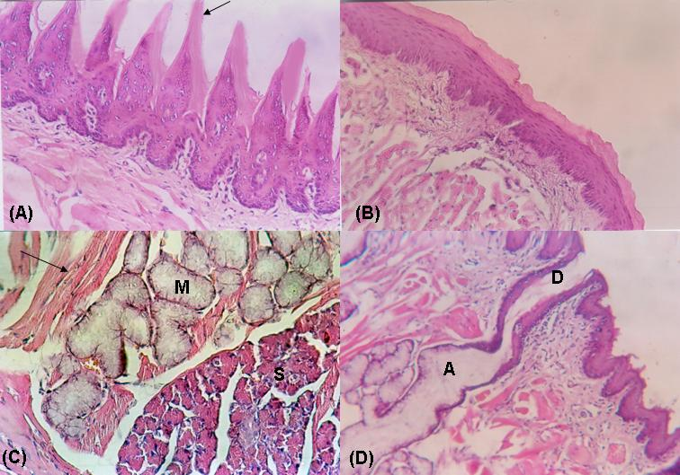
Plate 1: Hx & E of control group.
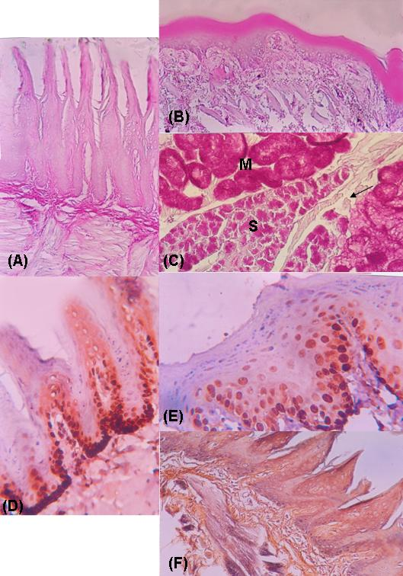
Plate 2: PAS & PCNA and Silver stains of control group.
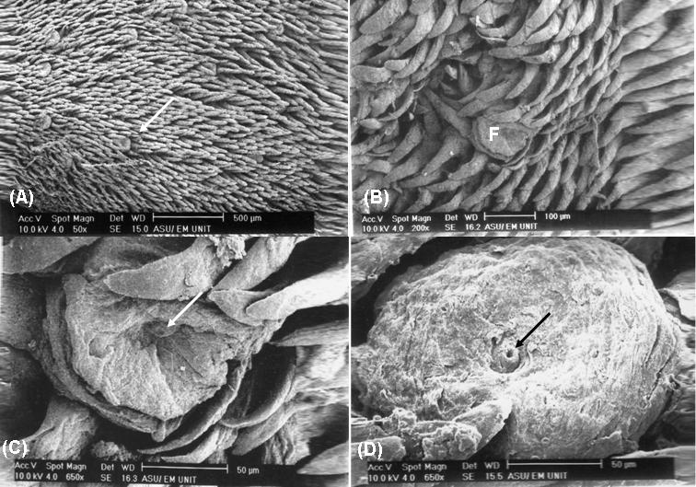
Plate 3: SEM of control group.

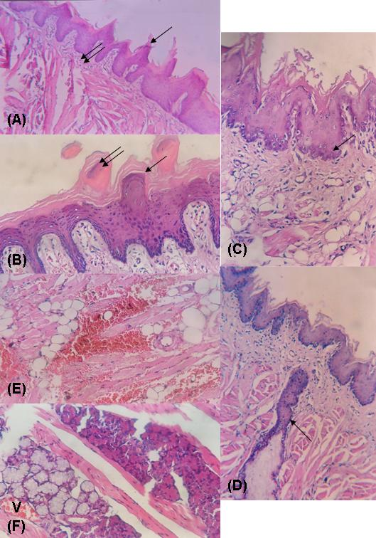
Plate 4: Hx & E of group IIA.

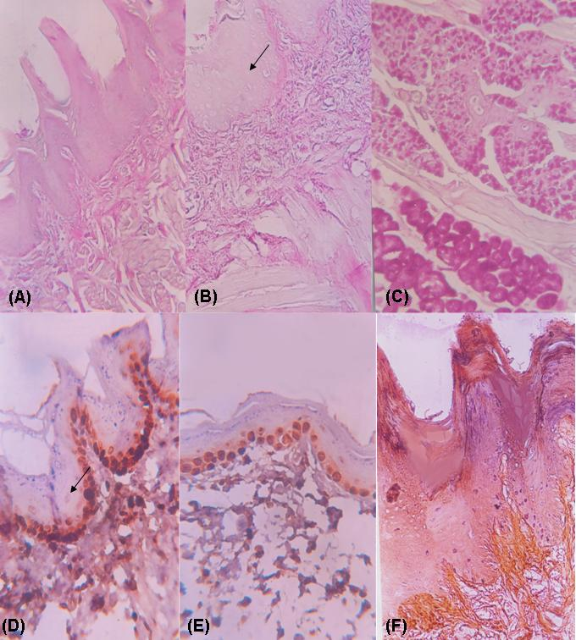
Plate 5: PAS & PCNA ans Silver stains of group IIA.

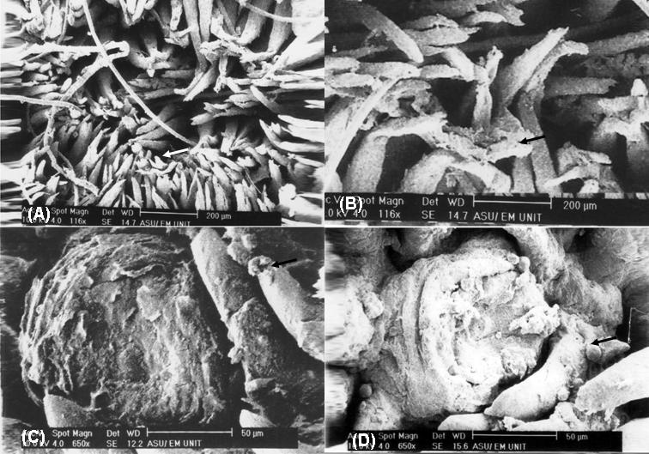
Plate 6: SEM of group IIA.

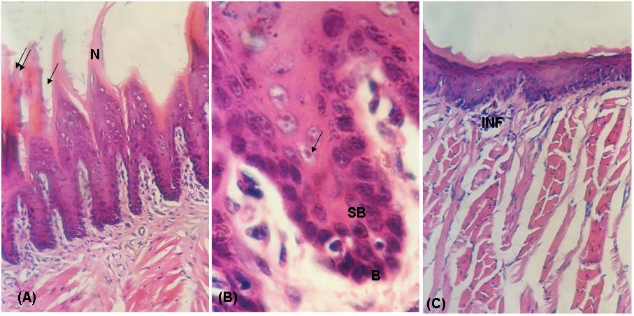
Plate 7: Hx & E of group IIB.

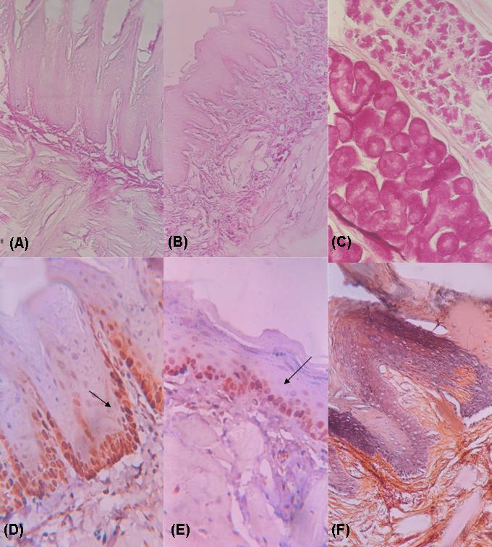
Plate 8: PAS & PCNA and Silver stains of group IIB.
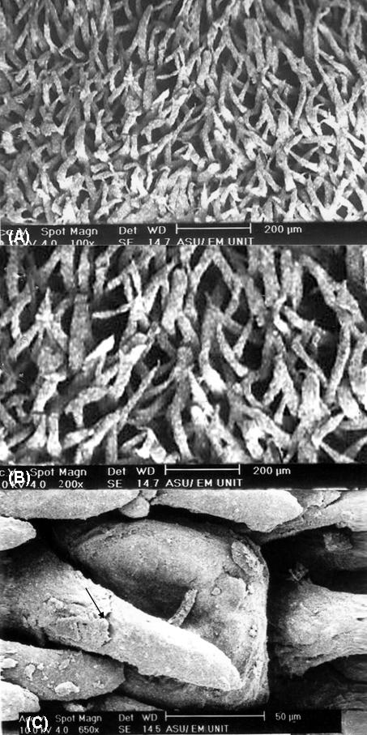
Plate 9: SEM of group IIB.

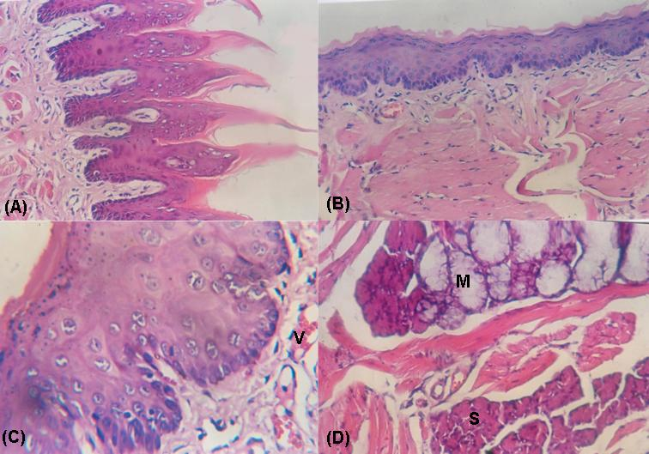
Plate 10: Hx & E of group IIC.
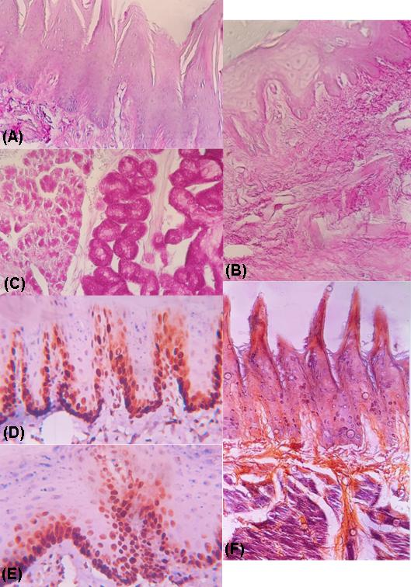
Plate 11: PAS & PCNA and Silver stains of group IIC.

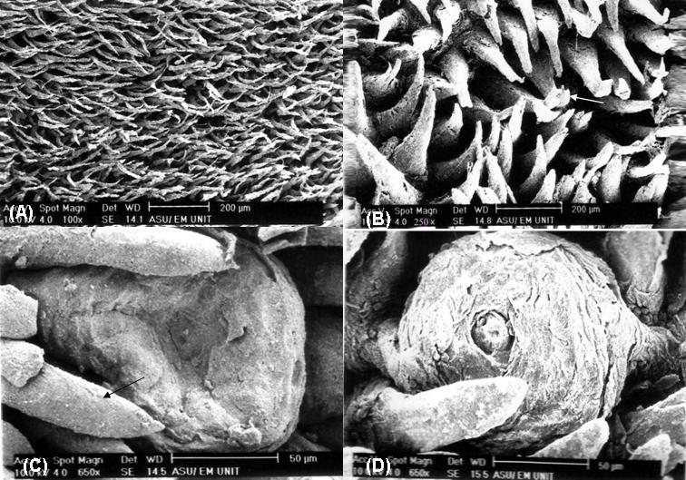
Plate 12: SEM of group IIC.

4. Discussion:
Iron deficiency is the most common cause of anemia worldwide (9). The oral mucous membrane is highly sensitive and its integrity is affected by adequate supply of nutrients including iron (2).The aim of this work was to study the effect of iron-deficient diet on the structure of adult male albino rats' tongue using light and scanning electron microscopes and to clarify the biochemical changes of serum iron, Hb as well as changes in body weight of different studied groups. The results of this study revealed significant decrease in the mean body weight, mean serum levels of Hb and iron in iron-deficient group IIA compared to control group I. These results were in agreement with others (10) who attributed these changes to the –ve effect of iron deficiency on serum levels of iron, Hb, skeletal muscle myoglobin and cytochrome C concentration. In addition, Other researchers (11) reported that iron deficiency causes depletion of hemoglobin and myoglobin resulting in lowering oxygen carrying capacity of skeletal muscle and reduction in mitochondrial oxidative capacity due to decrease of intracellular iron. Recently, (12) attributed the decrease of body weight to the associated glossitis, glossodynia and recurrent oral ulcers which impair the food intake and subsequently resulted in decrease body weight. Also, Ghosh et al. (13) reported that low intake of total dietary iron causes lowering serum level of iron, the same as reported in this study. They added that the poor iron absorption was the common cause of iron deficiency anaemia. The present study revealed that section of tongue was formed of masses of skeletal muscles arranged in different directions and covered in its dorsal surface by thick, rough and firmly adherent mucous membrane having lingual papillae, while the ventral surface was smooth, devoid of lingual papillae and covered by stratified squamous epithelium. These results were in harmony with what was reported by others (14) who added that the filliform papillae are the most common type of papillae on the dorsum of the tongue. Moreover, Other researchers (15) found two subtypes of filliform papillae; one type has pointed tip at the intermolar eminence and the other type has rounded tip in the anterior tongue. The iron-deficient group IIA revealed atrophy of lingual papillae. They appeared short, irregular or completely lost in some area with keratin replacement. These results could be explained by the fact that iron deficiency produces an impairment in iron metabolism and kinetics of the rapidly dividing oral epithelial cells including tongue mucosa (2).Moreover, oral mucous membrane is highly sensitive and its integrity is affected by adequate supply of nutrients including iron (12). The mononuclear inflammatory cell reaction in the lamina propria together with congestion of blood vessels and extra-vasation of blood in between muscle fibers and thinning of epithelial covering, recorded in this study, were signs of inflammatory changes associated with iron deficiency. The same as recorded by others who attributed the occurrence of glossitis, glossodynia and recurrent oral ulcers to the iron deficiency in diet (12). The apparent decrease in size of mucous and serous lingual salivary acini together with atrophy and obliteration of their duct, observed in this study, might be the cause of dryness of tongue and the associated glossodynia and angular cheilitis reported by others in case of iron deficiency (12). The basal cell layer of mucous membrane of iron deficient group IIA revealed apoptosis of cells with pyknosis of their nuclei and appearance of peripheral hallow. Also the supra basal cells revealed hypocellularity and apparent decrease in number. These changes were explained previously by others (16) on the basis that iron deficiency causes decrease epithelial thickness due to decrease number of maturating supra-basal layer resulting in epithelial atrophy. Moreover, Koch et al. (17) reported that iron deprivation induces apoptosis via mitochondrial changes related to Bax translocation to mitochondria, collapse of mitochondrial membrane potential, release of cytochrome C from mitochondria and activation of caspase-9 and caspase-3. The results of SEM were coincided with what was observed by L/M. The lingual papillae appeared short, widely separated, irregularly arranged and absent in some area. The upper portion of some papillae appeared bisected. Furthermore, some papillae showed desqumation of their epithelial lining and rounded structure could be seen on some papillae. These structures might be bacterial or fungal colonies. This was supported by others (12) who reported that the main oral signs and symptoms of iron deficiency was the occurrence of glossitis and oral candidosis. Experimental and clinical data suggest that there is an increase risk of infection during iron deficiency because iron is a critical component of peroxide- generating enzymes and nitrous oxide generating enzymes that are critical for the proper enzymatic functioning of immune cells (18). Moreover, others (19) reported presence of groups of microorganisms attached to the cell membrane of filliform papillae of rat's tongue and attributed this adhesion to the interaction between fibrillar components and the structure of microplicae (20). Howele and Carrier (21) also described observations about the adhesion of candida albicans on the surface of lingual papillae. The mechanism of this adhesion has not been clarified.However, Motoyama et al. (19) reported that the proteins of streptococci may provide the adherence of microorganisms on the epithelial cells of filliform and fungiform papillae. Tongue sections of iron deficient group IIA revealed decrease PAS +ve reaction. This could be due to iron deficiency. Previous morphological and biochemical studies have shown that iron deficiency causes mitochondrial dysfunction in heart and skeletal muscles (22). Also, Walter (9) reported that iron deficiency causes decrease of mitochondrial cytochrome concentration and gluconeogenesis and subsequently glycogen deposition. Proliferating cell nuclear antigen (PCNA), acidic non histone nuclear protein, is important for DNA synthesis. It allows DNA polymerase to initiate leading strands for DNA synthesis. PCNA expression may be used as marker of cell proliferation and for detection of stem cell regeneration (23). The present study revealed +ve PCNA reaction of the nuclei of the basal layer of tongue of group IIA similar to control group denoting hyperplasia. However, the supra-basal layer revealed –ve PCNA reaction compared to control group denoting hypocellularity and atrophy of the supra-basal layer. The possible explanation for the hyperplasia of the basal layer associated with iron deficiency could be due to the trophic effect consequent on the reduce epithelial thickness. This is because the smaller size and atrophy of the supra-basal cells could result in decrease concentration of inhibitory chalone, which in turn could lead to a proliferative response in the basal layer(16). Mairko et al (24) reported that production of lipid peroxides and other free radicals partly depends on the catalyzing function of iron. However, Kuntson et al. (25) added that both iron deficiency and continuous iron supplement increase lipid peroxidation which has contributing factor in induction of diseases such as atherosclerosis, cancer and aging. Moreover, iron deficiency causes impairment function of mitochondrial respiratory chain and DNA damage resulting in inhibition of cell proliferation and apoptosis induction (17) & (26). Silver stain demonstrated apparent increase of reticular fibers in lamina propria of group II A denoting fibrosis associated with inflammatory reaction and glossitis resulting from iron deficient diet (12). Administration of balanced diet to rats of group IIB resulted in little improvement of the histological picture as well as SEM appearance; some papillae appeared with normal tapering tips, while others appeared with blunted or bisected tips. Some basal cell nuclei showed pyknosis with peripheral hallow, while others appeared normal. The keratin layer of the ventral surface appeared irregular with focal area of detachment and the inflammatory reaction was still persistent. All these findings indicate that the balanced diet alone is not sufficient to correct the alteration in the histological structure of tongue. However, the biochemical measurements showed significant improvement compared to group IIA. This could be explained on the basis that histological changes that occurred at any tissue need long time to return back to the normal healthy state. On the contrary, the histological structure as well as the electron microscopic pictures of iron supplemented group IIC revealed good improvement as most of lingual papillae appeared regularly arranged with intact tapering tips. The ventral surface appeared with intact covering keratin. Moreover, the basal and supra- basal cells revealed mitotic figures. The PAS reaction appeared +ve like control group. PCNA reaction appeared frankly +ve denoting hyperplasia of the supra basal layer. The reticular fibers of the lamin apropria appeared within the normal amount. SEM results revealed long conical shaped, regularly arranged lingual papillae mostly with tapering tips. Only very few papillae appeared with bisected tips. The fungiform papillae appeared with intact smooth upper surface with visible intact taste pore. Moreover, the biochemical analysis of serum iron and Hb as well as body weight of rats of this group showed highly significant improvement compared to group IIA denoting the importance of iron supplement. Iron has been shown to be essential for cell proliferation and maintaining the cell viability (27). It is an irreplaceable compound of key enzymes of the mitochondrial respiratory chain and of ribo-nucleotide reductase, an enzyme responsible for deoxy ribo-nucleotide synthesis (28). Considering the roles of these enzymes within the cell, it is not surprising that iron deficiency could lead to impaired function of the mitochondrial respiratory chain and DNA damage resulting in inhibition of cell proliferation and apoptosis induction (26)&(29). It is concluded that iron deficiency causes significant decrease of body weight, decrease of serum levels of iron and Hb. It also causes alteration of the histological structure of tongue on both light and electron microscopic levels. Iron supplement resulted in improvement of body weight, serum iron and Hb levels together with amelioration of the histological structure as well as SEM appearance. Dietary iron supplement is recommended for those subjects who need iron as children and women of reproductive age. Further studies should be done for long period and in different organs.

Corresponding author:
Haitham Mohamed Sewilam El Bassiouny
Histology Department, Faculty of Medicine, Menoufiya University, Egypt.
E-mail: Elkashefdalia@yahoo.com

References:
- Agarwal, T., Kochar, G.K. and Goel, S. (2008): Impact of iron supplementation on anemia during pregnancy. Ethnomed; 2:149-151.
- Van Wyk, C. and Steenkamp, V. (2011): Host factors affecting oral candidiasis. Epidemiol Infect; 26:18-21.
- Osaki, T., Ueta, E., Arisawa, K., Kitamura, Y. and Matsugi, N. (1999): The pathophysiology of glossal pain in patients with iron deficiency and anemia. Am J Med Sci; 318:324-329.
- Fernandes, M.I., Galvào, L.C., Bortolozzi, M.F., Oliveira, W.P., Zucoloto, S. and Bianchi, M.L. (1997): Disaccharidase levels in normal epithelium of the small intestine of rats with iron-deficiency anemia. Braz J Med Biol Res; 30:849-854.
- Paget, G. and Barnes, J. (1964): Evaluation of drug activity. London: Academic Press.
- Kiernan, J. A. (2002): Histological and histochemical methods: theory and practice. 3rd ed., Arnold publisher, London, New York & New Delhi: 111-162.
- Estes LW and Apicella JV (1969): a rapid embedding technique for SEM. Lab. Invwst; 20:159-164.
- Rosner, B. (1990): Fundamentals of Biostatistics, 3rd edition BWS Kent publishing Co. Boston. P 111- 115.
- Walter, P.B., Knutson, M.D., Paler-Martinez, A., Lee, S., Xu, Y., Viteri, F.E. and Ames, B.N. (2002): Iron deficiency and iron excess damage mitochondria and mitochondrial DNA in rats. Proc Natl Acad Sci USA; 99:2264-2269.
- Hagler, L., Askew, E.W. and Neville, J.R. (1981): Influence of dietary iron deficiency on hemoglobin, myoglobin, their respective reductases and skeletal muscle mitochondrial respiration. American Journal of clinical nutrition 34: 2169- 2177.
- Thompson, C.H., Green, Y.S., Ledingham, J.G., Radda, G.K. and Rajopalan, B. (1993): the effect of iron deficiency on skeletal muscle metabolism of the rat. Acta physiol Scand, 147, 85-90.
- Lu, S.Y. and Wu, H.C. (2004): Initial diagnosis of anemia from sore mouth and improved classification of anemias by MCV and RDW in 30 patients. Oral Surg Oral Med Oral Pathol Oral Radiol Endod., 98:679–685.
- Ghosh, K. (2006): Non haematological effects of iron deficiency – a perspective. Indian J Med Sci; 60:30–37.
- Mescher, A. L. (editor) (2013): Junqueira's Basic Histology (Text&Atlas). 13 ed. NY. London. Mc Graw Hill Medical; pp:289-292
- Kawasaki K, Porntaveetus T, Oommen S, Ghafoor S, Kawasaki M, Otsuka-Tanaka Y, Blackburn J, Kessler JA, Sharpe PT, Ohazama A. (2012): Bmp signalling in filiform tongue papillae development. Arch Oral Biol; pp: 18-20.
- Scott, Valentine JA, Sthill CA and West CR (1985): morphometric analysis of atrophic changes in human lingual epithelium in iron deficiency anaemia. J Clin Pathol; 38:1025 – 1029.
- Koc M, Nad, Ova Z, Truksa J, Ehrhichova M and Kovar J (2005): Iron deprivation induces apoptosis via mitochondrial changes related to Bax translocation, Apoptosis; 10: 381 – 393.
- Hershko C (1996): Iron and infection. Iron Nutr. Health Dis. 22: 231 – 238.
- Motoyama AA, Watanabe LS, Semprini M, Lopes RA, Iyomasa MM and Mizusaki CI (1999): Scanning electron microscopy of the rat tongue mucosa with special attention to the bacteria on epithelial membranes. Braz Dent J, 10 (1): 1 – 60.
- Tokunaga M, Niimi M, Kusamichi M, and Koike H (1990): Initial attachment of candida albicans cells to buccal epithelial cells. Mycopathologia, 111: 61 – 66.
- Howelett, J.A. and Swier, C.A. (1980): Candida albicans ultra structure:colonization and invasion of oral epithelium. Infect. Immun 29: 252 – 260
- Dalman, P.R. (1986): Iron deficiency causes mitochondrial dysfunction in heart and skeletal muscles. Anno. Review Nutr, 6: 13-40.
- Phillipsen HP, Barnes L, Everson JW, Reichart P, Sidransky D (2005): Pathology and Genetics of Head and Neck Tumors. Lyon: IARC Press; WHO classification of tumors; pp. 306-07.
- Mariko U, Chiba H, Mogi H, Suzuki K and Goto S (1997): Induction of increased phosphotaidylcholine hydro peroxide by an iron – deficient diet in rats. Nutritional Biochemistry 8: 385 – 391.
- Knutson M D, Walter P B,Ames, Ames B N and Viteri F E (2000): Both iron deficiency and daily iron supplements increase lipid peroxidation in rats. J Nutr. 130: 621 – 628.
- Simonart T, Boelaett J R and Moselinans S R (2002): Anti proliferative and apoptotic effect of iron chelators on human cervical carcinoma cells. Gynocol Oncol: 85: 95 – 102.
- Richandson L DR (2002): The role of iron in cell cycle progression and the proliferation of neoplastic cells. Biochem. Biophys. Acta, 1603: 31 – 46.
- Lill R, Diekret K and Kaut A (1999): the essential role of mitochondria in the biogenesis of cellular iron – sulfur proteins. Biol. Chem; 380: 1157 – 1166.
- Ragba N, Loyer P and Gilot D (2000): anti proliferative and apoptotic effect of otrensox, a new synthetic iron chelator, on differentiated human hepatoma cell lines, Carcinogenesis 21: 943 – 951.

5/21/2015

