**Termites’ resistance of wood treated with *Lagenaria breviflora* B. Robert fruit pulp extract**

1Emerhi, E. A., 2Adedeji, G. A. and 3Ogunsanwo, O. Y.

1Department of Forestry and Wildlife, Delta State University, Asaba, Nigeria

2Department of Forestry and Wildlife Management, University of Port Harcourt, Nigeria

3Department of Forest Resources Management, University of Ibadan, Nigeria

[gabriel.adedeji@uniport.edu.ng](mailto:gabriel.adedeji@uniport.edu.ng)

**Abstract:** Synthetic chemicals have been the standards to extend the service life of wood for many years across the globe. But with the passage of time, many problems associated with their habitual uses became conspicuous with a ban on their usage in many countries. In recent times, exploring biocides of plants origin has been intensified with a view to replacing these chemicals. *Lagenaria breviflora* fruit pulp extract has broad spectrums of antimicrobial property. However its wood protection potential has not been reported. Therefore, this study was undertaken to assess the termites’ resistance of *Lagenaria breviflora* fruit pulp extractin *Triplochiton scleroxylon* wood under field test. Fruit’s pulp extract of *L. breviflora* was extracted using juice extractor. The wood blocks’ samples (8 replicates) of *T.* *scleroxylon* were treated with 5 mL, 10 mL, 15 mL, and 20 mL of the juice extract in 0.75 L of distilled water for 24 hours. The treated wood samples were exposed to termites using soil contact exposure method at the Institute of Agricultural Research and Development Conservation Plot (IARDCP), University of Port Harcourt for three months. Absorption of extractives at the tested concentrations showed no significant difference but was highest at 15 mL, followed by 10 mL, 20 mL, and 5 mL. In vitro studies revealed 20 mL treatment showing strongest resistance by reducing 70.18% weight loss of control to 24.31%, followed by 15 mL to 45.28%, 10 mL to 48.59%, and 5 mL to 65.24%. The results of this study showed the efficacy of the extract to control termites using higher quantity of the fruit juice extractive. *Lagenaria breviflora* fruit can be a very promising biocide for wood protection because of its better resistance performance at 20 mL concentration, abundance and renewability.

**[**Emerhi, E. A., Adedeji, G. A. and Ogunsanwo, O. Y. **Termites’ resistance of wood treated with *Lagenaria breviflora* B. Robert fruit pulp extract.** *Nat Sci* 2015;13(5):105-109]. (ISSN: 1545-0740). <http://www.sciencepub.net/nature>. 13

**Keywords:** Degradation agent; ground contact exposure method; treatability; weight loss; wood

**1. Introduction**

Wood preservation industry has produced many effective synthetic chemicals that have helped to protect wood products under varying services conditions against degradation agents for many years across the globe. However, with the passage of time many problems associated with their habitual uses became inimical to the survival of humans and thus banned in many countries. In the quest to develop environmental friendly suitable alternatives, exploring biocides of plant origin has become viable option. Hence, anti-degradation potential of plants extractives researches for wood protection has been intensified. The rationale behind the great attention being given to plants extracts as possible alternatives were due to their safe utility, notable extract yield, known antimicrobial properties, and anti-termites activity of some of the plants’ parts. The wood protection use of some of plant extractives are well known, but methods of obtaining some of them are destructive and not sustainable because it may involve felling of trees in case of heartwood extractives. Exploring fruits of weeds like *Lagenaria breviflora* for wood protection will not only contribute to the ultimate aim of solving global environmental problem but will also help to conserve trees that their parts extractives have shown excellent wood degradation protection activity for more pressing need.

*Lagenaria breviflora* (formerly *Adenopus breviflorus*) family Curcurbitaceae is a common climber weed found in disturbed vegetation in Nigeria. The fruits and its juice have been traditionally used in southwestern Nigeria as curative and preventive measures for measles, smallpox and fowl Newcastle disease. The potency of this indigenous knowledge against Fowl Newcastle Disease has been scientifically assessed (Sonaiya, 2000). The fruit has shown immense potential as anti-inflammatory and analgesic (Bernard and Olayinka, 2010; Onasanwo *et al.,* 2011; Oridupa and Saba, 2012), anti-nociceptive (Onasanwo *et al.,* 2011), anti-implantation activity (Elujoba *et al.,* 1985), anti-ulcerogenic (Onasanwo *et al*., 2010), Miracicidal and Cercaricidal activities (Ajayi, *et al.,* 2002), antioxidant (Bernard and Olayinka, 2010; Onasanwo *et al*., 2010), antimicrobial activity (Adesina and Akinwusi, 1984; Tomori *et al*., 2007). The excellent depilation effectiveness of *L. breviflora* fruit pulp has also been traditionally explored in processing of cow hide to edible product (pomo), and small animal skin into fine leather for drums production in Nigeria. Aiyeloja *et al*., (2015) pointed out that the use of *Lagenaria breviflora* fruit pulp was not limited to depilation capability but also impacted preservative property against leather boring insects. Regrettably, the fruit has not been explored for protection of wood products against wood attacking insects. To protect wood from termites and other biodegradation agents, natural preservatives from climber weed parts could be a better attractive alternative than any other natural materials. In the light of this, this study was undertaken to assess the anti-termites activity of *Lagenaria breviflora* fruit pulp juice under external environmental condition in the University of Port Harcourt, Nigeria.

**2. Materials and Methods**

**2.1 Study area**

The test yard was located at the Institute of Agricultural Research and Development Conservation Plot (IARDCP), Abuja campus (Latitude 4o 53’ 25’’ and 4o 54’ 35’’N and Longitude 6o 54’ 25’’ and 6o 55’ 55’’E) of the University of Port Harcourt (UNIPORT). The university falls within humid region characterized with two seasons, the dry season (November to March) and wet season (April to October). The rainfall distribution is nearly all year round though its intensity is seasonal and variable (Adedeji and Emerhi, 2015). The monthly mean maximum temperature ranges from 28oC to 33oC while the monthly minimum temperature ranges from 17oC to 24oC (Ogbonna *et al.,* 2007). The study area was highly prone to termites attack and other biodegradation agents.

**2.2 Preparation of the extract**

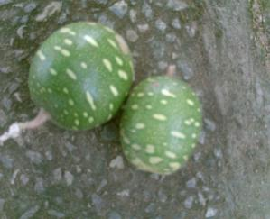

**Fig. 1: *L. breviflora* fruits**

Unblemished fruits of *L. breviflora* (Fig. 1) were collected from Choba campus of UNIPORT in November, 2014. The fruits were washed clean to remove any adhering dirt. The fruits pulp juice was extracted using juice extractor after the removal of their bark and seeds.

**2.3 Treatment of test wood blocks**

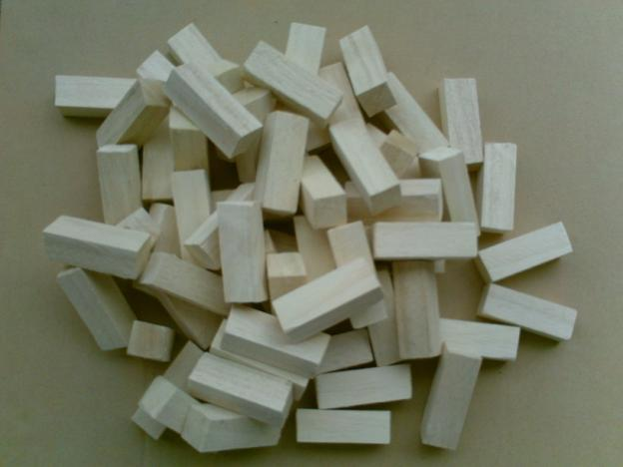

**Fig. 2: *Triplochiton scleroxylon* wood samples**

A total of 40 wood specimens (test blocks) of dimension 2 x 2 x 6 cm were obtained from 22 years *Triplochiton scleroxylon* wood samples (Fig. 2) in the Wood Laboratory Unit of the Department of Forest Resources Management, University of Ibadan. The wood test blocks were oven dried to constant weight at 103±2oC for 22 hours, conditioned, and weighed as **W1**. The wood blocks’ samples (8 replicate) of *T.* *scleroxylon* were treated with 5 mL, 10 mL, 15 mL, and 20 mL of the juice extract in 0.75 L of distilled water for 24 hours. After 24 hours of soaking, the treated wood blocks were removed from the treatment solutions, drained, and reweighed as **W2** to determine gross absorption of the extractives. The treated test blocks were then re-oven dried at 103±2oC for 22 hours, conditioned and reweighed as **W3** prior exposure to field test. The absorption of extractives was calculated thus:

**Absorption, kg/m3 = 1000(G) /V**

Where **G** = (**W2-W1) =** amount of the treating solution absorbed by the test wood blocks (g),

**W1** = is the oven dried weight of the conditioned wood blocks before treatment (g),

**W2 =** is the weight after treatment,

**V** = volume of wood test block (24cm3).

**2.4 Field test**

A total of forty samples, comprising 8 replicate of each treatment (5 mL, 10 mL, 15 mL, 20 mL) including control were exposed to termites attack at the Institute of Agricultural Research and Development Conservation Plot (IARDCP), UNIPORT at 0.5m apart for three months using ground contact exposure method and covered with leaves following the method of Lenz *et al.* (2003) to evaluate termites degradation resistance. After a period of three months of exposure, the test wood blocks were removed, taken back to laboratory, rinsed and scrubbed to remove all soil particles, and then finally re-oven dried at 103±2oC for 22 hours, conditioned and weighed as **W4**. The weight loss was calculated in percentage thus: **Wood block weight loss% =** **[(W3-W4)/W3] x 100.**

Where **W3** = is the oven dry weight before degradation exposure test,

**W4** = is the oven dry weight after degradation test.

**3. Results**

**3.1 Absorption of extractives**

The absorption rate ranged between 190.10±34.49 and 206.77±35.13 Kg/m3 with the 15 mL concentration having highest absorption (Table 1)

**Table 1: Analysis of variance (ANOVA) for absorption of extractives by *T. scleroxylon* wood**

|  |  |
| --- | --- |
| **Treatment** | **Mean (Kg/m3)** |
| Control | 0.00±0.00a |
| 5 mL | 190.10±34.49b |
| 20 mL | 193.75±42.66b |
| 10 mL | 197.91±46.02b |
| 15 mL | 206.77±35.13b |

Mean with the same alphabet are not significantly different from each other at α = 0.05

**3.2 Antitermites activity the juice extract**

The mean percentage weight loss due to field termites attack ranged between 24.31±11.57 and 70.18±03.48% with the 20 mL showing strongest resistance (Table 2).

**Table 2: Analysis of variance (ANOVA) for wood weight loss caused by termites**

|  |  |
| --- | --- |
| **Treatment** | **Mean (%)** |
| Control | 70.18±03.48a |
| 5 mL | 65.24±20.38ab |
| 10 mL | 48.59±28.10bc |
| 15 mL | 45.28±11.13c |
| 20 mL | 24.31±11.57d |

Mean with the same alphabet are not significantly different from each other at α = 0.05

**4. Discussion**

Absorption of extractives at the tested concentrations showed no significant difference. However, absorption was highest at 15% concentration, followed by 10%, 20%, and 5%. This result suggested that little variation existed on the viscosity and diffusivity impacts of pulp extractives in the aqueous diluents. Absorption ranged of 190.10±34.49 and 206.77±35.13 Kg/m3 obtained in this study were substantially higher than those previously reported by Omole and Onilude (2000) 24.9 Kg/m3,Olajuyigbe *et al.* (2010) ranged of 54.86 - 64.90 Kg/m3, Ogunsanwo and Adedeji (2010) ranged of 70.37 - 117.13 Kg/m3. This variation in solution uptake was likely the result of differences in period of treatment, diluents and preservatives used.

The test yard was found infested with many species of termites among which were *Amitermes evuncifer* Silvestriand *Macrotermes bellicosus* Smeathman, and many unidentified *Microtermes* spp. The test yard is known for severe termites’ infestations, and the present observations confirmed earlier reports (Aiyeloja *et al.*, 2014; Adedeji *et al.*, 2015). Despite the prevalent of high atmospheric moisture and abundance of soil moisture in the study area, no fungal activity was observed on the wood species in the test yard, most likely due to the method of exposure adopted. Hence, the weight loss of wood in the experimental layout was found to be exclusively due to termite attack. However, the impacts of precipitation on leaching of extractives from the test blocks and thus reduced the antitemites’ potentials could not be completely ruled out. The termites species found degrading the test blocks was unidentified but evidenced of their body size showed the species was *Microtermes* sp characterized with aggressive degradation of the blocks and filling the voids created with clay material.

Resistance of *L. breviflora* fruits pulp extractives at varying concentrations in *T. scleroxylon* wood was assessed by ground contact exposure method for three months. All the treated sample blocks showed significant level of resistance to termites attack as reflected by the various mean weight loss values in Table 2. The control samples (Fig. 3) suffered the highest level of damage (70.18±03.48% weight loss) while 20 mL treatment test blocks (Fig. 4) had the least level of damage (24.31±11.57% weight loss) by termites. This result further confirmed that *T. scleroxylon* wood is non-resistant. Analysis of variance (Table 2) showed that the resistance to termites attack significantly increased with increasing extractives concentration. The result indicated that the anti-termites active ingredient showed stronger resistance at higher concentrations. It seemed higher concentration tended to have stronger close bond of active ingredients against the termites, hence provided better resistance to ground termites attack in the treated woods. Though, the anti-degradation activity of *L. breviflora* fruits pulp extractives against termites has not been reported however, the better performance exhibited at higher concentration in this study was similar to those of Oridupa and Saba, (2012) who reported better anti-inflammatory and analgesic performance *L. breviflora* fruits pulp extract at higher dose in rats.

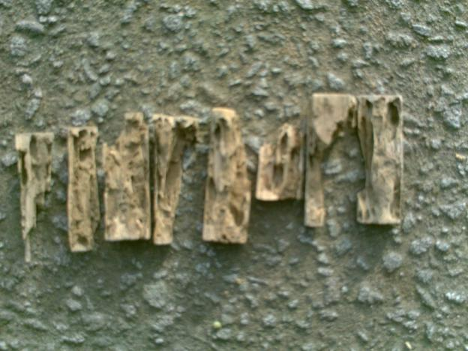

**Fig. 3: Degradation of control samples by termites after 3 months of exposure**

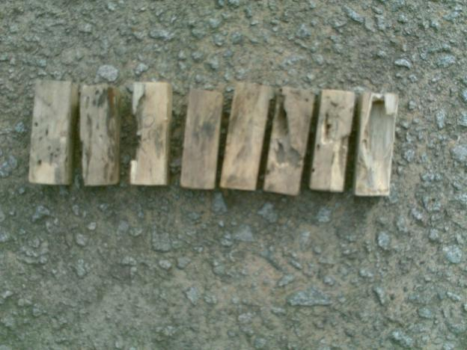

**Fig. 4: Degradation of 20 mL treatment test blocks by termites after 3 months of exposure**

**5. Conclusion**

Treatment of *T. scleroxylon* with *Lagenaria breviflora* fruits pulp extractives provided better resistance at 20 mL by reducing 70.18% weight loss of control to 24.31%, followed by 15 mL to 45.28%, 10 mL to 48.59%, and 5 mL to 65.24%. The results of this study demonstrated the efficacy of the extract to control termites using higher quantity of the fruit juice extractive. *Lagenaria breviflora* fruit can be a very promising biocide for wood protection because of its better resistance performance at 20 mL concentration, abundance and annual renewability.

**Corresponding Author**

Adedeji, G. A.

Department of Forestry and Wildlife Management,

Faculty of Agriculture, University of Port Harcourt,

Nigeria.

[gabriel.adedeji@uniport.edu.ng](mailto:gabriel.adedeji@uniport.edu.ng)

**References**

1. Adedeji G. A. and Emerhi, E. A. 2015. Occupancy of *Azadirachta indica* A. Juss. by fungus and termites in Port Harcourt: Implications for integrated protection strategies. IOSR Journal of Environmental Science, Toxicology and Food Technology (IOSR-JESTFT), 9(2-III): 68-72.
2. Adedeji, G. A., Emerhi, E. A. and Nyenke, E. 2015. Incidence and Severity of Termites Infestations on *Azadirachta indica* A. Juss. used as Avenue trees in University of Port Harcourt, Nigeria. IOSR Journal of Agriculture and Veterinary Science (IOSR-JAVS), 8(2-II): 123-126.
3. Adesina, S. K. and Akinwusi, D. D. 1984. Biological effects of *Calliandra portoricensis* and *Lagenaria breviflora* extracts. Fitoterapia, 55(6): 339-342.
4. Aiyeloja, A. A., Adedeji, G. A. and Adebisi, L. A. 2015. Suitability of *Gmelina arborea* (roxb.) wood for making talking drum in Ibadan, Nigeria. Journal of Agriculture and Veterinary Science (IOSR-JAVS), 8(2-II): 95-100.
5. Aiyeloja, A. A., Adedeji, G. A. and Larinde, S. L. 2014. Influence of seasons on honeybee wooden hives attack by termites in Port Harcourt, Nigeria. International Journal of Biological Veterinary, Agricultural and Food Engineering, 8(8):734-737.
6. Ajayi, G. O., Awujo, N. C. and Abulu, L. E. 2002. The Miracicidal and Cercaricidal Activity of the Methanolic Extracts of *Lagenaria breviflora* Robert Family Cucurbitaceae fruit on *Schistosoma mansoni*. Nigerian Quarterly Journal of Hospital Medicine, 12(1-4): 57-59.
7. Bernard, S. A. and Olayinka, O. A. 2010. Search for novel antioxidant, anti-inflammatory/analgesic or anti-proliferative: Cucurbitacins hold the ace. J. Med. Plants Res., 4: 2474-2488.
8. Elujoba, A. A., Olagbende, S. O. and Adesina, S. K. 1985. Anti-implantation activity of the fruit of *Lagenaria breviflora* Robert. J. Ethnopharmacol., 13: 281-288.
9. Lenz, M., Creffield, J. W., Evans, T. A., Kard, B. M., Vongkaluang, C., Sornnuwat, Y. and Preston, A. F. 2003. International comparison of three field methods for assessing the in-ground resistance of preservative-treated and untreated wood to termites and fungal decay - Summary of observations after five years. IRG/WP 03-20261. International Research Group on Wood Protection, Stockholm. 19 Pp.
10. Ogbonna, D. A., Amangabara, G. T. and Ekere, T. O. 2007. Urban solid waste generation in Port Harcourt metropolis and its implications for waste management. Management of Environmental Quality, 18 (1): 71-88.
11. Ogunsanwo, O. Y. and Adedeji, G. A. 2010. Effect of bark extract of Erythrophleum suaveolens (Guillemin & Perrottet) Brenan on fungal activities in wood of *Triplochiton scleroxylon* K. Schum*.* Journal of Environmental Extension, 9: 56-62.
12. Olajuyigbe, S. O, Ogunsanwo, O. Y. and Adegeye, A. O. 2010. Compressive strength in heartwood extract of teak (HWE) treated hardwoods after exposure to white rot attack. International Journal of Biological and Chemical Sciences, 4(3): 571-578.
13. Omole, A. O. and Onilude, M. A. 2000. Study on use of engine oil as wood preservative. Journal of Tropical Forest Resources, 16(1): 66-71.
14. Onasanwo, S. A., Saba, A. B., Oridupa, O. A., Oyagbemi, A. A. and Owoyele, B. V. 2011. Anti-nociceptive and anti-inflammatory properties of the ethanolic extract of *Lagenaria breviflora* whole fruit in rat and mice. Nig. J. Physoil. Sci., 26: 71-76.
15. Onasanwo, S. A., Singh, N., Saba, A. B., Oyagbemi, A. A., Oridupa, A. O. and Palit, G. 2010. Anti-ulcerogenic and in vitro antioxidant of *Lagenaria breviflora* (LB) whole fruit ethanolic extractin laboratory animals. Pharmacognosy Res., 3(1): 2-8.
16. Oridupa, O. A. and Saba, A. B. 2012. Relative anti-inflammatory and analgesic activities of the whole fruit, fruit bark, pulp and seed of *Lagenaria breviflora* Roberty. Journal of Pharmacology and Toxicology, 7(6): 288-297
17. Sonaiya, E. B. 2000. Family poultry and food security: research requirements in science, technology and socioeconomics. Proceedings XXI Word’s Poultry Congress, August 20-24. Montreal, Canada.
18. Tomori, O. A., Saba, A. B. and Dada-Adegbola, H. O. 2007. Antibacterial activity of ethanolic extract of whole fruit of *Lagenaria breviflora* Robert. J. Anim. Vet. Adv. 6: 752-757.

4/22/2015