Analysis of the relationship between automation systems and decision of managers of Iran National Steel Industrial Group

Shahram kardani ¹, Dr. Milad Jasemi zargani ²

^{1.} Department of productivity system engineering, Persian Gulf International Branch, Islamic Azad university, khorramshahr, Iran
^{2.} Assistant Professor, Masjed Soleiman Branch, Islamic Azad university, Masjed Soleiman, Iran

Abstract: This study aimed to analyze the relationship between automation system and managers decision making of Iran National Steel Industrial Group. The used method in this research was descriptive. The statistical sample was consisted of 52 directors and deputies of Iran National Steel Industrial Group who were selected by census method. The data in the two descriptive and inferential sectors were analyzed by using one-sample t-test. And the results of this study in a significant level 05/0 showed that office automation system has a positive impact on manager’s decision of Iran National Steel Industrial Group. Also office automation system has a positive impact on the correctness of managers’ decisions, office automation system on the accuracy of manager’s decision, office automation system on timely manager’s decision making and office automation system on economic decisions of managers Iran National Steel Industrial Group.
[Shahram kardani, Milad Jasemi zargani. Analysis of the relationship between automation systems and decision of managers of Iran National Steel Industrial Group. Nat Sci 2015;13(5):99-104]. (ISSN: 1545-0740). http://www.sciencepub.net/nature. 12

Keywords: system, office automation systems, decision-making, Iran National Steel Industrial Group.

Introduction
Generally the decision is a mental process that all human beings are involved throughout their lives. Decisions is most important skill responsibility of a manager that in addition to decision to lead to run the process. Decision means the evaluation of existing solutions and the selection of the best option. Decision is cycle of activities included a five-stage diagnosis and definition of the problem or issue, problem analysis, determining the adequacy criteria for problem solving, and implementing strategies and planning procedure. Satisfactory strategy is helpful to address the many issues of educational management. However, when a set of solutions is non-defined, and the consequences of each of the solutions is unpredictable due to certain desired level, an additive strategy is more useful. Additive process for comparisons is successive and limited. Above model is introduced and formulated By Charles Lyndblvm (and Myksl Hoy, 1382).

Statement of problem
Nowadays, all information systems play an essential role in all activities of a company. Paying attention to successful companies shows that all of them are equipped with information systems for their daily activities. Having the related, rapid and detailed information increases the speed and accuracy of decision making and avoids the choice of many wrong decisions. In this schedule, an effective manager without having the essential information cannot lead the organization and reach to predetermined goals. It is believed that the essence of management is to make a correct decision and usually management is synonymous with the decision. A proper definition, making the choice means selecting a solution within different practical ways to solve problems and to use of opportunities (Taleghani, 1382). Unknown aspects of the study is understanding of the relationship between system automation and managers s decision making of Iran National Steel Industrial Group, Also the independent variable is the office automation system and the dependent variable is managers s decision making of Iran National Steel Industrial Group. Therefore, the purpose of the study analyzes the relationship between the office automation system and managers s decision making of Iran National Steel Industrial Group.

The overall objective
Determining the impact of office automation on managers’ decision making of Iran National Steel Industrial Group.

Secondary objectives
1. Determining the impact of automation on managers’ decision making of Iran National Steel Industrial Group.
2. Determining the impact of automation on the correctness of decisions of managers of Iran National Steel Industrial Group.
3. Determining the impact of office automation system on managers’ careful decision making of Iran National Steel Industrial Group.
4. Determining the impact of office automation system on the timeliness of decisions of managers of Iran National Steel Industrial Group.
5. Determining the economic impact of automation on managers s decision making of Iran National Steel Industrial Group.

Hypotheses
1. Office System Automation has a positive influence on managers’ decision making of Iran National Steel Industrial Group
2. Office Automation System has a positive impact on the correctness of administrators’ decision making of Iran National Steel Industrial Group
3. Automation System has a positive influence on the careful correctness managers’ decision making of Iran National Steel Industrial Group.
4. The office automation system has a positive impact on the timeliness of decisions of managers of Iran National Steel Industrial Group.
5. The automation has a positive influence on the economic system of managers’ decision making of Iran National Steel Industrial Group.

Concept
System: is a series of interconnected and interdependent elements that interact together to achieve common goals (Taleghani, 1382).
Automation: is a mechanism along improvement of the efficiency of the organization through planning effective and efficient management with the use of electronic flow of communications in level of the organization, Easy search for stored information, quick and timely response to clients, removing the paper from the office correspondence cycle, proper control over users, recording and storing data efficiently, improving communication within the organization (Taleghani, 1382).
Decision: It is believed that the essence of management is to make a decision and management is usually synonymous with decisions. In a proper definition, making decision means selecting a solution within different practical ways to solve problems and using of the opportunities (Taliqani, 1382).
Iran National Steel Industrial Group is a complex that was established in 1342 in Ahvaz, in order to produce a variety of plain and embossed steel. The big complex with an annual capacity of 1435000 tons of steel products with regard to supplying the needs of the major part of the country is a major exporter of steel products (the site of Iran National Steel Industrial Group, 1393).

Operational definitions
Decision: for assessing the decision of the directors was used the questionnaire, a questionnaire was used to measure the economic decisions of managers in four dimensions, Timeliness, accuracy and decision according to automation system.
Conceptual model

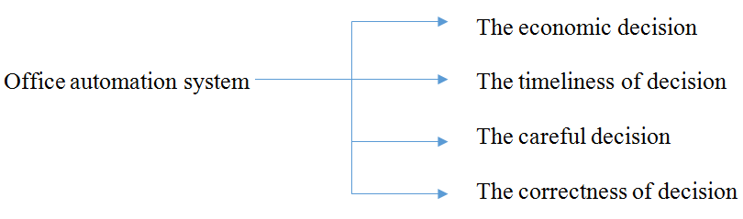

The statistical population
in this study the population consists of all directors and deputies of Iran National Steel Industrial Group that totally they were 52 persons Due to limiting of their lists was used census method, The whole population was considered as the volume of the sample.

Data
In this study was used the questionnaire to assess these variables.
Validity of the questionnaire was obtained by apparent validity on the basis of mutual agreement of professors and lecturers of the management team. Also To assess the construct validity of the questionnaire was used the test case kmo, bartletts, because the amount of the test795 / 0kmo = and the surface covered with Bartlett's chi-square for the index is equal to (bartletts = 0/000) and the level of significance is smaller(05/0), so the question of validity is appropriate.

Reliability
According to kind of the questions and answers, the most appropriate method for calculating the reliability or reliability of the questionnaire was Cronbach's alpha, After preliminary testing and information entrance into system by using Spss software was calculated reliability, The rate of 860/0 is obtained because it is over 7.0 it is acceptable.

Methods of data analysis
Data analysis was performed by descriptive and inferential statistics. In the level of descriptive statistics of the table, frequency distributions, graphs and indicators tend to center specially the mean and dispersion parameters such as variance, standard deviation and range. In the study, In order to analyze the data, was used spss statistical software that the following code was used in the descriptive study of descriptive statistics such as tables, graphs, mean, variance and standard deviation as well as in the statistical investigation of parametric t was used a single sample.
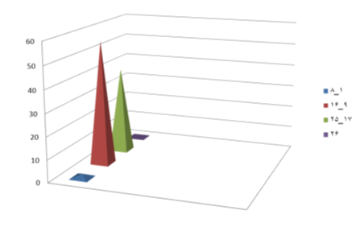
Figure 4.2 Distribution of ' years of service of respondents

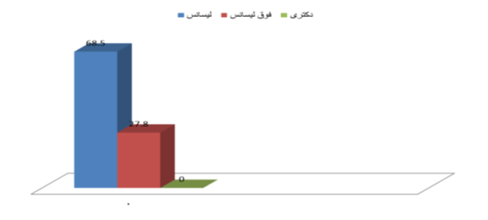
Figure 4-3 Distribution of 'educational level of respondents

As can be seen in Figure 4-2 more tests with years of service, 55.6% percent has service between 16-9 years, after that years of service17-25 years with38.9% percent and years of service 8-1 year’swith1.9 percentlie in the next term.
As can be seen in Figure 4-3 further 68.5% of respondents has bachelor’s degree, and after that with 27.8 percent have MA degree.

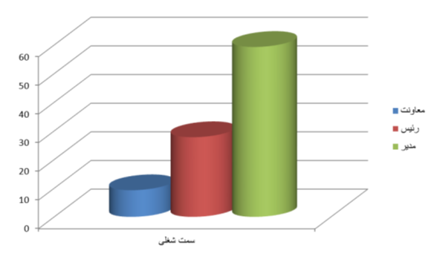Figure 4.4 Distribution of respondents' position

In Figure 4.4 it can be seen that 59.3 percent of respondents engaged as director and after that job positions of boss was27.8 percent assistant was9.3 percent.
Inferential statistics
First hypothesis: office automation system has a positive impact on improvement of managers’ decision making.

variables | number | The mean | Standard diversion | The mean of standard error
The decision of managers | 52 | 43.5385 | 11.78511 | 1.633402

This can be seen in Table 4.5, that the number of respondents was 52 people. Also the mean of the obtained responses in connection with the automation system to improvement of managers s decision making is equal to 43.532. And the standard deviation is equal to11.78 and the mean of standard error is1.63.

Table 4-6 one-sample t-test
variables | t | Rate of freedom | Significant level | Mean differ race | Confidence interval 95%
Decision of managers | 24.809 | 0.000 | 40.53846 | 37.2580 | 43.8189

In above table 4-6 can be seen that significant levels of T is equal to (0.000) Because the significance level is (05/0) smaller so the null hypothesis can be rejected and therefore the main hypothesis is confirmed. Also, since the claimed sample average has been f 43.53 the mean difference has been reported 40.53 but this difference was not statistically significant, the obtained mean difference of samples lies within the confidence interval for the mean difference, then the following hypothesis is confirmed. The obtained value of T is equal to 24.80.
The second hypothesis: office automation system has a positive effect on increasing the accuracy of decisions of managers.

Table 4.7 Descriptive statistics of one-sample t-test
variable | number | Mean | Standard diversion | The mean standard error
The correctness of decisions of managers | 52 | 12.6538 | 3.56390 | 0.49422

This can be seen in Table 4.7, the number of respondents was 52. The mean responses obtained in relation to the accuracy of management decision making is equal to 12.65. And a standard deviation of 3.56 was obtained and the average standard error is 0.494.

Table 4-8 one-sample t-test Average distance
variable | t | Rate of freedom | Significant level | The mean difference | least | more
The correctness of decision of managers | 19.533 | 51 | 0.000 | 9.6538 | 8.6617 | 10.6460

In the above table 4-8 can be seen that significant levels of T is equal to (0.000) and because the significance level is (05/0) smaller so the null hypothesis can be rejected and as a result the above hypothesis is accepted. Also, since the claimed sample average has been 12.65 the mean difference is 9.65 But this difference was not statistically significant, the obtained mean difference of sample lies within the confidence interval for the mean difference, then the following hypothesis is confirmed. The obtained value of T is equal to 19.533.
The third hypothesis: office automation system has a positive effect on increasing the accuracy of decisions of managers

Table 4.9 Descriptive statistics of one-sample t-test
variable | number | Mean | Standard diversion | The mean of standard error
The careful correctness of decision of managers | 52 | 13.5769 | 4.11285 | 0.57035

in Table 4.9,is seen that the number of respondents was 52 people. The mean of obtained responses in relation to the accuracy of decisions of managers is equal to 13.57. And the obtained standard deviation was equal to 4.112, and the average of standard error is 0.57035.

Table 4-10 one-sample t-test
variable | t | Rate of freedom | Significant level | Mean difference | The least | The most
The careful correctness | 18.545 | 51 | 0,000 | 10.57692 | 9.4319 | 11.7219

In the above table4.10 can be seen that the significance level of test is equal to (0.000) and because the significance level is (05/0) smaller so the null hypothesis can be rejected and as a result the above hypothesis is accepted.. Also, since the average of the claimed sample has been13.57 the mean differenceis10.57 but this difference was not statistically significant, mean difference of obtained sample lies within the confidence interval for the mean difference, then the following hypothesis is confirmed. The obtained t value obtained is equal to 18.54.
The fourth hypothesis: office automation system has a positive impact on the timeliness of decisions of managers.

Table 4.11 Descriptive statistics of one-sample t-test
variables | number | Mean | Standard diversion | The mean of standard error
timeliness | 52 | 7.1154 | 3.19714 | 0.44336

This can be seen in Table 4.11, which the number of respondents equals 52 people. Also the mean of obtained response of it in relation to the timeliness of decisions of managers equals to 7.11. And the obtained standard deviation is 3.19 and the average of standard error is 0.443.

Table 4-12 one-sample t-test
Variable | t | Rate of freedom | Significant level | Mean difference | The least | The most
timely | 9.282 | 51 | 0.000 |  | 3.22534.11538 | 5.0055

In above table 4-12 can be seen that significant levels of T equals to (0.000) and because the significance level is(05/0) smaller so the null hypothesis can be rejected and as a result the above hypothesis is accepted. Also, since the sample mean is 7.11and the mean difference is 4.11, But this difference was not statistically significant, the mean difference of obtained sample lies within the confidence interval for the mean difference then the following hypothesis is confirmed. The obtained value of T equals to 9.282.
The fifth hypothesis: office automation system has a positive effect on economic decisions of managers.

Table 4.13 Descriptive statistics of one-sample t-test
variable | Number | mean | Standard diversion | The mean of standard error
Economic system | 52 | 10.1923 | 3.07449 | 0.42636

This can be seen in Table 4.13, which the number of respondents equals 52 people. The mean of obtained responses in connection with the financial decisions of managers equals to 10.19. And the obtained standard deviation equals to 3.074, and the average of standard error is 0.426.

Table 4.14 one-sample t-test
variable | t | Rate of freedom | Significant level | Mean difference | The least | The most
economic system | 16.869 | 51 | 0.000 | 7.19231 | 6.3364 | 8.0483

The above table 4.14 can be seen that significant levels of T equals to (0.000) and because the significance level is (05/0) smaller so the null hypothesis can be rejected and as a result the above hypothesis is accepted Also, since the sample mean is10.1923 the mean difference is 7.19 But this difference was not statistically significant mean difference of the obtained sample lies within the confidence interval for the mean difference then the following hypothesis is confirmed. The obtained value of T equals to 16.869.

Conclusion
First hypothesis: office automation system has a positive impact on administrators’ decisions of Iran National Steel Industrial Group. The results showed that the automation system has a positive impact on managers’ decision of Iran National Steel Industrial Group. This finding is consistent with results of Shiykh Boloko and et al (1391) who studied the impact of automation on the performance of the organization that was collected with the done analysis on the data, The result showed that the automation system has impact on the optimal use of automation, speed and accuracy in responding to customers and thus it causes to increase the efficiency of the portfolio and it is consistent and coordinated. Also Norouzian R et al s research (1390) who studied the effects of automation on the parameters of the organization (A Case Study of the Central University of Mashhad) the results showed that automation system has the greatest impact on productivity and the ability of organization and the updating of procedures of planning. And also it is coordinated and aligned by the researches of Yazdani et al (1389), Mousavi Madani and Norouzi (1385), Naranjo (2009). The second hypothesis: office automation system has positive impact on the validity of decisions of administrators of Iran National Steel Industrial Group. The results showed that automation system has positive impact on the accuracy of decisions of administrators of Iran National Steel Industrial Group, This finding is consistent with results of researches of Yazdani et al s (1389), as well as Mousavi Madani, Norouzi (1385) they studied the impact of automation on organizational communication and it was based on field research in some areas of surveying the impact of automation on organizational communications. And the results indicated that office automation facilitated official communications, The system in the prevention of some negative and unnecessary conflict and communication in the organization plays a positive role in the harmony.. The results Bklv et al (1391), Norouzian et al (1390), Naranjo (2009), Pyakvvsky and Van Ark (2005).
The third hypothesis: office automation system has a positive impact on careful decision of managers of Iran National Steel Industrial Group. The results showed that automation system has a positive impact on the accuracy of decision of administrators of Iran National Steel Industrial Group.. This finding is consistent with results of researches of Bklv et al (1391), as well as with the research of Norouzian et al (1390) who studied the effects of automation on the indexes of organization The results showed that automation systems has the greatest impact of productivity and the ability of organization and the updating of administrative procedures. And productivity indexes, as well as ease of tracking a recovery time has the least impact in this type of system can be aligned and coordinated. And also with the results of researches of Jin Qiu et al (2011) that in the theorical research reviewed management information system and they surveyed their success in the field of management of natural Senior level, support and job s, and users of the information, service and quality the purpose of these systems.
The fourth hypothesis: automation system has a positive impact on the timeliness of decision of administrators of Iran National Steel Industrial Group. The results showed that automation system the timeliness of decision of administrators of Iran National Steel Industrial Group. The findings of the research with the results of Mousavi and Norouzi (1385) studied the impact of automation systems on organizational communication and it is based on field research in areas of checking organizational communications And the results indicated that office automation communications facilitated official communications and The system in the prevention of some negative and unnecessary conflict and communication in the organization plays a positive role. As well as research of Bklv et al (1391) studied the impact of automation on performance of organization and collected the done analysis on the data, it was concluded that automation has impact on the optimal use of automation, speed responsiveness to customers and accuracy in doing effective and it causes to increase the efficiency of the organization.
The fifth hypothesis: the automation system has a positive impact on economic system of decision of managers of Iran National Steel Industrial Group. The results showed that the automation has a positive impact on economic system of decisions of managers of Iran National Steel Industrial Group.. This finding is consistent with results of Bklv et al (1391) that studied the impact of automation on performance of organization and collected the done analysis on the data, it was concluded that the automation system has impact on optimal use of automation, speed and accuracy in tasks, affects of responsiveness to customers, And thus it causes to increase the efficiency of the organization. Also Norouzian R et al (1390) studied the effects of automation on the indexes of organization. The results showed that automation has the greatest impact on productivity and the ability of organization and the updating of administrative procedures And productivity indexes, as well as a recovery time has the least impact on this type of system that can be aligned and coordinated. the results of the study) is coordinated and aligned with results of the researches of Mousavi also Norouziand (1385), Naranjo (2009), Pyakvvsky and Van Ark (2005).

Reference
- Sheykh baghlu, Sarah and Sarafi zadeh, and Askhar and Timor zaded A. Kaveh., 1391, The effect of automation on performance of developmental management,, 9, S58-53.
- Taleghani M., 1382, engineering and information management, Rasht, published by Gale inscription.
- Mousavi, Madani F., Norouzi, M., 1385, The effect of automation systems on organizational communication, Title Tadbir- Magazine - Issue 174.
- Norouzian Ghoreh takan, F, Mohammadi, Ali, Hassan Zadeh, M., Soltani,., 1390, Journal of Science and Technology, Vol. I, No. 4.
- Hui, Wayne K. and Myskl, Sicily., 1382, Educational Administration: Theory, research and practice, translated by Mir Mohammad Sayed Abbas, Iran, Urmia University Press, Fourth Edition.
- Yazdani, Ebrahim, Fallah Makrani, Yasser, h, Ibrahim., 1389, to study the impact of automation to reduce costs and breakeven analysis, Journal of developmental management, article 6, Volume 1389, Issue Fifth, Fall 1389, page 49-56.

4/22/2015

