Histological Changes in Cornea Following Repeated Exposure to Benzalkonium Chloride and the Possible Protective Effect of Topically Applied Sodium Hyaluronate

Maha E. Soliman, Bothina L. Mahmoud, Maisa A. Kafafy, Hala M. El Haroun, Doaa M. Mohamed

Department of histology, Faculty of Medicine- Menoufyia University, Egypt
doaamostafa189@yahoo.com

Abstract: Objective: The aim of this study was to determine the toxic effect of Benzalkonium chloride (BAC) on the cornea of adult albino rats and to establish the possible protective effect of Sodium hyaluronate. Background: Benzalkonium chloride (BAC) is the most common preservative used in ophthalmic preparations to treat glaucoma and ocular surface disease. However, it has shown to be highly toxic. Material and Method: Forty adult male albino rats weighting 100-150g were divided into five groups: group (1), 5 rats kept without any treatment. Group (2), 10 rats received 10µl of 0.02% BAC for 2 weeks. Rats of this group were divided into2 equal subgroups. Subgroup (A) was sacrificed after 2 weeks. Subgroup (B) was left for another 2 weeks without treatment and served as recovery group, Group (3) 10 rats received 10 µl of 0.01% BAC for 2 weeks. Rats of this group were divided into2 equal subgroups. Subgroup (A) was sacrificed after 2 weeks. Subgroup (B) was left for another 2 weeks without treatment and served as recovery group, Group (4), 5 rats received 10µl of 1% sodium hyaluronate for 2 weeks, Group (5), 10 rats received sodium hyaluronate and BAC. Rats of this group were divided into 2equal subgroups. Subgroup (A) received sodium hyaluronate and 0.02% BAC for 2 weeks. Subgroup (B) received sodium hyaluronate and 0.01% BAC for 2 weeks. At the end of the study, samples were dissected, processed for histological, histochemical, immunohistochemical and morphometric studies. Results: Rats treated with 0.02% BAC showed degeneration of corneal epithelial cells which appeared vacuolated giving bubble like appearance with exfoliation of the upper surface cells together with distortion of Bowman's layer and stroma giving a strong positive immunoreactivity for caspase-3. These degenerative changes were less after treatment with 0.01% of BAC. Mild amelioration of these changes was detected after 2 weeks from stopping treatment especially in low dose of BAC. Concomitant administration of sodium hyaluronate and BAC makes improvement and unremarkable changes in the histological pictures of cornea especially in low dose. Conclusion: Exposure to BAC led to pronounced corneal damage in adult albino rats. These changes can be improved by concomitant administration of Sodium hyaluronate and BAC, which had antioxidant properties and could decrease cell apoptosis and corneal damage induced by BAC.
[Maha E. Soliman, Bothina L. Mahmoud, Maisa A. Kafafy, Hala M. El Haroun, Doaa M. Mohamed. Histological Changes in Cornea Following Repeated Exposure to Benzalkonium Chloride and the Possible Protective Effect of Topically Applied Sodium Hyaluronate. Nat Sci 2015;13(5):64-76]. (ISSN: 1545-0740). http://www.sciencepub.net/nature. 8

Keywords: Cornea, Benzalkonium chloride, Sodium hyaluronate

1.Introduction
Benzalkonium chloride (BAC) is the most commonly used bactericidal preservative in ophthalmic preparations in eye-drops, especially in antiglaucoma drugs (1,2). It is a quaternary ammonium compound, which is largely responsible for the ocular toxicities and inflammation associated with the chronic use of many ophthalmic solutions (2). It is well-documented that BAC causes dose-dependent conjunctival and corneal epithelial cell toxicity in vivo and in vitro (3,4).
It can accumulate and remain in ocular tissue for relatively long periods and may induce cell death in a dose dependent manner. Prolonged exposure to BAC caused indirect and direct toxic effects to the ocular surface (5).
Sodium hyaluronate is a kind of viscoelastic substances. Its elasticity, flexibility and pseudoplasticity can help protect the cornea, iris and lens in the ocular operation (6). It is synthesized in the cell membrane and has been reported to be involved in cell protection, control cell migration and growth control. It is widely distributed in connective tissues as an important constituent of extracellular matrix(7).
Sodium hyaluronate can restrain inflammation, obstruct the diffusion of inflammatory substances and alleviate inflammation. These can reduce the rate of postoperative infection (8)
The present study was done to verify histological changes in the cornea following topical repeated application of (BAC) and the possible protective effect of sodium hyaluronate.
2.Methods
Animal protocol
This study was carried out on 40 adult albino rats. The animals were divided into five main groups:
Group I (control group) composed of 5 rats that kept without any treatment.
Group II composed of 10 rats treated with Benzalkonium chloride at concentration of 0.02% (10 µL in each eye daily) for 2 weeks. Half of rats (subgroup IIa) were sacrificed 2 weeks after Benzalkonium chloride treatment and the other half (subgroup IIb) were left 2 weeks for recovery then were sacrificed.
Group III composed of 10 rats treated with Benzalkonium chloride at a concentration of 0.01% (10µL in each eye daily) for 2 weeks. Half of rats (subgroup IIIa) were sacrificed 2 weeks after Benzalkonium chloride treatment and the other half (subgroup IIIb) were left 2 weeks for recovery then were sacrificed.
Group IV composed of 5 rats treated with 1% sodium hyaluronate (10 µL drops in each eye daily) for 2 weeks then were sacrificed.
Group V composed of 10 rats treated with sodium hyaluronate and Benzalkonium chloride for 2 weeks. Half of rats (subgroup Va) were treated with sodium hyaluronate together with Benzalkonium chloride at concentration of 0.02% for 2 weeks and the other half (subgroup Vb) were treated with sodium hyaluronate together with Benzalkonium chloride at concentration of 0.01 % for 2 weeks.
Chemicals
Benzalkonium chloride was administrated at concentration of 0.02% (9) and 0.01% (10). Sodium hyaluronate was administrated at concentration of 1% (11).
Histological, Histochemical and immunohistochemical studies
Rats were killed by decapitation; both eyes of each animal were excised. Then they were fixed in 10% formol saline and then processed to obtain paraffin blocks. Sections of 4-6µm thickness were cut using a microtome and stained with hematoxylin and eosin (H&E) stain (12), Mallory trichrome (MT) stain (13), periodic acid Schiff (PAS) stain (12) and immunohistochemical staining using caspase-3 (14).
Morphometric study and Statistical analysis
The data collected (thickness of corneal epithelium, the whole corneal thickness, number of keratocyte and the area % of the stroma) were tabulated and analyzed by Statistical Package for Social Sciences (SPSS), Version 11. Quantitative data expressed as mean and standard deviation. Student t-test was used for comparison between more than two groups of normally distributed variables. P > 0.05 was considered to be statistically non significant, P< 0.01 was considered to be significant while P < 0.001 was considered to be highly significant.
3.Results
Histological, histochemical results
Group I (control group): The cornea showed the normal structure of five layer (epithelium, Bowman's layer, stroma, Descemet's membrane and endothelium). The epithelium of the cornea was stratified squamous epithelium with smooth and regular free surface. There was a non-cellular homogenous acidophilic layer; Bowman's layer beneath the epithelium. Stroma was formed of regularly arranged bundles of collagen fibers that were parallel to each other and to the surface best seen by Mallory trichrome stain. Keratocytes (corneal fibroblasts) were seen between the collagen fibers. They were flat cells with elongated spindle shape nuclei. Under the stroma there was the Descemet's membrane which appeared as a thin homogenous acidophilic layer. Lastly, a single layer of flat cells with flat or oval nuclei (corneal endothelium) was present on the posterior surface of Descemet's membrane (Figs. 1,a-b).
Histochemically, there was strong positive PAS reaction in the most superficial epithelial layer, glycocalyx, and moderately positive in the Bowman's and Descemet's membrane.
Group II
Treatment with 0.02% BAC caused marked degenerative changes. Corneal sections of these rats revealed irregular upper free surface together with exfoliation and desquamation of some surface epithelial cells. Some epithelial cells appeared degenerated and vacuolated giving bubble-like appearance. Most of animals showed thinning of the epithelium that became 2-3 layers thick. However, few animals showed increased epithelial thickness. Bowman's layer was interrupted in some animals while others showed complete loss of this layer, which was weak PAS positive in some parts and negative in other parts (Fig. 2,c). Stroma showed loss of its normal architecture. Collagen fibers were irregularly arranged and separated by wide spaces. Some areas showed complete loss of collagen fibers and were replaced by homogenous acidophilic areas and massive hyaline material seen by Mallory trichrome stain. Keratocytes were decreased in number and degenerated in most of animals with shrunken nuclei. Descemet's membrane and endothelial cells were normal in some animals while others showed loss of endothelial cells (Figs.2,a-b).
Rats left for recovery showed mild improvement (Fig.2,e).
Group III
Treatment with 0.01% BAC showed less degenerative changes in cornea than after treatment with 0.02% BAC with week positive PAS reaction in the glycocalyx and Bowman's membrane (Figs. 3,a-c).
Rats left to recover revealed slight reduction of corneal epithelial thickness with strong positive PAS reaction in the glycocalyx and moderately positive in the Bowman's and Descemet's membrane (Figs.3,e).
Group IV (Sodium hyaluronate treated group) showed a histological and histochemical picture more or less similar to that of the control (Figs.1,d-e).
Group V Rats treated with sodium hyaluronate and either 0.02% or 0.01% Benzalkonium chloride for 2 weeks revealed marked amelioration of degenerative changes especially when low dose is used (0.01%) (Figs.4, a-e).
Immunohistochemical results
Group I (control group) showed negative immunoreactivity for caspase-3 in cytoplasm of the epithelial cells and keratocytes(Fig.1,c).
Group II
Treatment with 0.02% BAC showed strong positive immunoreactivity for caspase-3 in epithelial cells and keratocytes (Fig.2,d), while rats left to recover after 0.02% showed moderate immunoreactivity for caspase-3(Fig.2,f).
Group III
Treatment with 0.01% BAC showed a moderate positive immunoreactivity for caspase-3 in cytoplasm of epithelial cells and keratocytes (Fig.3, d), while rats left to recover after 0.01% showed a mild immunoreactivity for caspase-3 (Fig.3,f).
Group IV (Sodium hyaluronate treated group) showed a negative immunoreactivity for caspase-3 in cytoplasm of epithelial cells and keratocytes (Fig.1,f).
Group V
Treatment with sodium hyaluronate and 0.02% Benzalkonium chloride showed mild positive immunoreactivity for caspase-3 in cytoplasm of epithelial cells and keratocytes (Fig.4, c),while rats treated with sodium hyaluronate and 0.01% Benzalkonium chloride showed negative immunoreactivity for caspase-3 in cytoplasm of epithelial cells and keratocytes (Fig.4, f).
- Quantitative results
The corneal epithelial thickness of 0.02% and 0.01% BAC treated groups showed highly significant decrease (P value <0.001) compared to control, however rats left to recover showed significant decrease(P value <0.01) and non significant decrease(P value > 0.05) in sodium hyaluronate treated group and in groups treated with BAC and sodium hyaluronate [tables (1&2), Fig.5,I]. The whole corneal thickness of 0.02% and 0.01% BAC treated groups showed highly significant decrease (P value <0.001) compared to control, however rats left to recover showed significant decrease(P value <0.01) and non significant decrease(P value > 0.05) in sodium hyaluronate treated group and in groups treated with BAC and sodium hyaluronate [tables (1&3), Fig.5,II]. The area % of stroma in 0.02% and 0.01% BAC treated groups showed highly significant decrease (P value <0.001) compared to control, however rats left to recover showed significant decrease(P value <0.01) and non significant decrease(P value > 0.05) in sodium hyaluronate treated group and in groups treated with BAC and sodium hyaluronate [tables (1&4), Fig.5,III]. No of keratocyte in 0.02% and 0.01% BAC treated groups showed highly significant decrease (P value <0.001) compared to control, however rats left to recover showed significant decrease(P value <0.01) and non significant decrease (P value > 0.05) in sodium hyaluronate treated group and in groups treated with BAC and sodium hyaluronate [tables (1&5), Fig.5, IV].

Table (1): Descriptive statistics for mean (X) and SD of different parameters in different groups.
Groups | Parameters
 | Epithelium thickness | Whole corneal thickness | Area% of stroma | No of Keratocyte
 | ±SD | ±SD | ±SD | ±SD
Group I | 102.7±1.06 | 561.21±64.06 | 81.54±2.95 | 108.8±8.67
Group IIa | 76.89±10.98 | 237.19±41.07 | 63.12±2.18 | 53.6±16.7
Group IIb | 91.94±5.03 | 481.01±92.33 | 77.34±3.55 | 97.8±9.96
Group IIIa | 86.34±7.09 | 427.73±101.25 | 77.19±5.92 | 92.7±6.1
Group IIIb | 92.28±5.12 | 490.44±75.45 | 78.16±3.56 | 99.3±8.9
Group IV | 102.06±1.2 | 561.36±64.05 | 81.52±2.87 | 106.4±8.5
Group Va | 100.47±0.55 | 558.32±63.06 | 80.61±3.02 | 107.8±7.8
Group Vb | 101.8±0.8 | 561.41±63.82 | 81.71±3.11 | 108.2±6.4
- Group I: (Control).
- Group IIa: (Treated with 0.02% BAC for 2 weeks).
- Group IIb: (Left 2 weeks to recover after treated with 0.02% BAC).
- Group IIIa: (Treated with 0.01% BAC for 2 weeks).
- Group IIIb: (Left 2 weeks to recover after treated with 0.01% BAC).
- Group IV: (Treated with sodium hyaluronate only for 2 weeks).
- Group Va: (Treated with sodium hyaluronate and 0.02% BAC).
- Group Vb: (Treated with sodium hyaluronate and 0.02% BAC).

Table 2: Comparison between control group and other studied groups as regards corneal epithelial thickness.
Reference group | Epithelium thickness
 | Other groups | T.test | P.value
Group I | Group IIa | 7.4 | 0.000
 | Group IIb | 5.4 | 0.023
 | Group IIIa | 7.2 | 0.005
 | Group IIIb | 4.56 | 0.035
 | Group IV | 1.6 | 0.779
 | Group Va | 1.3 | 0.35
 | Group Vb | 1.45 | 0.7
- P value > 0.05 means "non-significant".
- P value < 0.01 means "significant".
- P value < 0.001 means "highly significant".

Table 3: Comparison between control group and other studied groups as regards whole corneal thickness.
Reference group | Whole corneal thickness
 | Other groups | T.test | P.value
Group I | Group IIa | 13.5 | 0.0001
 | Group IIb | 2.25 | 0.03
 | Group IIIa | 3.5 | 0.002
 | Group IIIb | 2.26 | 0.04
 | Group IV | 0.006 | 0.9
 | Group Va | 0.102 | 0.92
 | Group Vb | 0.007 | 0.99
- P value > 0.05 means "non-significant".
- P value < 0.01 means "significant".
- P value < 0.001 means "highly significant".

Table 4: Comparison between control group and other studied groups as regards area % of stroma.
Reference group | Area% of stroma
 | Other groups | T.test | P.value
Group I | Group IIa | 15.9 | 0.00
 | Group IIb | 2.8 | 0.01
 | Group IIIa | 10.9 | 0.008
 | Group IIIb | 2.3 | 0.037
 | Group IV | 0.02 | 0.99
 | Group Va | 0.69 | 0.56
 | Group Vb | 0.12 | 0.92
- P value > 0.05 means "non significant".
- P value < 0.01 means "significant".
- P value < 0.001 means "highly significant".

Table 5: Comparison between control group and other studied groups as regards number of keratocytes.
Reference group | No of Keratocyte
 | Other groups | T.test | P.value
Group I | Group IIa | 4.8 | 0.00
 | Group IIb | 2.6 | 0.017
 | Group IIIa | 9.28 | 0.01
 | Group IIIb | 2.4 | 0.03
 | Group IV | 0.6 | 0.54
 | Group Va | 0.27 | 0.79
 | Group Vb | 0.05 | 0.62
- P value > 0.05 means "non significant".
- P value < 0.01 means "significant".
- P value < 0.001 means "highly significant".

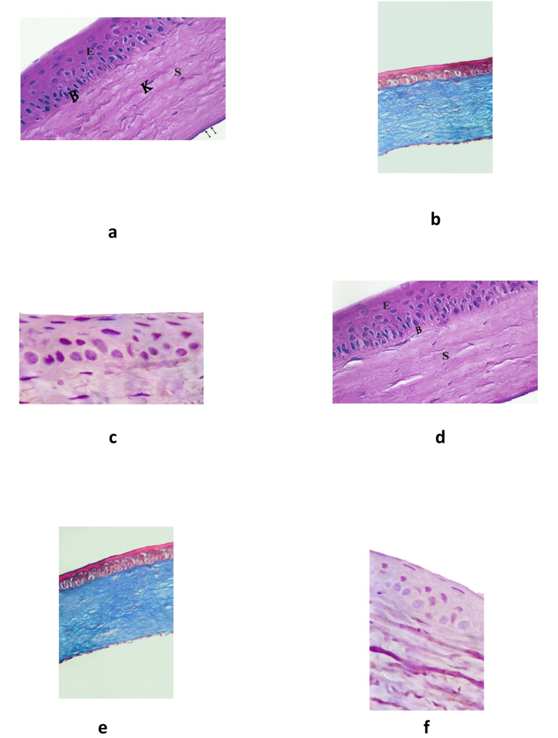
Figure 1: photomicrograph of sections of cornea of groups I & IV stained with H&E, Mallory trichrome and caspase-3. (a) Section of cornea of control albino rat showing normal corneal structure (H&E X400). (b) Section of cornea of control albino rat showing regularly arranged bundles of collagen fibers (Mallory trichrome X400). (c) Section of cornea of control albino rat showing negative cytoplasmic immunoreactivity for caspase-3 in the epithelial cells and keratocytes (PAP X1000). (d) Section of cornea of albino rat treated with Sodium hyaluronate only for 2 weeks showing normal appearance of cornea (H&E X400). (e) Section of cornea of albino rat treated with Sodium hyaluronate only for 2 weeks showing regular appearance of collagen fibers similar to control (Mallory trichrome ×400). (f) Section of cornea of albino rat treated with Sodium hyaluronate only for 2 weeks showing negative cytoplasmic immunoreactivity for caspase -3 (PAP X1000).

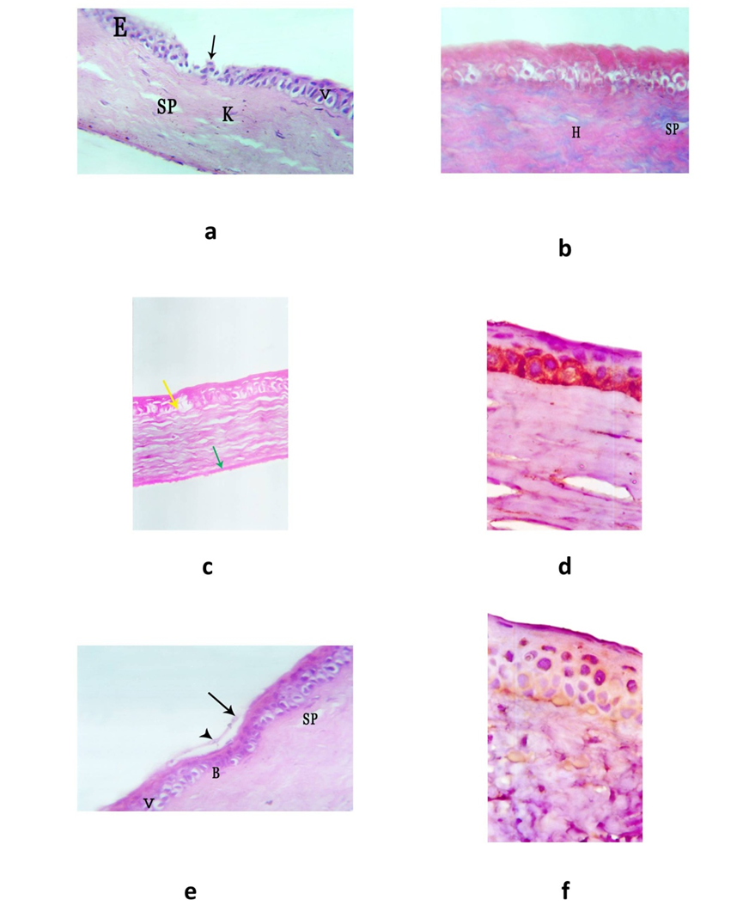
Figure 2: photomicrograph of sections of cornea of group IIa stained with H&E, Mallory trichrome,PAS and caspase-3 and group IIb stained with H&E and caspase-3. (a) Section of cornea after 0.02% BAC treatment showing degenerative changes of cornea (H&E X400). (b) Section of cornea after 0.02% BAC treatment showing massive hyaline material (H), some spaces between collagen fibers (SP) (Mallory trichrome X 400). (c) Section of cornea after 0.02% BAC treatment showing Bowman's membrane is weak positive in some parts and negative in other parts (yellow arrow) (PAS reaction X 400). (d) Section of cornea after 0.02% BAC treatment showing strong positive cytoplasmic immunoreactivity for caspase -3 (PAP X1000). (e) 2 weeks left to recover after 0.02% BAC treatment showing mild improvement (H&E X400). (f) 2 weeks left to recover after 0.02% BAC treatment showing moderate cytoplasmic immunoreactivity for caspase -3(PAP x1000).
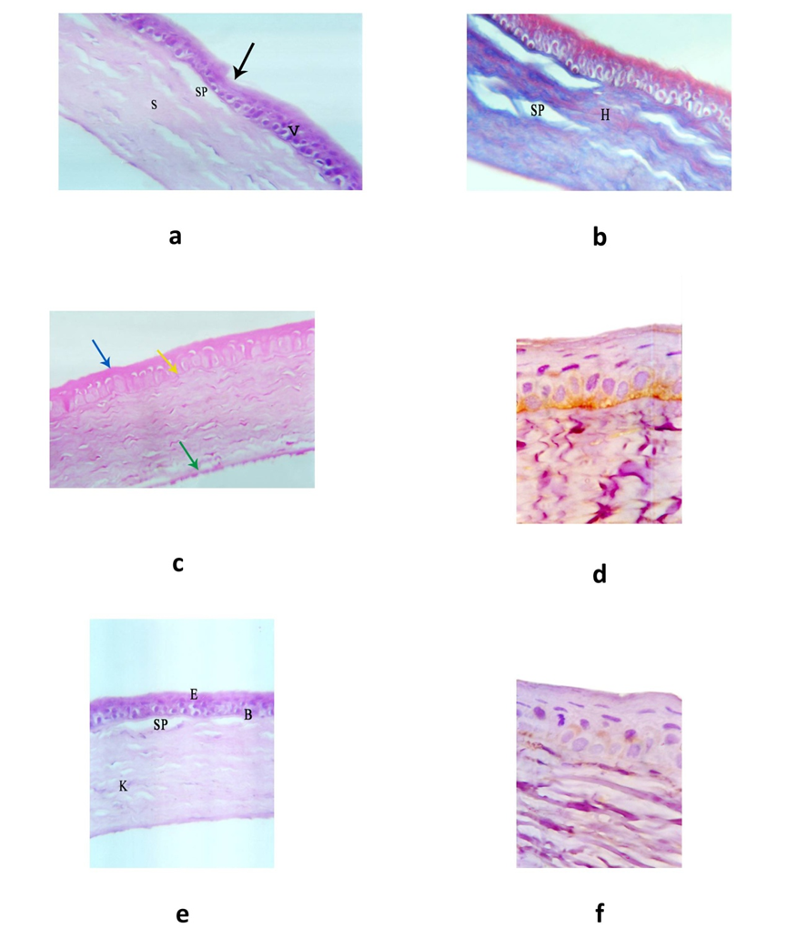
Figure 3: photomicrograph of sections of cornea of group IIIa stained with H&E, Mallory trichrome,PAS and caspase-3 and group IIIb stained with H&E and caspase-3. (a) Section of cornea after 0.01% BAC treatment showing less degenerative changes (H&E X400). (b) Section of cornea after 0.01% BAC treatment showing moderate hyaline material (H), some spaces between collagen fibers (SP) (Mallory trichrome X 400). (c) Section of cornea after 0.01% BAC treatment showing weak positive PAS reaction in the glycocalyx (blue arrow), Bowman's membrane (yellow arrow) (PAS reaction X 400).(d) Section of cornea after 0.01% BAC treatment showing moderate cytoplasmic immunoreactivity for caspase -3(PAP X1000).(e) 2 weeks left to recover after 0.01% BAC treatment showing mild improvement (H&E X400).(f) 2 weeks left to recover after 0.01% BAC treatment showing mild cytoplasmic immunoreactivity for caspase-3 (PAP X1000).

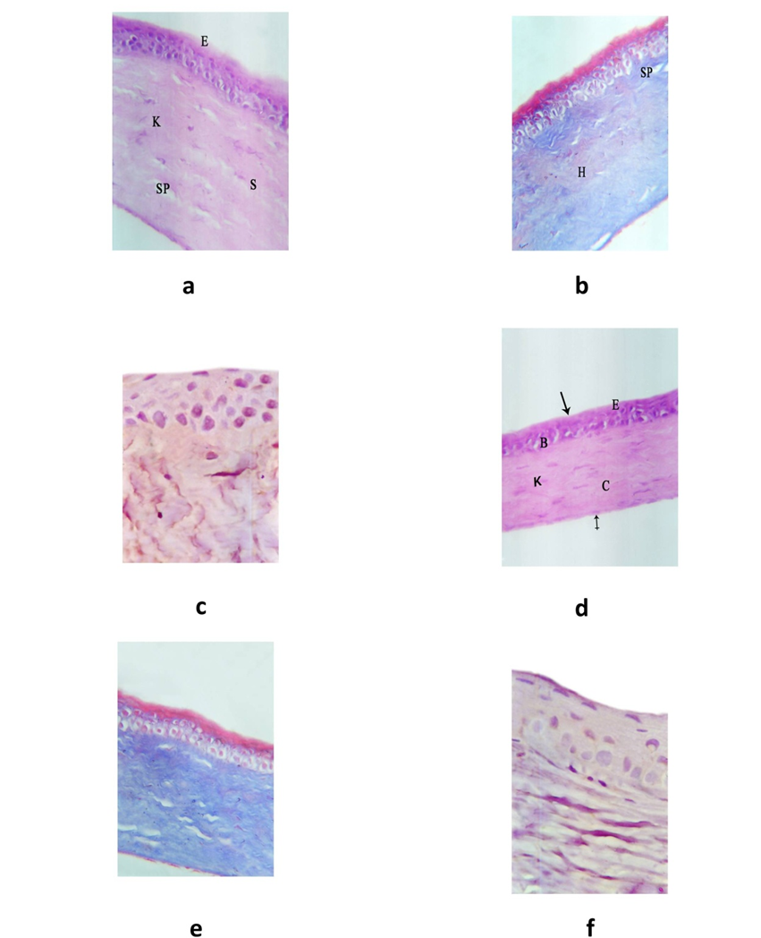
Figure 4: photomicrograph of sections of cornea of groups Va&Vb stained with H&E, Mallory trichrome and caspase-3. (a) Section of cornea of albino rat treated with Sodium hyaluronate and 0.02% BAC showing amelioration of degenerative changes (H&E X400). (b) Section of cornea of albino rat treated with Sodium hyaluronate and 0.02% BAC showing mild hyaline material (H), some spaces between its collagen fibers(SP) (Mallory trichrome ×400). (c) Section of cornea of albino rat treated with Sodium hyaluronate and 0.02% BAC showing mild cytoplasmic immunoreactivity for caspase -3 (PAP X1000). (d) Section of cornea of albino rat treated with Sodium hyaluronate and 0.01% BAC showing marked amelioration of degenerative changes (H&E X400). (e) Section of cornea of albino rat treated with Sodium hyaluronate and 0.01% BAC showing regularly arranged collagen fiber in the stroma nearly similar to the control (Mallory trichrome ×400).(f) Section of cornea of albino rat treated with Sodium hyaluronate and 0.01% BAC showing negative cytoplasmic immunoreactivity for caspase -3 (PAP X1000).
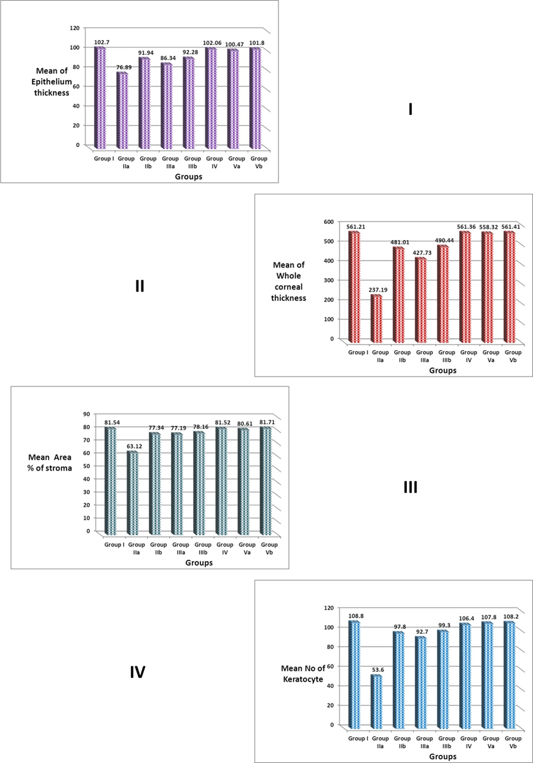
Figure 5: quantitative study.

4. Discussion
Cornea is the anterior part of the supporting layer of the eye. It protects the eye against external aggressors. In fact, this epithelium is a competitive barrier between fluid loss and penetration of pathogens. It also protects the eye from abrasion (15).
Furthermore, the permeability of the ocular surface epithelium can be altered by preservatives that are present in eye drops or antiseptic substances, such as quaternary ammonium salts. Benzalkonium chloride (BAC), a component of all multidose eye drop formulas, such as those used in the treatment of glaucoma, is known to induce the lysis of cell membranes at the ocular surface, even at very low doses (16).
Although topically administered medications are increasingly used with apparent safety and good tolerance, there is growing evidence that long-term use of topical drugs containing BAC may have adverse effects on the corneal epithelium. BAC is mostly often used at a concentration of 0.01% (ranging from 0.004% to 0.025%) in ophthalmic preparation (9).
Sodium hyaluronate is a viscoelastic substance which does not induce inflammation. It has been chosen in the present study as it is involved in the cell protection, control of cell migration, growth control and can stabilize ocular surface epithelial barrier (17).
This study is aimed to study the effect of Benzalkonium chloride on cornea and the possible protective and curable role of Sodium hyaluronate.
The present study revealed that administration of 0.02% BAC resulted in various histological changes in cornea; these changes were in the form of thinning of epithelial layer with degeneration of most cells and exfoliation of some of them. Some animals showed disorderly arranged epithelial cells together with abnormal shape of nuclei of surface flat cells. However few animals showed increase thickness of the epithelium. Bowman's layer was markedly interrupted and even completely absent. Stroma showed loss of its normal architecture with irregularly arranged collagen fibers that were separated by wide spaces and completely lost in some areas and there was massive hyaline material in the stroma seen by Mallory trichrome stain. There was also neovascularization. Keratocytes were decreased in number and degenerated with shrunken nuclei. Descemet's membrane and endothelium were normal in some animals, however there was loss of endothelium in others. On the other hand with 0.01% BAC, these changes were less evident than at the other higher BAC concentration. These findings were in agreement with those observed by others (9,10,15),who reported that in cornea of mice and rabbits after 0.01% and 0.02% Benzalkonium chloride there is desquamation, exfoliation, widely separated and considerably thin epithelial layer, thin or absent Bowman's layer, disarranged and loosely packed collagen lamellae, decreased keratocytes and corneal neovascularization.
Degeneration and loss of epithelial cells, keratocytes and endothelium detected in this study might be due to oxidative stress caused by Benzalkonium chloride. This could be explained by the fact that BAC leads to generation of free radicals (such as superoxide anion and hydroxyl radicals) and related reactive oxygen species (ROS) (such as hydrogen peroxide and singlet oxygen).It is well known that ROS are generated as a by-product of normal mitochondrial activity in aerobic cells. ROS over production can cause severe damage to cellular macromolecules, especially the deoxyribonucleic acid (DNA) through the mitochondrial dysfunction induced activation of apoptogenic proteases with secondary endonuclease activation and consequent apoptosis (18,19,20). It is now well demonstrated that BAC accelerates the desquamation of corneal epithelium cells with a concomitant depletion of intracellular ATP. Among the varied effects of ATP depletion, phosphorylation of regulatory light chain of myosin II (MLC) has been reported and it has been demonstrated clearly that the exposure of corneal epithelial cells to BAC leads to MLC phosphorylation, which contracts the cytoskeleton of epithelial cells, thus, breaking down the corneal barrier integrity (21).
Disorderly arranged cells and abnormal shaped nuclei of corneal surface epithelial cells detected after 0.02%Benzalkonium chloride could be due to DNA damage occurring in corneal tissue following exposure to BAC. This coincided with (22).
Thinning of epithelium in the present study might be due to cellular degeneration with loss of dead cells as well as failure of cellular proliferation and regeneration as had been reported by Fasce et al (8).
It was suggested by Saika et al (23) that damaged corneal epithelial cells produce substances like metalloproteinases which are capable of degrading components of the BM resulting in alterations of its structure and function. Decreased keratocyte detected in this study might be due to their contraction, apoptosis & death as previously shown by Rosin and Bell (24).
Disarrangement, destruction and loss of collagen fibers might be explained by apoptosis & loss of keratocytes as keratocytes synthesize and maintain stromal collagen, so loss of keratocytes would result in decreased collagen production. It could also stimulate the production of metalloproteinase enzymes (MMPs) in corneal stromal cell which are collagen degradation enzymes leading to increase collagen turn over with a net loss of stromal collagen as previously reported by Manni et al (25).
Stromal neovascularization (NV) detected in the present study were explained by activation and migration of corneal stromal cells to the site of injury. These cells express vascular endothelial growth factor (VEGF) leading to angiogenesis with formation of new blood vessels. It has been shown that VEGF is up-regulated in inflamed and vascularized corneas in humans and in animal models (26). Destafeno and Kim (27) also referred NV to imbalance between angiogenic factors (such as fibroblast growth factor and vascular endothelial growth factor) and anti-angiogenic molecules (such as angiostatin, endostatin, or pigment epithelium derived factor) in the cornea.
Descemet's membrane and endothelium were affected only in some animals as they represent the posterior layers of cornea which were less affected than the anterior part of the cornea (epithelium, Bowman's layer and stroma). This is coincided with Liang et al (9).
Immunohistochemically, there was a marked immune positive reactivity for caspase-3 in the cytoplasm of epithelial cells and keratocytes 2 weeks after 0.02% benzalkonium chloride. This could be referred to apoptosis of these cells. This agreed with Paimela et al (28).
Histological, immunohistochemical and image analysis of corneal sections of rats left for recovery 2 weeks after treatment with 0.02%Benzalkonium chloride showed mild recovery with slight reduction of corneal epithelial thickness and degeneration of stroma containing hyaline material.
Rats treated with 0.01% Benzalkonium chloride showed less corneal degenerative changes than after 0.02% BAC. There was variation in the corneal epithelial thickness with disorderly arranged cells and marked irregularity of the corneal surface. Bowman's layer appeared interrupted. The corneal stroma showed irregularly arranged collagen fibers separated by wide spaces with moderate hyaline material in the stroma seen by Mallory trichrome stain and loss of stromal keratocytes. These findings were confirmed by image analysis. Immunohistochemically, there was a moderate positive reaction forcaspase-3. These findings were in harmony with Meloni et al (29).
Rats left for recovery 2 weeks after treated with 0.01% Benzalkonium chloride showed slightly thin corneal epithelium and stroma showed some spaces between its collagen fibers and there was mild hyaline material seen by Mallory trichrome stain.
In the present study, concomitant uses of Sodium hyaluronate and 0.02% Benzalkonium chloride showed relatively normal corneal epithelium. Bowman's layer appeared intact. Collagen fibers of the stroma were better arranged than those of unprotected rats and less separated but there was mild hyaline material in the stroma seen by Mallory trichrome stain. These results were confirmed by image analysis. On the other hand corneal sections of rats treated by Sodium hyaluronate and 0.01% Benzalkonium chloride showed nearly normal corneal structure. These findings were in agreement with Yu et al (30) who stated that corneal epithelium was better arranged and the stroma was less swollen in corneal sections of rats protected with Sodium hyaluronate with treatment by Benzalkonium chloride than those exposed to Benzalkonium chloride without protection.
Sodium hyaluronate could protect cells against cell death, inflammation, and oxidative stress in ocular surface epithelial cells as previously reported by Debbasch et al (31), Pauloin etal (32) as it possesses antioxidant and anti-apoptotic properties. In our present study, we demonstrated that exposure to Sodium hyaluronate alone did not induce any toxicity in corneal epithelial cells, which was consistent with the study of (33).
Sodium hyaluronate may serve as a scavenger of free radicals and as an antioxidant. It is rich in hydroxyl functions, which can potentially absorb ROS as shown by Pauloin et al (33), Chen and Abatangelo (34).
From the foregoing, it was clear that Benzalkonium chloride can induce many histological and immunohistochemical changes in the cornea. These changes could be ameliorated with the use of Sodium hyaluronate. So, we recommend the use of Sodium hyaluronate as protective and curable measure against BAC induced corneal damage. Sodium hyaluronate had no toxic effect on corneal cells and had antioxidant properties and could decrease DNA damage and cell apoptosis induced by BAC. These advantages could make it to be considered in the future. Other protective measures against BAC commonly used in ophthalmic preparations need further studies in the future.

No funds.
No conflicts of interest.

Corresponding author
Name: Doaa Mostafa Mohamed
Address: Shebien El- Kom - Menoufyia
E-mail: doaamostafa189@yahoo.com

References
- Baudouin C, Liang H, Hamard P, Riancho L, Creuzot-Garcher C.: "The ocular surface of glaucoma patients treated over the long term expresses inflammatory markers related to both T-helper 1 and T-helper 2 pathways". Ophthalmology, 2008; 115: 109–115
- Guenoun J M, Baudouin C, Rat P, Pauly A, Warnet J M and Brignole Baudouin F.:" In vitro study of inflammatory potential and toxicity profile of latanoprost, travoprost and bimatoprost in conjunctiva-derived epithelial cells". Invest.Ophthalmol. 2005; Vis. Sci. 46(7):2444-2450.
- Buron N, Micheau O, Cathelin S, Lafontaine P O, Creuzot- Garcher C and Solary E: "Differential mechanisms of conjunctival cell death induction by ultraviolet irradiation and benzalkonium chloride". Invest Ophthalmol Vis Sci. 2006;,47:4221– 4230.
- Zhou Y, Liu Q, Zhou T, et al.: "Modulation of the canonical Wnt pathway by benzalkonium chloride in corneal epithelium". Exp Eye Res, 2011; 23.
- Debbasch C, Rat P, Warnet J M, De Saint Jean M, Baudouin C and Pisella P J.:" Evaluation of the toxicity of benzalkonium chloride on the ocular surface". J.Toxicol.Cutan.Ocular Toxicol., 2000; 19(2-3):105-115.
- Schwenn O, Dick H B, Krummenauer F, Christmann S, Vogel A and Pfeiffer N: "Healon5 versus Viscoat during cataract surgery: intraocular pressure, laser flare and corneal changes". J Cataract Refract Surgery, 2000; 238(10):861-867
- Jang H C, Hyung J K, Per F and Byung C C:" Effect of Topically Applied Na-Hyaluronan on Experimental Corneal Alkali Wound Healing ". Korean J. Ophthalmol, 1996; vol. 10: 68-75.
- Fasce F, Spinelli A, Bolognesi G, Rossi M and Gemma M: "Comparison of BD Multivisc with the soft shell technique in cases with hard lens nucleus and Fuchs endothelial dystrophy".Eur J Ophthalmol, 2007; 17(5):709-713.
- Liang H, Baudouin C, Pauly A and Baudouin F B: " Conjunctival and corneal reactions in rabbits following short- and repeated exposure to preservative-free tafluprost, commercially available latanoprost and 0.02% benzalkonium chloride". Br J Ophthamol, 2008; 92:1275-1282.
- Zhang Z, Huang Y, Xie H, Pan J, Liu P, Li F, Chen W, Hu J and Liu Z:" Benzalkonium Chloride Suppresses Rabbit Corneal Endothelium Intercellular Gap Junction Communication". PLOS ONE, 2014; 9(10):e109708.
- Hasegawa T, Amako H, Yamamoto T, Tazawa M and Sakamoto Y: " Corneal-Protective Effects of an Artificial Tear Containing Sodium Hyaluronate and Castor Oil on a Porcine Short-Term Dry Eye Model". J. Vet. Med. Sci. 2014; 76(9): 1219–1224.
- Kiernan J A:" Histological and histochemical methods: theory and practice". Boston Butterworth-Heinemann, 1999; 29.
- Drury R A B and Wallington E A: "Carleton's Histological Technique". Oxford University Press: 1980; 140.
- Duckers D F, Chris J, Meijer L M, Rosita L B, Wim V, Gert J O and Joost J O: "High numbers of active caspase 3 positive Reed-Sternberg cells in pretreatment biopsy specimens of patients with Hodgkin disease predict favorable clinical outcome". lood, 2002; 100(1):36-42.
- Lefaix M T D, Bueno L, Caron P, Belot E and Roche O: " Ocular Inflammation and Corneal Permeability Alteration by Benzalkonium Chloride in Rats: A Protective Effect of a Myosin Light Chain Kinase Inhibitor".Invest Ophthalmol Vis Sci, 2013; 54:2705-2710.
- Epstein S P, Chen D and Asbell P A:" Evaluation of biomarkers of inflammation in response to benzalkonium chloride on corneal and conjunctival epithelial cells". J Ocul Pharmacol Ther 2009; 25: 415–424.
- Aragona P, Papa V, Micali A, Santocono M and Milazzo G:" Long term treatment with sodium hyaluronate-containing artificial tears reduces ocular surface damage in patients with dry eye". Br J Ophthalmol 2002;,86:181-184.
- Debbasch C, Brignole F, Pisella P J, Warnet J M, Rat P and Baudouin C:" Quaternary ammoniums and other preservatives contribution in oxidative stress and apoptosis on Chang conjunctival cells". Invest Ophthalmol Vis Sci, 2001; 42:642-52.
- Barzilai A and Yamamoto K: "DNA damage responses to oxidative Stress". DNA Repair (Amst), 2004; 3:1109-15.
- Baudouin C, Labbe A, Liang H, Pauly A and Baudouin B F: "Preservatives in eye drops: the good, the bad and the ugly". Prog Retin Eye Res. 2010; 29:312–334.
- Guo Y, Satpathy M, Wilson G and Srinivas S: "Benzalkonium chloride induces dephosphorylation of myosin light chain in cultured corneal epithelial cells". Invest Ophthalmol 2007; Vis Sci.48:2001–2008.
- Kobayashi N, Katsumi S, Imoto K, Nakagawa A, Miyagawa S, Furumura M, and Mori T: "Quantitation and visualization of ultravioletinduced DNA damage using specific antibodies: application to pigment cell biology". Pigment cell Research. 2001; 14(2):94-102.
- Saika S, Ohnishi Y, Ooshima A, Liu C Y and Kao W W:"Epithelial repair: Roles of extracellular matrix". Cornea Mar, 2002; 21:S23-S29.
- Rosin L M and Bell N P: " Preservative toxicity in glaucoma medication: clinical evaluation of benzalkonium chloride-free 0.5% timolol eye drops". Clinical Opthalmology, 2013; 7:2131-2135.
- Manni G, Centofanti M, Oddone F, Parravano M and Bucci A M:" Interleukin-1 Tear Concentration in Glaucomatous and Ocular Hypertensive Patients Treated With Preservative-Free Non selective Beta-Blockers". Am J Ophthalmol, 2005; 139: 72- 77.
- Philipp W, Speicher L and Humpel C: "Expression of vascular endothelial growth factor and its receptors in inflamed and vascularized human corneas". Invest Ophthalmol Vis Sci. 2000; 41(9):2514–2522.

Destafeno J J and Kim T:"Topical Bevacizumab Therapy for Corneal Neovascularization". Arch Ophthalmol. 2007; 125(6):834-836.

Paimela T, Ryhanen T, Kauppinen A, Marttila L, Salminen A and Kaarniranta K: "The preservative polyquaternium-1 increases cytoxicity and NF-kappa B linked inflammation in human corneal epithelial cells". Mol Vis., 2012; 18: 1189–1196.

Meloni M, Cattaneo G and Servi B D:" Corneal epithelial toxicity of antiglaucoma formulations: in vitro study of repeated applications".Clin Ophthalmol, 2012; 5; 6:1433-40.

Yu F, Liu X, Zhong Y, Guo X, Li M, Mao Z, Xiao H and Yang S: " Sodium Hyaluronate Decreases Ocular Surface Toxicity Induced by Benzalkonium Chloride–Preserved Latanoprost: An In Vivo Study".Invest. Ophthalmol. Vis. Sci., 2013; 54(5):3385-3393.
- Debbasch C, De La Salle S B, Brignole F, Rat P, Warnet J M and Baudouin C:" Cytoprotective effects of hyaluronic acid and Carbomer 934P in ocular surface epithelial cells". Invest Ophthalmol Vis Sci, 2002; 43:3409-15.
- Pauloin T, Dutot M, Joly F, Warnet J M and Rat P:" High molecular weight hyaluronan decreases UVB-induced apoptosis and inflammation in human epithelial corneal cells". Mol Vis. 2009; 15:577-83.
- Pauloin T, Dutot M, Warnet J M and Rat P: " In vitro modulation of preservative toxicity: high molecular weight hyaluronan decreases apoptosis and oxidative stress induced by benzalkonium chloride". Eur J Pharm Sci, 2008; 34:263-73.
- Chen W Y and Abatangelo G: " Functions of hyaluronan in wound repair". Wound Repair Regen, 7(2): 1999; 79–89.

4/18/2015

