**Chelating and Antimicrobial Activities of Benzimidazole, 2-Chloromethylbenzimidazole and 4-((2-amino-1h-benzo(d)imidazol-1-yl)methylamino)-2-hydroxylbenzoic acid (2-Amino BISA).**

1 Durosinmi, L. M., 2Oluduro, A. O. and 1Fasasi, S. A.

1 Department of Chemistry, Obafemi Awolowo University, Ile-Ife.

2 Department of Microbiology, Obafemi Awolowo University, Ile-Ife.

[lateefahdurosinmi@yahoo.com](mailto:lateefahdurosinmi@yahoo.com), [ldurosinmi@oauife.edu.ng](mailto:ldurosinmi@oauife.edu.ng)

**Abstract**: The bioactive agent 4-((2-amino-1h-benzo(d)imidazol-1-yl)methylamino)-2-hydroxylbenzoic acid (2-amino BISA) was synthesized through the mannich reaction between 2-aminobenzimidazole, methanal and 4-aminosalicylic acid. The chelating properties of benzimidazole, 2-chloromethylbenzimidazole and 2-amino BISA were investigated using infrared, nuclear magnetic resonance spectroscopic methods and conductivity measurements. The antimicrobial activities were determined using agar well diffusion technique. Manganese (11), Copper (11) and Zinc (11) complexes of these ligands were synthesized and characterized by the same methods. The percentage metal composition was determined through complexometric titration. Conductivities of the metal complexes in acetonitrile showed them to be electrolytes. All the metal complexes are high melting solids and stable in air. all the ligands and their transition metal complexes are soluble in dimethyl sulfoxide but insoluble in water.the test fungi and bacteria, *pseudomonas fluorescence, altenaria* sp, *aspergillus flavus, trichophyta tonsuran* and *candida albicans*, were susceptible to all the compounds and their transition metal complexes. Copper complexes had the highest inhibitory activity against the fungi. The antimicrobial activities of biocide increased with increased concentration and cu (11) complex of 2-aminoBISA was found to be more inhibitory against *trichophyta tonsuras, aspergillus flavus* and *candidas albican* than ketofung used as reference.

**[**Durosinmi, L. M., Oluduro, A. O. and Fasasi, S. A. **Chelating and Antimicrobial Activities of Benzimidazole, 2-Chloromethylbenzimidazole and 4-((2-amino-1h-benzo(d)imidazol-1-yl)methylamino)-2-hydroxylbenzoic acid (2-Amino BISA).** *Nat Sci* 2015;13(5):1-13]. (ISSN: 1545-0740). <http://www.sciencepub.net/nature>. 1

**Keywords:** Benzimidazole, 2-Chloromethylbenzimidazole, 4-((2-amino-1h- benzo(d)imidazol-1-yl)methylamino)-2-hydroxylbenzoic acid (2-Amino BISA).

## Introduction

Benzimidazole derivatives are important class of nitrogen containing heterocycles and have been reported to possess wide spectrum of biological properties such as antitubercular, anticancer, antihelminthic and antimicrobial (Gowda *et al*., 2009).

Heterocyclic benzimidazoles, their derivatives and transition metal complexes have received considerable attention in coordination chemistry because it was found that such complexes showed larger antimicrobial activities than the free ligands (Gumus et al., 2003).

Furthermore, resistance against antibiotics by pathogenic bacteria has been a major concern in the anti-infective therapy of both humans and animals. Bacteria are able to adapt rapidly to new environmental conditions such as the presence of antimicrobial molecules and, as a consequence, resistance increases with the antimicrobial use (Falagas et al., 2007; Jansen et al., 2006). These concerns have made the drive for the synthesis of more potent antimicrobial drugs that will inactivate various resistance mechanisms.

### Mannich Reaction and Benzimidazoles

Benzimidazoles through Mannich reaction have been studied by (Bachman and Heisey,1940). Equimolecular amounts of benzimidazole, formaldehyde, and piperidine gave a 97 per cent yield of 1-(piperidinomethy1) benzimidazole.

Figure 1: *Benzimidazole through the Mannich Reaction.*

The Mannich reaction of benzimidazole derivative with 4-aminosalicyclic acid was first reported by Kamlesh V. Patel et al (2009).

**Metal Derivatives of Benzimidazole**

The hydrogen in the l-position of benzimidazoles is sufficiently acidic to be replaced by metals and give N-metal benzimidazoles. For example, when 2,5(or 2,6)-Dimethylbenzimidazole is treated in alcoholic solution with an ammoniacal silver nitrate solution, it yields the N-silver salt. The corresponding N-sodium salt may be prepared by adding an equivalent amount of sodium ethoxide, and then adding ether. The silver, copper, nickel, cobalt, cadmium, mercury (mercurous chloride salt), and zinc salts of benzimidazole have been prepared. 2-Phenylbenzimidazole and 2-methylbenzimidazole form silver and mercury salts but no salts with copper, cadmium, cobalt, or zinc. l-Benzylbenzimidazole, l-phenylbenzimidazole, and 1,6-dimethylbenzimidazole, containing no hydrogen in the l-position, are reported not to form metal salts with copper, cadmium, cobalt, zinc, and silver, John 1951.

The 2-Aminomethylbenzimidazole coordinates with metals such as copper to give a 1:2 metal :ligand complex.



**Figure 2**: *Structure of Aminomethylbenzimidazole Copper (II) Complex*.

Transition metal complexes of 1-(4-carboxy-3- hydroxyphenylaminomethyl) benzimidazole, (BISA) has also been reported, (Kamlesh V. Patel et al (2009).

1. **Experimental**

## reagents

All chemicals, Benzimidazole,(HL), 2-Aminobenzimidazole,(AHL), 2, chloromethylbenzimidazole, 4-Aminosalicylic acid, Manganese (II) acetate, Copper (II) acetate, Zinc (II) acetate and formaldehyde were obtained from Sigma-Aldrich.

## Physico-Chemical and Spectra Data

Melting points were determined in open capillary tubes on a Gallenkamp (variable heater) melting point apparatus. The Nuclear Magnetic Resonance (NMR) Spectra were scanned on bucker NMR spectrophotometer using dimethyl sulfoxide, (DMSO). Infra Red (IR) spectra were scanned on Nicolet 760 FTIR Spectophotometer in potassium bromide (KBr). The IR and NMR analysis were done at Chemistry Department, University of Forte Hare, South Africa. Percentage metal composition of the complexes was determined through complexometric titration using ethylenediaaminetetraacetic acid, (EDTA) and murexide indicator.

### Synthesis of 4-((2-Amino-IH benzo(d)imidazol-1-yl)methylamino)-2- hydroxylbenzoic acid. (2-Amino BISA)

Formaldehyde and 4-aminosalicylic acid were used in mannich reaction with 2-aminobenzimidazole (AHL) to give 4-((2-Amino-IH benzo(d)imidazol-1-yl)methylamino)-2-hydroxylbenzoic acid. (2-Amino BISA).

Mixture of 0.02 mole (2.64g) 2- aminobenzimidazole (AHL), 0.02 (0.6g) mole formaldehyde and 0.02 mole (3.06g) 4-amino salicylic acid in (70ml) ethanol was heated under reflux for 4 hours. The cream coloured precipitate was filtered followed by trituration in petroleum ether. The solid precipitate was air dried. A 4.88g of 4-((2-Amino-IH benzo(d)imidazol-1-yl)methylamino)-2-hydroxylbenzoic acid (2-Amino BISA) an equivalence of 82% yield was recorded. IR (cm-): 1480 (C=N), 1680 (CO of COOH), 3200-3600 (OH),3400 (Sec.NH) and 2850-2920 (CH2). NMR: 3.71 (2H) singlet NH2, 6.49 (2H) doublet CH2, 4.98 (1H) singlet OH and 6.99-8.43 (7H) multiplet Aromatic.

## Synthesis of Metal-Ligand Complexes

Benzimidazole, 2-chloromethylbenzimidazole, (CHL) and 2-Amino BISA were respectively complexed with metal (II) acetates of Manganese, Zinc and Copper.

A 0.005 mole, an equivalence of 1.49g of 2-Amino BISA was dissolved in 7.5ml ethanol-acetone (1:1v/v) mixture. 0.005N KOH was added drop wise with stirring. The precipitate obtained was filtered and air dried. The air dried precipitate was dissolved in 25ml water and was added drop wise to 0.0025mole of the metal salt in water at room temperature. Ammonia was added drop wise to complete the precipitation. Slight colour change was observed on dropwise addition of ammonia. The precipitate was digested on water bath at 80°C for 2 hours. The precipitate obtained was filtered using suction pump, washed with water and air dried.

### Metal Analysis and Molar Conductivity Measurement

Percentage metal content of the complexes synthesized was determined by complexometric titration of the digested samples of the metal complexes with standardized EDTA solution using ammonia/ ammonium chloride buffer to adjust the pH and murexide solution. The percentage of copper (ll) in 4-((2-Amino-IH benzo(d)imidazol-1-yl)methylamino)-2-hydroxylbenzoic acid.(2-Amino BISA) metal complex was determined. Conductivities of the ligands and their corresponding metal complexes were measured in acetonitrile, (Table 6).

### Antimicrobial Susceptibility Testing of the Compounds

Susceptibility of bacteria and fungi to the compounds was determined using agar well diffusion method described by Chen *et al.* (1997). The test organisms used include bacteria namely *Pseudomonas fluorescence, Bacillus pumilus, Citrobacter freundii, Serratia rubidae, Providencia stuartii* and *Bacillus pumilus* b; and fungi namely *Trichophyton tonsurans, Alternaria* sp., *Aspergillus flavus* and *Candida albicans* which were all obtained from the stock unit at the Department of Microbiology, Obafemi Awolowo University, Ile-Ife, Nigeria. The bacterial isolates were first enriched in nutrient broth for 18 hours while the fungi were grown on potato dextrose agar for seven days before use. Using sterile swab sticks, plates of Mueller Hinton agar and potato dextrose agar were seeded with standardized bacterial inoculums (106 CFU/ml) and fungal spores respectively. Seeded plates were allowed to stand for a while at room temperature before wells were bored on them using cork borer (6 mm). Each of the bored wells was filled with 5 μl of each compound.

The plates were allowed to stand on the laboratory bench for 1 hour to allow proper diffusion of the compounds into the media and incubated at 37oC for 24 hours and 25oC for seven days for bacteria and fungi, respectively. The diameters of zones of inhibition were measured using a transparent calibrated ruler in millimeter (mm). Susceptibility of the test bacteria and fungi to reference antibiotics (ciprofloxacin and ketofung) was by agar well diffusion method as described above.

## Results And Discussion

**Synthesis of 4-((2-Amino-1H-benzo(d)imidazol-1-yl)methylamino)-2-hydroxylbenzoic**

**acid (2-Amino BISA).**

The Mannich reaction of 2-aminobenzimidazole, methanal and 4-aminosalicylic acid yielded 4-((2-Amino-1H-benzo(d)imidazol-1-yl)methylamino)-2-hydroxylbenzoic acid (2-Amino BISA). This was confirmed from the IR and NMR spectroscopic data results of the Mannich product. The acid test gave a positive result. This confirmed the addition of the 4-aminosalicylic acid and thus, the presence of the carboxylic functional group end group (-COOH). The NMR spectroscopic data of 2-Amino BISA consistently aligned with the theoretical expectation. The NMR spectrum, (Appendix 1), showed 7 aromatic protons which are due to the protons labeled (2)Ha, (2)Hb,Hc, Hd and He as shown in Figure 3, below.



Figure 3: Proton NMR Sketch of 2-AminoBISA.

The two Ha protons are in the same chemical environments hence absorbed at same frequency 7.32 ppm. Although the two Hb protons are in the same chemical environment, they appear more upfield than the Ha because they are more shielded from the external magnetic field compared to the Ha potons. The absorption frequency was 6.99 ppm. The peaks at 8.43, 7.61 and 7.14, (Appendix 1), account for the protons labeled Hc, Hd and He respectively.

Similarly, the IR spectroscopic data, (Table 3) further confirm the formation of 2-AminoBISA. The C=O stretching frequency appeared at 1677 cm-1. This low value is not far from the expected due to the proximity of the –COOH functional group and the –OH group and the possible hydrogen bond interaction. The stretching vibration of the C=N and C=C of the benzene ring occurred at 1476cm-1 and 1580cm-1 respectively. The -N-H functional group gave two bands at 3300cm-1 and 1435cm-1 respectively. This confirmed the presence of sec- Amine functional group.

The melting point of the 2-Amino BISA is in the range of 194-195oC, (Table 2). This differs significantly from the melting points of each of the Mannich reactants.

**BENZIMIDAZOLE**

The spectroscopic data obtained from the NMR and IR spectra analysis for benzimidazole are given in Tables 1 and 3. The melting point is (174-175)oC.

The NMR spectrum, (Appendix 6) gave a total of six protons. A proton (1H) singlet at 8.23ppm is due to the proton on the amino group on the imidazole ring. The four protons on the benzene ring of benzimidazole correspond to values at 7.60 ppm and 7.20 ppm. The two hydrogens of the carbons labeled 5 and 6 as presented in Figure 4 are in the same chemical environment, thus absorb at same frequency of 7.20ppm while the remaining two hydrogens on the benzene, also in same chemical environment absorb at 7.60ppm. The IR gave a stretching vibration at 1428cm- due to presence of C=N. The skeletal bending vibration of the benzene ring also gave a band at 1574cm- while the N-H stretching vibration occurs at 3300 cm-1.

Strong absorption bands observed in the region of 2920 – 2850 cm-1 in the ligands are assigned to C-H stretching vibration. Also strong band in the range 1476cm-1 is assigned to C=N of the benzimidazole skeletal vibration and 3030 cm-1, 1500 cm-1 are matched to C=C stretching vibrations of the benzene ring. These bands also appear unchanged in the metal complexes.

A significant difference was observed between the parent ligand and its metal chelate due to a broad band in the region of 3200 -3600 cm-1for the metal chelates. This was expected however because the O-H of ligand formed a co-ordination bond with the metal ion. (Silverstein, 1991)

Also, the bands due to the COO- anion at 1677cm-1 for the parent ligand also decreased significantly due to possible complexation with the divalent metal in its metal chelates. (Kemp, 1998). The M-N band for the metal complexes are also summarized in Table 4.

Percentage metal composition confirmed the ligand: metal ratio of (2:1).

**2-Chloromethybenzimidazole**

The NMR spectrum and spectroscopic data analysis, (Appendix 5 and Table 5 respectively,) gave 2H singlet at 3.73ppm which is due to the proton on the –CH2Cl group on the imidazole ring. Also, the 4 protons on the benzene ring of

benzimidazole were measured in the range of 7.25 and 7.29 ppm.

The IR data gave a stretching vibration at 1434cm-1, which can be attributed to the C=Nstr.

The skeletal bending vibration of the benzene ring gave a band at 1550cm-1 while the N-H stretching and bending vibrations occur at 3300 cm-1 and 1476cm-1 respectively.

The melting points, colours, percentage yields and the physical properties of ligands, mannich products are presented in Table 2.

**Metal- ligand complexes of HL, CHL, 2-Amino BISA**

Transition metal complexes of the ligands, Benzimidzole (HL), 2-Chloromethylbenzimidazole (CHL) and 4-((2-Amino-1H-benzo(d)imidazol-1-yl)methylamino)-2-hydroxylbenzoic acid (2-Amino BISA) were synthesized using metal (II) acetates of manganese, copper and zinc.

Results of the % metal determination indicated a metal: ligand ratio of (1:2) for all the metal complexes. This is recorded in Table 2. The infrared spectral bands for the ligands {Benzimidazole (HL), 2-Chloromethylbenzimidazole (CHL) and 2-Amino BISA} and the corresponding metal complexes are presented in Tables 3-5. Infrared spectra of Manganese (11) and copper (11) complexes of 2-Amino BISA are presented in Appendixes 3-4. The NMR spectrum of 2-Chloromethylbenzimidazole (CHL) is presented in Appendix 5, while its Infrared spectra and the Zinc(11) complex are shown in Appendixes 6-7.

Significant differences between the IR Spectra of the ligands and their metal chelates characterized by the presence of more broadened bands in the region 3200cm-1 3600cm-1.for the metal chelates can be attributed to the fact that the oxygen of the ligand forms a coordination bond with the metal ions, Nakamoto, K, (1970).

The ionic conductivities and solubility are presented in Table 6. The ligands and their metal complexes are insoluble in water, fairly soluble in ethanol and very soluble in DMSO.

**Antimicrobial Susceptibility**

The results of the antimicrobial sensitivity testing of the ligands and their corresponding metal complexes against six strains of bacteria and four fungi are presented in Tables 7a-c.

Most of the isolates were sensitive to the ligands and their respective metal chelates at varied concentrations. 2-Amino BISA and its metal complex derivatives have a considerable effect on the fungi than the bacteria as evident in the Table 7.

Almost all the bacteria showed a significant resistance to 2-Amino BISA and its metal complex derivatives relative to the control standard, except 2- Amino BISA Cu2+ that showed a significant sensitivity against *Pseudomonas fluorescence*. Greater percentage of the fungal isolates were sensitive to 2-Amino BISA and its metal complex derivatives. 2-amino BISA Cu2+ showed higher activity against *Trichophyta tonsurans, Aspergillus flavus* and *Candida albicans* than the reference ketofung. 2-Amino BISA and its metal complex derivatives were appreciably sensitive to *Trichophyta tonsuras, Aspergillus flavus* and *Candida albicans* at all concentrations. The results also revealed that the concentration used play an important role in determining the antimicrobial effectiveness of the 2-Amino BISA and its metal complex derivatives. At high concentration of each biocide, most of the fungal isolates showed a considerable sensitivity depending on the biocide type.

The results of the in vitro screening of HL and CHL and their metal complexes against same strains of bacteria and fungi as in 2-Amino BISA using Ciprofloxacin and ketofung as clinical references for antibacterial and antifungal, respectively are also presented in Tables 1-7. The bacterial isolates showed a significant resistance to the HL, CHL and their corresponding metal complexes relative to the ciprofloxacin standard. Both HL and CHL and their metal complexes showed a close match effect on *Candida albicans* with reference to the standard ketofung. Although, CHL and its complexes are more significant when compared to HL and its metal complexes on the referenced fungus. 2-Amino BISA and its complexes had considerable and better biocidal effect on the *Candida albicans* when placed by the sides of CHL and HL and their metal complexes.

*Altenaria* sp was highly susceptible to CHL and its complexes especially at higher concentrations when compared to the reference ketofung. Results show that HL shows higher antifungal activity against *Aspergillus flavus* than CHL.

Table 1: 1H NMR Signal (ppm) for the ligands.

|  |  |  |  |  |  |  |
| --- | --- | --- | --- | --- | --- | --- |
| Compounds | -NH of benzimidazole ring | -NH2 of 2-Amino  BISA | -CH2Cl | N-CH2-N  Of 2-Amino  BISA | -OH | Aromatic  protons |
| Benzimidazole | 3.46 (s) |  |  |  |  | 7.20-8.23 (m) |
| 2- Amino  BISA | 5.76 | 3.71 |  | 6.49-6.58 | 4.98 | 6.99-8.43 |
| 2-Chloromethyl  Benzimidazole | 4.95 (s) |  | 3.73 (s) |  |  | 7.25-7.59 (m) |

Table 2: *Yields and Physical Properties ofligands and their Metal Complexes.*

|  |  |  |  |  |
| --- | --- | --- | --- | --- |
| Ligand/  complex | Yield (%) | Colour | Melting point (oC) | % Metal calculated (found) |
| **HL** |  | Yellow | 174-175 |  |
| HL Mn2+ | 80.4 | Light pink | 217-219 | 19.05 (18.71) |
| HL Cu2+ | 81.0 | Light blue | 197-198 | 16.91 (16.77) |
| HL Zn2+ | 76.7 | Yellow | 187-188 | 15.12 (14.95) |
| **2-Amino BISA** | 78.0 | Cream | 194-195 |  |
| 2-Amino BISA Mn2+ | 85.9 | Light brown | 239-240 | 8.02 (7.91) |
| 2-Amino BISA Cu2+ | 87.0 | Bluish green | 223-224 | 9.16 (9.34) |
| 2-Amino BISA Zn2+ | 81.7 | Yellow | 211-212 | 9.40 (9.23) |
| **CHL** |  | Dark yellow | 141-142 |  |
| CHL Mn2+ | 75.8 | Pink | 186-185 | 13.02 (14.11) |
| CHL Cu2+ | 74.0 | Bluish green | 180-181 | 14.76 (14.01) |
| CHL Zn2+ | 72.2 | Yellow | 178-179 | 15.12 (14.99) |

HL=Benzimidazole,2-AminoBISA=4-((2-Amino-1H benzo(d)imidazol-1-yl)methylamino)-2-hydroxylbenzoic acid and CHL = 2-Chloromethyl benzimidazole.

Table 3: *Infrared Spectra (Cm-1) Of 4-((2-Amino-1H-Benzo(d)Imidazol-1-Yl)Methylamino)-2-Hydroxylbenzoic Acid (2-Amino BISA) and Its Metal Complexes.*

|  |  |  |  |  |
| --- | --- | --- | --- | --- |
| 2-Amino Bisa | 2-Amino Bisa Mn2+ | 2-Amino Bisa Cu2+ | 2-Amino Bisa Zn2+ | Assignment |
| 3400 | 3265b | 3320b | 3330b | O-H |
| 3030, 1500 | 3030, 1500 | 3030, 1500 | 3030, 1500 | Ar-C=C |
| 1476 | 1485 | 1465 | 1466 | C=N |
| 1677 | 1600 | 1584 | 1610 | C=O of carboxylic acid |
| 3300 | 3340 | 3280 | 3380 | N-H stretching |
| 1620 | 1568 | 1586 | 1570 | N-H bending |
| 2920 | 2900 | 2920 | 2850 | CH2 |
|  | 560 | 592 | 600 | M-N |

Table 4: *Infrared Spectra (cm-) of Benzimidazole (HL) and its Metal Complexes.*

|  |  |  |  |  |
| --- | --- | --- | --- | --- |
| HL | HL Mn2+ | HL Cu2+ | HL Zn2+ | Assignment |
| 3300 | 3200 | 3150 | 3210 | N-H stretching |
| 1505 | 1494 | 1500 | 1490 | N-H bending |
| 1574 | 1568 | 1573 | 1579 | Ar-C=C stretching |
| 1428 | 1429 | 1429 | 1429 | C=N |
|  | 564 | 539 | 566 | M-N |

Table 5: *Infrared Spectra (cm-1) of 2-Chloromethyl Benzimidazole, (CHL) and its Metal Complexes.*

|  |  |  |  |  |
| --- | --- | --- | --- | --- |
| CHL | CHL Mn2+ | CHL Cu2+ | CHL Zn2+ | Assignment |
| 3300 | 3100 | 3170 | 3150 | N-H stretching |
| 1513 | 1505 | 1550 | 1502 | N-H bending |
| 1550 | 1568 | 1571 | 1579 | Ar-C=C stretching |
| 1434 | 1428 | 1432 | 1431 | C=N |
| 2920 | 2900 | 2920 | 2850 | CH2 |
|  | 563 | 562 | 585 | M-N |

Table 6: *Conductivity Measurements of Benzimidazole (HL), 2-Chloromethyl Benzimidazole (CHL), 2-Amino BISA and their Respective Metal Complexes at Room Temperature in Acetonitrile.*

|  |  |
| --- | --- |
| **Complexes** | **Molar conductivity (ohm- cm2 mol-)** |
| **HL** | 24.20 |
| HL Mn2+ | 29.30 |
| HL Cu2+ | 26.50 |
| HL Zn2+ | 29.60 |
| **CHL** | 19.40 |
| CHL Mn2+ | 21.70 |
| CHL Cu2+ | 25.10 |
| CHL Zn2+ | 22.70 |
| **2-Amino Bisa** | 39.90 |
| 2-Amino Bisa Mn2+ | 44.40 |
| 2-Amino Bisa Cu2+ | 42.70 |
| 2-Amino Bisa Zn2+ | 44.10 |

**Table 7a: *Diameter of Zones of Inhibition of the Benzimidazole (HL)and the Metal Complexes on Selected Bacteria and Fungal Isolates (mm)***

|  |  |  |  |  |  |  |
| --- | --- | --- | --- | --- | --- | --- |
|  | H L | HL-Cu | HL-Mn | HL-Zn | CIP | KETO |
| Bacteria / Conc. | 5 10 20 (mg/ml) | 5 10 20 (mg/ml) | 5 10 20 (mg/ml) | 5 10 20 (mg/ml) | 5 10 20 (mg/ml) | 5 10 20 (mg/ml) |
| *Pseudomonas fluorescence* | 4 8 11 | 2 4 6 | 2 2 4 | 4 2 3 | 7 18 22 | NA |
| *Bacillus pemilus* | 2 3 5 | 1 2 2 | 2 4 9 | 0 3 8 | 26 30 31 | NA |
| *Citrobacter freundii* | 3 5 7 | 3 4 7 | 0 0 0 | 0 1 2 | 25 33 35 | NA |
| *Serratia rubidae* | 2 2 2 | 0 0 0 | 0 0 0 | 0 0 0 | 32 34 34 | NA |
| *Providencia stuartii* | 2 5 7 | 1 7 10 | 1 3 6 | 5 6 8 | 25 27 30 | NA |
| *Bacillus pemilus b* | 2 2 4 | 3 8 11 | 3 4 6 | 0 0 0 | 23 29 31 | NA |
| Fungi |
| *Trichophyta tonsurans* | 3 8 14 | 15 24 32 | 2 2 5 | 5 10 12 | NA | 18 34 37 |
| *Alternaria* spp | 4 6 14 | 6 7 10 | 3 4 6 | 2 4 5 | NA | 11 13 17 |
| *Aspergillus flavus* | 6 15 28 | 4 10 20 | 11 20 28 | 4 6 13 | NA | 20 22 28 |
| *Candida albicans* | 4 8 12 | 14 21 28 | 8 12 17 | 6 11 15 | NA | 18 25 33 |
| Positive control | - - - | - - - | - - - | - - - | - - - | - - - |
| Negative control | + + + | + + + | + + + | + + + | + + + | + + + |

Key-: Zones of inhibition produced (i.e no growth around well). +: No zones of inhibition produced (i.e there was growth around well). CIP: Ciprofloxacin. KETO: Ketofung. NA: Not Applicable. HL: Benzimidazole.

**Table 7b: *Diameter of Zones of Inhibition of 2-Chloromethyl benzimidazole (CHL) and Metal Complexes on Selected Bacteria and Fungal Isolates (mm).***

|  |  |  |  |  |  |  |
| --- | --- | --- | --- | --- | --- | --- |
|  | CHL | CHL-Cu | CHL-Mn | CHL-Zn | CIP | KETO |
| Bacteria / Conc. | 5 10 20 (mg/ml) | 5 10 20 (mg/ml) | 5 10 20 (mg/ml) | 5 10 20 (mg/ml) | 5 10 20 (mg/ml) | 5 10 20 (mg/ml) |
| *Pseudomonas fluorescence* | 2 2 4 | 2 4 7 | 2 2 2 | 0 0 0 | 7 18 22 | NA |
| *Bacillus pemilus* | 2 5 9 | 2 4 5 | 2 4 6 | 2 4 7 | 26 30 31 | NA |
| *Citrobacter freundii* | 0 0 2 | 2 2 4 | 2 0 0 | 1 2 3 | 25 33 35 | NA |
| *Serratia rubidae* | 0 0 4 | 4 4 6 | 1 2 2 | 0 0 0 | 32 34 34 | NA |
| *Providencia stuartii* | 4 7 8 | 4 6 10 | 2 8 8 | 2 5 7 | 25 27 30 | NA |
| *Bacillus pemilus b* | 5 7 12 | 0 3 6 | 2 3 3 | 1 3 1 | 23 29 31 | NA |
| Fungi |
| *Trichophyta tonsurans* | 6 10 14 | 4 7 11 | 4 9 13 | 2 2 4 | NA | 18 34 37 |
| *Alternaria* spp | 4 10 18 | 8 12 19 | 6 12 28 | 3 11 22 | NA | 11 13 17 |
| *Aspergillus flavus* | 3 5 11 | 8 12 17 | 4 6 7 | 4 5 7 | NA | 20 22 28 |
| *Candida albicans* | 5 11 22 | 16 22 31 | 8 13 18 | 18 24 31 | NA | 18 25 33 |
| Positive control | - - - | - - - | - - - | - - - | - - - | - - - |
| Negative control | + + + | + + + | + + + | + + + | + + + | + + + |

Key-: Zones of inhibition produced (i.e no growth around well). +: No zones of inhibition produced

(i.e there was growth around well). CIP: Ciprofloxacin. KETO: Ketofung.

NA: Not Applicable. CHL: 2 Chloro methyl benzimidazole.

**Table 7c: *Diameter of Zones of Inhibition of 2-Amino BISA(NHL) and Metal Complexes on Selected Bacteria and Fungal Isolates (mm).***

|  |  |  |  |  |  |  |
| --- | --- | --- | --- | --- | --- | --- |
|  | NHL | NHL-  Cu | NHL-Mn | NHL-Zn | CIP | KETO |
| Bacteria / Conc. | 5 10 20 (mg/ml) | 5 10 20 (mg/ml) | 5 10 20 (mg/ml) | 5 10 20 (mg/ml) | 5 10 20 (mg/ml) | 5 10 20 (mg/ml) |
| *Pseudomonas fluorescence* | 2 3 6 | 611 16 | 510 12 | 3 6 8 | 7 18 22 | NA |
| *Bacillus pemilus* | 3 10 11 | 2 6 6 | 2 4 5 | 1 2 2 | 26 30 31 | NA |
| *Citrobacter freundii* | 1 3 4 | 1 2 4 | 3 5 8 | 6 9 11 | 25 33 35 | NA |
| *Serratia rubidae* | 1 2 3 | 5 10 14 | 4 7 13 | 4 7 11 | 32 34 34 | NA |
| *Providencia stuartii* | 2 10 14 | 3 5 7 | 4 6 10 | 3 3 5 | 25 27 30 | NA |
| *Bacillus pemilus b* | 5 8 13 | 5 9 14 | 3 6 7 | 3 3 6 | 23 29 31 | NA |
| Fungi |
| *Trichophyta tonsurans* | 10 12 15 | 25 37 41 | 18 21 28 | 6 16 19 | NA | 18 34 37 |
| *Alternaria* spp | 3 5 9 | 6 8 13 | 2 5 10 | 2 4 13 | NA | 11 13 17 |
| *Aspergillus flavus* | 10 13 15 | 20 24 31 | 13 16 19 | 15 20 23 | NA | 20 22 28 |
| *Candida albicans* | 10 16 22 | 25 32 46 | 15 19 26 | 11 15 21 | NA | 18 25 33 |
| Positive control | - - - | - - - | - - - | - - - | - - - | - - - |
| Negative control | + + + | + + + | + + + | + + + | + + + | + + + |

Key-: Zones of inhibition produced (i.e no growth around well). +: No zones of inhibition produced (i.e there was growth around well). CIP: Ciprofloxacin. KETO: Ketofung. NA: Not Applicable. NHL=2-AminoBISA.



HL



Benzimidazole metal complex

M2+ = Mn2+, Cu2+ and Zn2+

Figure 4: Proposed Structures of HL and its Metal Complexes.



2-AminoBISA



2-Amino BISA metal complex

M2+ = Mn2+, Cu2+ and Zn2+

**Figure 5:** Proposed Structures of 2-Amino BISA and its Metal Complex.

 CHL

CHL metal complex.

M2+ = Mn2+, Cu2+ and Zn2+

Figure 6: Proposed Structures of CHL and its Metal Complex.

## 

## Conclusion

4-((2-Amino-1H-benzo(d)imidazol-1-yl)methylamino)-2-hydroxylbenzoic acid (2-Amino BISA) has been successfully prepared through the mannich reaction between 2-aminobenzimidazole, methanal and 4-aminosalicylic acid.

The transition metal complexes of 2-Amino BISA gave a ligand – metal ratio of 2:1.

Benzimidazole, (HL), 2-chloromethylbenzimidazole, (CHL) and 2-amino BISA, and their transition metal complexes exhibited some antibacterial and antifungal activities against *Pseudomonas fluorescence, Altenaria* sp, *Aspergillus flavus, Trichophyta tonsuran* and *Candida albicans*,

Most of the metal complexes showed better activities than the ligand applied alone. This agrees with earlier works by (Gumus et al., 2003). The antifungal potency seems more pronounced than antibacterial activity hence HL, CHL, 2-Amino BISA and their metal complexes could be used as antifungal biocides.

**Correspondence to:**

Dr. Mrs. Lateefah. M Durosinmi,

Department of Chemistry, Obafemi Awolowo University, Ile-Ife.

E- mails: [lateefahdurosinmi@yahoo.com](mailto:lateefahdurosinmi@yahoo.com),

[ldurosinmi@oauife.edu.ng](mailto:ldurosinmi@oauife.edu.ng)

# 

# References

1. Gowda, N. R., Kavitha, C.V., Raghavan, S.C., Chiruvella, K.K. (2009). Bioorg. Med. Chem. Lett 19: 4594-4600
2. Gumus, F., Algul, O., Eren, G., Eroglu, H.,Diril,N., Gur, S., Ozkul, A.(2003.) Eur. J. Med. Chem. PP 38, 473.
3. Falgas, M. E., Bliziotis, J. A. (2007). Pandrug resistant Gram-negative bacteria, the dawn of the post – antibiotic era? Int. J. Antimicrob. Agent. PP 29, 630-636
4. Jansen, W.T, Van Der Bruggen, J.T., Verhoef, J., Fluit, A.C.(2006). Bacterial resistance: a sensitive issue complexity of the challenge and contaminant strategy in Europe. Drug Resistance Update PP 9, 123-133
5. Bachman,G.B. and Heisey, L.V. (1946) :J. Am. Chem. Soc.71, 1985.
6. Kamlesh V. Patel and Arun Singh, E- Journal of Chemistry, (2009), 6 (1), 281-288, Synthesis, Characterization and chelating properties of Benzimidazole-salicyclic acid combined molecule..
7. John, W. (1951): Chemistry of Benzimidazole. Pg 401, 523
8. Chen, H. J., Tan, R. X., Liu, Z. L. and Zheoy,V.(1997).Antibacterial Nuclenodane diterpenoids from Ajuga Lupulina. Journal of Natural Products. 59, 668-670
9. Silverstein, R.M.(1991). Spectrometric identification of organic compounds, 5th Ed., John Wiley
10. Kemp. W. (1998).Organic Spectroscopy, ELBS, (Macmillan’ UK).
11. Nakamoto, K, (1970),infrared Spectra of Inorganic and coordination compound, Wiley, NY.

Appendix 1 : Proton NMR spectrum of 2-AminoBISA



Appendix 2: Infrared spectrum of 2-AminoBISA

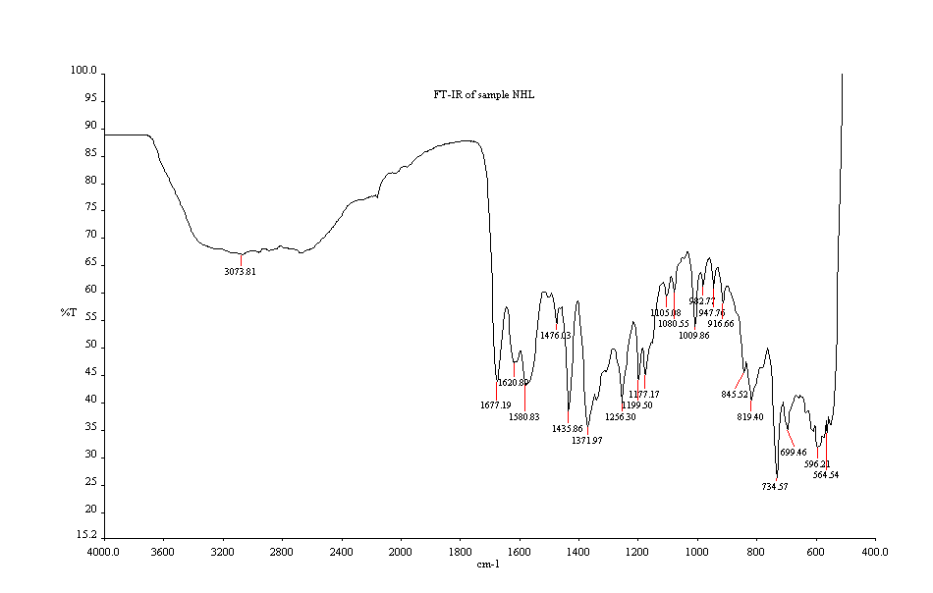

Appendix 3: Infrared spectrum of Mn (11)-2-AminoBISA

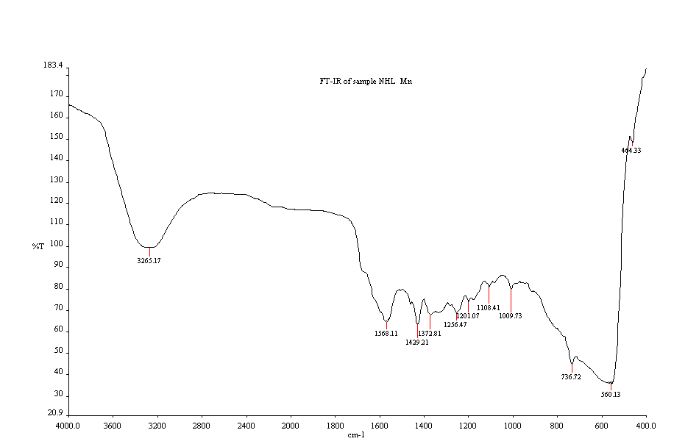

Appendix 4: Infrared spectrum of Cu (11)-2-AminoBISA

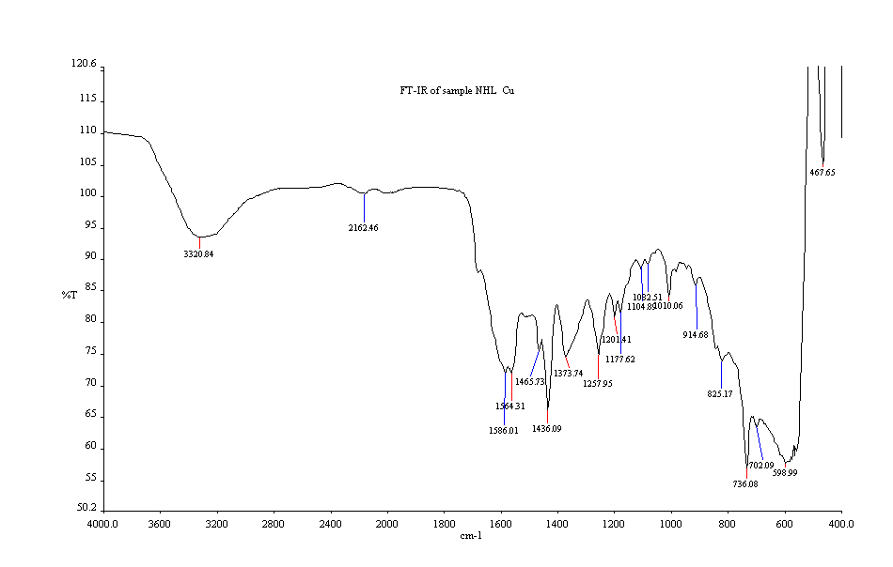

Appendix 5: Proton NMR spectrum of 2-chloromethylbenzimidazole



Appendix 6: Infrared spectrum of 2-chloromethylbenzimidazole

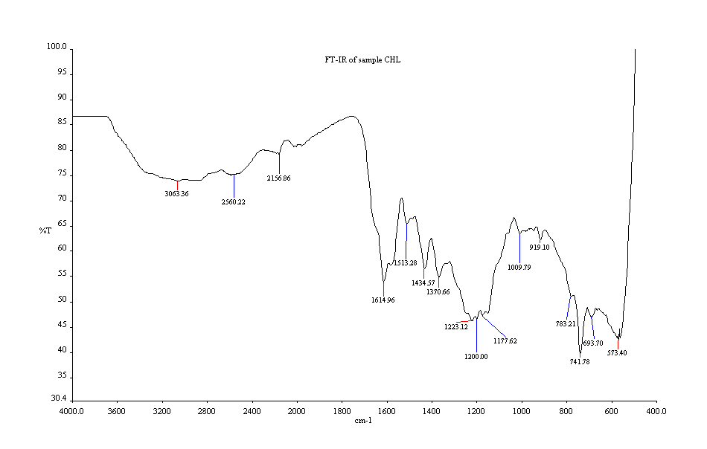

Appendix 7: Infrared spectrum of Zn (11)- 2-chloromethylbenzimidazole

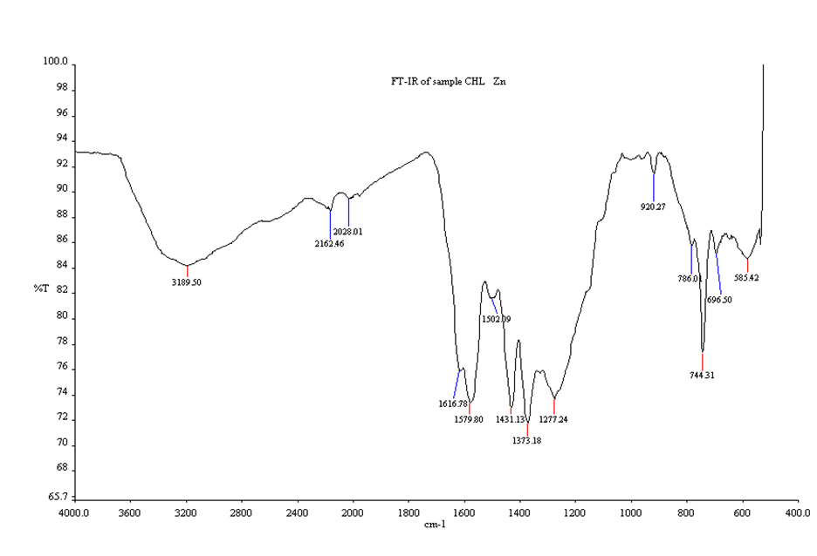

Appendix 8: Proton NMR spectrum of Benziimidazole



4/12/2015