Petroleum evaluation through subsurface and petrophysical studies of Hammam Faraun Member of Belayim Formation, Bakr Oil Field, Gulf of Suez, Egypt

Abd Elhady, M. A.¹, Fathy, M.¹, Hamed, T. ² and Reda, M.¹

¹Geology Department, Faculty of Science, Al Azhar University, Cairo, Egypt.
²General Petroleum Company, Cairo, Egypt

Abstract: Bakr Oil Field is located at the western coast of the Gulf of Suez. The Middle Miocene Hammam Faraun Member of Belayim Formation is considered to be a good reservoir in the study area. The present work mainly deals with the interpretation of geological and geophysical data to evaluate the hydrocarbon potentials of Belayim reefal limestone reservoir in Bakr Oil Field. Isopach, lithofacies and structural maps are constructed to study the subsurface configuration of the study area based on the well-log correlations and seismic interpretation. Wire-line logs, from four drilled wells in the study area are interpreted for petrophysical evaluation. Analytical reservoir rock analysis includes achieving the shale content (V_{sh}), effective porosity (Ø_{eff}), water and hydrocarbon saturation (S_{h}r & S_{w}), and net-pay thickness variation. Also, the vertical and horizontal variations of reservoir parameters are studied through constructing the litho-saturation cross plots and iso-parametric maps of the study area. As a result of the present study, using the subsurface and petrophysical evaluation, the hydrocarbon potentials of the Middle Miocene Belayim Formation in Bakr Oil Fields is determined. A new locations is recommended to be a prospect in the study area.
[Abd Elhady, M. A., Fathy, M., Hamed, T. and Reda, M. Petroleum evaluation through subsurface and petrophysical studies of Hammam Faraun Member of Belayim Formation, Bakr Oil Field, Gulf of Suez, Egypt. Nat Sci 2015;13(4):59-78]. (ISSN: 1545-0740). http://www.sciencepub.net/nature. 10

Keyword: subsurface structure, petrophysical studies and Hammam Faraun Member.

1. Introduction
Bakr Oil Field was one of the first commercials oil fields and the most prolific in the Gulf of Suez. Figure (1) shows that the Bakr Oil Field is located at the western coast of the Gulf of Suez, between latitudes 28° 47̀ - 28° 40̀ N and longitudes 32° 91̀ - 33° 00̀. It is located about 10 kms north of Gharib Oil Field, and about 40 kms north of Ras Shukheir Oil and Gas Field. Figure (2) shows the distribution of the available seismic lines and wells in the study area.

2. Materials and Methodology:
The present study mainly depends on the use of the available open-hole well log records (electric, radioactivity and sonic logs) in the form of composite well logs (Resistivity, SP, GR, Density, Neutron and Sonic) of four wells distributed in the area of study. In addition to this, twenty 2D and 3D seismic lines are used to delineate the subsurface structural setting.
The subsurface geologic setting is gained through the construction of isopach maps, lithofacies maps, seismic sections, structural cross sections and structure contour maps.
The petrophysical evaluation is gained through the computer processed interpretation that passes through the quantitative interpretation technique. The petrophysical characteristics are illustrated laterally (in the form of iso-parametric maps) and vertically (in the form of litho-saturation cross-plots).
This study is carried out by using the computer software programs, such as Petrel 2010 software program (@schlumberger, 2010), Interactive Petrophysics version 3.5 software program (@schlumberger, 2008).
Notice: To complete this study we looked at another of some other wells in the study area.
Subsurface Geologic Setting
Geologic setting of the study area is determined by reviewing the general stratigraphy and structural relations, using subsurface data with the aid of isopach, lithofacies and structural maps.
1- Subsurface Stratigraphy
The lithostratigraphic units in the Gulf of Suez area range from Precambrian to Holocene in age and have been divided into three major related tectonic rift sequences: Pre-rift lithostratigraphic sequence (Pre-Miocene unit), Syn-rift lithostratigraphic sequence (Miocene unit) and Post-rift lithostratigraphic sequence (Post-Miocene unit). Figure (3) shows a generalized stratigraphic column of Bakr Oil Field in the Gulf of Suez.
The Pre-rift succession disconformably overlies the basement rocks and unconformably underlies the Miocene sequence. The Pre-rift stratigraphic sequence is composed of strata range from Precambrian to Late Eocene and contains sandstone, shale and carbonate facies that were laid down under terrestrial and marine platform environments. This period of sedimentation was affected by major unconformities representing non-depositional or erosion at different geologic times.
The Syn-rift lithostratigraphic sequence was previously subdivided into two main groups "Ghrandal Group" and "Ras Malaab Group". The Miocene section in Gulf of Suez is mainly related to the Lower and Middle Miocene, while the Upper Miocene deposits are previously believed to be missed as a result of a major unconformity between the Middle Miocene and the Pliocene deposits. Recent publications supported the presence of Upper Miocene evaporite deposits in many areas in the Gulf of Suez (Ryan and Hsu, 1973 and Haq et al., 1987). The Post-rift sedimentary fill of Gulf of Suez is Pliocene-Holocene in age. The thickness and lithology of these strata show marked variation from one area to another.
The post Miocene strata consist of sandstone, shale and limestone. The strata were deposited in a shallow to deep marine setting.
Stratigraphic Setting of Belayim Formation
Belayim Formation is conformably overlying the Kareem Formation and underlying the South Gharib Formation. It represents the oldest strata in Ras Malaab Group. It represents the beginning of the main Miocene evaporite cycle and it is composed of thick bed of white, to grey, hard crystalline anhydrite intercalated with grey, to green, soft to medium hard shale and fine to medium grained sandstone. The clastic and carbonate section represents good target for oil reservoir in the Gulf of Suez. The evaporitic sequence represents an excellent seal and cap rocks for underlying oil reservoir (EGPC, 1974).
In the study area, Belayim Formation consists mainly of reefal limestone with some shale streaks, but in some wells it is distinguished into four members that have different identities. Feiran and Baba members consist of anhydrite and shale embedded by Sidri Member of shale with limestone interbeds and overlain by Hammam Faraun Member of reefal limestone and shale.

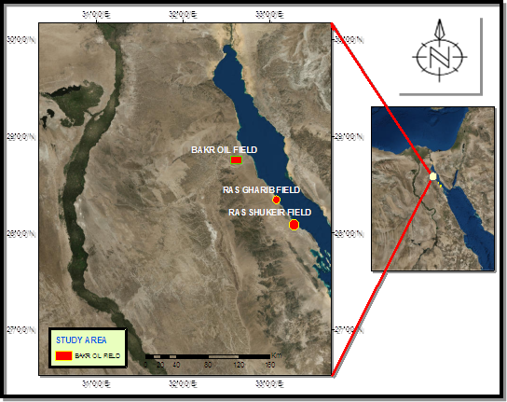
Figure (1): Location map of Bakr Oil Field.

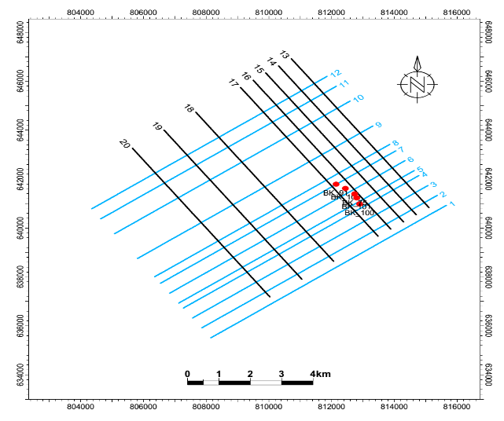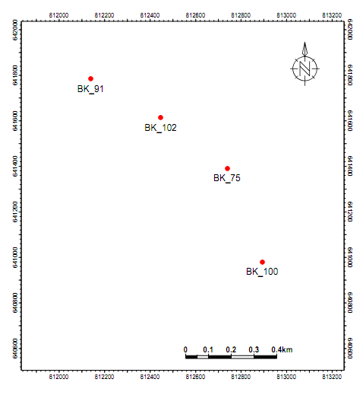
Figure (2): The distribution of the available seismic lines and wells in the study area.

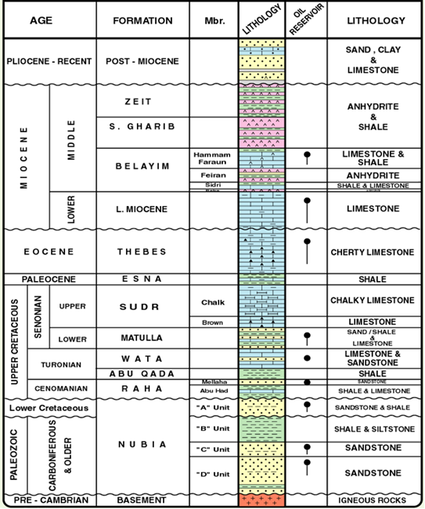
Figure (3): Generalized stratigraphic section in Bakr Oil Field after (GPC, 2013).

Baba Member is composed of anhydrite and shale interbeds (mostly one bed). It is the lower member of Belayim Formation, which is conformably, overlies the Kareem Formation.
Sidri Member is the lower clastic member of Belayim Formation, which is composed of calcareous shale intercalated with limestone.
Feiran Member is composed of thick bed of anhydrite with minor shale streaks. It is the thickest member of Belayim Formation in the study area.
Hammam Faraun Member is the youngest member of Belayim Formation, mainly composed of reefal limestone with shale at few wells. Its type section is selected at Wadi Ghrandal, north of Gebel Hammam Faraun. This member is affected by facies changes and remarkable lithological variation all over the Gulf of Suez. It consists of sandstone, shale, and limestone.
The stratigraphic correlation, (figure 4), runs in the northwest-southeast direction passing through the wells in the study area, using Belayim Formation as a datum line. This stratigraphic correlation shows that the thickness of Belayim Formation increases in the northwestern and southeastern parts and reach its maximum thickness at Bk-102 well with 76m and decreases towards the central part of the study area at Bk-75 with 38m.
Figure (5) shows the isopach map of Hammam Faraun Member of Belayim Formation. It shows that the thickness of Hammam Faraun Member of Belayim Formation increases in the western part of the study area and decreases in the central part of the area. The basinal area is directed to the western part of the study area recording its maximum thickness in the western part, while the platform occurs in the northwestern and central parts of the study area.
Lithofacies map of Hammam Faraun Member of Belayim formation:
According to Warner (1977), lithofacies map is a map showing the distribution of different types of rock attributes or facies occurring within a designated geologic unit.
In the study area, The Nullipore facies in Bakr area is described based on well-log data analysis. The Belayim carbonates are dated to Hammam Faraun Member. The Hammam Faraun Member of Belayim Formation is mainly composed of reefal limestone termed Nullipore with some highly calcareous shale interbeds.
Facies distribution map of Hammam Faraun Member of Belayim Formation (Nullipore zone) shows distribution of reefal limestone at most of the area especially along the eastern and central parts of the study area, and shows gradual change laterally to calcareous shale to the western part where the upthrown side of the horst block is found (Fig.6).
Hammam Faraun Member of Belayim Formation lithofacies map is characterized by the presence of three lithologic groups, as follows:
The first lithologic group is limestone. It is located in the northeastern part of the study area (at Bakr-75 well). In this part the sand /shale ratio is 0%, while the clastic/non-clastic ratio is 0.16%. The second lithologic group is Lime-shale. It is located in the central and northwestern parts of the study area (at Bakr-91 and Bakr-102 wells). In this part the sand /shale ratio ranges from 0.3%in Bakr-102 to 0.6% in Bakr-91, while the clastic/non-clastic ratio ranges from 0.4% in Bakr-91 to 0.8% in Bakr-102. The third lithologic group is shale-lime. It is located in the southern part of the study area (at Bakr-100well). In this part the sand /shale ratio is 0.9%, while the clastic/non-clastic ratio is 0.5%.

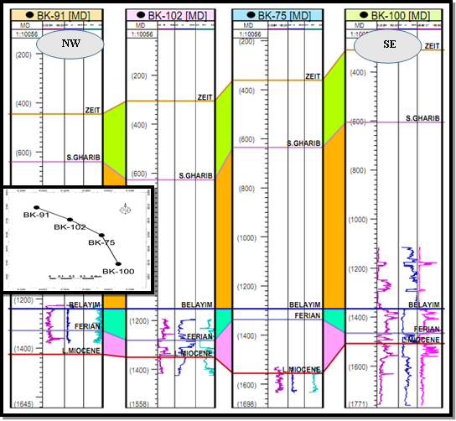
Figure (4): NW-SE correlation section in the study area.
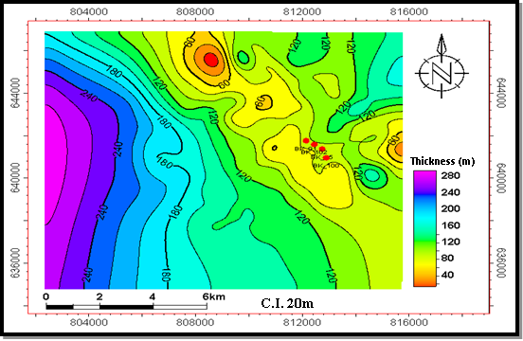
Figure (5): Isopach map of Hammam Faraun Member of Belayim Formation.

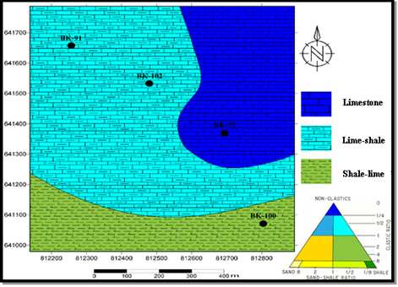
Figure (6): Lithofacies map of Hammam Faraun Member of Belayim Formation.

2- Structural setting of Bakr area
To get a real structural pattern in the study area, well-logging and seismic data are needed. Moustafa (1976) defined Bakr area within the second down faulted block (Belayim province). This province is characterized by a strong deformation and exhibits a rather complex intersection of fault pattern, mainly Suez (clysmic) and Aqba trend (Van der ploeg, 1953). The cross-sections reflect the structural image vertically but it is completed by the construction of structural model and structural maps, to illustrate the structural feature laterally.
Seismic Interpretation
Seismic interpretation implies detection of the subsurface structural configuration. To understand the geology and subsurface structure of the area under investigation, the interpretation of several seismic sections would be done. To understand the subsurface structure of the study area, twelve dip seismic sections are constructed and oriented towards NE-SW direction, and eight strike seismic sections are constructed and oriented towards NW-SE direction as is shown in figure (2). The interpreted seismic sections 4, 7, and 12 are shown in figure (7), which are dip seismic sections and take the NE-SW trend. Seismic section-4 is located at the southern part of the study area and passes near Bakr-100 well. Seismic section-7 is located at the central part of the study area and passes near Bakr-91 well. Seismic section-12 is located at the northern part of the study area and passes near Bakr-91 well. The interpretation of these sections is done by using the time-depth chart constructed using checkshot data of Bakr-100 well, so the detection of the two way time of the selected stratigraphic horizon is easily done. These sections pass through the studied rock units (Zeit Formation, South Gharib Formation, Hammam Faraun Member of Belayim Formation, Feiran Member of Belayim Formation, Lower Miocene formations and Lower Senonian Matulla Formation). These sections show a set of two normal faults (F1 and F2) forming a horst block that affects on all the stratigraphic units. F1 and F2 are directed towards the NW-SE trend forming a horst block that would be an excellent location for oil and gas accumulations.
Structure contour maps

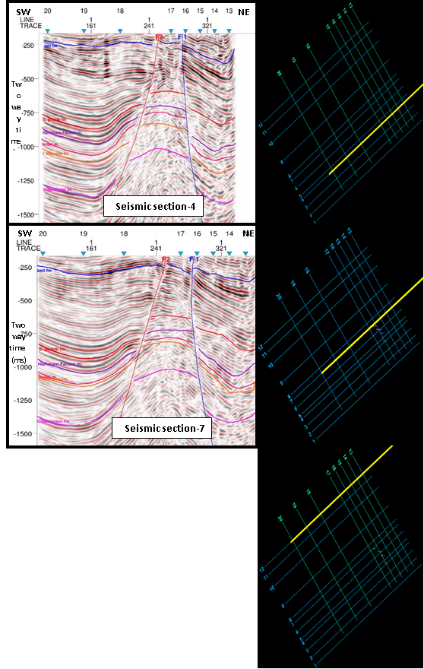

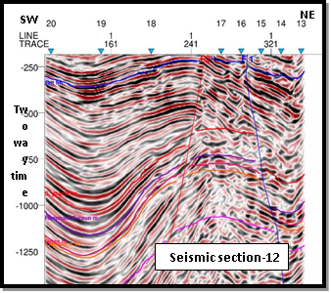
Figure (7): NE-SW interpreted seismic sections.

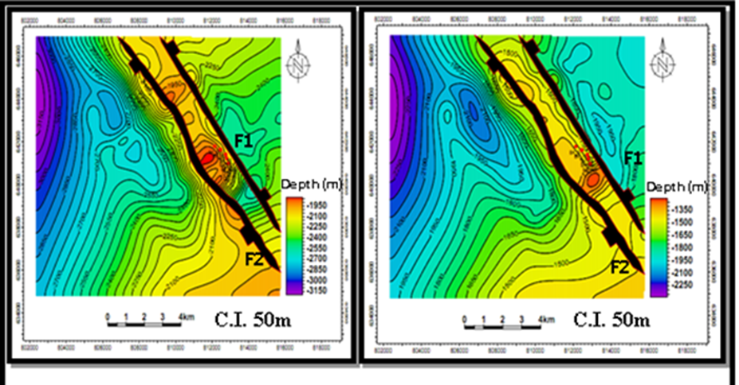
Structure contour map on top Lower  Miocene formations. | Structure contour map on of Lower  Senonian Matulla Formation.
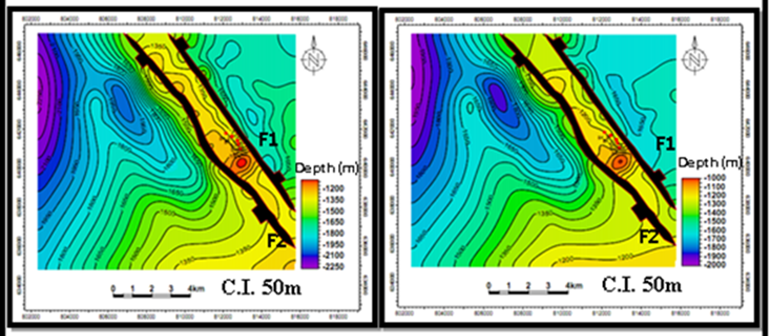
Structure contour map on top Feiran  Member of Belayim Formation. | Structure contour map on top Hammam Faraun Member of Belayim Formation.
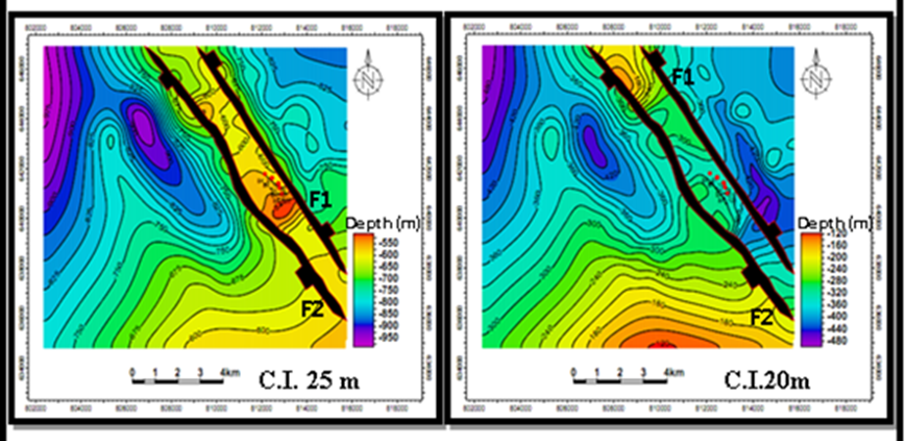
Structure contour map on top South Gharib Formation | Structure contour map on top Zeit Formation
Figure (8): Structure contour maps on top of selected rock units in Bakr Oil Field.

After the interpretation of the seismic sections we construct structure contour maps for each of the selected stratigraphic horizons by using Petrel 2010 software program (@ Schlumberger, 2010(.To illustrate the subsurface structural configuration of the study area, six structure contour maps are constructed on top of selected rock units (Zeit Formation, South Gharib Formation, Hammam Faraun Member of Belayim Formation (reservoir in the study area), Feiran Member of Belayim Formation, Lower Miocene formations, and Lower Senonian Matulla Formation) as is shown in figure (8). These maps show a set of two normal faults (F1 and F2) which are determined from the interpreted seismic sections. F1 and F2 form a horst block that would be an excellent location for oil and gas accumulations. F1 and F2 are taking the NW-SE direction with a down-thrown side towards the NE and SW directions respectively. All the studied wells are located on the horst block and located within the three-way dip closure that is very suitable place for oil and gas accumulations.
Mekkey (2012) mentioned that the uplifting caused due to rift tectonic during the Eocene and some of structures during the Early Miocene time. This may indicate that the area was affected by faults in Pre-Miocene and rejuvenated during the Miocene time.
Structural model of the study area
To delineate the subsurface structure of the study area, structural model is constructed and also structural cross sections are done through the study area in different directions. Figure (9) shows that the structure affecting the study area is mainly normal faults forming a horst block which would be an attractive trap for oil and gas accumulations.

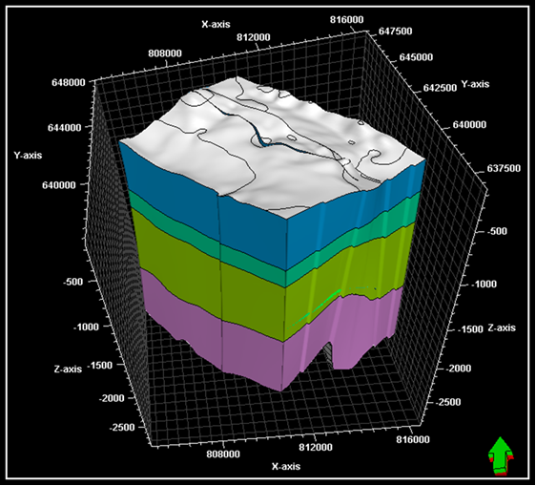
Figure (9): Structural model which constructed in the area of study.

Structural Cross Sections
Four structural cross sections have been constructed using the interpreted seismic lines. Figure (10) shows the structural cross sections which reflect that the study area was affected by two normal faults F1 and F2, forming a horst block. F1 is directed towards the NW-SE trend and its downthrown side is directed towards the NE trend. F2 is also directed towards the NW-SE trend and its downthrown side is directed towards the SW trend.
Petrophysical Evaluation
This part of the study is concerned with the petrophysical characteristics of reservoir rock units in Bakr Oil Field, Gulf of Suez, Egypt. We need to evaluate the reservoir in the term of petrophysical parameters of both rock and fluid constituents. In order to assess a possible petroleum reservoir, the porosity and hydrocarbon saturation are required to be evaluated, which together define the amount of hydrocarbons per unit volume of rock. Petrophysics, in its simplest form, is the calculation of porosity and fluid saturations as a function of depth in a well (Luthi, 2001).
In this study, the petrophysical analysis was performed for four wells restricted in the central part of the study area (Bakr-75, Bakr-91, Bakr-100 and Bakr-102).
The value of formation water resistivity (R_{w}) for Belayim Formation is obtained from the composite-log data at S_{w} equals 100%, by using the Archie's water saturation equation (Schlumberger, 1987). Another method for determining R_{w} is the using of "Pickett plot", which is developed by plotting porosity values with deep resistivity values on two-by-three cycle log-log paper (Asquith and Gibson, 1982). The value of formation water resistivity (Rw) for Hammam Faraun Member of Belayim Formation ranges from 0.095 (Ohm.m.) in Bakr-100 to 0.813 (Ohm.m.) in Bakr-75.
The calculated net pay, Effective porosity, water saturation and hydrocarbon saturation values were tabulated and mapped for Hammam Faraun Member of Belayim Formation (table 1). The cutoffs used are as follows: Effective porosity 10%, Volume of shale 35%, Water saturation 50%.

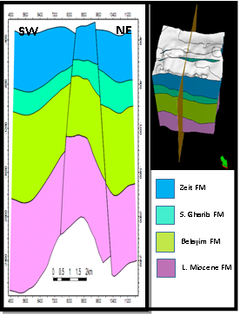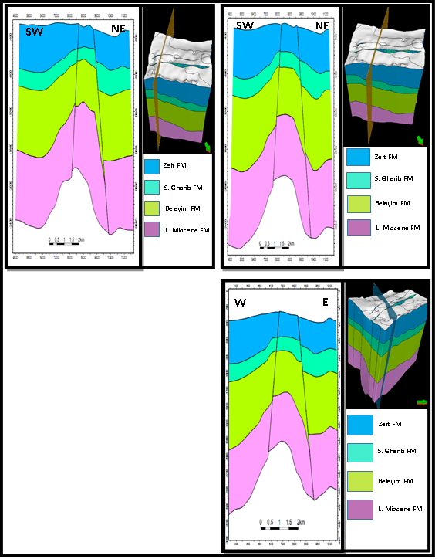
Figure (10): Structural cross sections in Bakr Oil Field.

Table (1): The Petrophysical parameters of Hammam Faraun Member of Belayim Formation in Bakr Oil Field.
Well no. | Interval  ( m) | Gross (m) | Net pay (m) | Effective porosity  (%) | Water saturation  (%) | Shale content  (%) | Hydrocarbon saturation  (%)
Bakr-75 | 1520-1562 | 42 | 20 | 16 | 40 | 21 | 60
Bakr-91 | 1240-1379 | 139 | 5 | 18 | 75 | 30 | 25
Bakr-100 | 1372-1474 | 102 | 13 | 22 | 51 | 12 | 49
Bakr-102 | 1200-1348 | 148 | 50 | 19 | 40 | 27 | 60

Well log analysis
Well-log analysis represents the most important stage in the evaluation of petrophysical characteristics (effective porosity, shale content, water saturation, and hydrocarbon saturation).

Lithological Identification cross-plot
Identification of lithology is of a particular importance in formation evaluation process. Logs can be used as indicators of lithology. The most useful logs for this purpose are density, neutron, sonic and gamma-ray logs. Figure (11) shows the neutron-density and the neutron-sonic cross-plots (lithological identification cross plot) of Hammam Faraun Member of Belayim Formation in all wells. As is shown in this figure, it is mainly characterized by the predominance of reefal limestone. It is also characterized by the presence of shale.

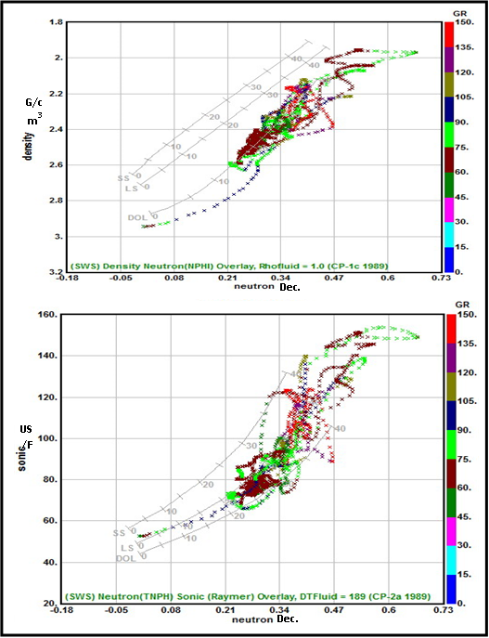
Figure (11): Lithological identification cross plots of Belayim Formation in Bakr-100 well.

Mono-Porosity cross-plot
Figure (12) shows mono-porosity cross-plot of Hammam Faraun Member of Belayim Formation which carried out to determine the water saturation (S_{w}). The value of water saturation ranges from 40% in Bakr-75 and Bakr-102 to 75% in Bakr-91. It indicates the probability of presence of hydrocarbon sub-reservoir intervals as the mean value is 52%.
Dia-Porosity cross-plot
For the determination of shale volume (V_{sh}) and effective porosity (Ø_{eff}), a combination of porosity logs can be used. Dia-porosity cross-plot is a specific graphical log analysis technique for actual petrophysical evaluation. In this investigation, figure (13) and figure (14) show dia-porosity cross-plot which is carried out to determine the shale volume (V_{sh}) and effective porosity (Ø_{eff}).
The value of shale content ranges from 12% in Bakr-100 to 30 % in Bakr-91. It indicates the probability of presence of hydrocarbon sub-reservoir intervals as the mean value is 22 %, while the value of effective porosity ranges from 16% in Bakr-75 to 22% in Bakr-100. It indicates the probability of presence of hydrocarbon sub-reservoir intervals as the mean value is 19%.

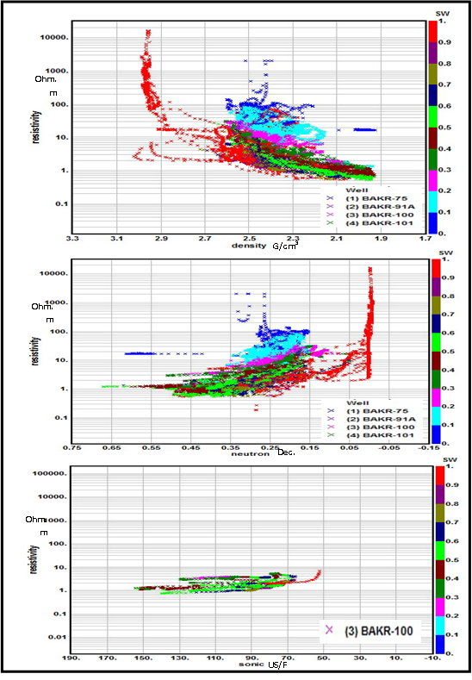
Figure (12): Mono-porosity cross-plot of Hammam Faraun Member of Belayim Formation in the wells of study area.
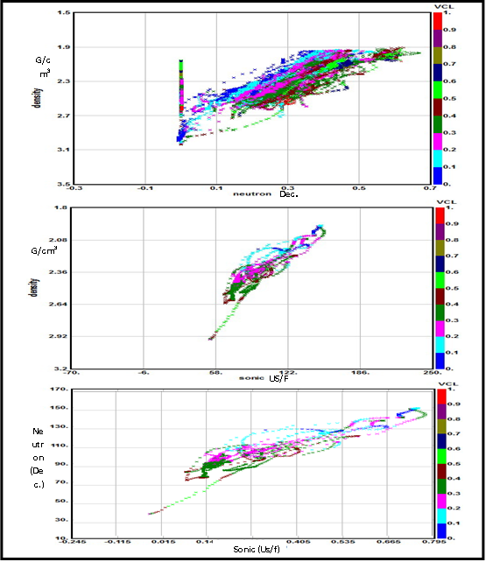
Figure (13): Dia-porosity cross-plot for determining the shale volume (V_{sh}) of Hammam Faraun Member of Belayim Formation.

Illustration of Petrophysical Parameters
Lateral Variation of Petrophysical Characteristics
The lateral variation of petrophysical characteristics in the area under investigation could be studied through a number of gradient and saturation maps (iso-parametric maps, that include, net pay (m), shale content (V_{sh} %), effective porosity (Ø_{eff} %), water saturation (Sw %), and hydrocarbon saturation (Shr %) to complete the vision of hydrocarbon potentialities in the study area.
Belayim net pay thickness distribution map:
Figure (15) shows the net pay thickness distribution. The net pay ranges between 5m in Bk-91 to 50m in Bk-102. The highest thickness of the pay zone is concentrated in the central part of the study area and decreased in the southeastern and northwestern parts of the study area. This map indicates that the central and northeastern parts of the study area are the most promising parts for hydrocarbon accumulations.

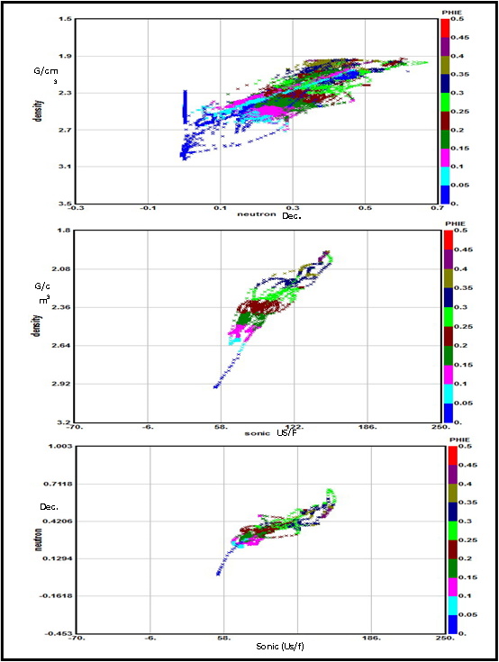
Figure (14): Dia-porosity cross-plot for determining the effective porosity (Ø_{eff}) of Hammam Faraun Member of Belayim Formation.

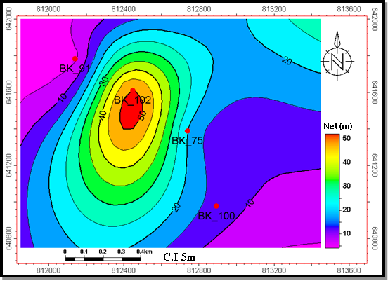
Figure (15): Net pay thickness map of Hammam Faraun Member of Belayim Formation.

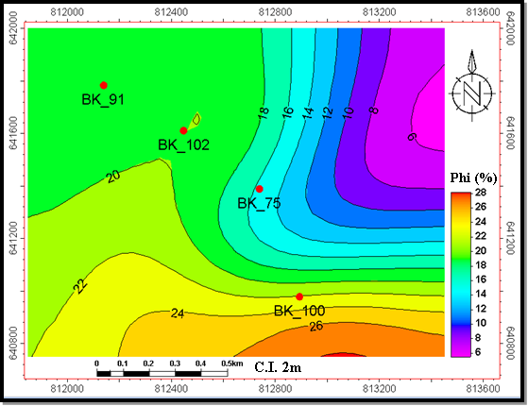
Figure (16): The Effective porosity map of Hammam Faraun Member of Belayim Formation.
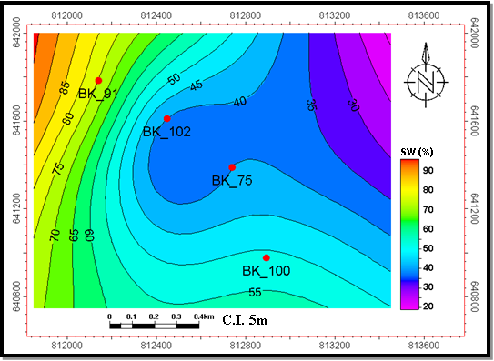
Figure (17): Water saturation map of Hammam Faraun Member of Belayim Formation.

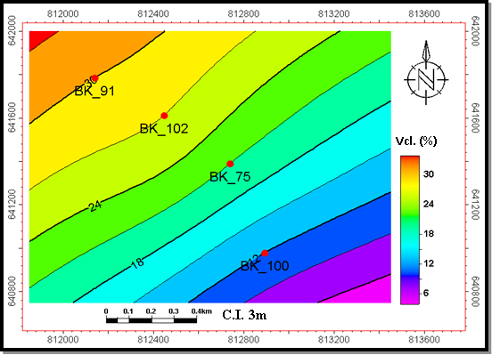
Figure (18): Shale content distribution map of Hammam Faraun Member of Belayim Formation.

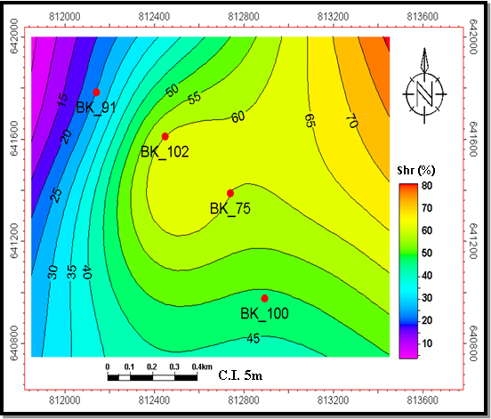
Figure (19): Hydrocarbon saturation map of Hammam Faraun Member of Belayim Formation.

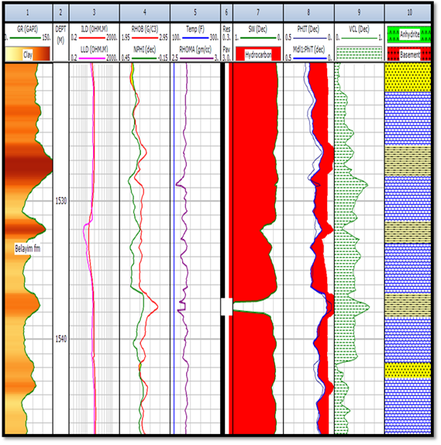
Figure (20): The litho-saturation cross-plot of Hammam Faraun Member of Belayim Formation in Bakr-75 well.

Belayim Effective porosity (Øeff %) distribution map:
Figure (16) illustrates the effective porosity distribution. The most frequent porosity is observed within the range of 16% in Bk-75 to 22% in Bk-100. The highest value of effective porosity is found at the central and southeastern parts of the study area, while the lowest value of effective porosity is found at the northeastern part.
Belayim water saturation (Sw %) distribution map:
Figure (17) shows the distribution of water saturation in the study area. The most water saturation occurrence is observed within the range of 40% in Bk-102 to 75% in Bk-91. The highest water saturation value is found at the western and northwestern parts in the study area while the lowest water saturation value is found at the central and northeastern parts.
Shale content (Vcl %) variation map
Shale content is an important quantitative function of log analysis. It is considered as an important indicator of reservoir quality, in which the lower the shale content usually reveals a better reservoir. Figure (18) shows the shale content map of Hammam Faraun Member of Belayim Formation and illustrates that the shale content ranges from 12% in Bk-100 to 30% in Bk-91. The shale content decreases at the southeastern part, while it increases in the northwestern part of the study area.
Hydrocarbon saturation variation map
Determination of hydrocarbon saturation (Shr %) is the main target of the current study. The hydrocarbon saturation map of Hammam Faraun Member of Belayim Formation, figure (19), illustrates that the hydrocarbon saturation ranges from 49% in Bakr-100 to 60% in Bakr-102. This map illustrates that the hydrocarbon saturation in the study area increases in the northeastern and central parts and decreases in the northwestern part of the area.
Vertical Variation of Petrophysical Characteristics
The vertical distribution of hydrocarbon occurrences can be explained and presented through the construction of the litho-saturation cross-plots. Litho-saturation cross-plot is a representation, zone-wise, for the content of fluids and rocks with depth through the studied well. The contents of rocks include shale and matrix, while the contents of fluids include water and hydrocarbon saturation. Figure (20) illustrates the computer processed interpretation (CPI) plot for Hammam Faraun Member of Belayim Formation in Bakr-75 well. As is shown in this figure it is encountered at depth ranges from 1520m to 1562m. The gross interval of Belayim Formation is 42ms. It is mainly characterized by the predominance of limestone. It is also characterized by the presence of sandstone and siltstone. Limestone tends to increase in the central and lower part of the member. In this member, the shale content ranges between 0% to 70% and the mean value is 21%. The effective porosity ranges between 0% to 29% but the mean value is 16%. The water saturation ranges between 0% to 100% and the mean value is 40%. The net pay is 20m. The hydrocarbon saturation reaches up to 60%.
Figure (21) illustrates the computer processed interpretation (CPI) plot for Hammam Faraun Member of Belayim Formation in Bakr-91 well. As is shown in this figure it is encountered at depth ranges from 1240m to 1379m. The gross interval is 139m. It is mainly characterized by the predominance of limestone. It is also characterized by the presence of shale, and siltstone. Limestone tends to increase in the central and upper part of this member. In this member the shale content ranges between 0% to 50% and the mean value is 30%. The effective porosity ranges between 0% to 41% but the mean value is 18%. The water saturation ranges between 0% to 100% and the mean value is 75%. The net pay is 5m.
Hydrocarbon Potential
From the subsurface and petrophysical information of this study, we can concluded the petroleum potentialities in the study area. According to Ashraf (1999), the source rock in the study area is suggested to be of Lower Miocene section of calcareous, dark grey shale and reefal limestone which is considered as a good source rock. The reservoir rock in the study area is represented by Hammam Faraun Member of Belayim Formation (Middle Miocene Serravalian age) which consists mainly of reefal carbonate. The seal rock in the study area is represented by the evaporite series of South Gharib and Zeit formations. The structural traps in the study area, are represented by fault traps. A set of normal faults F1 and F2 are present and forming a horst block.
Prospect Evaluation
According to Gluyas and Swarbrick (2004), exploration wells are drilled into prospect. Prospects are volumes of rock in the earth crust that are believed, but not proven to contain the four key component: a valid trap, an effective seal, a reservoir and petroleum source rock that has generated and expelled petroleum into the trap. Once an exploration well penetrates a prospect, it ceases to be a prospect. It became a proven petroleum field or more likely a dry hole, which means that it lacks petroleum. A lead is nothing more than an ill-defined prospect. The boundary between what is lead and what is prospect is open to individual interpretation.
As a result of the present study, using the subsurface and petrophysical evaluation, a new location is proposed to be a prospect as in figure (22). The area which has the red color, is recommended to be a prospect area according to the subsurface petrophysical evaluation.

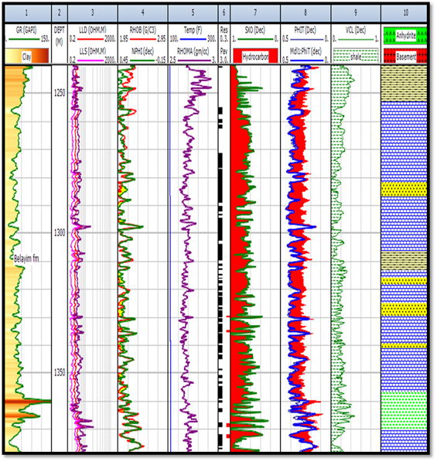
Figure (21): The Litho-saturation cross-plot of Hammam Faraun Member of Belayim Formation in Bakr-91 well.

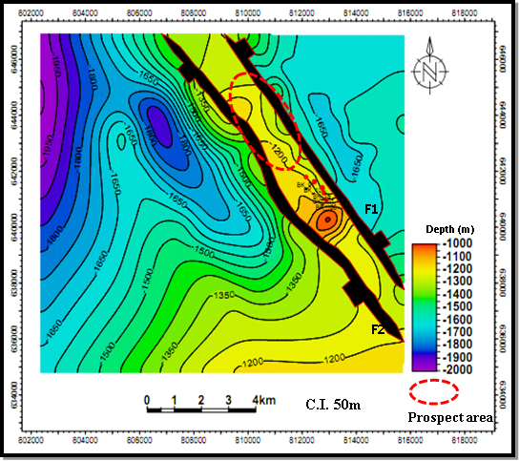
Figure (22): Depth structure contour map of Hammam Faraun Member of Belayim Formation and the recommended prospect area.

Hammam Faraun Member of Belayim Formation has a net pay thickness increasing towards the central and northeastern parts of the study area, while the effective porosity increases gradually into the central and southeastern parts, the clay volume decreases towards the northwestern and eastern parts of the study area, while water saturation decreases towards the central and northeastern parts of the study area, while the hydrocarbon saturation increases gradually towards the central and northeastern parts of the study area.

Summary and Conclusions
The present work mainly deals with the interpretation of geological and geophysical data to evaluate the hydrocarbon potentials of carbonate reservoir in Bakr Oil Field, Gulf of Suez, Egypt. The subsurface evaluation in this study was achieved by well-log and seismic data analysis to determine both stratigraphic and structural features as related to the general subsurface setting of the Gulf of Suez province.
The stratigraphic succession penetrated by the wells drilled in the study area is as the same as the Gulf of Suez province. The structural setting is delineated by the seismic and geologic cross-sections interpretation. The geologic structural model was constructed to study the structural setting in the area of study. Several seismic and geologic cross-sections are constructed and interpreted to illustrate the structural setting vertically. The geologic cross sections confirm the presence of the normal faults that are observed on the interpreted seismic sections.
Formation evaluation in the area under investigation was aimed to evaluate the hydrocarbon potentialities in the porous carbonate zone that is encountered in Middle Miocene (Nullipore of Belayim Fm). All resulted petrophysical parameters are represented vertically in litho-saturation cross-plots and laterally in different types of iso-parametric maps (iso-effective porosity, shale content, hydrocarbon saturation, and net-pay thickness variations).
From the subsurface and petrophysical information of this study we can be in a clear vision on the petroleum potentialities in the area of study. The source rock in the study area is suggested to be Lower Miocene formations based on previous studies. The reservoir rock in the study area is the Hammam Faraun Member of Belayim Formation which consists mainly of reefal carbonate. The seal rock in the study area is represented by the evaporite series of South Gharib and Zeit formations. The structural trap in the study area is represented in the form of fault blocks.
As a result of the present study, using the subsurface and petrophysical evaluation, a new location is proposed to be a prospect area that is located on such a three-way dip closure that is very suitable place for hydrocarbon accumulations.

References
- Asquith, G., and Gibson, C. (1982): "Basic well log analysis for geologists", The American Association of Petroleum Geologists, Tulsa, Oklahoma, USA, 216 p.
- EGPC Stratigraphic Committee (1974): "Miocene rock stratigraphy of Egypt". Egypt. Journ. Geol, 18, pp.1-59.
- General Petroleum Company (2013): "Stratigraphic setting of Bakr oil Field", internal report, 36p.
- Gluyas, J. and Swarbrick, R. (2004): "Petroleum geoscience", Blackwell Science Ltd. 349 p.
- Haq, B., Hardenbol, J. and Vail, P. (1987): "Chronology of fluctuating sea level since the Triassic", science, No. 236, pp. 1156-1167.
- Luthi, S. M. (2001): "Geological Well Logs, their use in reservoir modeling", Springer-Verlag Berlin Heidelberg.
- Mekkey, M. (2012): "Evaluation of hydrocarbon potential of carbonate reservoir in Al Hamd and Amer offshore Oil Field, Gulf of Suez, Egypt". Ph.D. Thesis, Faculty of Science, Al Azhar Univ., Cairo, 191P.
- Moustafa, A. G. (1976): "Block faulting in the Gulf of Suez". 5th Petroleum Exploration and Production Conference, Cairo, pp.14-38.
- Rayan, W., and Hsu, K. (1973): "Initial report", DSDP, V. 13, Washington (US. Convt. Printing office) 1447 p.
- Schlumberger (1987): "Log interpretation", Principles / Application, Schlumberger educational services, U.S.A., 168 p.
- Van der Ploeg, P. (1953): "The World's Oil Fields: The Eastern Hemisphere", Egypt In: V. G Illing (Ed.). The Science of Petroleum, Oxford Univ. Press 6(1): pp.151-157.
- Warner, L. (1977): "An introduction to the technology of subsurface wastewater injection". Municipal Environmental Research Laboratory, U.S., 334p.

3/15/2015

