Prevalence and Antibiotic Susceptibility Pattern of Enterohemorrhagic Escherichia coli O157:H7 isolated from various samples obtained from three different areas of Rivers State, Nigeria

¹Odu NN, ²Akujobi CO and ¹Iwuji CO

¹Microbiology Department, University of Port Harcourt, Port Harcourt, Rivers State, Nigeria.
E-mail: ngozi.odu@uniport.edu.ng; odungozi@yahoo.com; Tel: +2348064341944; 07069177380
²Microbiology Department, Federal University of Technology, PM 1526, Owerri, Imo State, Nigeria.
E-mail: campbell205@yahoo.com

Abstract: Prevalence and antibiotic susceptibility pattern of enterohemorrhagic escherichia coli 0157:H7 isolated from various samples obtained from three different areas of Port Harcourt, Rivers State, Nigeria were investigated.Two hundred and forty (240) samples of fresh beef, dung, cabbages and carrots were obtained from three different areas of Port Hartcourt viz: Rumuokoro, Rumuji and Oginigba. Isolates were obtained on Sorbitol-MacConkey Agar (SMAC) supplemented with cefixime and potassium tellurite following pre-enrichment on Triptycase Soy Broth supplemented with novobiocin and cefixime and incubated at 37˚C for 24h. Following routine biochemical tests, confirmation was carried out with the Wellcotex E. coli 0157:H7 specific antiserum (Oxoid, Uk). Both E.coli 0157 and E.coli 0157:H7 strains were isolated depending on the sample and sample site. Determination of beta lactamase enzyme production ability of the isolates revealed that most isolates produced Metallo β-lactamase enzyme while none of them produced Extended Spectrum β-lactamase enzyme (ESBL). The antibiotic susceptibility screening revealed that Nitrofurantoin, Ceftazidime, Gentamicin and Ciprofloxacin were effective against the isolates obtained with the isolates being most sensitive to Ciprofloxacin. Due to its public health importance, although the prevalence level was very low, only the presence of one positive sample can serve as a source of a major chain of events. It is therefore very important to develop proper sanitary hygiene within and outside the home, vegetable farms and slaughter houses. The need for proper education of farm workers by the relevant government agencies cannot be overemphasized.
[Odu NN, Akujobi CO, Iwuji CO. Prevalence and Antibiotic Susceptibility Pattern of Enterohemorrhagic Escherichia coli O157:H7 isolated from various samples obtained from three different areas of Rivers State, Nigeria. Nat Sci 2015;13(4):50-58]. (ISSN: 1545-0740). http://www.sciencepub.net/nature. 9

Keywords: Antibiotic Susceptibility Pattern, Escherichia coli O157:H7, Prevalence, Nigeria

1. Introduction

E. coli includes a very large population of bacteria that exhibit a very high degree of both genetic and phenotypic diversity. Studies have shown that E. coli remains one of the most diverse bacterial species with only about 20% of the genome common to all strains (Lukjancenko et al., 2010). Different strains are often host-specific making it possible to determine the source of feacal contamination in samples (Feng et al., 2002). For instance, knowing the E. coli strains present in cow dung allows a researcher to make assumptions about the origin or source of a particular contamination.

Although a normal flora of the gut of humans, some strains develop traits that can be harmful to the host. In the developing world, these virulent strains typically cause a bout of diarrhoea that is unpleasant in healthy adults and is often lethal to children (Nataro and Kaper, 1998). More virulent strains such as O157:H7 cause serious illness or death in the elderly, the very young or the immune compromised (Hudault et al., 2001; Nataro and Kaper, 1998).

Currently, there are six main classes of diarrheagenic E. coli based on their pathogenic features and distinct virulence determinants. These include the enteropathogenic E. coli (EPEC), enterotoxigenic E. coli (ETEC), enterohemorrhagic E. coli (EHEC), Shiga toxin-producing E. coli (STEC), enteroinvasive E. coli (EIEC), enteroaggregative E. coli (EAEC) and diffusively adherent E. coli (DAEC) (Nataro and Kaper, 1998).

Studies have shown that among the diarrheagenic E. coli strains, STEC strains are distinguished by their ability to cause complications that are severe and life-threatening, such as haemolytic uremic syndrome (HUS) and thrombotic thrombocytopenic purpura (TTP) (Karch et al., 2005). Most people infected with STEC O157 usually develop watery diarrhoea, often bloody diarrhoea, abdominal cramps and hemorrhagic colitis (HC) may also occur. STEC strains that cause HC and HUS are also called EHEC. Most illnesses end on their own within 7 days while some last longer and can be more severe. Rarely, some develop the more severe infection, Hemolytic Uremic Syndrome (HUS), which is a type of kidney failure that begins as the diarrhoea is improving. HUS can occur in people of any age but children under 5years, the elderly and immunocompromised individuals are more likely to suffer from the most severe complications (Thorpe, 2004; Duffy et al., 2006, Razzaq, 2006; Walch et al., 2006; Centre for Disease Control and Prevention, 2012).

In the fall of 1991, an E. coli 0157:H7 outbreak in Southern Massachusetts provided an opportunity to study and identify the transmission of the pathogen via an unlikely vehicle. From the study, it was revealed that E. coli 0157:H7 likely to cause severe infections can be transmitted through fresh pressed unpreserved apple cider. Thorough washing and brushing of the apples before pressing and preservation of the cider with sodium benzoate can reduce the risk of transmission (Besser et al., 1993).

In 1994, there was a multistate outbreak of Escherichia coli O157:H7 in Washington. The largest reported outbreak resulted from errors in meat processing and cooking. Infection was associated with eating hamburgers at a fast food chain in 10 days before the symptoms began (Bell et al., 1994). In 1996, another multistate outbreak of Escherichia coli O157:H7 infection associated with the consumption of Mesclun lettuce was reported in Connecticut and Illinois. The implicated lettuce was traced to a single grower-processor, where cattle, a known E. coli O157:H7 reservoir, were found near the lettuce fields (Hilborn et al., 1999).

In May 2011, an E. coli strain, Escherichia coli 0104:H4, was the subject of a bacterial outbreak that began in Germany. The outbreak started when several people in Germany were infected with EHEC bacteria, leading to HUS, a medical emergency that requires urgent treatment. The outbreak did not only concern Germany but 11 other countries including regions in North America. On 30 June 2011, the German Federal Institute for Risk Assessment, a federal fully legal entity under public law of the Federal Republic of Germany, an institute within the German Federal Ministry of food, Agriculture and Consumer Protection announced that seeds of fenugreek from Egypt were likely the cause of the EHEC outbreak (Federal Institute for Risk Assessment, 2011). Knowing that E. coli O157:H7 is host specific and has the ability to infect foods, vegetables and food products, it is important to investigate its presence in various samples of interest.

2. Materials And Methods

2.1. Sample Collection
The samples were obtained from different sources in three different markets/areas (Rumuokoro, Rumuji and Oginigba) of Rivers State. For each of the four sample types, twenty were collected per market/area (that is, 60 samples per sample type). The beef samples were purchased from retailers in local markets, placed in sterile plastic bags and appropriately labelled. The cow dung samples were collected directly from the rectum of cow using sterile arm-length gloves placed in sterile sample collection bottles and appropriately labelled. The carrots were purchased from retailers at local markets or shops, placed in sterile plastic bags and appropriately labelled. The cabbages were purchased from retailers at local markets or shops, placed in sterile plastic bags and appropriately labelled. After collection, samples were held at 4˚C in an ice box and immediately transported to the laboratory for analyses. The samples were analysed at not more than 2h on arrival.

2.2. Isolation of Enterohemorrhagic E. coli 0157:H7
Twenty-five grams (25g) of each sample was homogenised, using Lab Stomacher blender 400, in 225ml of Triptycase Soy Broth supplemented with novobiocin (2µg/ml) and cefixime (50µg/ml) and incubated at 37˚C for 24h. A tenfold serial dilution of the pre-enriched samples was made using Peptone Water. From the dilution for use, 0.1ml aliquot dilution was plated onto Sorbitol-MacConkey Agar (SMAC) supplemented with cefixime (0.05mg/ml) and potassium tellurite (2.5mg/ml) and seeded plates incubated at 37˚C for 24h.
2.3. Serological Confirmation Of Escherichia coli 0157:H7
Confirmation of isolates was by slide agglutination using Wellcotex E. coli O157:H7 specific antiserum, Oxoid, UK. (Ateba and Mbewe, 2011 modified). Forty micrograms (40μl) of sterile normal saline was placed on four circles of the reaction card and labelled accordingly. The mixing stick was used to obtain a small amount of the test isolates and emulsified in the saline with the flat end of the sticks and the sticks were discarded. A drop of the 0157 test latex (Wellcolex REF 30959601) was placed in one circle; a drop of the O157 positive control latex was dropped on the second circle, a drop of H7 test latex on the third circle and H7 positive control latex on the fourth. The contents of the individual circles were mixed together in each circle, spreading the latex over the entire area of the circle. The card was rocked slowly for 30secs and observed for agglutination. The presence of agglutination (clumping) indicated a positive result while absence of agglutination indicated negative result for either 0157 and/or H7 antigens as was applicable.
2.4. Determination Of Enzyme Production

2.4.1. Determination of Extended Spectrum Beta Lactamase (ESBL) Production

Mueller Hinton agar plates were seeded with the standard inoculum suspensions of the test isolates and allowed to stand for 15mins for diffusion. Antibiotic disks containing 30µg of Aztreonam, Ceftazidime and Ceftriaxone were placed 15mm from an Amoxicillin-Clavulanic acid disk (20 and 10µg respectively) on the seeded medium and incubated at 37°C for 18-24h. An enhanced zone of inhibition between any of the β-lactam disks and the disk containing clavulanic acid was interpreted as an evidence for the presence of an ESBL (Akujobi et al., 2008).
2.4.2. Determination of AmpC Beta Lactamase Production
Mueller Hinton agar plates were seeded with the standard inoculum suspensions of the test isolate and allowed to stand for 15mins for diffusion. Antibiotic disks containing 30µg of Cefoxitin and another containing 30µg of Cefoxitin and 40µg of Boronic acid were placed on the seeded medium. An organism demonstrating a zone diameter around the disk containing Cefoxitin and Boronic acid ≥5mm than the zone diameter around the disk containing Cefoxitin alone was considered an AmpC producer. (Akujobi et al., 2010).
2.4.3. Determination of Metallo Beta Lactamase Production
Mueller Hinton agar plates were seeded with the standard inoculum suspensions of the test isolate and allowed to stand for 15mins for diffusion. Antibiotic disks containing Meropenem, Meropenem+EDTA, Imipenem and Imipenem+EDTA were placed on each of the seeded plates. The plates were incubated for 18-24h at 37◦C and examined for growth inhibition. An increase in zone size of ≥7mm around imipenem+EDTA and/or meropenem+EDTA disk than meropenem or imipenem alone is taken as a positive test for metallo β-lactamase production. (Akujobi et al., 2010).
2.5. Antibiotic Sensitivity Screening
2.5.1. Inoculum Preparation
Ten millilitres (10mls) of sterile Nutrient broth was prepared. A loopful of the test isolate (18h) was collected and inoculated into the sterile broth to make a suspension. To achieve a turbidity equivalent to a McFarland standard, which contains approximately 1×10⁸ CFU/ml, adequate light was visually used to compare the inoculum tube and the 0.5 McFarland standards against a white card with a contrasting black line.

2.5.2. Antibiotic Susceptibility Screening Using Disk Diffusion Test
Fifteen minutes after adjusting the turbidity of the inoculum suspension, a sterile swab stick was dipped into the adjusted suspension and the dry surface of the Mueller-Hinton agar plate seeded with the test organism by streaking the swab over the entire surface of the sterile agar. This was repeated twice to ensure an even distribution of the test isolate. The seeded plate was then allowed to stand for 15mins afterwards, and then the antibiotic disks were placed on seeded plates. The antimicrobial agents tested include Ceftazidime, Cefuroxime, Gentamycin, Ciprofloxacin, Floxacin, Amoxycillin/ Clavulanate, Nitrofurantoin and Ampicillin. The plates were inspected for growth after 24h incubation at 37˚C and the diameters of the zones of inhibition carefully measured then translated into susceptible, intermediate or resistant categories as is applicable. The presence of a growth inhibition zone larger than the established breakpoint diameter is an indication of susceptibility to that agent (British Society for Antimicrobial Chemotherapy, 2012).

3. Result

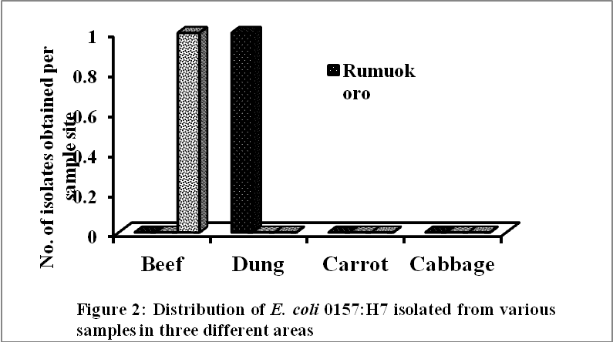

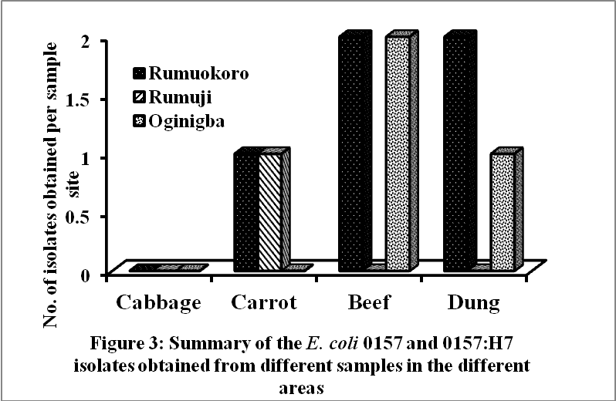

Samples were collected from tree locations in Port Harcourt, Rivers State, Nigeria. The locations are Rumuokoro, Rumuji and Oginigba areas of Port Harcourt. There were variations in the distribution of isolates made in the different locations. Beef samples from Rumuokoro yielded the highest number of E.coli 0157 isolates but no isolate of E.coli 0157:H7 strain was recovered. Beef sample from Rumuji yielded neither E.coli 0157 nor E.coli 0157:H7 strains while the beef samples Oginigba yielded equal numbers of both strains. Also, the cow dung samples from Rumuokoro yielded equal numbers of both strains of E.coli. There was no isolate from dung samples of Rumuji. Equally, there was no isolate of any of the strains from cabbage samples collected from Oginigba while carrot samples from Rumuji and Rumuokoro yielded equal numbers of E.coli 0157 strain. These are presented in figures 1 and 2. There was no isolation of E.coli 0157:H7 from carrot samples. Generally, the highest numbers of isolates were obtained from beef and dung samples of Rumuokoro and Oginigba (Figure 3).
The strains were tested for the production of Extended Spectrum β-Lactamase (ESBL), AmpC β-lactamase and Metallo β-lactamase enzymes. Among the E.coli 0157:H7 isolates, only cow dung isolates were positive for the production of AmpC and Metallo β-lactamase enzymes. The number of isolates that produced AmpC β-lactamase enzyme were higher than those that produced Metallo β-lactamase enzyme (Figure 4).

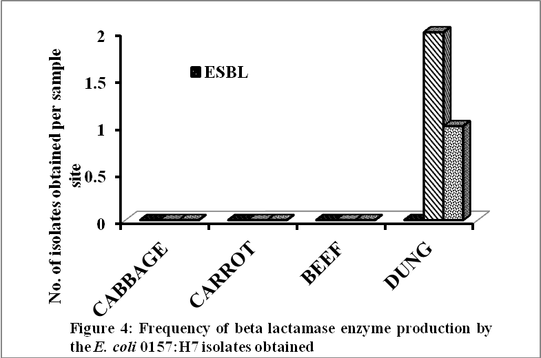

Figure 5 shows the frequency of β-lactamase enzyme production by E.coli 0157 isolates. The result shows that more isolates from beef samples produced Metallo β-lactamase enzyme.ESBL was not produced by any isolate while equal numbers of isolates from carrot and dung samples produced AmpC and Metallo β-lactamase enzymes respectively. Considering the production of the enzymes by both isolates from various samples, it was discovered that the highest number of isolates from beef samples produced AmpC and Metallo β-lactamase enzymes. Equal numbers of isolates from carrot samples produced AmpC and metallo β-lactamase enzyme. Also equal numbers of isolates from dung samples produced AmpC and metallo β-lactamase enzymes but the numbers of isolates that produced these enzymes in dung samples were higher than those that produced the enzymes in carrot samples as depicted in figure 6.
The isolates had varying degrees of sensitivities to the various antibiotics tested. Most of the isolates were susceptible to ciprofloxacin antibiotic (Figure 7). Most of the isolates were resistant to ampicillin and ofloxacin antibiotics. The second highest level of susceptibility was observed in nitrofurantoin antibiotic. The highest percentage sensitivity to the antibiotics in both strains was observed in their sensitivity to ciprofloxacin, E.coli 0157 showed higher percentage antibiotic sensitivity than E.coli 0157:H7 (Figure 8). E.coli 0157:H7 strain showed higher percentage antibiotic sensitivity in nitrofurantoin, ampicillin, augmentin, cefuroxime and ceftazidime while E.coli 0157 strain showed higher percentage antibiotic sensitivity to gentamicin and ciprofloxacin only.

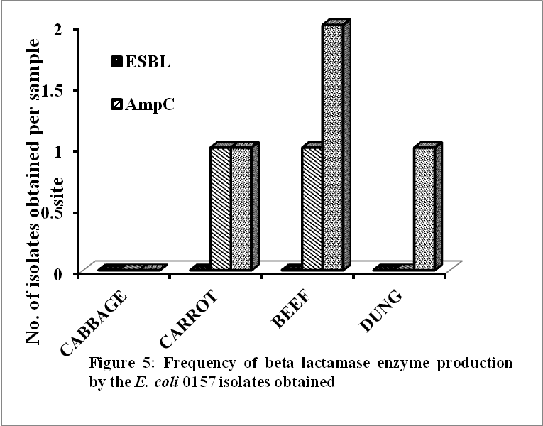

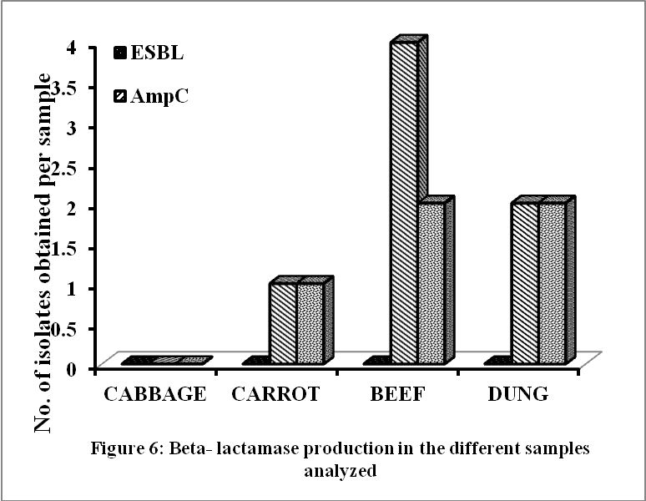

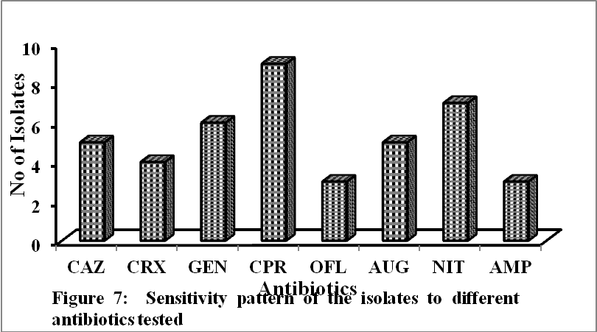
KEY: CAZ-Ceftazidime; CRX- Cefuroxime; GEN- Gentamicin; CPR- Ciprofloxacin OFL- Ofloxacin; AUG- Augmentin; NIT-Nitrofurantoin; AMP-Ampicillin
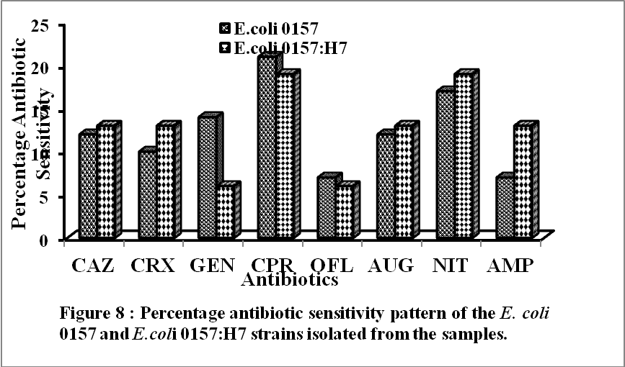
KEY: CAZ-Ceftazidime; CRX- Cefuroxime; GEN- Gentamicin; CPR- Ciprofloxacin OFL- Ofloxacin; AUG- Augmentin; NIT-Nitrofurantoin; AMP-Ampicillin

4. Discussion

Due to the health implications of the microorganism of interest, the extent to which the isolates can contaminate foods and food products cannot be overemphasized. The microorganisms from a normal and healthy animal can contaminate the slaughtering environment, cutting materials and even the personnel during the production and processing. If good hygiene is not properly observed, the pathogens may also be transferred to the food products, especially at sale points (Bouvet et al., 2001; Tutenel et al., 2003; Yilmaz et al., 2006).

In this study, E. coli 0157:H7 was successfully isolated from the cow dung and beef samples tested. E. coli 0157 was isolated from a carrot sample while neither E. coli 0157 nor 0157:H7 was isolated from the cabbage samples tested.

The mere presence of E. coli O157:H7 and E. coli O157 isolates in the dung samples analyzed is a cause for alarm because it reveals the presence of the STEC in the gastrointestinal tract of the ruminant which may be transferred by cross contamination to beef cuts and other materials that may come in contact with the dung. Furthermore, studies have also revealed that E. coli and related bacteria possess the ability to transfer DNA via bacterial conjugation, transduction or transformation which allows genetic material spread horizontally through an existing population. It is this process that can lead to the spreading of the gene encoding shiga toxin from Shigella to E. coli O157:H7 carried by a bacteriophage as reported by Brussow et al., (2004). It is therefore imperative to ensure that even one cell of this pathogen is not transferred to foods or food products so as to avoid a transfer of virulent genes to previously non-toxigenic bacteria because just one cell has the ability to transfer plasmids to surrounding populations of microorganisms.
The fresh beef samples from Rumuokoro and Oginigba had varying numbers each of E. coli 0157 and 0157:H7 while Rumuji had neither of the strains. Under normal circumstances, meat is sterile prior to the exsanguinations and slaughtering of animals. It is therefore most likely that the isolates obtained from the fresh beef were introduced from the gastrointestinal tract, cow dung on the slaughter floor or poor handling practices during the slaughtering and exsanguinations of cattle. Furthermore, there is also the possibility of transferring the isolates during the transportation of the beef as beef cuts from an uncontaminated batch may be mixed with those from a contaminated lot. As such, contamination ensues.
With a high potential for food borne transmission to humans, STEC are mainly commensal bacteria in animals (Caprioli et al., 2005). The predominant reservoir of STEC are ruminants, predominantly cattle, and beef products serve as one of the most important sources of food-borne STEC transmission (Tsuji et al., 2002; Caprioli et al., 2005; Maruzumi et al., 2005) as was supported by the result in a study showing that almost all STEC isolates obtained in a study involving different samples were recovered from ground beef (Ateba and Mbewe, 2011). Other researchers around the world have also studied the contamination of beef by STEC. A recent study by Samapdour et al. in the United States reported STEC in 3.5% of 1750 retail ground beef samples obtained from stores in Seattle, WA (Samadpour et al., 2006). Other studies on STEC revealed 4% in beef samples in France (Pradel et al., 2000), 3% in raw beef samples in Australia, 1.75% of minced beef samples in Switzerland (Fantelli and Stephan, 2001) and 1.5% of beef samples in Korea (Lee et al., 2009).
It is worthy of note that the demand for beef in Nigeria is quite high and as such, a possible contamination of beef is a cause for serious concern. Although the results of studies carried out worldwide to show the prevalence of E. coli 0157:H7 in beef varies, it would be fair to suggest that the prevalence of E. coli 0157:H7 in animals and meats sold by meat vendors in the markets largely depends on the hygienic conditions of the farms that reared the animals, the equipment used in the slaughters, the surrounding environments during slaughter and the personnel involved in meat processing.
The Rumuokoro market is densely populated with a carnal flowing beside and used water from the slaughter flows back into the water body. After slaughtering, beef cuts, primal and sections are transferred by carriers using wheel barrows, trucks or bikes to the meat vendors at different sale points within and/or outside the market. An originally sterile beef cut, if mixed with a contaminated batch will get contaminated. Also, the meat vendors at the markets neither wash their aprons daily nor do they package the beef cuts and as such there could be an easy and repeated transfer of the pathogen from one beef cut to another. The beef cuts are repeatedly touched by either the meat vendors or possible buyers hence exposing the beef cuts to more contamination. The meat vendors sometimes have to serve more than one person at a time; using the butchers’ knife to cut a bought part into smaller cuts and using the same knife for another cutting can result in a possible transfer of the pathogen to a previously ‘pathogen-free’ cut. The underlying issue of poor hygiene and handling practices is therefore a cause for concern and meats bought must be adequately cooked to reduce the risk of a possible infection in humans.
The study revealed the presence of E. coli O157 strain in Rumuokoro and Rumuji carrot samples tested while the Oginigba sample had none. From the results obtained in this study, the pathogens may have been transferred in the market or at the vegetable purchasing point. Another possibility is that the contamination may have come from the farm land by contaminated manure, the water used for washing the vegetables prior to display on the market tables or during transportation to the market.
The cabbage samples obtained from the three different areas and analyzed did not have the pathogens of interest. Inability to isolate the pathogen may have been due to the nature of the cabbage, which consists of clusters of stiff vegetables superimposed one over the other in compact layers giving it a round or globular shape, and the fact that only the inner layers are consumed. Although the cabbages tested were not contaminated, contamination may have been on the surface of the cabbage and as such removal of the outer leaves and subsequent washing may get rid of any remaining microorganisms. It is, however, still very important to observe good sanitary hygiene on farms, during harvesting, handling and packaging to ensure that the vegetable is not contaminated at any point.
The beta lactamase production ability of the isolates obtained from the study was also determined. Increasing resistance to third-generation cephalosporins is predominantly due to the production of extended-spectrum beta lactamases. These plasmid mediated enzymes mostly evolved via point mutations of the classical TEM-1 and SHV-1 beta lactamases but other groups are increasingly predominant, notably the CTX-M types, which evolved via the escape and mutation of chromosomal beta lactamases from Kluyvera spp (BSAC, 2012). In this study, none of the isolates obtained were able to produce the extended beta-lactamase enzyme but produced the metallo and AmpC beta lactamase enzyme although at varying capabilities. The cow dung isolates were also observed to produce the beta lactamases more than the other isolates obtained from other sources.
Antibiotic susceptibility pattern of the isolates obtained in this study was also carried out. Studies have shown that in recent times, E. coli strains have evolved the ability to withstand antibiotics and as such there is a need to check the susceptibility pattern of the isolates obtained to regular antibiotics routinely used in hospitals. From the antibiotic sensitivity pattern in this study, it was observed that different isolates responded differently to the antibiotics used. However, the study revealed that all the isolates were most sensitive to Ciprofloxacin and the highest resistance was observed in Ampicillin. The sensitivity of a particular isolate to an antibiotic may be due to the host specific nature of the isolate or the position of its virulence gene.

References
- Akujobi, C. O., Odu, N. N., Okorondu, S. I. and Nwachukwu, I. N. (2010). Growth inhibition of AmpC β-lactamase producing Escherichia coli and metallo β-lactamase producing Pseudomonas aerugenosa by components of Aloe vera. Curr. Trends in Microbiol. 6: 35-40.
- Akujobi, C. O., Ogbulie, J. N. and Alisi, C. S. (2008). Occurrence of extended-spectrum β-lactamases in Escherichia coli isolated from piggery farms in Imo State, Nigeria. World J. Microbiol. Biotechnol. 24: 2167-2170.
- Ateba C. N. and Mbewe M. (2011). Detection of Escherichia coli O157:H7 virulence genes in isolates from beef, pork, water, human and animal species in the northwest province, South Africa: public health implications. Res. Microbiol. 162: 240-248.
- Bell, P. B., Goldoft, M., Griffin, P. M., Davis, M. A., Gordon, D. C., Tarr, P. I., Bartleson, C. A., Lewis, J. H., Barrett, T. J., Wells, J. G., Baron, R. and Kobayashi, J. (1994). A multistate outbreak of Escherichia coli 0157:H7- Associated bloody diarrhea and hemolytic uremic syndrome from harmburgers: The Washington experience. JAMA 272(17):1349-1353.
- Besser, R.E., Lett, S.M., Weder, J.T., Doyle, M.P., Barett, T.J., Wells, J.G. and Griffin, P.M. (1993). A multistate outbreak of Escherichia coli 0157:H7 associated with fresh pressed, unpreserved apple cider. JAMA 269(17):2217-2220.
- Bouvet, J., Bavai, C., Rossei, R., LeRoux, A., Montel, M. P., Ray-Gueniot, S., Mazuy, C., Arquilliere, C., Vernozy-Rozand, C. (2001). Prevalence of verotoxin producing Escherichia coli and E. coli 0157:H7 in pig carcasses from three French slaughter houses. Int. J. Food Microbiol. 71:249-255.
- British Society for Antimicrobial Chemotherapy (2012). BSAC Methods for Antimicrobial susceptibility testing. Version 11.1 pp 13-21, 25, 85.
- British Society for Antimicrobial Chemotherapy (2012). BSAC Methods for Antimicrobial susceptibility testing. Version 11.1 pp 13-21, 25, 85.
- Brussow, H., Canchaya, C. and Hardt, W. C. (2004). Phages and evolution of bacterial pathogens: from genomic rearrangements to lysogenic conversion’. Microbiol. Mol. Biol. Rev. 68(3):560-602.
- Caprioli, A., Morabito, S., Brugere, H. and Oswald, E. (2005). Enterohemorrhagic Escherichia coli: emerging issues on virulence and modes of transmission. Vet. Res. 36:289-311.
- Center for Disease Control and Prevention (2012). Multistate outbreak of Shiga toxin-producing Escherichia coli 0157:H7: Infections linked to spinach and mixed blend. www.cdc.gov/ecoli/; cdcinfo@cdc.gov.
- Duffy G, Cummins, E., Nally, P., O’Brein, S., Butler, F. (2006). A review of quantitative microbial risk assessment in the management of E. coli 0157:H7 on beef. Meat Sci. 74: 76-88.
- Federal Institute for Risk Assessment (2011). Fenugreek seeds with high probability for EHEC O104:H4 responsible outbreak’. 30 June 2011.
- Feng, P., Weagant, S. and Grant, M. (2002). Enumeration of Escherichia coli and Coliform Bacteria. Bacteriological Analytical Manual (8th ed.) FDA/Center for Food Safety and Applied Nutrition.
- Hilborn, E. D., Mermin, J. H., Mshar, P. A., Hadler, J. L., Voetsch, A., Wojtkunski, C., Swartz, M., Mshar, R., Lambert-Fair, M., Farrar, J. A., Glynn, M. K. and Slutsker, L. (1999). A multistate outbreak of Escherichia coli 0157:H7- Infections associated with consumption of mesclun lettuce. Arch. Intern. Med. 159(15):1758-1764.
- Hudault S., Guignot, J. and Servin, A. L. (2001). Escherichia coli strains colonizing the gastrointestinal tract protect germ-free mice against Salmonella typhimirium infection. Gut. 49(1): 47-55.
- Karch, H. C., Janetzki-Mittmann, C., Aleksic, S. and Datz, M. (2005). Isolation of enterohemorrhagic Escherichia coli O157 starins from patients with haemolytic-uremic syndrome by using immunomagnetic separation, DNA-based methods and direct culture. J Clin. Microbiol. 34: 516-519.
- Lee, G. Y., Jang, H. I., Hwang, I. G. and Rhee, M. S. (2009). Prevalence and classification of pathogenic Escherichia coli isolated from fresh beef, poultry and pork in Korea. Int. J. Food Microbiol. 134:196-200.
- Lukjancenko, O., Wassenaar, T. M. and Ussery, D. W. (2010). Comparison of 61 sequenced Escherichia coli genomes. Microb. Ecol., 60(4):708-20.
- Maruzumi, M., Morit, M., Matsuoka, Y., Uekawa, A., Nakamura, T. and Fuji, K. (2005). Mass food poisoning caused by beef offal contaminated by Escherichia coli 0157. Japan J. Infect. Dis. 58: 390-397.
- Nataro, J. P and Kaper, J. B. (1998). Diarrheagenic Escherichia coli. Clin. Microbiol. Rev. 11(1): 142-201.
- Pradel, N., Livrelli, V., De Champs, C., Palcoux, J. B., Reynaud, A., Scheutz, F., Sirol, J., Joly, B. and Forester, C. (2000). Prevalence and characterization of Shiga toxin-producing Escherichia coli isolated from cattle, food and children during a one-year prospective study in France. J. Clin. Microbiol. 38:1023-1031.
- Razzaq, S. (2006). Hemolytic uremic syndrome: an emerging healthrisk. Am. Fam. Phy. 74: 991-996.
- Samadpour, M., Barbour, M. W., Nguyen, T., Cao, T.M., Buck, F., Depavia, G. A., Mazengia, E., Yang, P., Alfi, D., Lopes, M. and Stopforth, J. D. (2006). Incidence of enterohemorrhagic Escherichia coli, Escherichia coli 0157, Salmonella and Listeria monocytogenes in retail fresh ground beef, sprouts and mushrooms. J. Food Prot. 69:441-443.
- Tsuji, H., Oshibe, T., Hamada, K., Shinya, K., Nakamaya, A. and Nakajima, H. (2002). An outbreak of enterohemorrhagic Escherichia coli 0157 caused by ingestion of contaminated beef at grilled meat-restaurant chain stores in the Kinki district in Japan: Epidemiological analysis by Pulsed field gel electrophoresis. Japan J. Infect. Dis. 55:91-92.
- Tutenel, A. V., Pierard, D., Van Hoof, J., Cornelis, M. and DeZutter, L. (2003). Isolation and molecular characterization of Escherichia coli isolated from cattle, pigs and chickens at slaughter. Int. J. Food Microbiol. 84:63-69.
- Walch C, Duffy, G., O’Mahony, R., Fanning, S., Blair, I. S. and McDowell, D. A. (2006). Antimicrobial resistance in isolates of verotoxigenic Escherichia coli (E. coli) – VTEC. Int. J. Food Microbiol. 109:173-178.
- Yilmaz, A., Gun, H., Ugur, M., Turan, N. and Yilmaz, H. (2006). Detection and frequency of VT1, VT2 and eaeA genes in Escherichia coli 0157 and 0157:H7 strains isolated from cattle, cattle carcasses and abattoir environment in Istanbul. Int. J. Food Microbiol. 106:213-217.

3/14/2015

