The Incidence and Histopathological Patterns of Ovarian Tumours in Bab Alshaaria University Hospital: Retrospective Study

Tarek Ramadan Abbas¹ and Emadeldin R. Matar²

¹Obstetric& Gynecology Department, Faculty of Medicine, Al-Azhar University, Egypt
²Pathology Department, Faculty of Medicine, Al-Azhar University, Egypt
Email: tariqramadan1@hotmail.com

Abstract: Objective: of our study is to retrospectively determine the nature of various ovarian tumours and to ascertain the frequency and distribution of the various neoplastic lesions. Patients &Methods: Out of 8691 gynaecology cases seen in the outpatient clinic in Bab Alshaaria University Hospital (Cairo) [from January 2010 to January 2014], 201 ovarian tumours were retrospectively collected to find out frequency of different histological patterns of ovarian tumors in our hospital. Results: Among 201 ovarian tumor cases, majority 159(79.1%) were benign, but an alarming number of 40 (19.9%) were malignant, remaining 2 cases were borderline. The commonest histological pattern observed in the study was epithelial tumors (69.8%). The commonest benign tumours were serous cyst adenoma and teratoma, while; the commonest malignant tumors were serous cystadenocarcinoma and mucinous cystadenocarcinoma. Conclusion: The commonest ovarian tumours in our study are the epithelial tumours. Germ cell tumours were next to epithelial ovarian tumours which are more common in adult and adolescent age group. Late reporting is common among malignant ovarian tumours and patients usually present in advanced stages of the disease.
[Tarek Ramadan Abbas and Emadeldin R. Matar. The Incidence and Histopathological Patterns of Ovarian Tumours in Bab Alshaaria University Hospital: Retrospective Study. Nat Sci 2015;13(4):37-41]. (ISSN: 1545-0740). http://www.sciencepub.net/nature. 6

Key words: Ovarian tumor, epithelial tumor, germ cell tumor.

1. Introduction:
A number of non-neoplastic and neoplastic lesions occur within the ovaries. They can present from the neonatal age to post-menopause. Most are functional in nature and fade away with minimal treatment. However, ovarian cysts can herald an underlying malignant process. When cysts are large, persistent, or painful, surgery may be required[1, 2].
The most recent Surveillance of lifetime risks for ovarian cancer showed that 1 in 55 women will develop ovarian cancer over their lifetime. Detection of various histological patterns of ovarian tumours is very important in diagnosis, prognosis as well as treatment of ovarian tumours. Prognosis of the tumours can also be predicted from the degree of differentiation of the tumours. Primary tumours are classified into surface epithelial tumours, germ cell tumours, sex cord stromal tumours, germ cell sex cord stromal tumours, tumours of rete ovarii and miscellaneous tumours of which surface epithelial tumours are most common[3].
Ovarian cancer is the second most common gynecological malignancy with the highest mortality rate of all gynecological malignancies and overall 5-year survival rate is46%. An important cause for this high mortality is the extensive disease at the time of diagnosis which makes it important to characterize these lesions early in its course. Many of the ovarian lesions are detected by the way, for which imaging plays an important role in treatment planning by characterization of these lesions. An accurate characterization of a lesion as benign may obviate the need for surgery, while an indeterminate or malignant lesion needs surgical intervention and perhaps detailed chemotherapeutic planning [4].
Ovarian carcinoma represents the fourth leading cause of death due to cancers in women and is seen mainly after 3rd decade. Ovarian cysts of benign nature may occur at any point in the life but they are more frequent during childbearing age and constitute about 90% of ovarian tumours. [5]
Previous epidemiological studies have concentrated on etiology of epithelial tumours and found advanced age, null parity and a family history of ovarian cancer to be consistently associated with an increased risk while repeated pregnancies, oral contraceptive (OC) use and history of hysterectomy or tubal ligation has been found to be associated with a decreased risk[6,7]. On the other hand, few studies have focused on etiology of non-epithelial ovarian tumours. It has been observed that an increased risk of germ cell ovarian cancer occur in women the mothers of whom were under 20 years of age at time of pregnancy, had used exogenous hormones during the pregnancy or had a high pre-pregnancy body mass, while history of oral contraceptives use oroestrogen replacement therapy was associated with a decreased risk of developing sex cord-stromal ovarian tumors.[8]
Malignant neoplasms involve epithelial ovarian carcinoma (70% of all ovarian malignancies), germ-cell tumours (20%), sex-cord stromal tumours (5%), other rare types and metastases to the ovaries. Subtypes of epithelial tumours include serous, mucinous, endometrioid, clear cell, and Brenner tumours. Germ cell tumours (GCTs) include mature teratoma, dysgerminoma, endodermal sinus tumor (yolk sac tom our), malignant teratoma, embryonal carcinoma, and choriocarcinoma. Sex cord stromal tumours include tumours arising from the sex cords, granulosa cells, Sertoli cells, and the specialized stroma of the genital ridge, theca, and Leydig cells.[9]
The objective of our study is to retrospectively determine the nature of various ovarian tumours and to ascertain their frequency and distribution.
2. Materials and Methods:
Our study is a retrospective study done for a period starting from January2010 to January2014 (4years) in Bab Alshaaria University Hospital (Cairo). The diagnosis of ovarian tumor submitted by ultrasound and confirmed by histopathology. This was a descriptive study describing the frequency of benign and malignant ovarian tumours in our hospital along with age of presentation and histopathological pattern. Patients with pelvic or pelviabdominal masses supported by clinical data and US presenting as primary ovarian masses were included in this study. Ovarian masses with GIT lesions, endometrial carcinoma, and cervical carcinoma were excluded from the study. Frequency of the ovarian tumours (benign and malignant) was determined and the age of presentation of ovarian tumours was analyzed.
Statistical analysis was performed using Chi-square, Fisher’s exact, Mann-Whitney U, and Kruskal-Wallis tests where appropriate, utilizing the Statistical Package for the Social Sciences (SPSS) software.
3. Results:
Our retrospective study included 8691 gynecological cases. Total numbers of ovarian tumours collected in this four years period were 201 cases. Out of which benign ovarian tumours were 159 (79.1%), malignant ovarian tumours were 40 (19.9%) and border line tumours were 2 (1.0%) (Figure,1).

Figure 1: different histopathological patterns of ovarian tumours, benign ovarian tumours (79.1%), malignant ovarian tumours (19.9%) and border line tumours (1.0%).

The commonest histological patterns observed in the study were epithelial tumours
(52.23%) including both benign and malignant epithelial tumours. The frequency of different histopathological types of benign ovarian tumor showed that the commonest tumor was serous cyst adenoma (21.89%) followed by mature cystic teratoma (20.89%) (Figures: 2, 3, 4&5).
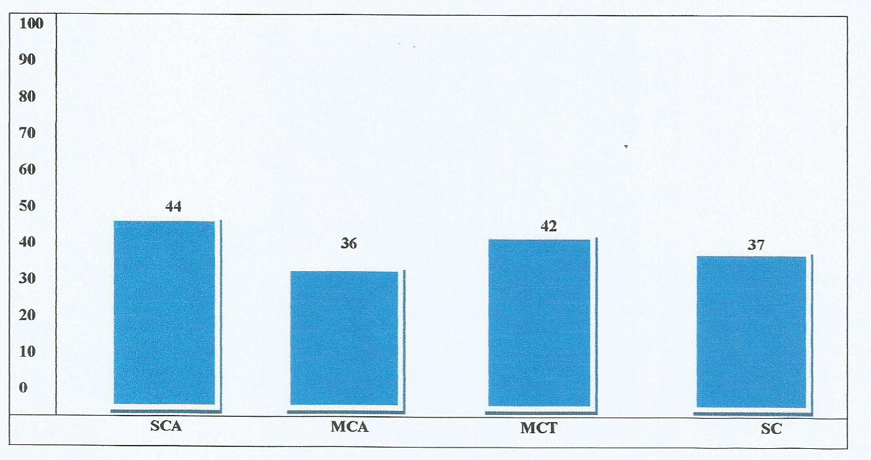
Figure-2: Frequency of Various histological types of Benign ovarian tumours (n=159) SCA= Serous cystadenoma, MCA=Mucinous cyst adenoma, MCT=Mature cystic teratoma, SC= Serous cyst.

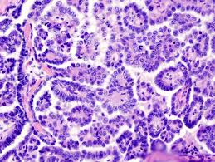 | 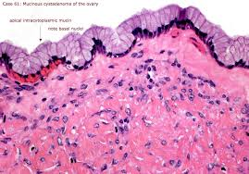 | 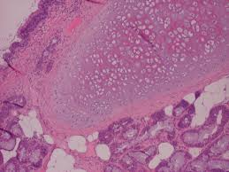
Figure 3: Serous cystadenoma | Figure 4: Mucinous cystadenoma | Figure 5: Teratoma

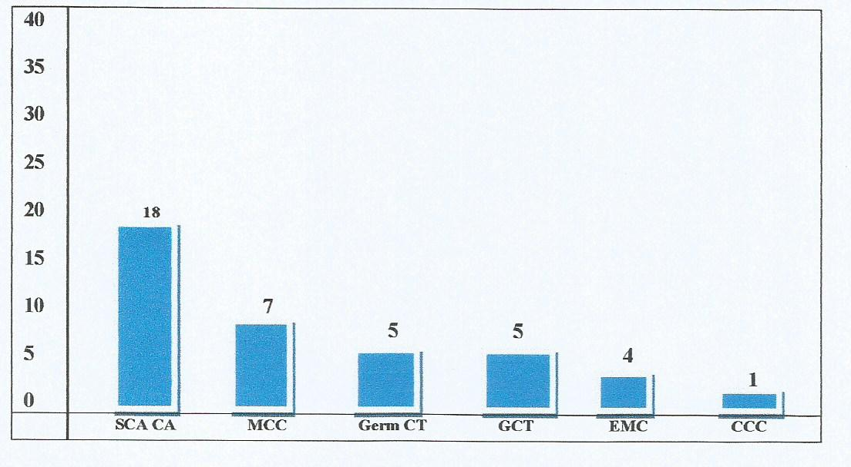
The Commonest malignant ovarian tumours were serous cystadenocarcinoma (8.95%) and mucinous cyst adenocarcinoma (3.48%) (Figures: 6, 7, 8&9).
Figure-6: Frequency of various histological types of malignant ovarian tumours (n=40), SCA CA= Serous cyst adenocarcinoma, MCC=Mucinous Cystadeno Carcinoma, Germ CT= Germ cell tumor GCT=Granulosa cell tumors, EMC=Endometriod Carcinoma, CCC= Clear cell Carcinoma.

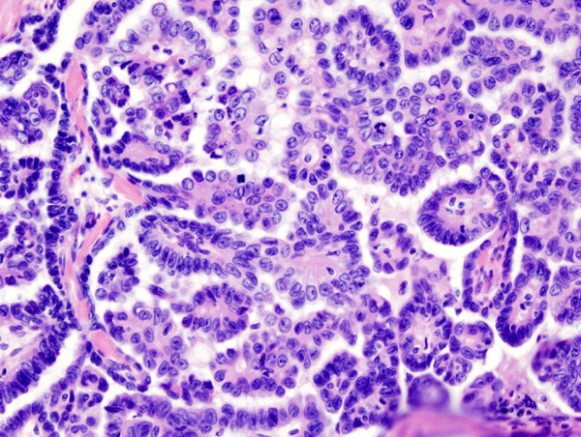
Figure 7: Serous cystadenocarcinoma

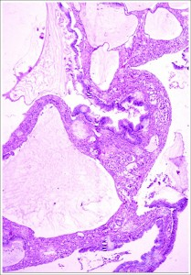
Figure 8: Mucinous cystadenocarcinoma

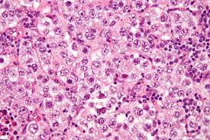
Figure 9: Germ cell tumor

The commonest presenting symptom was abdominal pain followed by abdominal mass (Table-1):

Table-1: Clinical presentation of the cases (n=201)
Symptoms | Cases | Percentage
Abdominal pain | 134 | 66.66 %
Abdominal mass | 56 | 27.83 %
Menstrual disturbance | 6 | 2.98 %
GIT disturbance | 3 | 1.49 %
Urinary symptoms | 2 | 1.00 %
No specific age for ovarian tumours observed in our study, but we noticed that germ cell tumours occurring at younger age group (table 2)

Table-2: Age of patients at time of presentation with ovarian tumours :
Type of Tumours | Mean Age of patients (Yr)
EPITHELIAL TUMORS
Serous cystadenoma | 36.26
Serous cystadenocarcinoma | 43.63
Mucinous cystadenomas | 32.85
Mucinous cystadenocarcinoma | 46.64
Endometrioid carcinoma | 44.81
Brenner | 39.12
GERM CELL TUMORS
Mature Cystic Teratomas | 27.86
Dysgerminoma | 18.17
Mixed Germ Cell Tumours | 18.84
SEX CORD STROMAL TUMORS
Granulosa Cell Tumours | 37.61
Fibromas | 38.01
Sertoli Leydig Cell Tumour | 53.21
4. Discussion:
The commonest presenting symptom in our study was abdominal pain 134(66.66%) followed by abdominal mass 56(27.83%).The results in agreement with a study carried out by Rashid et al.[10] in which abdominal pain was the commonest presenting complaint (59%) followed by abdominal mass/distension (37%).In another retrospective analysis study by Jamal et al. [11] the commonest mode of presentation was bleeding per vaginum, followed by abdominal pain , pelvic mass and gastrointestinal symptoms.
An increase of Ca125 serum levels is associated with ovarian, epithelial, malignant, non-mucinous tumours. Besides, Ca125 is related to the volume of the tumor mass. Ca125 represents the gold standard tumor markers for ovarian cancerin two different clinical conditions: as a diagnostic tool for evaluating the risk of malignancy of an adnexal mass and as a monitoring tool in the evaluation of the disease state, in patients already treated for adnexal cancer [12, 13].
The use of color Doppler adds significant contributions to differentiating between benign and malignant masses and is recommended in all cases of complex masses [14]. More recent work states that the addition of diffusion- and perfusion-weighted MRI for diagnosis of ovarian tumours improved accuracy, compared to conventional MRI alone, with an accuracy rate of 95% with the combined technique [15].
The commonest histopathological category of the ovarian tumours observed in our study was epithelial tumor followed by germ cell tumours. The most common benign tumor was serous cyst adenoma followed by mature cystic teratoma. Serous tumours were found to be more common than mucinous. Similar results were submitted by Prabhakar et al. in which serous tumours were the commonest followed by mucinous tumours [16].
Some molecular and histological evidence suggests that mucinous epithelial ovarian cancers build up via a sequence from benign tumor through borderline tumor to invasive cancer which suggests the potential preventability of borderline and invasive mucinous ovarian cancer by surgical excision of identifiable precursor lesions.[17] A retrospective study by Ahmed et al showed benign cystic teratoma to be the commonest benign tumor(35.17%)[18]
Epithelial tumours are hardly seen in children but there prevalence increases with age and peaks in 4th and 5th decades of life.[19],in our study most of the epithelial tumours are seen in 4th and 5th decades. We found no case of epithelial neoplasm in 1st decade and only 5cases in 2nd decade. Borderline ovarian tumours are of low malignant potential having favorable prognosis and relatively early age at onset.[20]. They comprise 4%–14% of all epithelial ovarian neoplasm’s.[21].
In the present study, serous cystadenocarcinoma (8.95%) was the commonest malignant epithelialneoplasm closely followed by mucinous cystadenocarcinoma (3.48%).
Pilli et al explored epithelial tumours to be the commonest variety constituting 70.9% of all the ovarian tumours. Second most common to be the germ cell tumor (21.2%) followed by sex cord stromal tumours (6.7%) [22].
The most common malignant tumor in adolescent and adult age group (10-30 years) in our study is germ cell tumor constitute about 2.48%. These results are similar to Mencezer et al. study [23], in this study the incidence rate for the total group of ovarian malignancies in the 0-19 age group was 0.52 and for ages 5-19 it was 0.71 per 100,000. This is in correlation with most of the western literature.
Sex-cord stromal tumours represent approximately 8% of ovarian neoplasm’s and affect allage groups. These tumours are of interest because of their hormonal effects which are rare in other ovarian neoplasms. Granulosa cell tumor is the most common malignant sex-cord stromal tumor as well as the most common oestrogen-producing ovarian tumor. Adultgranulosa cell tumours are far more common than the juvenile type. They occur predominantly in peri- and postmenopausal women. [9, 24]. This is comparable to our findings.
The borderline tumours characterized by epithelial proliferation greater than that of the benign tumor more than two layers and less than four layers stratification but there is no destructive invasion of the stroma [25] .In our study we encountered 2 cases of ovarian tumor with borderline malignancy, one case was atypical proliferative mucinous tumor and one was atypical proliferative serous tumor.

Conclusion:
The commonest ovarian tumours in our study are the epithelial tumours. Germ cell tumours were next to epithelial ovarian tumours which are more common in adult and adolescent age group. Late reporting is common among malignant ovarian tumours and patients usually present in advanced stages of the disease.

References:
- Grimes DA, Jones LB, Lopez LM, Schulz KF. Oral contraceptives for functional ovarian cysts. Cochrane Database Syst Rev 2006;4: CD006134.
- Holt VL, Cushing-Haugen KL, Daling JR. Risk of Functional Ovarian Cyst: Effects of Smoking and Marijuana Use according to Body Mass Index. Am J Epidemiol., 2005;161:520–5
- Piver MS. Prophylactic Oophorectomy: Reducing the U.S. Death Rate from Epithelial Ovarian Cancer. A Continuing Debate. Oncologist, 1996;1:326–30
- Cancer facts and figures. Atlanta: American cancer society,2010: 19 (accessed January 2, 2011)
- Day N.E, Krishnan E. Epidemiology of gynaecological cancers. Gynaecology by Shaw R W. 2nd ed. Edinburgh: Churchill Living Stone, 1997; p. 477–87.
- Jung SE, Lee JM, Rha SE, Byun JY, Jung JI, Hahn ST. CT and MR Imaging of Ovarian Tumors with Emphasis on Differential Diagnosis. Radiographics 2002;22:1305–25.
- Ness RB, Grisso JA, Cottreau C, Klapper J, Vergona R, Wheeler JE, et al. Factors Related to Inflammation of the Ovarian Epithelium and Risk of Ovarian Cancer. Epidemiology 2000;11(2):111-7.
- Zhang J, Ugnat AM, Clarke K, Mao Y. Ovarian cancer histology-specific incidence trends in Canada 1969-1993: age-period-cohort analyses. British Journal of Cancer 1999;81(1):152–8.
- Herbst AL. The Epidemiology of Ovarian Carcinoma and the Current Status of Tumor Markers to Detect Disease. Am J Obstet Gynecol., 1994;170:1099–107.
- Rashid S, Sarwar G, Ali A. A clinicopathological Study of ovarian cancer. Departments of Radiotherapy and oncology Sir Ganga Ram Hospital and Mayo Hospital Lahore. J Pak Med Assoc., 1998;36;117–25.
- Jamal S, Quddusi H, Mehmood A. A Clinico Histopathological analysis of 110 ovarian tumours. Pak J Med Sci., 1997;14:19–23.
- Bast RC, Badgwell D, Lu Z, Marquez R, Rosen D, Liu J, Baggerly KA, Atkinson EN, Skates S, Zhang Z, Lokshin A, Menon U, Jacobs I, Lu K. New tumor markers: Ca125and beyond. Int J Gynecol Cancer 2005;15(suppl.3):274-281.
- Duffy MJ. Tumor Markers in Clinical Practice: A Review Focusing on Common Solid Cancers. Med Princ Pract. 2012 May 15.
- Guerriero S, Alcazar JL, Ajossa S, et al. Transvaginal color Doppler imaging in the detection of ovarian cancer in a large study population. Int J Gynecol Cancer. 2010;20(5):781-786.
- Thomassin-Naggara I, Toussaint I, Perrot N, et al. Characterization of complex adnexal masses: value of adding perfusion- and diffusion-weighted MR imaging to conventional MR imaging. Radiology. 2011;258(3):793-803.
- Prabarker, Maingi K. Ovarian tumours--prevalence in Punjab. Indian J pathol Microbiol 1989;32:276–81.
- Jordan SJ, Green AC, Whiteman DC, Webb P M. Australian Ovarian Cancer Study Group. Risk factors for benign, borderline and invasive mucinous ovarian tumors: epidemiological evidence of a neoplastic continuum? Gynecol Oncol., 2007;107:223–30.
- Ahmed Z, Kiyani N, Hasan S. H, Muzaffar S. Gill M. S. Histological Patterns of ovarian neoplasia. J Pak Med Assoc Ovarian tumours- Incidence and distribution in a tertiary referral center in south India www.iosrjournals.org 77 000;50:416–9.
- Koonings PP, Campbell K, Mishell DR Jr, Grimes DA. Relative frequency of primary ovarian neoplasm’s: a 10-year review. Obstet Gynecol., 1989;74:921–6.
- Levi1 F, Vecchia CL, Randimbison L, Te VC. Borderline ovarian tumors in Vaud. Switzerland: incidence, survival and second neoplasm’s. Br J Cancer 1999;79(1):4–6.
- Burkholz KJ, Wood BP, Zuppan C. Best Cases from the AFIP: Borderline papillary serous tumor of the right ovary. Radiographics 2005;25:1689–92.
- Pilli GS, Suneeta KP, Dhaded AV, Yenni VV. Ovarian tumours: a study of 282 cases: J Indian Med Assoc., 2002;100:420, 423–4.
- Menczer J, Sadetzki S, Murad H, Barda G, Andreev H, Barchana M. Childhood and adolescent ovarian malignant tumors in Israel. A nationwide study: Acta Obstet Gynecol Scand. 1999 Oct;78(9):813-7.
- Jung SE, Rha SE, Lee JM, Park SY, Oh SN, Cho KS, et al. CT and MRI Findings of Sex Cord-Stromal Tumor of the Ovary. AJR Am J Roentgenol 2005;185:207–15.
- Barakat R.R. Borderline tumours of the ovary. Obstet Gynaecol Clin North Am 1994;21:93–105.

3/25/2015

