Role of genetic studies towards solving problems of human society

Shumaila Zulfiqar¹, Muhammad Nadeem Hafeez², Muhammad Shahzad Iqbal² and Qurban Ali²

^{1.} National Institute of Biotechnology and Genetic Engineering, Faisalabad Pakistan
^{2.} Centre for Excellence In Molecular Biology, Punjab University, Lahore, Pakistan
Corresponding author: chnadeemhfz@gmail.com, qurban.ali@cemb.edu.pk

Abstract: Genetic science is evolving day by day. This is a powerful motivational approach in understanding various gene(s) association in communicable and non-communicable disease. Society has been willing in the past and continues to be willing to pay significant amounts of money for research in this area. The primary reason behind such studies is the enormous potential to improve human well-being. By the realization of this perception, there is marked increase in the number of people and organizations involved in human genetic studies. Different mechanisms are combined to develop various useful techniques which enable geneticists to find different genetic basis of disorders. Premarital screening, carrier screening, prenatal diagnosis and rehabilitation of at risk individuals are eminent drive of genetic studies. Genetic studies have helped to combat disorder. Personalized medicine can be introduced for prevention of monogenic and polygenic diseases. In a nutshell, genetics has played a vital and splendid role in making human lives easy, glorious and satisfactory.
[Zulfiqar, S., N. Hafeez, S. Iqbal and Q. Ali. Role of genetic studies towards solving problems of human society.. Nat Sci 2015;13(4):15-19]. (ISSN: 1545-0740). http://www.sciencepub.net/nature. 3

Key Words: Premarital screening, Carrier screening, Prenatal diagnosis, Personalized medicine, Monogenic disorder, Polygenic disorder

Introduction

Human genome project is tremendously helping to combat many monogenic and polygenic disorders. Significant progress has been made in elucidating the molecular defects in many genetic diseases, but the impact of these discoveries on clinical management is often unclear (Kelavkar 2006). In Pakistan, genetic diseases are more common due to elevated percentage of consanguineous marriages (Schulze and McMahon 2003). Moreover, there is a severe lack of public health awareness along with dearth of genetic counselling worldwide (Meulenbelt et al. 1995). The field of genomics is evolving at a dizzying speed. Researchers are producing genome wide data sets on ever-expanding study populations. Broad studies are accelerating understanding of the role of genes in health and disease. Translational research is also transforming new knowledge into diagnostics and accessibility for drug development, and new horizons about how to prevent and treat disease (Collins and McKusick 2001).

Collins et al., (2003) has reported that human genetic research has generated knowledge with the vast potential to improve individual and community health. Specific studies reveal individual’s susceptibility to disease and therefore, health of individual is improved. Research on this subject may be of interest and benefit to research participants especially if preventive strategies exist. These genetic studies are generating distinctive amounts of huge data about the genetic differences among individuals. Proper application of these contrasting features will transform our understanding of the origins and nature of human diseases. Human genetic research has another aspect which is the potential to generate great controversy. Ideas drawn from genetics have been used both by geneticists and by individuals outside the field to justify and continue racial and ethnic discrimination in the past (Bailey et al. 2001). The completion of the first mapping of the human genome under the Human Genome Project has opened huge potential for research. Most of the diseases have been characterized according to pathophysiology and mode of inheritance. Common diseases are complex genetic traits with multiple genetic and environmental components contributing to susceptibility. It has been proposed that common genetic alleles, including single nucleotide polymorphisms (SNPs), influence susceptibility to common diseases (Kent et al. 2002). This has to inspect numerous studies of association between genetic variation at these common DNA polymorphisms and variation in disease susceptibility. There must be good understanding to use genetic information and to promote public health.

As the knowledge in genetics is increasing it is being recognized that a lot of efforts will be utilized in considerable time and funding to move discoveries from the scientific laboratory into the medical clinic (Judith 2005). Though recent efforts have just considerably shortened that interval, but still most new drugs based on genome-based research are estimated to be at least 10 to 15 years away. However, screening and diagnostic tests of some disorders are available. Rapid progress is also being made in the emerging field of pharmacogenomics, applies complete set of information about a patient's genetic make-up. Unfortunately, there is history of misuse of genetics ideas therefore geneticists have a special responsibility in this regard (Lohmueller et al. 2003). Moreover, the completion of the first mapping of the human genome under the human genome project and recently the data generated by 1000 genome project has opened new horizons for research in which genes relate to human genetic conditions and risk factors could be better understood (Read and Donnai 2007).

Integration of genetics into medicine
Integration of genetics into medicine is a breakthrough in genomic world. The successful integration of genetic testing into medicine requires an educated health care workforce which will employ protections against inappropriate revelation and discriminatory use of genetic information that ensures the accuracy and reliability of genetic tests are important to make medical decisions. Increase in the medical and genetic tests has created many regulatory challenges (Khoury et al. 2007). These test are playing a significant role in change of intuition. Mechanism of regulating medical-testing laboratories was forwarded in place more than 20 years ago. Human Genome Project was projected as the main sequencing procedure a patient's genome to diagnose a disease was virtually unimaginable (Korf 2002). Another biggest technique is regenerative medicine which involves clinical therapies that may involve the use of stem cells. For instance, it also includes the injection of stem cells or progenitor cells, when biologically active molecules administered alone or as a secretion by merged cells (immunomodulation therapy) and transplantation of in vitro grown organs and tissues. Regenerative medicine also includes the possibility of growing tissues and organs in the laboratory and safely implants them when the body cannot heal (Hetteberg and Prows 2004).
Carrier screening of population
Carrier screening for various genetic disorders is predominantly important. As in case of B-Thalassemia, parents along with their children are screened for identification of most common causative mutation(s). Beta-thalassemia is a monogenic disorder that affects body’s ability to synthesize functional haemoglobin molecules. It is inherited in an autosomal recessive mode. Individuals inheriting the pathogenic mutation(s) in homozygous condition show severe anaemia in postnatal life and depend on regular blood transfusion for survival.
Prenatal diagnosis
The severity of such defects is different among individuals reflecting the wide range of mutations or genetic variants. Different methods like invasive or non -invasive can be adopted to diagnose certain disorders. In some cases, the tests are administered to determine if the foetus will be terminated, though physicians and patients also find it useful to diagnose high-risk pregnancies early so that delivery can be scheduled in a tertiary care hospital where the baby can receive appropriate care.
This DNA was obtained from the blood of eighteen pregnant women. Then, it can be followed by mapping the chromosome using the quantification of fragments. By using advanced methods in DNA sequencing the amount of sequence tags mapped to each chromosome.
Genetic studies applications includes methods for identification of a disorder which may leads to treatment and hence prevention of diseases in new-borns as well as in adults.

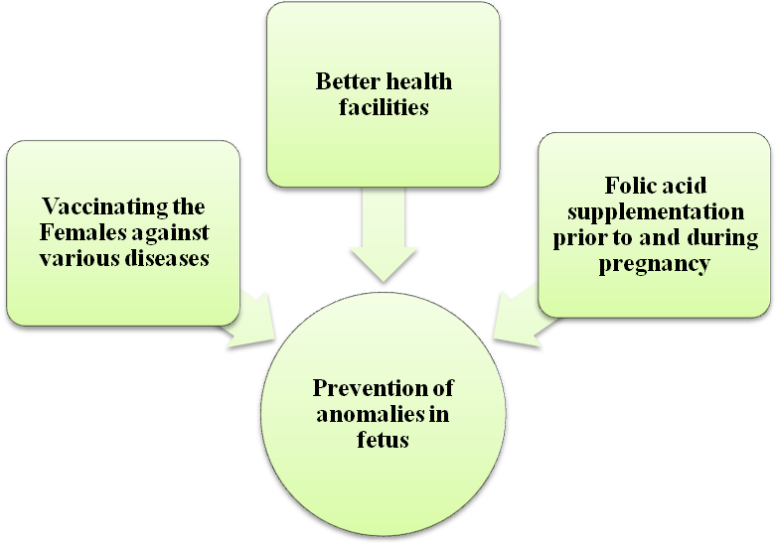
Figure 1: Various methods for prevention of abnormalities in foetus

Invasive

First-Trimester Screening
Genetic studies show that an increased amount of fluid at the back of the foetal neck (referred to as nuchal translucency) is associated with foetal chromosomal abnormalities.In some cases, the tests are administered to determine if the foetus will be terminated, though physicians and patients also find it useful to diagnose high-risk pregnancies early so that delivery can be scheduled in a tertiary care hospital where the baby can receive appropriate care (Offit 2011). This DNA was obtained from the blood of eighteen pregnant women. Then, it can be followed by mapping the chromosome using the quantification of fragments. By using advanced methods in DNA sequencing the amount of sequence tags mapped to each chromosome (Shafritz et al. 1981).

Combined First-Trimester and Second-Trimester Screening
Second-trimester ultrasonographic examinations are often routinely performed to detect fetal anatomical abnormalities. It finds different inherited abnormalities.

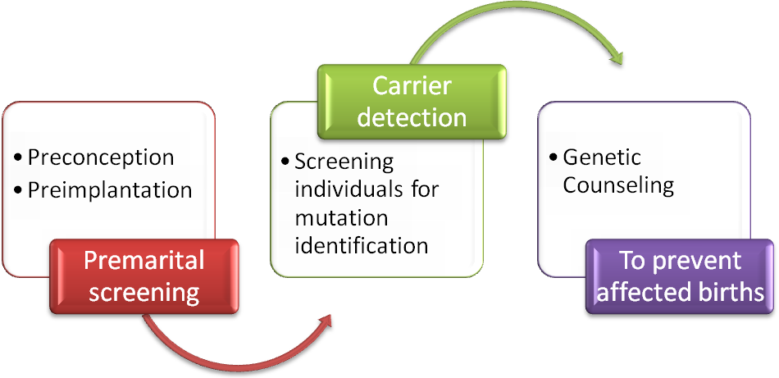
Fig. 2. Steps in genetic screening to prevent affected births

Nanotechnology for molecular imaging and targeted therapy
Different synthetic nanostructures can be used in harnessing microbial enzyme functions Colloidal particles in the nanometre size range (less than 1 μm in diameter) can be engineered (Matsunaga et al. 2007).
Management and Prevention
An important aspect is genetic counselling which can be fruitful in achieving many goals. These objectives include:
- Family either adjust or admit specified disability.
- Administration in terms of training.
- Professional or adaptive assistance in terms of guidance.
- Can also assist in occupation and independent living.
The basic and significant feature is to train these counsellors so that they are able to recognize genetic disorders in a specific population. For pursuing such goals family history is an important basic step that can assist in recognition of certain genetic disorders in a given population. Once the genetic disorder is identified then the family can be counselled to go for carrier screening and further necessary screening and methodology for such counselling (Milunsky 1975).
Beside the limitations or deficiencies in these laws, they are still quite significant for a healthy society.
Genetics in addition to the above mentioned applications has also a vital role in certain cases or fields, some of which are discussed below. Understanding, of genetics and biotechnology have provides a new horizon to develop vaccinations for various diseases (RASHID et al., 2014; AHMAD et al., 2014; DAUD et al., 2014; NAZIR et al., 2014; SIDDIQUI et al., 2014).
Sex Chromosomal Complexities in Human-Beings
Along with sequence mutations chromosome number imbalance is another important factor for various fatal disorders (leads to out of order functions or death) (Robbins et al. 1997). Examples includes turner syndrome (X0) where 45 chromosomes are present instead of 46 and leads to sterile female with abnormal sexual functions and abnormal body parts. Another example is male sterility (XXY). All these variations are under study and come under the field of genetics (Egozcue et al. 2000).
Genetic discrimination
Genetic studies are not only helpful for mankind in eliminating health related problems but also exposes genetically inferior individuals. This reduces their fitness in society. Certain laws are available which minimizes the risk of wrong use of genetic information and could exert pressure on people to take a certain course of action against people who compromise confidentiality (Billings et al. 1992). Genetic discrimination is defined as denial of rights, privileges or opportunities on the basis of information obtained from genetically based diagnostic and prognostic tests. Several laws at the federal and state levels help protect people against genetic discrimination (Gostin 1991).
Genetics has also played a vital role in various other fields.
Insect Control:-
a) Induced sterility:-
Different insects harmful to human are controlled by the use various genetic disturbance approaches, such as: irradiation for sterility in bool weevil, medfly. These are susceptible to sterilization (Panda and Khush 1995).
b) Genetic control of Luciliacuprina (Australian sheep bowfly):-
It can be controlled by:
- Genetic manipulation
- High level sterility
- Release of strains due to chromosome.
c) Genetic control of spider mites:-
This is mainly based upon:
- Sterile male techniques
- Use of sterile male
- Leaving incompatible population based upon reproduction.
Encouraging Health Of Plants:-
Various bacterial species are being utilized for increasing health of plants. e.g. bacteria that stays on plant and form ice crystal, these are changed from ice+ to ice- bacteria. Some bacteria also provided with genes that are helping in producing such products which are beneficial against insects attack, e.g. in corn (Goff et al. 2011). Similarly sunflowers’ verities that are resistant against “charcoal rot ,also developed by using various techniques based on genetics such as late maturing (Lyng Manchurians) and medium late maturing (KN HD-1)cultivars of sunflower (Campbell et al. 1989).
The way far ward
Genetic studies have prime importance worldwide. Nowadays, breakthroughs in molecular biology are happening at an unprecedented rate it will enable geneticist to exploit different aspects of human genetic disorder. These studies raise the exciting prospect of harnessing diseases. These will provide foundation for the premarital screening of various genetic disorders. It will also fuel prenatal diagnosis of diseases whose mechanism is not understood so far. The application of genomics to population health has the potential to revolutionize the practice of medicine. Indeed, discoveries into the genomic basis of cancer and other common chronic diseases have resulted in new and improved predictive tests for identifying individuals at increased risk for these conditions and long before their onset occurs. When used properly, information gained from predictive genomic tests can be combined with other leading indicators (e.g., environmental and behavioural risk factors) to inform medical management decisions, preventive health practices, and risk-reducing strategies However, despite considerable progress over the past few years, there is much work to be done in the field of genetics.

References
- Bailey, J. A., A. M. Yavor, H. F. Massa, B. J. Trask and E. E. Eichler, 2001 Segmental duplications: organization and impact within the current human genome project assembly. Genome research 11: 1005-1017.
- Billings, P. R., M. A. Kohn, M. De Cuevas, J. Beckwith, J. S. Alper et al., 1992 Discrimination as a consequence of genetic testing. American journal of human genetics 50: 476.
- Campbell, E. I., S. E. Unkles, J. A. Macro, C. van den Hondel, R. Contreras et al., 1989 Improved transformation efficiency of Aspergillus niger using the homologous niaD gene for nitrate reductase. Current genetics 16: 53-56.
- Collins, F. S., and V. A. McKusick, 2001 Implications of the Human Genome Project for medical science. Jama 285: 540-544.
- Egozcue, S., J. Blanco, J. Vendrell, F. Garcia, A. Veiga et al., 2000 Human male infertility: chromosome anomalies, meiotic disorders, abnormal spermatozoa and recurrent abortion. Human reproduction update 6: 93-105.
- Goff, S. A., M. Vaughn, S. McKay, E. Lyons, A. E. Stapleton et al., 2011 The iPlant collaborative: cyberinfrastructure for plant biology. Frontiers in plant science 2.
- Gostin, L., 1991 Genetic discrimination: the use of genetically based diagnostic and prognostic tests by employers and insurers. Am. JL & Med. 17: 109.
- Hetteberg, C., and C. A. Prows, 2004 A checklist to assist in the integration of genetics into nursing curricula. Nursing outlook 52: 85-88.
- Judith, G., 2005 Oxford desk reference clinical genetics Author (S).
- Kelavkar, U. P., 2006 Human Genome Project. eLS.
- Kent, W. J., C. W. Sugnet, T. S. Furey, K. M. Roskin, T. H. Pringle et al., 2002 The human genome browser at UCSC. Genome research 12: 996-1006.
- Khoury, M. J., M. Gwinn, P. W. Yoon, N. Dowling, C. A. Moore et al., 2007 The continuum of translation research in genomic medicine: how can we accelerate the appropriate integration of human genome discoveries into health care and disease prevention? Genetics in Medicine 9: 665-674.
- Korf, B. R., 2002 Integration of genetics into clinical teaching in medical school education. Genetics in medicine 4: 33S-38S.
- Lohmueller, K. E., C. L. Pearce, M. Pike, E. S. Lander and J. N. Hirschhorn, 2003 Meta-analysis of genetic association studies supports a contribution of common variants to susceptibility to common disease. Nature genetics 33: 177-182.
- Matsunaga, T., T. Suzuki, M. Tanaka and A. Arakaki, 2007 Molecular analysis of magnetotactic bacteria and development of functional bacterial magnetic particles for nano-biotechnology. Trends in biotechnology 25: 182-188.
- Meulenbelt, I., S. Droog, G. Trommelen, D. I. Boomsma and P. E. Slagboom, 1995 High-yield noninvasive human genomic DNA isolation method for genetic studies in geographically dispersed families and populations. American journal of human genetics 57: 1252.
- Milunsky, A., 1975 The prevention of genetic disease and mental retardation.
- Offit, K., 2011 Personalized medicine: new genomics, old lessons. Human genetics 130: 3-14.
- Panda, N., and G. S. Khush, 1995 Host plant resistance to insects. CAB International.
- Read, A. P., and D. Donnai, 2007 New clinical genetics. Scion Bloxham/Oxfordshire.
- Robbins, W. A., M. L. Meistrich, D. Moore, F. B. Hagemeister, H.-U. Weier et al., 1997 Chemotherapy induces transient sex chromosomal and autosomal aneuploidy in human sperm. Nature genetics 16: 74-78.
- Schulze, T. G., and F. J. McMahon, 2003 Defining the phenotype in human genetic studies: forward genetics and reverse phenotyping. Human heredity 58: 131-138.
- Shafritz, D. A., D. Shouval, H. I. Sherman, S. J. Hadziyannis and M. C. Kew, 1981 Integration of hepatitis B virus DNA into the genome of liver cells in chronic liver disease and hepatocellular carcinoma: studies in percutaneous liver biopsies and post-mortem tissue specimens. New England Journal of Medicine 305: 1067-1073.
- Siddiqui MF, Hasnain S, Batool Z, Qazi MH, Imtiaz M, Fatima I, Alam R. Clinical effectiveness of Carbimazole and Propylthiouracil for Hyperthyroidism in Patients of Punjab, Pakistan (2014). Adv. Life Sci. 2(1). pp: 10-15.
- Nazir S, Faraz A, Shahzad N, Ali N, Khan MA, Iqbal M, Khan MF, Ahmed T, Rakha, A, Sabzwari J, Bhatti MS. Prevalence of HCV in β-thalassemia major patients visiting tertiary care hospitals in Lahore - Pakistan. (2014). Adv. life sci., 1(4), pp. 197-201.
- Daud S, Shahzad S, Shafique M, Bhinder MA, ,Niaz M1, Naeem A, Azam M, Rehman Z, Husnain T. (2014). Optimization and Validation of PCR protocol for three Hypervariable Regions (HVI, HVII and HVIII) in Human Mitochondrial DNA. Adv. life sci., 1(3) pp. 165-170.
- Ahmed T, Ahmed RS, Basharat MU, Mushtaq MH, Gill SS, Khawaja AR, Basit A, Khan A, Khan MF. Comparative study to assess coagulation abnormalities in breast cancer. Adv. life sci., 1(2), pp. 96-103.
- Rasheed A, Ullah S, Naeem S, Zubair M, Ahmad W, Hussain Z. 2014. Occurrence of HCV genotypes in different age groups of patients from Lahore, Pakistan. Adv. life sci., 1(2), pp. 89-95.

3/8/2015

