**Natural Polymers 1: Mechanical Properties of Composite Material Using Natural Rubber with Gum Arabic**

Muyiwa Turoti and Samson Kikiowo

Department of Chemistry, Obafemi Awolowo University, Ile-Ife, Nigeria

[myiwaturoti@yahoo.co.uk](mailto:myiwaturoti@yahoo.co.uk)

**Abstract**. The deficiency inherent in the mechanical property of pristine natural rubber or gum Arabic polymers has been partly resolved through the study of mechanical properties of films obtained from mutual photografting of their composite using varying Co-60 gamma irradiation doses of 2,4,6,8 and 10KGy. The study entailed determination of tensile strength (TS), initial modulus (YM), elongation at break (EB), FTIR spectroscopy as well as degree of grafting and crystallinity of the photografted composites. The 30% gum Arabic and 70% natural rubber composite sample with the following characteristics; pH=8.10, degree of grafting =16%, and degree of crystallinity=83.4% using 10KGy irradiation dosage at 8.4KGy per hour showed the appropriate mechanical properties of TS=1.7MPa, YM=0.76MPa and EB=115% appropriate for useful products including coatings. Mechanism for production of the grafted composite is proposed and discussed.

**[**Muyiwa Turoti and Samson Kikiowo. **Natural Polymers 1: Mechanical Properties of Composite Material Using Natural Rubber with Gum Arabic.** *Nat Sci* 2015;13(4):6-14]. (ISSN: 1545-0740). <http://www.sciencepub.net/nature>. 2

**Key words:** Grafting, Crystallinity, Tensile strength, Young’s modulus, Elongation at break, Density and Gamma irradiation.

**1.Introduction**

Natural rubber is a polymer obtained from the bark of *Hevea brasilensis* in a latex form consisting of poly(cis-1,4-polyisoprene) having molecular weights ranging from 50,000 to 3,000,000. Usually, other materials, such as proteins, fatty acids, resins, and inorganic salts are found in natural rubber up to 5% of dry mass. Rubber latex is soft and sticky with relatively low tensile strength, and elasticity, due to its amorphous nature (Kumar and Nijasure, 1997). These show that there are no crosslinks between the polymer chains. This feature has led to the processes of crosslinking pure rubber chains, including vulcanization, which has yielded improved properties for this polymer. Natural rubber has various commercial applications including tyres and inner tubes for transport (medical products such as gloves, catheters and contraceptives and drug delivery (Borges et al, 2014, Herculano et al, 2009) and consumer products like erasers, balloons and sport goods. anti-vibration mounts, haul-off pads, drive couplings. Natural rubber is an elastomer and a thermoplastic. If it is heated and cooled, it is degraded but not destroyed. It is fully biodegradable but has poor resistance to elevated temperature, oil, flame, gas permeability and ozone attack but good abrasion, chemical, and water resistance as well as fair electrical properties.

*Acacia senegal* and *Acacia seyal* are the main African plants that produce exudates known as Gum Arabic (GA) (Azeez, 2005; Badreldin *et al*., 2008; Abdul-Hadi *et al*., 2010). Gum Arabic is commonly used in the pharmaceutical and food industries as emulsifier and stabilizer and suspending agent for insoluble drugs (Abdul-Hadi *et al*., 2010; Lelon *et al*., 2010). The chemical composition of GA varies with its source, the age of the trees from which it was obtained, climatic conditions and soil environment. It contains a branched-chain, complex polysaccharide, either neutral or slightly acidic, found as mixed calcium, magnesium and potassium salt of a polysaccharidic acid (Arabic acid) (Badreldin *et al*., 2008; Abdul-Hadi *et al*., 2010). The major amino acids present in the protein of an Arabino Galactan (AG) and Ara binogalactan-Protein complex (AGP) were hydroxyproline, serine and proline, whereas in GlycoProtein (GP), aspartic acid was the most abundant (Badreldin *et al*., 2008).

The formation of free radicals from natural rubber and gum Arabic by irradiation with X-rays has long been established. Further polymerization of gum Arabic has been effected through irradiation by gamma rays (Tsuoyoshi et al, 2006; AL-Asssaf, 2007; Kafi and Sabahalkhair, 2010). The combination of the two polymers through their radicals could be a possibility by mutual irradiation grafting. By this coupling some of the weakness of natural rubber including low temperature softness, oil permeability and possibly ozone attack may be reduced as gum Arabic has been found as a stable polymer. However, the brittleness of gum Arabic films, due to its relatively low viscosity, could be improved if grafted with natural rubber that has better mechanical properties. The present study therefore is an introductory report of the possibility of diversifying the uses of these two polymers through gamma-ray grafting of their composites. The level of elastomeric properties could be reduced where it is not highly demanded, such as in coatings, while its softness and other properties could be integrated into gum Arabic moiety. Anti-oxidant activity of Gum Arabic has been reported (Ko et al, 2014). The grafting of it onto rubber could reduce susceptibility of the latter towards ozone attack These two polymers are the natural products that are readily available and cheap, particularly in the sub-saharan zones, and as such settles an economic aspect of the industrial production of the composite.

**2. Methods**

Materials

The raw rubber(NR) solution was collected from Araromi Obu Rubber Plantation, Ore-Sagamu express road, Ondo state, Nigeria, West Africa. Coagulation of the fresh rubber was prevented by adding 1.5% ammonia solution.

Preparation of the samples and blends.

The composite samples used in this study were prepared by blending 10,30,50,70,90% of gum Arabic (GA) with 90,70,50,30 and 10% natural rubber(NR) respectively. The raw rubber solution was drop wisely added into a quick fit conical flask containing measured aqueous GA. The blend was stirred for 30mins using a mechanical stirrer.

Seven samples were prepared including the neat GA and NR and five of the blends GA and NR.

Irradiation of mixture of Gum Arabic and Raw rubber Solution and Films Preparation

Cobalt 60 radioactive cell machine at the Lagos University Teaching Hospital (LUTH), Lagos, Nigeria, West Africa, was used under atmospheric pressure and at room temperature conditions. Five different samples of the same ratio of 90 % GA to 10% of NR, were each blended using mechanical stirrer at the same speed of 100 revolutions per minute for 100minutes and separately irradiated to selected doses of 2KGy, 4KGy, 6KGy, 8KGy and 10KGy using 20cm3 of each composite solution. The same procedure was repeated using 70%, 50%, 30%, 10% of GA to 30%, 50%, 70 %, 90%, respectively. Thus each blend was irradiated proportionately at 14.3min, 28.6min, 42.9min., 57.1min, 71.4 min at the machine dose rate of 8.4KGy per hour.

Preparation of Films from the Irradiated Gum Arabic and Raw Rubber.

The graft films of Gum Arabic with raw rubber were prepared from non-irradiated and irradiated samples by spreading them on aluminum sheets of 8cm by 4cm using 10cm3 of the mixture. The films were allowed to dry to constant weight at room temperature. The prepared samples were coded for easy reference.

pH Determination

The pH of an aqueous suspension of composite samples consisting of 30-70% GA was determined before and after irradiation by using a Jenway 4330 pH- meter at room temperature.

Determination of Degree of grafting.

The ungrafted GA film obtained from the solution containing the same mass of GA in any blend was weighed in each case as Wo. The grafted composite polymer, in each case, was dissolved in a mixture of the water and refined petroleum in ratio 2:1 for 72hrs so as to dissolve unreacted GA and NR. The solution was then filtered through suction drier and the insoluble fraction (residue) was weighed as Wg. The degree of grafting of each sample was obtained using the expression stated below (Ibrahim et al,2014)

Degree of grafting (%) = [(Wg — W0)/W0] X 100

Where Wo and Wg represent the weight of the films before and after grafting respectively.

Mechanical Properties

Mechanical properties measurements were carried out using a dumbbell shaped specimens of 4 mm width and 20 mm length. Parameters such as Tensile strength, (TS) elongation at break percentage (EB %) and Young’s (YM) were measured using a universal Instron tensile tester machine (Model 3399) at Engineering Material and Development Institute (EMDI) Akure, Nigeria, West Africa.

Determination of degree of Crystallinity

The methodof Nara and Komaya (1983) was adopted with minor changes due to solvent used for the base gum Arabic. An X-ray diffraction (XRD) pattern of each film was recorded using X-ray diffraction spectrophotometer Model lO at the Centre for Energy Research and Development (CERD) Ile-Ife, Nigeria, West Africa. The upper diffraction peak area and the total diffraction area over the diffraction angle 10°-30° 2θ were integrated using Smadchrom software(Wang et al, 2006). All X-ray diffraction measurements were done in air at room temperature.

The ratio of upper area to total diffraction was taken as the degree of crystallinity. The equation of the degree of crystallinity is as follows:

Xc = Ac / (Ac + Aa)

Where: Xc refers to the degree of crystalline; Ac refers to the crystalline area and Aa refers to the amorphous area, on the X-ray diffractogram.

Determination of Density

Dried-to-constant weight film of each composite sample containing 30-70% GA was cut into rectangular shape of 1cm x 2cm and thickness measured using micrometer screw gauge. The volume of each dry film was calculated and its mass obtained using the Mettler Toledo weighing balance. The density of each film was determined using mass to volume in gcm-3.

Infra-red analysis

Infra-red analysis of the grafted (irradiated) and ungrafted (non-irradiated) films were carried oat ut the Central Laboratory, University of Lagos, Nigeria, West Africa using a model FTIR 600 Spectrophotometer.

**3. Results and Discussion**

In the course of production the irradiated films of pure Gum Arabic, Natural rubber and their composites important visual observations were made which were crucial to the characterization of the film samples as shown in Table 1.Visual observations have been employed as an important aspect in film characterization (Turoti et al(1999).

Table 1. Visual assessment of Dry film at 10KGy irradiation

|  |  |  |
| --- | --- | --- |
| Sample | Physical properties of dry film on the substrate before irradiation | Appearance of dry film formed after irradiation and drying |
| Neat GA | Hard to peel | Brown and very brittle. |
| 90GA:10NR | Hard to peel | Brown and slightly brittle film |
| 70GA:30NR | Hard to peel | Brown and slightly brittle film |
| 50GA:50NR) | Hard to peel | Light brown and tough |
| 30GA:70NR  10GA:90NR | Hard to peel  Easy to peal | Brown and very tough film  Light brown and tough |
| Neat NR | Easy to peel | Light brown soft and tough |

Table 1 suggests that suitable film that can withstand environmental changes and challenges for durable coatings should be hard to peel from the substrate, moderately flexible and very tough in line with earlier worker (Lambourne, 1987). There is a progressive indication from Table 1 that these features are likely found about the region of 30-70%GA content in these test samples and obviously not towards the two ends. For instance, coating films should not be weak, soft and brittle or have low adhesion to the substrate as it is true for some of the composites in Table1.

Table 2 shows that as the irradiation dosage increases the pH of composite increases when GA content is greater but decreases when its content is smaller.

Table 2: pH of composite medium before and after grafting.

|  |  |  |  |  |  |  |
| --- | --- | --- | --- | --- | --- | --- |
| Sample | pH at 0KGy | pH at 2KGy | pH at 4KGy | pH at 6KGy | pH at 8KGY | pH at 10KGy |
| 70GA:30NR | 4.883 | 4.893 | 4.893 | 4.921 | 5.101 | 5.102 |
| 50GA:50NR | 6.694 | 6.680 | 6.680 | 6.674 | 6.650 | 6.630 |
| 30GA:70NR | 8.325 | 8.247 | 8.247 | 8.212 | 8.205 | 8.101 |

This is understandable and in agreement with the fact that GA is acidic while NR is basic. But then at 50% of either component of the composite the pH is still acidic although weakly so at 6.30 and weakly basic at pH of 8.101 with 30%GA after 10KGy irradiation. This shows that the appropriate pH for composite of GA and NR most probably lies between 6.301 and 8.101at higher dosage or the composite should contain less NR content at 10KGy.

Considering Tables 1 and 2 indicates that blends or composites of GA and NR are likely more appropriate for coating or film formation formulation since the pure form of each component has poor fundamental coating features. Apart from the fact that brown colour coating from composites can be generated during irradiation without pigmentation, hardness and toughness are basic requirements for good coating material. Moreover, a pH just above the neutral may be most appropriate for an effective composite with good film characteristics attained through blending of 30%GA and 70%NR subjected to gamma irradiation.

Figure 1 shows that the degree of grafting increases with irradiation dosage and grafting does not occur until when irradiation commenced at the dosage of 2KGy in agreement with similar earlier work (Madanni, 1988). At this dosage the 10 and 30% GA samples have commenced grafting onto 90 and 70%NR respectively and these two formulations, have almost the same level of grafting from the beginning of irradiation to 8KGy, culminating at 19.7 and 16% respectively by 10KGy irradiation.. The formulations consisting of 50, 70 and 90% GA do not commence grafting until when the irradiation dosage was 4KGy. In all, the order of grafting is: 10%GA>30%GA>50%GA>70%GA>90%GA. The more the GA content the less degree of grafting. This is to say NR seems to have more tendency to grafting reaction with GA than the converse. This could most probably be attributed to preponderance of radical generation in NR per unit gamma irradiation. As dosage of irradiation increases there is more synergy toward grafting. At 10KGy dosage the total insoluble fraction (graft) for 100%GA and100% NR is 13% whereas 10 or 30%GA have19.7 or 16% gel or graft respectively. The pure polymers do not produce insoluble fraction until 4KGy dosage whereas the blends have commenced by 2KGy proceeding at higher gradient with increasing dosage. The tendency to form gel or insoluble fraction or graft increases with increasing initial NR content that is 90%>70%NR>50%NR>30%NR The choice of using photograft containing 10%GA (90%NR) for coating is defeated as its protective and appearance properties are unacceptable (Table1). The apparent disqualification is obviously due to greater proportion of NR which on its own right is generally unsuitable coating polymer due to its elastomeric property and low resistance to oil and ozone attack. It is envisaged that some of these flaws in NR could be reduced by irradiation of its blend with GA. On the other hand, pure gum Arabic coating embrittles easily when it is hard dry. With these preliminary investigations, further studies are focused on photografts synthesized mainly from composites containing 30,50 and 70% GA and not the pure GA and NR.

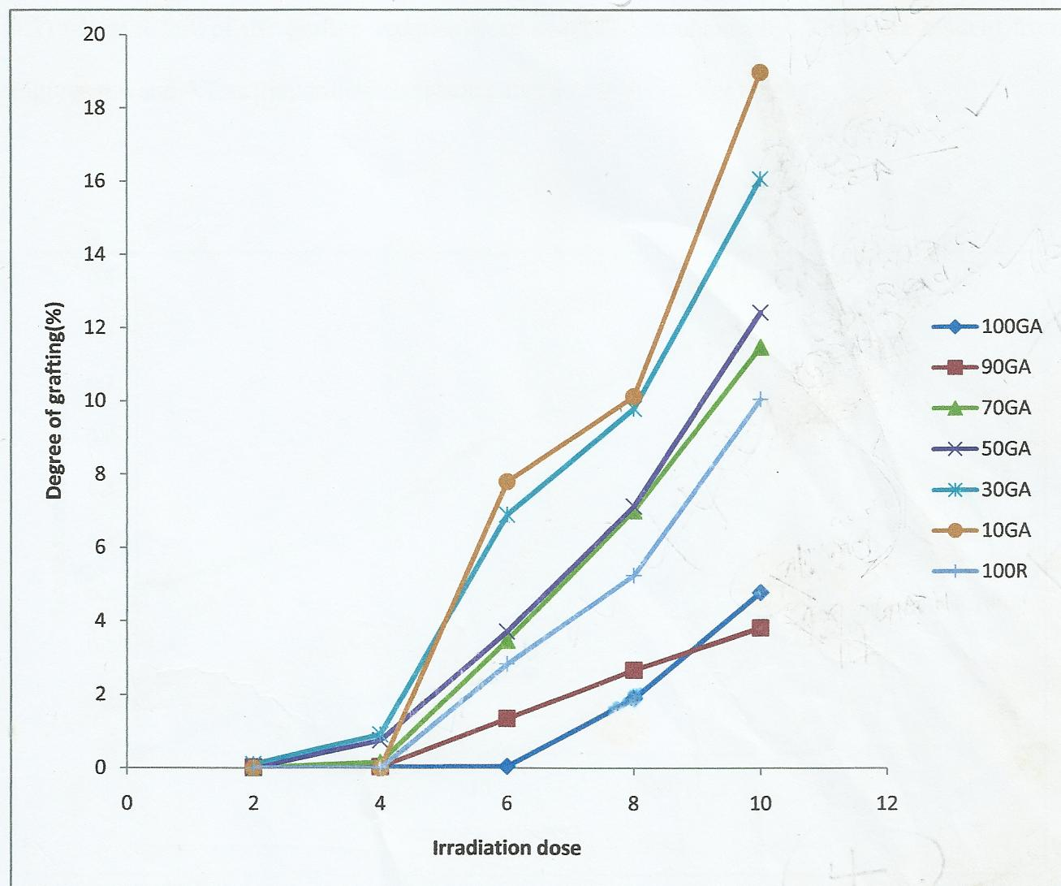

Fig. 1: Effect of irradiation dosage on degree of grafting for composites of NR and GA

Mechanical Properties

Resins produce good coating films which have good mechanical properties such as tensile strength (TS), Young’s modulus (YM) and relatively low flexibility (elongation at break EB) (Lambourne1987). Fig.2 shows that tensile strength of the selected composites increases with irradiation dosage following the trend, 30GA: 70NR>>50GA>70GA: 30NR,%, particularly as irradiation dosage increases.

30GA:70NR>>50GA:50NR>70GA:30NR,%.The highest values of TS before and after irradiation for 10KGy were 0.52 and 1.2MPa respectively. Fig.3 shows that prior to and during irradiation, the Young’s modulus of the composites increases with increasing proportion of natural rubber and increasing irradiation dosage. This important parameter actually increases after 4KGy dosage with that of the 30 GA:70NR composite increasing significantly and linearly at the highest gradient.

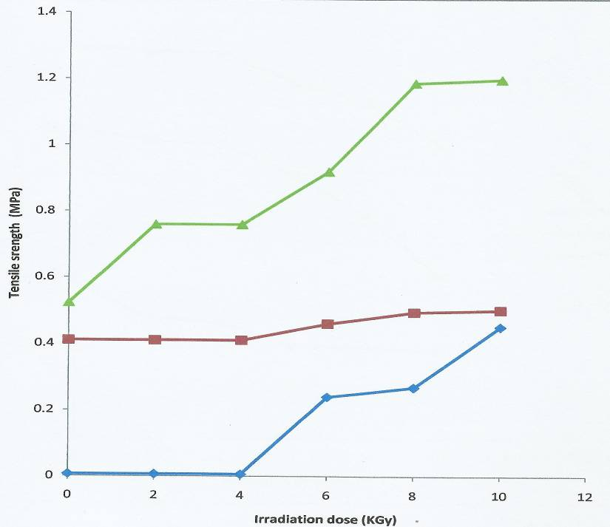

(a)

(b)

(c)

Fig 2. Effect of irradiation dosage on tensile strength of composite photografts (a) 30GA:70N (b) 50GA:50NR (c) 70GA:30NR,%

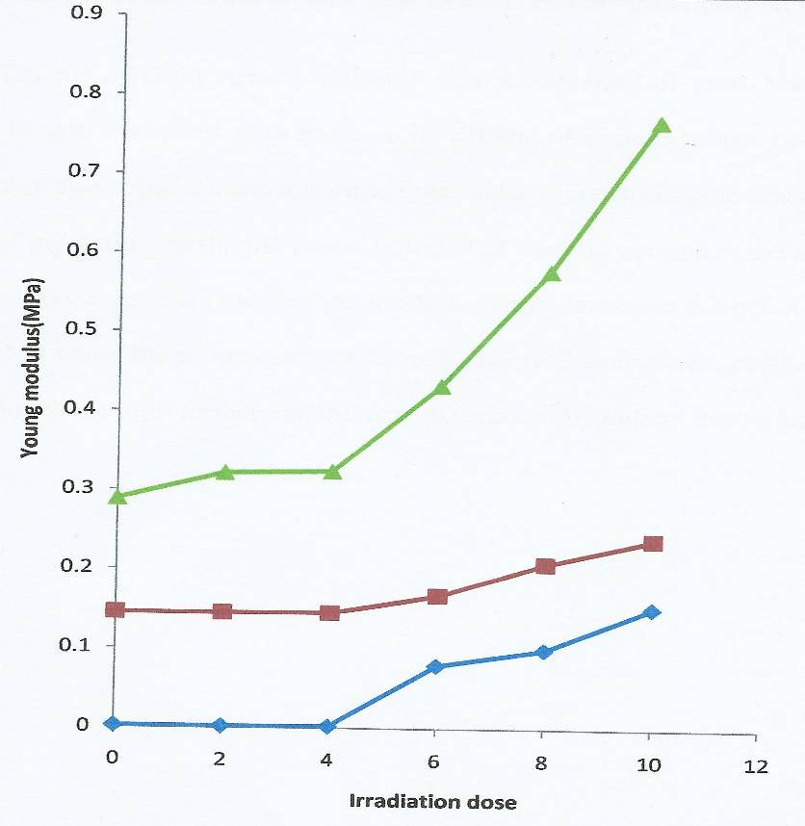

(a)

(b)

(c)

As expected, YM has similar trend as the TS. The generally well established inverse relationship between TS or YM and EB is also demonstrated in Fig.4.Thus for a particular composite formulation such as the 30GA: 70NR %, when the TS increases its EB decreases and vice versa and not necessarily that its EB should be lower than that of 50GA: 50NRor70GA:30NR,%.

As the irradiation dosage increases the degree of grafting increases and hence the mechanical properties. For instance the TS and the YM, increase as can be seen in Figs 5 and 6.

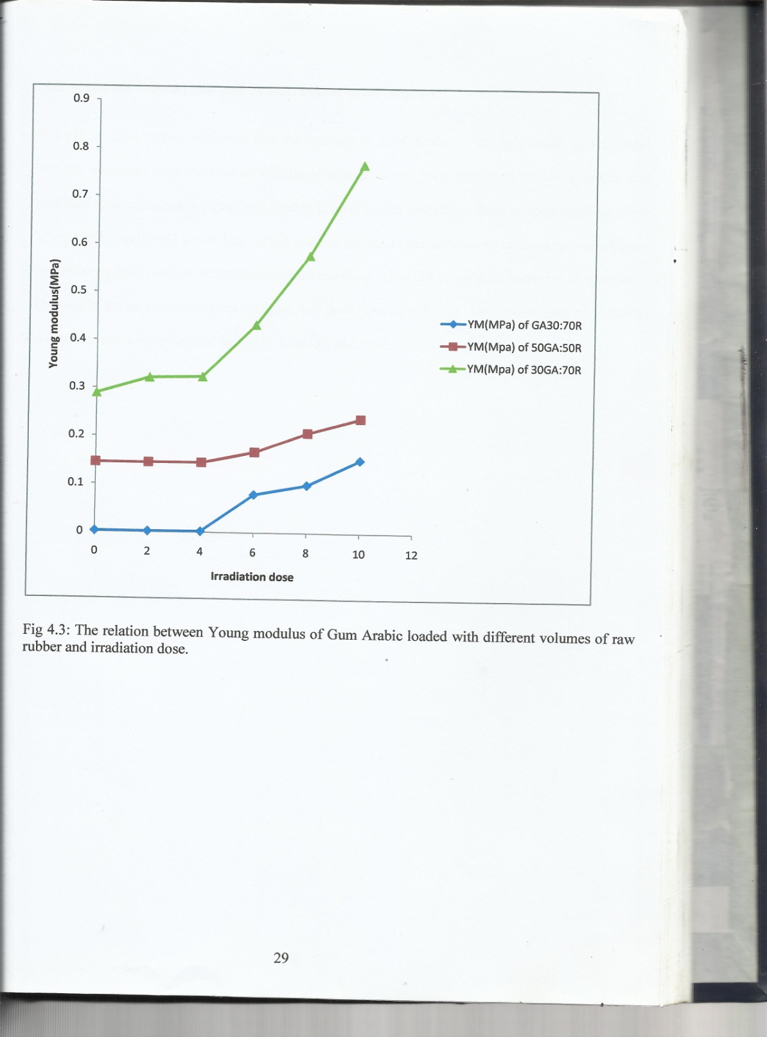

Fig. 3. Effect of irradiation dosage on Young’s modulus of composite photografts (a) 30GA:70N (b) 50GA: 50NR (c) 70GA:30NR,%

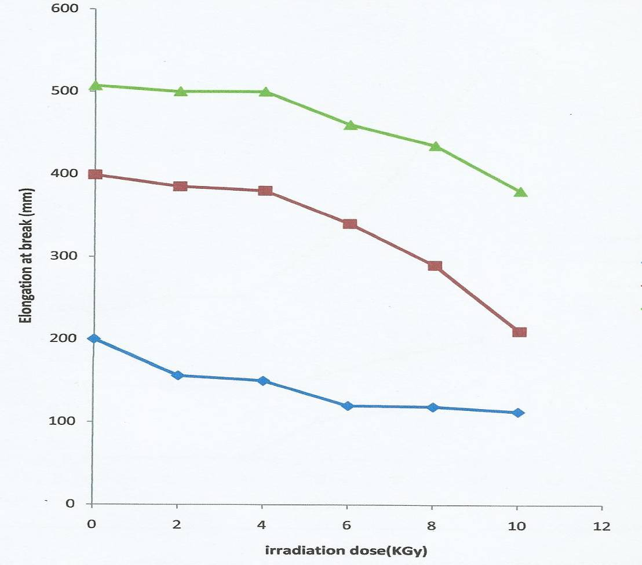

(a)

(b)

(c)

(%)

Fig.4. Effect of irradiation dosage on elongation at break (%) of composite photografts (a) 70GA: 30NR,% (b) 50GA:50NR (c) 30GA:70NR

0.4 0.5 0..6 0.7

Density (g/cm3)

(a)

(b))

(c)

2 4 6 8 10

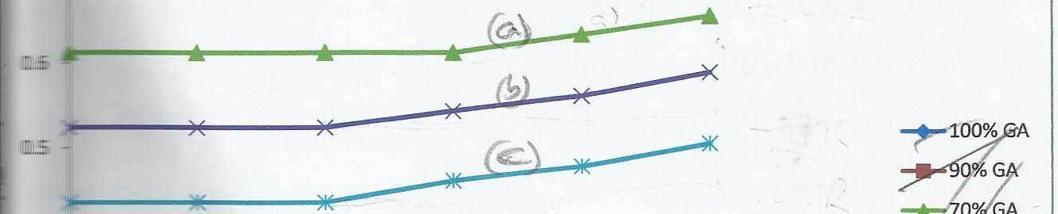

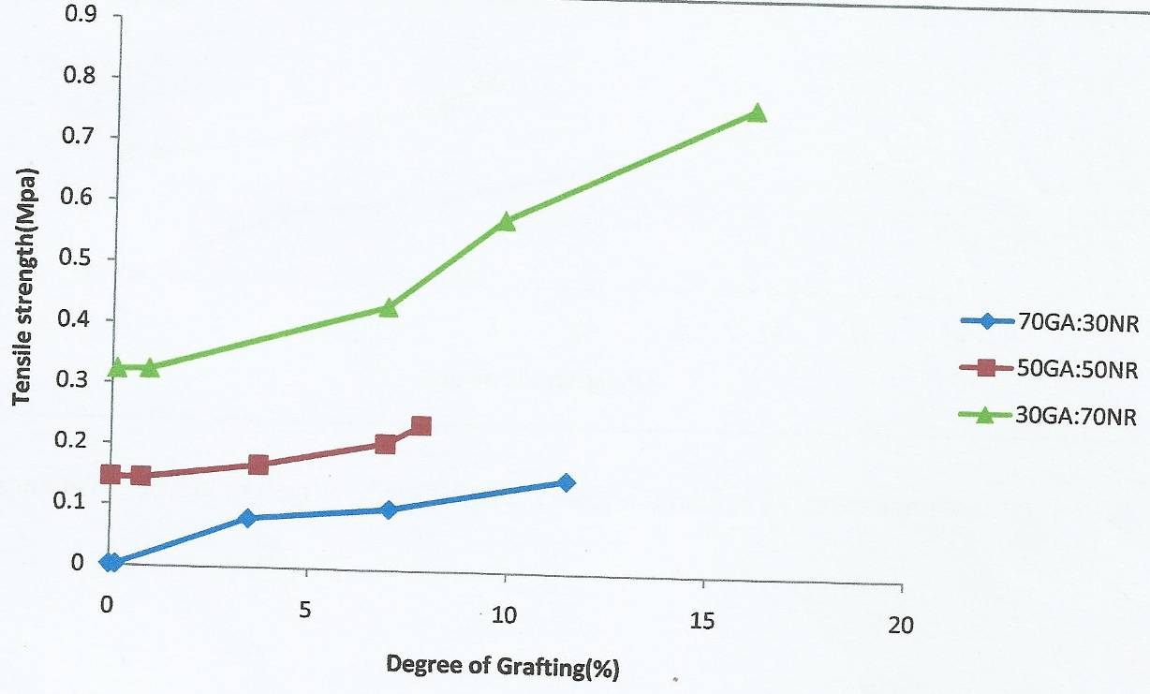

(a)

(b)

(c)

Figure 5. Effect of degree of grafting on tensile strength of composite photografts (a) 30GA:70NR (b) 50GA: 50NR, (c) 70GA:30NR.

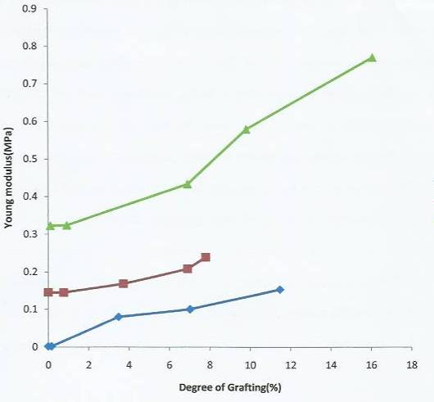

(a)

(b)

(c)

Fig. 6. Effect of degree of grafting on Young’s modulus of composite photografts (a) 30GA:70NR (b) 50GA:50NR, (c) 70GA:30NR.

Irradiation dosage (KGy)

Fig. 7. Effect of irradiation dosage on the density of composite photografts; (a) 30GA:70NR (b) 50GA: 50NR; (c) 70GA:30NR

Fig.7 shows that as irradiation dosage increases the density of the films remain constant up to 4KGy and thereafter appreciates for each composite up to 10KGy with the trend as: 30GA:70NR > 50GA:50NR > 70GA:30NR.This evidence may be attributed to decreasing bulk volume as irradiation increases. The packing density increases with increasing irradiation dosage from 4KGy.

Figures 8 shows the FTIR of pristine GA films where the broad band between 3200-3550cm-1 is attributed to the hydroxyl groups of the acids present in the resin and being broad shows the intermolecular hydrogen bond(Williamsand Flemming,1980). The amount of hydroxyl groups has reduced as can be seen in Fig.9 which is the FTIR of the 50:50 GA:NR film. This could be attributed to the irradiative dissociation of the hydroxyl groups in GA leaving radicals on the resin which could react with the NR radicals to for GA-NR bond yielding the inter-polymer graft in the composite. Gaseous products such as hydrogen, hydrogen peroxide, would be expected The graft of 50GA:50NR,% was used as the films used was lighter in colour than that of 30GA:70NR,% to allow the passage of the IR ray in the FTIR machine to bring the spectra.

Table 3 shows that the fundamental polymer property of degree of crystallinity is responsible for the observed trend in the properties of the photografts obtained in this study. It is clear, given the experimental conditions of this study, that the natural rubber radicals could have penetrated into the gum Arabic radicals domain to produce the photograft. The two different polymer chains seems to have come closer before and after irradiation. At the 10KGy the irradiation actually increased the degree of crystallinity in all the samples but most pronounced for the 30 %GA : 70%NR composite than the chains of the individual resin separately. There is an increasing crystallinity of samples containing100% to 30% GA where this parameter doubles and optimizes(Table 3).

Table 3. Degree of crystallinity of untreated and irradiated composites of natural rubber and gum Arabic.

|  |  |  |
| --- | --- | --- |
| Sample | Degree of crystallinity before irradiation | Degree of crystallinity after irradiation at 10KGy |
| 100GA:0R | 0.3540 | 0.4860 |
| 70GA:30R | 0.5300 | 0.6094 |
| 30GA:70R | 0.6988 | 0.8337 |
| 0GA:100R | 0.6346 | 0.6572 |

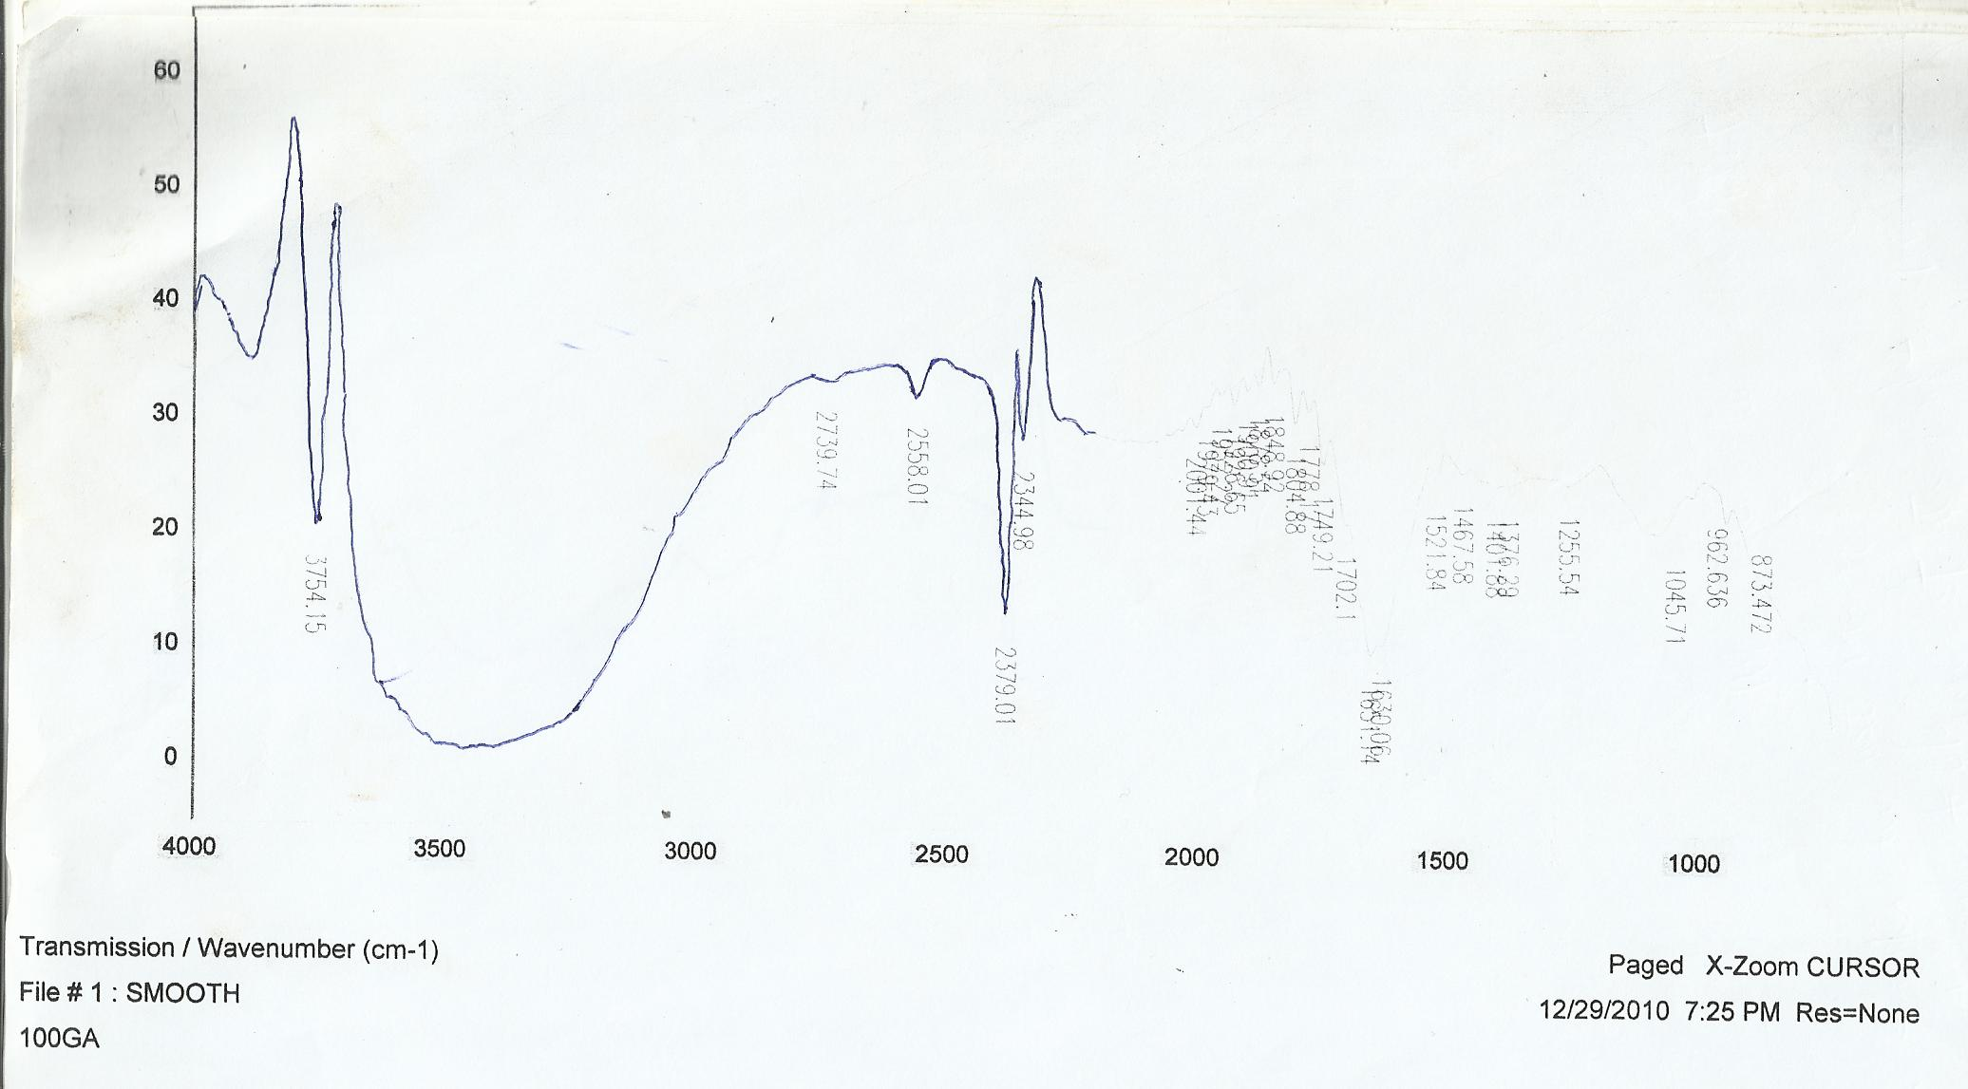

Fig.8. Infrared spectrum of non-irradiated Pure film of gum Arabic

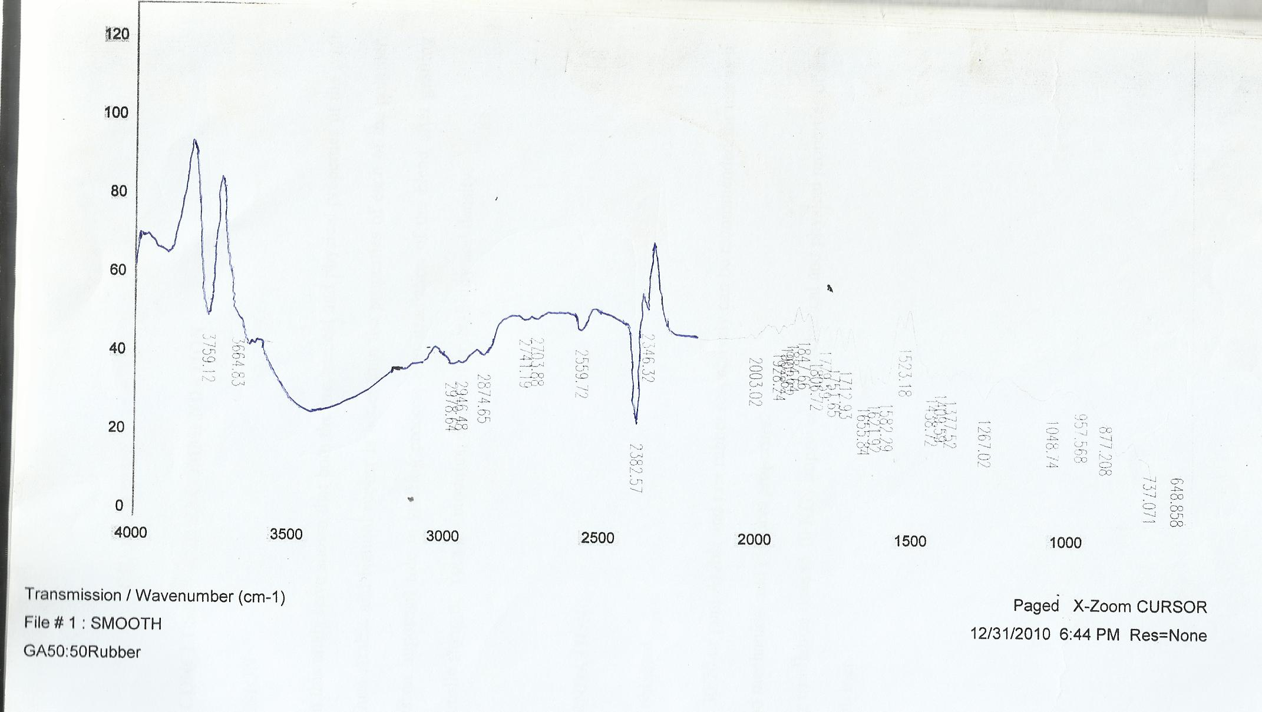

Fig. 9: Infrared Spectrum of irradiated blend of 50:50 (GA:NR) at 10Kgy

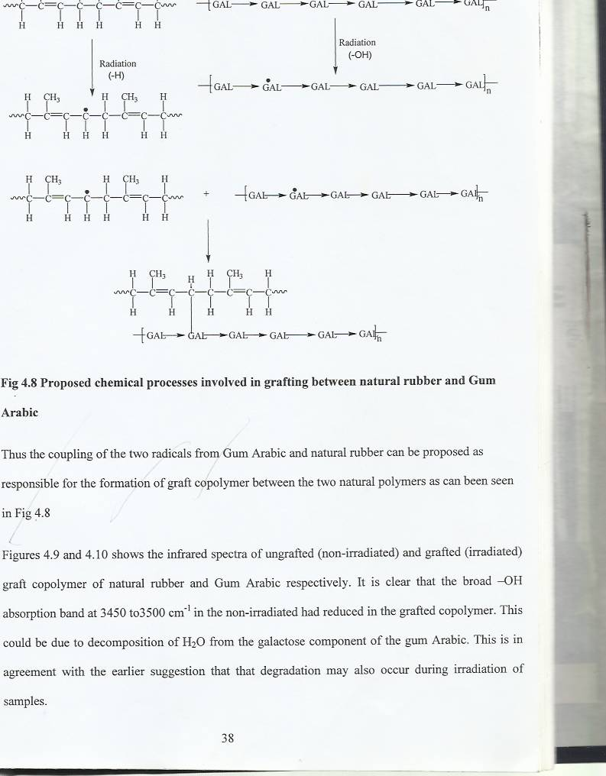

Fig.10. Proposed grafting chemical processes between natural rubber and Gum Arabic

The proposed chemistry of grafting between natural rubber and Gum Arabic, According to Katayama *et a*l (2006) there are two mechanisms accepted for the radical formation of Gum Arabic using irradiation process. One, the direct induced process and the other is the water radiolysis of the galactose in the resin (Philips,1972). The first mechanism yields a polymerization product whereas the second produce degradation products. The first will produce an increase in grafting whereas the converse will indicate a decrease. The present work has shown that gamma irradiation used lead to increased grafting (Fig. 1) not polymerization in the composite.t induced radical formation is assumed. However the possibility of the second process (water radiolysis) may be occurring simultaneously probably r at the higher irradiation dosage. Irradiation of natural rubber produces radicals (Hossain et al 2010) and the induced direct radical formation during irradiation of Gum Arabic (Karamalla et al, 2006). The two processes are shown in fig 10. Thus the coupling of the two radicals from Gum Arabic and natural rubber can be proposed as responsible for the formation of graft copolymer between the two natural polymers.

**4. Conclusion**

Gamma irradiation of composites of natural rubber and gum Arabic produced films that have enhanced technological properties than those films obtained from either polymer. Degree of grafting and crystallinity in the presence of both natural polymers directly determine these properties within the limits of 2 and 10KGy irradiation dosage. These properties are optimized at the ratio of 30 to70% of gum Arabic and natural rubber respectively.

**References**

1. Abdul-Hadi, AH; Mahmoud, A.E.; and Abdel-Wahab, H.M. (2010) Effect of gum Arabic on coagulationsystem of albino rats. Int. J. Pharm. Tech. Res., 2:1762-17662.
2. AL-Assaf, S.; Phillips, G.O.; Williams, P.A. (2005) Studies on acsacia exudate gums. Part1: the molecular weight of Acacia senegal gum exudates. Food Hydrocoll.; 19, 647–660.
3. Azeez, OS.(2005) Decolourization of gum Arabic using activated charcoal. Leonardo J. Sci., 7: 23-32.
4. Badreldin, H.A.; Amal, Z. and Gerald, B. (2008). Biological effects of gum Arabic:A review of somerecent research. Food Chem. Toxicol., 47.
5. Borges, FA.; Balognesi, L.F.C,; Trecco, A; Drago, B.C.; Arrud, L.B.; Filho, P.N.L.; Graeff, C.F.O.; Santos, A.G.; Miranda, M.C.R and Herculano, R.D. (2014) Natural Rubber Latex: Study of a Novel carrier for Casearia Sylvestris Swartz Delivery. SRN Polymer Science vol.2014,1-5.
6. Herculano, R.D.; Silva, C.P.; Ereno, C.; Guimaraes, S.A.C.; Kinoshita, A.C.; Graefo, C.F.O. (2009) Natural Rubber Latex used as drug delivery system in guid ed bone regeneration (GBR). Mat. Res. Vol.12 (2).
7. Hossain, K.M.Z.; Chowdhury, A. M.S.; Haque, D.N.C. and Akhter. (2010 Utilization of Diospyrus peregrine as a Natural Antioxidant in Radiation Vulcanized Natural Rubber Latex.Film. Dhaka Univ. J. Sci. 58(1):27-30.
8. Ibrahim, S.M; Mousaa I.M.; Ibrahim, M.S.(2014) Characterization of Gamma Irradiated plasticized Carboxymethyl Cel,lulose (CMC)/Gum Arabic (GA) Polymer Blends as an Absorbents for Dyestuffs. Bull. Mater.Sc. vol.37,No 3,603-608
9. [Kong, H](http://www.ncbi.nlm.nih.gov/pubmed/?term=Kong%20H%5BAuthor%5D&cauthor=true&cauthor_uid=24418338); [Yang, J](http://www.ncbi.nlm.nih.gov/pubmed/?term=Yang%20J%5BAuthor%5D&cauthor=true&cauthor_uid=24418338); [Zhang, Y](http://www.ncbi.nlm.nih.gov/pubmed/?term=Zhang%20Y%5BAuthor%5D&cauthor=true&cauthor_uid=24418338), Ang Y, [Nishinari K](http://www.ncbi.nlm.nih.gov/pubmed/?term=Nishinari%20K%5BAuthor%5D&cauthor=true&cauthor_uid=24418338), [Phillips GO](http://www.ncbi.nlm.nih.gov/pubmed/?term=Phillips%20GO%5BAuthor%5D&cauthor=true&cauthor_uid=24418338). (2014) Synthesis and antioxidant property of gum arabic-stabilized selenium nanoparticles. Int J Biol Macromol; 65:155-62.
10. Kafi, S.T; and Sabahalkhair, M. K. (2010). Effects of ã-Irradiation on Some Properties of Gum Arabic (*Acacia Senegal* L) Research Journal of Agriculture and Biological Sciences, 6(2): 113-117, 2010.
11. Karamalla, K.A.; Siddig, N.E.; and Osman, M.E. (2006). Analytical data for Acacia Senegal gum samples collected between 1993 and 1995 from Sudanood Hydrocolloids, 9: 1-6.
12. Katayama, T.; Nakauma, M.; Todoriki, S.; Phillips, G.O.; Tada, M.; (200). Radiation-induced polymerization of gum Arabic (Acacia Senegal) in aqueous soluteion. Food Hydrocolloids 20 (7) 983—989.
13. Kumar, C.S.S.R; and Nijasure, A.M (1997). Vulcanization of rubber; how to alter molecular structure and influence physical properties. Resonance, 2(4),55-59.
14. Lindley, P.B. (2008). Automobile Anti-impact bumpers of natural rubber. SAE. Journal of Automotive Engineering. Publisher. Society of Automotive Engineers.
15. Lelon, J.K.; Jumba, I.O.; Keter, J.K.; Wekesa C.; and Oduor, F.D.O. (2010.) Assessment of physicalproperties of gum Arabic from *Acacia Senegal* varieties in Baringo District, Kenya. Afr. J. PlantSci., 4: 95-98.
16. Lambourne, R. (1987) Durability testing. In Paint and Surface Coatings: Theory and Practice. John Wiley & Sons. N.Y P.663.
17. Nara, S. and Komiya, T. (1983) Use of X-Ray diffractometer to the Study the relationship between water saturated state and crystallinity by the diffraction method for moistened potato starch. Food Ingredient —Gum Arabic, U.S. Department of Commerce, (1972), p. 49.
18. Phillips, G.O. (1972). Effect of ionization radiation on carbohydrates system.Radiation Research Reviews,3:335-351.
19. Tsuyoshi, K.; Makoto, N.; Setsuko, T.; Phillips, G.; and Mikiro, T. (2006). Radiation–induced polymerization of gum Arabic (Acacia Senegal) in aqueous solution. Food Hydrocolloids, 20:983-989.
20. Turoti, M, JY; Olayemi, JB; and Adeniyi Olufemi Peters (I999) Themooxidative degradation of poly (vinylchloride). Part 3. The stabilizing action of Dibutyltin malteate and Trisnitro (l,3-dihydroxymethyl-2- nitropropane) on PVC exposed to outdoor. *Poly. Deg. and Stab.* 63, 341-347.
21. Wang-Shujun; Yu Jinglin; and Gao Wenjuan (2006). Use of X-ray Diffractometry for identification of different Frotillaria Traditionalal Chinese Medicine. Science Alert p.32.
22. William, D.H.; and Fleming, I. (1980). Spectroscopic Methods in Organic Chemistry. McGRAW-HILL Company Ltd. U.K., London, 10.

3/7/2015