The In Vitro Antioxidant Properties of Hibiscus Anthocyanins Rich Extract (HAE)

Owoade, A.O*¹ , Lowe, G.M² and Khalid, R.²

¹Department of Biochemistry, LadokeAkintola University of Technology, Ogbomosho, Nigeria
²School of Biomolecular Sciences, Liverpool John Moores University, Byrom Street, Liverpool, L3 3AF, UK
aoowoade@lautech.edu.ng

Abstract: This study investigate the antioxidant properties of Hibiscus anthocyanins rich extract (HAE) prepared from Hibiscus sabdariffa. The extract significantly inhibited superoxide production by xanthine – xanthine oxidase by 41.18% at 5% (v/v) of the reaction volume. In addition, the antioxidant investigation showed that HAE has potent scavenging ability against DPPH and ABTS radicals and these radicals scavenging abilities were found to be dose dependent. HAE was found to contain high level of total phenolic content (56.6 ± 3.7 mg/g in GAE/g dried weight).The anthocyanins components of HAE were identified through several chromatographic analyses. The results indicate that delphinidin-3-sambubioside, delphnidin-3-monoglucoside, cyanidin-3-sambubioside and cyanidin-3-monoglucoside as the major anthocyanins and delphinidin and cyanidin as major anthocyanindin. These studies demonstrated that Hibiscus sabdariffa is an efficient antioxidant plant in vitro and may prevent or reduce the development and progression of free radical mediated diseases. Antioxidant ability displayed by Hibiscus sabdariffa may in part be due to the presence of different phenolic compounds in the plant.
[Owoade, A.O , Lowe, G.M and Khalid, R. The In Vitro Antioxidant Properties of Hibiscus Anthocyanins Rich Extract (HAE). Nat Sci 2015;13(3):22-29]. (ISSN: 1545-0740). http://www.sciencepub.net/nature. 4

Key Words: Hibiscus sabdariffa, Antioxidants, lipid peroxidation, free radical-mediated damage.

1. Introduction
Plants extracts are rich source of important vitamins namely vitamin E, Vitamin C and β-carotene, flavonoids and other polyphenols which have been discussed as potential antioxidant prophylactic agents for both health and diseases management (Aruoma, 2003). Studies suggest that plant polyphenols such as the flavonoids are potent antioxidant compounds both in vitro and in vivo. They have been shown to scavenge free radicals, chelate redox–active metal ions and inactivate other pro-oxidants (Schroeter, 2002; Fraga, 2007). Their consumption have been shown to help reduce the risk and prevent against cardiovascular diseases, cancer and neuronal diseases (Damianaki et al., 2000; Mennen et al., 2004). These pharmacological properties of flavonoids which are mostly related to their antioxidant potential have been postulated to be due to their structural features (Schroeter et al., 2002; Valko et al., 2006; Fraga, 2007). This enables them to scavenge reactive radical species, interfere with the oxidation of macromolecules and inhibit key endogenous free radicals generating enzymes such as NAD(P)H-oxidase, xanthine oxidase, tyrosine kinase by their hydrogen (electron) donating ability and their hydroxylation/methylation patterns (Terao, 1999; Engler and Engler, 2006; Stratil et al., 2006).
Hibiscus sabdariffa is a rich source of phenolic compounds (Ali et al., 2005). Numerous phenolic compounds have been identified in the plant extracts (Salah et al., 2002; Lin, 2005). Hibiscus sabdariffa is also rich in anthocyanins which is responsible for its deep red colouration. Anthocyanins are polyphenolic compounds responsible for cyanic colours ranging from salmon pink through red and violet to dark blue of most flowers, fruits, leaves and stems. They comprise the largest group of the water-soluble pigments in the plant kingdom (Strack and Wray, 1994). Anthocyanins have received increasing attention over the last fifteen years due to their potential health effects, and they are nowadays regarded as important nutraceuticals. This is mainly due to their possible antioxidant effects, and they have been given a potential therapeutic role related to cardiovascular diseases, cancer treatment, inhibition of certain types of virus including the human immunodeficiency virus type 1 (HIV-1), and improvement of visual acuity (Cecchini et al., 2005; Cooke et al., 2005; Jang et al., 2005; Talavera et al., 2006).
Due to use of improved analytical techniques, about 575 anthocyanins with complete structure have been reported (Andersen and Jordheim, 2006). Even though there are around 30 different anthocyanidins, approximately 90% of all anthocyanins are based on the six most common anthocyanidins; pelargonidin, cyanidin, delphinidin, peonidin, petunidin and malvidin, which only differ by the hydroxylation and methoxylation pattern on their B-rings. The anthocyanins differ with respect to glycoslyation of hydroxyl groups, nature of glycosyl units, substitution pattern, and potential aliphatic and aromatic acylation (Andersen and Jordheim, 2006). Hibiscus sabdariffa pigment has been reported to be rich in delphinidin-3-sambubioside, delphnidin-3-monoglucoside, cyanidin-3-sambubioside and cyanidin-3-monoglucoside (Shibata and Furukawa, 1969; Du and Francis, 1973; Hong and Wrostad, 1990; Wong et al., 2002; Sukwattanasinit et al., 2007), although only few studies have been able to link the antioxidant potential of Hibiscus sabdariffa to its anthocyanins content.
The aim of this study was to investigate the in vitro antioxidant potential and chemical constituents of Hibiscus anthocyanins rich extract (HAE). Evidence is presented to suggest that Hibiscus sabdariffa is an effective antioxidant plant in vitro and this antioxidant potential may be related to the high concentration of polyphenolic antioxidants in the plant.
2. Materials and Methods
2.1. Reagents
All chemical used were of analytical grade. Special reagents were Cytochrome C, Xanthine, Xanthine Oxidase (Grade III from bovine milk), ABTS (2,2 -azino-bis-(3-ethylbenzthiazoline 6-sulfonic acid), Folin - ciocalteu’s Phenol reagent, Trolox (6-hydroxy - 2, 5, 7, 8, - tetramethyl-chroman -2-carboxylic acid (C-stock -solution = 2.5mmol/L), Gallic acid and all other chemicals were purchased from Sigma -Aldrich Company Limited, Dorsert, United Kingdom.
2.2. Plant Material
Flowers of Hibiscus sabdariffa (Malvaceae) were bought at a market in Nigeria. The identification and authentication of the plant was done by Dr A.J. Ogunkunle at Department of Pure and Applied Biology, Ladoke Akintola University of Technology, Ogbomoso, where a specimen was deposited in the herbarium. The dried flowers were further dried at room temperature and blended to a coarse powder.
2.3. Preparation of Hibiscus Anthocyanins Rich Extract (HAE)
HAE was prepared from the dried flower of Hibiscus sabdariffa L. as described by Chang, et al., (2006). The dried flower (20g) was mixed with 120ml methanol containing 1% HCl for 24 hrs at 4⁰C. The extract was filtered and the filtrate was applied to an amberlite Diaion HP-20 resin column for 24h, and then washed with distilled water containing 0.1% HCl solution and eluted with methanol. The filtrate was concentrated in a rotary evaporator and then lyophilized to obtain approximately 0.5g of HAE and stored at - 20⁰C before use.
2.4. Preparation of a Diethyl Ether Extract of HAE
Due to intense colouring of HAE, it was necessary to prepare a less intense extracts, which did not interfere with some of the spectrophotometric assays. One part of HAE was gently mixed with two parts diethyl ether and centrifuge at 2000rpm for 10 minutes. The diethyl ether extract was removed and dried under a stream of oxygen-free nitrogen gas. The residue was then re-suspended in phosphate buffered saline (PBS) pH 7.2 to its original volume.
2.5. Superoxide and xanthine oxidase activity
This was carried out as reported by Dillion et al., (2003). Superoxide production and xanthine oxidase activity were measured as cytochrome C reduction and uric acid production, respectively. Xanthine oxidase was prepared to a concentration of 107mU/ml in Phosphate Buffered Saline (PBS), pH 7.2 and Xanthine was prepared as a 1.6mM solution also in PBS. Superoxide ions were generated in a reaction volume of 1ml containing 160µM xanthine and 1.25mg cytochrome C. The reaction was initiated by the addition of 10.7mU xanthine oxidase, and superoxide ion production was monitored at 550nm (Edwards, et. al., 1987). In a series of separate experiments, xanthine oxidase activity was monitored as the production of uric acid at 284nm. Generation of superoxide ions was confirmed by the addition of 50U superoxide dismutase (SOD), which inhibited the reduction of cytochrome C without affecting xanthine oxidase activity. Extracts were added at 0 – 10% (v/v). Results for superoxide production are expressed as ΔA550nm/minute whilst, result for uric acid production are expressed as ∆ A284nm/minute.
2.6. Trolox Equivalent Antioxidant Capacity (TEAC) with Manganese dioxide
The assay was performed as previously described by Schelesier et al., (2002). The ABTS radical cation was prepared by filtering a solution of ABTS (in PBS) through manganese dioxide powder. Excess manganese dioxide was removed from the filtrate by passing it through a 0.2µm syringe filter. This solution was diluted in 5mM PBS pH 7.4, adjusted to an absorbance of 0.700 ± 0.020 at 734mm and preincubated at room temperature prior to use for 2 hours. 1 ml of ABTS^{●+} solution and various concentrations of the extracts (diluted with water) were vortexed for 45 seconds in reaction tubes, and the absorbance (734nm) was taken exactly 2 minutes after initiation of mixing. PBS blanks were run in each assay. The antioxidant activity of the extracts was calculated by determining the decrease in absorbance at different concentrations by using the following equation:
% antioxidant activity = (A _{(ABTS●+)} -A _{(Extracts)}) / (A _{(ABTS●+)}) X 100.
where E is the extinction.

2.7. Trolox Equivalent Antioxidant Capacity with Potassium Persulfate
The assay was performed essentially as described by Re et al., (1999). ABTS radical cation was produced by reacting 7 mM ABTS stock solution with 2.45 mM potassium persulphate and allowing the mixture to stand in the dark at room temperature for 12–24 h before use. The ABTS^{●+} solution was diluted with water for the hydrophilic assay and with ethanol for the lipophilic assay and adjusted to an absorbance of 0.700 ± 0.020 at 734nm. For the photometric assay, 1ml of the ABTS^{●+} solution and various concentrations of the extracts were mixed for 45 seconds and measured immediately after 1 minute at 734nm. The antioxidant activity of the extracts was calculated by determining the decrease in absorbance at different concentrations by using the following equation.
% antioxidant activity = ((A _{(ABTS●+)} -A _{(Extracts)}) / (A _{(ABTS●+)}) X 100.

2.8. DPPH (2,2-Diphenyl-1-picrylhydrazyl) radical scavenging Activity
The assay was performed as previously described by Schelesier et al., (2002). The radical solution is prepared by dissolving 2.4 mg DPPH• in 100 ml methanol. For the photometric assay 1.95 ml DPPH• solution and 50 µl antioxidant solution were mixed. At first, the absorbance of the disposable cuvette with 1.95 ml DPPH• was measured as blank, then the antioxidant solution was added and mixed. The reaction was measured at 5 min interval at 515 nm until ΔA=0.003 min⁻¹. The anti-oxidative activity was calculated by determining the decrease in absorbance at different concentrations by using the following equation:
%Inhibition activity = ((A _{(DPPH}●₎ –A _{(Extracts)}) / (A _{(DPPH}●₎) X 100

2.9. Determination of Total Phenolic Compounds in HAE
The content of total phenolic compounds in HAE was determined by Folin–Ciocalteu method as described by Miliauskas et al., (2004). Briefly, l ml aliquots of 0.024, 0.075, 0.0105 and 0.3 mg/ml ethanolic gallic acid solutions were mixed with 5ml Folin-ciocalteu reagent (diluted ten-fold) and 4ml (75g/L) sodium carbonate. The absorption was read after 30 min at 20⁰C at 765 nm and the calibration curve was drawn. One ml of HAE (1mg/ml) was mixed with the same reagents as described above, and after l h the absorption was measured for the determination of plant phenolics. All determinations were performed in triplicate. Total content of phenolic compounds in plant methanol extracts in gallic acid equivalents (GAE) was calculated by the following formula:
C = c • V/m΄

Where: C-total content of phenolic compounds, mg/g plant extract, in GAE; c-the concentration of gallic acid established from the calibration curve, mg/ml; V- the volume of extract, ml; m΄- the weight of pure plant methanolic extract, g.
2.10 TLC Separation of Anthocyanin in HAE
Individual anthocyanins in anthocyanins rich extract of Hibiscus sabdariffa were isolated by TLC using merck 60 silica gel plates (0.2mm). For detection of anthocyanins the plates were developed using a mixture containing n-butanol, acetic acid and water in the ratio of 40:10:20 (v/v/v). Diluted HAE (10µl), and 10µl standards were loaded onto silica gel 60 TLC plates and left to dry. The plate was allowed to run, dried and then visualized under visible light.
2.11. HPLC Separation of Anthocyanin in HAE
The separation and identification of anthocyanin was performed according to the procedure describe by De Ancos et al., (2000). The anthocyanins in HAE were separated by HPLC, a symmetry shied RP 18 column (80A, 5µ) and UV/Visible detector (monitored at 530nm). The mobile phase was composed of 4 per cent phosphoric acid (solvent A) and 100 per cent acetonitrile (solvent, B). The solvent program was isocratic elution with 6% B from 0 to 10min, linear gradient to 20% B from 10 to 50min and isocratic elution at 20% B from 50 to 60 minutes. The flow rate was set at 1ml/minute.
2.12. HPLC Separation of Anthocyanindin in HAE
To standardised the Hibiscus anthocyanins, the delphinidin and cyanidin contained in the HAE were determine by HPLC, using a symmetry shield RP 18 column (80A, 5µ) and UV/visible detector (monitored at 540nm). The mobile phase was composed of 4% phosphoric acid (solvent A) and 100% Acetonitrite (solvent B) run on a gradient of 10% B to 50% B for 15minutes and monitored at 540nm. 1ml of the sample was boiled with 1ml HCl at 95⁰C for 30minute to assist in the process of hydrolysis and 10µl of this were injected into chromatography. The flow rate was set at 1ml/min.
Statistical analysis
Results are expressed as means ± SEM. Statistical analyses were performed using Student’s t test; a p <0.05 was considered statistically significant.
3. Results
3.1. Superoxide Scavenging Ability of HAE
Superoxide production by xanthine – xanthine oxidase gave a reaction rate of 0.085 ± 0.002 ∆A550 nm/min while xanthine oxidase activity gave a reaction rate of 0.106 ± 0.001 ∆A284nm/minutes. At 5% (v/v) of the reaction volume, diethyl ether extract of HAE significantly inhibited superoxide production i.e the reduction of cytochrome C by 41.18% (Table 1). Superoxide production was inversely related to the concentrations of diethyl ether extract of HAE. The extract significantly affects uric acid production indicating that the components of HAE inhibit xanthine oxidase.

Table 1 The effect of SOD, diethyl ether extracts of HAE on superoxide and uric acid production by xanthine-xanthine oxidase.
Extract/Agent | Superoxide Production  (∆A550nm/min) | Uric Acid Production  (∆A295nm/min)
None¹ | 0.085 ± 0.002 | 0.106 ± 0.001
50U SOD | 0.001 ± 0.001* | 0.099 ± 0.002
5% diethyl ether extract of HAE | 0.050 ± 0.001* | N.D
Values are means of three experiments ± SEM. Significant differences (p < 0.05) from control¹ (xanthine-xanthine oxidase only) are indicated by ٭

3.2. ABTS Radical Cation Scavenging Ability of HAE
In the three versions of TEAC assay, TEAC II and TEAC III (hydrophilic and lipophilic version) the inhibition of ABTS^{●+} radical cation was directly related to the concentration of the extracts and the TEAC value of Trolox is 1.00. HAE showed comparable antioxidant activity in TEAC II and TEAC III hydrophilic version but TEAC values analysed in TEAC III (lipophilic version) were much lower when compared with the other two TEAC assays (Table 2).

Table 2 Trolox equivalent antioxidant capacities (TEAC) (Mmol/L) of Trolox, Gallic acid and HAE
Assay/antioxidant | Trolox | Gallic | HAE
TEAC II | 1 | 3.96 ± 0.31 | 0.85 ± 0.07
TEAC III hydrophilic | 1 | 3.34 ± 0.20 | 0.74 ± 0.04
TEAC III lipophilic | 1 | 3.99 ± 0.16 | 0.67 ± 0.05

3.3. Diphenyl-1-picrylhydrazyl (DPPH) scavenging activity of HPE
The Hibiscus anthocyanin rich extract (HAE) demonstrated a concentration dependent scavenging activity by quenching DPPH radicals (data not shown) and was compared with gallic acid, as a positive control. The IC50 values (defined as the concentration of test compound required to produce 50% inhibition) for DPPH scavenging by HAE and gallic acid were 260.7± 6.4 µg/dL and 16.33 µg/dL respectively (Table 3).

Table 3 Total phenolic content and DPPH radical scavenging value of HAE
Sample |  | Total Phenolª |  | DPPH Scavenging activity (IC 50)^{b}
HAE |  | 56.6 ± 3.7 |  | 260.7± 6.4
Gallic | ̶ |  |  | 16.3± 1.5
Each value represents the mean ± SEM. (n=3).
a Total phenolic content was expressed as mg gallic acid equivalents/g dried extract.
b Expressed as µg/mL
3.4. The Phenolic Content of HAE
The phenolic content of the three extracts of Hibiscus sabdariffa (HAE ) were determined using a colorimetric assay namely Folin-Ciocalteu assay, and by constructing a standard curve using Gallic acid as the standard. The total amount of phenolic compounds present in HAE was found to be 56.6 ± 3.7 mg/g (Table 3)
3.5 Analysis of Anthocyanins in HAE by TLC
Thin layer chlaromatography (TLC) analysis was performed to compare the nature of anthocyanins present in HAE with two standard anthocyanidins (delphinidin and cyanidin). For comparative TLC analysis Silica gel 60 plates and an organic solvent system (n-butanol, acetic acid and water (40:10:20 v/v/v) were employed. The plates were visualized with visible light. Under this system five well resolved bands were detected (Table 4).

Table 4. TLC separation of anthocyanins in anthocyanin rich extract (HAE). Values are the means of three experiments ± SEM
Standard/Sample | Standard Name/Band | Visible Light Rf value
Standards | Delphinidin Chloride | 0.25
 | Cyanidin Chloride | 0.49
HAE | Band 1 | 0.19
 | Band 2 | 0.25
 | Band 3 | 0.32
 | Band 4 | 0.51
 | Band 5 | 0.71

3.6. Analysis of Anthocyanins in HAE by HPLC
Separation of anthocyanins in HAE was achieved using high pressure liquid chromatography (HPLC). The acetonitrile/water gradient system used allowed separation of anthocyanins compounds present in HAE by polarity with the most polar compounds eluted first. Five peaks were obtained (two major and three minor). The chromatogram (Figure 1), compared well with the results of previous workers, who separated and identified four anthocyanins in Hibiscus sabdariffa using HPLC (Hong and Wrolstad, 1990; Wong, et. al., 2002). In this study anthocyanins a-d (Figure 1) were identified by matching their retention times to those of the anthocyanins present in an authentic sample of Hibiscus sabdariffa, as described by Hong and Wrolstad. The anthocyanins were expressed as percentage based on total peak area. The relative percentages distributed by delphinidin-3-sambubioside, delphinidin -3- glucoside, cyanidin -3- sambubioside and cyanidin -3- glucoside in HAE were 56.85%, 4.50%, 36.60% and 1.00% respectively (Figure 1 & 3). Results of this study showed that delphinidin -3- sambubioside and cyanidin -3- sambubioside were the major anthocyanins present and this corresponded to those reported previously by Hong and Wrolstad, (1990). In a separate study, HPLC analysis on Acid – hydrolysed HAE showed two peaks with retention time of 7.1 minutes and 8.18 minutes. These two peaks corresponded to peaks obtained with delphinidin and cyanidin standards (Figure 2 & 3). This showed that delphinidin and cyanidin are the major antocyanidins in Hibiscus sabdariffa.

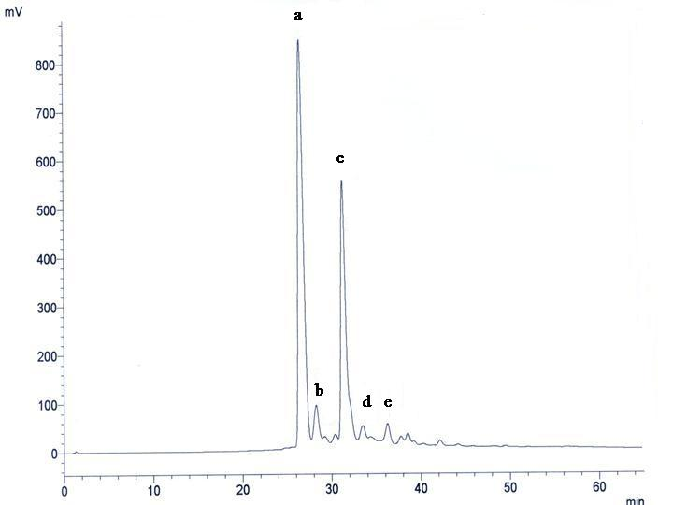
Figure 1 A typical HPLC chromatogram of HAE with detection at 530nm. Peak identification (relative peak areas calculated with detection at 530nm in parentheses): a. delphinidin 3-sambubioside (56.8%); b. delphinidin 3-glucoside (4.5%) ; c. cyanidin 3-sambubioside (36.6%) ; d. cyanidin 3-glucoside (1.0%) ; e. unknown (1.9%). Proportion of delphinidin glycosides: 61.3%. Proportion of cyaniding glycosides 37.6%. All experiments were repeated three times.
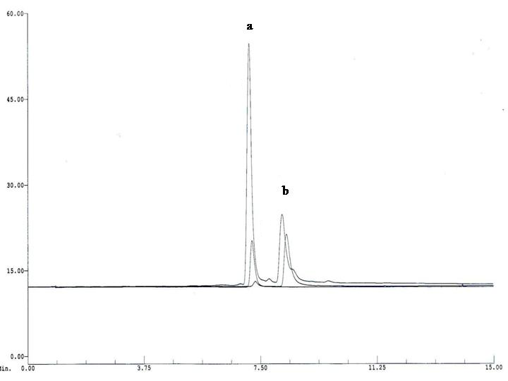
Figure 2 A typical HPLC chromatogram of acid hydrolysed HAE. Peak (a) co-elute with delphinidin at 7.11 minutes and Peak (b) co-elute with cyanidin at 8.18 minutes. All experiments were repeated three times.

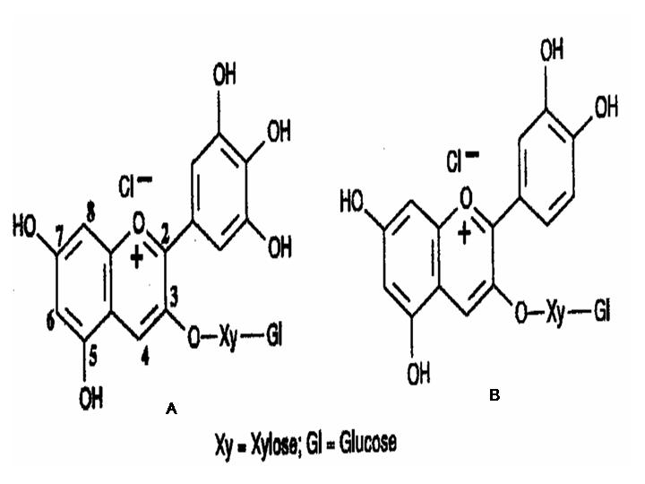
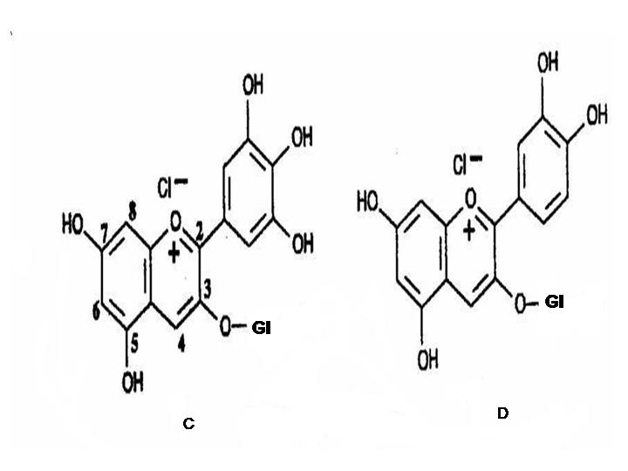
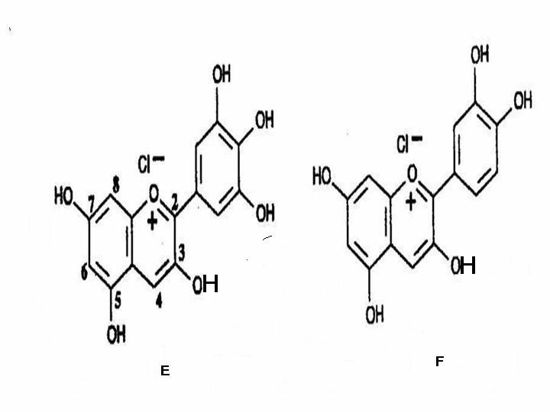
Figure 3 Chemical structures of anthocyanin and anthocyanindin identified in HAE. (A) delphinidin-3-sambubioside (B) cyanidin-3-sambubioside (C) delphnidin-3-monoglucoside (D) cyanidin-3-monoglucoside (E) delphinidin (F) cyanidin.

4. Discussions
Hibiscus sabdariffa has been demonstrated to be rich in polyphenols such as flavonoids, phenolic acids and anthocyanins (Ali, et. al., 2005; Salah, et. al., 2002; Lin, et. al., 2005). Studies suggest that plant polyphenols such as the flavonoids and anthocyanins are potent antioxidant compounds both in vitro and in vivo (Fraga, 2007). Therefore it would not be surprising if the antioxidant properties associated with Hibiscus sabdariffa is related to the flavonoids and anthocyanins components of the plant.
This study investigate the antioxidant potential of Hibiscus anthocyanins rich extract (HAE). The result suggest that diethyl ether extract of HAE did not scavenge superoxide radical but rather inhibited xanthine oxidase in the production of the radical. This result therefore supports the works of Tseng et al., (1997) that Hibiscus sabdariffa and its constituents have inhibitory effect on xanthine oxidase activity. In addition, this study demonstrates that, the extract has ABTS^{•+} and DPPH radicals cation scavenging ability. Hibiscus sabdariffa is a rich source of a plant polyphenols such as flavonoids and phenolics acids (Salah, et. al., 2002; Lin, et. al., 2005; Jamilah, 2014). The results presented in this study suggest the same is true for HAE. Using Folin-Ciocalteu assay HAE was shown to have high phenolic content (Table 3).
The pigment of Hibiscus sabdariffa is rich in anthocyanins (Hong and Wrolstad, 1990; Wong, et. al., 2002; Du and Francis, 1973). The anthocyanins composition of HAE was determined in this study. The results obtained through various methods of analysis suggest the presence of delphinidin-3-sambubioside, delphnidin-3-monoglucoside, cyanidin-3-sambubioside and cyanidin-3-monoglucoside as the major anthcyanins and delphinidin and cyanidin as major anthocyanindin in HAE, these results support earlier findings (Hong and Wrolstad, 1990). Anthocyanins have been reported to exert multiple biological effects, such as, anti-inflammatory, anti-atherosclerotic and anti-carcinogenic activities (Garciäa-Alonso, et. al., 2004; Weisel, et. al., 2006). Also, high antioxidant activity of anthocyanins has been demonstrated in many studies (Weisel, et. al., 2006). As observed in this study, a substantial proportion of the total phenolics in Hibiscus sabdariffa is represented by monomeric anthocyanins, and since anthocyanins are known to exhibit antioxidant activities, this group of compounds would therefore play a significant role in antioxidant effect demonstrated by Hibiscus sabdariffa, although it is, not yet clear, whether the protective potential of Hibiscus sabdariffa in vivo can be ascribed to this class of compounds alone.
It is however important to note that the extent of the anthocyanins and other polyphenolic compounds, antioxidant potential in humans, and other observed positive health effects studied in vitro, are of course in vivo dependent on the absorption, metabolism, distribution, and excretion of these compounds within the body after ingestion (Rice-Evans and Parker, 2003). In addition, since plants also contain other antioxidant micronutrients such as vitamin C, β-carotene and lycopene, it has to be kept in mind that their antioxidant efficacy may not be attributed alone to the presence of these phenolic compounds (Bonorden and Pariza, 1994).
Corresponding Author:
Owoade Abiodun Olusoji
Department of Biochemistry
Faculty of Basic Medical Sciences
Ladoke Akintola University of Technology
Ogbomoso. Nigeria.
Telephone: +2348068013304
Email.: aoowoade@lautech.edu.ng

References
- Ali BH, Naser AW, Gerald B. Phytochemical, Pharmacological and Toxiological Aspect of Hibiscus sabdariffa L. Phytother Res 2005; 19: 369-375.
- Andersen, OM., Jordheim, M. The Anthocyanins. In Flavonoids: Chemistry, Biochemistry and Applications. Andersen, OM., Markham, KR., editors. CRC Press: Boca Raton, 2006; pp. 471–553.
- Aruoma, OI. Methodological considerations for characterizing potential antioxidant actions of bioactive components in plant foods. Mutation Research, 2003; 523–524: 9–20
- Bonorden, W.R., Pariza, M.W., Antioxidant nutrients and protection from free radicals, Raven Press, New York 1994.
- Cecchini, C., Silvi, S., Orpianesi, C., Cresci, A. Red wine polyphenols influence carcinogenesis, intestinal microflora, oxidative damage and gene expression profiles of colonic mucosa in F344 rats. Mutation Research, 2005; 591: 237–246.
- Chang YC, Hungang KX, Hungang AC, et al. Hibiscus anthocyanins - rich extract inhibited LDL oxidation and oxLDL mediated macrophage apoptosis. Food Chem Toxicol 2006; 244: 1015-1023.
- Cooke, D., Steward, WP., Gescher, AJ., Marczylo, T. Anthocyans from fruits and vegetables - Does bright colour signal cancer chemopreventive activity? European journal of cancer, 2005; 41:1931–1940.
- Damianaki, A., Bakogeorgou, E., Kampa, M., Notas, G., Hatzoglou, A., Panagiotou, S., Gemetzi, C., Kouroumalis, E., Martin, PM., Castanas, E. Potent inhibitory action of red wine polyphenols on human breast cancer cells. Journal of cellular biochemistry, 2000; 78:429–441.
- De Ancos B, Ibanez E, Reghero G, Cano MP. “Frozen storage food effects of anthocyanins and volatile compounds of raspberry fruit’’. J Agric Food Chem 2000; 48: 873-9.
- Dillon SA, Burmi RS, Lowe GM, et al. Antioxidant properties of aged garlic extract: an in vitro study incorporating human low density lipoprotein. Life Sci 2003; 72: 1583–1594.
- Du CT, Francis FJ. Anthocyanins of rosella (Hibiscus sabdariffa, L.). J Food Sci 1973; 38: 810-2.
- Edwards SW, Nurcombe HL, Hart CA. Oxidative inactivation of myeloperoxidase released from human neutrophils. Biochem J 1987; 245 (3): 925–8.
- Engler, MB., Engler, MM. The emerging role of flavonoid-rich cocoa and chocolate in cardiovascular health and disease. Nutrition Review, 2006; 64: 109–129.
- Fraga CG. Plant Polyphenols, How to Translate their in vitro Antioxidant Actions to in vivo Conditions. IUBMB Life 2007; 59 (4 – 5): 308 – 315.
- Garciäa-Alonso, M., Rimbach, G., Rivas-Gonzalo, JNC., Pascual-Teresa, SD. Antioxidant and Cellular Activities of Anthocyanins and Their Corresponding Vitisins As Studies in Platelets, Monocytes, and Human Endothelial Cells. Journal of Agricultural and Food Chemistry, 2004; 52: 3378-3384.
- Hong V, Wrolstad RE. Use of HPLC Separation/Photodiode Array Detection forCharacterization of Anthocyanins? J Agric Food Chem 1990; 38 (3): 708-715.
- Jamilah MH. Hibiscus Sabdariffa Calyx Extract Alleviate Hepatotoxicity Induced by CarbonTetrachloride on Male Albino Rats. Nat Sci 2014;12(6):111-120.
- Jang, YP., Zhou, J., Nakanishi, K., Sparrow, JR. Anthocyanins protect against A2E photooxidation and membranepermeabilization in retinal pigment epithelial cells. Journal of Photochemistry and Photobiology, 2005; 81, 529–536.
- Lin HH, Huang HP, Huang CC, et al. Hibiscus polyphenol-rich extract induces apoptosis inhuman gastric cercinomal cells via p53 phosphorylation and p38 MAPK/Fasl caslade pathyway. Mol carcinogenesis 2005; 43: 86-99.
- Mennen LI, Sapinho D, Bree AD, et al. Consumption of Foods Rich in Flavonoids Is Related to a Decreased Cardiovascular Risk in Apparently Healthy French Women. J Nutr 2004; 134: 923–6.
- Miliauskas G, Venskutonis PR, van Beek, TA. Screening of radical scavenging activity of some medicinal and aromatic plant extracts. Food Chem 2004; 85: 231–7.
- Re R, Pellegrini N, Proteggente A, et al. “Antioxidant activity applying an improved ABTS radical cation decolorization assay”. Free Rad Biol Med 1999; 26: 1231–7.
- Salah AM, Gathumbi J, Vierling W. Inhibition of intestinal motility by methanolic extracts of Hibiscus sabdariffa L. (Malvaceae) in rats. Phytother Res 2002; 16: 283–5.
- Schlesier K, Harwat M, Bohm V, et al. Assessment of Antioxidant Activity by Using Different In Vitro Methods. Free Rad Res 2002; 36 (2): 177–187.
- Schroeter, H., Boyd, C., Spencer, JPE., Williams, RJ., Cadenas, E., Rice-Evans, C. MAPK signaling in neurodegeneration: influences of flavonoids and of nitric oxide. Neurobiology, 2002; 861–880.
- Shibata, M., Furukawa, M. Re examination of the structure of the so-called hiviscin. Botanical Magazine (Tokyo), 1969; 82 : 341– 347.
- Strack, D., Wray, V. The Anthocyanins. In The Flavonoids: Advances in Research since 1986, Harborne, J. B., Ed., Chapman and Hall: London.1994; chap.1
- Stratil P, Klejdus B, Kuba´ V. Determination of total content of phenolic compounds and their antioxidant activity in vegetables—evaluation of spectrophotometric methods. Journal of agricultural and food chemistry, 2006; 54:607–616.
- Talavera, S., Felgines, C., Texier, O., Besson, C., Mazur, A., Lamaison, JL., Remesy, C. Bioavailability of a bilberry anthocyanin extract and its impact on plasma antioxidant capacity in rats. Journal of the science of food and agriculture, 2006; 86: 90–97.
- Terao, J. Dietary flavonoids as antioxidants in vivo: Conjugated metabolites of (2)-epicatechin and quercetin participate in antioxidative defense in blood plasma. The Journal of Medical Investigation, 1999; 46: 159–168.
- Tseng, TH., Kao, ES., Chu, HY. et al. Protective effects of dried flower extracts of Hibiscus sabdariffa L. against oxidative stress in rat primary hepatocytes. Food and Chemical Toxicology, 1997; 35: 1159–1164.
- Valko, M., Rhodes, CJ., Moncol, J., Izakovic, M., Mazur, M. Free radicals, metals and antioxidants in oxidative stress-induced cancer. Chemico-Biological Interactions, 2006; 6 (10): 1–40.
- Weisel, T., Baum, M., Eisenbrand, G., Dietrich, H., Will, F., Stockis, JP., Kulling, S., Rüfer, C., Johannes, C., Janzowski, C. An anthocyanin/polyphenolic-rich fruit juice reduces oxidative DNA damage and increases glutathione level in healthy probands. Biotechnology Journal, 2006; 1(4) : 388-397.
- Wong P, Yusof S, Ghazal HM, et al. Physico-chemical characteristics of roselle (Hibiscus sabdariffa L.) Nutr Food Sci 2002; 32 (2): 68-73.

2/20/2015

