**On the significance of Dyar’s rule to different hopper instars of *Acrida* *exaltata* Walker (Orthoptera: Acrididae)**

S. Tariq Ahmad

Entomology Research Division, Department of Zoology, University of Kashmir, Srinagar, Jammu & Kashmir-190006, India

drtariqento@kashmiruniversity.ac.in; drtariqiari@yahoo.co.in

**Abstract:** Present study was carried out to find out the role of Dyar’s rule in various hopper instars of *A. exaltata.* Dyar (1890) used this law in lepidopterous insects and was also applied in various other insects by many workers. This law can also be applied in case of acridoids where successive formation of instars is a progressive development. The measurements of head width of the successive instars were made separately in both the sexes and within the same sex. The head width in successive instars increases in a geometrical progression. The average ratio of increase in each instar for males was 1.213 (minimum) under crowded conditions and goes up to 1.220 (maximum) at 370C under isolated conditions while in female hoppers, the average increase was 1.178 (minimum) at 370C under crowded conditions and reaches up to 1.281(maximum) at the same temperature under isolated conditions, before they reach the adult stage. The calculated head width was found close to the observed head width. The Dyar’s rule has been mainly applied in Lepidopterous insects and the present study reveals its significance in Orthopteriod insects as well.

[S. Tariq Ahmad. **On the significance of Dyar’s rule to different hopper instars of *Acrida* *exaltata* Walker (Orthoptera: Acrididae).** *Nat Sci* 2015;13(3):18-21]. (ISSN: 1545-0740). <http://www.sciencepub.net/nature>. 3

**Keywords:** Dyar’s rule, hopper instars, Morphometrics, *Acrida* *exaltata*

1. **Introduction**

Physical factors play a very important role in the life history of an insect. The effect of physical factors viz., temperature, relative humidity, food and crowding on *Acrida exaltata* has not been worked out in detail and there is no comprehensive information on different aspects of its life except scattered reports by Ali (1982), Dwivedi *et al.* (1987), Garlinge *et al.* (1991), Golemonskey *et al.* (1998), Lo (1992), Patel and Dwivedi (1997), Zhong *et al.* (2001). All these workers have dealt with some biological aspects of grasshopper which attack various important crops, plants and conversely their suggestive biological control possibilities through nematodes, mites and other predators notwithstanding, the present species under study has been neglected in India especially in North Indian states like Aligarh where it is tuning out to be a major pest of some agricultural crops like Maize, Wheat, Cabbage and Cauliflower (Ahmad *et al.,* 2007, Ahmad, 2008, 2012; Ahmad & Nabi, 2009, 2012, 2015). By these recent studies, the authors have thrown light on its present status in and around Aligarh as well as have suggested their control strategies.

Although the present study is not divulging towards the recent parameters being studied viz., biology, feeding behavior, economic losses and control strategies, the author in current paper tries to correlate the role of Dyar’s rule, successfully used in Lepidopterous insects, in Orthopteriod insects. Therefore, the present work is an attempt to verify the role of Dyar’s rule, described by Dyar (1890), in *A. exaltata* where successive formation of instars is a progressive development. It has already been applied by a few workers like Majeed and Aziz (1979); Basit (1990) in *Gastrimargus transverses* and *Gastrimargus africanus,* respectively.

1. **Material and Methods**

Mature adults and immature stages of *A. exaltata* Walker, were collected from different areas of Aligarh city, Lat. 27 º 34' 30" N and Long. 78º 4" 26' E. They were reared in wooden cages, each measuring 53 x 40 x 30 cm. Three sides of the cages were covered by wood while the upper part of front side was covered by glass of size 31x 31cm, while the lower part with wooden window measuring 31 x 12cm, for cleaning. The three wooden sides were ventilated with the windows fitted with wire gauze. At about 40cm from the top of the cage, a false floor of wire gauze was provided with six holes each measuring 3.5cm in diameter. The metallic tubes, each measuring 11cm in length and 3cm in diameter filled with moist sterilized sand (8.00ml distilled water for 100gm of sand) as a pseudoearth for oviposition. The wooden roof was provided with a lid measuring 13 x 13cm for transferring the insects and food etc. These cages were not thermostatically controlled but the heat could roughly be regulated by changing the number and, wattage of the electric bulb in the cage served two purposes, such as heat and photoperiod. Each cage was provided with a number of sticks for perching, moulting and basking of insects. A petridish of water covered with perforated zinc sheet was placed in each cage and refilled as often as necessary, to maintain the humidity at the desired level. The hoppers thus hatched were held in glass jars (15 x 20cm) and fed twice daily with fresh leaves of maize *(Zea mays*) as per the experimentally designed conditions of temperature, food and crowding. The open ends of the jar were covered with muslin cloth held with rubber band. The measurements were recorded in 10 replicates (1 pair in each replicate) under solitary and gregarious conditions, respectively at two different temperatures (270C & 370C).

Measurements were done with the help of micrometer and dial Vernier caliper while the sexes were differentiated based on genitalia and other taxonomic characters by running the key for identification of males and females.

Formula for calculation of head width

Calculated width of head = Observed width of head × Average ratio of increase in width of head

1. **Results and Discussion**

The head width in successive instars increased in a geometrical progression (Fig., 01). The rate of increase in width of head in males was 1.214 and 1.219 at 270C while it was 1.220 and 1.213 at 370C whereas it was 1.273 and 1.267 at 270C and 1.281 and 1.178 at 370C in female hoppers (Tables, 1 & 2). The average ratio of increase in each male instar was 1.213 (minimum) under crowded conditions and increased up to 1.220 (maximum) at 370C under isolated conditions, while in female hoppers, the average increase was 1.178 (minimum) at 370C under crowded conditions and reached up to 1.281 (maximum) at the same temperature under isolated conditions, before reaching the adult stage. The calculated head width was found close to the observed head width (Tables, 1 & 2; Fig., 1).

Although the above figures are not completely identical in nature, they are sufficiently close to infer that the increase in head width follows Dyar’s law. The slightest variation in ratios may be due to less number of measurements in each instar and also because of sex differentiation. Further, the law has not been widely applied in acridid pests, nevertheless, the experiments carried out by Majeed and Aziz (1979) and Basit (1990) in *Gastrimargus* *transversus* and *Gastrimargus* *africanus*, respectively, explain that the law is also applicable to acridids and the present study further confirms the significance and cements the role of dyar’s law in acridoids.

**Table : 01. Application of Dyar’s law on the hoppers of *Acrida exaltata* at 27±20C fed on *Zea mays.* (10 replicates)**

|  |  |  |  |  |  |
| --- | --- | --- | --- | --- | --- |
| **Sex** | **Hopper instar** | **Observed width of head of hoppers**  **(cm)** | | **Calculated width of head of hoppers**  **(cm)** | |
| **Solitary** | **Gregarious** | **Solitary** | **Gregarious** |
| Male | **I Instar**  **II Instar**  **III Instar**  **IV Instar**  **V Instar** | 0.092  0.117  0.149  0.167  0.199 | 0.094  0.128  0.155  0.175  0.206 | –  0.092×1.214 = 0.111  0.117×1.214 = 0.142  0.149×1.214 = 0.180  0.167×1.214 = 0.202 | –  0.094×1.219 = 0.114  0.128×1.219 = 0.156  0.155×1.219 = 0.189  0.175×1.219 = 0.213 |
| **Female** | **I Instar**  **II Instar**  **III Instar**  **IV Instar**  **V Instar** | 0.096  0.150  0.180  0.197  0.244 | 0.102  0.158  0.191  0.204  0.254 | –  0.096×1.273 = 0.122  0.150×1.273 = 0.191  0.180×1.273 = 0.229  0.197×1.273 = 0.250 | –  0.102×1.267 = 0.129  0.158×1.267 = 0.200  0.191×1.267 = 0.242  0.204×1.267 = 0.258 |

Calculated width of head = Observed width of head×Average ratio of increase in width of head.

**Table : 02. Application of Dyar’s law on the hoppers of *Acrida exaltata* at 37±20C fed on *Zea mays.* (10 replicates)**

|  |  |  |  |  |  |
| --- | --- | --- | --- | --- | --- |
| **Sex** | **Hopper instar** | **Observed width of head of hoppers**  **(cm)** | | **Calculated width of head of hoppers**  **(cm)** | |
| **Solitary** | **Gregarious** | **Solitary** | **Gregarious** |
| Male | **I Instar**  **II Instar**  **III Instar**  **IV Instar**  **V Instar** | 0.098  0.137  0.164  0.182  0.214 | 0.103  0.142  0.174  0.188  0.220 | –  0.098×1.220 = 0.119  0.137×1.220 = 0.167  0.164×1.220 = 0.200  0.182×1.220 = 0.222 | –  0.103×1.213 = 0.125  0.142×1.213 = 0.172  0.174×1.213 = 0.211  0.188×1.213 = 0.228 |
| **Female** | **I Instar**  **II Instar**  **III Instar**  **IV Instar**  **V Instar** | 0.107  0.167  0.207  0.213  0.276 | 0.118  0.176  0.219  0.222  0.214 | –  0.107×1.281 = 0.137  0.167×1.281 = 0.213  0.207×1.281 = 0.265  0.213×1.281 = 0.272 | –  0.118×1.178 = 0.139  0.176×1.178 = 0.207  0.219×1.178 = 0.258  0.222×1.178 = 0.261 |

Calculated width of head = Observed width of head×Average ratio of increase in width of head.

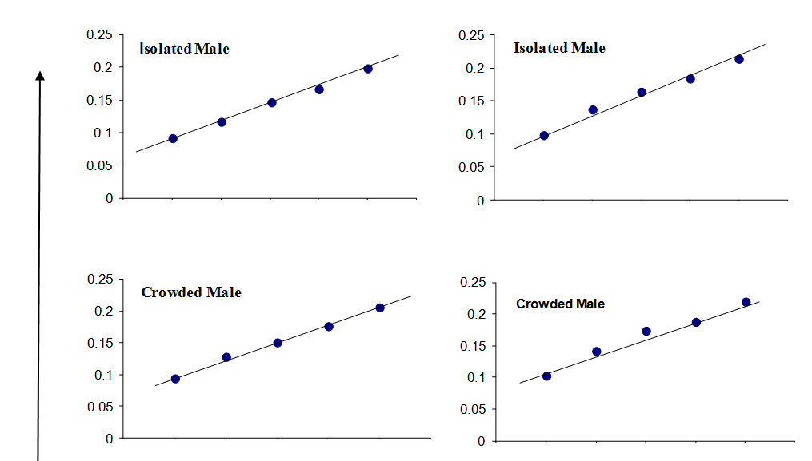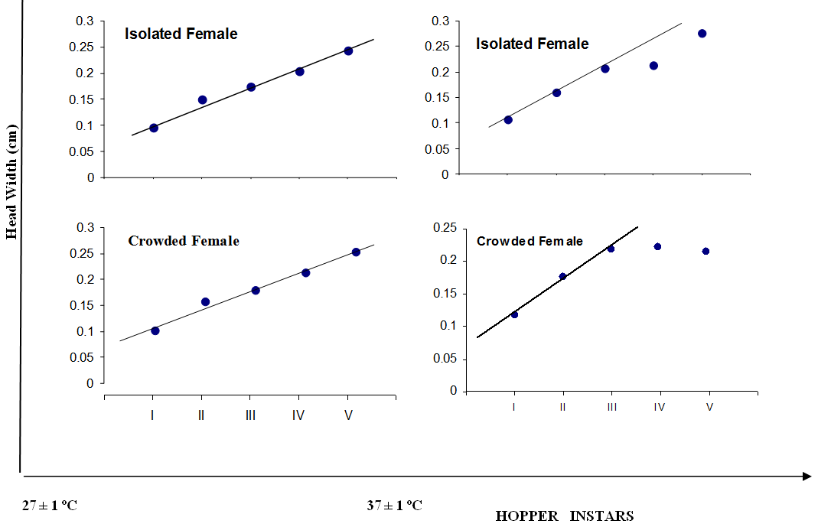

**Fig. 01. Application of Dyar’s law to *Acrida exaltata* under isolated and crowded conditions at 27 ± 1ºC & 37 ± 1ºC fed on *Zea mays*.**

**Acknowledgements**

The author is grateful to Prof. M. Hayat, Chairman, Department of Zoology, Aligarh Muslim University, Aligarh for providing research facilities and to Dr. Irfan Ahmad, Scientist-F, AFRI, Jodhpur, Rajasthan for providing the research material.

**Corresponding Author**

Dr. S. Tariq Ahmad

Entomology Research Division

P.G. Department of Zoology

University of Kashmir, Srinagar,

J & K – 190006, India

E-Mail: [drtariqento@kashmiruniversity.ac.in](mailto:drtariqento@kashmiruniversity.ac.in)

[drtariqiari@gmail.com](mailto:drtariqiari@gmail.com)

**References**

1. Ali, S. Effect of temperature and humidity on the development and fertility, fecundity of *Acrida* *exaltata* Walker *Proc. Indian. Acad. Sci.* (Anim. Sci.) 1982: 19 (3): 267 – 273.
2. Ahmad, Tariq *et al*. Ecological studies on *Choreodocus illustris* Walker (Orthoptera: Acrididae) with special reference to suspected gregariousness in hoppers. *Pant. J. Res.* 2007: 5(1): 21– 23.
3. Ahmad T. Effect of temperatures on duration, survival and development of *Choroedocus illustris* Walker (Orthoptera: Acrididae). *Insect Environment* 2008: 14: 66–67.
4. Ackonor, J.B. Effects of soil moisture and temperatures on hatchling weight and survival in *Locusta migratoria migratorioides* (Reiche and Fairmarie). *Insect Sci. appl.,* 1988: 9(5): 625 – 628.
5. Ahmad T & Nabi, S. On food preferences and application of Dyar’s rule to different hopper instars of *Choroedocus illustris* Walker (Orthoptera: Acrididae). *Italian Journal of Zoology,* Italy.2012: i*First*: 1-9.
6. Ahmad T. On food preferences and application of Dyar’s rule to different hopper instars of *Acrida exaltata* Walker (Orthoptera: Acrididae). *Zoology Ecology* 2012: 22(2): 114-124.
7. Ahmad T & Nabi S. Preferential role of food plants on the development of *Acrida exaltata* walker *Indian Journal of Entomology* 2009: 71: 299–301.
8. Ahmad T & Nabi S. A preliminary observation on behavior in the hoppers of *Choroedocus illustris* Walker (Orthoptera: Acrididae). *Pantnagar Journal of Research* 2009: 8: 133–134.
9. Ahmad, T.S. & Nabi., S. Effect of different temperatures on the incubation period and hatching of eggs of bamboo locust, C*horoedocus illustris* Walker (Orthoptera: Acrididae). *N Y Sci J* 2015: 8(2): 70-73.
10. Basit, A. Ecological studies on some occasionally gregarious acridoids of north India. Ph.D. thesis, A.M.U. Aligarh.1990: pp 500.
11. Dwivedi, K.P.; Chattoraj, A.M. and Rao, K.V.S. Soil – plant *Acrida* *exaltata* nitrogen relationship in tropical grassland. *Comp. Physiol. Ecol.,* 1987: 12 (4): 206 – 212.
12. Dyar, H.G. The number of moults of Lepidopterous larvae. *Psyche*, 1890: 5: 420 – 422.
13. Garlinge, J.; Calver, M.C. and Bradley, J.S. Sex–related morphs frequencies in *Acrida* *conica* (F.) (Orthoptera: Acrididae). *J. Aust. Ent. Soc.* 1991: 30 (1): 61 – 62.
14. Golemansky, V. G.; Lipa, J.; Pilarska, D. K. and Todorov, M.T. Unicellular parasites (Protozoa: Eugregarinida, Microsporida & Trychostomatida) of the orthopterous insects (Insecta: Orthoptera) in Bulgaria. *Acta Zoologica Bulgarica,* 1998: 50 (1): 123 – 135.
15. Lo, P.K.C. Two new species of Podapolipidae (Acari), ectoparasites of grasshoppers (Orthoptera: Acrididae) in Taiwan. *Bull. Inst. Zool., Academia Sinica.,* 1992: 31 (1): 65–72.
16. Majeed, Q. and Aziz, S.A. Application of Dyar’s Law to different hopper instars of *Gastrimargus* *transversus* Thunb. *Indian J. Ent.* 1979: 41 (3): 240 – 243.
17. Patel, T.L. and Dwivedi, K.P. Population dynamics of three grasshoppers populations in a social ecoregion. *Flora and Fauna.* 1997: 3 (1): 19 – 24.
18. Zhong YuLin,; Liu Chang Hai and Zheng Zhemin. Transplantation of two mermithid nematodes to control insect pests in corn fields. *Chinese J. Biological Control.* 2001: 17 (2): 57 – 59.

2/20/2015