Purification and Kinetic Study on Cellulase Produced by Local Trichoderma viride

Abdul Sattar Jabbar Taha¹, Alaa Jabbar Taha², Zeena G. Faisal¹

^{1.} Department of Biology, College of Educatio, Al-Iraqia University, 10001, Iraq.
^{2.} Department of Biology, College of Science, Al-Mustansirya University, 10001, Iraq.
E-mail: sattaraldelemi@yahoo.com

Abstract: Aphysical-chemical study was made on crud cellulase enzymes from local Trichoderma viride. Many Kinetic parameters were estimated. Using carboxymethyl cellulose as substrate, the enzyme showed maximum activity (Vmax) 75g/lmin⁻¹mg⁻¹with its corresponding Km value of2.5x10⁻⁵g/l. The purified enzyme displayed 6 and 50°C as an optimum pH and temperature respectively.
[Abdul Sattar Jabbar Taha, Alaa Jabbar Taha, Zeena G. Faisal. Purification and Kinetic Study on Cellulase Produced by Local Trichoderma viride. Nat Sci 2015;13(1):87-90]. (ISSN: 1545-0740). http://www.sciencepub.net/nature. 13

Keywords: Enzyme; Kinetics; Purification; Cellulase.

1. Introduction
Cellulase is a generic name for the group of enzymes which catalyze the hydrolysis of cellulose and related cellu-oligosaccharide derivatives. Cellulose consists mainly of long polymers of β 1-4, linked glucose units and forms a crystalline structure (Shallom, D. and Shoham, Y.2003). The cellulase complex is comprised of three major components: Carboxymethyl cellualase (CMCases) or Endo-ß-glucanase (EC 3.2.1.4), Exo-ß-glucanase (EC 3.2.1.91) and β-glucosidase (EC 3.2.1.21) (Kaur, J., et al. 2007, Thongekkaew, J., et al.2008). Cellulases from various sources have distinctive features as they exhibit specific pH optima, solubility depending on the amino acid composition. Thermal stability and exact substrate specificity may also vary with the origin (Bhat, M.K. 2000, Parry, N.J., et al. 2001). In recent years, the enzyme, cellulase finds wide application to a variety of fields such as textile, paper and pulp, food and animal feed, fuel and chemical industry. Additionally, they can be used in waste management, pharmaceutical industry, protoplast production, genetic engineering and pollution treatment (Bhat MK2000). Many filamentous fungi produce cellulases to perform cellulolysis necessary for growth and product formation under appropriate conditions. Commercial cellulase pre- parations from most often used species Trichoderma ressei and Trichoderma viride are popular as it contains high activities of both exo-glucanase and endo-glucanase but low levels of β-glucosidase (Cherry, J.R. and Fidantsef, A.L.2003).
Cellulase enzymes from various microorganisms, mainly fungi, act on cellulosic materials and biodegrade them. Cellulase is a synergistic enzyme that is used to break up cellulose into glucose or other oligosaccharide compounds (Chellapandi, P. and Jani, H.M. Bra. 2008).

Incorporation of suitable toxic substances in the cellulosic materials may prevent them from microbial attack. The mechanism of fungicidal action on cellulolytic micro-organism was studied to facilitate the problem of selecting suitable fungicides for the protection of stores, such as, textiles, timber, leather etc. against microbial attack. For this purpose a highly cellulolytic fungus Aspergillus niger was selected and kinetic studies were made.
The present work deals with the physical-chemical studies on cellulase enzyme elaborated by the fungi.

2. Material and Method
Cellulase Purification using Ion exchange chromatography: cellulase extracted from Trichoderma viride was purified by ion Exchange chromatography using DEAE-Cellulose an anionic exchanger. This matrix was used for purification because it has high capacity for bioseparation, easy to prepare, multiple use, in addition to simplicity to separate different biomolecules (Karlsson, E.; Ryden, L. and Brewer, J. 1998). According to these findings, anionic exchanger DEAE-Cellulose was used for purification of cellulase enzyme of 3 ml of partially purified concentrated with sucrose was applied onto the surface of column gel matrix (DEAE-Cellulose). then column was washed and equilibrated with equal volume of 0.05 M potassium phosphate buffer solution (pH 8.0) to wash unbound proteins (uncharged and positively charged proteins) in cellulase crude extract. The bound proteins (negatively charged) were then eluted using linear gradient concentrations of sodium chloride ranged between 0.1-0.5M.
Gel filtration chromatography: Gel filtration chromatography technique was the next step used in the purification of cellulase produced by T.viride after purification by ion exchange chromatography technique. A volume of 5 ml of partially purified cellulase was applied on Sepharose 4-B column (1.6×43 cm) which previously equilibrated with 0.1 M potassium phosphate buffer (pH 8.0). Sepharose 4-B column has a separation limits ranging between (5000-600000 Dalton) which allows ability of separation with high degree of purification (Sivasankar, A. 2005)..Furthermore, gel filtration is the simplest and mildest of all the chromatography techniques and separates molecules on the basis of differences in molecular size [11]. Cellulase were eluted through the column matrix in a flow rate of 20 ml/hour. Protein peaks were detected by measuring the optical density at 280 nm using UV-VIS spectropmetehotor.
Determination of Enzyme Activity: Enzyme activity was determined using spectrophotometer by the method of Mandels et al, [11]. The reaction mixture contained 0.9mL of carboxymethyl cellulose as substrate in 0.05 M Na–citrate buffer of pH 4.8 and finally 0.1 mL of pure enzyme and incubated at 45°C for 1 h. An appropriate control which contained 1 mL of distal water instead of pure enzyme was also run along with the test. At the end of the incubation period. The tubes were incubated for 5 min in a boiling water bath for color development and were cooled rapidly. The activity of reaction mixture was measured against a reagent blank at 540 nm. The concentration of glucose released by enzyme was determined by comparing against a standard curve constructed similarly with known concentrations of glucose. The unit of enzymatic activity defined as the amount of enzyme required to liberate Micro Mol of reducing sugars per hour under the conditions of the reaction.
Kinetic parameters:The kinetic parameters (Vmax and Km) were calculated by plotting the initial enzyme reaction velocities (V) against the substrate concentration (S) according to the linear Hanes-Woolf and Lineweaver-Burk transformations of the Michaelis-Menten equation.

3. Result and Discussion
Results in figure (1) showed that no protein peak appeared in the washing step, while there are four protein peaks were appeared after elution with gradient concentrations of sodium chloride. All these protein peaks in washing step were detected by measuring the absorbance at 280 nm for each eluted fraction. The four eluted proteins were assayed to detect cellulase activity. Results in table (1) showed that the third peak that eluted in fraction numbers 80 to 84 has cellulose activity that reaches 558.0 U/ml. Fractions represents protease were collected and pooled, then protein concentration, protease activity, specific activity were estimated. Results in table (1) showed that the maximum cellulose activity and specific activity in the protease concentrate were 554.8 U/ml and 154.1 U/mg respectively, with 13.7% yield 2.03 fold. Results in figure (2) showed that only one peak represents cellulose activity was appeared after elution with potassium phosphate buffer. Fractions representing protease activity were pooled, then protein concentration, protease activity and specific activity were measured in 20 ml of enzyme concentrate. Results in table (1) showed that there is an increase in both activity of purified enzyme (732.4 U/ml) and specific activity (228.8 U/mg) with a purification fold 3.02 with an increase in the yield of cellulose (24.2%).

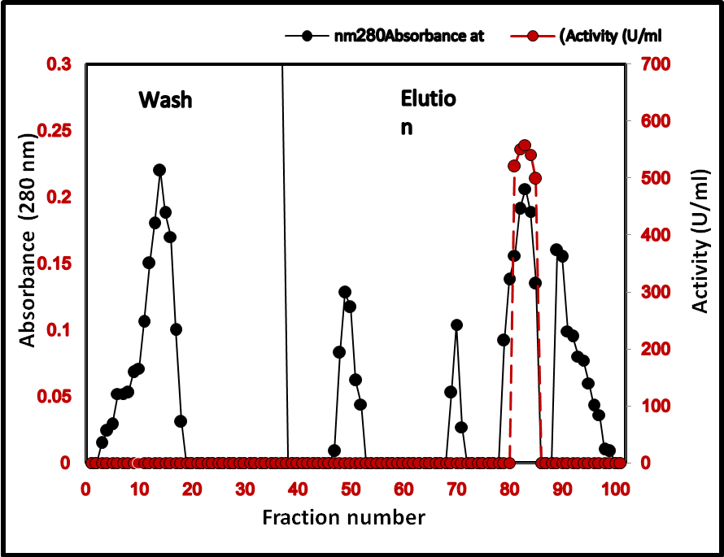
Fig 1. Ion exchange chromatography for purification of cellulose produced from trichoderma viridi using DEAE-Cellulose column (2×23 cm) with a flow rate of 20 ml/hour.

Effect of Temperature on Cellulase Activity: The experiment was conducted to determine the effect of different incubation temperatures (20 - 80°C) on the purified enzyme. The purified cellulase was incubated under different temperature controlled conditions. After 15 minutes of incubation cellulase was assayed to determine the effect of temperature on enzyme activity with the same procedure as mentioned previously. Temperature optimum for purified cellulase was observed at 50°C. Results of figure (3) showed that at temperatures higher than 50°C enzyme starts to losses its activity rapidly as the denaturation of the enzymes' protein occurs at elevated temperatures (Mandels, M. and Andreotii, R. C.1976).

Table 1. Purification steps of cellulose extracted from T.viride
Yield (%) | Purification fold | Total activity (U) | Specific activity (U\mg) | Protein conc. (mg\ml) | Activity (U\ml) | Volume (ml) | Step
100 | 1 | 60500 | 75.6 | 8.0 | 605.0 | 100 | Crude enzyme
13.7 | 2.03 | 8322 | 154.1 | 3.6 | 554.8 | 15 | Ion exchange DEAE-Cellulose
24.2 | 3.02 | 14648 | 228.8 | 3.2 | 732.4 | 20 | Gel filtration Sepharose 4-B

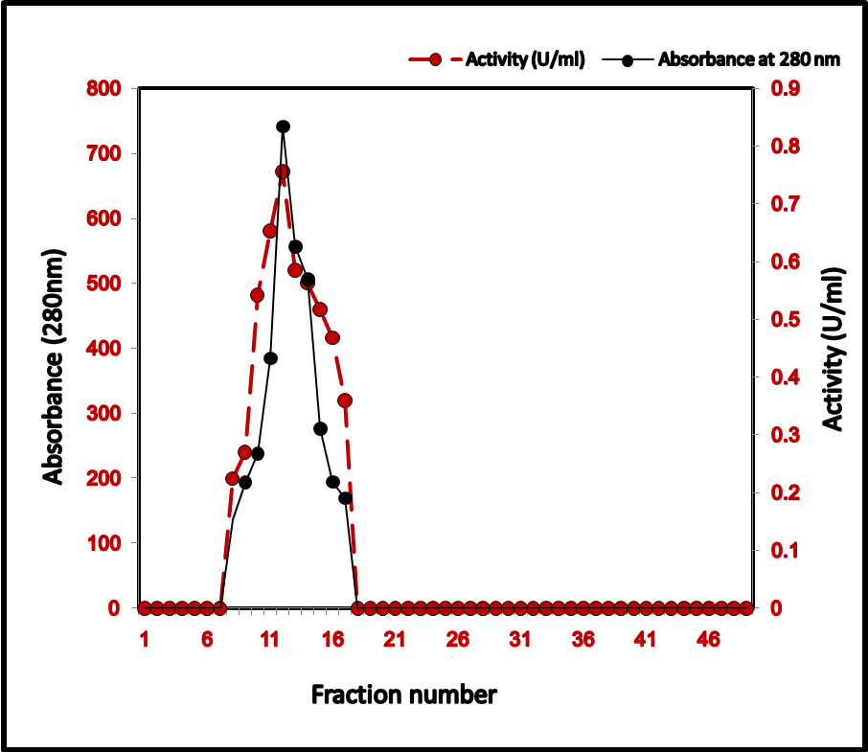
Fig. 2. Gel filtration chromatography for purification of cellulose extracted from T.viride using Sepharose 4-B column (1.6×43 cm) equilibrated with potassium phosphate buffer pH8.0, fraction volume was 5ml at flow rate of 20ml/hour

Effect of pH on Cellulase Activity: To investigate the effect of different pH values ranging from 3 - 9 on the purified enzyme, an experiment was conducted with following buffer (0.2M) sodium phosphate. Normal enzyme assay as described earlier was performed after 15 minutes of incubation using carboxymethyl cellulose as substrate on spectrophotometer at the wavelength of 540 nm. Results of enzyme assay showed that the cellulase enzymes was completely active in a large pH range (4 - 9) and presented an optimum activity at a pH value of 6 figure (4) Where as any further increase in pH from optimum value (pH, 6) cellulase showed decreasing trends in its activity. The reason for this declining attributable efficiency at basal pH values returns to influence the groups of amino acids in active center or enzyme molecule on the ionic state of substrate. (Englard, E. M., and Sifters. 1990).
Effect of Substrate Concentration: Determination of Km and Vmax: The Michaelis-Menten kinetic constants Km and Vmax for purified cellulase were determined by using varying concentration of carboxymethyl cellulose.Enzyme activities were measured under standard assay conditions as described earlier and Enzyme activity (U/mL) against concentration of substrate (M) was plotted, which yielded a hyperbolic curve, as shown in figure (5). From the catalytic properties, Km and Vmax values of purified cellulase from Trichoderma viride were 2.5x10⁻⁵g/l and 75g/l min⁻¹mg⁻¹ respectively. In literature, different ranges of Km and Vmax for different fungal species have been reported. The difference in Km value of presently purified cellulase from Trichoderma viride and other reported fungal species maybe due to genetic variability among different species (Hafiz Muhammad, et al. 2011).
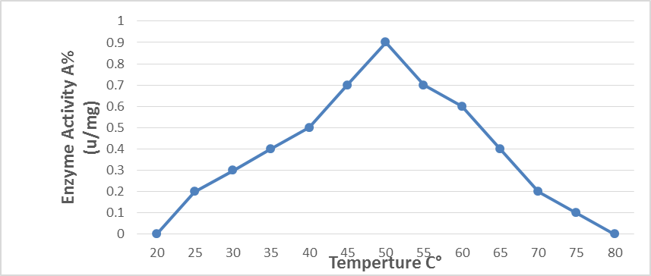
Fig 3. Effect of different temperatures on Cellulase activity from T.Viride.

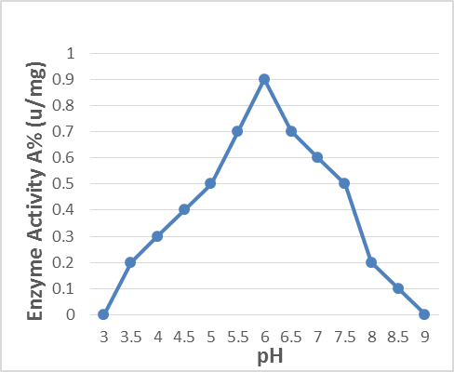
Fig 4. Effect of variant pH values on Cellulase activity from T.Viride

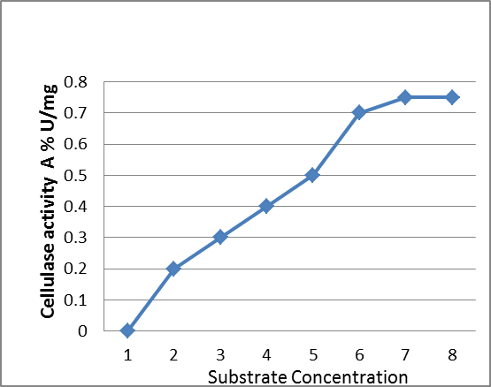
Fig 5. The dependence of the catalytic activity of Trichoderma viride on the substrate concentration.

4. Conclusion
The enzyme cellulase has an optimum activity at pH 6 and 50°C. Enzyme showed maximum activity (Vmax) of 75g/ l min⁻¹mg⁻¹ with its corresponding KM value of2.5x10⁻⁵g/l. The enzyme was active in an alkaline environment and was more thermo labile, making him useful in the initial stages of enzymatic degradation of complex polysaccharides. These results confirm a previous hypothesis that differences in the kinetic and thermodynamic parameters of enzyme could be due to the presence of different isoenzymes.

Corresponding Author:
Dr. Abdul Sattar Jabbar Taha
Department of Biology.
College of Education
Al-Iraqia University, 10001, Iraq.
E-mail: sattaraldelemi@yahoo.com

Reference
- Shallom, D. and Shoham, Y. (2003) Microbial hemicellulases. Current Opinion in Microbiology, 6, 219-228. doi:10.1016/S1369-274(03)00056-0.
- Kaur, J., et al. (2007) Purification and characterization of two endoglucanases from Melanocarpus sp. MTCC 3922. Bioresource Technology, 98, 74-81. doi:10.1016/j.biortech.2005.11.019.
- Thongekkaew, J., et al. (2008) An acidic and thermosta-ble carboxymethyl cellulase from the yeast Cryptococcus sp. S-2: Purification, characterization and improvement of its recombinant enzyme production by high cell-den- sity fermentation of Pichia pastoris. Protein Expression and Purification, 60, 140-146. doi:10.1016/j.pep.2008.03.021.
- Bhat, M.K. (2000) Cellulases and related enzymes in biotechnology. Biotechnology Advances, 18, 355-383. doi:10.1016/S0734-750(00)0004-0.
- Parry, N.J., et al. (2001) Biochemical characterization and mechanism of action of a thermostable ß-glucosidase purified from Thermoascus aurantiacus. Biochemical Jour-nal, 353, 117-127.
- Bhat MK. Biotechnol Adv. 2000, 18:355-383.
- Cherry, J.R. and Fidantsef, A.L. (2003) Directed evolu-tion of industrial enzymes: An update. Current Opinion in Biotechnology, 14, 438-443. doi:10.1016/S0958-1669(03)00099-5.
- Chellapandi, P. and Jani, H.M. Bra. J. Microbiol., 39; 122-127, 2008.
- Karlsson, E.; Ryden, L. and Brewer, J. (1998). Protein Purification, High resolution Methods and Applications, In Janson, J. C. and Ryden, L. (eds.) 2nd, Vol: 59, Wiley-VCH, Inc. Welnbeim, Germany, Pp:145-205.
- Sivasankar, A. (2005). Bioseparation: Principle and Techniques. Prentice-Hall of India, New delhi, ISBN- 81-203-2649.
- Mandels, M. and Andreotii, R. C.(1976). Measurment of saccharifying Cellulase. Biotechnol. Bioeng. Symp. 6:21-23.
- Englard, E. M., and Sifters.(1990). Precipitation in: Methods in enzymology (ed.Murray, E.D. and Dentscher, P.). 182:425-441.
- Hafiz Muhammad, et al.(2011) Purification and characterization of the kinetic parameters of cellulase produced from wheat straw by Trichoderma viride under SSF and its detergent compatibility. Advances in Bioscience and Biotechnology. 2, 149-156.

1/13/2015

