**Fibrous and Firm Pituitary Macroadenomas;Surgical Considerations**

Mustafa H. Alwalily

Department of Neurosurgery, Faculty of Medicine Al-Azhar University, Cairo, Egypt

[mhwalily@yahoo.com](mailto:mhwalily@yahoo.com)

**Abstract: Background:** Pituitary tumors are usually soft creamy and succable. Fibrous adenomas are tough and firm and more difficult to remove. Their incidence among pituitary tumors is 5% -13.5%. Fibrous adenomas contain more abundant collagen and reticulin. MRI can predict firm and fibrous adenomas in that, the tumor is isointense in T2-WI and homogeneously enhancing in T1WI. The problem of such a tumor is how to excise it safely with preservation of neurovascular structures and normal pituitary function. **Material and methods:** Among 45 cases of pituitary adenoma operated upon over 3 years (2011-2013), 10cases found firm and fibrous. Six cases had been operated upon by microscopic transsphenoidal approach and 4 cases operated by endoscopic transsphenoidal approach. Five cases in whom we failed to achieve proper resection and decompression; they had been reoperated in a second surgical setting either by microscopic transsphenoidal or transcranial pterional approach. A third surgical transcranial setting done for one patient aiming at achieving proper decompression and preserving visual function. **Results:** Partial tumor resection achieved in 7 patients and subtotal resection achieved in 3 patients. Complications included major vascular injury in one patient, temporary diabetes insipidus in two patients, and CSF rhinorrhea in one patient that ceased with lumbar drainage without patching. **Conclusions:** Preoperative prediction of firm and fibrous pituitary adenoma is of great value for the surgeon to plan the surgical strategy. MRI is the modality of choice in that way. The endoscopic transsphenoidal approach is safe, minimally invasive, and efficient surgical technique for partial tumor resection. Extended endonasal endoscopic approach offers a potentially viable treatment option. Microscopic transsphenoidal surgery is properly effective but may require multi-staged operation. Long sized and small calibered ultrasonic aspirator applicable to the transsphenoidal approach must be used to optimize the surgical technique. Transcranial approach should be reserved for eccentric tumors and for cases that failed to be properly managed by the transsphenoidal route.

[Mustafa H. Alwalily. **Fibrous and Firm Pituitary Macroadenomas; Surgical Considerations.** *Nat Sci* 2015;13(1):69-80]. (ISSN: 1545-0740). <http://www.sciencepub.net/nature>. 11

**Key words:** Firm fibrous pituitary macroadenoma, giant pituitary adenoma, endoscopic transsphenoidal, microscopic transsphenoidal approach, transcranial pituitary, cabergoline.

**1.Introduction:**

Pituitary tumors are common lesions believed to account for 10% - 15% of all primary brain tumors. By several epidemiologic, incidence, and prevalence measures; pituitary tumors are the third most common primary intracranial tumor, preceded in frequency only by glioma and meningioma.(1) Pituitary adenomas are usually soft creamy and succable and easy to remove surgically by aspiration and curettage.

Fibrous adenomas are more difficult to remove, and occur with an incidence of 5% - 13.5%. (2,3,4,5,6,7,8,9,10,11,12,13,14) The transsphenoidal approach is a less invasive and safer procedure for removing pituitary adenomas. However, this procedure becomes extremely difficult when the tumor consistency is fibrous.

Fibrous pituitary adenomas are usually difficult to remove in a one-stage operation especially in large adenomas.(6,11,15)These cases require two – stage operations.(11,15)

Fibrous or dumbbell – shaped adenomas are especially difficult to remove using only induced pressure.(11,16)

The major problem is how to remove fibrous pituitary adenomas with preservation of normal pituitary function.

Fibrous adenomas contain more abundant collagen than soft adenomas, however, the collagen content in fibrous adenomas is not well understood and the mechanism of collagen accumulation in pituitary adenomas is not known.(17)

Prolonged treatment of prolactin-secreting microadenomas with dopaminergic agonists over a period of 6 months or more many cause fibrosis of the tumor and adhesions to the pituitary capsule and the lateral walls of the sella turcica.(18)

This loss of the plane between normal gland and tumor increases the risk of leaving neoplastic tissue behind. In such cases the pseudo capsule should be peeled away from the margin of normal gland beneath it.(1)

There is no clear definition of fibrous pituitary adenomas.

Several reports showed that fibrous adenomas are firm and difficult to remove by aspiration or curettage.(4,5,6,8,14)

CT cannot differentiate fibrous tumors from soft tumors.(12)

MRI can predict fibrous pituitary adenomas in that T2 – weighted images show firm and fibrous pituitary adenomas as isointense with the surrounding brain;(7,8,11,12,15,19) and the degree of signal intensity on T2- weighted images is significantly correlated with the percentage of collagen content.(8) However some soft adenomas are also isointense with the brain so the possibility that the tumor is fibrous is about 70%.(19,20).

Adenomas showing lower signal intensities on T2 – weighted images contain more collagen; softer tumors are hyperintense. On enhanced images, homogeneously enhanced adenomas tend to include more collagen, even though the grade of enhancement effect shows only weak correlation with the tumor hardness. However, MRI gives us useful information on tumor consistency in view of adenomas maybe firm and fibrous if they show low signal intensities on T2- weighted images and homogeneous enhancement.(8)

By utilizing the MRI to give a presurgical indications of firm and fibrous pituitary adenomas; if the tumors appear isointense on T2-weighted images, the surgeon should be prepared to deal with a fibrous tumor in planning the surgical strategy;(17) and it is wise to warn patients whose MRI images has this characteristic that a second transcranial operation maybe required.

Transsphenoidal hypophysectomy of solid enhancing tumors with restricted diffusion in MRI is more likely to fail, possibly because of the greater reticulin content of the tumor; initial transcranial surgery may be appropriate in these cases.(21)

Grossly pituitary tumors are yellow – gray to purple; they often have a soft fluid to creamy texture, in contrast to the firmness of the normal gland. The histological growth pattern of pituitary adenomas varies, ranging from diffuse to sinusoidal to papillary. Beyond their descriptive merit, such designations are without prognostic significance. The most important histologic characteristics of pituitary adenomas are cellular monomorphism and a lack of acinar organization. In contrast, the normal pituitary exhibits an intimate admixture of different cell types arranged in a well-organized acinar pattern. Disruption of this acinar structure in adenomas is particularly well seen with silver stains for reticulin fibers. When studied in this manner, the presence of the interface between adenoma and nontumorous pituitary gland can be especially eye-catching, because the compressed rim of the latter forms a pseudocapsule around the former. This pseudocapsule of compressed normal gland, although thin, is often robust and in many cases fully contains the tumor.(22)

A challenge facing both the surgeon and the pathologist in cases with previously treated adenomas that may present excessive fibrous deposition.

Adenoma cells containing fibrous bodies show peripheral displacement of the nuclei, often with crescent formation and may harbor multinucleated or pleomorphic nuclei. The cytoplasm contains sparse and small secretory granules (100-250nm), showing variable immunoreactivity. The fibrous bodies consist of concentric aggregates of keratin-intermediate filaments that are strongly reactive for low molecular weight cytokeratins, particularly for keratin 8.(23)

The overwhelming majority of all pituitary adenomas can be accessed through a transsphenoidal approach. The remainder require transcranial approaches consisting of standard pterional or subfrontal craniotomy or various skull base approaches. The choice of surgical approach depends on several factors. the most important of these include the size of the sella and its degree of mineralization, the size and mineralization of the sphenoid sinus, the position and tortuosity of the carotid arteries, the presence and direction of any intracranial tumor extensions, the presence of any uncertainty about the pathology of the lesion, and whether prior therapy (surgical, pharmacologic, or radiotherapeutic) has been administered. if there is a reason to believe that the consistency of a tumor with suprasellar extension is sufficiently fibrous to prevent its collapse and descent into the sella when resected from below, in such a condition, the transsphenoidal approach is not preferred. Transsphenoidal surgery is among the safest procedures in neurosurgical practice.

In the stage of tumor removal via the transsphenoidal approach whether microscopic or endoscopic for the typical soft creamy macro-adenoma, the tumor is entered with a ring curet, tissue is loosened and then removed with a relatively blunt curet or forceps. The surgeon should attempt tumor removal in an orderly fashion. the common and safe practice is to first remove tumor in the inferior aspect and then proceed laterally from inferior to superior aspects on both sides, removing tumor along the medial side of the cavernous sinus. The surgeon must resist coring out the central and most accessible portion of the tumor first, because this may cause premature descent of the diaphragma and entrapment of more laterally situated tumor. Any maneuver more forceful than gentle curetting may be dangerous; pulling of adherent fragments must be avoided. Decompression of the intrasellar portion of the tumor frequently permits a suprasellar extension to prolapsed into view within the sella. After this has been resected, the diaphragma prolapses and generally signifies that the resection is complete. In all cases, a concerted effort is made to preserve normal pituitary tissue. In a large diffuse adenoma, normal glandular tissue usually appears as a thin membrane situated superolaterally against the sellar wall.

The orange – yellow gland, together with its firm consistency, distinguishes it from the grayish color and finely granular texture typical of the tumor.(24)

In the case of fibrous pituitary adenoma, the tumor is firm, tough, non succable, and cannot be manipulated in such a way like the soft ones. Trials of removing the tumor piece meal by using sharp fine dissectors and blunt forceps with sharp curetto be entered within the core of the tumor without exerting any traction or exceeding the tumor limits can help achieving central debulking and partial tumor resection.

To remove such tumors, a long sized and small calibered ultrasonic aspirators applicable to transsphenoidal approach must be prepared and multistage operations maybe more than likely needed.(8)

A micropressure- suction irrigation system is a surgical device that cleans the operative field of blood and tumor tissues with one hand manipulation, dissects tumor tissue with its rapid flow and removes debris by suction without injury to the normal tissue structures.

Ultrasonic surgical aspirators with needle type probes and an electromagnetic field system, all recently developed in Japan, are improving the results of direct transnasal surgery on pituitary adenomas. Thick mucosa and a firm tumor can be vaporized with an electromagnetic field system.(36)

The side – cutting tissue resector is safe, easy to use, and an effective tool for non-vascularized firm tumors.(25)

The pulsed laser – induced liquid jet system can achieve safe and optimal removal without vascular damage.(26)

Transcranial approach may be required; the major advantage of the craniotomy approach is that it affords the surgeon a complete view of the pituitary tumor's effect on intracranial structures. The optic nerves and chiasm, unusual intracranial extension into the anterior and middle cranial fossae and retrosellar clival extensions can be visualized and accessed. Similarly, when sufficiently large, some suprasellar extension involve third ventricular structures; craniotomy allows such extensions to be dealt with directly. The major limitation of the transcranial approach is that the intrasellar portion of the tumor can be more difficult to remove particularly when a prefixed chiasm also exists.(24)

**Aim of the work:**

The aim is to study how to elaborate the surgical procedure upon expectation, and when come across with cases of fibrous and firm pituitary adenomas, and to present the author's experience in surgical management of such cases.

**2.Material and methods:**

This is a retrospective study that had been conducted at Al-Azhar university Hospitals for the cases of firm and fibrous pituitary macroadenomas which had been met with in the period between 2011-2013.

During that period of time we had operated upon 45 cases of pituitary macroadenomas. Ten of these cases were firm and fibrous; which this study has included; they constituted 22% of all the cases.

Of the 10 cases of firm and fibrous pituitary macroadenoma, 6 were females and 4 males, ranging in age between 28-57 years with mean age 38.9 years.

All the cases presented to the OPD of Al-Azhar university Hospitals with a variety of clinical presentations including: amenorrhea galactorrhea syndrome, impotence, acromegaly, visual field defects, and headache of intracranial hypertension.

All the cases had undergone full clinical assessment by history taking and clinical examination. Being macroadenomas, visual perimetry done for all cases to check for the visual field defect.

Hormonal assay done for all the cases to verify the activity and the functional type of the tumor. MRI done for all cases and in some cases whenever the tumor is too large and incarcerating the major vessels, MR Angiography or CT Angiography had been done.

Surgery had been done for all cases using the transsphenoidal approach, 6 of the cases done by the microscopic transseptal transsphenoidal approach via gengivolabial incision, and 4 of the cases done by the endoscopic transnasal approach.

The fibrous nature and the firmness of the tumors was not expected before surgery except in 2 cases with long history of bromocriptine therapy and the hypointense appearance in T2-WI MRI.

So, the nature of the tumor in most of the cases have been discovered during surgery.

Among the 4 cases of endoscopic approach, 2 of them had been reoperated for a second surgery by microscopic transsphenoidal approach.

Among the 6 cases of microscopic transsphenoidal approach, 3 cases of them had been reoperated in a second setting by the transcranial pterional approach. The tumor nature being firm and fibrous and tough enough to be dissatisfactorily dealt with through the nose, beside the progressive visual failure caused by chiasmal compression by the suprasellar extension of the tumor, all have dictated another setting for transcranial approach. Depending upon our long experience in microscopic transsphenoidal approach we expected that the microscopic approach having direct three dimensional view maybe superior to the endoscopic approach in manipulating such a type of tumors, that is why we have reoperated upon 2 cases in a second setting by microscopic approach after endoscopic approach. The second surgery was 2-3 weeks after the first one. One of the cases had been operated upon 3 times; endoscopic, microscopic transsphenoidal, and pterional approaches aiming at achieving total resection.

In all conditions, piecemeal excision of the tumor had been tried using sharp and fine microdissectors, sharp scoop curets, and blunt tumor forceps with long handed bipolar coagulation.

Ultrasonic aspirator was used in the pterional approach and was not appropriate for transsphenoidal.

Histopathological examination done for all the biopsies taken.

For the remaining tumor, cabergoline (Dostinex) had been used orally in a dose of 0.25 mg twice a week for 6 months.

Seven cases for which partial tumor resection has been achieved whether transsphenoidal or pterional, for them, cabergoline (Dostinex) is given for 6 months upon recommendation of endocrinology department.

The program of follow- up was 1 month, 3 months, 6 months, and 1 year postoperative visits with MRI done 3 months and 6 months after surgery.

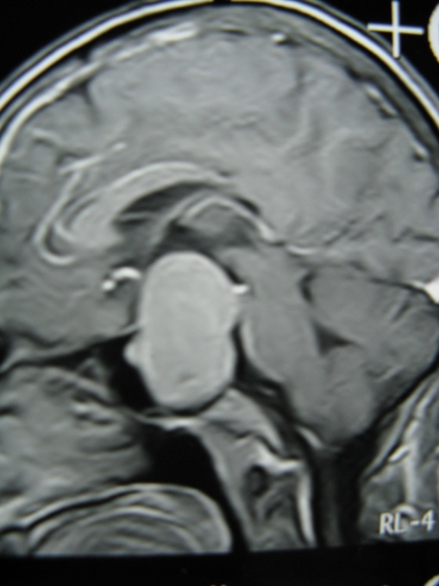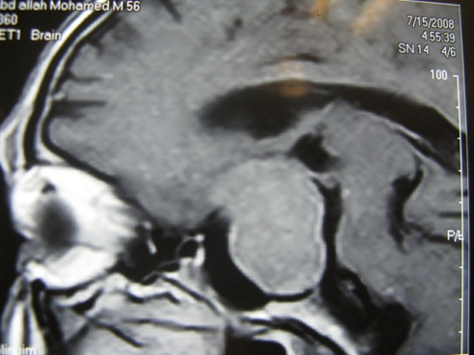

(1) (2)

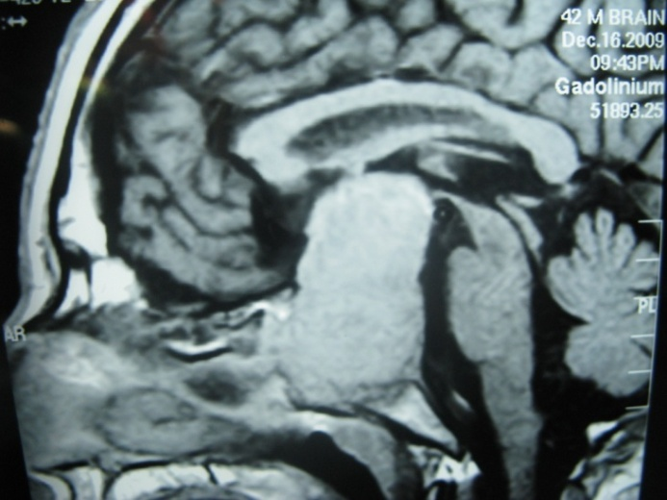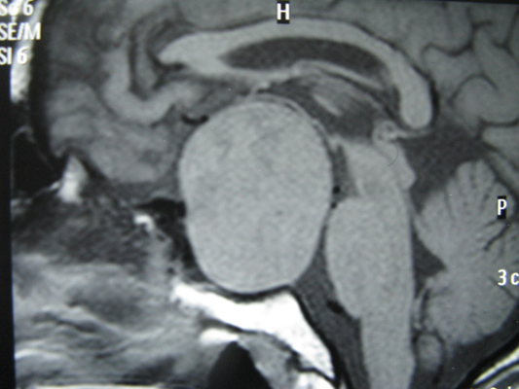

(3) (4)

Images (1), (2), (3), (4): Giant pituitary adenomas that were firm and fibrous; they are homogeneously enhancing after contrast administration and they extend up to the third ventricle.

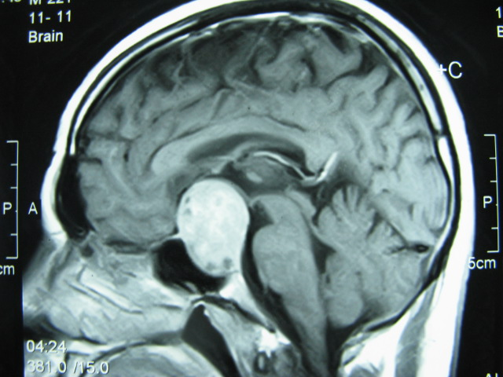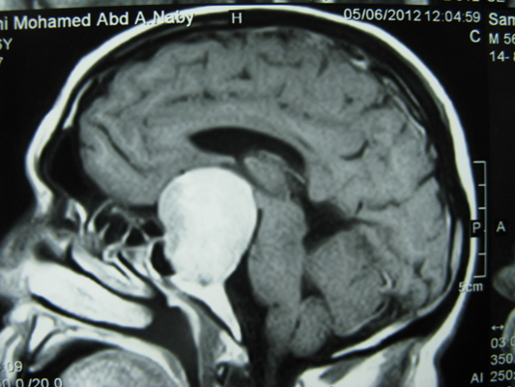

(5) (6)

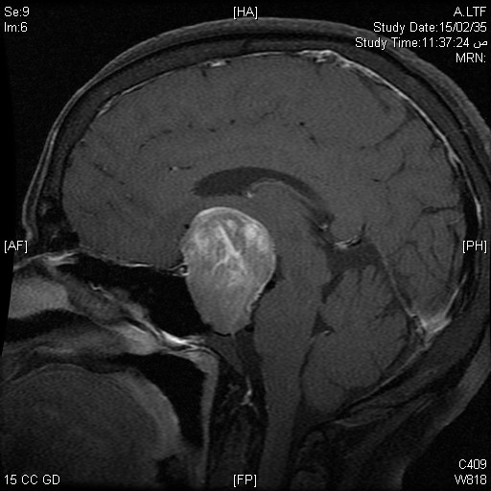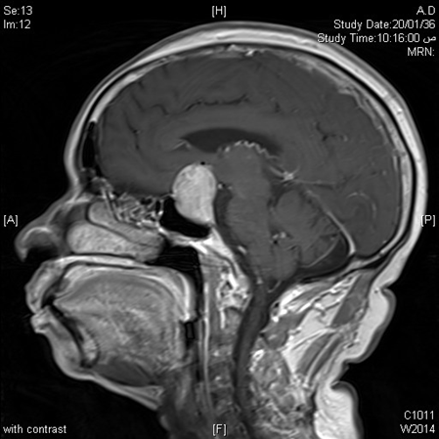

(7) (8)

Images (5), (6), (7), (8): Pituitary macroaenomas exceeding the limits of the sella and markedly enhancing indicating more collagen content and high vascularity.

Table (1) shows the age incidence of different pathologic lesions and the number of cases.

|  |  |  |  |
| --- | --- | --- | --- |
| Pathology | Number of cases | Percentage | Age in years |
| Prolactinoma | 6 | 60% | 28, 30, 36, 39, 40, 45 |
| GH secreting adenoma | 1 | 10% | 31 |
| Nonfunctioning adenoma | 3 | 30% | 35, 48, 57 |

Table (2) shows the gender incidence of different adenomas in the study.

|  |  |  |
| --- | --- | --- |
| Pathology | Number of cases | Male / Female |
| Prolactinoma | 6 | 1/5 |
| GH secreting adenoma | 1 | 1/- |
| Nonfunctioning adenoma | 3 | 2/1 |

Table (3) shows the number of patients receiving bromocriptine in relation to each pathology.

|  |  |  |  |
| --- | --- | --- | --- |
| Pathology | Number of cases | Bromocriptine therapy | Non- Bromocriptine therapy |
| Prolactinoma | 6 | 4 | 2 |
| GH secreting adenoma | 1 | - | 1 |
| Nonfunctioning adenoma | 3 | 1 | 2 |

Table (4) shows the frequency of the surgical approaches in different surgical settings.

|  |  |  |  |
| --- | --- | --- | --- |
| Surgical approach | 1st surgery | 2nd surgery | 3rd surgery |
| Endoscopic transsphenoidal app | 4 | - | - |
| Microscopic transsphenoidal app | 6 | 2 | - |
| Pterional app | - | 3 | 1 |

**3. Results:**

Over three years between 2011-2013 we had operated upon 45 cases of pituitary macro adenoma, and we have experienced the nature of such adenomas being soft, creamy, and succable and easy to excise totally using the classical pituitary instruments; scoops, curets, forceps and suction. Among these cases, 10 cases found to be firm and fibrous and sometimes vascular with marked difficulty in achieving appropriate tumor resection as it did not descend down even with Valsalva maneuver.

The firm and fibrous cases constituted 22% of all cases.

There was female preponderance in fibrous adenomas 6:4.

There was marked incidence in the fourth decade of life and in the child bearing period in females; rare case seen after menopause.

Patients which their history indicates the long term use of bromocriptine showed more incidence of fibrous adenoma; 50% of cases.

There was a spectrum of presenting symptoms including: amenorrhea galactorrhea syndrome, impotence, acromegaly, visual field defects, and headache of endocranial hypertension; none of which was indicative of the nature of the tumor.

Optic atrophy of various degrees was a common sign in all cases with visual field defects even in those with no symptoms of profound visual failure.

Prolactinoma with high serum prolactin levels constituted 60% of all the cases, 4 cases of which were on bromocriptine therapy for long time; 6 months or more and the other two cases were not on specific medications. The other histological types of adenoma included nonfunctioning adenoma 3 cases and GH secreting adenoma 1 case forming 40% of cases and only one patient with nonfunctioning adenoma was on bromocriptine.

The MRI was not conclusive about the nature of the adenoma and only two cases were expected to be fibrous and firm from the hypo- intense appearance in T2-WI beside the long history of bromocriptine therapy.

Based on the size of the tumor in MRI, all the cases were macroadenomas exceeding the limits of the sella and 4 of which were giant adenomas measuring 4 cm or more in the longest diameter.

Endoscopic endonasal approach was utilized in 4 cases; partial tumor resection up to 30% of the tumor had been achieved in two cases and for the otter two cases only a small biopsy had been taken because of the toughness, firmness, and the fibrous nature of the tumor beside being vascular with dense fibrous bands and vessels seen traversing through all the tumor tissues.

Based upon our long experience in microscopic transsphenoidal transseptal approach, we had primarily operated upon 6 cases as a first surgical setting and we achieved partial tumor resection in three cases and for the other 3 cases only small biopsies had been taken because of the nature of the tumor that made it not to be satisfactorily dealt with through the nose.

For the 2 cases that had been only biopsied endoscopically, a second surgical setting for microscopic transsphenoidal approach was planned for; being three-dimensional and having direct vision for more appropriate tumor tissue manipulation.

By that approach in this second surgical setting, we have attained partial resection of the tumor (only approximating 30%) in only one case using the sharp dissectors and sharp curets with the pituitary forceps and mirror and the bipolar coagulation; and for the other case just biopsy had been taken.

The 3 cases in which we failed to do appropriate tumor decompression by the microscopic transsphenoidal approach in the first setting, were planned for a second setting via the transcranial pterional approach.

The pterional approach was appropriate and with the use of microscopic dissectors, bipolar coagulation, and the ultrasonic aspirator we have achieved subtotal tumor resection in two cases and partial resection in one case because of the incarceration of both carotids and the optic nerves by the tumor extension.

One case in this study had been operated upon for a third surgical setting by the pterional approach after failure of both endoscopic and microscopic transsphenoidal approaches to achieve an appropriate tumor decompression; the result was subtotal tumor resection. The insistence to get a tumor decompression through various surgical approaches was justified by the progressive visual failure caused by marked chiasmal compression.

For the cases in which we did partial tumor resection via the transsphenoidal approach, only about 30% of the tumor had been removed.

Finally we have achieved subtotal resection in 3 cases 30%, partial resection in 7 cases 70%.

We have a catastrophe in the present study for one female patient aged 57 years which died on table during endoscopic transsphenoidal approach after partial tumor resection with the enthusiasm to get more tumor out with somewhat vigorous manipulation that had led to a major vascular injury with devastating bleeding that all measures failed to control. So, the mortality rate is 10%.

Histopathological examination of the taken biopsies revealed a prominent deposition of collagen in the perivascular areas, and the percentage of collagen content was more than 5% and significantly higher than that in soft adenomas.

For the 7 cases in whom partial tumor resection had been attained, cabergoline (Dostinex) was decided upon recommendation of the endocrinology department in a dose of 0.25 mg twice a week for 6 months. Follow-up MRI of such patients after 6 months showed satisfactory diminution and shrinkage of tumor sizes to the extent that no more surgery is indicted.

Regarding the complications, two patients had developed diabetes insipidus that had resolved spontaneously within 2-3 weeks without specific medications. One patient developed CSF rhinorrhea which necessitated lumbar drainage for 5 days and finally ceased and did not need patching. One patient in whom major vessel injury happened while endoscopically manipulating the tumor, hedied due to severe out of control bleeding.

No replacement therapy needed for any patient.

Other complications have not been seen in the patient group of study.

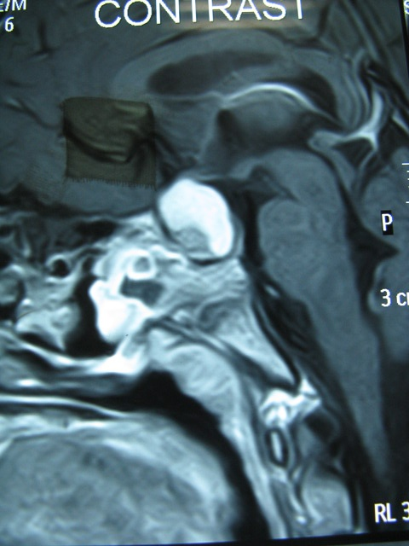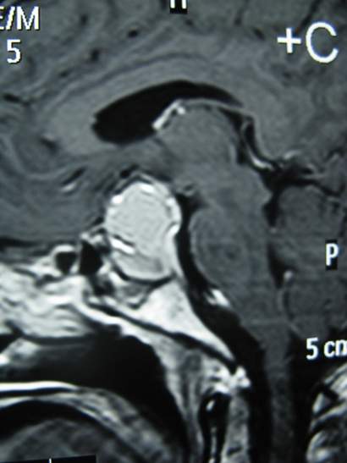

(9) (10)

Image (9), (10): Following transsphenoidal approach; a small part of the tumor excised from below.

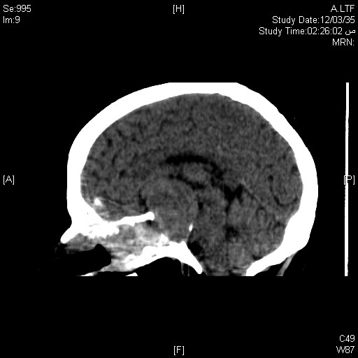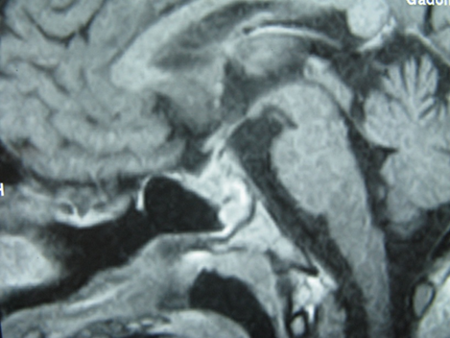

(11) (12)

Image (11): Postoperative CT in sagittal view; just biopsy had been taken from the tough tumor via transsphenoidal route.

Image (12): Postoperative MRI showing partial tumor resection after both transsphenoidal and transcranial approaches.

Table (5) shows the different presenting symptoms and the number of cases.

|  |  |
| --- | --- |
| Symptoms | Number of cases |
| Amenorrhea Galactorrhea | 5 |
| Impotence | 2 |
| Acromegaly | 1 |
| Visual field defect | 8 |
| Headache | 7 |

Table (6) shows the extent of achievement in tumor resection in relation to the surgical approaches in different surgical settings.

|  |  |  |  |  |  |
| --- | --- | --- | --- | --- | --- |
| First Surgical Setting | | | | | |
| Approach | Number of cases | Biopsy | Partial resection | Subtotal R. | Total R. |
| Endoscopic Transsphenoidal | 4 | 2 | 2 | - | - |
| Microscopic Transsphenoidal | 6 | 3 | 3 | - | - |
| Second Surgical Setting | | | | | |
| Microscopic Transsphenoidal | 2 | 1 | 1 | - | - |
| Pterional | 3 | - | 1 | 2 | - |
| Third Surgical Setting | | | | | |
| Pterional | 1 | - | - | 1 | - |

**4.Discussion:**

The present study retrospectively has revised 10 cases of firm and fibrous pituitary macroadenoma among 45 cases of classic pituitary macroadenoma that surgically managed over three years.

The incidence of fibrous and firm adenomas in the present study is 22% which to some extent is higher than what had been reported in literatures being 5-13.5%.(8)

This higher incidence can be explained by the pathologic nature of the adenomas included in this specimen as most of which were prolactinomas receiving bromocriptine that might cause fibrosis of the tumor.(18)

The patient group of study in this series showed higher incidence of fibrous and firm pituitary adenomas in females specially in the child bearing period with the main occurrence in the third and fourth decades of life. That's an observation has not been reported or confirmed by the researchers or literatures.

The clinical presentation of such a type of tumor does not differ from the classic adenoma and there is no clinical indication of the nature of the tumor. In spite of that, patients harboring prolactinoma (as indicated by high prolactin level) and on bromocriptine for long time should be considered as having firm and fibrous adenomas. This agrees with what had been reported by Esiri*et al.,(18)* in that the tumor become fibrotic and adherent to the surroundings.

The present study reported that no predilection of certain pathologic types of the tumor to be fibrous and firm whether functioning or nonfunctioning.

That's logically accepted by Naganuma*et al.,(17)*as the collagen content and the mechanism of its accumulation in pituitary adenomas is not known.

It is of great value for the neurosurgeon to predict a fibrous and firm adenoma to make the plan of surgical strategy and prepare himself and the surgical field for properly dealing with such a type of tumors. MRI is the modality of choice that can help in that way. In the present series only two cases were expected to have fibrous adenomas from their MRI appearance being hypointense in T2-WI. Iuchi*et al.,(8)* investigated radiologically both soft and firm adenomas and reported that adenomas with lower signal intensities on T2-WI contain more collagen, and homogeneously enhancing adenomas tend to include more collagen, even though the grade of enhancement effect shows only weak correlation with the tumor hardness. Suzuki *et al.,(27)* studies pituitary macroadenomas by apparent diffusion coefficient (ADC) with line-scan diffusion weighted imaging aiming at evaluating the consistency of pituitary macroadenomas, and finally he concluded that no relationship between tumor consistency and the (ACDs) of soft and intermediate macroadenomas. Bahuleyan *et al.,(28)* prospectively studied the ability of MRI to predict the consistency of pituitary adenomas on 80 patients the MRI of which evaluated preoperatively by the radiologist and the tumor consistency reported by the surgeon as soft of firm. Of the firm tumors 33% were homogeneously isointense, 8% homogeneously hyper intense, and 59% were heterogeneous in appearance in T2-WI.

So they concluded that the consistency of pituitary macroadenomas con not be accurately predicted based on MRI signal intensities.

In their study of 8 cases of fibrous adenomas, Hirofumi *et al.,(29)* reported that CT cannot differentiate fibrous tumors from soft ones, and T2-weighted MR imaging shows firm and fibrous pituitary adenomas as isointense with the surrounding brain, and signal intensities on T2-WI are significantly correlated with the percentage of collagen content. However, some soft adenomas are also isointense with the brain, so the possibility that the tumor is fibrous is about 70%. That's also confirmed by Snow *et al.,(19)*.Therefore, if the tumor appears isointense on the T2-WI, the surgeon should be prepared to deal with a fibrous tumor. Yamamoto *et al.,(30)* assessed the role of contrast enhanced FIESTA in predicting the tumor consistency of pituitary macroadenomas. They classified the adenomas as either solid or mosaic types. Solid type was characterized by a homogeneous pattern of tumor signal intensity without intratumoral hyperintense dots, whereas the mosaic type was characterized by many intratumoral hyper intense dots on each MR image. The sensitivity and specificity are higher for contrast enhanced FIESTA than for contrast enhanced T1-WI and T2-WI. Compared with mosaic types adenomas, solid type tends to have a hard tumor consistency as well as significantly higher collagen content.

Jerrold *et al.,(21)* studied the MRI imaging features predictive of successful transsphenoidal surgery and they realized that macrocystic and macrohemorrhagic adenomas and solid tumors with enhanced diffusivity are more likely to be successfully managed with transsphenoidal hypophysectomy. On the other hand transsphenoidal hypophysectomy of solid enhancing tumors with restricted diffusion is more likely to fail, possibly because of the greater reticulin content of the tumor; so initial transcranial surgery may be appropriate in these cases.

Russel and Patterson(31)pointed that almost all firm tumors that are difficult to remove transsphenoidally are isointense on the T2-WI of the MRI. It is therefore wise to warn the patients whose MRI image has this characteristic that a second transcranial operation may be required. They have found that 70% of the T2 isointense tumors are firm but 30% are soft enough to allow an adequate transsphenoidal removal. Prior radiation therapy is also a predictor of a firm tumor.

The present study included 3 different histopathological types of fibrous pituitary macroadenoma; prolactinoma, GH secreting adenoma, and nonfunctioning adenoma. This indicates that the fibrous and firm nature is not restricted to a certain functional type of the tumor.

The study of Hirofumi *et al.,(29)* on 8 cases of fibrous adenomas included 7 nonfunctioning tumors and 1 GH – secreting adenoma and like the present series, their study included 4 cases with giant adenomas. This means that fibrous adenomas can attain a large size and could be giant.

The endoscopic transsphenoidal approach had been utilized in the present series for 4 cases; we achieved partial resection in 2 cases and only biopsy have been taken from the other two cases.

Based upon the author's long experience in microscopic transsphenoidal approach beside being three- dimensional direct vision, we had applied that approach primarily for 6 cases among whom 3 achieved partial resection and the other 3 just biopsied. Also it is applied as a second setting for the two endoscopically managed cases with just biopsy aiming at achieving proper decompression and saving vision. The partial tumor resection did not exceed 30% of the tumor in all cases using the sharp and fine micro dissectors and sharp curets with the pituitary forceps and mirror beside bipolar coagulation. Unfortunately, the surgical set in our field is lacking the specific ultrasonic aspirator that could be used transsphenoidally. In such cases it is not allowed to apply any traction or to do vigorous manipulation to get the tumor out.

We have resorted to the transcranial approach after failure of both the endoscopic and microscopic transsphenoidal approaches to achieve a proper decompression. Transsphenoidal approaches attained partial tumor resection in 6 cases 60%.

Interestingly, Russel(31)went in the same way and did a prior transsphenoidal operation for 6 patients 33% of cases before deciding a transcranial surgery, and they found firm and fibrous adenomas difficult to be dealt with satisfactorily through the nose.

TAO YU-Xin*et al.,(32)* in their study of endoscopic transsphenoidal approach, realized that when the adenoma is firm and fibrous, it is difficult to remove and it is easy to injure parasellar dura and suprasellar arachnoid, and bleeding or CSF leakage would increase the difficulty of surgery.

Contrary to that, Agrawal 2012 in his study of transsphenoidal approach for giant pituitary adenomas, reported that if the bony opening in the floor of the sella is adequate, even tumors which are very fibrous and firm may fall down leading to symptomatic improvement.

Matsuyama *et al.,(33)* in their study for management of large and giant pituitary adenomas; they did a transcranial surgery following transsphenoidal surgery because the suprasellar portion of the tumor was so irregularly shaped and so fibrous that the suprasellar tumor did not descend into the sella after transsphenoidal surgery.

Sankhla*et al.,(34)* considered fibrous pituitary adenomas difficult to remove by the classic endoscopic transsphenoidal approach and they found the extended endoscopic endonasal approach(EEEA) much more suitable for excision of this subgroup of pituitary adenoma successfully.

Hirofumi *et al.,(29)* presented their technical tips in transsphenoidal removal of fibrous pituitary adenomas; they stated that the fibrous adenomas could not be removed by curettage or aspiration, and require piecemeal resection. The firmness of the tumor varies from one area to another, and large fibrous adenomas can be resected transsphenoidally and may require two – stage operation. They leave the sellar floor open without packing or reconstruction in partially resected tumors. Postoperative MRI reveals the descent of the remaining tumor into the sella. Therefore, the transsphenoidal approach again was selected for the second operation. They could identify the interface between the tumor tissue and the thinned normal pituitary tissue at the anterior superior portion of the tumor. They also admitted that the fibrous tumor did not collapse into the operating field during operation so the tumor is gently pulled using tumor forceps. Subtotal resection is possible by repeating gentle pulling and dissection of the interface posteriorly or laterally. This maneuver results in preservation of the anterior and posterior pituitary functions. The key to successful two-stage operation is to make a large empty space at the first operation to promote the descent of the suprasellar mass. They also considered the extracapsular approach to large adenoma another possibility. Radical removal of the tumor is not recommended in case of nonfunctioning adenomas when the function of the pituitary gland is fairly well preserved before operation. A tumor should never be pulled forcibly.

Iuchi*et al.,(8)* recommended the use of long and small caliber ultrasonic aspirator applicable to transsphenoidal approach that may help in removal of fibrous adenomas and optimize tumor resection.

Bal Krishna *et al.,(35)* in their selected case utilized and reported transsphenoidal and simultaneous transventricular endoscopic approach for giant adenoma in which the size, configuration, consistency, and prior treatment preclude removal by one approach alone.

In the present study transcranial pterional approach applied in 4 cases after failure of transsphenoidal approach to achieve proper decompression. The approach resulted in subtotal resection in 3 cases and partial resection in 1 case.

Russel(31) stated that the transcranial pituitary surgery has a small, but distinct, role in the management of pituitary adenomas; the morbidity and mortality of which are not much different than that of a transsphenoidal operation.

Matsuyama *et al.,(33)* limited the transcranial approach to irregularly-shaped adenomas and those with eccentric extensions that could not be reached through the transsphenoidal route.

Jerrold *et al.,(21)* proposed initial transcranial surgery for solid enhancing tumors with restricted diffusion because of the greater reticulin content.

No total resection has been achieved in the present series, and we achieved subtotal resection in 3 cases 30%; partial resection achieved in 7 cases 70% and regarding the complications; one patient died of major vessel injury with severe bleeding, two patients developed early diabetes insipidus that resolved 2-3 weeks postoperatively, and one patient with postoperative CSF rhinorrhea that ceased with lumber drainage.

Hirofumi *et al.,(29)* attained subtotal resection in their series of 8 cases of fibrous adenomas via transsphenoidal approach for all the cases; 4 of which had been operated in a second setting with the same approach to achieve subtotal tumor section. There were no complications related to that approach in their series.

In the study of Jerrold *et al.,(21)* transsphenoidal hypophysectomy succeeded in the management of 9 out of 17 solid tumors and they recommended initial transcranial surgery for solid enhancing tumors with restricted diffusion.

Sankhla*et al.,(34)* in their study of 13 patients with certain pituitary tumors which are difficult to remove by the standard endoscopic approaches; they managed them with the extended endoscopic endonasal approach (EEEA); the tumor removal was gross total in 8 (61.5%), subtotal in 4 (30.7%) and partial in 1 (7.7%) of patients and clinical improvement was observed in almost all patients. They had 3 patients developed temporary diabetes insipidus, 4 patients developed postop. CSF rhinorrhea two of them required surgical repair, 2 patients suffered transient ischemic attacks, and 1 patient experienced a serious injury to the perforating artery.

In the present series, patients on follow up were well and 7 of which with partial tumor resection went on cabergoline (Dostinex) the follow-up MRI of which showed satisfactory reduction in tumor size and improvement of visual symptoms. Longer follow up and larger series are needed to establish the efficacy of this medication on such firm and fibrous adenomas.

**Conclusions:**

Pituitary adenomas are usually soft, creamy, and succable and easy to remove surgically by curettage and aspiration. Firm and fibrous adenomas contain more collagen and reticulin and operatively feel tough and vascular so, they are more difficult to remove.

Because of the high collagen content, fibrous adenomas are generally shown as isointense on T2-WI MRI. Adenomas showing lower signal intensity in T2-WI and homogeneously enhancing tend to include more collagen. The endoscopic transsphenoidal approach is safe, minimally invasive, and efficient surgical technique for partial resection of fibrous pituitary adenomas. Extended endoscopic endonasal approach (EEEA) offers a potentially viable treatment option. Firm and fibrous adenomas are resectable to some extent by microscopic transsphenoidal surgery but may require multi-staged operation. Identification of the interface between the normal pituitary gland and the adenoma is helpful to remove the fibrous adenoma and preserve the pituitary functions.

Long sized and small calibered ultrasonic aspirator applicable to the transsphenoidal approach must be used to improve the safety and quality of the surgical procedure and to optimize the surgical technique and tumor removal. Pulling the fibrous adenoma and vigorous surgical techniques are not allowed as they might jeopardize vascular and neural structures.

Partial tumor resection with appropriate decompression via the transsphenoidal approach to be followed by cabergoline therapy still needs longer follow-up and larger series to be established as an acceptable surgical strategy.

The transcranial approach has a small but distinct role in management of firm and fibrous pituitary adenomas and should be reserved for eccentric tumors and cases that failed to be properly managed by the transsphenoidal route.

**References:**

1. Jules Hardy and Ian E. McCutcheon: Pituitary Microadenomas. In: Brain surgery; complication avoidance and management. By Michael L.J. Apuzzo, Churchill livingstone chapter 14, vol 1: 276-295, 1993.
2. Apuzzo MLJ, Heifetz M, Weiss MH, *et al.*: Neurosurgical endoscopy using the side-viewing telescope. Technical note. J Neurosurg. 16:398-1977.
3. Arita K, Kurisu K, Tominaga A, *et al.*: Trans-sellar color Doppler ultrasonography during transsphenoidal surgery. Neurosurgery. 42:81-1998.
4. Chadduck WM: Chromophobe pituitary adenoma: excessive fibrous tissue component in three Patients with diabetes mellitus. Neurosurgery 8: 582–585, 1981.
5. Ciric I, Mikhael M, Stafford T, Lawson L, Garces R: Transsphenoidal microsurgery of pituitary macroadenomas with long-term follow-up results. J Neurosurg 59: 395–401, 1983.
6. Hashimoto N, Handa H, Yamagami T: Transsphenoidal extracapsular approach to pituitary tumors. J Neurosurg 64: 16–20, 1986.
7. Hirsch O: Endonasal method of removal of hypohyseal tumors. JAMA. 5:772 1910.
8. Iuchi T, Saeki N, Tanaka M, Sunami K, Yamaura A.: MRI prediction of fibrous pituitary adenomas. Acta Neurochir (Wien) 140(8):779-86, 1998.
9. Jane JA Jr, Thapar K, Alden TD, *et al.*: Fluoroscopic Frameless Stereotaxy for Transsphenoidal Surgery. Neurosurgery. 48:1302-2001.
10. Kanavel AB: The removal of tumors of the pituitary body by an infranasalroute. JAMA. 53:1704-1909.
11. Saito K, Kuwayama A, Yamamoto N, Sugita K: The transsphenoidal removal of nonfunctioning Pituitary adenomas with suprasellar extensions: the open sella method and intentionally staged operation. Neurosurgery36:668-676,1995.
12. Snow RB, Lavyne MH, Lee BC, Morgello S, Patterson RH Jr: Craniotomy versus transsphenoidal Excision of large pituitary tumors: the usefulness of magnetic resonance imaging in guiding the Operative approach. Neurosurgery 19: 59–64, 1986.
13. Von Eisenberg A: Operations upon the hypophysis. Ann Surg. 52:1 1910.
14. Wilson CB: Neurosurgical management of large and invasive pituitary tumors, In: Tindall GT, Collins WF Clinical Management of Pituitary Disorders. New York, Raven Press, pp 335–342 1979.
15. Abe T, Iwata T, Kawamura N, Izumiyama H, Ikeda H, Matsumoto K: Staged transsphenoidal surgery for fibrous nonfunctioning pituitary adenomas with suprasellar extension. Neurol Med Chir, 37: 830–837, 1997.
16. Landolt AM: Transsphenoidal surgery of pituitary tumors: Its pitfalls and complications, In: de Villiers JC: Some Pitfalls and Problems in Neurosurgery, Vol 13. Basel, Karger, pp 1–30, 1990.
17. Naganuma H, Satoh E, Nukui H.: Technical considerations of transsphenoidal removal of fibrous pituitary adenomas and evaluation of collagen content and subtype in the adenomas. Neurol Med Chir (Tokyo), 42(5):202-12; 2002.
18. Esiri MM, Bevan JS., Burke CW. *et al.*: Effect of bromocryptin treatment on the fibrous tissue content of prolactin – secreting and non-functioning macroadenomas of the pituitary gland. J clin Endocrinol Metab 63: 383, 1986.
19. Snow RB, Johnson CE, Morgello S, Lovyne MH, Patterson RH Jr: Is magnetic resonance imaging useful in guiding the operative approach to large pituitary tumors? Neurosurgery 26:801-803, 1990.
20. Elias WJ, Chadduck JB, Alden TD, *et al.*: Frameless stereotaxy for transsphenoidal surgery. [see comment] Neurosurgery. 45:271, 1999.
21. Jerrold L. Boxerman, Jeffrey M. Rogg, John E. Donahue, Jason T. Machan, Marc A. Goldman, Curt E. Doberstein: Preoperative MRI Evaluation of Pituitary Macroadenoma: Imaging Features Predictive of Successful Transsphenoidal Surgery. AJR:195, September 2010.
22. Oldfield EH, Vortmeyer AO: Development of a histological pseudocapsule and its use as a surgical capsule in the excision of pituitary tumors. [see comment] J Neurosurg. 104:7 2006.
23. Obari A., Sano T., Ohyama K. Kudo E., Qian Z.R., Yoneda A. *et al.*; Clinicopathological features of growth hormone – producing pituitary adenomas: Difference among various types defined by cytokeratin distribution pattern including a transitional form. Endocrpathol., 19: 82-91, 2008.
24. John A. Jane Jr., Kamal Thapar, Edward R. Laws Jr.: Pituitary tumors: functioning and Nonfunctioning. In: Youmans Neurological surgery sixth Edition, Richard H. winn Elsevier saunders. chapter 134, vol 2: 1476-1510, 2011.
25. Garcia-Navarro V, Lancman G, Guerrero-Maldonado A, Anand VK, Schwartz TH: Use of a side-cutting aspiration device for resection of tumors during endoscopic endonasal approaches. Neurosurg Focus 2011;30:E13.
26. Ogawa Y, Nakagawa A, Takayama K, Tominaga T. Pulsed laser-induced liquid jet for skull base tumor removal with vascular preservation through the transsphenoidal approach: A clinical investigation. Acta Neurochir (Wien) 2011;153:823-30.
27. Suzuki C., M. Maeda, K. Hori, Y. Kozuka, H. Sakuma, W. Taki, K. Takeda: Apparent diffusion coefficient of pituitary macroadenoma evaluated with line-scan diffusion-weighted imaging. Journal of Neuroradiology, Vol 34, N 4,228-235, 2007.
28. Bahuleyan B., L. Raghuram, V. Rajshekhar, and A. G. Chacko: To assess the ability of MRI to predict consistency of pituitary macroadenomas. Neurol India, Vol. 20, No. 5, Pages 324-326; 2006.
29. Hirofumi NAGANUMA, Eiji SATOH, and Hideaki NUKUI: Technical considerations in Transsphenoidal removal of fibrous pituitary adenomas and evaluation of collagen content And subtype in the adenomas. Neurol Med Chir (Tokyo) 42, 202-213, 2002.
30. Yamamoto J., S. Kakeda, S. Shimajiri, M. Takahashi, K. Watanabe, Y. Kai, J. Moriya, Y. Korogi, and Nishizawa S.: Tumor Consistency of Pituitary Macroadenomas: Predictive Analysis on the Basis of Imaging Features with Contrast-Enhanced 3D FIESTA at 3T. AJNR Am J Neuroradiol. A3667: 1-7, 2014.
31. Russel H. Patterson: The role of transcranial surgery in the management of pituitary adenoma. Pituitary tumors, Endocr Rev 9: 417-738, 1996.
32. TAO Yu-xin, QU Qiu-yi, WANG Zhen-lin, ZHANG Qiu-hang: Endoscopic transsphenoidal approach to pituitary adenomas invading the cavernous sinus. Chinese Medical Journal; 123(24):3519-3523, 2010.
33. Matsuyama J, Kawase T, Yoshida K, Hasegawa M, Hirose Y, Nagahisa S, Watanabe S, Sano H. Management of large and giant pituitary adenomas with suprasellar extensions. Asian J Neurosurg; 5:48-53, 2010.
34. Sankhla SK, Jayashankar N, Khan GM. Surgical management of selected pituitarymacroadenomas using extended endoscopic endonasaltranssphenoidal approach: Early experience. Neurol India;61(2):122-30, 2013.
35. Bal Krishna Ojha, Mazhar Husain,Manu Rastogi, Anil Chandra, AshishChugh, Nuzahat Husain: Combined trans-sphenoidal and simultaneous trans-ventricular-endoscopic Decompression of a giant pituitary adenoma: case report. Acta Neurochir 151:843–847, 2009.
36. Abe T.: New devices for direct transnasal surgery on pituitary adenomas. Biomed Pharmacother; 56 Suppl 1:171s-177s, 2002.
37. Agrawal D. Image guidance in trans-sphenoidal surgery for giant pituitary adenomas: Luxury or necessity? Indian J Neurosurg; 1:181-4, 2012.
38. Antonio Di Ieva, Fabio Rotondo, Luis V. Syro, Michael D. Cusimano, and Kalman Kovacs: Aggressive pituitary adenomas—diagnosis and emerging treatments. Nature Reviews Endocrinology, 10: 423–435, 2014.
39. Ray S. Patterson RH Jr: Surgical treatment of pituitary adenomas. J Neurosurg 18: 1-8, 1962.
40. Tanja Sˇkoric´, MirkoKorsˇic´, Kamelija Zˇ arkovic´, VesnaPlavsˇic´, Nada Besˇenski, Ljiljana Breskovac, ZlatkoGiljevic´ and Josip Paladino: Clinical and morphological features of Undifferentiated monomorphous GH/TSH-secreting pituitary adenoma. European Journal of Endocrinology, 140: 528–537, 1999.
41. Yadav YR, Sachdev S, Parihar V, Namdev H, Bhatele PR: Endoscopic endonasal trans-sphenoid Surgery of pituitary adenoma. J Neurosci Rural Pract: Vol. 3, Issue 3, 328-337, 2012.
42. Yvette Marquez, Alexander Tuchman, and Gabriel Zada: Surgery and Radiosurgery for Acromegaly: A Review of Indications, Operative Techniques, Outcomes, and Complications. International Journal of Endocrinology, Volume 2012, Article ID 386401, Art, 1-7, 2012.

1/13/2015