Effect of Some Dormancy Breaking Agents on Fruit Quality and Storability of Florida Prince Peach under Cold Storage Conditions.

Fahmy M. A., Baghdady G. A., Abd-Elrazik A. M., Abdrabboh G. A. and Kabsha, E. A.

Department of Horticulture, Faculty of Agriculture, Al-Azhar University, Nasr city, Cairo, Egypt.
gabdrabboh65@yahoo.com

Abstract: This elucidate was carried out during the two successive seasons of 2012 and 2013 to study the effect of some dormancy breaking agents on fruit quality of Florida prince peach variety under cold storage conditions. All treatments were done on 23rd Dec. The results showed that fruit weight loss (%), decay (%), T.S.S. (%) and T.S.S./acid ratio of fruit juice were increased with prolonging the period of cold storage, while fruit firmness as well as total acidity were decreased. Milagro at 0.06% was the best treatment for improving the peach fruit quality under cold storage conditions comparing with other treatments and control.
[Fahmy M. A., Baghdady G. A., Abd-Elrazik A. M., Abdrabboh G. A. and Kabsha, E. A. Effect of Some Dormancy Breaking Agents on Fruit Quality and Storability of Florida Prince Peach under Cold Storage Conditions. Nat Sci 2015;13(1):21-26]. (ISSN: 1545-0740). http://www.sciencepub.net/nature. 4

Key words: Peach, Hydrogen Cyanamide, mineral oil, Milagro, fruit quality, cold storage.

1. Introduction:
Peach is one of the most important deciduous fruit trees grown in Egypt. Deciduous fruit trees production under warm climates face the problem of inadequate winter needed hours. Under such conditions the peach trees might be subjected to delay foliation may occur (Saure, 1985), subsequently the number and fruit set percentage showed be directly decreased. Many chemicals have been proved to induce the physiological dormancy breaking activity, such as mineral oils, hydrogen Cyanamide, potassium nitrates (Covillon, 1987 and Erez, 2000) and Milagro. Mineral oil was the first chemical used to break dormancy, its effect is mild (Honey and Rabe, 1993). Hydrogen Cyanamide is the main rest break agent registered for use to deciduous fruit trees. Milagro is contain 20% Phosphorus, 10% potassium, 3% Boron and 0.2% Brassinolaid which considered a plant hormone from Brassica pollen (Grove et al., 1979).
Peaches ripen and deteriorate quickly at ambient temperature. Therefore, cold storage has always been used as the main method to slow these processes as well as decay development. The main goal of this study is to determine fruit quality and storability of Florida prince peach variety after subjecting the trees in the field to different break dormancy agents.
2. Material and Methods:
The present study was carried out during 2012 and 2013 seasons on 30 trees (10 treatments X3R) of (Prunus persica L.) Florida prince peach variety grafted on Nemagaurd rootstock grown in a private orchard located at Abo-Ghaleb- Giza governorate. Trees nearly similar in vigor, 5×5 m apart were chosen grown in sandy soil, irrigated through drip irrigation system and received the same cultural practices in the orchard. Average medium of the two years were showed in figs. (1 and 2) and tables (1 to 6). All treatments sprayed on 23rd Dec. before bud burst by 7 to 10 days.
The following treatments were applied once a year:-
- Control: the trees were sprayed with water.
- Hydrogen Cyanamide 0.25%.
- Hydrogen Cyanamide 0.5%.
- Hydrogen Cyanamide 0.75%.
- Milagro 0.04 %.
- Milagro 0.05 %.
- Milagro 0.06 %.
- Mineral oil (kabel2) 1%.
- Mineral oil (kabel2) 1.5%.
- Mineral oil (kabel2) 2%.
Sample of 10 fruits/tree was collected at harvesting date from each treatment to determine the fruit quality characteristics: Weight loss (%) and decay (%) were measured. Fruit firmness (lb/inch²) was measured using pressure tester (digital force-Gouge ModelIGV-O.SA to FGV-100A.Shimpo instruments). TSS (%) was measured by a hand refractometer as outlined in A.O.A.C., 2000. Total acidity (%) was measured as malic acid as outlined in A.O.A.C., 2000. Thereafter the fruits were transferred to the refrigerator to be stored at 0°C and 90-95% relative humidity for thirty days to study the effect of treatments on fruit quality under cold storage. The fruits were taken periodically each five days out of refrigerator to determine the fruit quality characteristics under cold storage conditions.
Statistical Analysis: The significance of differences was examined by applying analysis of variance (GLM- ANOVA) procedures and means were separated by least significant differences test (LSD) at P<0.05 according to Snedecor and Cochran (1980).
3. Results and Discussion
Physical fruit properties:
Fruit weight and volume:
The results in Fig. (1 and 2) clearly indicated that spraying trees with Milagro at three concentrations induced the highest fruit weight and volume compared with other treatments. The highest value of fruit weight was obtained when Milagro was used at 0.06% while the minimal fruit weight was obtained with control (untreated). Other treatments were intermediate differences between Milagro at (0.05% and 0.06%) and other treatments were significant. The increase in fruit weight and volume may be due to availability of applied nutrients (Amjad et al., 2014).

Weight loss:
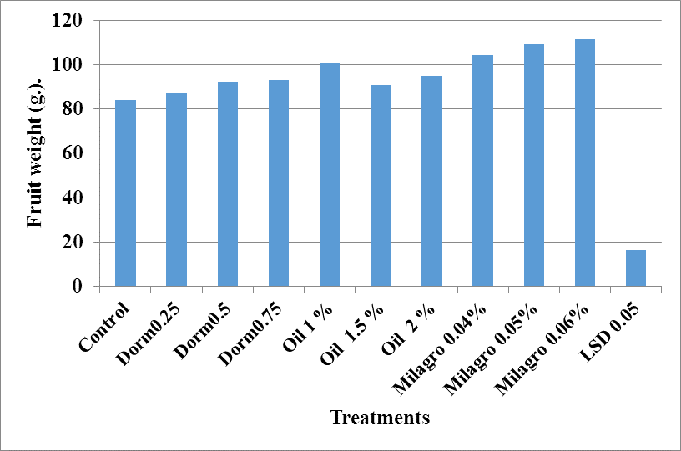
Fig. (1): Effect of some dormancy breaking agents on fruit weight (g) of Florida prince peach variety means 2012 and 2013 seasons.

Data in Table (1) indicated that the lowest loss in fruit weight (%) was obtained by Milagro at (0.06%) in both seasons followed by 0.05% and 0.04 % Milagro while the maximal weight loss (%) was recorded by control.

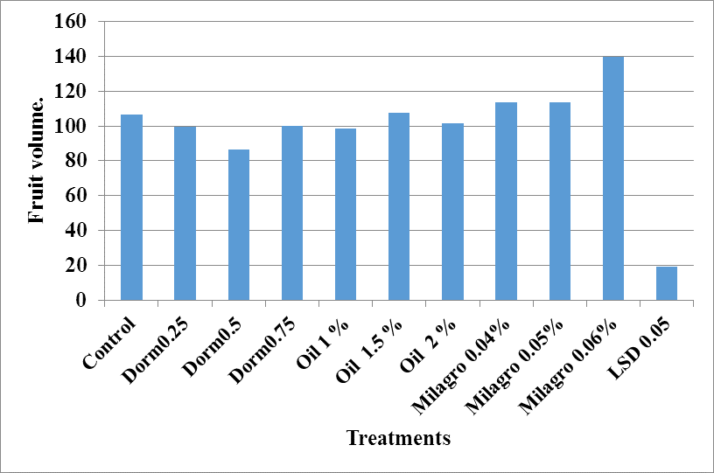
Fig. (2): Effect of some dormancy breaking agents on fruit volume (cm³) of Florida prince peach variety means 2012and 2013 seasons.

As for the effect of storage, data in Table (1) showed that fruit weight loss percentage was increased with increasing the storage period. So thirty days period under cold storage recorded the highest values of fruit weight loss percentage, whereas the lowest fruit weight loss values were obtained after six days under cold storage in both seasons. Differences between Milagro treatments and others were significant. As for the effect of the interaction between storage period and dormancy breaking treatments, data in Table (1) cleared that the lowest loss in fruit weight (%) was obtained by the interaction between remaining six days in cold storage and Milagro at (0.06%) in both seasons while the highest values were gained by the interaction of thirty days storage period, particularly that of control treatment in both seasons. The loss in fruit weight is mainly due to water loss as a result of evaporation and transpiration and amount of dry matter was lost by respiration (Ribeiro et al., 2007).

Table 1: Effect of some dormancy breaking agents on weight loss (%) of Florida prince peach variety under cold storage conditions means 2012 and 2013 seasons.
Treatments | Storage period
 | 0 | 6 | 12 | 18 | 24 | 30 | Means
Control | 0.00 | 2.79 | 7.30 | 10.50 | 13.95 | 15.35 | 8.31
Dormex 0.25 % | 0.00 | 2.35 | 7.95 | 10.48 | 13.75 | 14.54 | 8.18
Dormex 0.5 % | 0.00 | 2.23 | 5.98 | 9.79 | 13.50 | 14.18 | 7.61
Dormex 0.75 % | 0.00 | 2.10 | 5.35 | 9.47 | 11.59 | 13.22 | 6.95
Oil 1 % | 0.00 | 2.51 | 5.35 | 10.03 | 10.99 | 13.74 | 7.10
Oil 1.5 % | 0.00 | 2.41 | 5.03 | 9.84 | 10.13 | 13.26 | 6.78
Oil 2 % | 0.00 | 2.27 | 4.71 | 8.52 | 9.46 | 12.58 | 6.26
Milagro 0.04% | 0.00 | 2.30 | 3.51 | 7.43 | 8.63 | 10.48 | 5.39
Milagro 0.05% | 0.00 | 1.44 | 3.05 | 6.54 | 8.24 | 10.25 | 4.92
Milagro 0.06% | 0.00 | 1.30 | 2.66 | 5.83 | 7.42 | 8.98 | 4.37
Means | 0.00 | 2.26 | 5.02 | 8.70 | 10.64 | 12.79
LSD 5% Treatments= 0.71 - LSD 5% Storage period = 0.55 - LSD 5% Treatments X Storage period = 1.74

Firmness:
It is clear from Table (2) that fruit firmness decreased by increasing storage period. The highest values of fruit firmness were recorded by Milagro (0.06%) treatment in both seasons and the lowest by control. At begging and the end of storage period. As for storage period, data in Table (2) showed gradual loss in Florida prince peach fruits firmness with the advancement of storage period. The initial reading scored the higher values of fruit firmness (Lb. /inch²) whereas, thirty days of cold storage recorded the lowest values of fruit firmness. Data in Table (2) cleared that the interaction effect between storage periods and the tested dormancy breaking treatments of six days storage period registered the highest values of fruit firmness especially Milagro at (0.06%) followed by (0.05%) treated fruits in two seasons. On the contrary, the lowest values of fruit firmness were recorded by the interactions of thirty days storage period, especially control treatment, the other values came in-between fruit firmness in general followed a declining trend with advancement in storage period (Abdel-wahab and El-Shinawy, 2004). The decrease in fruit firmness of peaches with the progress of storage period is due mainly to decomposition of enzymatic degradation in soluble protopectins to more simple soluble pectins, solubilization of cell and cell wall content as a result of the increasing in pectin esterase activity (Deshpamde and Salunkhe, 1964). The previous results are in agreement with those obtained by Hegazi (2012) worked on apricot and found that firmness of fruits treated with different concentration of urea and zinc were higher than that of fruits treated with different concentration of Hydrogen Cyanamid.

Table 2: Effect of some dormancy breaking agents on firmness (Lb. /inch²) of Florida prince peach variety under cold storage conditions means 2012 and 2013 seasons.
 | Storage period
Treatments | 0 | 6 | 12 | 18 | 24 | 30 | Means
Control | 5.40 | 4.79 | 4.68 | 3.88 | 3.64 | 2.93 | 4.22
Dormex 0.25 % | 5.70 | 4.58 | 4.20 | 3.97 | 3.50 | 3.19 | 4.19
Dormex 0.5 % | 6.10 | 5.04 | 4.79 | 4.22 | 3.83 | 3.39 | 4.56
Dormex 0.75 % | 6.64 | 5.85 | 5.37 | 5.03 | 3.92 | 3.52 | 5.06
Oil 1 % | 7.07 | 6.32 | 5.37 | 7.52 | 3.83 | 3.08 | 5.53
Oil 1.5 % | 7.86 | 6.13 | 5.42 | 4.68 | 4.32 | 3.75 | 5.36
Oil 2 % | 7.06 | 5.79 | 5.20 | 4.13 | 3.93 | 3.60 | 4.95
Milagro 0.04% | 8.11 | 6.16 | 5.46 | 4.48 | 3.50 | 3.42 | 5.19
Milagro 0.05% | 8.46 | 7.18 | 5.29 | 4.47 | 4.34 | 3.71 | 5.57
Milagro 0.06% | 8.92 | 7.63 | 6.52 | 5.94 | 5.24 | 4.47 | 6.45
Means | 7.25 | 5.87 | 5.16 | 4.74 | 3.99 | 3.53
 |  | LSD 5% Treatments= 0.65
 |  | LSD 5% Storage period = 0.50
 |  | LSD 5% Treatments X Storage period = 1.59

Decay %:
Data in Table (3) showed that, most tested treatments decreased the fruit decayed percentage under cold storage compared with control. It is clear from the data that, Milagro at 0.06% was induced the lowest decay percentage at the end of storage period. Data in the same table cleared that fruit decay (%) gradually increased with prolonging the storage period in all treatments and control in both seasons. So 18 days of cold storage period possessed the lowest values in this parameter while the highest values were recorded at 30 days in both seasons. Regarding the effect of the interaction between storage period and tested treatments, data in Table (3) showed that the lowest decay (%) was gained by the interaction between remaining 18 days under cold storage and Milagro at 0.06 %. (Abdrabboh, 2012) found that decay percentage of Canino apricot variety was increased considerably with prolonged storage period in all treatments.

Table 3: Effect of some dormancy breaking agents on decay (%) of Florida prince peach variety under cold storage conditions means 2012 and 2013 seasons.
 | Storage period |  |  |  |  | Means
Treatments | 0 | 6 | 12 | 18 | 24 | 30
Control | 0.00 | 0.00 | 0.00 | 11.00 | 24.33 | 52.00
Dormex 0.25 % | 0.00 | 0.00 | 0.00 | 0.00 | 22.00 | 33.00
Dormex 0.5 % | 0.00 | 0.00 | 0.00 | 0.00 | 22.00 | 33.00
Dormex 0.75 % | 0.00 | 0.00 | 0.00 | 0.00 | 0.00 | 22.00
Oil 1 % | 0.00 | 0.00 | 0.00 | 0.00 | 0.00 | 33.00
Oil 1.5 % | 0.00 | 0.00 | 0.00 | 11.00 | 11.00 | 25.33
Oil 2 % | 0.00 | 0.00 | 0.00 | 11.00 | 33.00 | 33.00
Milagro 0.04% | 0.00 | 0.00 | 0.00 | 11.00 | 11.00 | 11.00
Milagro 0.05% | 0.00 | 0.00 | 0.00 | 0.00 | 11.00 | 11.00
Milagro 0.06% | 0.00 | 0.00 | 0.00 | 0.00 | 0.00 | 6.67
Means | 0.00 | 0.00 | 0.00 | 5.92 | 14.56 | 28.46
 | Storage period |  |  |  |  | Means
 |  | LSD 5% Treatments= 8.0
 |  | LSD 5% Storage period = 6.2
 |  | LSD 5% Treatments X Storage period =19.6

Chemical fruit properties:
TSS%:
Data in Table (4) illustrated that all tested treatments affected fruit total soluble solids in both seasons than that of control. On the other hand, 0.06 % Milagro treatment had statistically higher total soluble solids than all tested treatments in the two seasons. The same table showed that storage period of (30 days) recorded the highest fruit total soluble solids percentage. However, from the data, it is cleared that total soluble solids of fruit s gradually increased under cold storage in all treatments including control up to 30 days. Evaluating the interaction effect between storage periods and the tested treatments, data in Table (4) showed that by prolonging time of storage increased TSS contents in fruit in both seasons. The control treatment was induced the lower TSS in fruit, while other treatments were intermediate. The increase in TSS percentage may be due to water loss during storage (Abdur et al., 2010). These results are in parallel with the findings by Mahrous and El-Fakharani, 2006 on apricot who found that application of dormancy breaking agents improved fruit quality.

Table 4: Effect of some dormancy breaking agents on TSS (%) of Florida prince peach variety under cold storage conditions means 2012 and 2013 seasons.
Treatments | Storage period
 | 0 | 6 | 12 | 18 | 24 | 30 | Means
Control | 6.59 | 7.90 | 9.37 | 9.50 | 10.00 | 10.53 | 8.98
Dormex 0.25 % | 7.80 | 8.57 | 9.87 | 10.63 | 12.10 | 12.80 | 10.29
Dormex 0.5 % | 8.20 | 9.70 | 10.50 | 11.00 | 12.27 | 13.03 | 10.78
Dormex 0.75 % | 8.31 | 10.20 | 9.13 | 12.00 | 12.37 | 13.47 | 10.91
Oil 1 % | 7.25 | 8.83 | 9.13 | 10.07 | 10.97 | 12.37 | 9.77
Oil 1.5 % | 8.13 | 10.60 | 10.90 | 11.00 | 11.50 | 13.00 | 10.86
Oil 2 % | 7.95 | 9.50 | 10.63 | 11.10 | 11.47 | 12.87 | 10.59
Milagro 0.04% | 8.49 | 9.40 | 9.90 | 10.43 | 12.43 | 13.33 | 10.66
Milagro 0.05% | 9.11 | 9.90 | 11.00 | 11.30 | 12.57 | 13.50 | 11.23
Milagro 0.06% | 9.71 | 11.00 | 11.93 | 12.50 | 12.90 | 13.73 | 11.96
Means | 8.19 | 9.63 | 10.34 | 11.11 | 11.94 | 12.71
 | LSD 5% Treatments= 0.54
 | LSD 5% Storage period = 0.42
 | LSD 5% Treatments X Storage period = 1.33

Acidity and TSS/acid ratio:
The results in Table (5) showed that all dormancy breaking agents decreased the titrable acidity as compared with control, the lowest value of this parameter was gained by using Milagro at 0.06 % followed by 0.05%, 0.04% and Dormex at 0.75% The differences between Milagro at 0.06% treatments and other treatments were statistically significant.
Data in the same Table also showed that prolonging the storage period induced a remarkable decrease in fruit total titrable acidity content of Florida prince peach fruits, where the initial value of fruit (zero day storage) recorded the highest readings of total titrable acidity percentage in comparison with the other tested storage periods, while the lowest values were recorded by those cold stored for thirty days. The differences between the studied storage periods in this respect were significant. Concerning the interaction effect between the tested treatments and storage period, it is quite clear from Table (5) that the interactions of zero day storage period scored the highest values of fruit titrable acidity content, especially control treatment in both seasons. On reverse, the lowest values were registered by combinations of thirty days storage duration, particularly those interacted with the treatment of Milagro 0.06 %. The decrease in fruit acidity during storage period may be due to the metabolic changes in fruits or due to the use of organic acids in respiratory process (Echeverria and Valich, 1989). Abdrabboh, 2012 worked on Canino apricot demonstrated that, total acidity % of fruits gradually decreased under cold storage.
Regarding to TSS/acid ratio, data in Table (6) showed that the TSS/acid ratio was increased in all treatments under cold storage. The maximum increase was appeared in Milagro treatments. While the least ratio was gained from the control. The increase in TSS/acid ratio may be due to increase the TSS and decreased the acidity under cold storage at both seasons. Similar results on orange were obtained by Abdur et al. (2010) and Hifny et al. (2012).

Table 5: Effect of some dormancy breaking agents on total acidity (%) of Florida prince peach variety under cold storage conditions means 2012 and 2013 seasons.
Treatments | Storage period |  |  |  |  |  | Means
 | 0 | 6 | 12 | 18 | 24 | 30
Control | 1.31 | 1.02 | 0.96 | 0.80 | 0.70 | 0.62 | 0.90
Dormex 0.25 % | 1.11 | 1.08 | 0.91 | 0.79 | 0.67 | 0.46 | 0.84
Dormex 0.5 % | 1.08 | 1.02 | 0.90 | 0.74 | 0.64 | 0.42 | 0.80
Dormex 0.75 % | 1.05 | 0.99 | 0.87 | 0.79 | 0.62 | 0.40 | 0.79
Oil 1 % | 1.18 | 1.01 | 0.87 | 0.75 | 0.73 | 0.55 | 0.85
Oil 1.5 % | 1.15 | 0.99 | 0.83 | 0.74 | 0.61 | 0.48 | 0.80
Oil 2 % | 1.15 | 0.97 | 0.79 | 0.70 | 0.47 | 0.40 | 0.75
Milagro 0.04% | 1.07 | 0.95 | 0.90 | 0.71 | 0.48 | 0.40 | 0.75
Milagro 0.05% | 1.05 | 0.92 | 0.87 | 0.67 | 0.44 | 0.39 | 0.72
Milagro 0.06% | 0.99 | 0.86 | 0.80 | 0.65 | 0.51 | 0.37 | 0.70
Means | 1.12 | 0.98 | 0.87 | 0.73 | 0.59 | 0.45
 |  | LSD 5% Treatments= 0.08
 |  | LSD 5% Storage period = 0.06
 |  | LSD 5% Treatments X Storage period = 0.18

Table 6: Effect of some dormancy breaking agents on TSS/Acid ratio of Florida prince peach variety under cold storage conditions means 2012 and 2013 seasons.
 | Storage period |  |  |  |  |  | Means
Treatments | 0 | 6 | 12 | 18 | 24 | 30
Control | 5.02 | 7.72 | 9.76 | 11.88 | 14.22 | 17.08 | 10.94
Dormex 0.25 % | 7.05 | 7.96 | 10.88 | 13.46 | 17.97 | 27.83 | 14.19
Dormex 0.5 % | 7.57 | 9.48 | 11.71 | 14.86 | 19.27 | 31.03 | 15.65
Dormex 0.75 % | 7.89 | 10.30 | 10.46 | 15.19 | 20.05 | 33.67 | 16.26
Oil 1 % | 6.13 | 8.72 | 10.46 | 13.48 | 15.02 | 22.48 | 12.72
Oil 1.5 % | 7.05 | 10.67 | 13.13 | 14.86 | 18.85 | 27.08 | 15.28
Oil 2 % | 6.92 | 9.76 | 13.46 | 15.86 | 24.40 | 31.90 | 17.05
Milagro 0.04% | 7.91 | 9.86 | 11.04 | 14.63 | 25.72 | 33.33 | 17.08
Milagro 0.05% | 8.65 | 10.80 | 12.64 | 16.78 | 28.56 | 34.32 | 18.63
Milagro 0.06% | 9.81 | 12.79 | 14.85 | 19.23 | 25.13 | 36.79 | 19.77
Means | 7.34 | 9.81 | 11.88 | 15.13 | 20.32 | 28.27
 | LSD 5% Treatments=1.7
 | LSD 5% Storage period = 1.37
 | LSD 5% Treatments X Storage period = 4.32

References:
- Abdel-Wahab, S.M. and I.E. El-Shinawy, 2004. Effect of some pre-harvest treatments on improving quality on Thompson Agric. Sci. Moshtohor, 42(4): 1965-1981.
- Abdrabboh G. A., (2012): Effect of Some Preharvest Treatments on Quality of Canino Apricot Fruits Under Cold Storage Conditions. Journal of Horticultural Science & Ornamental Plants 4 (2): 227-234, 2012.
- Abdur R. Saeedul Haq, Shahid Akbar Khalil and Syed Ghias Ali, 2010. Fruit quality and senescence related changes in sweet orange cultivar blood red different packing materials. J. Agric., 26(2): 221-227.
- Amjad A., Sajida P., Syed N, Muhammad S., Zengqiang Z., Fazli W., Mohib S., Shahida B. and Abdul M. (2014): Effect of Foliar Application of Micronutrients on Fruit Quality of Peach. American Journal of Plant Sciences, 5, 1258-1264.
- Association of Official Agricultural Chemists. (2000): Official Methods of Analysis of. A. O. A. C. international 17th Ed. Published by A. O. A. C. international USA.
- Deshpande, P.B. and D.K. Salunkhe. 1964. Effects of maturity and storage on certain biochemical changes in apricots and peaches. Food Technol. 18:85-88.
- Echeverria, E. and J. Valich. 1989. Enzymes of sugar and acid metabolism in stored Valencia organs. J. Amer. Soc. Hort. Sci. 114:445-449.
- Erez, A. (2000). Bud dormancy: phenomenon, problems and solutions in the tropics and subtropics. In: Temperate Fruit Crops in Warm Climates, EREZ, A., pp. 17-48, Kluwer Academic Publishers, ISBN041263290X, The Netherlands.
- Grove, M. D.; Spencer, G. F.; Rohwedder, W. K. (1979). Brassinolide, a plant growth promoting steroid isolated from Brassica napus pollen Nature, Volume 281, Issue 5728, pp. 216-217.
- Hegazi A. A. (2012): Effects of Some Dormancy Breaking Agents on Flowering, Fruiting and Fruit Characteristics of 'Canino' Apricot Cultivar. World Journal of Agricultural Sciences 8 (2): 169-173.
- Hifny H. A., Abd Elrazik, A.M., Abdrabboh G.A. and Sultan, M.Z. (2012): Effect of Some Citrus Rootstocks on Fruit Quality and Storability of Washington Navel Orange Under Cold Storage Conditions. American-Eurasian J. Agric. & Environ. Sci., 12 (10): 1266-1273.
- Honeyborne, G.E. and E. Rabe (1993). Evaluation of two mineral oil based artificial rest-breaking compounds on Golden Delicious apples. Deciduous Fruit Frower, 43: 6, 206-210.
- Mahrous, H.A.H. and E.M.M. El-Fakharani, 2006. Effect of some dormancy breaking agents on fruiting quality and powdery Mildew and productivity severity of apricot. Acta Hort., 701: 659-664.
- Ribeiro, C., Vicente, A. A., Teixeira, J. A., & Miranda, C. (2007). Optimization of edible coating composition to retard strawberry fruit senescence. Postharvest Biology and Technology, 44,63–70.
- Saure, M.C. 1985. Dormancy release in deciduous fruit trees. Hortic. Rev. 7:239–300.
- Snedecor, G. and Cochran, W. G. (1980): Statistical Methods. Oxford and J. B. H. Publishing Com. 7th edition.

1/5/2015

