Soil Moisture Conservation by Kaolin, Rice Straw and Shale Applications

Mohamed M. M

Soils and Water Dept., Fac. of Agric., Al-Azhar University, Cairo, Egypt
dr_mohamedmostafa@yahoo.com

Abstract: This work aims to study the effect of using soil conditioner (shale 10 Ton ⁄Fed), soil mulching (Rice straw) and plant foliar antitranspiration (kaolin 6℅) on water conservation for soil and plant. A pot experiment was conducted during 2012 and 2013 summer seasons by using calcareous soil from Noubaria region. Soil moisture content was adjusted at field capacity during the experiment. The treatments used were control, kaolin(K), Rice straw(RS), shale(S) as a single treatments and, kaolin with Rice straw(K+RS), kaolin with shale(K+S), shale with Rice straw(S+RS) as a double treatments, finally, kaolin with Rice straw and shale (K+RS +S)as a triple treatment.Corn as indicator plant was harvested after 90 days from planting. Soil evaporation, soil moisture retention and plant transpiration was controlled by using Rice straw,shale and kaolin, respectively as a commercial and economical materials. Results showed that shale treatment (S) led to a significant increase in W.H.C℅, F.C℅, W.P℅ and A.W ℅ than kaolin (K), Rice straw (RS) and control treatments. Also, shale and Rice straw (S+RS) treatment showed a pronounced increase in all soil moisture constant studied than the other applied treatments (K+RS) and (K+S). Highest values for W.H.C℅, F.C℅, W.P ℅ and A.W ℅ were obtained by using (K+RS+S) treatment. Also, shale treatment was decrease water consumptive use (W.C.U) values from 7.18 L/pot for control treatment to 7.05 L/pot. Consequently, shale (S) increased water use efficiency (W.U.E) values more than kaolin (K) and Rice straw (RS) treatment from 1.22gm/L for control to 1.42gm/L due to high soil moisture retention of shale. Also data for (S+RS) treatment was more effective in increasing (W.U.E) values than (K+RS) and (K+S) treatments. Concerning the (K+RS+S) treatment a higher increase was obtained in W.U.E value and higher decrease in W.C.U was observed than all other experimental treatments used in this study. Whereas, the relative increase percentage of W.U.E over control for (K+RS+S) reached to 36.07℅. These results showed an important use of kaolin, shale and Rice straw as a commercial and economical materials in controlling water for soil and plant.
[Mohamed M. M Soil Moisture Conservation by Kaolin, Rice Straw and Shale Applications. Nat Sci 2015;13(1):12-17]. (ISSN: 1545-0740). http://www.sciencepub.net/nature. 2

Keywords: water conservation-kaolin-shale-Rice straw-moisture constant-water use efficiency

1. Introduction
In arid and semi-arid areas, where water is scarce and population growth is high, the success of sustained agriculture depends entirely on water availability therefore; great potential for improving water use efficiency must be done. This may be achieved by reduce runoff, soil evaporation, plant transpiration and drainage loss using antitranspiration materials, mulching methods and soil conditioners.
Surface mulch (mulch refers to a material placed on the soil surface) has a significant effect on reducing evaporation of water therefore it can decrease salt accumulation of water as well (Al-Rawahy et al., 2011 and Leila et al.,2014).
Many materials have been used as mulch,such as plastic film, crop residue,straw, paper pellets, gravel-sand, rock fragment, volcanic ash, poultry and live- stock litters, city rubbish, etc.(Yun-min et al., 2005, Balwinder-Singh etal., 2011 and Adnan etal., 2012).
Grass mulch is more useful in cultivation of Nagpur mandarin orchards (Gaikwad, 2004).Soil mulsh with Egyptian clover or weed residues gave the best vegetative growth and fruit quality of orange trees under To sakha conditions (Abdel-Aziz et al., 2010).
Mulching by black polyethylene (BPE) and dry cut grass increased the percentage of soil moisture due to reducing evaporation water from soil surface.
Rice straw becomes a big problem to get rid of, so that the farmers oblige to burn the rice straw and this lead to environmental pollution; such straw can be used as mulch (Lal and Stewart, 1995, Ti and Unger, 2001, Unger, 2001, Bu et al., 2002, Sarkar, 2005, Xiying et al., 2005,Berglund et al., 2006 and Sadeghi et al.,2014).
To reduce the transpiration rate,certain materials could be used called antitranspiration which were grouped into three categories, (1) film -forming types( which coat leaf surface with film that are impervious to water vapor), (2) reflecting materials (which reflect back a portion of the incident radition falling on the upper surface of the leaves) and (3) stomutal closing types, (Prakoish etal., 2000) which affect the metabolic processes in leave tissues. The types 1and 2 of antitranspirations were found to be non-toxic and have a larger period of effectiveness than metabolic types (Gawish, 1992).
A reflective spray was found to decrease leaf temperature by increasing leaf reflectance and to reduce transpiration rate in many plant species grown at high solar radiation levels (Nakane and Uehara, 1996). Early studies demonstrated that kaolin improved water status and yield of apple while it did not reduce carbon assimilation (Glenn et al., 2003 and Abd el-Kader et al., 2006). Under subtropical conditions like Egypt, using antitranspiration may reduce transpiration rate from the plant, consequently, the amount of used water and improved the water use efficiency (Makus, 1997 and Singh et al., 1999).
Wallace and Terrey 1998 defined soil conditioner as any substances- natural or manufactured that has the abilities to improve the physical properties and water conservation of soil, which emphasis on the soil ability to grow plants, soil conditioners enhance the quality of soil for many of its functions. Application of shale led to an increase in the soil moisture retention (Abdel-Aziz et al., 1990 and Mohamed, 1990).
Nawar, 2002 found that the retained moisture of maize plant values increased by 152.4℅ and 175.3 ℅ in sandy and calcareous soils, respectively after application of soil conditioners.
The present study was outlined to study the effect of some factors on soil moisture retention and water conservation by using corn plants as: (i) soil mulching by Rice Straw (ii) soil conditioning by shale (iii) use antitranspiration kaolin as a commercial and economic materials in calcareous soil.

2. Material and Methods:
The current investigation aims to study the effect of soil mulching, soil conditioning and antitranspiration on soil water conservation. Field experiment was conducted during 2012 and 2013 summer seasons in Agriculture College of al-azhar university, Cairo. Plastic pots have a diameter 30 cm were filled with 8kg.of air-dried soil collected from Nobaria region. Chemical and physical properties of the soil used were determined according to Black 1965; Tables 1 and 2. Five seed of zea maize (Giza 3) were planted in each pot then thinned to one plant. Climate of the studied area during the growth period were obtained from the meteorological department, Ministry of agriculture which shown in Table 3. Recommended doses of fertilizers were applied for maize production.
2.1. Soil treatments:
Eight soil treatments were applied as follows: control, kaolin; K (6℅) was spread on the corn leaves every 15 days for two month as antitranspiration, rice straw (RS) as soil mulching, shale; S(10 Ton ⁄Fed) as soil conditioner, kaolin and rice straw (K+RS) as fifth treatment, kaolin and shale (K+S) as sixth treatment. shale and rice straw(S+RS) as seventh treatment, finally, kaolin,rice straw and shale (K+RS+S). Kaolin analysis used was SiO₂ 56.0, TiO₂ 1.3, Al₂O₃ 30.0, Fe₂O₃ 0.9, MgO 0.05,CaO 0.1, Na₂O 0.07, K₂O 0.03 and L.O.I 11.0 ℅ while shale analysis used was clay 81.88, silt 3.30, fine sand 13.73, coarse sand 1.09, bulk density 1.50 gm ⁄cm³ and EC 2.8 dSm⁻¹.

Table 1: Chemical Analysis of the Soil Used:
Soluble ions  meq l⁻¹ |  |  |  |  |  |  |  | C.E.C | pH  Soil paste | E.C | CaCO₃  (%) | O.M  % | Textural class | Particle size distribution  (%)
Anions |  |  | Cations |  |  |  |  |  |  |  |  |  |  | Clay | Silt | Fine sand | Course sand
SO₄ | Cl | HCO3 | CO₃ | K | Na | Mg | Ca
14.03 | 19.63 | 6.11 | --- | 2.90 | 20.31 | 3.81 | 8.93 | 29.49 | 7.96 | 2.99 | 19.66 | 0.18 | Sandy  clay loam | 28.43 | 19.77 | 39.61 | 12.19
C.E.C: meq/100gm E.C: dSm⁻¹ (Soil paste extract)

Table 2: Some Physical Properties of the Soil Used:
Hydraulic conductivity  h / cm | Pore size distribution% |  |  | Total porosity  % | Bulk density  gm/cm³ | A.W  % | W.P  % | F.C  % | W.H.C  %
 | Macropores  ˃100μ | Mesopores  30-100μ | Micropores  ˂30μ
9.66 | 15.01 | 12.02 | 19.01 | 46.04 | 1.43 | 13.57 | 19.83 | 33.40 | 43.0
W.H.C:Water holding capacity F.C:Field capacity W.P: Wilting point A.W: Available water

Table 3: The Meteorological Data during Growth Period:
Month |  |  |  | Meteorological  Parameter
August | July | June | May
34.99 | 35.09 | 35.31 | 35.40 | Average Maximum Temp. (ºC)
23.96 | 24.03 | 24.20 | 24.31 | Average Minimum Temp. (ºC)
51.11 | 51.36 | 52.13 | 52.19 | Average Relative Humidity ( ℅)
11.56 | 11.81 | 11.95 | 12.30 | Average Sunshine (hr.)
1.79 | 1.81 | 1.95 | 2.03 | Average Wind Speed ( m/sec.)

Soil moisture content was adjusted gravimetrically at field capacity during the experiment and the loss in pot weights represented the amount of water lost and W.C.U and W.U.E were calculated for different treatments. The corn plants were harvested after 90 days from planting. Experimental layout was a randomized complete block design replicated three times.

3. Results and Discussion:
3.1. Effect on Soil Moisture Retention:
Soil moisture retention characteristics is very important because it doesn’t only give the total amount of water held by the soil, but also its pattern release. This information is important for the proper planning of irrigation regions, particularly in arid and semiarid zones, where the amount of water is very limited. Data in Table 4 showed that soil moisture retention was significantly affected by the shale (10 Ton ⁄Fed) as soil conditioning, rice straw as soil mulching, kaolin as foliar antitranspiration and their interactions in sandy clay loam soil.
Shale (S) treatment showed a significant increase in W.H.C,F.C,W.P and A.W ℅ than control, rice straw (RS) and kaolin(K) as single treatments. The highest A.W values(18℅ ) were recorded for shale while for rice straw, kaolin and control were 17.92 ℅, 16.07 ℅ and 14.66 ℅, respectively.
Concerning to double treatments used in this study; Shale and rice straw treatment, (S+RS ) showed an pronounced increase in all soil moisture constant studied than the other applied treatments; (K+RS) and ( K+S); Table 4.
A.W values was reached to 18.71 ℅ for(S+RS) treatment, while for (K+RS) and (K+S) were 18.1℅ and 18.51℅, respectively.
Generally, results in Table 4 indicated that using of three materials kaolin, rice straw and shale (K+RS+S) as triple treatment led to highest value for W.H.C, F.C, W.P and A.W than all other investigated treatments. These values were 53℅, 39.22℅, 19.95 ℅ and 19.27℅ for W.H.C, F.C, W.P and A.W, respectively compared with control (48.11 ℅, 33.55 ℅, 18.85℅ and 14.66℅) for the same moisture constant respectively.
The relative increase percentages of W.H.C, F.C, W.P and A.W over control was illustrated in Fig.1_{a,b,c,d}. The highest values of relative increase percentages of A.W was clearly observed for (S) as a single treatment, (S+RS) as a double treatment and (K+RS+S) treatment; Fig.1_{d}. These values were 22.85℅, 27.63 ℅ and 31.45 ℅, respectively. Finally, results show the enhancing role of mulching, conditioning and antitranspiration processes in reducing water loss from soil and plant. These results were agreement with those obtained by El-Nady and Borhan, 2008.

Table 4: Effect of Application Treatments on Soil Moisture Content of Sandy Clay Loam Soil:
A.W  % | W.P  % | F.C  % | W.H.C  % | Treatment
14.66 | 18.85 | 33.51 | 48.11 | Control
16.07 | 18.89 | 34.96 | 48.75 | K
17.92 | 19.99 | 36.91 | 48.88 | RS
18.00 | 19.11 | 37.11 | 48.97 | S
18.01 | 19.18 | 37.19 | 49.78 | K+RS
18.51 | 19.29 | 37.80 | 50.63 | K+S
18.71 | 19.39 | 38.10 | 52.11 | S+RS
19.27 | 19.95 | 39.22 | 53.00 | K+RS+S
K: Kaolin RS: Rice Straw S: Shale

3.2. Effect on W.U.E and W.C.U:
Water consumptive use (W.C.U) or crop water requirement refers to the amount of water that needs to be supplied, while crop evaportranspiration refers to the amount of water that is lost through evapotranspiration processes. Also, the irrigation water requirement includes additional water for leaching salts. The water use efficiency (W.U.E) represents the ratio between the dry matter produced by photosynthesis and the water consumed in evapotranspiration. It was calculated according to Allen et al., 1998.
Water use efficiency can be increased by decreasing losses from water consumed.
Water consumptive use (W.C.U) and water use efficiency (W.U.E) of corn plants as affected by soil conditioning, soil mulching and foliar ant transpiration were recorded in Table 5.
Single treatments indicated that shale was successive over kaolin and rice straw treatments. Whereas, shale decreased the W.C.U value from 7.18 L / pot for control treatment to 7.05 L/pot. Consequently, shale increased the W.U.E values from 1.22 gm/L for control treatment to 1.42gm/L due to high moisture retention of shale. Regarding to kaolin treatment values of W.U.E reached to 1.29 gm/L due to the effect of spray kaolin in decrease leaf temperature by increasing leaf reflectance and to reduce transpiration rate in plants leaves grown at high solar radiation levels (Nakano and Uehara, 1996).
Rice straw becomes a big problem to get rid of, so that the farmer’s oblige to burn it and this lead to the environmental pollution. Mulch management by rice straw as plant residues was employed to a benefit way for soil and water conservation. In this concern, data in Table 5 referred that mulching rice straw increased W.U.E value to 1.40 gm/L compared to control treatment; 1.22 gm/L. These result in agreement with El-Nady and Borhan, 2008.

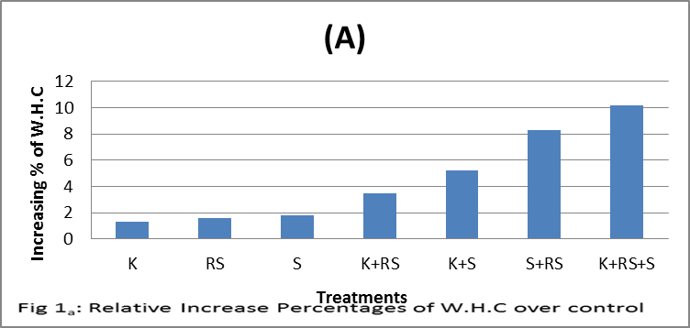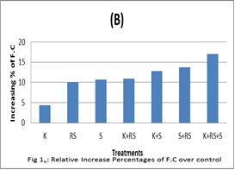

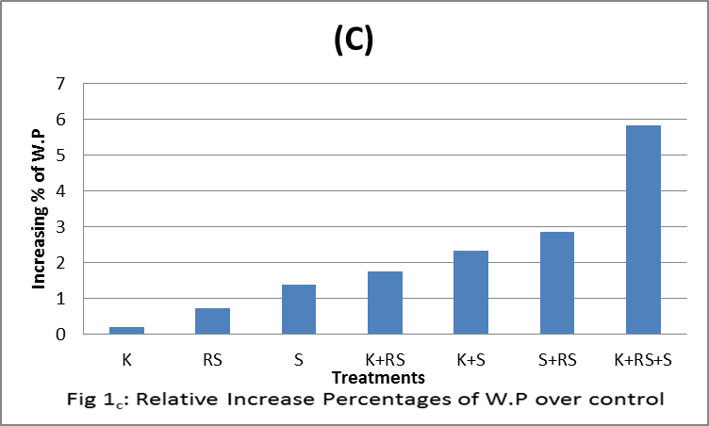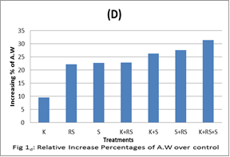

Data also, showed that (S+RS) treatment was decreased W.C.U values from 7.18L/pot for control treatment to 6.70 L/pot. Also, the values of W.U.E for (S+RS) treatment were increased to 1.60 gm/L.
Data for (S+RS) treatment was more effective for increasing W.U.E values than (K+RS) and (K+S) treatments.
Concerning, the (K+RS+S) treatment, a higher increase was observed in W.U.E values and higher decreased in W.C.U values was obtained than all other experimental treatments used in this work. Whereas, W.C.U value reached to 6.59 L/pot and W.U.E value reached to 1.66 gm/L for control treatment, respectively.

Table 5:Effect of Experimental Treatments on Water Consumptive Use and Water Use Efficiency for Corn Plants:
W.U.E  gm/L | W.C.U  L/pot | Treatment
1.22 | 7.18 | Control
1.29 | 7.14 | K
1.40 | 7.13 | RS
1.42 | 7.05 | S
1.45 | 6.88 | K+RS
1.50 | 6.58 | K+S
1.60 | 6.70 | S+RS
1.66 | 6.59 | K+RS+S

Fig.2_{a}, illustrated the relative decrease percentage in W.C.U values over control for all treatments used. K+RS+S treatment has highest relative decrease percentage over control which reached to 8.22 ℅. While fig2_{b} showed a relative increase percentage in W.U.E values over control treatment. (K+RS+S) treatment was more effective than the other treatments used for increasing W.U.E. relative percentage over control treatment (36.07℅).
Finally, this study was confirmed to the important use of kaolin, Rice straw and shale (K+RS+S) in triple treatment as a commercial and economical materials in controlling water for soil and plant.

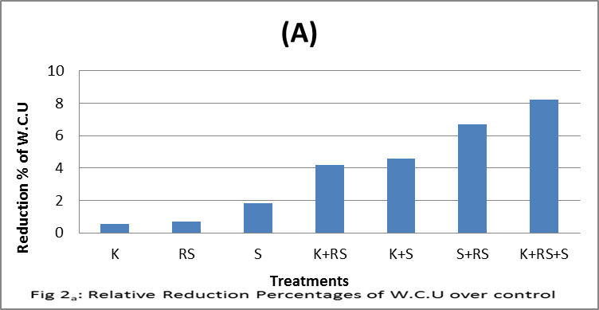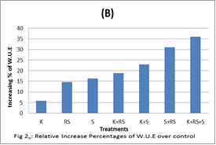

References:
- Abdel-Aziz, R.A.; Sabri, M.A. and AL-Bitar, L. (2010). Impact of some soil mulch treatments on tree growth, yield, fruit quality and storability of Valencia orange under Toshka conditions. Zagazig J. Agric.Res., 37(1): 57-79.
- Abdel-Aziz, S.M.; Fathi,A.I. andSelem, M.M. (1990). Effect of applied soil conditioner on sandy characteristics and wheat production. Annual of Agric.Sci, Moshtohor, 28:2681-2691.
- Abd El-Kader, A.M.; Saleh, M.M.S.; and Ali, M.A.( 2006). Effect of soil moisture levels and some antitranspirants on vegetative growth, leaf mineral content, yield and fruit quality of Williams banana plants. J. of Applied Sci., 2(12): 1248-1255.
- Adnan, Y., Muhammad, Z. M. B., Atif,R., Usman, T., Muhammad, A., Muhammad, N., and Muhammad, A. (2012). Effect of different types of mulching on growth and flowering of freesia alba cv. Aurora. Pak. J. Agri. Sci., 49(4): 429-433.
- Allen, R.G.; Pereira,L.S.,Raes,D. and Smith,M. (1998). Crop evapotranspiration Guidelines for computing crop water requirements. Irrig.and Drain. No.56,FAO, Rome, Italy.
- Al-Rawahy, S.A.,Al-Dhuhli,H.S.,Prathapar,S. and Abdel-Rahman,H.(2011).Mulching material impact on yield, soil moisture and salinity in saline –irrigated Sorghum plots.International J. of Agric.Research,6(1):75-81.
- Ansary, E.M. and Abdulrahman, I.A. (2005). Effects of Kaolin and Pinolene Film-forming Polymers on Water Relations and Photosynthetic Rate of Tuberose (Polianthes tuberosa L.). J. King Saudi Univ., Agric. Sci. 18 (1): 35-49.
- Balwinder-Singh, Eberbacha, P.L, Humphreysb, E., Kukalc, S.S. (2011). The effect of rice straw mulch on evapotranspiration, transpiration and soil evaporation of irrigated wheat in Punjab, India. Agricultural Water Management 98: 1847– 1855.
- Berglund, R.; Svensson, B. and Gertsson, U. (2006). Impact of plastic mulch and poultry manure on plant establishment in organic strawberry production. J. Plant Nutr. 29(1):103-112.
- Black, CA. (1965). Methods of soil analysis. part 1. Physical and Mineralogical Properties including Statistics of Measurements Amer. Soc. of Agronomy, Inc. publisher Madison, Wisconsin USA.
- Bu,Y.S; Shao, H.L. and Wang,J.C.(2002). Effect of different mulch materials on corn seeding growth and soil nutrients and distributions. J. Soil Water Cons. 16(3): 40-42.
- El-Nady,M.A,and Borham,T.I.(2008). Mulching effect on water use Efficiency of corn yield. Egypt. J. Soil Sci.48(3):267-278.
- Gaikwad, S.C.; Ingle, H.V., Panchbhai, D.M. and Ingle,S.H. (2004). Effect of different types of mulches on soil moisture soil temperature and fruit drop in nagpur mandarin. Agric. Sci. Digest. 24 (1):71-72.
- Gawish,R.(1992). Effect of antitranspirants Applications on snap Bean (Phaseolus vulgaris L) Grawn under different Irrigation Regimes. Minufiya J. Agric. Res.17:1309-1325.
- Glenn,D.M., Erez, A., Puterka, G.J. and Gundrum, P. Particle films affect carbon assimilation and yield in Empire apple. J. Amer. Hort. Sci. 128: 356-362.
- Ji, S.and Unger, P.W. (2001). Soil water accumulation under different precipitation potential evaporation and straw mulch conditions. Soil Sci.Soc.Am.J.65:442-448.
- Lai, R. and Stewart, B.A.(1995). Managing soil for enhancing and sustaining agricultural production. Soil Mangement: Experimental Basis for sustainability and Environmental Quality: 1-9.
- Leila, G,, Kazimierz, B., Seyed, H. S., Abdulvahed K. D. and Leszek, H. (2014). Effectiveness of straw mulch on infiltration, splash erosion, runoff and sediment in laboratory conditions. J. Water Land Dev. No. 22 (VII–IX): 51–60.
- Makus, D.J.(1997). Effect of an antitranspirant on cotton grown under conventional tillage systems. Proceeding Beltwide cotton Conference. New Orieans, LA,USA,1: 642-644.
- Mohamed, M.M.(1990). Effect of soil management practices on soil properties and yield, PhD. Thesis Fac. of Agric. Al-Azhar Univ. Cairo.
- Nakano, A. and Uehara,Y,(1996). The Effect of kaolin Clay on Cuticle Transpiration in Tomato. Acta Hort., 440:233-238.
- Nawar, A.A. (2002). The potentiality for improving some soil properties and plant growth in sandy soils by using soil amendment. MSc. Thesis Fac. of Agric. Menoufia Univ., Egypt.
- Prakash, M. and Amachandran, K.R. (2000). Effect of chemical ameliorants in brinjal (Solanum melongena L.) under moisture stress conditions. F.A.O. Irrigation and Drainage No.33.
- Sadeghi, S. H. R., Gholami1,L., Sharifi,E. and Khaledi, A.(2014). Scale effect on runoff and soil loss control using rice straw mulch under laboratory conditions. Solid Earth Discuss., 6: 2915–2938.
- Sarkar, S. (2005). Evapotranspiration and yield response of wheat to irrigation frequencies and fertilizer levels. J.Indian Soc.Soil Sci. 53:54-59.
- Singh,S.; Singh, A.; Singh V.P.; Singh S. and Singh, A. (1999). Use of dust mulch and antitranspirant for improving water use efficiency of menthol mint ( Mentha arvensis.J. Medicinal and Aromatic plant Sciences. 21(1):29-33.
- Unger, P.W.(2001). Paper pellets as a mulch for dry land grain sorghum production. Agron.J. 93: 349-357.
- Wallace, A. and Terry,E.R.(1998).Handbook of soil conditioners. Wallace, A. and Terry. R(ed.) 1-41.
- Xiying, Z.; Suying,C.;Mengyu,L.; Dong,P. and Hongyong, S. (2005). Improved water use efficiency associated with cultivars and agronomic management in the North China Plain. Agron.J. 97:783-790.
- Yan-min,Y.L.; Xiao-jing,L.Wei-qiang and Cun-zhen, L. (2006). Effect of different mulch materials on winter wheat production in desalinized soil in Heilonggang region of North China. J. of Zhejiang University and Biotechnology, 7(11):858-867.

12/8/2014

