Effect of Aerobic Exercise, Vitamin K and Vitamin D on Bone Metabolism in Ovariectomized Adult Rats.

Aziza Khalil and Gehan A. Youssef

Medical Physiology Department, Faculty of Medicine (Girls) Al-Azhar University, Egypt
gehanphysiology@yahoo.com

Abstract: Background: Osteoporosis is a progressive disease that has physical and psychosocial consequences,it is the most common bone disease in humans, it occurs accompanying menopause and induces bone loss. Therefore, the objective of this study was to assess associations between exercise training, vitamin K supplementation and vitamin D supplementation either alone or in combinations on the prevention of osteoporosis in ovariectomized rats, and to find the best combination that gives the highest treatment of osteoporosis. Methods: eighty ovariectomized rats with an average weight of 150 g were used in this study. They were equally divided into eight groups. Group I Sedentary control ovariectomized group (n=40). This group was further subdivided into 4 subgroups I a, I b, I c and I d. Group II Exercise group (n=40): This group was further subdivided into 4 subgroups II a, II b, II c and II d. Blood samples were taken from all groups. We investigated the circulating concentrations of Osteocalcin (Oc), Bone specific alkaline phosphatase (BSAP), Undercarboxylated osteocalcin (UnOc) and Serum Tartrate resistant acid phosphatase iso-enzyme 5b (TRAP5b). Results: Exercise trainings in overiectomized adult rats induced significant increase in Oc and significant decrease in UnOc and TRAP5b. Vit K alone produce significant decrease in UnOc and TRAP5b while Vit K with exercise produced significant increase in BSAP and significant decrease in UnOc and TRAP5b. Vit D alone produced significant decrease in TRAP5b while Vit D with exercise produced significant increase in Oc and BSAP with significant decrease in UnOc and TRAP5b. Combind Vit K with Vit D without exercise produced significant increase in BSAP and significant decrease in UnOc and TRAP5b while combined Vit K, Vit D with exercise produced significant increase in Oc and BSAP and significant decrease in UnOc and TRAP5b.Conclusions: Exercise has a great role in the treatment of osteoporosis that is mainly due to increased bone formation together with mild decrease in bone resorption so that the combination of exercise training with vitamin K and /or D supplementation was beneficial in the treatment of osteoporosis as they augment the effect of each other through combining increased bone formation with decreased bone resorption.
[Aziza Khalil and Gehan A. Youssef. Effect of Aerobic Exercise, Vitamin K and Vitamin D on Bone Metabolism in Ovariectomized Adult Rats. Nat Sci 2015;13(1):1-11]. (ISSN: 1545-0740). http://www.sciencepub.net/nature. 1

Key words: Vitamin K, Vitamin D,Osteocalcin (Oc), Bone specific alkaline phosphatase (BSAP), Undercarboxylated osteocalcin (UnOc) and Tartrate resistant acid phosphatase iso-enzyme 5b (TRAP5b).

1. Introduction:
The estrogen deficiency accompanying menopause induces bone loss and increased risk of fracture. Osteoporotic fractures are associated with high morbidity, increased mortality risk, and major economical impact (Autier et al., 2000). Osteoporosis is a progressive disease that has physical and psychosocial consequences, It is the most common bone disease in humans, characterized by low bone mass, deterioration of bone tissue, disruption of bone architecture, compromised bone strength, and increased bone fracture risk over time (Sadat-Ali et al., 2011).
Osteoporosis treatment too often consists of drug prescription (anti resorption drugs e.g. bisphosphonate, estrogen replacement therapy) (body et al., 2010). In addition to drug prescription, current osteopenia treatment guidelines include exercise, vitamin D and recently vitamin K supplementation (Cheung et al., 2008).
Exercise provides an osteogenic stimulus to the bones by increasing serum concentrations of bone formation markers as well as decreasing bone resorption markers (Bakhtyar et al., 2011). Despite it is generally thought that disuse (prolonged periods of inactivity) and unloading of the skeleton (e.g.in cases of paralysis) promotes reduced bone mass whereas mechanical loading through exercise increases bone mass (dolbow et al., 2011).
In addition Iwamoto et al. (2005) reported that treadmill exercise in ovariectomized rats prevents cancellous bone loss at the tibia, and increases bone mass of the tibia and mechanical strength of the femur, as a result of suppressed bone resorption and increased bone formation in osteopenic rats after ovariectomy. Also Safinaz.et al. (2011) observed that 3-months exercise program was associated with improvement of bone densitometry and significant increment of the bone formation marker Procollagen I N-terminal extension peptide (PINP) in Egyptian type 1 diabetic osteopenic adolescents.
Vitamin K is best known for its function in the blood coagulation pathway, but recent data suggest that the K vitamins play an important role in bone metabolism, perhaps at serum levels higher than those required for normal blood coagulation. Vitamin K is the essential cofactor for the carboxylation of glutamate to gamma-carboxy glutamic acid (Gla), which confers functionality to vitamin K–dependent Gla-containing proteins. (Angela et al., 2008).
Vitamin K through the gamma carboxylation of osteocalcin can hold calcium in the skeleton, while preventing it from being deposited in organs, joint spaces, and arteries (Mitchell, 2000). In other words, without the help of vitamin K2, calcium that vitamin D so effectively lets in, might be working against the body by building up in coronary arteries rather than bones. Concurrent arterial calcification and osteoporosis have been called the "calcification paradox" and occur frequently in postmenopausal women. There is even evidence that the safety of vitamin D is dependent on vitamin K, and that vitamin D toxicity (although very rare with the D3 form) is actually caused by vitamin K2 deficiency. (Adams et al., 2005).
Vitamin D plays a major role to regulate bone cell proliferation and maturation as well as bone mineralization and resorption (Lamb et al.,2011). The vitamin D insufficiency increase with aging, due to thinning of the skin, reduced exposure to sunlight and is exacerbated by estrogen deficiency (Glowacki et al., 2011). So the increased bone resorption of vitamin D insufficiency lead to increased bone loss and osteoporosis and the increased turnover appears to increase fracture risk (Allan, 2006).
Osteocalcin, an abundant noncollagenous protein in bone, which is synthesized by osteoblasts during bone formation, undergoes a posttranslational vitamin K–dependent modification in which 3 glutamic acid residues are carboxylated, which thereby allows the protein to bind calcium. The circulating measure of total osteocalcin, which includes both carboxylated and undercarboxylated forms, is used as a biomarker of bone turnover, whereas the percentage of osteocalcin that is undercarboxylated is a measure of the vitamin K status of bone (Neil et al., 2009).
During bone metabolism, osteocalcin is released from bone matrix through the actions of various enzymes, including one produced by osteoclasts during bone resorption. Most of the three glutamate residues are decarboxylated on osteocalcin (Un-OC) when it is released into blood from bone. In addition, vitamin K deficiency inhibits the γ-carboxylation of glutamic acid residues in osteocalcin so the affinity of undercarboxylated osteocalcin for hydroxyapatite is reduced, which provides a means for it to enter the systemic circulation more easily. (Binkley et al., 2009a).
BSAP is synthesized by the osteoblasts and is presumed to be involved in the calcification of bone matrix, increased serum levels of BSAP are seen in conditions characterized by excessive bone turnover including postmenopausal women, osteoporosis, Paget's disease, hyperparathyroidism, thyrotoxicosis, and metastatic cancer. BSAP levels decrease following anti-resorptive therapy in a dose-dependent manner. These short-term changes are inversely correlated with long-term changes in bone mineral density. BSAP levels are correlated with bone growth in children and reflect pubertal growth stages.(Haima, 2013).
Tartrate-resistant acid phosphatase serum band 5 is one of seven acid phosphatases found in hematopoietic tissues. It is one of the most abundant enzymes in osteoclasts. TRAP5 is a 37 kDa glycoprotein, present in two isoforms 5a and 5b. TRAP5b, the active isoform of TRAP is specifically synthesized by bone-resorbing osteoclasts, whereas TRAP5a originates from macrophages and dendritic cells. (Ljusberg et al., 2005).

2. Methods:
This study was performed on eighty adult female albino rats; with an average weight of 150 g. Animals were kept for 2 weeks before beginning the experiment, and then they were subjected to ovariectomy operation. The rats were allowed for complete healing for a period of 2 weeks.
Ovariectomized rats were divided into two equal main groups.

Group I Sedentary group (n=40):
Rats were put on treadmill without running for the same period as group II. This group was further subdivided into 4 subgroups a, b, c and d:
Subgroup Ia (n=10): They didn’t receive any vitamin; they received only water by gavage for simulation of experimental conditions.
Subgroup Ib (n=10): They received 0.1ug/kg body weight of vitamin D3 supplementation daily by gavage.
Subgroup Ic (n=10): They received 0.0009 mg/gm body weight of vitamin K supplementation daily by gavage.
Subgroup Id (n=10): They received both vitamin D3 and vitamin K supplementation daily by gavage in the same previous doses.

Group II Exercise group (n=40):
Rats performed treadmill exercise 30 minutes /day for 9 weeks (for 63 successive days).
This group was further subdivided into 4 subgroups a, b, c and d:
Subgroup IIa (n=10): They didn’t receive any vitamin; they received only water by gavage for simulation of experimental conditions, simultaneous with treadmill exercise.
Subgroup IIb (n=10): They received 0.1ug/kg body weight of vitamin D supplementation daily by gavage simultaneous with treadmill exercise.
Subgroup IIc (n=10): They received 0.0009 mg/g body weight of vitamin K supplementation daily by gavage simultaneous with treadmill exercise.
Subgroup IId (n=10): They received both vitamin D and vitamin K supplementation daily by gavage in the same previous doses simultaneous with treadmill exercise.

Exercise protocol
Rats performed exercise on treadmill 7 days /week for 9 weeks (for 63 successive days). Running on treadmill began for 5 minutes/day and then increased gradually by 5 minutes every 2 days till it reached 30 minutes /day after 2 weeks and continued with the same duration for the following 7 weeks. (Kim et al., 2002).

Blood sampling:
At the end of experiment (on the 64th day, 9 weeks) blood samples were collected after 12-14 hours fasting rats, from the retro -orbital sinus under light ether inhalation anesthesia. (Parasuraman et al., 2010).
It were taken from all groups. We investigated the circulating concentrations of:
Bone formation markers:
- Serum Osteocalcin (Oc) using Rat Gla-Osteocalcin High Sensitive Eliza Kit(Allison et al., 2000).
- Serum Bone specific alkaline phosphatase (BSAP) using Bone Eliza Kit (Halima,2013)

Bone resorption markers:
- Serum Undercarboxylated osteocalcin (UnOc) using (UnOc) Eliza Kit.(Ferron et al., 2008)
- Serum Tartrate resistant acid phosphatase isoenzme 5b (TRAP5b) using QuidelR TRAP5b Eliza Kit.(Angel et al., 2000)
Statistical Analysis:
Statistical analysis was done using SPSS (Statistical Program for Social Science) statistical package (SPSS Inc.) version 8.0.1.Quantitative data were expressed by mean ± standard deviation (SD).Comparing groups was done using students t-test and Analysis of variance (1-way ANOVA) to find inter-groupal significance.
Statistical significance was determined by LSD (Least significant difference).
Statistical significance for analysis of variance was determined at a level of significance of P <0.05.

3. Results
There was significant increase in Osteocalcin level from (20.6 ± 0.86µg/L) in sedentary control group (group Ia) to (24.3±2.2 µg/L, 18 %, p=0.003) in the exercise group (†: insignificant Figure 1).
There was insignificant change in Bone Specific Alkaline Phosphatase level from (29.5 ± 0.57U/L) in sedentary control group (group Ia) to (31.1±1.9U/L, 5.4 %, p =0.07) in the exercise group (group IIa) (†: insignificant Figure 2).
There was significant decrease in Undercarboxylated Osteocalcin level from (462.6 ± 4.78 ng/ml) in sedentary control group (group Ia) to (442.2±15.2ng/ml, -4.4%, p=0.008) in the exercise group (group IIa) (†: insignificant Figure 3).
There was insignificant change in Tartrate Resistant Acid Phosphatase level from (27.8 ±1.46IU/L) in sedentary control group (group Ia) to (21.7±3.6IU/L,-22 %, p=0.004) in the exercise group (group IIa) (Figure 4).

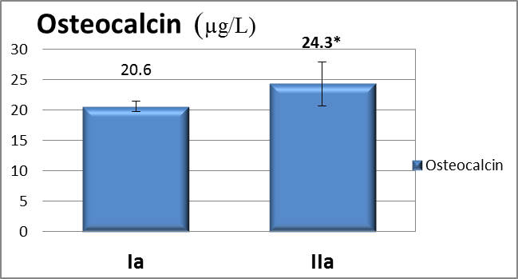
*: significant
Figure 1: Effect of exercise (group IIa) on Osteocalcin level in comparison to sedentary control group (group Ia).

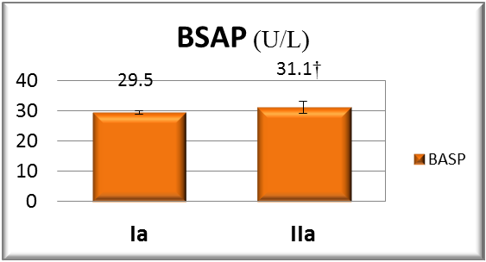
†: insignificant
Figure 2: Effect of exercise (group IIa) on Bone Specific Alkaline Phosphatase level in comparison to sedentary control group (group Ia).
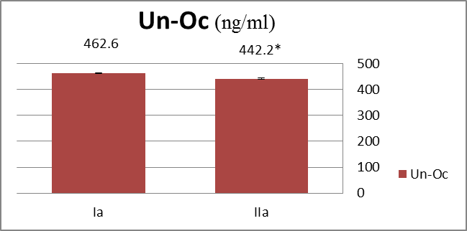

*: significant
Figure 3: Effect of exercise (group IIa) on Undercarboxylated Osteocalcin level in comparison to sedentary control group (group Ia).

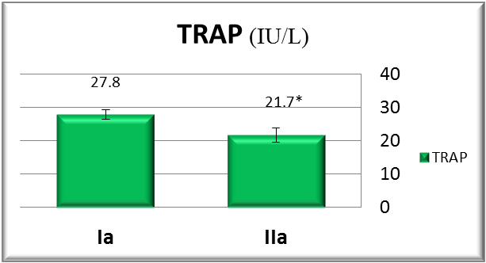
*: significant
Figure 4: Effect of exercise (group IIa) on Tartrate Resistant Acid Phosphatase level in comparison to sedentary control group (group Ia).

Within group comparison of sedentary group revealed significant decrease of bone resorption markers i.e. Undercarboxylated Osteocalcin &Tartrate Resistant Acid Phosphatase levels. (F=17.9, P=0.001& F=1.5, P <0.001 respectively). (Figures 7,8).
Vitamin D, vitamin K & both vitamins supplementation (groups Ib, Ic& Id respectively) significantly decreased Tartrate Resistant Acid Phosphatase level as compared to control group (group Ia). (Figure 8).
Vitamin K supplementation (group Ic) significantly decreased Undercarboxylated Osteocalcin level as compared to control group (group Ia) & vitamin D supplementation (group Ib). (Figure 5)
Combined vitamin D& K supplementation (group Id) significantly decreased Undercarboxylated Osteocalcin level as compared to control group (group Ia). (Figure 7)
Within group comparison of sedentary group revealed insignificant increase of bone formation markers i.e. Osteocalcin &Bone Specific Alkaline Phosphatase levels. (F=0.62, P = 0.6& F=7.4, P =0.2 respectively). (Figure 5,6).

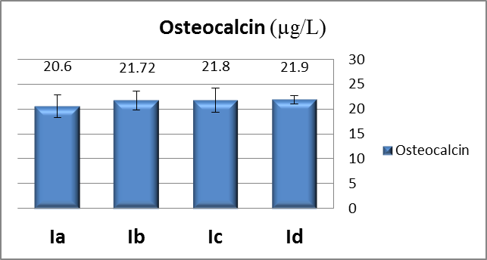
Figure 5: Effect of vitamin D 3 &/or K supplementation on osteocalcin level within sedentary groups(ANOVA test).

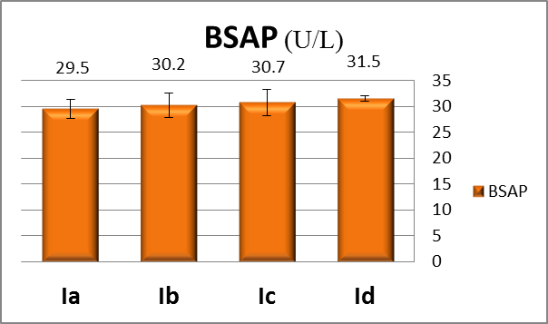
Figure 6: Effect of vitamin D3&/or K supplementation on Bone specific Alkaline Phosphatase level within sedentary groups (ANOVA test).

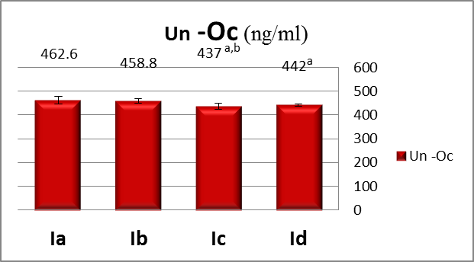
Figure 7: Effect of vitamin D3&/or K supplementation on Undercarboxylated Osteocalcin level within sedentary groups(ANOVA test).
a: Significant versus group Ia.
b: Significant versus group Ib.
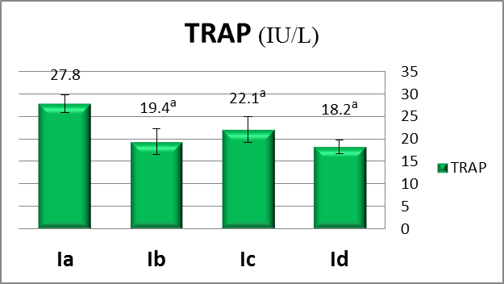
Figure 8: Effect of vitamin D3&/or K supplementation on Tartrate Resistant Acid Phosphatase level within sedentary groups (ANOVA test).

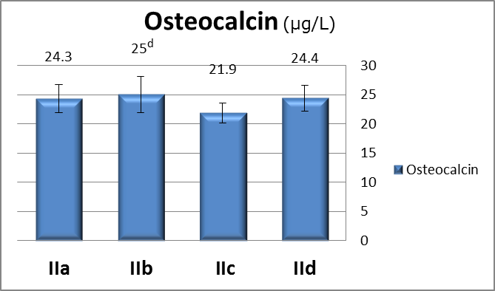

d: significant versus IIa group
Figure 9: Effect of vitamin D3&/or K supplementation on osteocalcin level within exercise groups (ANOVA test).
c:significant versus IIa group, d:significant versus IIc group

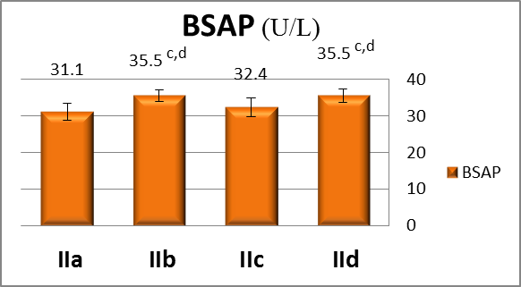
Figure 10: Effect of vitamin D3&/or K supplementation on Bone specific Alkaline Phosphatase level within exercise groups (ANOVA test).

a:significant versus group Ia
Within group comparison of exercise group revealed significant increase of bone formation markers i.e. Osteocalcin & Bone Specific Alkaline Phosphatase levels. (F=3.5, P =0.03& F=0.86, P <0.001 respectively) (Figure 8).
Combined vitamin D supplementation with exercise training (group IIb) significantly increased osteocalcin level as compared to vitamin K supplementation with exercise training (group IIc). (Figure 9).
Combined vitamin D supplementation with exercise training (group IIb) significantly increased Bone Specific Alkaline Phosphatase level as compared to exercise alone (group IIa) & vitamin K supplementation with exercise training (group IIc). (Figure 10).
Combined vitamin D&K supplementation with exercise training (group IId) significantly increased Bone Specific Alkaline Phosphatase level as compared to exercise alone (group IIa) & vitamin K supplementation with exercise training (group IIc). (Figure 10).
Within group comparison of exercise group revealed insignificant decrease of bone resorption markers i.e. Undercarboxylated Osteocalcin & Tartrate Resistant Acid Phosphatase levels (F=0.44, P =0.5& F=11.2, P =0.7 respectively). (Figure, 12).

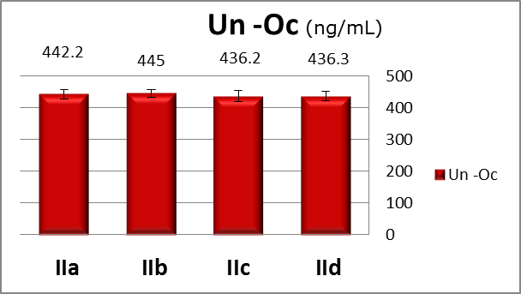
Figure 11: Effect of vitamin D3&/or K on undercarboxylated osteocalcin level within exercise groups (ANOVA test).

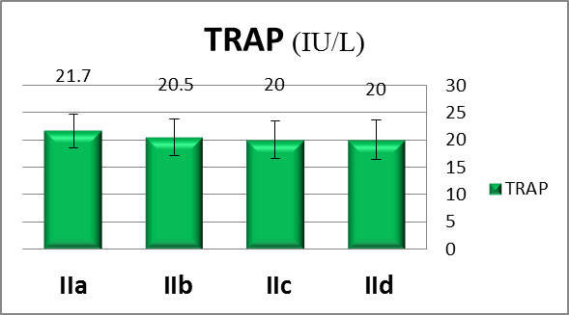
Figure 12: Effect of vitamin D3&/or K on Tartrate Resistant Acid Phosphatase level within exercise groups(ANOVA test).

4. Discussion
In the present study treadmill exercise training in ovariectomized rats for 9 weeks induced a significant increase in Osteocalcin level compared to ovariectomized control rats.
This finding is in concordance with Carstanjen et al. (2005) who reported that in racehorses osteocalcin level significantly increased 2-3 months after a control sample.
Also Pollock (2011) reported a significant increase in total osteocalcin level after exercise. He explained that bones can possibly sense environmental stimuli such as being physically active or sedentary and dictate energy regulation accordingly. Fernández-Real et al. (2009) suggested that resistance exercise led to increased serum osteocalcin concentration through increasing muscle pull, producing strains on the skeleton that are perceived by bone cells. This explanation is also supported by Bonnet & Ferrari (2010) who reported that exercise influences the skeleton by its direct impact on bone and by improving muscle mass and strength, which exerts further strains on the skeleton.
In addition Exercise decreases body weight and hence decrease Leptin secretion from adipose tissue which inturn increase bone formation (increase osteocalcin) indirectly through stimulating serotonin production and release from brain stem (i.e.leptin negatively affect bone mass) (Fanxin, 2012).
Moreover exercise increases levels of growth hormone (GH) and insulin-like growth factor (IGF)-1, which exert anabolic effects on muscle and bone. (Bonnet and Ferrari, 2010).
Contrary to our finding Nowak et al. (2008) reported that circulating osteocalcin levels in exercised rats trained for 4 weeks on a motor-driven treadmill significantly decreased in comparison to control animals.
In the present study treadmill exercise training in ovariectomized rats for 9 weeks induced insignificant change in Bone Specific Alkaline Phosphatase level (BSAP) compared to ovariectomized control rats.
This finding is in consistence with Maïmoun et al. (2005) who reported that exercise induced insignificant changes in serum BSAP and serum OC in response to a single session of strenuous exercise. Also Khorshidi et al. (2012) reported that exercise induced insignificant change in alkaline phosphatase after a period of 10 weeks.
In the present study treadmill exercise training in ovariectomized rats for 9 weeks induced significant decrease in undercarboxylated osteocalcin level (UnOc) compared to ovariectomized control rats.
According to our knowledge there is no data available on the effect of long term exercise on undercarboxylated osteocalcin, all available data study the change in the level of UnOc post-acute exercise (i.e. after a single bout of exercise) and they all report a significantly increased UnOc level shortly after acute exercise (Levinger et al., 2011). This apparent conflict with the results of the present study may be explained that our results are on long term exercise, while the available studies are on a single session of exercise. Moreover our results don't reflect the short term effect of our last exercise cession because we did the blood sampling 36h after the last cession which is relatively long duration.
In the present study treadmill exercise training in ovariectomized rats for 9 weeks induced a significant decrease in Tartrate Resistant Acid Phosphatase (TRAP) level compared to ovariectomized control rats.
This finding is in accordance with Rogers et al. (2011) who observed a significant transient decline in the bone resorption marker TRAP5b during the 2 h following a single bout of exercise.
Also Whipple et al. (2004) observed that moderate intensity resistance training acutely reduces bone resorption for at least 8 hours post exercise in untrained young men then markers return to baseline within 24 hrs.
In contrast to our results Shih et al. (2010) reported that a 12-week exercise program in obese Chinese male adolescents didn’t affect Tartrate-resistant acid phosphatase 5a level. Also Pollock (2011) reported that there was insignificant effect of exercise on bone resorption.
In the present study vitamin D supplementation in ovariectomized rats for 9 weeks induced insignificant change in Osteocalcin level compared to ovariectomized control rats.
This finding is in accordance with David et al. (2000) who reported that vitamin D supplementation for 6 months in healthy postmenopausal women (under the age of 70 years) with normal vitamin D levels, induced insignificant changes in osteocalcin level at 3 months or 6 months. Also Viljakainen et al. (2006) stated that vitamin D supplementation in adolescent girls had no effect on serum osteocalcin.
Ambroszkiewicz et al. (2009) reported that vitamin D and calcium supplementation for 4-months in children on vegetarian diet induced insignificant differences in osteocalcin level.
In contrast to the present study Herrmann et al. (2013) reported that one year of supplementation with vitamin D3 to healthy subjects significantly decreased bone formation markers osteocalcin and BSAP.
In the present study vitamin D supplementation in ovariectomized rats for 9 weeks induced insignificant change in Bone Specific Alkaline Phosphatase level compared to ovariectomized control rats.
This finding is in Concurrence with Sosa et al., (2000) who reported that 25hydroxy cholecalciferol treatment in postmenopausal osteoporotic females with femoral fractures revealed insignificant change in Alkaline Phosphatase. Similarly Barnes et al. (2006) stated that 8 weeks of vitamin D Supplementation in young adults, Induced insignificant changes on bone turnover markers.
Tanzy and Camacho (2011) reported that correction of vitamin D deficiency in postmenopausal women with osteopenia and osteoporosis with high-dose vitamin D supplementation for 1 year lead to a significant decrease in BSAP. The contradiction with the present study may be explained by the differences in dosage and duration of the study.
In the present study vitamin D supplementation in ovariectomized rats for 9 weeks induced insignificant change in Undercarboxylated Osteocalcin level compared to ovariectomized control rats.
This finding is in accordance with Takahashi et al. (2001) who reported that 4 weeks of vitamin D supplementation in premenopausal, postmenopausal healthy females and osteoporotic patients with vertebral fractures or hip fractures; did not change undercarboxylated osteocalcin while intact OC tended to increase slightly but not significantly. This is probably because vitamin D induces osteocalcin gene expression while it has no role in the post translational modification (i.e. carboxylation of osteocalcin), accordingly has no effect on Undercarboxylated Osteocalcin level. (Adams et al., 2005).
In the present study vitamin D supplementation in ovariectomized rats for 9 weeks induced significant decrease in Tartrate Resistant Acid Phosphatase level compared to ovariectomized control rats.
This finding is in Concurrence with El Khassawna et al. (2013) who reported that consumption of vitamin D and calcium-fortified dairy product by healthy postmenopausal women for 18 weeks, reduces the serum concentration of the bone resorption marker TRAP5b and increase serum IGF-I. Similarly Bonjour et al. (2009) suggests that vitamin D fortification of soft cheese consumed by elderly women with vitamin D insufficiency can reduce bone resorption marker, tartrate-resistant acid phosphatase isoform 5b.
Contrary to the present study Ambroszkiewicz et al. (2009) reported that vitamin D and calcium supplementation for 4-months in children on vegetarian diet induced insignificant differences in tartrate-resistant acid phosphatase isoenzyme 5b markers.
Kristin et al. (2012) reported that four weeks of daily supplementation with 10 μg vitamin D3in young individuals, increased tartrate-resistant acid phosphatase 5b concentration and decreased intact parathyroid hormone (iPTH), and this did not differ by mode of administration. These results suggest an increased bone resorption following vitamin D supplementation, despite a decrease in parathyroid hormone levels.
In the present study vitamin K supplementation in ovariectomized rats for 9 weeks induced insignificant change in osteocalcin level (OC) compared to ovariectomized control rats.
This finding is in Concurrence with Takahashi et al. (2001) who reported that 4 weeks of vitamin K supplementation in perimenopausal healthy and osteoporotic females, induced insignificant change in osteocalcin level.
The present study revealed that vitamin K supplementation in ovariectomized rats for 9 weeks induced insignificant change in Bone Specific Alkaline Phosphatase level compared to ovariectomized control rats.
This finding is in consistence with Binkley et al. (2009) reported that Phylloquinone and MK4 treatment reduced serum undercarboxylated osteocalcin but did not alter serum bone-specific alkaline phosphatase (BSAP). Also Bügel et al. (2007) reported that daily supplementation with phylloquinone for 6 weeks in postmenopausal women induced insignificant change in serum bone-specific alkaline phosphatase while it induced significant increase in total osteocalcin.
In the present study vitamin K supplementation in ovariectomized rats for 9 weeks induced significant decrease in undercarboxylated osteocalcin (UnOc) level compared to ovariectomized control rats (group Ia) & vitamin D supplementation (group Ib).
This finding is concurrent with Vermeer and Theuwissen, (2011); Naito et al. (2012); Miki et al., (2012); who reported that serum undercarboxylated osteocalcin (UnOc) is a marker for vitamin K metabolism. It increases in vitamin K deficiency and decreases after supplementation with vitamin K.
In support of this Takahashi et al. (2001) reported that 4 weeks of vitamin K supplementation in perimenopausal healthy and osteoporotic females, decreased undercarboxylated osteocalcin. Similarly Purwosunu et al. (2006) reported that vitamin K₂ supplementation with calcium significantly decreased UnOc level in postmenopausal women in Indonesia.
The present study revealed that vitamin K supplementation in ovariectomized rats for 9 weeks induced a significant decrease in Tartrate Resistant Acid Phosphatase level compared to ovariectomized control rats.
This finding is in consistence with Atkins et al. (2009) demonstrate that vitamin K inhibits expression of RANKL in the osteocyte cell-like line, thus it decrease osteoclastogenesis and so it decrease TRAP which is a marker of osteoclast viability. Moreover Shea et al.(2008) suggested that vitamin K’s inverse association with inflammatory markers was separate from its gamma-carboxylation function, since UnOc showed no association with these markers. This anti- inflammatory action of vitamin K plays a role in the suppression of osteoclastogenesis and so decreases tartrate-resistant acid phosphatase level.
The present study revealed that vitamin D &K supplementation in ovariectomized rats for 9 weeks induced insignificant change in osteocalcin level compared to ovariectomized control rats.
This finding is in acceptance with Je et al. (2011) who reported that combined vitamin D & K supplementation for 6 months in postmenopausal Korean women over sixty years old insignificantly increased osteocalcin level while it significantly decreased UnOc concentration.
In the present study combined vitamin D & K supplementation in ovariectomized rats for 9 weeks induced a synergistic effect that significantly increased Bone Specific Alkaline Phosphatase level compared to ovariectomized control rats, with no significant difference with other groups as detected by ANOVA.
This finding is in consistence with Binkley et al., (2009) who observed that combined vitamin K (Phylloquinone or MK4) with vitamin D &calcium supplementation for 1 year did not alter Bone Specific Alkaline Phosphatase level as compared to calcium and vitamin D supplementation alone.
In the present study combined vitamin D & K supplementation in ovariectomized rats for 9 weeks induced a significant decreased in Undercarboxylated Osteocalcin level compared to ovariectomized control rats.
This finding is in concurrence with Binkley et al. (2009) reported that combined vitamin K (Phylloquinone or MK4), vitamin D &calcium supplementation for 1 year reduced serum under carboxylated osteocalcin as compared to calcium and vitamin D supplementation.
Recently Je et al. (2011) detected that combined vitamin K2 therapy with vitamin D3 for postmenopausal Japanese women for 6 months significantly decreased UnOc concentration and improved BMD values.
In the present study combined vitamin D & K supplementation in ovariectomized rats for 9 weeks induced a significant decreased in Tartrate Resistant Acid Phosphatase level compared to ovariectomized control rats.
This finding is in consistence with Lijima et al. (2012) who reported that Both vitamins have been found to down-regulate pro-inflammatory cytokines and biomarkers, proinflammatory imbalances of cytokines such as IL-6 and tumor necrosis factor-alpha (TNF-a) are implicated in osteoporotic bone deterioration through increasing osteoclastogenesis and bone resorption (Bagger et al., 2006). Therefore combined vitamins D and K induce more reduction in bone resorption and more decrease in Tartrate Resistant Acid Phosphatase level.
On the other hand Fu et al. (2012) reported that phylloquinone, MK4 or MK7 Supplementation in ovariectomized Norway rats fed a diet that meets nutritional requirements for calcium and vitamin D, insignificantly changed Tartrate Resistant Acid Phosphatase level.

References:
- Adams, J. and Pepping, J. (2005) Vitamin K in the treatment and prevention of osteoporosis and arterial calcification. Am J Health Syst Pharm.;62(15):1574-81
- Allan, G.; and Need. (2006) Bone resorption markers in vitamin D insufficiency. Clinica Chimica Acta. Pages 48–52.
- Allison J.L.; Stephen H. and Srichord F. (2000) Measurment of osteocalcin. Ann Clin Biochem; 37; 432-446.
- Ambroszkiewicz, J.; Klemarczyk, W.; Gajewska, J.;Chełchowska, M.;Strucińska, M.; Ołtarzewski, M. and Laskowska-Klita, T. (2009) Effect of vitamin D supplementation on serum 25-hydroxyvitamin D and bone turnover markers concentrations in vegetarian children. Med Wieku Rozwoj.;13(1):34-9.
- Angel NZ, Walsh N, Forwood MR, Ostrowski MC, Cassady AI, Hume DA (2000). "Transgenic mice overexpressing tartrate-resistant acid phosphatase exhibit an increased rate of bone turnover". J. Bone Miner. Res. 15 (1): 103–10.
- Angela, M.C.; Lianne, T.; Yuna, L.; George, T.; Gillian, H.; Judy, S.; Hanxian, H; Reinhold, V.; Lilian, T.; Sophie, J. and Robert, J. (2008) Vitamin K Supplementation in Postmenopausal Women with Osteopenia (ECKO Trial): A Randomized Controlled Trial PLoS Med; 5(10): 1–12.
- Atkins, GJ.;Welldon, KJ.;Wijenayaka, AR.; Bonewald, L. and Findlay, DM. (2009) Vitamin K promotes mineralization;osteoblast to osteocyte transition;and an anti-catabolic phenotype by γ-carboxylation-dependent and -independent mechanisms. Am J Physiol Cell Physiol.;10.1152.
- Autier, P.; Haentjens, P.; Bentin, J.; Baillon, J.M.; Grivegnee. A.R,; Closon, M.C. and Boonen, S. (2000) Costs induced by hip fractures: a prospective controlled study in Belgium. Belgian Hip Fracture Study Group. Osteoporos Int;11:373-380.
- Bagger, YZ.; Tanko, LB.;Alexandersen, P.;et al. (2006) Radiographic measure of aorta calcification is a site-specific predictor of bone loss and fracture risk at the hip. J Intern Med.;259:598-605.
- Bakhtyar Tartibian; Behzad Hajizadeh Maleki; Jill Kanaley; and Karim Sadeghi. (2011) Long-term aerobic exercise and omega-3. supplementation modulate osteoporosis through inflammatory mechanisms in post-menopausal women: a randomized; repeated measures study. Nutr Metab (Lond); 8: 71.
- Barnes, MS.;Robson, PJ.;Bonham, MP.;Strain, JJ. and Wallace, JM. (2006) Effect of vitamin D supplementation on vitamin D status and bone turnover markers in young adults. European Journal of Clinical Nutrition.;60;727–733.
- Binkley, N. C.; Krueger, D. C.; Engelke, J. A.; Foley, A. L.; and Suttie, J. W. (2009a, December). Vitamin K supplementation reduces serum concentrations of under-gamma-carboxylated osteocalcin in healthy young and elderly adults. The American Journal of Clinical Nutrition;72:1523-1531.
- Body, J.J.; Bergmann, P.; Boonen, S.; Boutsen, Y.; Devogelaer, J.P.; Goemaere, S.; Kaufman, J.M.; Rozenberg, S. and Reginster, J.Y.(2010) Evidence-based guidelines for the pharmacological treatment of postmenopausal osteoporosis: a consensus document by the Belgian Bone Club. Osteoporos Int;21:1657-1680.
- Bonjour, J.P.; Benoit, V.; Pourchaire, O.; Ferry, M.; Rousseau, B.; and Souberbielle, J.C. (2009). Inhibition of markers of bone resorption by consumption of vitamin D and calcium-fortified soft plain cheese by institutionalised elderly women. The British Journal of Nutrition, 102(7), 962–6.
- Bonnet, N.; and Ferrari, S. L. (2010). Exercise and the skeleton: How it works and what it really does. IBMS Bone KEy.; 27:1112- 1121.
- Bügel, S.;Sørensen, AD.;Hels, O.;Kristensen, M.; Vermeer, C.; Jakobsen, J.;Flynn, A.; Mølgaard, C. and Cashman, KD. (2007) Effect of phylloquinone supplementation on biochemical markers of vitamin K status and bone turnover in postmenopausal women. Br J Nutr.;97(2):373-80.
- Carstanjen, B.; Amory, H.; Sulon, J.; Hars, O.; Remy, B.; Langlois, P.; and Lepage, O. M. (2005). Serum osteocalcin and CTX-MMP concentration in young exercising thoroughbred racehorses. Journal of veterinary medicine. A, Physiology, Pathology, Clinical Medicine, 52(3), 114–20.
- Cheung, A.M.; Tile, L.; Lee, Y.; Tomlinson, G.; Hawker, G.; Scher, J.; Hu, H.; Vieth, R.; Thompson, L.; Jamal, S. and Josse, R.(2008) Vitamin K supplementation in postmenopausal women with osteopenia (ECKO trial): a randomized controlled trial.PLoS Med. 14;5(10):e196.
- David Hunter;Philippa Major;Nigel Arden; Swaminathan,;Toby Andrew, et al. (2000) Randomized Controlled Trial of Vitamin D Supplementation on Preventing Postmenopausal Bone Loss and Modifying Bone Metabolism Using Identical Twin Pairs Journal of Bone and Mineral Research.;2276–2283.
- Dolbow, D.R.; Gorgey, A.S.; Daniels, J.A.; Adler, R.A.; Moore, J.R. and Gater, D.R. (2011) The effects of spinal cord injury and exercise on bone mass: A literature review. Neuro Rehabilitation. 1;29(3):261-9.
- El Khassawna T, Böcker W, Govindarajan P, Schliefke N, Hürter B, et al. (2013): Effects of Multi-Deficiencies-Diet on Bone Parameters of Peripheral Bone in Ovariectomized Mature Rat. PLoS ONE 8(8): e71665.
- Fanxin, L. (January 2012) Building strong bones: molecular regulation of the osteoblast lineage. Nature Reviews Molecular Cell Biology; 13, 27-38.
- Ferron, M.;Hinoi, E.;Karsenty, G. and Ducy, P. (2008) Osteocalcin differentially regulates beta cell and adipocyte gene expression and affects the development of metabolic diseases in wild-type mice. Proc Natl Acad Sci USA.;105: 5266– 5270.
- Fernández-Real, J. M.; Izquierdo, M.; Ortega, F.; Gorostiaga, E.; Gómez-Ambrosi, J.; Moreno-Navarrete, J. M. et al. (2009). The relationship of serum osteocalcin concentration to insulin secretion, sensitivity, and disposal with hypocaloric diet and resistance training. The Journal of Clinical Endocrinology and Metabolism.;10:210-222.
- Fu X, Moreines J, Booth S L. (2012):Vitamin K supplementation does not prevent bone loss in ovariectomized Norway rats. Nutr Metab (Lond). 20; 9(1):12.
- Glowacki, J.; Shuo Geng, M. D.; and Shuanhu Zhou, P. D. (2011). Vitamin D Metabolism in Osteoblast Progenitor Cells in Human Marrow. Orthopaedic Journal.;2:11-14.
- Halima, P. (2013). Bone Alkaline Phosphatase (BAP) a biochemical marker of bone turnover. Monograph_English_.;3:32-37.
- Herrmann, W.;Kirsch, SH.;Kruse, V.;Eckert, R.; Gräber, S.;Geisel, J. and Obeid, R. (2013) One year B and D vitamins supplementation improves metabolic Biochemical markers of bone turnover. Clin Chem Lab Med.;1;51(3):639-47.
- Iwamoto, J.;Takeda, T. and Sato, Y. (2005) Effect of treadmill exercise on bone mass in female rats. Exp Anim. 54(1):1-6.
- Je, S. H.; Joo, N.S.; Choi, B.; Kim, K.M.; Kim, B.T.; Park, S.B.;and Lee, D.J. (2011). Vitamin K supplement along with vitamin D and calcium reduced serum concentration of undercarboxylated osteocalcin while increasing bone mineral density in Korean postmenopausal women over sixty-years-old. Journal of Korean medical science, 26(8), 1093–8.
- Khorshidi, D.; Matinhomaee, H.; Azarbayjani, M.A. et al. (2012). effect of one period of aerobic exercise on serum levels of alkaline phosphatase and osteocalcin in patients with type 2 diabetes. journal of shahid sadoughi university of medical sciences and health services. 5 (80),676-19.
- Kim, SH.;Kim, HB.;Jang, MH.;Lim, BV.;Kim, YJ.; Kim, YP.;Kim, SS.;Kim, EH. and Kim, CJ. (2002) Treadmill exercise increases cell proliferation without altering of apoptosis in dentate gyrus of Sprague-Dawley rats. Dongdaemoon-gu;Seoul.;130-701.
- Kristin Holvik Ahmed, A. Madar;Haakon, E. Meyer; Cathrine, M. Lofthus and Lars, C. (2012) Stene Changes in the vitamin D endocrine system and bone turnover after oral vitamin D3 supplementation in healthy adults: results of a randomised trial. BMC Endocrine Disorders.;12:7.
- Lamb, J.J.; Holick, M.F.; Lerman, R.H.; Konda, V.R.; Minich, D.M.; Desai,A.; Chen, T.C.; Austin, M.; Kornberg, J.; Chang, J.L.; His, A.; Bland, J.S. and Tripp, M.L.(2011)Nutritional supplementation of hop rho iso-alpha acids; berberine; vitamin D₃; and vitamin K₁ produces a favorable bone biomarker profile supporting healthy bone metabolism in postmenopausal women with metabolic syndrome. Nutr Res.; 31(5):347-55.
- Levinger, I.; Zebaze, R.; Jerums, G.; Hare, D. L.; Selig, S.; and Seeman, E. (2011). The effect of acute exercise on undercarboxylated osteocalcin in obese men. Osteoporosis International .; 10 -1370-7.
- Lijima, H.;Shinzaki, S. and Takehara, T. (2012) The importance of vitamins D and K for the bone health and immune function in inflammatory bowel disease. Curr Opin Clin Nutr Metab Care.;15(6):635-40.
- Ljusberg J, Wang Y, Lång P, Norgård M, Dodds R, Hultenby K, Ek-Rylander B, Andersson G. (2005): Proteolytic excision of a repressive loop domain in tartrate-resistant acid phosphatase by cathepsin K in osteoclasts. J Biol Chem. 5; 280(31): 28370-81.
- Maïmoun, L.; Simar, D.; Malatesta, D.; Caillaud, C.; Peruchon, E.; Couret, I.; and Mariano-Goulart, D. (2005). Response of bone metabolism related hormones to a single session of strenuous exercise in active elderly subjects. British Journal of Sports Medicine. 4:44-49.
- Miki, T. and Masaki, H. (2012) New approved markers of bone turnover for osteoporosis in Japan. Clinical Calcium.;22(6):877-83.
- Mitchell, T. (2000). Stunning new research shows that vitamin K may be one of the most extraordinary anti-aging vitamins ever discovered. LE Magazine.;4:33-38.
- Naito, K.;Watari, T.;Obayashi, O.;Katsube, S.; Nagaoka, I. and Kaneko, K. (2012) Relationship between serum undercarboxylated osteocalcin and hyaluronan levels in patients with bilateral knee osteoarthritis. International Journal of Mol Med.; 29(5):756-60.
- Neil Binkley;Judith Harke;Diane Krueger and Jean Engelke.(2009) Vitamin K Treatment Reduces Undercarboxylated Osteocalcin but Does Not Alter Bone Turnover; Density; or Geometry in Healthy Postmenopausal North American Women. J Bone Miner Res; 24(6).
- Nowak, A.; Pogrzebna, M.; Celichowski, J.; and Pilaczyńska-Szcześniak, Ł. (2008). Serum Osteocalcin Concentration in Treadmill-Trained Adult Male Wistar Rats. Journal of Human Kinetics, 19(-1), 121–130.
- Parasuraman,S.; Raveendran,R. and Kesavan,R. (2010). Blood sample collection in small laboratory animals J Pharmacol Pharmacother. Jul-Dec; 1(2): 87–93.
- Pollock, N. (2011). Increased exercise improved bone turnover, insulin sensitivity, adiposity in obese children | Endocrinology.;5:45-49.
- Purwosunu, Y.;Muharram;Rachman, IA.; Reksoprodjo, S. and Sekizawa,A. (2006) Vitamin K2 treatment for postmenopausal osteoporosis in Indonesia. J Obstet Gynaecol Res.;32:230–234.
- Rogers, R. S.; Dawson, A. W.; Wang, Z.; Thyfault, J. P.; and Hinton, P. S. (2011). Acute response of plasma markers of bone turnover to a single bout of resistance training or plyometrics. Journal of Applied Physiology; 111(5), 1353–60.
- Sadat, A.; Abdulmohsen, H. Al Elq; Haifa, A. Al-Turki; Fathma, A. AlMulhim;and Amein, K. Al-Ali (2011) Influence of vitamin D levels on bone mineral density and osteoporosis. Ann Saudi Med.; 31(6): 602-608.
- Safinaz, A. Elhabashy;Omaima, M. Said; Mervat, H. Agaiby;Amr, A. Abdelrazek and Sayed Abdelhamid (2011) Diabetology & Metabolic Syndrome.;3:25-29.
- Shea, MK.;Dallal, GE.;Dawson-Hughes, B.; Ordovas, JM.;O'Donnell, CJ.;Gundberg, CM.; Peterson, JW. and Booth, SL.(2008) Vitamin K;circulating cytokines; and bone mineral density in older men and women. Am J Clin Nutr.;88(2):356-63.
- Shih, K.C.; Janckila, A.J.; Kwok, C.F.; Ho, L.T.; Chou, Y.C. and Chao, T.Y.(2010) Effects of exercise on insulin sensitivity, inflammatory cytokines, and serum tartrate-resistant acid phosphatase 5a in obese Chinese male adolescents. Metabolism; 59(1):144-51.
- Sosa, M.; Láinez, P.; Arbelo, A.; and Navarro, M. C. (2000). The effect of 25-dihydroxyvitamin D on the bone mineral metabolism of elderly women with hip fracture. Rheumatology.;220:111-118.
- Takahashi, M.;Naitou, K.;Ohishi, T.;Kushida, K. and Miura, M. (2001) Effect of vitamin K and/or D on undercarboxylated and intact osteocalcin in osteoporotic patients with vertebral or hip fractures. Clin Endocrinol (Oxf).; 54(2): 219-24.
- Tanzy, ME.;and Camacho, PM. (2011) Effect of vitamin D therapy on bone turnover markers in postmenopausal women with osteoporosis and osteopenia. Endocr Pract.;17(6):873-9.
- Vermeer, C. and Theuwissen, E. (2011) Vitamin K; osteoporosis and degenerative diseases of ageing. Menopause International.;17(1):19-23.
- Viljakainen, H. T.; Natri, A.M.; Kärkkäinen, M.; Huttunen, M.M.; Palssa, A.; Jakobsen, J.; and Lamberg-Allardt, C. (2006). A positive dose-response effect of vitamin D supplementation on site-specific bone mineral augmentation in adolescent girls: a double-blinded randomized placebo-controlled 1-year intervention. Journal of bone and mineral research : the official journal of the American Society for Bone and Mineral Research, 21(6), 836–44.
- Whipple, T.; Le, B.; Demers, L.; Chinchilli, V.; Petit, M.; Sharkey, N.; and Williams, N. (2004). Acute effects of moderate intensity resistance exercise on bone cell activity. Int J Sports Med.;11:132-137.

9/26/2014

