Synthesis, docking and anticancer activity of some new thienopyrimidine and thienooxazine derivatives

Eman Abd EL-maboud Fayed ¹*, Taghreed Zakaria Shawer²

^{1.} Department of Organic Chemistry, Faculty of Pharmacy (Girls), Al-Azhar University, Cairo, Egypt
^{2.} Department of Pharmaceutical Chemistry, Faculty of Pharmacy (Girls), Al-Azhar University, Cairo, Egypt
*alfayed_e@yahoo.com

Abstract: Synthesis of certain new fused 1,3-pyrimidine, 1,3-oxazine and 1,4-oxazepine derivatives, to produce new compounds of possible anticancer activity. Various series of 2-aryl-4,5,6,7-tetrahydrobenzo[b]thieno[2,3-d]-pyrimidin-4(3H)-one 5 a-g and 2-aryl-5,6,7,8-tetrahydrobenzo[b]thieno[3,2-e][1,3]oxazin-4(H)-one 8 a-d were synthesized. Most of the synthesized compounds exhibited antitumor activity against human breast cancer cell line (MCF-7) and against human liver carcinoma (HepG-2) in vitro. All tested compound showed the anticancer activity against HepG-2 cells with IC₅₀ ranging from 6.04 to 43.5 μg.
[Fayed EA, Shawer TZ. Synthesis, docking and anticancer activity of some new thienopyrimidine and thienooxazine derivatives. Nat Sci 2014;12(12):171-181]. (ISSN: 1545-0740). http://www.sciencepub.net/nature. 23

Keywords: 1,3-pyrimidine; 1,3-oxazine and 1,4-oxazepine derivatives; anticancer activity

1. Introduction
Fused thieno[2,3-d]pyrimidine and its analogue oxazine derivatives has been widely reported over the last years. They were shown to possess antiviral ^{1,2} and antibacterial activity. ³⁻⁶ Their remarkable medicinal properties cover also anti-inflammatory ⁷⁻⁹ and antihistaminic ¹⁰ action. Moreover, among other thieno[2,3-d]-pyrimidin-4-ones of these family, the compound 1 was recently identified as inhibitor of tumor cells proliferation. ¹¹ Diversification of this scaffold using its cyclohexane moiety afforded another potent derivative 2 displaying IC 50 of 91 nM in the p21-deficient cell line ¹² (Chart 1). The same core compounds are found to be phosphodiesterase PDE9 inhibitors, for example, 3. ^{13,14} Such inhibitors can be applied for treating memory deficits that are associated with aging and neurodegenerative disorders such as Alzheimer’s disease. ¹⁵

Chart 1

2. Material and Methods
Chemistry
All melting point were taken on Electrothermal LA9000 series, Digital Melting point Apparatus were uncorrected. IR Spectra were determined using KBr disc technique on Nikolet IR 200 FT IR Spectrophotometer at Pharmaceutical Analytical Unit, Faculty of Pharmacy, Al-Azhar University, and values are represented in (cm⁻¹). The ¹H-NMR Spectra was recorded on Varian Gemini EM-300MHz, NMR Spectrometer at Research Service Unit, Faculty of Science, Cairo University. DMSO-d ₆ was used as solvents; Chemical shifts were measured in δ ppm, relative to TMS as internal standard. Mass Spectrum were recorded at 70 ev on DI-50 unit of Schimadzu GC/ MS- QP5050A Spectrometer at Regional Center for Mycology and Biotechnology (RCMB), At–Al-Azhar University represented as m/z (relative abundance %)( formula). Element Analysis (C,H,N) were carried out at Regional Center for Mycology and Biotechnology, Al-Azhar University, the values were found to be within± 0.4 % of the theoretical ones unless otherwise indicated. Progress of the reaction was monitored by TLC using TLC sheets precoated with UV fluorescent silica gel Merck 60 F254 plates and was visualized using UV lamp.
2-Cyano-2-cyclohexylideneacetamide (1)
Prepared using reported procedure. ¹⁶
2-Amino-4,5,6,7-tetrahydro[1]benzothiophene-3-carboxamide (2)
Prepared using reported procedure. ^{17, 18}
2-Styryl-5,6,7,8-tetrahydrobenzo[b]thieno[2,3-d]-pyrimidin-4(3H)-one (3)
A mixture of compound 2 (1.96, 0.01 mol), cinnamaldehyde (1.32 g, 0.01 mol) in N, N-dimethylformamide (10 ml) in presence of KOH was heated under reflux for 6 h. The reaction mixture was cooled, poured onto ice, filtered, washed with water, then dried and crystallized from ethanol to give compound 3; yield 80%; m.p.: 292-294ºC, IR: 3166 (NH); 3035 (Ar-H); 2922, 2847 (aliphatic C-H); 1652 (C=O); 748, 681 (phenyl),¹HNMR: 1.79 (m, 4H, 2CH₂ at positions 6, 7); 2.73 (s, 2H, CH₂ at positions 5); 2.88 (s, 2H, CH₂ at positions 8); 6.95-7.00 (d, 2H, CH=CH); 7.21-7.90 (m, 5H, Ar-H); 12.30 (S, 1H, NH exchangeable by D₂O), MS (m/z %): 309 (21.56) (M+1), 308 (84.76) (M^{•+}), 179 (40.85) (C₉H₉NOS^{┐•+}), 77 (48.76) (C₆H₅^{┐•+}), 43 (100) (HNCO^{┐•+} &/or CH₃CO^{┐+}). Anal. Calcd for C₁₈H₁₆N₂OS; C, 70.10; H, 5.23; N, 9.08; Found: C, 70.34, H, 5.34, N 9.21.
2-(4-Morpholinobenzylideneamino)-4,5,6,7-tetra-hydrobenzo[b]thiophene-3-carboxamide (4a) and 2-(4-(piperazin-1-yl)benzylideneamino)-4,5,6,7-tet-rahydrobenzo[b]thiophene-3carboxamide (4b)
General procedure:
A mixture of compound 2 (1.96, 0.01 mol), respective aldehyde (0.01 mol) in N, N-dimethylformamide (10 ml) in presence of KOH was stirred at room temperature for 2 hours. The product precipitated was filtered, washed with water, then dried and crystallized from ethanol to give compound 4 a& b; For 4 a yield 80%; m.p.: 243-244ºC; IR: 3339, 3174 (NH₂); 3050 (Ar-H); 2916, 2846 (aliphatic C-H); 1650 (C=O); 812 (p-substituted phenyl),¹HNMR: 1.70-1.76 (m, 4H, 2CH₂ at positions 5, 6); 2.64 (s, 2H, CH₂ at positions 4); 2.75 (s, 2H, CH₂ at positions 7); 3.71-3.75 (m, 8H, morpholino CH); 7.02-7.05 (d, 2H, Ar-H); 7.30 (s, 2H, NH₂ exchangeable by D₂O ); 7.73-7.76 (d, 2H, Ar-H), 8.36 (s, 1H, N=CH), MS (m/z %): 370 (17.89) (M+1), 369 (77.81) (M^{•+}), 352 (100)( C₁₉H₁₈N₃O₂S^{┐•+} ), 191 (77.25) (C₁₀H₇O₂S^{┐+}),77 (13.14) (C₆H₅^{┐•+}). Anal. Calcd for C₂₀H₂₃N₃O₂S; C, 65.01; H, 6.27; N, 11.37; Found: C, 65.28, H, 6.31, N, 11.52.
For 4 b yield 75%; m.p.: 244-245ºC; IR: 3320, 3186 (2 NH); 3073 (Ar-H); 2930, 2850 (aliphatic C-H); 1660 (C=O); 885 (p-substituted phenyl),¹HNMR: 1.70 (m, 4H, 2CH₂ at positions 5, 6); 2.26 (s, 1H, NH (piperazino) exchangeable by D₂O); 2.66 (s, 2H, CH₂ at positions 4); 2.72 (s, 2H, CH₂ at positions 7); 2.88 (s, 4H, 2CH₂NH (piperazinyl CH)); 3.30 (s, 4H, 2CH₂N (piperazinyl CH)); 6.91-8.27 (m, 4H, Ar-H); 8.36 (s, 1H, N=CH); 8.55 (s, 1H, NH₂ exchangeable by D₂O). Anal. Calcd for C₂₀H₂₄N₄OS; C, 65.19; H, 6.56; N, 15.20; Found: C, 65.32, H, 6.63, N, 15.37.
2-Aryl-4,5,6,7-tetrahydrobenzo[b]thieno[2,3-d]-pyrimidin-4(3H)-one 5 a-g
General procedure:
The products were prepared by 2 methods.
Method 1:
The products were prepared starting from compounds 4 (0.01 mol) by refluxing in DMF (10 ml) in the presence of KOH for 5 hours. The product formed was filtered while hot dried and crystallized from ethanol yielded 5 b & c.
Method 2:
A mixture of compound 2 (1.96, 0.01 mol), respective aldehyde (0.01 mol) in N, N-dimethylformamide (DMF) (10 ml) in presence of KOH was refluxed for 6 hours. The product precipitated was filtered, washed with water, then dried and crystallized from ethanol to give compound 5 a, d- g.
2-(4-(Piperidin-1-yl)phenyl)-4,5,6,7-tetrahydro-benzo[b]thieno[2,3-d]pyrimidin-4(3H)-one 5 a
Compound 5 a was prepared as described from IV and 4-(piperidin-1-yl)benzaldehyde. Yield 77 %; m.p.: >300 ºC; IR: 3180 (NH); 3071 (Ar-H); 2927, 2847 (aliphatic C-H); 1657(C=O); 860 (p- substituted phenyl); ¹HNMR: 1.58 (s, 6H, 3CH₂ (piperidinyl CH)); 1.79 (s, 4H, 2CH₂); 2.72 (s, 2H, CH₂); 2.88 (s, 2H, CH₂); 3.3 (s, 4H, 2CH₂ (piperidinyl CH)); 6.95-6.98 (d, 2H, Ar-H, J=9Hz ); 7.99-8.02 (d, 2H, Ar-H, J=9Hz ); 12.14 (s, 1H, NH exchangeable by D₂O); MS m/z: 365 (1.32) (M^{•+}), 57 (100) (C₂HS^{┐+} &/or C₂H₃NO^{┐•+}), 43 (89.81) (HNCO^{┐•+} &/or CH₃CO^{┐+}). Anal. Calcd for C21H23N3OS; C, 69.01; H, 6.34; N, 11.50 Found: C, 69.17; H, 6.42; N, 11.67.
2-(4-(Piperazin-1-yl)phenyl)-4,5,6,7-tetrahydro-benzo[b]thieno[2,3-d]pyrimidin-4(3H)-one 5 b
Compound 5 b was prepared as described from IV and 4-(piperazin-1-yl)benzaldehyde. Yield 75 %; m.p.: >300 ºC; IR: 3275 (br 2NH); 3050 (Ar-H); 2923, 2834 (aliphatic C-H); 1646 (C=O); 816 (p- substituted phenyl); ¹HNMR: 1.78 (s, 4H, 2CH₂); 2.10 (s, 2H, CH₂); 2.49 (s, 2H, CH₂); 2.73 (s, 4H, 2CH₂-NH piperazinyl CH); 2.89 (s, 4H, 2CH₂-N piperazinyl CH); 7.04-7.07 (d, 2H, Ar-H J= 9 HZ); 8.07-8.10 (d, 2H, Ar-H J= 9 HZ); 8.54 (s, 2H, 2NH exchangeable by D₂O); MS m/z: 366 (0.5) (M^{•+}), 307 (12.90) (C₁₈H₁₅N₂OS^{┐+} &/or C₁₆H₁₁N₄OS^{┐+}), 77 (37.93) (C₆H₅^{┐+}), 43 (100) (HNCO^{┐•+}&/or CH₃CO^{┐+}). Anal. Calcd for C₂₀H₂₂N₄OS; C, 65.55; H, 6.05; N, 15.29; Found: C, 65.78; H, 6.11; N, 15.41.
2-(4-Morpholinophenyl)phenyl)-4,5,6,7-tetrahyd-robenzo[b]thieno[2,3-d]pyrimidin-4(3H)-one 5 c
Compound 5 c was prepared as described from IV and 4-morpholinobenzaldehyde. Yield 76 %; m.p.: >300 ºC, IR: 3318 (NH); 3056 (Ar-H); 2931, 2839 (aliphatic C-H); 1657 (C=O); 869 (p- substituted phenyl); ¹HNMR: 1.78 (s, 4H, 2CH₂); 2.49 (s, 4H, 2CH₂); 2.74 (s, 4H, 2CH₂-O morpholino CH); 2.89 (s, 4H, 2CH₂-N morpholino CH); 7.00-7.03 (d, 2H, Ar-H J= 9 HZ); 8.04-8.07 (d, 2H, Ar-H J= 9 HZ); 12.18 (s, 1H, NH exchangeable by D₂O). Anal. Calcd for C₂₀H₂₁N₃O₂S; C, 65.37; H, 5.76; N, 11.44; Found: C, 65.49; H, 5.82; N, 11.57.
2-(2-Tosylphenyl)-4,5,6,7-tetrahydrobenzo[b]-thieno[2,3-d]pyrimidin-4(3H)-one 5 d
Compound 5 d was prepared as described in method 2 from III and 2-tosylbenzaldehyde. Yield 67 %; m.p.: >300 ºC, IR: 3327 (NH); 3046 (Ar-H); 2933, 2870 (aliphatic C-H); 1646 (C=O); 840, 668 (p- & o-substituted phenyl); ¹HNMR: 1.80 (s, 4H, 2CH₂); 2.49 (s, 3H, CH₃); 2.75 (s, 2H, CH₂); 2.90 (s, 2H, CH₂); 6.92-8.13 (m, 8H, Ar-H); 12.25 (s, 1H, NH exchangeable by D₂O); MS m/z: 453 (0.5) (M+1), 298 (65.61) (C₁₆H₁₄N₂O₂S^{┐•+}), 179 (100) (C₉H₉NOS^{┐•+}), 151 (68.33) (C₈H₉NS^{┐•+}), 43 (19.93) (HNCO^{┐•+}&/or CH₃CO^{┐+}). Anal. Calcd for C₂₃H₂₀N₂O₄S₂; C, 61.04; H, 4.45; N, 6.19; Found: C, 61.25; H, 4.46; N, 6.32.
2-(2-(4-Chlorophenylsulfonyl)phenyl)-4,5,6,7-tetrahydrobenzo[b]thieno[2,3-d]pyrimidin-4(3H)-one 5 e
Compound 5 e was prepared as described in method 2 from III and 2-(4-chlorophenyl-sulfonyl)benzaldehyde. Yield 87 %; m.p.: >300 ºC, IR: 3198 (NH); 3059 (Ar-H); 2931, 2860 (aliphatic C-H); 1650 (C=O); 850, 653 (p- & o-substituted phenyl); ¹HNMR: 1.71-1.91 (m, 4H, 2CH₂); 2.62 (s, 2H, CH₂); 2.69 (s, 2H, CH₂); 6.77-8.15 (m, 8H, Ar-H); 8.64 (s, 1H, NH exchangeable by D₂O); MS m/z: MS m/z: 474 (1.50) (M+2), 300 (70.63) (C₁₆H₁₆N₂O₂S^{┐•+}), 298 (41.24) (C₁₆H₁₄N₂O₂S^{┐•+}), 179 (100) (C₉H₉NOS^{┐•+}), 151 (44.90) (C₈H₉NS^{┐•+}). Anal. Calcd for C₂₂H₁₇ClN₂O₄S₂; C, 55.87; H, 3.62; N, 5.92; Found: C, 56.04; H, 3.60; N, 6.01.
2-(4-(4-Chlorophenylsulfonyl)phenyl)-4,5,6,7-tetr-ahydrobenzo[b]thieno[2,3-d]pyrimidin-4(3H)-one 5 f
Compound 5 f was prepared as described in method 2 from III and 4-(4-chlorophenyl-sulfonyl)benzaldehyde. Yield 85 %; m.p.: >300 ºC, IR: 3282 (NH); 3050 (Ar-H); 2955, 2850 (aliphatic C-H); 1663 (C=O); 820 (p-substituted phenyl); ¹HNMR: 1.78 (s, 4H, 2CH₂); 2.73 (s, 2H, CH₂); 2.88 (s, 2H, CH₂); 6.85-8.16 (m, 8H, Ar-H); 8.41 (s, 1H, NH exchangeable by D₂O); MS m/z: 474 (2.61) (M+2), 472 (5.05) (M^{•+}), 298 (100) (C₁₆H₁₄N₂O₂S^{┐•+}), 297 (35.82) (C₁₇H₁₅NO₂S^{┐•+}), 270 (84.74) (C₁₅H₁₄N₂OS^{┐•+}), 151 (32.29) (C₈H₉NS^{┐•+}), 120 (70.17) (C₇H₄S^{┐•+}), 43 (65.92) (HNCO^{┐•+}&/or CH₃CO^{┐+}). Anal. Calcd for C₂₂H₁₇ClN₂O₄S₂; C, 55.87; H, 3.62; N, 5.92; Found: C, 55.84; H, 3.68; N, 5.99.
2-(2-(4-Bromophenylsulfonyl)phenyl)-4,5,6,7-tetr-ahydrobenzo[b]thieno[2,3-d]pyrimidin-4(3H)-one 5 g
Compound 5g was prepared as described in method 2 from III and 2-formylphenyl 4-bromobenzenesulfonate. Yield 75 %; m.p.: >300 ºC, IR: 3186 (NH); 3073 (Ar-H); 2930, 2850 (aliphatic C-H); 1660 (C=O); 885, 650 (o-, p-substituted phenyl); ¹HNMR: 1.78 (s, 4H, 2CH₂); 2.73 (s, 2H, CH₂); 2.89 (s, 2H, CH₂); 6.65-8.23 (m, 8H, Ar-H); 9.50 (s, 1H, NH exchangeable by D₂O). Anal. Calcd for C₂₂H₁₇BrN₂O₄S₂; C, 51.07; H, 3.31; N, 5.41; Found: C, 51.24; H, 3.38; N, 5.39.
2-Hydroxy-4,5,6,7-tetrahydro[1]benzothiophene-3-carboxamide (6)
A mixture of compound 2 (1.96 g, 0.005 mol) was dissolved in a mixture of water (30 ml) and hydrochloric acid (4.5 ml of 37%w/v soln). A cold solution of sodium nitrite (0.35gm, 0.005 mol) in water (1ml) was added dropwise with stirring to the cooled amine solution (0-5ºC) to yield the diazonium salt. Stirring was continued for 15 min to ensure complete reaction. Hydrolysis was done easily by adding an equal amount of water, heating in a warm water bath at 50 ºC for 30 min. After evolution of N₂ ceased, the formed precipitate was filtered, dried and crystallized from absolute ethanol to yield the target hydroxy compound. m.p.:179-180ºC, IR: 3404 (OH); 2929, 2880 (aliphatic C-H); 1664 (C=O), ¹HNMR: 1.79 (s, 4H, 2CH₂); 2.88 (s, 4H, 2CH₂); 14.96 (br. s, 1H, OH, exchangeable by D₂O). MS m/z: 196 (5.62) (M-1); 179 (65.67) (C₁₀H₁₁OS^{┐+}); 151 (100) (C₈H₉NS^{┐•+}). Anal. Calcd for C₉H₁₁NO₂S; C, 54.80; H, 5.62; N, 7.10; Found: C, 54.97; H, 5.68; N, 7.24.
6,7,8,9-Tetrahydrobenzo[b]thieno[3,2-f][1,4]oxa-zepine-2,5-dione (7)
Chloroacetyl chloride (1.13gm, 0.8ml, 0.01mol) was added to a stirred solution of compound 6 (1.97, 0.01 mol) in N,N-dimethyl formamide (DMF) (20 ml), then the mixture was heated under reflux for 5 hours. The mixture poured onto ice cold water. The solid was then filtered dried and crystallized from ethanol. m.p.:166-168ºC, IR: 3185 (NH); 2926, 2870 (aliphatic C-H); 1662 (C=O), ¹HNMR: 1.81 (s, 4H, 2CH₂); 2.90 (s, 4H, 2CH₂); 3.81 (CH₂-NH); 14.96 (br. s, 1H, NH, exchangeable by D₂O). MS m/z: 237 (9.29) (M^{•+}); 206 (100) (C₁₀H₈NO₂S^{┐•+}); 179 (95.84) (C₁₀H₁₁OS^{┐+}); 151 (78.40) (C₈H₉NS^{┐•+}). Anal. Calcd for C₁₁H₁₁NO₃S; C, 55.78; H, 4.67; N, 5.90, Found: C, 55.84; H, 4.71; N, 5.99.
2-Aryl-5,6,7,8-tetrahydrobenzo[b]thieno[3,2-e]-[1,3]oxazin-4(H)-one 8 a-d
General method:
Respective benzoyl chloride (0.01mol) was added to a stirred solution of compound 6 (1.97, 0.01 mol) in N,N-dimethyl formamide (DMF) (20 ml) in presence of triethylamine (5drops), then the mixture was heated under reflux for 6 hours. The mixture cooled, poured onto ice cold water. The solid was washed with water, and then filtered dried and crystallized from ethanol.
2-Phenyl-5,6,7,8-tetrahydrobenzo[b]thieno[3,2-e]-[1,3]oxazin-4(H)-one 8 a
Compound 8a was prepared as described in the previous method from 6 and benzoyl chloride. Yield 65 %; m.p. 97-100 ºC, IR: 3070 (Ar-H); 2947 (aliphatic C-H); 1675 (C=O); 750 (phenyl); ¹HNMR: 1.76 (br s, 4H, 2CH₂); 2.73 (s, 2H, CH₂); 2.88 (s, 2H, CH₂); 7.39-8.03 (m, 5H, Ar-H). MS m/z: 283 (0.76) (M^{•+}); 105 (14.38) (C₈H₉ ^{┐+}); 91 (10.74) (C₇H₇^{┐+}); 77 (16.72) (C₆H₅^{┐+}); 43 (100) (HNCO^{┐•+}&/or CH₃CO^{┐+}). Anal. Calcd for C₁₆H₁₃NO₂S; C, 67.82; H, 4.62; N, 4.94, Found: C, 67.98; H, 4.68; N, 4.99.
2-(4-ChloroPhenyl)-5,6,7,8-tetrahydrobenzo[b]-thieno[3,2-e][1,3]oxazin-4(H)-one 8 b
Compound 8b was prepared as described in the previous method from 6 and 4-chlorobenzoyl chloride. Yield 80 %; m.p. 197 ºC, IR: 3050 (Ar-H); 2930 (aliphatic C-H); 1671 (C=O); 834 (p-substituted phenyl); ¹HNMR: 1.90 (s, 4H, 2CH₂); 2.73 (s, 2H, CH₂); 2.88 (s, 2H, CH₂); 7.41-7.94 (m, 4H, Ar-H). MS m/z: 317 (0.50) (M^{•+}); 156 (29.96) (C₆H₅NO₂S^{┐+}); 139 (100) (C₈H₁₀S^{┐+} &/or C₇H₆OS^{┐+}); 111 (50.04) (C₆H₅Cl^{┐+}). Anal. Calcd for C₁₆H₁₂ClNO₂S; C, 60.47; H, 3.81; N, 4.41; Found: C, 60.58; H, 3.79; N, 4.52.
2-(4-FlouroPhenyl)-5,6,7,8-tetrahydrobenzo[b]-thieno[3,2-e][1,3]oxazin-4(H)-one 8 c
Compound 8c was prepared as described in the previous method from 6 and 4-flourobenzoyl chloride. Yield 88 %; m.p.: 158-160 ºC, IR: 3074 (Ar-H); 2932, 2860 (aliphatic C-H); 1678 (C=O); 848 (p-substituted phenyl); ¹HNMR: 1.74 (s, 4H, 2CH₂); 2.73 (s, 2H, CH₂); 2.98 (s, 2H, CH₂); 6.56-8.05 (m, 4H, Ar-H). MS m/z: 301 (0.01) (M^{•+}); 123 (100) (C₇H₇S^{┐+}); 95 (69.47) (C₆H₆F^{┐+}). Anal. Calcd for C₁₆H₁₂FNO₂S; C, 63.77; H, 4.01; N, 4.65; Found: C, 63.89; H, 4.09; N, 4.71.
2-(2,4-DimethoxyPhenyl)-5,6,7,8-tetrahydrobenzo-[b]thieno[3,2-e][1,3]oxazin-4(H)-one 8 d
Compound 8d was prepared as described in the previous method from 6 and 2,4-dimethoxy-benzoyl chloride. Yield 76 %; m.p.: 122 ºC, IR: 3050 (Ar-H); 2963 (aliphatic C-H); 1690 (C=O); 845 (p-substituted phenyl). MS m/z: 344 (2.02) (M+1); 165 (100) (C₉H₉OS^{┐+}); 153 (52.68) (C₇H₇NOS ^{┐•+}). Anal. Calcd for C₁₈H₁₇NO₄S; C, 62.96; H, 4.99; N, 4.08; Found: C, 63.14; H, 4.09; N, 4.71.
2-(4-Chlorophenyl)-5,6,7,8-tetrahydrobenzo[b]-thieno[2,3-d]pyrimidin-4(1H)-one (9a)
A mixture of compound 2 (1.96g, 0.01mol) and p-chlorobenzoyl chloride (1.74 g, 0.01mol) in N,N-dimethyl formamide (DMF) (10 ml) and trimethylamine (3 drops) was heated under reflux for 6 hours .The reaction mixture was cooled; poured onto ice cold water, the formed solid was filtered, dried and crystallized from ethanol. m.p: 138-140 ºC. Yield 71%; IR: 3150 (NH); 3085 (Ar-H); 2930, 2850 (aliphatic C-H); 1657 (C=O);866 (p- substituted phenyl); ¹HNMR: 1.77 (s, 4H, 2CH₂); 2.73 (s, 2H, CH₂); 2.88 (s, 2H, CH₂); 7.43-7.98 (m, 4H, Ar-H); 12.26 (s, 1H, NH exchangeable by D₂O). Anal. Calcd for C₁₆H₁₃ClN₂OS; C, 60.66; H, 4.14; N, 8.84; Found: C, 60.63; H, 4.09; N, 8.81.
2-(4-Fluorophenyl)-5,6,7,8-tetrahydrobenzo[b]-thieno[2,3-d]pyrimidin-4(1H)-one (9b)
A mixture of compound 2 (1.96g, 0.01mol) and p-flourobenzoyl chloride (1.57 g, 0.01mol) in N,N-dimethyl- formamide (DMF) (10 ml) and trimethylamine (3 drops) was heated under reflux for 6 hours. The reaction mixture was cooled; poured onto ice cold water, the formed solid was filtered, dried and crystallized from ethanol. m.p: 86-87 ºC. Yield 71%; IR: 3186 (NH); 3073 (Ar-H); 2930, 2870 (aliphatic C-H); 1660 (C=O); 885 (p- substituted phenyl); ¹HNMR: 1.78 (s, 4H, 2CH₂); 2.73 (s, 2H, CH₂); 2.89 (s, 2H, CH₂); 6.96-7.95 (m, 4H, Ar-H); 8.60 (s, 1H, NH exchangeable by D₂O). MS m/z: 301 (0.06) (M+1), 300 (0.08) (M^{•+}), 140 (66.19) (C₆H₈N₂S^{┐•+}), 123 (100) (C₇H₇S^{┐+}), 95 (66.98) (C₆H₅F^{┐•+}). Anal. Calcd for C₁₆H₁₃FN₂OS; C, 63.98; H, 4.36; N, 9.33; Found: C, 64.00; H, 4.30; N, 9.37.
Docking studies
All docking studies were performed using "Internal coordinate Mechanics (Molsoft ICM 3.5-0a)" as follow:
Generation of the structures of ligands and enzymes:
2qu5 ¹⁹ were downloaded through the Protein Data Bank PDB/ RCSB site (http://www.rcsb.org/pdb/home/home.do) and saved as *.pdb file.
Molecular modeling of the target compounds were built using ChemDraw Ultra version 9.0.3 and minimized their energy through Chem3D Ultra version 9.0.3/ MOPAC, Jop Type: Minimum RMS Gradient of 0.010 kcal/mol and RMS distance of 0.1 ºA, and saved as MDL MolFile (*.mol).
Conversion of PDB files (2qu5) into ICM objects:
This conversion involves addition of hydrogen bonds, assignment of atoms types, and charges from the residue templates.
Click on Mol Mechanics/ Convert/ Protein, and then delete water molecules.
Docking using Molsoft ICM 3.4-8C program: ^{20,21}
Setting up docking project:
Setting project name:
Clicking on Docking/ Set project name, pressing OK.
Setting up the receptor:
Clicking on Docking/ Receptor Setup, entering the receptor molecule in the receptor molecule data entry box (a_*), then clicking on identify the binding sites button to identify the potential ligand binding pockets, pressing OK.
After the receptor setup is complete, the program normally displays the receptor with selected binding site residues highlighted in yellow Xstick presentation.
Reviewing and adjusting binding sites:
ICM makes a box around the ligand binding site based on the information entered in the receptor setup section. The position of the box encompasses the residues expected to be involved in ligand binding. Clicking on the menu Docking/ Review/ Adjust ligand/ Box.
Making receptor maps:
The step now is to construct energy maps of the environment within the docking box by clicking on menu Docking / Make Receptor Maps and selecting the resolution of the map by entering a value into the grid cell size data entry box which is 0.5.
Starting docking simulation:
The interactive docking was used to dock one ligand at a time by clicking on menu Docking/ Interactive docking / Mol Table Ligand, using the drop down arrow to find the table of ligand and / or compounds we wish to dock, and then entering the thoroughness which represents the length of simulation. Generally 1 is reasonable value, selecting Calc. ICM Score, then selecting Display run which display the ligand sampling the energy in the ligand binding project.
Displaying the result:
Clicking Docking/ Browse/ Stack Conformations.
Evaluation of the Antitumor Activity
Mammalian cell lines: The cell lines that used in this study were Human breast cancer cell line (MCF-7 cells) and human hepatocellular cancer cell line (HepG₂ cells). All cell lines were obtained from Vacsera Tissue Culture Unit.
The mammalian cells were propagated in Dulbecco’s modified Eagle’s medium (DMEM) or RPMI-1640 depending on the type of cell line supplemented with 10% heat-inactivated fetal bovine serum, 1% L-glutamine, HEPES buffer and 50µg/ml gentamycin. All cells were maintained at 37ºC in a humidified atmosphere with 5% CO₂ and were subcultured two times a week along experimentation.
Antitumor activity evaluation using viability assay:
The extracts or pure compounds were tested against two tumor cell lines i.e., Breast cancer cell line (MCF-7) and liver carcinoma cell line (HepG2). All the experiments concerning the cytotoxicity evaluation were performed and analyzed by tissue culture unit at the Regional Center for Mycology and Biotechnology RCMB, Al-Azhar University, Cairo, Egypt. Antitumor viability assay was carried according to the method described by (Saintigny et al., 2004).
Procedure:
The tumor cell lines were seeded in 96-well plate in 100µl of growth medium at a cell concentration of 1×10⁴ cells per well. After 24 h of seeding, the monolayers were then washed with sterile phosphate buffered saline (0.01 M pH 7.2) and simultaneously the cells were treated with 100 µl from different dilutions of the test sample in fresh maintenance medium and incubated at 37ºC. Serial two-fold dilutions of the tested compound (50, 25, 12.5, 6.25, 3.125 and 1.56 µg/ml) were added to confluent cell monolayers dispensed into 96-well, flat-bottomed microtiter plates (Falcon, NJ, USA) using a multichannel pipette. The microtiter plates were incubated at 37ºC in a humidified incubator with 5% CO₂ for a period of 24 h. Untreated cells were served as controls. Three independent experiments were performed each containing six replicates for each concentration of the tested samples. The cytotoxic effects of the tested compounds were then measured using crystal violet staining viability assay. Briefly, after 24-h of treatment, the medium was removed, 100 μL of 0.5% of crystal violet in 50% methanol was added to each well and incubated for 20 minutes at room temperature and subsequently excess dye was washed out gently by distilled water. The plate was allowed to dry then the viable crystal violet-stained cells were lysed using 33% glacial acetic acid solution. Absorbance at 570 nm was then measured in each well using microplate reader (SunRise, TECAN, Inc, USA). Doxorubicin was used as positive control. The absorbance is proportional to the number of surviving cells in the culture plate. Thus, using this colorimetric procedure, the tested compounds-mediated cell lysis and the cytotoxic effect of doxorubicin (used as a positive control) were measured and compared to the viability of untreated cells.
Because the stock solutions to prepare the different concentrations from the tested compounds were solubilized in DMSO, controls with DMSO alone were performed in parallel for each concentration. ²²⁻²⁶
Data analysis
The percentage cell viability was calculated using the Microsoft Excel®. Percentage cell viability was calculated as follows: according to the following calculation: the percentage of cell viability = [1− (ODt/ODc)] × 100%, where ODt is the mean optical density of wells treated with the tested compound and ODc is the mean optical density of untreated cells. The test compounds were compared using the IC₅₀ value, i.e., the concentration of an individual compound leading to 50% cell death that was estimated from graphical plots of surviving cells vs compound concentrations.

3. Results and Discussion
Chemistry
Reaction of cyclohexanone in dry benzene, with cyanoacetamide, ammonium acetate and glacial acetic acid ²⁷ afforded 2-cyano-2-cyclohexylidine-acetate (1). Cyclization of 1 with sulfur applying Gewald's reaction conditions ^{16, 27} yielded ethyl 2-amino-4,5,6,7-tetrahydro[1]benzothiophene-3-carbo-xylate (2). The main start 2 reacted in three pathways, firstly with cinnamaldehyde in dimethylformamide DMF in the presence of potassium hydroxide (KOH) and reflux to afford compound 3. ²⁸ The presence of signals of aromatic protons in the ¹HNMR spectrum and the presence of NH absorption band in the IR spectrum confirmed the formation of compound 3. The reaction was with 4-(piperazin-1-yl)benzaldehyde and 4-morpholino-benzaldehyde in the same solvent system and stirring at room temperature gave the target compounds 4 a&b the presence of N=CH and aromatic protons in the ¹HNMR spectrum and the presence of NH₂ absorption bands in the IR spectrum confirmed the formation of open structure 4 a& b. the compounds number 5 a-g were synthesized by two ways firstly by refluxing compounds 4 a&b in the same solvent system for 5hours or by refluxing the compound 2 with substituted aldehydes in DMF and KOH for 6 hours. The absence of N=CH in addition to the presence of aromatic protons in the ¹HNMR spectrum and the presence of NH absorption bands in the IR spectrum explained the formation of closed 5 a-g. (Scheme 1).

Scheme 1: Synthesis of compounds 1 -5

Scheme 2 starting by diazotization ²⁹ and hydrolysis of 2 brought about 2-hydroxy-4,5,6,7-tetrahydro[1]benzothiophene-3-carboxamide (6). The reaction of compound 2 with chloroacetyl chloride gave 6,7,8,9-Tetrahydrobenzo[b]thieno[3,2-f][1,4]-oxazepine-2,5-dione (7). The presence of O=C-CH₂-NH in ¹HNMR and the absence of broad OH in the IR spectrum confirmed the formation of compound 7. Compound 6 also reacted with derivatives of benzoyl chloride afforded 8. These compounds were confirmed by the presence of aromatic protons in the ¹HNMR spectrum and the absence of OH and NH₂ in ¹HNMR spectrum and IR spectrum. Furthermore the compound 2 was reacted with benzoyl chloride derivatives to afford pyrimidine derivative which confirmed by spectral data. (Scheme 2)
Biological activity:
Out of fifteen compounds, nine compounds were selected depending on the docking study to be evaluated in the of MCF-7 and HepG-2 cells. All tested compound showed the anticancer activity against HepG-2 cells with IC₅₀ ranging from 6.04 to 43.5 μg (Table 3). Compound 9b elicited the highest antitumor activity against the two cell lines with IC₅₀ 8.6 and 6.04 μg against MCF-7 and HepG-2 respectively. Studying the structure-activity-relationships of oxazine and pyrimidine derivatives (8c,d and 5a-f) revealed that, oxazines showed higher activity than pyrimidines in both cells. Comparing anticancer activities of compounds 5a-f where the pyrimidine ring is substituted with orho or para substituted phenyl, compound 5e with ortho 4-chlorophenylsulfonate group imparts higher activity than 5d with ortho 4-tolylsulfonate group therefore; the electron wihdrawing group in this position is favored for anticancer activity. Introduction of substitutedphenylsulfonate group in para position decrease the anticancer activity. Among compounds with heterocyclic ring 5a-c, it was obvious that, compound 5a bearing pipridine ring has slight better activity than 5b,c having piprazine or morpholine ring .against MCF-7 while piprazine and morphine increase the activity against HepG-2 cells.

Scheme 2: Synthesis of compounds 6 -9

Table 1: % Viability of MCF-7 cells
Viability % |  |  |  |  |  | compounds
50 μg | 25 μg | 12.5 μg | 6.25 μg | 3.125 μg | 1.56 μg
46.81 | 82.76 | 90.45 | 90.23 | 99.17 | 100 | 5a
61.48 | 89.43 | 97.36 | 99.64 | 100 | 100 | 5b
54.78 | 72.41 | 80.69 | 91.46 | 96.81 | 98.72 | 5c
43.59 | 65.73 | 80.92 | 89.47 | 95.69 | 98.16 | 5d
18.97 | 29.42 | 43.71 | 78.34 | 90.76 | 96.81 | 5e
57.12 | 69.23 | 82.77 | 93.51 | 98.46 | 100 | 5f
20.39 | 34.65 | 76.34 | 89.26 | 96.87 | 99.04 | 8c
22.78 | 37.36 | 54.19 | 62.74 | 79.61 | 91.87 | 8d
13.27 | 24.78 | 36.29 | 59.43 | 83.78 | 94.82 | 9b
Table 2: % Viability of HepG-2 cells
Viability % |  |  |  |  |  | compounds
50 μg | 25 μg | 12.5 μg | 6.25 μg | 3.125 μg | 1.56 μg
38.97 | 81.46 | 89.52 | 98.18 | 100 | 100 | 5a
31.64 | 76.27 | 87.49 | 95.22 | 98.74 | 100 | 5b
34.98 | 69.17 | 88.73 | 96.56 | 99.08 | 100 | 5c
23.75 | 41.34 | 64.29 | 79.43 | 85.62 | 92.40 | 5d
10.28 | 16.32 | 34.19 | 57.76 | 69.88 | 83.64 | 5e
37.98 | 78.42 | 91.53 | 98.48 | 100 | 100 | 5f
13.67 | 31.05 | 42.89 | 66.72 | 89.26 | 95.24 | 8c
9.64 | 17.08 | 48.81 | 69.37 | 83.68 | 92.01 | 8d
6.83 | 12.94 | 23.17 | 47.91 | 78.34 | 92.57 | 9b

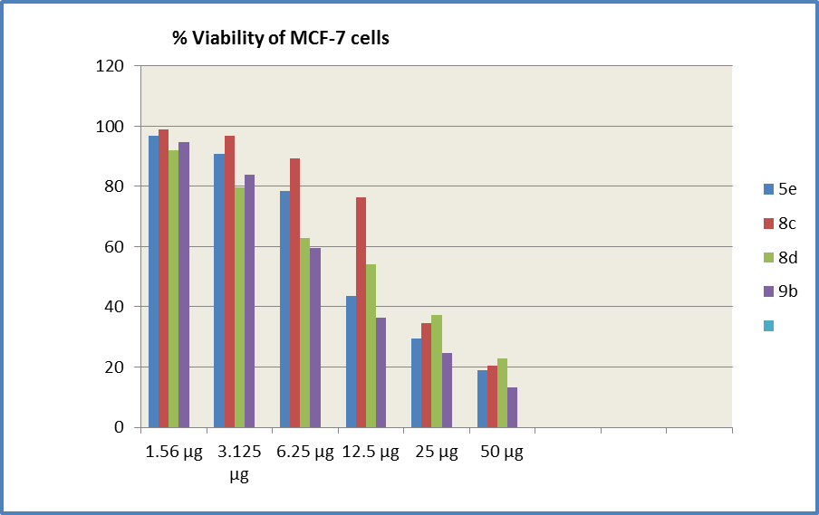
Figure 1: % Viability of MCF-7 cells

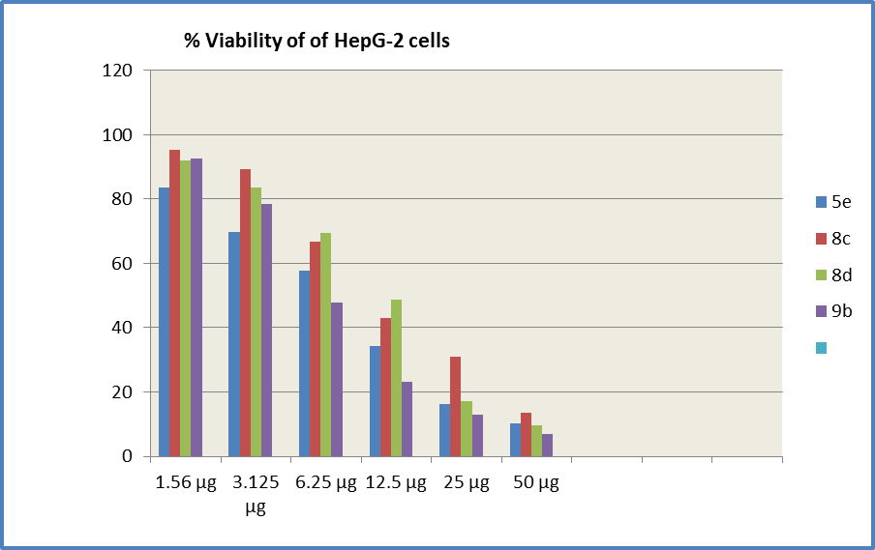
Figure 2: % Viability of HepG-2 cells

Table 3: IC50 of the test set of compounds against human breast cancer cells MCF-7 and human hepatocellular carcinoma cell line HepG2
Compounds | IC₅₀(μg)  MCF-7 cells | IC₅₀(μg) HepG-2 cells
5a | 47.8 | 43.5
5b | >50 | 39.7
5c | >50 | 39
5d | 42.8 | 20.3
5e | 11.4 | 8.31
5f | >50 | 42.6
8c | 20.4 | 10.6
8d | 15.6 | 12.1
9b | 8.8 | 6.04

VEGFR-2 (KDR) docking simulation:
One of the key features of the cocrystal structure of some inhibitors bound KDR is the reorganization of Phe 1047 (of the Asp 1046, Phe 1047, Gly 1048 triad, the “DFG” motif) to induce the inactive “DFG-out” conformation. This conformational change inhibits the ability of the kinase to bind ATP productively and accommodates the binding of an appropriately substituted inhibitor into an extended lipophilic pocket. ¹⁹
KDR requires other binding features including close proximity to the gate keeper site (Val 916) and hinge-region (Cys 919). ³⁰

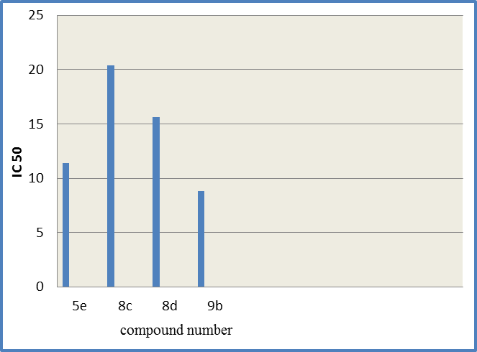
Figure 3: Cytotoxicity of 5e, 8c, 8d & 9b against human breast cancer cells MCF-7

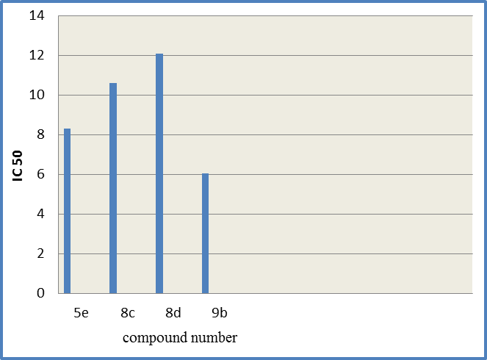
Figure 4: Cytotoxicity of 5e, 8c, 8d & 9b against human hepatocellular carcinoma cell line HepG2

In our investigation, the 3D-coordinates in X-ray structure of KDR in complex with the ligand, 4-(2-(4-Chloro-3-(trifluoromethyl)phenyl)amino)-1H-benzimidazol-5-yl)oxy)-N-methyl-2-pyridinecarboxamide; (PDB code 2qu5) ¹⁹ were used as the receptor model in KDR docking simulation.
The docked model of ligand revealed ICM score of -98.1 and forms four H bonds with: Cys 919 (2 H bonds), with Glu 885 (strong H bond) and Asp1046 (1 H bond), (table 4).
On the other hand, the docking study of our target compounds (table 4) revealed that: All compounds showed docking scores ranging from -65.37 to -96.55 Kcal/mol., most compounds formed hydrogen bonds with Glu 885 and Asp1046 similar to ligand. The most active compound, 9b formed four hydrogen bonds inside the active site of VEGFR-2 with Asp1046, Glu 885 and Lys 868. (Figure5). Compound 5e formed six hydrogen bonds with the five amino acids, (Table 4).

Table 4: ICM Scores of the compounds, and hydrogen bonds formed with amino acid residues and their lengths
Length of  hydrogen bond(A) | Atom of ligand  involved | Involved group of  amino acid | No. of  hydrogen  bonds | ICM  scores | Compounds
2.51  1.97  2.05  2.43 | n4  h5  h12  h4 | C919 hn  E885 oe2  C919 o  D1046 o | 4 | -98.13 | Ligand
2.19  2.13 | n1  h9 | D1046 hn  E885 oe2 | 2 | -75.74 | 5a
1.89  2.03 | o1  h18 | C919 hn  E885 oe2 | 2 | -73.76 | 5b
2.18  2.13 | n1  h9 | D1046 hn  E885 oe2 | 2 | -70.57 | 5c
2.45  0.91 | o3  h9 | D1046 hn  E885 oe2 | 2 | -96.55 | 5d
1.63  1.27  2.12  0.87  2.63  1.80 | o3  o2  n1  o4  o4  h9 | K868 hz1  D1046 hn  D1046 hn  F1047 hn  G1048 hn  E885 oe2 | 6 | -79.65 | 5e
1.60  2.47 | n1  h9 | D1046 hn  E885 oe2 | 2 | -88.49 | 5f
1.97  2.68 | o2  n1 | C919 hn  C919 hn | 2 | -68.48 | 8c
1.64  2.78 | o2  o3 | C919 hn  D1046 hn | 2 | -65.37 | 8d
1.68  1.99  2.73  2.68 | o1  o1  n1  h5 | K868 hz1  K868 hz2  D1046 hn  E885 oe1 | 4 | -66.69 | 9b

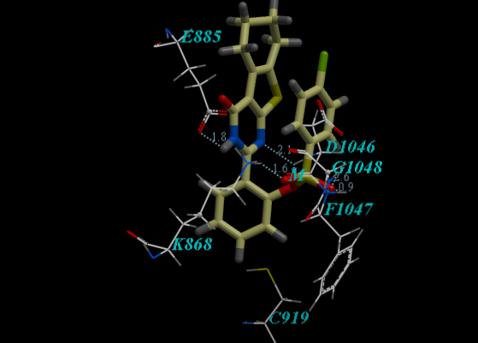
Figure 5: The proposed binding mode of compound 5e in the binding site of KDR, created with Molsoft ICM-Pro software
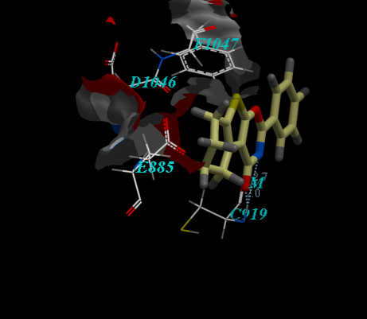
Figure 6: The proposed binding mode of compound 8c in the binding site of KDR, created with Molsoft ICM-Pro software

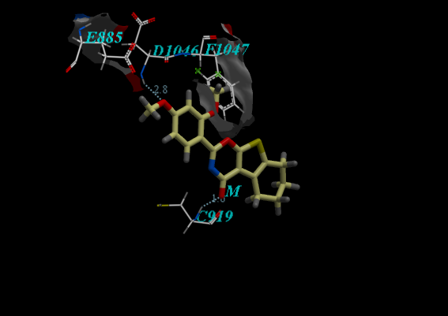
Figure 7: The proposed binding mode of compound 8d in the binding site of KDR, created with Molsoft ICM-Pro software

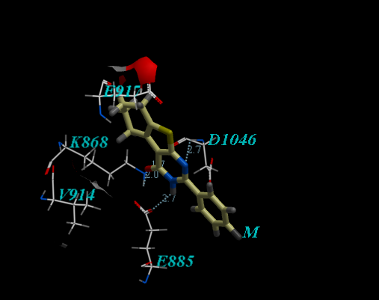
Figure 8: The proposed binding mode of compound 9b in the binding site of KDR, created with Molsoft ICM-Pro software

Corresponding Author:
Dr. Eman Abd EL-maboud Fayed
Department of Organic Chemistry
Faculty of Pharmacy (Girls), Al-Azhar University, Cairo, Egypt
E-mail: *alfayed_e@yahoo.com

References
- Thakur, C. S.; Jha, B. K.; Dong, B.; Gupta, J. D.; Silverman, K. M.; Mao, H.; Sawai, H.; Nakamura, A. O.; Banerjee, A. K.; Gudkov, A.; Silverman, R. H. Proc. Natl. Acad. Sci. U.S.A. (2007), 104 (23), 9585–9590.
- Silverman, R. Chem. Abstr. (2007), 147, 496301; Patent WO 2007127212, 2007.
- Kapustina, M. V.; Kharizomenova, I. A.; Shvedov, V. I.; Radkevich, T. P.; Shipilova, L. D. Pharm. Chem. J. (1992), 26 (1), 73–75.
- Hafez, H. N.; El-Gazzar, A. B. A Bioorg. Med. Chem. Lett. 2008, 18 (19), 5222–5227.
- Balasubramanian, N.; Meena, K.; Nitin, J.; Avinash, D.; Chandrasekaran, S. Bioorg. Med. Chem. Lett. (2006), 16 (18), 4951–4958.
- Prasad, M. R.; Prashanth, J.; Shilpa, K.; Kishore, D. P. Chem. Pharm. Bull. (2007), 55 (4), 557–560.
- Alagarsamy, V.; Vijayakumar, S.; Solomon, V. R. Biomed. Pharmacother. (2007), 61 (5), 285–291.
- Alagarsamy, V.; Shankar, D.; Solomon, V. R. ARKIVOC 2006, 16, 149–159.
- Manhas, M. S.; Sharma, S. D.; Amin, S. G. J. Med. Chem. (1972), 15, 106–107.
- Shishoo, C. J.; Shirsath, V. S.; Rathod, I. S.; Yande, V. D. Eur. J. Med. Chem. (2000), 35 (3), 351–358.
- Wang, Y. D.; Johnson, S.; Powell, D.; McGinnis, J. P.; Miranda, M.; Rabindran, S. K. Bioorg. Med. Chem. Lett. (2005), 15 (16), 3763–3766.
- Jennings, L. D.; Kincaid, S. L.; Wang, Y. D.; Krishnamurthy, G.; Beyer, C. F.; McGinnis, J. P.; Miranda, M.; Discafani, C. M.; Rabindran, S. K. Bioorg. Med. Chem. Lett. 2005, 15 (16), 4731–4735.
- Gotanda, K.; Shinbo, A.; Nakano, Y.; Kobayashi, H.; Okada, M.; Asagarasu, A. Chem. Abstr. (2006), 146, 81884; Patent WO 2006135080, 2006.
- Gotanda, K.; Shinbo, A.; Nakano, Y.; Kobayashi, H.; Okada, M.; Asagarasu, A. Chem. Abstr. (2008), 149, 734240; Patent WO 2008072778, 2008.
- Van der Staay, F. J.; Rutten, K.; Barfacker, L.; DeVry, J.; Erb, C.; Heckroth, H.; Karthaus, D.; Tersteegen, A.; Van Kampen, M.; Blokland, A.; Prickaerts, J.; Reymann, K. G.; Schroder, U. H.; Hendrix, M. Neuropharmacology (2008), 55, 908–918.
- Gewald, k.; Z. Chem. 1962, 2, 305; through chem. Abstr. (1963), 58, 6770.
- Gewald, K.; Schinke, E.; Bőttcher, H.; Chem Ber., (1966), 99, 94.
- Chusheng, H.; Zhe, Z.; Shuhua, L.; Yulin, L.; J. Chem. Res (S)., (1999), 148.
- Potashman, M. H., Bready, J., Coxon, A., DeMelfi, Jr., T. M., DiPietro, L., Doerr, N., Elbaum, D., Estrada, J., Gallant, P., Germain, J., Gu, Y., Harmange, J., Kaufman, S. A., Kendall, R., Kim, J. L., Kumar, G. N., Long, A. M., Neervannan, S., Patel, V. F., Polverino, A., Rose, P., Plas, S., Whittington, D., Zanon, R., and Zhao H., J. Med. Chem., (2007), 50, 4351-4373.
- Abagyan, R. A., Totrov M. M., J. Mol. Biol., (1994), 235, 983-1002.
- Abagyan, R. A., Totrov M. M., and Kuznetsov, D. N. J. Comp. Chem., (1994), 15, 488-506.
- Saotome K, Morita H, Umeda M., Toxicol In Vitro, (1989), 3(4):317-21.
- Kueng W, Silber E, Eppenberger U., Anal Biochem, (1989), 182(1):16-19.
- Gangadevi, V. and Muthumary, J., African Journal of Biotechnology. (2007), 6: 1382-1386.
- Wilson, A. P. A Practical Approach, 3rd ed. (ed. Masters, J. R. W.) Oxford University Press, (2000).
- Mosmann, T., J. Immunol. Methods; (1983), 65: 55-63.
- Arya, V. P. Indian J. Chem., (1975), 10, 1141.
- Sergey G. Dzhavakhishvili,, Nikolay Yu. Gorobets,, Svetlana V. Shishkina, Oleg V. Shishkin, Sergey M. Desenko,† and Ulrich M. Groth, J. Comb. Chem. (2009), 11, 508–514
- Stakey, G. W.; Villaescusa, F. W.; Wollner, T. E. J. Org. Chem., (1965), 30, 4074.
- Dinges, J., Ashworth, K. L., Akritopolou-Zanze, I. Arnold, L. D., Baumeister, S. A. Bousquet, P. F., Cunha,G. A., Davidsen,S. K. Djuric, S. W., Gracias, V. J., Michaelides, M. R., Rafferty, P., Sowin, T. J., Stewart, K. D., Xia Z. and Zhanga H. Q., Bioorg & Med. Chem. Lett., (2006), 16, 4266–4271.

12/21/2014

