Composting of Fertilizers from Threshed Palm Fruit Bunch (TPFB) With Poultry Droppings as Activator and Its Agronomic Evaluation

*T.O. Chukwudi, M.K. Bakare and O. Odeyemi

Department of Microbiology, Obafemi Awolowo University, Ile-Ife Nigeria
*Corresponding author, e-mail: timmy4good@yahoo.com

Abstract: Production of compost fertilizer from threshed palm fruit bunches (TPFB) using poultry droppings as activator was investigated. Two composting piles of TPFB mixed with poultry droppings (ratio 1:1 and 2:1) and TPFB without activator (control) were formulated. Parameters such as bacterial and fungal counts, temperature, pH, C/N ratio and elemental contents were determined. The poultry treated composting piles recorded between 7.0 x 10⁴ cfu/g to 2.0 x 10⁸ cfu/g and 1.0 x 10⁴ cfu/g to 6.0 x 10⁶ cfu/g for bacterial and fungal counts respectively while the control pile recorded 6.0 x10⁴ cfu/g to 2 x 10⁷ cfu/g for bacterial count and 5 x 10⁵ cfu/g to 4.0 x 10⁷ cfu/g for fungal count. The bacterial and fungal species isolated and identified include Corynebacterium sp., Salmonella sp., Enterobacter sp., Arthrobacter sp., Serratia sp., Kurthia sp., Pseudomonas sp., Proteus sp., Escherichia sp., Bacillus sp., Actinomyces, Aeromonas sp., Chromobacterium sp., Acinetobacter sp., Micrococcus sp., Edwarsiella sp., Rhizopus sp., Alterneria sp., Aspergillus niger., Mucor sp., Ulocladium, sp., Penicillium sp., Aspergillus flavus. and yeast. The maximum temperature of the treated piles was 39ºC while the control pile was 35ºC. The poultry treated piles had C/N ratio of 11.1 and 14.6 while the control pile had 28.9. The end products contained appreciable amount of N, P, K but very low levels of heavy metals were detected in the final compost. The agronomic evaluation of the composts showed that all the composts especially the poultry treated piles had positive effect on maize growth.
[T.O. Chukwudi, M.K. Bakare and O. Odeyemi. Composting of Fertilizers from Threshed Palm Fruit Bunch (TPFB) With Poultry Droppings as Activator and Its Agronomic Evaluation. Nat Sci 2014;12(12):148-155]. (ISSN: 1545-0740). http://www.sciencepub.net/nature. 20

Key words: Threshed palm fruit bunches, composting, poultry droppings, C/N ratio, Microbial population

1. 0 Introduction
With great concern over the increased production of wastes in the world, modern concept of environmental management is based on the recycling of wastes. In this regard, recycling organic wastes through appropriate biological treatments render many wastes safe and often produce valuable organic matter which can be of great value to the farmers. Thus, Parr et al. (1986) noted that when agricultural and municipal organic wastes are properly managed through composting, the end product (compost) has the capability of improving soil productivity which can lead to about 60 % food production increase worldwide. Composting has been described as a viable means of transforming various organic wastes into products that can be used safely and beneficially as biofertilizers and soil conditioners (Odeyemi, 2011). Composting can be applied to many waste products to release nutrients and render them safe to use (Jones and Martin, 2003).
In Nigeria, the potentials for compost have been recognized long ago, but its exploitation has remained at rudimentary level abandoned to peasant poor farmers (Odeyemi, 1998), and most of the potential biodegradable/compostable wastes such as food residues, farm yard materials, agricultural wastes, human and livestock manure are rather thrown away instead of converting them into valuable products (compost). One of the agricultural wastes commonly generated in Nigeria is the oil palm bunch refuse. Nigeria, as the third largest oil palm producing country after Malaysia and Indonesia, generates large amounts of threshed palm fruit bunches (TPFB), fibres/nuts, palm oil mill effluent (POME), and trunk/fronds during palm oil processing. Of all the aforementioned wastes, TPFB, the ligno-cellulose fibrous medium left after bunch stripping, remains the most abundant of all these wastes (Baharuddin et al., 2009).
In many oil palm plantations, producers have access to a plentiful supply of this waste material which is mostly used as mulch and as fuel to generate heat for oil processing. Large proportions of this by- product are often heaped in the open in an oil mills and plantation fields where they not only contribute to the emission of green house gases into the atmosphere, but attract mosquitoes, beetles, rodents, scorpions, soldier-ants and snakes. Also, the dumping of TPFB on land results in pollution of the surrounding area as the TPFB still contains oil which can be distributed through the local environment. Composting TPFB in a controlled condition is a possible way to transform the bulky bunches into a valuable soil conditioner for use in crop productions. Through composting, the nutrients locked up in threshed palm fruit bunch could be released and rendered safe to use instead of using them directly as mulch which tends to lead to nitrogen immobilization as threshed palm fruit bunch has wide C:N ratio. However, in order to attain the goal of having quality end products from composting, monitoring and understanding the various microorganisms involved in a composting process are highly necessary. To this effect, the objective of this research was to investigate the rotting characteristics of composting TPFB using different concentrations of poultry droppings which served as activator.

2.0 Methodology
2.1 Sources of Materials
Threshed palm fruit bunches (TPFB) was collected from ENPOST farm in Ilesha, Osun State, Nigeria, the poultry droppings used as activator was collected from the Teaching and Research Farm of Obafemi Awolowo University, Ile-Ife, Nigeria.
2.2 Compost Preparations
The (TPFB) was shredded into loose fibrous material with a milling machine. Three composting piles were prepared with locally made palm baskets lined with polythene sheets as follows: the first pile (TPFB-P1) had 3 kg of threshed palm fruit bunch and 3 kg of poultry droppings which translate to ratio 1:1 w/w, the second pile (TPFB-P2) had 4 kg of threshed palm fruit bunch and 2 kg of poultry droppings which translate to ratio 2:1 w/w, the third pile (TPFB) had 6 kg of threshed palm fruit bunch without an activator. Water was added to the piles until moisture content was adjusted between 40-60%. Subsequent watering was done when the piles were turned once every week.
2.3 Sampling and Analysis
The microbial load and identification of the isolates were carried out on each composting piles at the beginning of the compost preparation and subsequently weekly until full compost maturity stage. The temperature of the compost was measured at the start of the composting process and repeated at the interval of 3 days until the full compost maturity stage. The pH of the piles were measured at the beginning of compost preparation and subsequently repeated weekly until full maturity stage of the various composts.
2.4 Microbial Analysis
The dilution plate count method was used to enumerate the microorganisms in each compost pile. A sample (10 g) from 3 different locations of each pile was mixed with sterile distilled water (90 ml) and then shaken vigorously. Serial dilutions of this stock were made and then appropriate dilutions were plated. Nutrient agar and Potato Dextrose Agar (PDA) were used in the estimation of bacteria and fungi populations respectively. Fungi were characterized and identified according to Barnett and Hunter, (1980). Biochemical tests such as Gram stain, spore stain, catalase, gelatin liquefaction test, methyl red-Voges Proskauer (MRVP), oxidative- fermentation, citrate utilization, sugar fermentation, motility, indole and nitrate reduction were carried out to identify the bacterial isolates using conventional techniques. The bacterial isolates were identified using Bergey’s Manual of Determinative Bacteriology (Holt and Krieg, 1984).
2.5 Germination index.
The test was done at the end of composting period to evaluate the compost toxicity using seed germination. Germination index was determined using an adaptation of the method of Zucconi et al., (1981). Ten grammes (10 g) of screened sample was shaken with 100 ml of distilled water for 1 h. The suspension was centrifuged for 15 min at 3000 rpm and the supernatant was filtered through a Whatman No 6 filter paper. Ten soybean seeds were placed on filter paper Whatman No 1 in a Petri dish of 10 cm diameter. Two milliliter (2 ml) of the extract was added to the Petri dish and 2 ml of distilled water was used for the control sample. The test was run in triplicate. Petri dishes were left on laboratory bench and after 48 h, the total length of each soybean root was measured. If the seeds did not germinate, their root length was considered to be 0 mm. The germination index was estimated using the formula below:
Relative seed germination (%)
= Number of seeds germinated in the extract x 100
Number of seeds germinated in the control

Relative root elongation (%)
= Mean root elongation in the extract x 100
Mean root elongation in the control

GI = (% Seed germination) x (% Root elongation)
100

Where

GI = Germination Index

2.6 Physico-Chemical Analysis
The temperature of each composting piles were measured using a mercury thermometer graduated in degree Celsius. The pH of the piles were determined in 1:10 (w/v) distilled water soluble extract. Chemical analysis of the composts such as C, N, P, K, Ca, Mg, Zn, Fe, Mn, Cu, Cr were determined according to AOAC (1995).

2.7 Agronomic evaluation
The matured composts were tested in a potted experiment to assess their effects on maize crop. Black polythene bags holding 2 kg of garden soil were used. Each compost treatment was combined with the garden soil in a ratio 1:2 (w/w) of soil and each treatment prepared in triplicate. A control (soil without compost treatment) was also prepared. In all, a total of twenty four labelled pots were used for the analysis. The pots were irrigated with tap water and left to stand for 3 d after which seeds of the maize were planted in each pot. Three seeds were planted per pot. After germination, the pots were thinned down to two plants per pot and random sampling was done on a weekly basis for a period of five weeks to determine the plant height, while the dry and fresh weight yield of the maize plants per pot for all the treatments were done on 35 d after planting (DAP). Maize heights were measured using a meter rule, and the fresh and dry weight of harvest for all the treatments (treated and untreated (control) pot) and their replicates were determined immediately after harvest by weighing the plants. After taken the fresh weights, the plant was put in an oven at 105ºC for 24 h. The dry weight was calculated as the change in weight following the oven drying to the total fresh weight.

3.0 Results
3.1 Temperature regime of composting piles: The temperature variations of each composting piles are illustrated in Fig. 1. As shown on this figure, the initial temperature regime of all composting piles ranged between 27 and 28ºC. As composting commenced, the temperature of all piles rapidly increased to maximum after 3-6 days. The high temperature ranged between 35 and 39ºC was maintained for the next one week. The highest temperature (39ºC) was observed in TPFB-P1 on the sixth day which was slightly higher than TPFB-P2 (37ºC) on the third day, while that of TPFB (control pile) was 35ºC on the sixth day. After attaining these respective maximum temperatures, the temperature of each pile decreased continuously and then fall below 30ºC on day 24 for the control pile and day 27 for both TPFB-P1 and TPFB-P2.
3.2 pH regime of composting piles: The weekly pH of composting piles are shown in Fig. 2. As can be observed in this figure, the initial pH of composting piles ranged between 6.46 and 7.9. During composting process, the pH of the piles fluctuated till the end of composting. At the end of composting, the pH was in the range of 7.68 to 8.25.
3.3 Microbial populations of composting piles: Microbial populations of composting piles are presented in Table 1. From this table, TPFB-P1 had the highest bacterial and fungal load which ranged from 9.0 x 10⁵ cfu/g to 2.0 x 10⁸ cfu/g for bacteria and 3.0 x 10⁴ cfu/g to 2.0 x 10⁶ cfu/g for fungi. The bacterial and fungi populations of TPFB-P2 ranged from 7.0 x 10⁴ cfu/g to 9.0 x 10⁷ cfu/g and 1.0 x 10⁴ cfu/g to 1.0 x 10⁶ cfu/g respectively while TPFB (control pile) ranged between 6 x 10⁴ cfu/g to 2.0 x 10⁷ cfu/g for bacteria and 4.0 x 10³ cfu/g to 5.0 x 10⁵ cfu/g for fungi.
3.4 Nutrients changes of composting piles: There was significant different at p< 0.05 in the initial and final nutrients of the piles (Table 2). Total nitrogen, organic carbon, phosphorus, potassium and some micronutrients in the composts of TPFB (control pile) were significantly lower than that of TPFB-P1 and TPFB-P2. However, the nutrient levels of TPFB-P1 and TPFB-P2 varied slightly depending on the concentration of activator (poultry droppings).
The C/N ratio of all compost piles decreased at the end of composting (Table 2). At the end of 60 days composting, the C/N ratio of all piles ranged between 11.1 and 28.9. The TPFB-P1 had the lowest C/N ratio (11.1) while the TPFB (control pile) had the highest C/N ratio (28.9). The C/N ratio of TPFB-P2 was 14.6.
3.5 Physical changes of composting plies: As shown on Plate 1, shredding of oil palm bunches, produced stringy strands of porous fibres which lost substantial amounts of water making it to appear crystalline. At the end of 60-day composting, the strands of the threshed palm fruit bunch were no longer recognizable especially in TPFB-P1 and partially in TPFB-P2. Also, all the mature composts exhibited varying degree of blackish color in the following order TPFB-P1>TPFB-P2>TPFB (control pile) (Plate 1).

3.6 Effect of final composts on maize plant height, fresh and dry weight
The mean plant height (cm) of maize plants fertilized with the different composted threshed palm fruit bunch taken at 7, 14, 21, 28 and 35 day after planting (DAP) is shown on Table 3. The mean height of maize plant after 35 d showed that there was no significant (p<0.05) difference. In the height of the maize plant treated with threshed palm fruit bunch supplementedwith poultry dropping (1:1) (69.80) and the threshed palm fruit bunch treated with poultry dropping (2:1) (68.75). The threshed palm fruit bunch without any activator on the other hand, recorded mean height of 62.65. On the other hand, the mean fresh and dry weights of maize plants treated with each of the composted threshed palm fruit bunch at 35 DAP are shown on Table 4. Composted threshed palm fruit bunch treated with poultry droppings (1:1) yielded significant higher fresh and dry weights (78.30 g and 7.38 g) while threshed palm fruit bunch treated with poultry droppings (2:1) yielded fresh and dry weights of 70.00 g and 7.21 g. Threshed palm fruit bunch without activator yielded fresh and dry weights of 59.03 g and 5.16 g. The lowest mean height of maize was recorded under the soil alone (that is soil without the treatment of any of the composts).

4.0 Discussion
Composting is a microbiological process that depends on the growth and activity of mixed populations of bacteria and fungi that are indigenous to the wastes being composted. In the present study, the total heterotrophic bacterial loads in all the compost were greater than the fungal population. This demonstrated that bacteria were the predominant microbes. This agreed with the report of Ryckeboer et al. (2003) who noted that during composting, the numbers of bacteria are usually higher than the numbers of other microorganisms including fungi. In the first two to three weeks of composting there was rapid increase of microbial load in all composting piles. The phenomenon was equally observed by Klamer and Baath (1998) who reported that microbes proliferating in the composting processes would be adapted to the composting environment and selected by factors within the composting materials. Thus microbial load varied among the piles with TPFB-P1 having the highest microbial load. The TPFB-P1 and TPFB-P2 piles are heterogeneous, so also are their initial microbial communities. The higher microbial load of TPFB-P1 may be due to the concentration of the activator, which agreed with the work of Fuchs (2010) who reported that during composting microorganisms are influenced by the composition of the substrate and temperature in the pile. Hargerty et al. (1999) also reported that maximum increase in microbial population of composting is dependent on the rich nutrient composition of the composting materials and favourable environmental conditions of the composting milieu, the rate of increase in microbial population of the piles was dependent on the supply of nutrient in the composting and other environmental factors such as temperature and pH.
The pH values of the piles which ranged between 6.46 and 8.25 (Fig. 1), was appropriate for organic matter degradation (Kulcu and Yaldiz, 2004). The increase in the pH of all the piles at the end of composting may be attributed to microbial activity as a result of transformation of organic N into ammonia (NH₃) or NH₄⁺. The increase in pH value can be an indicator of maturity at the level of the three composted piles studied (Saidi et al., 2008). Absence of foul odour from the piles even with high pH in the piles showed that there was sufficient oxygen in all the piles as insufficient levels of oxygen has been reported to result in NH₃- decay reaction and production of different nitrogen compounds including amines which causes the emission of foul odour in compost piles as reported by Goldstein (2001).
The bacterial and fungal species isolated and identified include Corynebacterium sp., Salmonella sp., Enterobacter sp., Arthrobacter sp., Serratia sp., Kurthia sp., Pseudomonas sp., Proteus sp., Escherichia sp., Bacillus sp., Actinomyces, Aeromonas sp., Chromobacterium sp., Acinetobacter sp., Micrococcus sp., Edwarsiella sp., Rhizopus sp., Alterneria sp., Aspergillus niger., Mucor sp., Ulocladium, sp., Penicillium sp., Aspergillus flavus. and yeast. All the isolated bacteria and fungi have been reported to be associated with waste and wastes degradations (Obire et al., 2002; Anastas et al., 2005; Adegunloye et al., 2007). Majority of the isolates were soil microbes widely found in nature. Except for the high diversity of enteric organisms in the piles treated with poultry droppings as activator, there was no much difference in the diversity of the microbes isolated from the different compost treatments. The similarity in the microorganisms isolated from the different piles could be due to the similar prevailing temperature and pH of the piles. Salmonella, Escherichia and Enterobacter which were isolated in the early weeks of composting in the piles treated with poultry droppings were all eliminated at the completion of the composting.
The temperature values (27-39ºC) obtained in this study occurred within the mesophilic range (25-45ºC). This is an indication that the organic materials of all the piles experienced similar degradation process. The inability of the piles to exhibit the 3 typical phases (mesophilic, thermophilic and mesophilic) associated with many composting system might be due to the small size of the composting system in this study which concurred with Kutzner (2007), who reported that the heat produced in the metabolism of microbes cultivated on a small scale is rapidly dissipated to the environment. However, each composting mass experienced rapid rise in temperature immediately after pilling in the first week of composting. The rapid rise in temperature may be due to rapid mineralization of organic carbon and nitrogen contained in the composting piles by the microorganisms (Kutzner, 2007). All the piles attained their respective maximum temperatures within 6 days of composting which may be as a result of high microbial activities in the first week of composting. The TPFB-P1 pile attained the highest temperature (39ºC) than the other piles due to the high nutrient content in this pile required by the active microorganisms which corresponded well with the higher microbial populations of these piles.
A C/N ratio lower than 20 is the criterion used in this study to determine the maturity of composts (Huang et al., 2006). The C/N ratios of all composting pile decreased greatly at the end of 60 days composting. However, only the TPFB-P1 and TPFB-P2 compost piles had C/N ratios lower than 20 (11.1 and 14.6 for TPFB-P1 and TPFB-P2 respectively) at the end of composting whereas TPFB (control) pile still had C/N ratio higher than 20, an indication that most of the lignin and cellulose content of the control pile were yet to be degraded to the minimum level by the composting microorganisms. As a consequence, more time is required for the microorganisms to act on these substrates. On the other hand, the lower C/N ratios of TPFB-P1 (11.1) and TPFB-P2 (14.6) at the end of 60 days composting demonstrated that the organic matter decomposition of these piles especially TPFB-P1 (11.1) had been depleted to the best level for soil application as shown by the reduction of C/N ratio. According to Zucconi et al. (1981), a germination index (a factor of relative seed germination and relative root elongation) of ≥ 60 % indicated the disappearance of phytotoxins in composts. This recommended value was reached by all composts at the end of 60 d composting as germination idex (GI) of 78 %, 99 %, 91 % were recorded for threshed palm fruit bunch alone (control pile), threshed palm fruit bunch treated with poultry droppings (1:1), threshed palm fruit bunch treated with poultry droppings (2:1) respectively.
The end products contained appreciable amount of N, P and K. However, the compost treated with poultry droppings (1:1) had the highest levels of these nutrients (2.30 %, 0.46 % and 3.1 %) followed by that treated with poultry droppings (2:1) (1.8 %, 0.46 % and 2.48 %), while the control pile had the least of these nutrients (1.12 %, 0.23 % and 2.34 %). The higher content of N, P and K in the piles treated with activator (poultry droppings) than the control pile suggested that most of the nutrients in these piles were derived from the poultry droppings.
The agronomic evaluation of the end products showed that all the composts had positive effect on maize growth. It is pertinent to state that higher height, fresh and dry weights of maize were obtained with the threshed palm fruit bunch treated with poultry droppings than that without activator. This is an indication that composting threshed palm fruit bunch with activator such as poultry droppings tends to enhance the compost quality of threshed palm fruit bunches more than when this waste is allowed to rot on its own.
The study concluded that threshed palm fruit bunch can be transformed into organic fertilizer using simple and traditional composting method. However, addition of poultry droppings as source of nitrogen produced better stable end product at 60 days than TPFB (Control).

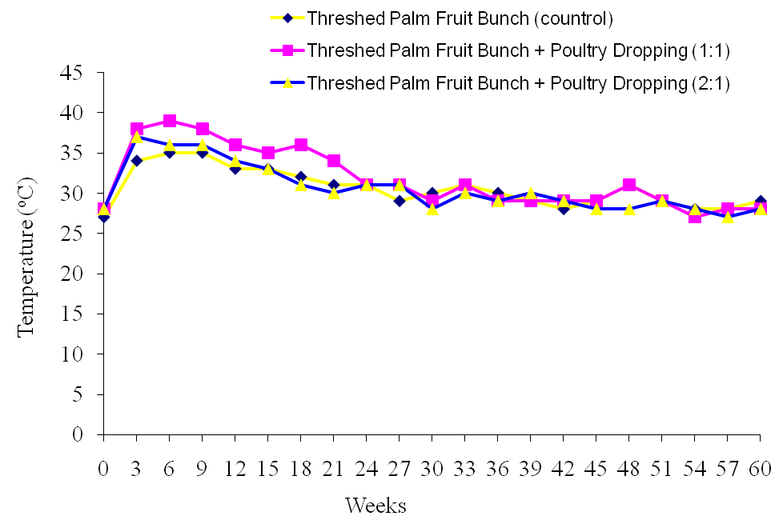
Figure 1: Temperature changes of threshed palm fruit bunch following 60 days of composting

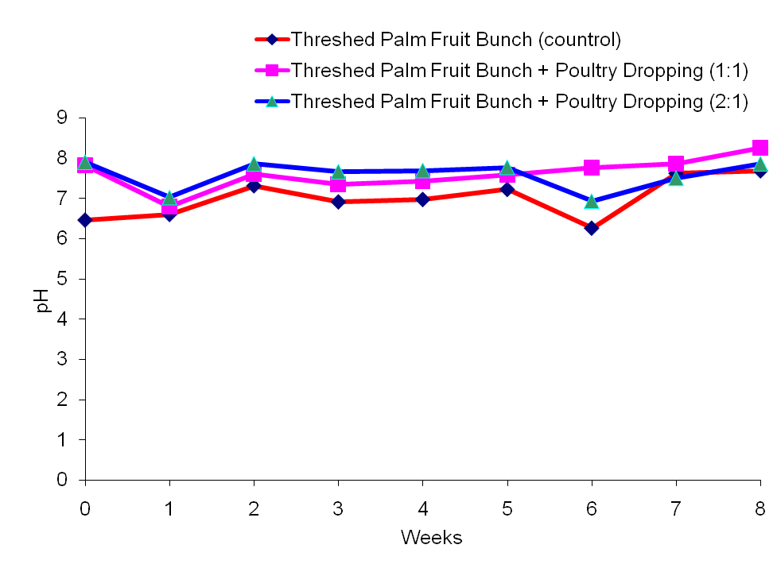
Figure 2: Weekly pH changes of threshed palm fruit bunch following 60 days of composting

Table 1: Total heterotrophic bacterial and fungal populations of threshed palm fruit bunch
Days | TPFB |  | TPFB-P1 |  | TPFB-P2
 | Bacteria (cfu/ml) | Fungi (sfu/ml) | Bacteria (cfu/ml) | Fungi (sfu/ml) | Bacteria (cfu/ml) | Fungi (sfu/ml)
0 | 4.0 x 10⁵ | 6.0 x 10⁴ | 1.0 x 10⁶ | 3.0 x 10⁵ | 8.0 x10⁵ | 1.0 x 10⁵
7 | 4.0 x 10⁶ | 3.0 x 10⁵ | 9.0 x 10⁷ | 6.0 x 10⁵ | 6.0 x10⁷ | 3.0 x 10⁵
14 | 2.0 x 10⁷ | 5.0 x 10⁵ | 2.0 x 10⁸ | 2.0 x 10⁶ | 9.0 x10⁷ | 1.0 x 10⁶
21 | 5.0 x 10⁶ | 5.0 x 10⁵ | 2.0 x 10⁸ | 6.0 x 10⁶ | 7.0 x10⁷ | 8.0 x 10⁵
28 | 2.0 x 10⁶ | 3.0 x 10⁵ | 6.0 x10⁷ | 8.0 x 10⁵ | 3.0 x10⁷ | 7.0 x 10⁵
35 | 6.0 x 10⁶ | 4.0 x 10⁵ | 2.0 x 10⁷ | 5.0 x 10⁵ | 1.0 x10⁷ | 1.0 x 10⁵
42 | 4.0 x 10⁶ | 3.0 x 10⁵ | 5.0 x 10⁷ | 2.0 x 10⁵ | 8.0 x10⁶ | 8.0 x 10⁴
49 | 3.0 x 10⁵ | 3.0 x 10⁵ | 3.0 x 10⁶ | 1.0 x 10⁵ | 5.0 x10⁵ | 2.0 x 10⁴
60 | 6.0 x 10⁴ | 4.0 x10³ | 9.0 x 10⁵ | 3.0 x 10⁴ | 7.0 x10⁴ | 1.0 x 10⁴
Keys:
TPFB Threshed palm fruit bunch alone (Control)
TPFB-P1 threshed palm fruit bunch treated with poultry droppings (1:1)
TPFB-P2 threshed palm fruit bunch treated with poultry droppings (2:1)

Table 2: Initial and final chemical level of threshed palm fruit bunch following 60 days of composting
Treatments | The initial chemical parameters of the different compost piles
 | (%w/w ) |  |  |  |  |  | Mg/kg (Dry Matter) |  |  |  |  |  | C/N
 | C | N | P | K | Ca | Mg | Zn | Fe | Cu | Mn | Cr | Pb
Threshed palm bunch alone (control) | 41.60 | 0.95 | 0.40 | 2.15 | 0.67 | 0.07 | 7 | 313 | 1 | 23 | 6 | 0 | 43.8
Threshed palm bunch + poultry droppings (1:1) | 40.45 | 1.85 | 0.44 | 2.58 | 1.20 | 0.12 | 8 | 314 | 1 | 27 | 15 | 0 | 21.9
Threshed palm bunch + poultry dropping (2:1) | 39.85 | 1.60 | 0.27 | 2.23 | 0.98 | 0.18 | 8 | 168 | 0 | 12 | 9 | 0 | 24.9
Treatments | The final chemical parameters of the different compost piles
 | (%w/w ) |  |  |  |  |  | Mg/kg (Dry Matter) |  |  |  |  |  | C/N
 | C | N | P | K | Ca | Mg | Zn | Fe | Cu | Mn | Cr | Pb
Threshed palm bunch alone (control) | 32.41 | 1.12 | 0.23 | 2.34 | 0.82 | 0.09 | 11 | 1005 | 0 | 58 | 4 | 0 | 28.9
Threshed palm bunch + poultry droppings (1:1) | 25.55 | 2.30 | 0.46 | 3.10 | 2.40 | 0.15 | 11 | 528 | 0 | 74 | 14 | 0 | 11.1
Threshed palm bunch + poultry dropping (2:1) | 26.25 | 1.80 | 0.46 | 2.48 | 1.76 | 0.49 | 12 | 4104 | 2 | 215 | 7 | 0 | 14.6

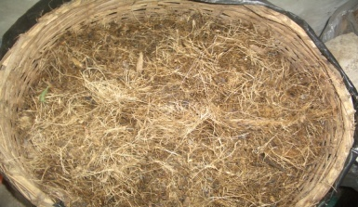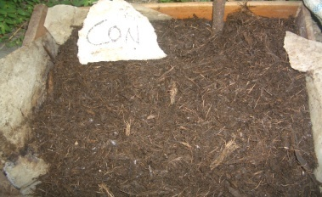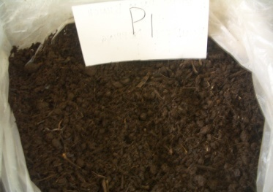
A
B
C

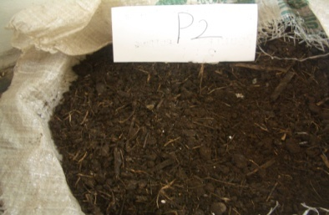
D
Plate 1: Physical changes during composting (A) Shredded TPFB (day 0); (B) TPFB (control pile) (day 60); (C) TPFB-P1 (day 60); (D) TPFB-P2 (day 60)

Table 3: Mean plant height (cm) of maize fertilized with the different threshed palm fruit bunch composts
Treatments | Days after planting (DAP)
 | 7 | 14 | 21 | 28 | 35
Threshed palm bunch alone (control) | 11.0b | 22.50c | 31.0c | 44.45c | 62.65b
Threshed palm bunch + poultry droppings (1:1) | 13.45a | 26.75a | 40.75a | 51.70a | 69.80a
Threshed palm bunch + poultry dropping (2:1) | 10.20c | 24.65b | 35.40b | 47.95b | 68.75a
Blank (Soil only) 8.50d 12.70d 20.60d 30.10d 46.75c
Values followed by the same letters in a column are not significantly different at p < 0.05 according to Student-Newman-Kuels Test.

Table 4: Mean fresh and dry weights of maize fertilized with different matured different Composted palm fruit bunch
 | Parameters (g)
Treatments | Wet weight Dry weight
Threshed palm bunch alone (control) 59.03c 5.16b
Threshed palm bunch + poultry dropings (1:1) 78.30a 7.38a
Threshed palm bunch + poultry dropping (2:1) 70.00b 7.21a
Blank (Soil only) 10.89d 0.99c
Values followed by the same letters in a column are not significantly different at p < 0.05 according to Student-Newman-Kuels Test.

Reference
- Adegunloye, D. V., Adetuyi, F. C., Akinyosoye, F. A. and Doyeni M. O. (2007). Microbial analysis of compost using cowdung as booster. Pakistan Journal of Nutrition, 6(5): 506-510.
- Anastas, A., Varese, G. C. and Marchisio, V. F. (2005). Isolation and identification of fungal communities in compost and vermicompost. Mycologia, 97(1): 33-44.
- AOAC (1995). Official Methods of Analysis of Association of official Analytical Chemists. William Horwitz (ed). Association of Official Analytical Chemists Publication.
- Baharuddin, A. S., Kazunori, N., Abd-Aziz, S., Tabatabaei, M., Abdul Rahman, N. A., Hassan, M. A., Wakisaka, M., Sakai, K. and Shirai, Y. (2009). Characteristics and microbial succession in co-composting of oil palm empty fruit bunch and partially treated palm oil mill effluent. The Open Biotechnology Journal, 3: 87-95.
- Barnett, E. A. and Hunter, B. H., 1980. Illustrated Genera of Imperfect Fungi. Bruges Publishing Company, Minneapolis, Pp. 13-55.
- Fuchs, J. G. (2010). Interactions between beneficial and harmful microorganisms: From the composting process to compost application. In: Insam H. et al. (eds) Microbes at work. Springer-Verlag Berlin Heidelberg, pp 213-229.
- Goldstein, N. (2001). Controlling odours in biosolids recycling. Biocycle, 42(3): 67-70.
- Hargerty, D. J., Pavoni, J. L. and Heer, J. E. (1999). Solid waste management van Nostrant Reinhold, New York, pp. 12-13.
- Holt, J. G. and Krieg, N. M. (1984). The Shorter Bergey’s Manual of Determinative Bacteriology. 8th Ed., Williams and Wilkins, Baltimore, pp. 551-770.
- Huang, G. F., Wu, Q. F., Wong, J. W. C. and Nagar, B. B. (2006). Transformation of organic matter during co composting of pig manure with sawdust. Bioresource Technology, 97:1834-1842.
- Jones, P. and Martin, M. (2003). A Review of the literature on the occurrence and survival of pathogens of animals and humans in green compost. WRAP. Pp. 1-34.
- Klamer, M. and Baath, E. (1998). Microbial community dynamics during composting of straw material studied using phospholipid fatty acid analysis. FEMS Microbiol Ecol. 27: 9-20.
- Kulcu, R. and Yaldiz, O. (2004). Determination of aeration rate and kinetics of composting some agricultural waste. Bioresource Technology, 93: 49–57.
- Kultzner, H. J. (2007). Microbiology composting. Retrieved from http://www.wiley-vch.de/books/biotech/pdf/v11c_comp.pdf on 3/6/2007.
- Obire, O., Nwaubeta, O. and Adue, S. B. N. (2002). Microbial Community of a Waste Dump site. Journal of Applied Sciences and Environmental Management. 6(1): 78-83.
- Odeyemi, O. (2011). Development of quality control standards for organic fertilizer in Nigeria: the producer’s perspective. Paper Delivered at a 1-day Planning Meeting on the development of quality control standards for organic fertilizer in Nigeria held at Chida Hotels, Abuja, 16th February, 2011.
- Odeyemi, O. (1998). Solid waste management and recycling in Nigeria: Some current recycling practices. Centre for African Settlement Studies and Development: Ibadan. Pp. 12-19.
- Parr, J. F., Papendick, R. I. and Colacicco, D. (1986). Recycling of wastes for a sustainable agriculcure. Biological Agriculture and Horticulture, 3: 115-130.
- Ryckeboer, J., Mergaert, J., Coosemans, J., Deprins, K. and Swings, J. (2003). Microbial aspects of biowaste during composting in a monitored compost bin. Journal of Applied Microbiology, 94:127–137.
- Saidi, N., Cherif, M., Jedidi, N. Mahrouk, M., Fumio, M., Boudabous, A. and Hassen, A. (2008). Evolution of biochemical parameters during composting of various waste compost. American Journal of Environmental Sciences. 4(4): 332-341.
- Zucconi, F., Pera, A., Forte, M. and de Bertoldi, M. 1981). Evaluating toxicity of immature compost. Biocycle, 22(2): 54-57.

12/20/2014

