**Study the Effect of Emitted Gases from the Used Fertilizers on Some Meteorological Elements in Egypt**

M.M. Eid1*, Amgad Saber1, Fathy M. El-Hussainy1 and Mosaad Kotb Hassanein2

1. Astronomy and Meteorology Dept., Fac. of Sci., Al-Azhar Univ., Cairo, Egypt.

2. Central Laboratory of Agricultural Climate (CLAL), Agricultural Research Center, Ministry of Agriculture

[*mm_eid2000@yahoo.com](mailto:*mm_eid2000@yahoo.com)

**Abstract:** Greenhouse gases (CO2 and N2O) play an important role in the atmospheric chemistry. The agricultural sector is the second largest sector's contribution to greenhouse gas emissions, as contributes to global emissions by about 14%.Agricultural sector contributes about 16% from emissions of GHGs in Egypt. Agricultural soils are considered sources of carbon dioxide emissions and nitrous oxide. The nitrogen fertilizer is the most important sources of nitrous oxide emissions. This study aims to: 1) Measure the emissions of carbon dioxide and nitrous oxides resulting from the addition of both urea and ammonia nitrate into the clay soil and sandy soil; 2) Study the impact of these emissions on both the temperature and humidity. This study was conducted four experiments are as follows: 1) Clay soil fertilized with urea; 2) Sandy soil fertilized with urea; 3) Clay soil fertilized with ammonium nitrate; 4) Sandy soil fertilized with ammonium nitrate. Each experiment was a three replicates the soil fertilized and three replicates the soil non-fertilized, to take the average of each group and the comparison between them. The most important results as follows: 1) Clay soil fertilized with urea gave the highest emissions of carbon dioxide (15607 ppm), followed by the sandy soil fertilized with urea (1204 ppm). Then clay soil fertilized with ammonium nitrate (11281 ppm). Sandy soil fertilized with ammonia nitrate gave lower emissions of carbon dioxide (3568 ppm). Sandy soil fertilized with urea gave the highest emissions of nitrous oxide (6.07 ppm), followed by both the sandy soil fertilized ammonium nitrate (5.49 ppm), clay soil fertilized ammonium nitrate (4.32 ppm) and clay soil fertilized with urea (3.57 ppm), respectively. Largest difference in temperature between repeaters fertilized and non-fertilized was 1.7 oC in the second experiment and 1.5 oC in the first experiment which coincided with the occurrence the great value of emissions value occurrence. Has always been the relative humidity in the fertilized repeaters (in all experiments) is higher than in non-fertilized repeaters. Where the differences in the average moisture during the probationary period as follows: 3.7%, 5.4%, 7.5% and 6.9% in four experiments, respectively.

[Eid MM, Saber A, El-Hussainy FM and Hassanein MK. **Study the Effect of Emitted Gases from the Used Fertilizers on Some Meteorological Elements in Egypt.** *Nat Sci* 2014;12(12):133-147]. (ISSN: 1545-0740). <http://www.sciencepub.net/nature>. 19

**Keywords:** Climate change; Air pollution; Greenhouse Gases; Fertilizers; Emitted Gases and Egypt

**Aim of the work:**

### In this research will be study the effect of different types of fertilizers are used in Egypt (Urea and Ammonium nitrate), in different types of soil in Egypt (Sandy soil and Clay soil), on the emission in the atmosphere .And then the impact of these emission on some meteorological variables (Temperature and Relative humidity).

The aim of these experiments as follows:

1. Measurement the direct emissions from agricultural soils for each of carbon dioxide and nitrous oxide.
2. Study the impact of carbon dioxide and nitrous oxide emissions on both the temperature and humidity.

**1. Introduction**

The Earth’s global mean climate is determined by incoming energy from the Sun and by the properties of the Earth and its atmosphere, namely the refection, absorption and emission of energy within the atmosphere and at the surface. Although changes in received solar energy (e.g., caused by variations in the Earth’s orbit around the Sun) inevitably affect the Earth’s energy budget, the properties of the atmosphere and surface are also important and these may be affected by climate feedbacks. The importance of climate feedbacks is evident in the nature of past climate changes as recorded in ice cores up to 650,000 years old. Changes have occurred in several aspects of the atmosphere and surface that alter the global energy budget of the Earth and can therefore cause the climate to change. Among these are increases in greenhouse gases concentrations that act primarily to increase the atmospheric absorption of outgoing radiation, and increases in aerosols (microscopic airborne particles or droplets) that act to reflect and absorb incoming solar radiation and change cloud radiative properties. Such changes cause a radiative forcing of the climate system (IPCC 2007).

**1.1. Climate change**

Climate change in IPCC usage refers to a change in the state of the climate that can be identified (e.g. using statistical tests) by changes in the mean and/or the variability of its properties, and that persists for an extended period, typically decades or longer. It refers to any change in climate over time, whether due to natural variability or as a result of human activity. This usage differs from that in the United Nations Framework Convention on Climate Change (UNFCCC), where climate change refers to a change of climate that is attributed directly or indirectly to human activity that alters the composition of the global atmosphere and that is in addition to natural climate variability observed over comparable time periods. The atmospheric component of the climate system most obviously characterises climate; climate is often defined as ‘average weather’. Climate is usually described in terms of the mean and variability of temperature, precipitation and wind over a period of time, ranging from months to millions of years (the classical period is 30 years). The climate system evolves in time under the influence of its own internal dynamics and due to changes in external factors that affect climate (called ‘forcings’). External forcings include natural phenomena such as volcanic eruptions and solar variations, as well as human-induced changes in atmospheric composition. Solar radiation powers the climate system. There are three fundamental ways to change the radiation balance of the Earth: 1) by changing the incoming solar radiation (e.g., by changes in Earth’s orbit or in the Sun itself); 2) by changing the fraction of solar radiation that is reflected (called ‘albedo’; e.g., by changes in cloud cover, atmospheric particles or vegetation); and 3) by altering the long wave radiation from Earth back towards space (e.g., by changing greenhouse gas concentrations).



Figure 1. Schematic view of the components of the climate system, their processes and interactions

The climate system is a complex, interactive system consisting of the atmosphere, land surface, snow and ice, oceans and other bodies of water, and living things. Warming of the climate system is unequivocal, as is now evident from observations of increases in global average air and ocean temperatures, widespread melting of snow and ice and rising global average sea level. Some extreme weather events have changed in frequency and/or intensity over the last 50 years: 1) It is very likely that cold days, cold nights and frosts have become less frequent over most land areas, while hot days and hot nights have become more frequent, 2)It is likely that heat waves have become more frequent over most land areas, 3) It is likely that the frequency of heavy precipitation events (or proportion of total rainfall from heavy falls) has increased over most areas, 4) It is likely that the incidence of extreme high sea level has increased at a broad range of sites worldwide since 1975. There is observational evidence of an increase in intense tropical cyclone activity in the North Atlantic since about 1970, and suggestions of increased intense tropical cyclone activity in some other regions where concerns over data quality are greater. Multi-decadal variability and the quality of the tropical cyclone records prior to routine satellite observations in about 1970 complicate the detection of long-term trends in tropical cyclone activity (IPCC 2007).

It is a scientifically proven fact that the earth will face increased temperatures and changes in precipitation in the coming decades. In the last 100 years the global climate has gotten 0.5°C warmer due to greenhouse gas emissions partially caused by human activities. Climate models envisage a temperature increase between 1.4° and 5.8°C in the next hundred years unless measures are taken to critically reduce emissions. These changes will render the globe’s hydrological cycle unstable to a great extent, will cause bigger changes in precipitation and water flow and will increase the intensity of extreme hydrological events (Ministry of Water Resources and Irrigation Climate Change Risk Management in Egypt (MWRI 2013).

**1.2. Greenhouse Gases**

The dominant factor in the radiative forcing of climate in the industrial era is the increasing concentration of various greenhouse gases in the atmosphere. Several of the major greenhouse gases occur naturally but increases in their atmospheric concentrations over the last 250 years are due largely to human activities. Other greenhouse gases are entirely the result of human activities. The contribution of each greenhouse gas to radiative forcing over a particular period of time is determined by the change in its concentration in the atmosphere over that period and the effectiveness of the gas in perturbing the radiative balance. Current atmospheric concentrations of the different greenhouse gases considered in this report vary by more than eight orders of magnitude (factor of 108), and their radiative efficiencies vary by more than four orders of magnitude (factor of 104), reflecting the enormous diversity in their properties and origins. The current concentration of a greenhouse gas in the atmosphere is the net result of the history of its past emissions and removals from the atmosphere. The gases and aerosols considered here are emitted to the atmosphere by human activities or are formed from precursor species emitted to the atmosphere. These emissions are offset by chemical and physical removal processes. With the important exception of carbon dioxide (CO2), it is generally the case that these processes remove a specific fraction of the amount of a gas in the atmosphere each year and the inverse of this removal rate gives the mean lifetime for that gas. In some cases, the removal rate may vary with gas concentration or other atmospheric properties (e.g., temperature or background chemical conditions). Long-lived greenhouse gases (LLGHGs), for example, CO2, methane (CH4) and nitrous oxide (N2O), are chemically stable and persist in the atmosphere over time scales of a decade to centuries or longer, so that their emission has a long-term influence on climate. Because these gases are long lived, they become well mixed throughout the atmosphere much faster than they are removed and their global concentrations can be accurately estimated from data at a few locations. Carbon dioxide does not have a specific lifetime because it is continuously cycled between the atmosphere, oceans and land biosphere and its net removal from the atmosphere involves a range of processes with different time scales (IPCC 2007).Human activities result in emissions of four principal greenhouse gases: carbon dioxide (CO2), methane (CH4), nitrous oxide (N2O) and the halocarbons (a group of gases containing fluorine, chlorine and bromine). These gases accumulate in the atmosphere, causing concentrations to increase with time. Significant increases in all of these gases have occurred in the industrial era. All of these increases are attributable to human activities.

**1.3. Carbon dioxide (CO2)**

Carbon dioxide is the single most important anthropogenic greenhouse gas in the atmosphere, contributing 65% to radiative forcing by LLGHGs. It is responsible for 84% of the increase in radiative forcing over the past decade and 83% over the past five years. The pre-industrial level of 278 ppm represented a balance of relatively large annual two-way fluxes between the atmosphere and oceans (80 PgCyr–1) and the atmosphere and terrestrial biosphere (120 PgCyr–1). Atmospheric CO2 reached 142% of the pre-industrial level in 2013, primarily because of emissions from combustion of fossil fuels and cement production (CO2 emissions were 9.7±0.5 PgC in 2012, according to http://www.globalcarbonproject.org). Globally averaged CO2 in 2013 was 396.0±0.1 ppm (Figure 2 (a)). The increase in global annual mean CO2 from 2012 to 2013 of 2.9 ppm is greater than the increase from 2011 to 2012, the average growth rate for the 1990s (1.5 ppm yr–1), and the average growth rate for the past decade(2.1 ppm yr–1), (WMO2014).

|  |  |
| --- | --- |
|  |  |

Figure 2.Globally averaged CO2 mole fraction (a) and its growth rate (b) from 1984 to 2013. Differences in successive annual means are shown as shaded columns in (b)

**1.4. Methane (CH4)**

Methane contributes 17% to radiative forcing by LLGHGs. Approximately 40% of methane is emitted into the atmosphere by natural sources (e.g. wetlands and termites), and about 60% comes from anthropogenic sources (e.g. ruminants, rice agriculture, fossil fuel exploitation, landfills and biomass burning). As a result of increased anthropogenic emissions, atmospheric CH4 reached 253% of its pre-industrial level (722 ppb) in 2013. Atmospheric CH4 increased from ~1650 ppb in the early 1980s to a new high of 1824±2 ppb in 2013 (Figure 3 (a)). Since 2007, atmospheric CH4 has been increasing again; its global annual mean increased by 6 ppb from 2012 to 2013. Studies using GAW CH4 measurements indicate that increased CH4 emissions from wetlands in the tropics and from anthropogenic sources at mid-latitudes of the northern hemisphere are likely causes. As shown in WMO Greenhouse Gas Bulletin No. 9, increased emissions from the Arctic did not contribute to the continued increase in atmospheric CH4 since 2007 (WMO 2014).

|  |  |
| --- | --- |
|  |  |

Figure 3.Globally averaged CH4 mole fraction (a) and its growth rate (b) from 1984 to 2013. Differences in successive are shown as shaded columns in (b)

**1.5. Nitrous oxide (N2O)**

Nitrous oxide contributes 6% to radiative forcing by LLGHGs. It is the third most important contributor to LLGHG radiative forcing and has the largest emissions of substances that deplete stratospheric ozone (O3) when weighted by ozone-depleting potential. Prior to industrialization, the atmospheric N2O burden reflected a balance between emissions from soils and the ocean, and chemical losses in the stratosphere. In the industrial era, additional anthropogenic emissions are from synthetic nitrogen fertilizers (direct emissions from agricultural fields and indirect emissions from waterways affected by agricultural runoff), fossil fuel combustion, biomass burning and other minor processes. Currently, anthropogenic sources emit 40% of total emissions; that total, determined from GAW measurements of globally averaged N2O (Figure 4 (a)) and its rate of increase in recent years (Figure 4 (b)), is about 16 TgN yr–1. Synthetic nitrogen fertilizers are the largest contributor to the increase since pre-industrial times. The globally averaged N2O mole fraction in 2013 reached 325.9±0.1 ppb, which is 0.8 ppb greater than the previous year and 121% of the pre-industrial level (270 ppb). The increase in annual means from 2012 to 2013 is comparable to the mean growth rate over the past 10 years (0.82 ppb yr–1). GAW N2O measurements have been used with atmospheric chemical transport models to estimate emissions at regional to continental spatial scales. Recent studies have identified tropical and subtropical land regions as the largest source regions (Thompson et al., 2014) and significant trends in N2O emissions from Asia (Saikawa et al., 2014).

|  |  |
| --- | --- |
|  |  |

Figure 4.Globally averaged N2O mole fraction (a) and its growth rate (b) from 1984 to 2013. Differences in successive annual means are shown as shaded columns in (b)

Despite these advances in understanding the N2O budget, improvements to inter-network compatibility of measurements by GAW participants are necessary. Because atmospheric N2O has a long atmospheric lifetime (130 yr), spatial gradients are small. So, to infer estimates of emissions from the data using a transport model, biases among measurement programmes must be small, <0.1 ppb, a target that is difficult to reach with commonly used measurement technologies.

**1.6. Greenhouse gases and Agriculture**

Climate change is real and already taking place, according to the IPCC’s most recent Assessment Report (IPCCIV 2007). According to the report, the impacts of climate change and their associated costs will fall disproportionately on developing countries threatening to undermine achievement of the Millennium Development Goals, reduce poverty, and safeguard food security. A major component of development assistance is support for the agriculture sector since agricultural production worldwide is increasingly under pressure to meet the demands of rising populations. At the same time, there is concern also about the contributions that the agriculture sector makes to greenhouse gas emissions and climate change.

The main agricultural GHGs methane and nitrous oxide account for 10%–12% of anthropogenic emissions globally (Smith et al 2008), and about 14% of total global GHG (Pachauri and Reisinger, 2007), or around 50% and 60% of total anthropogenic methane and nitrous oxide emissions, respectively, in 2005. Net carbon dioxide fluxes between agricultural land and the atmosphere linked to food production are relatively small, although significant carbon emissions are associated with degradation of organic soils for plantations in tropical regions (Smith et al 2007, FAO 2012). Population growth and shifts in dietary patterns toward more meat and dairy consumption will lead to increased emissions unless we improve production efficiencies and management. Developing countries currently account for about three-quarters of direct emissions and are expected to be the most rapidly growing emission sources in the future (FAO 2011). Greenhouse gas (GHG) emissions from agriculture, including crop and livestock production, forestry and associated land use changes, are responsible for a significant fraction of anthropogenic emissions, up to 30% according to the Intergovernmental Panel on Climate Change (IPCC).

Agriculture contributes about half of the global emissions of two of the most potent non-carbon dioxide greenhouse gases–nitrous oxide and methane. Nitrous oxide emissions from soils (from fertilizer application and manures) and methane from livestock production each account for about a third of agriculture’s total non-carbon dioxide emissions and are projected to rise. The rest of non-carbon dioxide emissions are from biomass burning, rice production and manure management. Agriculture is also a major contributor of reduced carbon sequestration (storage) through land use change (e.g., the loss of soil organic matter in cropland and pastures, and forest conversion to agriculture), although quantitative estimates are uncertain (World development report 2008). Agriculture Total contains all the emissions produced in the different agricultural emissions sub-domains, providing a picture of the contribution to the total amount of GHG emissions from agriculture. GHG emissions from agriculture consist of non-CO2 gases, namely methane (CH4) and nitrous oxide (N2O), produced by crop and livestock production and management activities.

* + 1. **1.7. Types of agricultural soils in Egypt**

Most cultivated soils in Egypt are clayey to loamy in texture. About 420 thousand ha are sandy and calcareous. The average results of physical and chemical analyses of soils, sampled at various locations to represent the various types of soils, are presented in Table (1), (Taha-2000). The results obtained indicate a wide range of physical and chemical characteristics. The organic matter content is low and so, accordingly, is the concentration of total nitrogen. As regards the alluvial soils (clayey and loamy clay), available phosphorous determined by Olsen’s method is generally moderate.

The results indicate that available (soluble and exchangeable) potassium extracted with a neutral solution of ammonium acetate is high, and this is characteristic of most Egyptian alluvial soils. Micronutrients are above the critical limits, as determined by the DTPA method. Levels of available phosphorus, potassium and micronutrients are fairly low on calcareous and sandy soils.

**1.8. Fertilizer used in Egypt**

Nitrogen is a vital element for plant life. It stimulates root growth and photosynthesis, as well as uptake of other nutrients. However, 99 % of the nitrogen on earth is stored in the atmosphere and less than 1 % is available in the earth’s crust. The nitrogen molecules (N2) in the atmosphere are chemically inactive and cannot be easily absorbed by plants. Nitrogen use in agriculture is a major cause of water pollution and damaging emissions to air in many parts of the world (Galloway et al., 2008). The importance of fertilizer use as one of the drivers of eutrophication has long been recognized. But nitrogen (N) additions to soil are also gaining increasing attention as the main anthropogenic source of increases in emissions of nitrous oxide (N2O), a potent greenhouse gas1 (Stehfest and Bouwman, 2006). At the same time, synthetic fertilizer and manure N are essential in order to meet global food demand. Nitrogen availability is after water the most limiting factor to plant growth for the world's major food crops. But since crop productivity is subject to diminishing returns to nitrogen input large crop yields are generally associated with large N losses, including emissions of N2O (Van Groenigen et al., 2010). Synthetic nitrogen fertilizers are the largest contributor to the increase since pre-industrial times. The globally averaged N2O mole fraction in 2013 reached 325.9±0.1 ppb, which is 0.8 ppb greater than the previous year and 121% of the pre-industrial level (270 ppb). The increase in annual means from 2012 to 2013 is comparable to the mean growth rate over the past 10 years (0.82 ppb yr–1), (WMO 2014).

Direct N2O-emissions from agricultural soils are reacted by a number of factors such as climate, soil conditions (texture, drainage, soil organic carbon content and PH) and management related factors. Among the most inuential are the N application rate and crop type (Bouwman et al., 2002). In current national inventory reports submitted under the UN Framework Convention on Climate Change (UNFCCC), direct N2O emissions from agricultural soils are estimated as linear functions of applied nitrogen (IPCC, 2006). However, when studying the relationship between N additions to soil and N2O emissions, (Van Groenigen et al., 2010) found that N2O emissions appear to increase progressively at high application rates (above 200 kg per hectare). A potential explanation is that N2O emissions increase exponentially when more nitrogen is applied than what is taken up by the crop (Van Groenigen et al., 2010), N2O emissions could potentially rise quickly with soil nitrogen surplus. (Van Groenigen et al., 2010) therefore estimated per hectare emissions as a function of the nitrogen surplus rate, where surplus was calculated as the amount of inorganic and organic N fertilizer applied minus the amount of N accumulated in the harvested crop. The small amount of reactive nitrogen in the soil limits biomass production in natural ecosystems. Agriculture further depletes reactive nitrogen from the soil. Nitrogen is absorbed during plant growth and then exported from the fields by harvesting. It needs to be restored by organic or mineral sources of nitrogen. Fertilizers, whether applied as manure or as mineral nitrogen, are therefore a key element of sustainable agriculture.

Ammonium nitrate (AN) contains nitrogen as NH4+ (ammonium) and as NO3 (nitrate) in equal portions. Calcium ammonium nitrate (CAN) Contains in addition dolomite or limestone. Urea contains nitrogen in its amide (NH2) form. Urea ammonium nitrate (UAN) is an aqueous solution of urea and ammonium nitrate. Conclusions for specialty produces, such as NPKs or sulphur containing products, even if not specifically mentioned, can be easily derived from general observations. Nitrogen undergoes transformations in the soil, depending on the chemical composition of the nitrogen applied. While nitrate is taken up directly by plants, ammonium and urea need to be first transformed into nitrate. Transformation losses are lowest with nitrate and highest with urea Figure (5) (Yara International 2011).

Table 1.Physical and chemical analysis of various soil types. Source: (Taha-2000)

|  |  |  |  |  |  |
| --- | --- | --- | --- | --- | --- |
| **Item** | **North Delta** | **South Delta** | **Middle & Upper Egypt** | **East Delta** | **West Delta** |
| **Soil texture** | **Clayey** | **Clayey** | **Loamy clay** | **Sandy** | **Calcareous** |
| **pH (1:2.5)** | **7.9-8.5** | **7.8-8.2** | **7.7-8.0** | **7.6-7.9** | **7.7-8.1** |
| **Percent total soluble salts** | **0.2-0.5** | **0.2-0.4** | **0.1-0.5** | **0.1-0.6** | **0.2-0.6** |
| **Percent calcium carbonate** | **2.6-4.4** | **2.0-3.1** | **2.6-5.3** | **1.0-5.1** | **11.0-30.0** |
| **Percent organic matter** | **1.9-2.6** | **1.8-2.8** | **1.5-2.7** | **0.35-0.8** | **0.7-1.5** |
| **Total soluble N (ppm)** | **25-50** | **30-60** | **15-40** | **10-20** | **10-30** |
| **ppm available P (Olsen)** | **5.4 -10** | **3.5-15.0** | **2.5-16** | **2-5.0** | **1.5-10.5** |
| **ppm available K (amm. acetate)** | **250-500** | **300-550** | **280-700** | **105-350** | **100-300** |
| **Available Zn (DTPA) (ppm)** | **0.5-4.0** | **0.6-6.0** | **0.5-3.9** | **0.6-1.2** | **0.5-1.2** |
| **Available Fe (DTPA) (ppm)** | **20.8-63.4** | **19.0-27.4** | **12.4-40.8** | **6.7-16.4** | **12-18** |
| **Available Mn (DTPA) (ppm)** | **13.1-45** | **11.2-37.2** | **8.2-51.6** | **3-16.7** | **10-20** |



Figure 5. Transformation of urea, ammonium and nitrate in the soil. Urea suffers the highest transformation losses, nitrate the lowest. UAN, a 50/50% mix of ammonium nitrate and urea, undergoes the same transformations and losses as its components

Numbers in figure (5), 1) Application of fertilizers containing mineral nitrogen as urea, ammonium nitrate or a mix. Organic fertilizers and manure contain mostly complex organic nitrogen compounds and ammonium, 2) Uptake of nitrate is rapid due to the high particle mobility. Most plants therefore prefer nitrate over ammonium, 3) Uptake of ammonium is slower than nitrate. Ammonium is bound to clay particles in the soil and roots have to reach it. Most of the ammonium is therefore nitrified before it is taken-up by plants, 4) Nitrification by soil bacteria converts ammonium into nitrate in between a few days and a few weeks. Nitrous oxide and nitric oxide are lost to the atmosphere during the process, 5) Denitrification is favoured by lack of oxygen (water logging). Soil bacteria convert nitrate and nitrite into gaseous nitrous oxide, nitric oxide and nitrogen. These are lost to the atmosphere, 6) Immobilization transforms mineral nitrogen into soil organic matter. Activity of soil microbes is mainly stimulated by ammonium. Immobilized nitrogen it is not immediately available for plant uptake, but needs to be mineralized first. Mineralization of soil organic matter (and manure) releases ammonium into the soil, 7) Hydrolysis of Urea by soil enzymes converts urea into ammonium and CO2 gas. Depending on temperature, hydrolysis takes a day to a week. The soil pH around the urea granules strongly increases during the process, favouring ammonia volatilization, 8) Ammonia volatilization occurs when ammonium is converted to ammonia and lost to the atmosphere. A high soil pH level favours conversion of ammonium to ammonia. If conversion takes place at the soil surface, losses are highest. These two conditions are met when urea is spread and not immediately incorporated, 9) Leaching of nitrate occurs mainly in winter when rainfall washes residual and mineralized nitrates below the root zone. Accurate fertilization prevents leaching during the growth period. Only nitrate is easily taken up by plants. Ammonium and amide is transformed into nitrate by hydrolysis and nitrification. Nitrate (NO3-) is easily absorbed by plants at high rates. Unlike urea or ammonium, it is immediately available as a nutrient. Nitrate is highly mobile in the soil and reaches the plant roots quickly. Applying nitrogen as ammonium nitrate or calcium ammonium nitrate therefore provides an instant nutrient supply. The negative charge of nitrate carries along positively charged nutrients such as magnesium, calcium and potassium. It is important to note that essentially all the nitrogen in the soil, whether it was applied as urea, ammonium or nitrate, ends up as nitrate before plants take it up. If nitrate is applied directly, losses from the transformation of urea to ammonium and from ammonium to nitrate are avoided. Ammonium (NH4+) is directly absorbed by plants at low rates. The positively charged ion fixes to soil minerals and is less mobile than nitrate (NO3-). Plant roots therefore need to grow towards the ammonium. Most of the ammonium is transformed into nitrate by soil microbes. This nitrification process depends on temperature and takes between one and several weeks. Another part of the ammonium is immobilized by soil microbes and released only over longer periods of time, thus building up soil organic matter. Plant roots do not directly absorb the ureic form of nitrogen in significant quantities. Urea needs to be first hydrolysed to ammonium by soil enzymes, which takes between a day and a week, depending on temperature. Moisture is required for hydrolysis. The ammonium generated by hydrolysis does not, however, behave exactly as the ammonium from ammonium nitrate. Hydrolysis of urea results in a short-term alkalinization in the immediate vicinity of the urea grain applied. It shifts the natural balance between NH4+ and NH3 to the latter form, resulting involatilization losses. These losses are the main reason for the lower N-efficiency observed with urea. This is also the reason why urea, whenever possible, should be incorporated into the soil immediately upon application. In the long term, urea, as well as other sources of nitrogen, has an acidifying effect on the soil (Yara International 2011).

**2. Site description**

The experiment site is located in the city of Giza-Dokki, Agricultural Research Center-Central Laboratory of Agricultural Climate (CLAL). Which co-ordinates as follows: Longitude: 31.13 – Latitude: 30.02. And the rise above the mean sea level (Altitude) 22.5m. And the climate of this region and specifically the point is clear from the study site table (2).

**3. The tools**

Glass chambers (Thickness 0.6mm), Adhesive material (silicon), Glass cup Listed, Wire of iron, Tape for welding, Urea 46%N, Ammonia nitrate 33.5%N and Pots.

**4. Experimental designs**

In the beginning we design glass chambers. Unity of them are shaped basin, all of which are pasted faceted except the upper face. The upper face is free, so we can put the soil and install equipment, and the then paste it by material adhesive. There are four holes in this chipboard, so as to install measuring instrument, which measure emissions (N2O and CO2), as well as temperature and humidity (diameter of the holes 1.7cm), these holes with specified diameter to fit the neck of instruments.

We have two types of fertilizer and the two types of soil (We have four experiments, each experiment we have three replicates the soil fertilized and the three other containing soil non fertilized then have twenty-four pilot unit). Every time conducting one experiment and therefore we will need to six chambers have glass previous specifications. And the dimensions of this chamber are as follows: Length 100 cm, Width 40 cm and Height 40 cm as in figure (6).

Table 2.Climatological normals of different climatic elements of the site study

|  |  |  |  |  |  |  |  |  |  |
| --- | --- | --- | --- | --- | --- | --- | --- | --- | --- |
| **Month** | **Mean Temp.**  **oC** | **Max Temp.**  **oC** | **Min Temp.**  **oC** | **RH**  **%** | **Wind speed**  **Node** | **Avg. Sunshine**  **hour** | **Avg. Radiation**  **MJ/m2** | **Rain**  **mm** | **ETo**  **mm** |
| **January** | **12.3** | **19.9** | **6.2** | **66** | **3.9** | **7.1** | **12.4** | **3.5** | **2.33** |
| **February** | **14** | **21.5** | **6.9** | **59** | **4.7** | **7.4** | **15** | **3.5** | **3.36** |
| **March** | **17.2** | **24.4** | **9** | **58** | **5.1** | **8.1** | **18.8** | **2.4** | **4.44** |
| **April** | **20.3** | **28.6** | **12.1** | **48** | **5.3** | **9.3** | **22.6** | **0.9** | **6.42** |
| **May** | **24.3** | **32.4** | **15.7** | **46** | **5.4** | **10.5** | **25.6** | **1.3** | **7.72** |
| **June** | **27.1** | **34.8** | **18.9** | **48** | **5.4** | **12.4** | **28.6** | **0** | **8.34** |
| **July** | **27.3** | **35.3** | **20.6** | **58** | **5** | **11.9** | **27.6** | **0** | **7.67** |
| **August** | **27.4** | **34.7** | **20.7** | **61** | **4.4** | **11.1** | **25.6** | **0** | **7.09** |
| **September** | **25.8** | **32.6** | **18.7** | **61** | **4.3** | **10.3** | **22.5** | **0** | **5.81** |
| **October** | **23.3** | **30.5** | **16.2** | **61** | **4.2** | **9.9** | **18.9** | **2.5** | **4.62** |
| **November** | **18.5** | **25.8** | **12.1** | **69** | **3.8** | **7.6** | **13.5** | **3.2** | **2.80** |
| **December** | **14.2** | **21.3** | **8** | **68** | **3.7** | **6.7** | **11.4** | **4.9** | **2.05** |

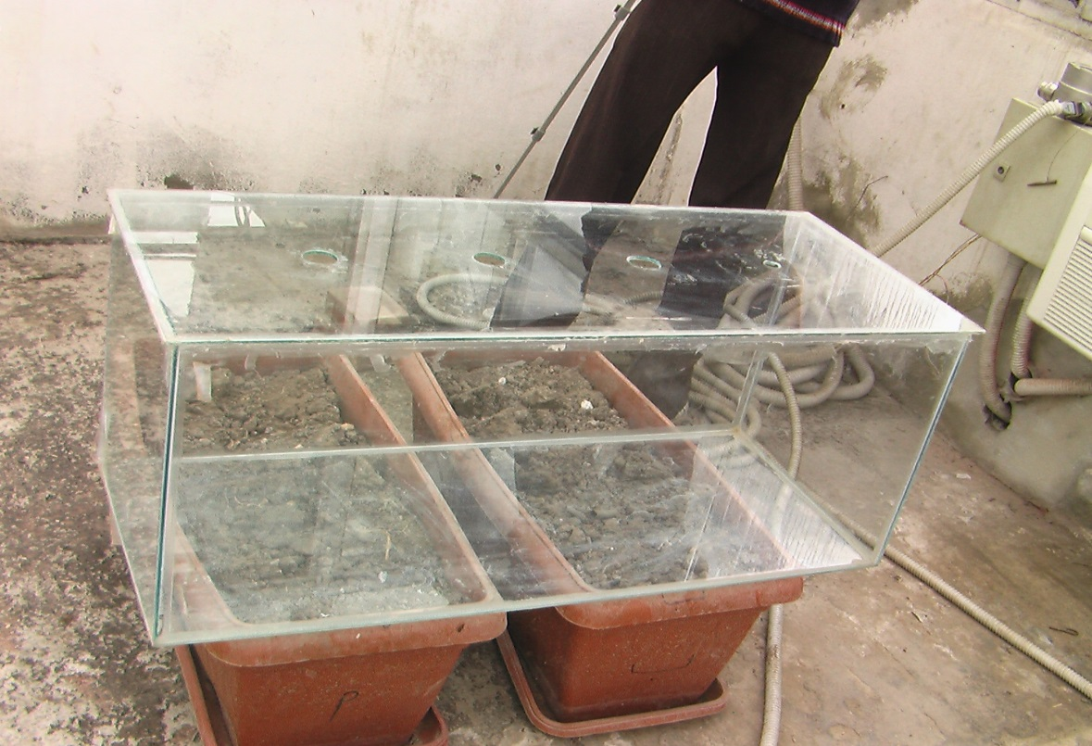

Figure 6. Shows the experimental unit (Glass Chamber) and the holes necessary to install the devices in the cover

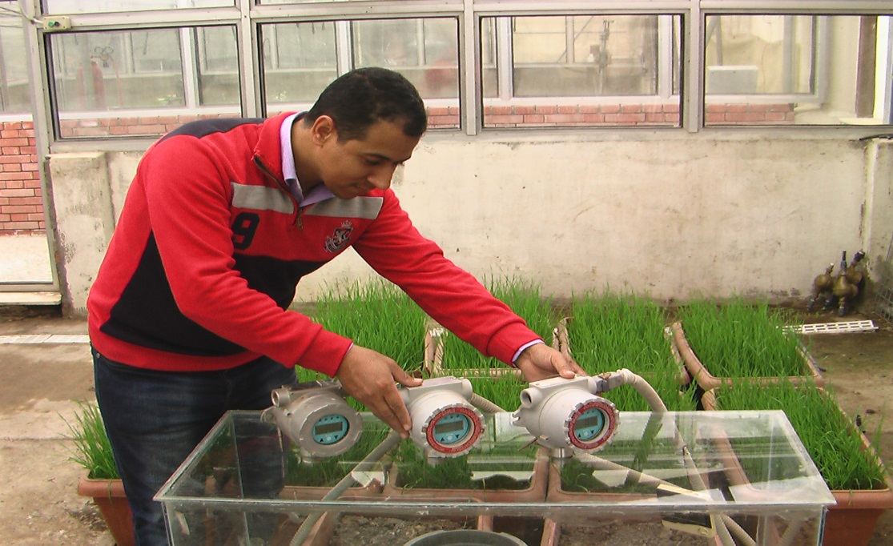

Figure 7.Researcher while he installed the devices on Chamber

After that fill the pots with soil (you need to six pots in each experiment), these pots with diameter 25cm (with area 0.0491 m2).And soil taken from the study site taking into account the well-mixed. Cut iron wires to cut (about 20 cm) we suspend temperature measurement instruments through the hole designed for that. These experiments were conducted inside a large glass rooms (because the devices installed inside) and the dimensions of this rooms as follows: Length 5m, Width 5 m and Height 4 m as in figure (9). These large glass rooms are at the same conditions while conducting experiments. In each experiment, and after filling pots with soil and irrigated still fit in chamber, and prove instrument temperature and humidity measurement and then prove the upper mobile face by the adhesive.

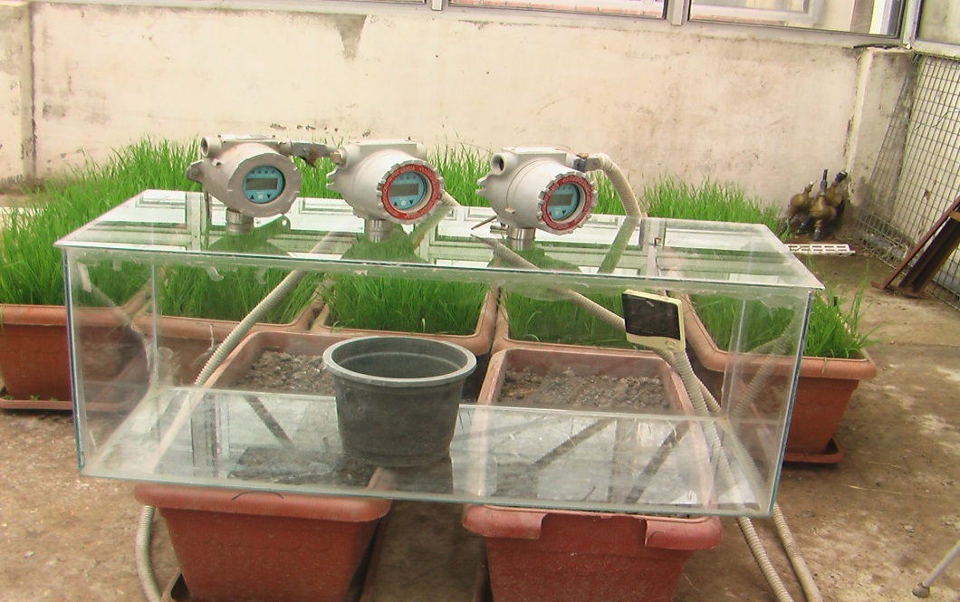

Figure 8. Shows the experimental unit, and measurement devices of CO2, NO and N2O it installed on the cover and the measurement of temperature and humidity device installed inside it and also pot content the soil placed inside

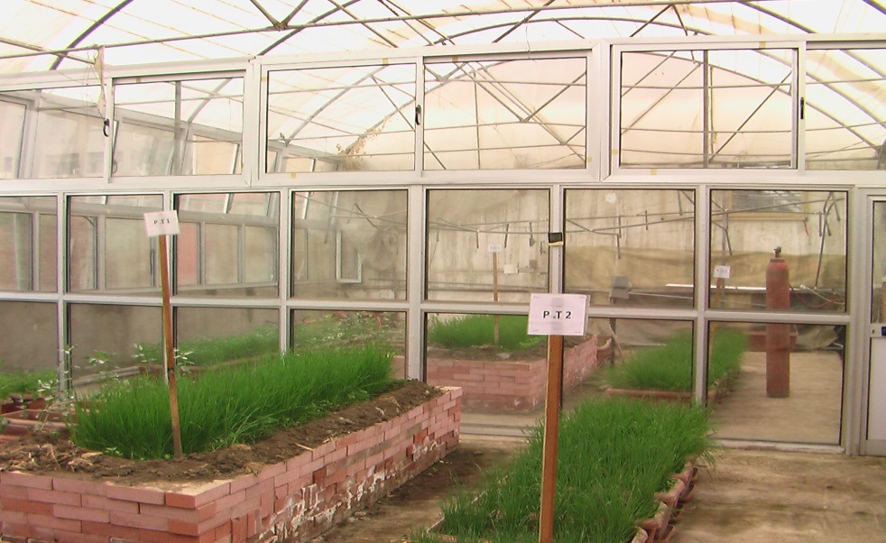

Figure 9. Large glass rooms, which have been conducting experiments inside it shows

**5. Measurements**

Experiments were carried out in the period from 06/04/2014 to 10/05/2014..The earlier period of preparation for the site of experiment and also instruments. First experiment Data were taken in individual days (first, third, fifth, seventh, ninth, atheist and thirteenth), but the second experiment, after the ninth day of the tenth and twelfth, was a period where every experience was thirteen days except the second experiment was only twelve days. The data monitored manually in the selected days from nine o'clock AM to third PM (local time). And so every half hour (to have thirteen observation every day of those days), we take the average of these observations and then compare these averages and painted with time to find out the views important. Elements that have been measured are: 1) Carbon dioxide, which measured by a device (RAE Guards CO2 FGM-1200S, WITH RANGE 0-50000ppm); 2) Nitrous oxide, which is measured as the product of the compilation of nitric oxide emissions and nitrogen dioxide. Gases were measured with instruments following: a) Nitric oxide, which measured by a device (RAE Guards NO FGM-1305, WITH RANGE 0-1000ppm), b) Nitrogen dioxide which is measured by a device (RAE Guards NO2 FGM-1302, WITH RANGE 0-70ppm); 3) Temperature and relative humidity measured by a device (TEMPERATURE-RH%- HTC-1).

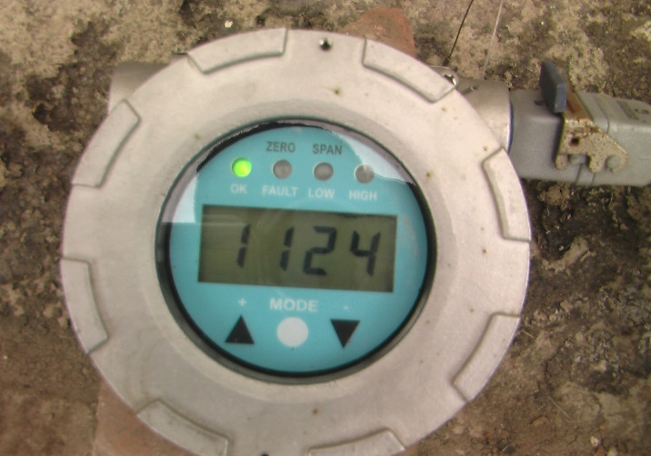

Figure 10. Measurement of carbon dioxide emissions device

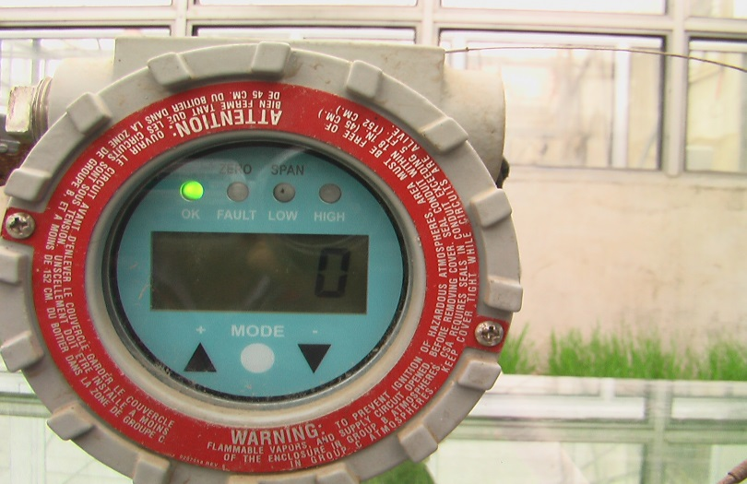

Figure 11.Measurement of nitric oxide emissions device (mono nitrogen oxide)

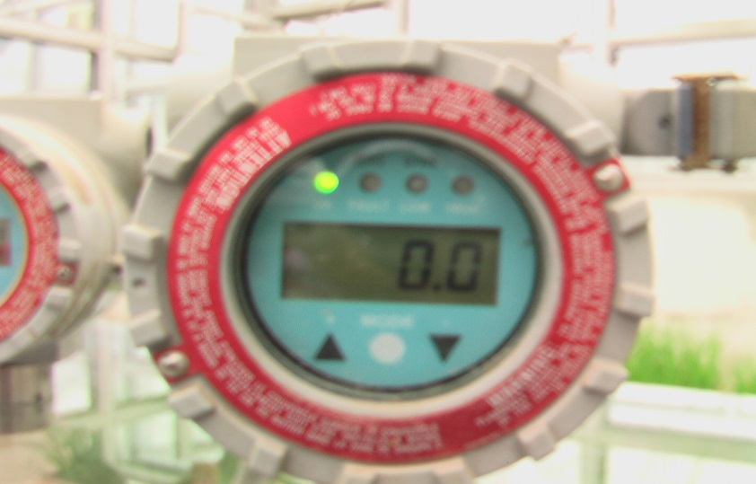

Figure 12.Measurement of nitrogen dioxide emissions device

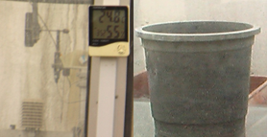

Figure 13.Measurement of temperature and relative humidity device and Pot which placed the soil

**6. Experiments**

**6.1. The first experiment**

This experiment was conducted in the period from 04/06/2014 to 04/19/2014. And which has been added urea (CO(NH2)2 – 46 %N) to clay soils. We have three pilot units containing clay soil fertilized with urea and three pilot units containing clay soil non-fertilized (Each pilot unit at the same conditions). In this experiment was to measure carbon dioxide (CO2) and nitrous oxide (N2O) emissions (through the collection of NO and NO2) and measuring the temperature and relative humidity inside the chambers. Previous measurements were taken in the pilot units containing the clay soil fertilized with urea and pilot units containing non-fertilized soil. Through the comparison of these emissions can recognize the effect of fertilizer only in these emissions. Also can draw these concentrations change with time to see the time that is most active of interact. The temperature inside the closed chamber influenced by the large rooms temperature and then the temperature in large rooms affected by the temperature in the open field.

**6.2. The second experiment**

This experiment was conducted in the period from 29/04/2014 to 10/05/2014. In this experiment has been added urea fertilizer (46% N) to the sandy soil, where we had three pilot units containing sandy soil fertilized with urea and three pilot units containing sandy soil non-fertilized(under the same conditions). In this experiment, we will also measure the carbon dioxide and nitrous oxide (through the collection of NO and NO2) emissions, as well as temperature and relative humidity inside closed chambers (in pilot units containing fertilized soil and pilot units containing non-fertilized soil). Can also emissions from sandy soil fertilized with urea compared to the non-fertilized soil to see the contribution of both fertilizer and soil in these emissions. It can also draw these emissions, temperature and relative humidity with time as well as. As in the first experiment, the temperature inside the closed rooms affected by the temperature inside the large room - and then the temperature inside the large room affected by the temperature in the open field.

**7. Results and Discussion**

**7.1. The first experiment**

In this experiment has been added urea fertilizer to the soil clay (S1+F1) as described in the previous chapter and the results were as follows:

**7.1.1. Carbon dioxide**

Results showed that the clay soil fertilized with urea gave the highest emissions of carbon dioxide, because the mud massive store of soil carbon and also contain urea on the carbon. The highest emissions of carbon dioxide from the clay soil fertilized with urea 3658 ppm, while the highest emissions of carbon dioxide from clay soil non- fertilized 2097 ppm was on the third day. This day was the top of Activity interaction. The difference between the carbon dioxide emissions from soil fertilized and non-fertilized soil 1561 ppm (fertilizer contribution represents only) and is equivalent to 42.7%, while the contribution of clay soil 57.3% as in the figure (14). When the hydrolysis of urea in the soil is produced carbon dioxide and ammonia, either carbon dioxide out of the interaction and released into the atmosphere. After that turn ammonium into ammonia, which are oxidized to give oxides of nitrate nitrogen and nitrogen gas (by soil bacteria, to plant-available nitrate through immobilization process and under limited amounts of oxygen or anaerobic conditions, another group of soil bacteria converts nitrates to N, N2O and NO2 gases, through denitrification process). The accumulated total amount of emissions of carbon dioxide from the clay soil fertilized with urea was 15608 ppm, while the amount was accumulated total emissions of carbon dioxide from non-fertilized soil 9228 ppm as in table (4) during the period of the experiment. The proportion of clay soils contribute to the total emission amounted to 59.1% and was the carbon dioxide emitted by the urea ratio of 40.9%.

Table 4. Carbon dioxide emitted from the, a) Clay soil fertilized by urea and, b) Clay soil without fertilizer (ppm)

|  |  |  |
| --- | --- | --- |
|  | **CO2** |  |
|  | **(a)S1+F1** | **(b)S1** |
| **DAY 1** | **640.9611** | **516.4103** |
| **DAY 3** | **3658.154** | **2097.59** |
| **DAY 5** | **3346.128** | **1939.718** |
| **DAY 7** | **2422.462** | **1420.949** |
| **DAY 9** | **2111.385** | **1284.359** |
| **DAY 11** | **1794.59** | **1051.923** |
| **DAY 13** | **1634.179** | **917.2821** |
| **SUM** | **15607.86** | **9228.231** |

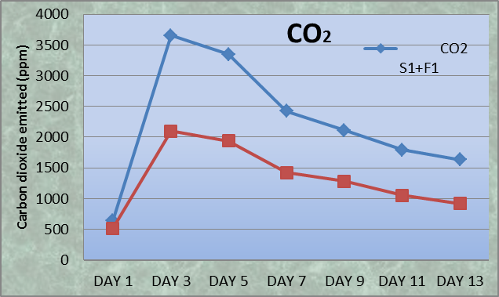

Figure 14.Carbon dioxide emitted from the clay soil fertilized by urea (Blue) and clay soil without fertilizer (Red) (ppm)

**7.1.2. Nitrous oxide**

Results showed that emissions of nitrous oxide from clay soil fertilized with urea were least at all and also clay soil non-fertilized less emissions, because of the small size of the granules in which at least oxygen. Which helps interaction processes. The highest emissions of nitrous oxide from clay soil fertilized with urea 0.68 ppm, while the highest value of nitrous oxide emissions from non-fertilized soil 0.48 ppm as result from figure (15).

The emission of nitrous oxide accumulated during the period of the experiment with 3.57 ppm of clay soil fertilized with urea, it was a 2.42 ppm of non- fertilized soil as in table (5).

Clay soil in the emission of nitrous oxide contributed 67.9% of the total quantity, While 32.1% of the amount of nitrous oxide emitted urea contributed during the experimental period.

Table 5. Nitrous oxide emitted from the, a) clay soil fertilized by urea and, b) clay soil without fertilizer (ppm)

|  |  |  |
| --- | --- | --- |
|  | **N2O** |  |
|  | **(a)S1+F1** | **(b)S1** |
| **DAY 1** | **0.361538** | **0.293077** |
| **DAY 3** | **0.623077** | **0.405128** |
| **DAY 5** | **0.674359** | **0.44359** |
| **DAY 7** | **0.679487** | **0.482051** |
| **DAY 9** | **0.528205** | **0.366667** |
| **DAY 11** | **0.433333** | **0.3** |
| **DAY 13** | **0.266667** | **0.130769** |
| **SUM** | **3.566667** | **2.421282** |

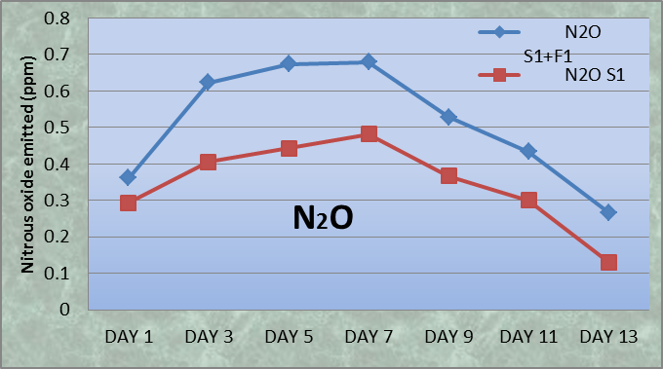

Figure 15. Nitrous oxide emitted from the clay soil fertilized by urea (Blue) and clay soil without fertilizer (Red) (ppm)

**7.1.3. The temperature inside the chamber**

It is well known that greenhouse gases (CO2, N2O) works on increase the temperature inside chamber. Figure (16) shows that there is a difference in temperature between the two chambers, we find that the temperature in the chamber in which the higher concentration of Emitted gases (CO2, N2O) warmer than the chamber in which the concentration is less. This difference value change during the experiment, where the greatest value to accompany this difference to the highest concentration of emitted gases (CO2, N2O).

The average temperature in the chamber containing the soil fertilized throughout the experimental period 41.83oC, while the average temperature in the chamber where there is a non-fertilized soil 41.05 oC as in table (6).

Figure (16) shows that the temperature difference is less than what can be on the first day (0.06 oC) where the interaction in its infancy, while we find that the greatest difference in temperatures will be on the third day (1.5 oC) because of the decomposition of interaction and provide a significant amount of urea fertilizer, which led to carbon dioxide and ammonia springboard which is oxidized to give the other nitrous oxide. The difference in temperatures graded 0.06, 1.5, 1.1, 0.84, 0.75, 0.66 and 0.55 oC from the first day to the last day of the experiment, respectively, it is figure(14), figure(15) and figure(16), we find that the large differences in temperature associated with high concentrations of CO2 and N2O.

Table 6.Temperature inside the chamber, a) Clay soil fertilized by urea, b) Clay soil without fertilizer T oC

|  |  |  |
| --- | --- | --- |
|  | **T oC** |  |
|  | **(a)S1+F1** | **(b)S1** |
| **DAY 1** | **43.96154** | **43.9** |
| **DAY3** | **44.32821** | **42.82821** |
| **DAY 5** | **40.25897** | **39.11538** |
| **DAY 7** | **41.86154** | **41.04872** |
| **DAY9** | **44.21282** | **43.46154** |
| **DAY 11** | **43.20769** | **42.54872** |
| **DAY 13** | **35.00513** | **34.45385** |
| **AVER** | **41.8337** | **41.05092** |

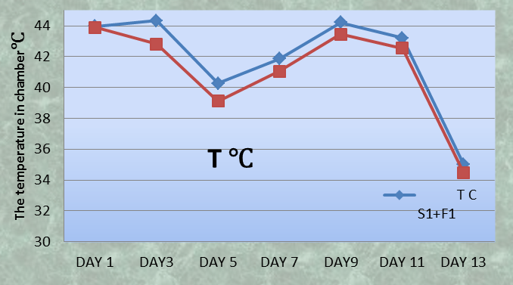

Figure 16.The temperature inside chamber, a) the clay soil fertilized by urea (Blue), b) clay soil without fertilizer (Red) T

**7.1.4. Relative Humidity**

The results show that there are simple differences between the average humidity in the chamber containing the fertilized soil (91.8%) and average moisture in the chamber in which the soil is not fertilized (88.1%) and illustrated in Table (7). But there are differences between them on the first day and the rest of the days of the experiment and observe is very approached in the last day, where the interaction has decreased activity, and the activity of the interaction in these days that is gives the direct emissions that are under study. Through figure (17), we find that the humidity in the chamber containing fertilized soil with urea less than humidity in the chamber containing the soil without urea on the first day, where it was two respectively (71.8%), (78.7%). This is due to that during the hydrolysis of urea by the soil moisture decreasing the amount of moisture in the soil and thereby decreasing the amount of evaporation. Also through figure (17), we find that the differences in the other days as follows: 5.7, 6.7, 6.3, 5.8, 6.2, 2.3 % respectively. This is due to that after the hydrolysis of urea produce the ammonia and carbon dioxide. Oxidized ammonia to produce then water (which increases the humidity) and nitrogen oxides (by immobilization and denitrification process), carbon dioxide and nitrous oxide leads to increase the temperature in the chamber containing soil fertilized by urea.

Table 7. The Relative Humidity inside chamber, a) the clay soil fertilized by urea, b) clay soil without fertilizer RH %

|  |  |  |
| --- | --- | --- |
|  | **RH %** |  |
|  | **(a)S1+F1** | **(b)S1** |
| **DAY 1** | **71.82051** | **78.74359** |
| **DAY 3** | **95.71795** | **90.02564** |
| **DAY 5** | **96.71795** | **90.07692** |
| **DAY 7** | **95.23077** | **88.92308** |
| **DAY 9** | **93.66667** | **87.87179** |
| **DAY 11** | **92.10256** | **85.94872** |
| **DAY 13** | **97.64103** | **95.38462** |
| **AVER** | **91.84249** | **88.13919** |

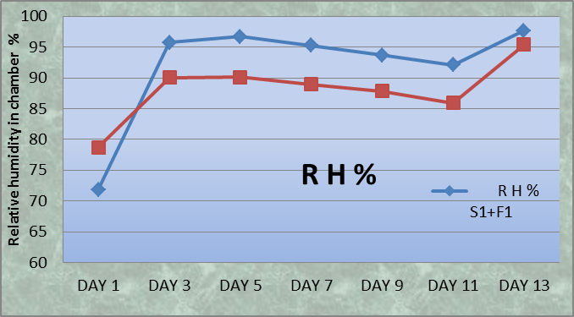

Figure 17. Relative Humidity inside the chamber, a) clay soil fertilized by urea (Blue), b) clay soil without fertilizer (Red) RH%

**7.2. The second experiment**

In this experiment has been added urea fertilizer to the sandy soil (S2+F1) as described in the previous chapter and the results were as follows:

**7.2.1. Carbon dioxide**

The results showed that there were significant differences between the carbon dioxide emissions from the sandy soil fertilized with urea and non-fertilized sandy soil, these differences are significant because of the type of soil where the sandy soil does not have a stock of carbon as in the clay soil. Higher emissions were measured from sandy soil fertilized with urea on the fifth day and was worth 3087 ppm, while the highest value for the carbon dioxide emissions from non-sandy soil fertilized 815 ppm was on the fifth day also, urea fertilizer may contribute to 2272 ppm (by 73.6%), as shown in figure (18).Through table (8), we find that the accumulated amount of carbon dioxide emissions during the period of the experiment from the chamber containing soil fertilized 12042 ppm, while it was in the chamber containing the non-fertilized soil 3888 ppm. Sandy soil contributed about 32.3% in the amount of total emissions, and urea contributed about 67.7%.

Table 8. Carbon dioxide emitted from, a) Sandy soil fertilized by urea and b) Sandy soil without fertilizer (ppm)

|  |  |  |
| --- | --- | --- |
|  | **CO2** |  |
|  | **(a)S2+F1** | **(b)S2** |
| **DAY 1** | **658.2821** | **501.0769** |
| **DAY 3** | **2246.333** | **763.9487** |
| **DAY 5** | **3086.974** | **815.6667** |
| **DAY 7** | **2493.256** | **560.2308** |
| **DAY 9** | **1468.026** | **457.2564** |
| **DAY 10** | **1025.308** | **402.7949** |
| **DAY 12** | **1064.282** | **386.8974** |
| **SUM** | **12042.46** | **3887.872** |

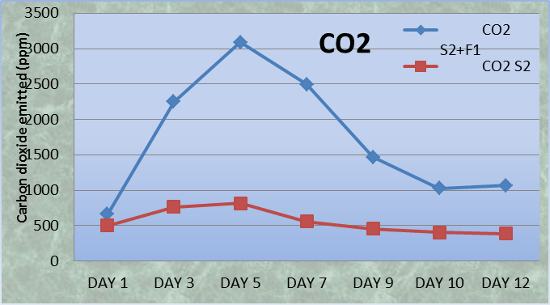

Figure 18.Carbon dioxide emitted from the sandy soil fertilized by urea (Blue) and sandy soil without fertilizer (Red) (ppm)

**7.2.2. Nitrous oxide**

Table 9. Nitrous oxide emitted from, a) Sandy soil fertilized by urea and, b) Sandy soil without fertilizer (ppm)

|  |  |  |
| --- | --- | --- |
|  | **N2O** |  |
|  | **(a)S2+F1** | **(b)S2** |
| **DAY 1** | **0.923077** | **0.658974** |
| **DAY 3** | **1.133333** | **0.758974** |
| **DAY 5** | **1.148718** | **0.758974** |
| **DAY 7** | **0.897436** | **0.571795** |
| **DAY 9** | **0.751282** | **0.448718** |
| **DAY 10** | **0.612821** | **0.45641** |
| **DAY 12** | **0.697436** | **0.571795** |
| **SUM** | **6.074359** | **4.215385** |

The results showed that the sandy soil fertilized with urea give higher emissions of nitrous oxide gas at all. This is because the sandy soil with large granules and there is between these granules spacing to accommodate larger air intake (greater than clay soil) this air oxidized greater than the amount of ammonia and also oxidation air nitrogen (denitrification). The top of the nitrous oxide emissions 1.15 ppm of sandy soil fertilized with urea was 0.76 ppm of non-fertilized soil and that was on the fifth day as shown in figure (19).

Through table (9), we find that the accumulated emissions of nitrous oxide during the period of the experiment 6.01 ppm of the fertilized soil was 4.21 ppm of non-fertilized soil, sandy soils contributed by 69.5% in the total amount, while urea contributed 30.5% of this amount.

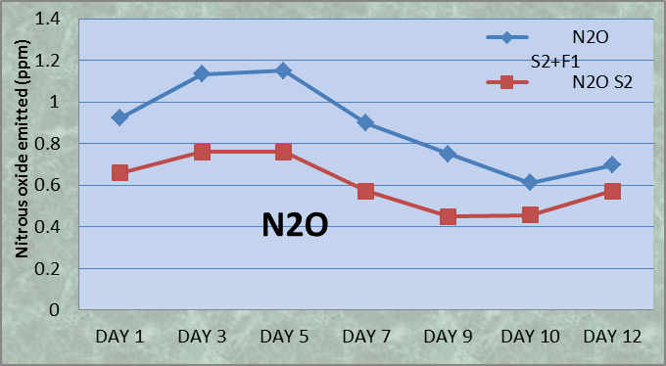

Figure 19. Nitrous oxide emitted from the sandy soil fertilized by urea (Blue) and sandy soil without fertilizer (Red) (ppm)

**7.2.3. The temperature inside the chamber**

The results obtained show that there are significant differences in temperature between the chamber containing the sandy soil fertilized with urea and the chamber containing the non-fertilized soil, were temperature in the chamber containing soil fertilized larger (where the concentration of gases emitted higher) than the temperature in the chamber containing the non-fertilized soil (where the concentration of gases emitted less), this difference changes from day to day depending on the concentration of gases emitted from the interaction, the largest value of the difference accompanied the highest concentration of these gases. Through table (10), we find that average temperature in the chamber containing the sandy soil fertilized with urea 46.67 oC throughout the experimental period, while the average temperature in the chamber containing the sandy soil non-fertilized 45.66 oC, (with difference 1.01 oC). From figure (20) it is clear that the temperature in the chamber containing soil fertilized be greater than the temperature in the chamber containing the non-fertilized soil, this difference very least a in the first day (0.09 oC), where the limited the interaction activity, activity increased the interaction thereafter we find that the greatest difference in temperature between the two chambers is 1.73 oC, in the fifth day, where the speed of the reaction rate most that can be, this activity is meant to increase the speed of decomposition of urea and the emission of carbon dioxide and ammonia, where oxidized to give ammonia nitrogen oxides (Denitrification). The difference in temperature was graduation throughout the experimental period as follows: 0.09, 1.54, 1.73, 1.68, 0.88, 0.62 and 0.52 oC from the first day to the last day, respectively. Through both of figure (18), (19) and (20), we find that great differences in temperature between the two chambers to be associated with high concentrations in a period in which the interaction can be more active.

Table 10.Temperature inside the chamber, a) Sandy soil fertilized by urea, b) Sandy soil without fertilizer T oC

|  |  |  |
| --- | --- | --- |
|  | **T oC** |  |
|  | **(a)S2+F1** | **(b)S2** |
| **DAY 1** | **49.4359** | **49.34615** |
| **DAY 3** | **50.05641** | **48.51282** |
| **DAY 5** | **52.83333** | **51.10513** |
| **DAY 7** | **47.80769** | **46.13077** |
| **DAY 9** | **39.83333** | **38.94872** |
| **DAY 10** | **39.9641** | **39.33846** |
| **DAY 12** | **46.73846** | **46.22308** |
| **AVER** | **46.66703** | **45.65788** |

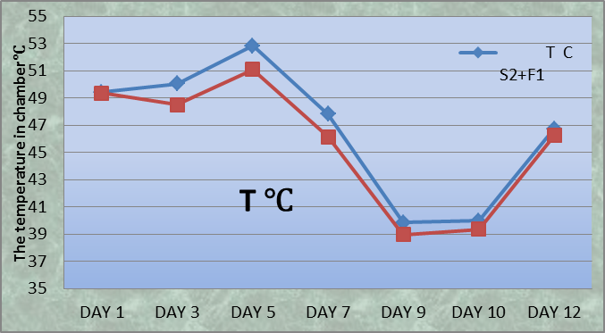

Figure 20. Temperature inside the chamber, a) Sandy soil fertilized by urea (Blue), b) Sandy soil without fertilizer (Red) T oC

**7.2.4. Relative Humidity**

Through the results, we find that the difference in the average relative humidity between the chamber containing the sandy soil fertilized with urea (82.3%) and the chamber containing the non-fertilized soil (76.9%) is about 5.4%, table (11).There are similarity in the behavior of the relative humidity between the first experiment and this experience, where we find that the relative humidity in the chamber containing soil fertilized less of them in the chamber containing the non-fertilized soil on the first day, where the hydrolysis of urea consumed part of the soil moisture, which affects the evaporation. Turned situation the relative humidity after the first day to become the humidity in the chamber containing soil fertilized higher than in the chamber containing the non-fertilized soil, this is because the hydrolysis of urea produced ammonia which are oxidized to produce water, which increases the humidity as shown in figure (21). The differences in the relative humidity of the first day to the last day as follows: 4.6, 5.8, 6.2, 6.4, 8.3, 7.0, and 9.2%, respectively.

Table 11. Relative Humidity inside the chamber, a) Sandy soil fertilized by urea, b) Sandy soil without fertilizer RH %

|  |  |  |
| --- | --- | --- |
|  | **RH %** |  |
|  | **(a)S2+F1** | **(b)S2** |
| **DAY 1** | **56.20513** | **61.58974** |
| **DAY 3** | **82.05128** | **76.20513** |
| **DAY 5** | **81.87179** | **75.66667** |
| **DAY 7** | **89.74359** | **83.33333** |
| **DAY 9** | **92.28205** | **84.02564** |
| **DAY 10** | **89.15385** | **82.15385** |
| **DAY 12** | **84.71795** | **75.46154** |
| **AVE** | **82.28938** | **76.91941** |

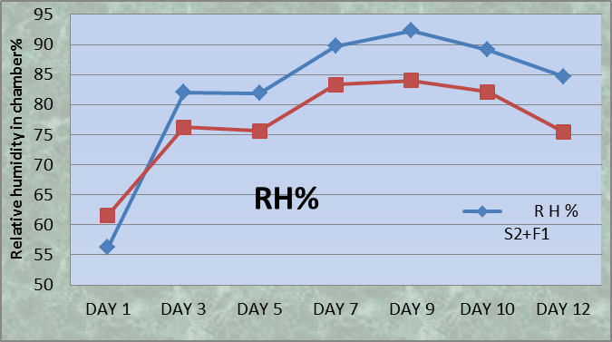

Figure 21. Relative Humidity inside the chamber, a) Sandy soil fertilized by urea (Blue), b) Sandy soil without fertilizer (Red) RH%

**8. Conclusion**

In each experiment we had three replications of fertilized soil to take the average and three replicates of the soil non-fertilized (control chambers) to take the average also in order the comparison between the two groups. The aim of these experiments as follows:

Measurement the direct emissions from agricultural soils for each of carbon dioxide and nitrous oxide.

Study the impact of carbon dioxide and nitrous oxide emissions on both the temperature and humidity. We got the following results:

1. **The accumulated amount of carbon dioxide**

Clay soil fertilized with urea gave the largest amount of emissions of carbon dioxide and were15607 ppm, while in the control chambers were 9228 ppm (The proportion of clay soils contribute in the total emission amounted to 59.1% and was the carbon dioxide emitted by the urea ratio of 40.9%).

Carbon dioxide emissions from the sandy soil fertilized with urea came second where 12042 ppm, while in the control chambers were 3888 ppm (Sandy soil contributed about 32.3% in the amount of total emissions, and urea contributed about 67.7%).

Carbon dioxide emissions from the clay soil fertilized ammonium nitrate came third, where 11281 ppm, while in the control chambers were 11112 ppm (no significant differences in emissions).

While the carbon dioxide emissions from the sandy soil fertilized ammonium nitrate in fourth place and are the lowest absolutely, where 3568 ppm, while in the control chambers were 3489 ppm (no significant differences in emissions).

The largest value of the carbon dioxide emissions from the clay soil fertilized with urea occurred on the third day, where 3658 ppm.

The largest value of carbon dioxide emissions from the sandy soil fertilized with urea occurred on the fifth day where 3086 ppm.

The largest value of carbon dioxide emissions from the clay soil fertilized with ammonium nitrate occurred on the fifth day where 1930 ppm.

The largest value of carbon dioxide emissions from the sandy soil fertilized with ammonium nitrate occurred on the third day where 809 ppm.

1. **The accumulated amount of nitrous oxide**

Sandy soil fertilized with urea gave the highest emissions of nitrous oxide, where 6.07 ppm, while in the control chambers were 4.22 ppm.

Nitrous oxide emissions from the sandy soil fertilized ammonium nitrate came second, where 5.49 ppm, while in the control chambers were 3.96 ppm.

The nitrous oxide emissions from the clay soil fertilized ammonium nitrate came in third place, where 4.32 ppm, while in the control chambers were 3.02 ppm.

While the clay soil fertilized with urea has given lower emissions of nitrous oxide and its value 3.57 ppm, while in the control chambers were 2.42 ppm.

The largest value of the nitrous oxide emissions from the clay soil fertilized with urea occurred on the seventh day, where 0.67 ppm.

The largest value of nitrous oxide emissions from the sandy soil fertilized with urea occurred on the fifth day where 1.15 ppm.

The largest value of nitrous oxide emissions from the clay soil fertilized with ammonium nitrate occurred on the first day where 0.84 ppm.

The largest value of nitrous oxide emissions from the sandy soil fertilized with ammonium nitrate occurred on the third day where 1.11 ppm.

Accumulated total quantity as well as the maximum value of the emissions of both carbon dioxide and nitrous oxide affected by the temperature during the experiment and today, but the maximum value of the emissions did not exceed the fifth day. Except only great value for the the emission of nitrous oxide from clay soil fertilized with urea were on the seventh day.

1. **The temperatures**

In the first experiment we note that the largest difference in temperature 1.5oC and has coincided greater value to carbon dioxide emissions.

In the second experiment also note that the largest difference in temperature 1.73oC and has coincided greater value to emissions of carbon dioxide and nitrous oxide.

1. **The Relative humidity**

In experiments, the first and second similar behavior of relative humidity. where urea reduce moisture (because of the hydrolysis of urea) in the first day, while the situation is reflected afterwards. And be The largest difference in moisture 6.7% on the fifth day in the first experiment, while it 9.2% on the last day in the second experiment.

**Corresponding Author:**

Dr. Mohamed M. Eid

Astronomy and Meteorology Dept.

Fac. of Sci., Al-Azhar Univ., Cairo, Egypt

E-mail: [*mm_eid2000@yahoo.com](mailto:*mm_eid2000@yahoo.com)

**References**

1. FAO (2012) FOSTAT onlin edatabase (<http://faostat.fao.org/>).
2. FAO (2011) Linking Sustainability and Climate Financing: Implications for Agriculture (Rome: FAO) (<http://faostat.fao.org/>).
3. Galloway, A. R. Townsend, J. W. Erisman, M. Bekunda, Z. Cai, J. R. Freney, L. A. Martinelli, S. P. Seitzinger, and M. A. Sutton. Transfor- mation of the nitrogen cycle: Recent trends, questions, and potential so- lutions. Science, 320(5878):889{892,2008.doi:10.1126/science.1136674.URL<http://www.sciencemag.org/content/320/5878/889.abstract>.
4. IPCC 2007 Guidelines for National Greenhouse Gas Inventories ed H S Eggleston, L Buendia, K Miwa, T Ngara and K Tanabe (Hayama: IGES) (Prepared by the National Greenhouse Gas Inventories Programme).
5. IPCC 2007 IPCC Fourth Assessment Report: Climate Change 2007; Working Group I: The Physical Science Basis.
6. Met-Office Hadley Centre (2011), Climate: Observations, projections and impacts; The Rt Hon. Chris Huhne MP, Secretary of State for Energy and Climate Change; Julia Slingo, Met Office Chief Scientist.
7. MWRI (2013) Ministry of Water Resources and Irrigation Climate Change Risk Management in Egypt (2013). Prepared for UNESCO – Cairo; By: Dr. Mohamed M Nour El-Din, January 2013.
8. Pachauri and Reisinger(2007) (eds), Climate Change 2007, supra, note 1, at 48.69Caney, supra, note 11, at 80.
9. Saikawa, E., R.G. Prinn, E. Dlugokencky, K. Ishijima, G.S. Dutton, B.D. Hall, R. Langenfelds, Y. Tohjima, T. Machida, M. Manizza, M. Rigby, S. O’Doherty, P.K. Patra, C.M. Harth, R.F. Weiss, P.B. Krummel, M. van der Schoot, P.J. Fraser, L.P. Steele, S. Aoki, T. Nakazawa, and J.W. Elkins, 2014: Global and regional emissions estimates for N2O. Atmos. Chem. Phys., 14(9):4617–4641, doi:10.5194/acp-14-4617-2014.
10. Smith P et al 2007 Agriculture Climate Change 2007: Mitigation. Contribution of Working Group III to the Fourth Assessment Report of the Intergovernmental Panel on Climate Change ed B Metz, O R Davidson, P R Bosch, R Dave and LA Meyer (Cambridge: Cambridge University Press) pp 497–540.
11. Stehfest and L. Bouwman. N2O and no emission from agricultural _ elds and soils under natural vegetation: summarizing available mea- surement data and modeling of global annual emissions. Nutrient Cy- cling in Agroecosystems, 74:207{228, 2006. ISSN 1385-1314. URL http://dx.doi.org/10.1007/s10705-006-9000-7. 10.1007/s10705- 006-9000-7.
12. Taha, M.H. 2000. Soil fertility management in Egypt. Regional Workshop on Soil Fertility Management Through Farmer Field Schools in the Near East, Amman, Jordan, 2–5 October 2000.
13. Thompson, R.L., F. Chevallier, A.M. Crotwell, G. Dutton, R.L. Langenfelds, R.G. Prinn, R.F. Weiss, Y. Tohjima, T. Nakazawa, P.B. Krummel, L.P. Steele, P. Fraser, S. O’Doherty, K. Ishijima and S Aoki, 2014: Nitrous oxide emissions 1999 to 2009 from a global atmospheric inversion. Atmos. Chem. Phys., 14(4):1801–1817, doi:10.5194/acp-14-1801-2014.
14. UNFCCC:http://unfccc.int/files/documentation/text/html/list_search.php?what=&val=&valan=a&anf=0&id=10;http://unfccc.int/files/documentation/text/html/list_search.php?what=&val=&valan=a&anf=0&id=10.
15. Van Groenigen, G. L. Velthof, O. Oenema, K. J. Van Groeni- gen, and C. Van Kessel. Towards an agronomic assessment of N2O emissions: a case study for arable crops. European Jour- nal of Soil Science, 61(6):903{913, 2010. ISSN 1365-2389. URL <http://dx.doi.org/10.1111/j.1365-2389.2009.01217.x>.
16. WMO (2014) GREENHOUSE GAS BULLETIN, The State of Greenhouse Gases in the Atmosphere Based on Global Observations through 2013; No. 10 | 9 September 2014.
17. (Worled development report 2008) <http://siteresources.worldbank.org/INTWDRS/Resources/4773651327599046334/Brief_AdptMitClimateChng_webpdf>.
18. Yara International 2011 - N-Sensor™ and N-Tester™ are Trade Marks of Yara International ASA; Nitrate fertilizer Optimizing yield, preserving the environment;http://www.yara.com/doc/33521_Nitrate_-_Pure_Nutrient.pdf.

12/22/2014