Mechanical properties of SBR and IIR blends loaded with Nano structure fillers at percolation

A. Samir, G. Ramzy, M.H. Osman, H.H. Hassan

Physics Department, Faculty of Science, Cairo University, Giza, Egypt.
asmaphysics@yahoo.com

Abstract: The mechanical properties of SBR and IIR blends loaded with different types of carbon black at percolation were investigated. Young's modulus was found to be maximum for ISAF and HAF carbon blacks. Moony-Riviln equation was used to calculate C₁ and C₂. The parameters σ_{o} and G and the average molecular weight between cross links and the number of effective molecular chain per unit volume were calculated.
[H.H. Hassan, G. Ramzy, M.H. Osman, A. Samir. Mechanical properties of SBR and IIR blends loaded with Nano structure fillers at percolation. Nat Sci 2014;12(12):75-80]. (ISSN: 1545-0740). http://www.sciencepub.net/nature. 11

Key words: Percolation, mechanical properties, molecular weight, cross links.

1. Introduction
Polymer blends and composites are widely used for different technological purposes because of their high strength, their high elastic deformability and their ability to be strained repeatedly to high levels without destruction or permanent distortion. The mechanical behavior of rubber (polymers) is affected by many external and internal factors ⁽¹⁾. The external factors are environmental factors included time, temperature, pressure and radiation that may cause changes in physical or chemical behaviors. The internal variables are those, which produce changes in chemical and physical structure of the polymer. Accordingly, changes of mechanical properties affect some of the important internal factors such as chemical structure and composition, degree of crystallinity, polar nature of substituent, molecular weight diluents such as water, monomer and plasticizer and the degree and extent of copolymerization.
The blending of two or more types of polymers is a useful technique for the preparation and development of materials with properties superior to those of individual constituents ⁽²⁾. The purpose of blending the rubber is to improve the physical and mechanical properties as well as modify processing characteristics and reduce the cost of the final products.
The classical kinetic theory developed by Wall ⁽³⁾, Flory ⁽⁴⁾, and James and Guth ⁽⁵⁾, attributed the high elasticity of a cross-linked rubber to the change of conformational entropy of the long flexible molecular chains, the theory predicts the relations:
Where σ is the true stress, is the number of effective plastic chains per unit volume,
K is Boltzmann’s constant, T is the absolute temperature, λ is the extension ratio and
A is a pre factor, depending on the considered model.
This paper aims to study the effect of blend ratio on the mechanical properties of SBR and IR loaded with different types of Nano structure carbon black at percolations.

2. Experimental work.
Samples of SBR and IIR were prepared according to standard methods with the compositions shown in Table (1).

Table (1)
Sample |  |  |  |  | Ingredients phr
2 | 2 | 2 | 2 | 2 | Srearic acid.
5 | 5 | 5 | 5 | 5 | Zno.
10 | 10 | 10 | 10 | 10 | Paraffinic oil.
----- | ----- | ----- | ----- | 30 | N₂₂₀ (ISAF)
----- | ----- | ----- | 40 | ----- | N₃₂₆ (HAF)
----- | ----- | 60 | ----- | ----- | N₅₅₀ (FEF)
----- | 70 | ----- | ----- | ----- | N₆₆₀ (GPF)
80 | ----- |  | ----- | ----- | ----- | N₇₇₄ (SRF)
2 | 2 |  | 2 | 2 | 2 | TMTD
1 | 1 |  | 1 | 1 | 1 | IPPD 4020
3 | 3 |  | 3 | 3 | 3 | sulfur
The ingredients in the table was used for blend ratios (100-0, 75-25, 50-50, 25-75, 0-100) of SBR- IIR respectively.

3. Results and discussion
The uniaxial compression true stress-true strain of the IIR and SBR composites was investigated. Concerning the stress-strain behavior for all the rubber composites exhibit a similar mechanical response. First, an initial elastic response was observed followed by strain softening, yielding, and then a dramatic strain hardening. The extent of the strain hardening depends on the investigated rubber composites.
Young's modulus of a composite is a bulk property that attracted more attention in this area of research. Modulus is the ratio of stress to strain in the linear region of stress-strain curve and it is characterizing the rigidity of the material. It was found that young's modulus gives the maximum values for (ISAF and HAF) carbon blacks for both rubber types as illustrated in table 1. As the smaller particle size of black filler results in an increase of hardening, so different blends between IIR and SBR with the ratios (25/75, 50/50 and 75/25) have been prepared for this two types of carbons. Figure 1 gives the stress strain curves of IIR and SBR loaded with ISAF and HAF carbon black.

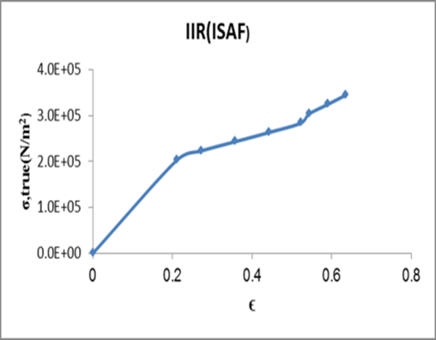 | 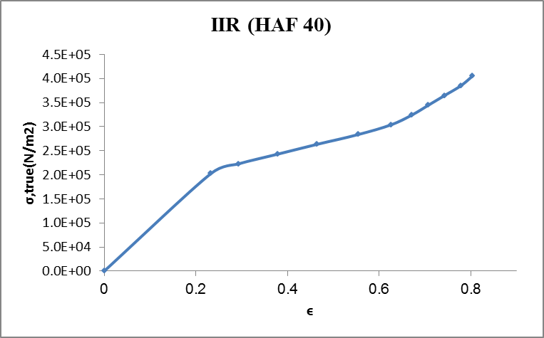
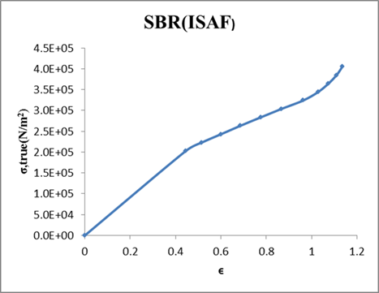 | 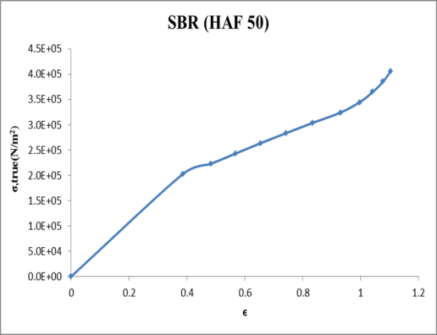
Fig 1 the stress-strain for IIR and SBR loaded with ISAF and HAF carbon blacks.

Table 1 young's modulus for all samples
Sample | Young's modulus E( Pa) x10⁻⁵ | Sample | Young's modulus E( Pa) x10⁻⁵
IIR(ISAF) | 10 | SBR(GPF) | 4.0
IIR(HAF) | 9.0 | SBR(SRF) | 3.6
IIR(FEF) | 8.6 | IIR25:SBR75(ISAF) | 4.4
IIR(GPF) | 8.3 | IIR25:SBR75(HAF) | 2.9
IIR(SRF) | 6.9 | IIR50:SBR50(ISAF) | 2.0
SBR(ISAF) | 5.0 | IIR50:SBR50(HAF) | 2.4
SBR(HAF) | 6.0 | IIR75:SBR25(ISAF) | 3.6
SBR(FEF) | 4.6 | IIR75:SBR25(HAF) | 2.1

It has been shown by Rivilin et al ⁽⁶⁾ that the stress-strain behavior of rubber vulcanizates can be described by the Moony-Rivlin ⁽⁷⁾ relation which in simple extension gives:
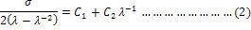
Where, C₁ and C₂ are parameters characterizing the rubber vulcanizates. It has been shown that C₁ is a quantity pertaining to the ideal elastic behavior, while C₂ expresses the departure from the ideal elastic behavior ⁽⁸⁾.
Figures (2) show the experimental stress-strain to three samples of data as an example, replotted in the form

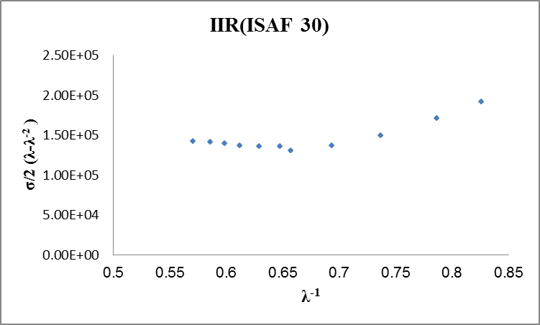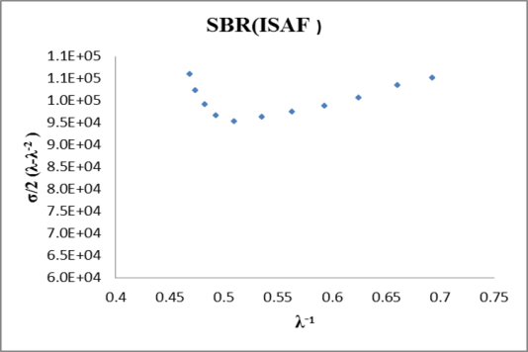
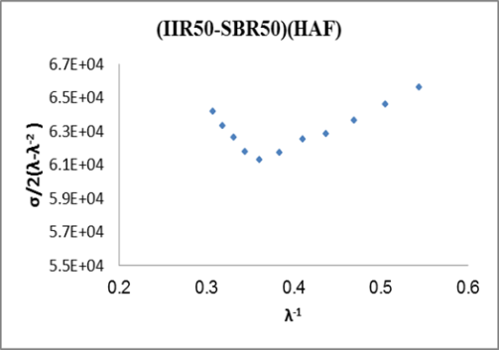
Fig 2. the Mooney-Riviln coordinates for three samples.

A limited linear part of the stress-strain curves may be utilized to find C₁from the intercept with the ordinate and C₂ from the slope(Fig. 3).
In the range of low strains, from these plots the constants C₁ and C₂ are readily determined and are illustrated in table 2. The constant C₁ describes the behavior predicted by the statistical theory of rubber like elasticity and its value is directly proportional to the number of network chains per unit volume of the rubber ⁽⁹⁾. On the other hand, the value of C₂ describes the number of steric obstructions and the number of effectively trapped elastic entanglements as well as other network defects ⁽¹⁰⁾.

Sample | C₂ (MPa) | C₁ (MPa) | Sample | C₂ (MPa) | C₁ (MPa)
IIR(ISAF) | .366 | .115 | IIR25:SBR75(HAF) | .045 | .047
IIR(HAF) | .31 | .079 | IIR50:SBR50(ISAF) | .0574 | .028
SBR(ISAF) | .055 | .066 | IIR50:SBR50(HAF) | .023 | .053
SBR(HAF) | .09 | .049 | IIR75:SBR25(ISAF) | .0545 | .052
IIR25:SBR75(ISAF) | .085 | .043 | IIR75:SBR25(HAF) | .0615 | .0275

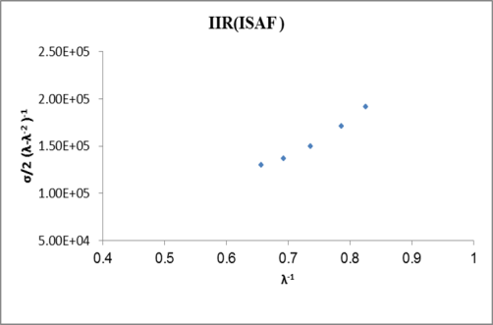 | 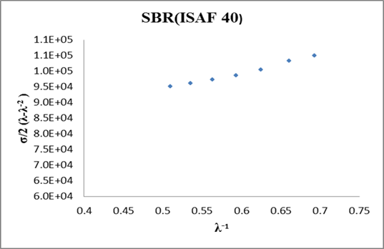
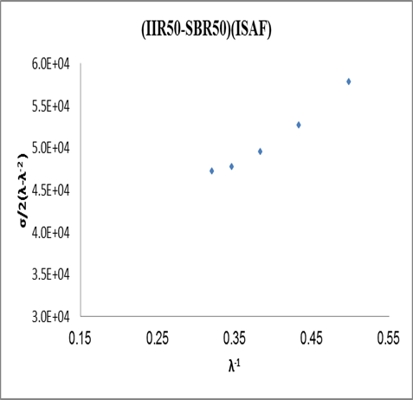
Fig. 3 The linear part of stress strain of figure 2 for three samples.

By changing the blend ratio contents for both types of carbon black, it was found that the values of C₁, C₂ and C₁ + C₂ decrease then increase again with the increase of butyl rubber contents as illustrated in figures: [4, 5, 6]. The minimum value of C₁, C₂ and C₁ + C₂ for both types of carbon blacks is in the case of (50/50) IIR/SBR which means that at this blend ratio the steric obstructions and other network defects have minimum values. This confirms the values of young’s modulus obtained before.

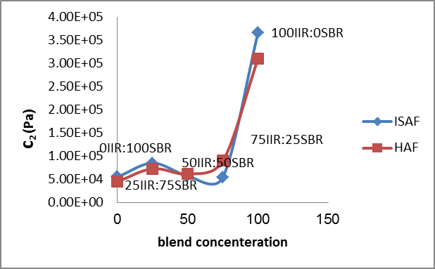
Figure 4 the values of C₂ for both types of carbon black.

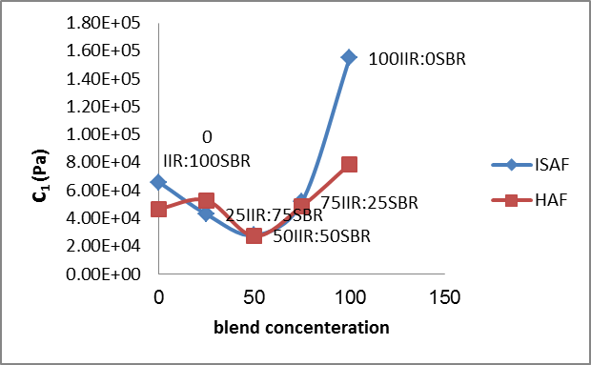
Figure 5 the values of C₁ for both types of carbon black

.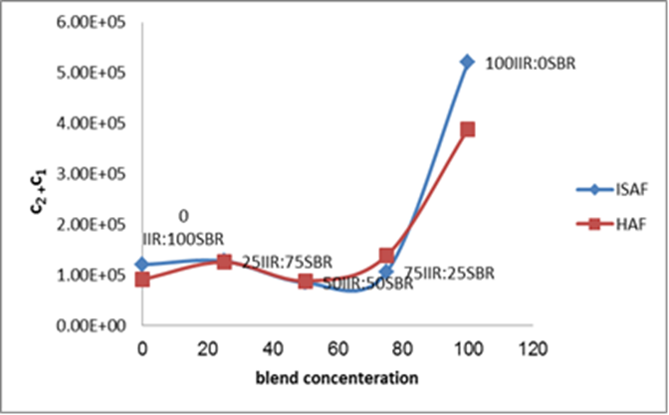
Figure 6 the values of C₁+C₂ for both types of carbon black.

Returning to equation (1), it is noticed that the stress is a linear function of the quantity (λ²- λ⁻¹) in a moderate range of deformations. According to the experimental data in figures (1, 2) the tensile stress can be described as a simple function of (λ²- λ⁻¹) according to the following expression:
Where σ_{o} is a parameter depending only on the chemical nature of the rubber matrix and G is the rubbery modulus of kinetic theory that depends on the degree of crosslinks ⁽¹¹⁾.
The data of stress strain are replotted between true stress and (λ²- λ⁻¹) and shown in figure (7), where a good agreement between the theoretical solid lines represented by equation (2) and the experimental data. The interception with the axis at (λ²- λ⁻¹) =0 gives the values of σ_{o} while the slopes gives the values of G which

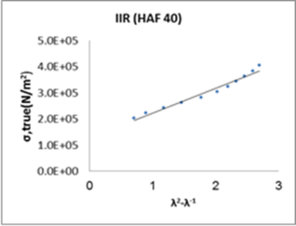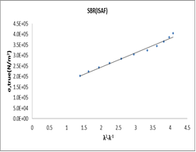
Figure (7) The dependence of the true stress on (λ²- λ⁻¹) for some samples.

Table 3
sample | G (MPa) | σ₀ (MPa) | sample | G (MPa) | σ₀ (MPa)
IIR(ISAF) | .108 | .123 | IIR25:SBR75(HAF) | .148 | .128
IIR(HAF) | .095 | .125 | IIR50:SBR50(ISAF) | .015 | .142
SBR(ISAF) | .0686 | .107 | IIR50:SBR50(HAF) | 0164 | .136
SBR(HAF) | .069 | .11 | IIR75:SBR25(ISAF) | .04315 | .125
IIR25:SBR75(ISAF) | .04799 | .13 | IIR75:SBR25(HAF) | .214 | .13

The average molecular weight M_{e} between cross links and the number of effective plastic chains per unit volume have been calculated from the values of G according to the equation ⁽¹²⁾.
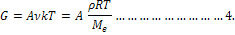
.Where, ρ is the density of the rubber matrix and R is the universal gas constant. The values of M_{e} and for all the studied vulcanized samples have been calculated assuming A =1⁽¹²⁾ and are illustrated in figures (8, 9) as a function of the blend ratio.
The figures show a maximum average molecular weight between crosslinks for the vulcanizates containing (50/50) (IIR/SBR). The behavior of the number of effective plastic chains as seen from figures (8&9) is opposite to that of the average molecular weight.

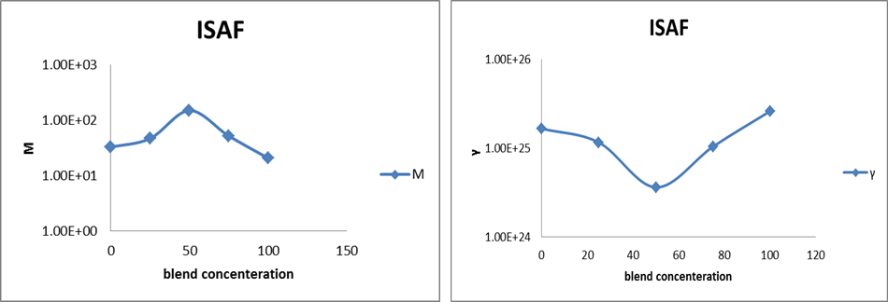
Figure (8) the plots of M_{e} and with the blend ratio for (ISAF).
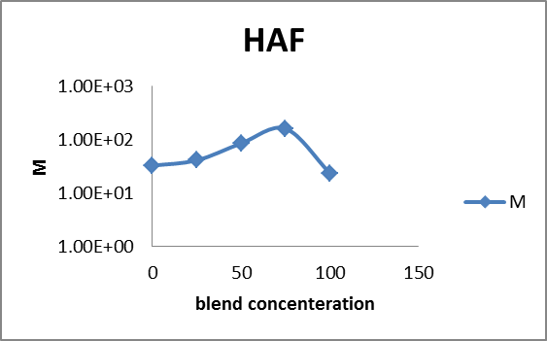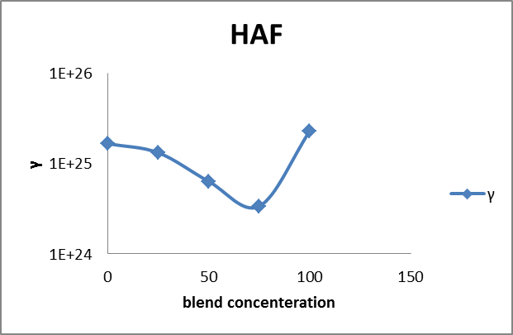
Figure (9) the plots of M_{e} and with the blend ratio for (HAF).

Conclusion
Summarizing, we have investigated the influence of pressure on the mechanical and physical properties of SBR and IIR doped with different types of carbon blacks (ISAF, HAF, FEF, GPF, and SRF) at percolation.
- Carbon black loaded in both IIR and SBR matrices enhances the mechanical and physical properties of the composites.
- The mechanical measurement proved that the highest young’s modulus obtained for the two samples 30ISAF/IIR and 40 HAF/IIR.
- By application of Mooney-Rivlin model the blend ratio 50IIR/50SBR gives the minimum network defects and the minimum obstructions with both types of carbon black (ISAF, HAF).

References
- Perepechko I. I., "An Introduction to Polymer Physics ", Mir Pub., Moscow, (1981).
- Findik F., R. Yilmaz, T. koksal, Investigation of mechanical and physical properties of several industrial rubbers. Mater .Des. 25 (2004) 269-276.
- Wall, F.T. J Chem. Phys., 1943, 11, 527.
- Flory, P.J. polymer chemistry; Cornell Univ. Press, Itaca, NY, 1953.
- James H.M.; Muller R.; R.; Frolich, D.J. Rheol 1986, 30, 1165.
- Mullins, L.; Tobin, N.R., J. Appl. Polym. Sci. 1965, 9, 2993.
- Rivlin, R.S.; Saunders, D.W. Philos. Trans. R. Soc. 1951, A213, 251.
- Hamza, S.S. Mater let 1997, 30, 153.
- Kontou, E.; , G. J. Appl. Polym. Sci. 1990, 39, 649.
- Priss, L.S. J. Polym. Sci. 1975, 3, 195.
- Zang, Y.H., Muller, R.;R.; Frolich. D. J. Rheol 1986, 30, 1165.
- James, H.M.; Guth, E. J. Chem. Phys. 1942, 11, 455.

11/26/2014

