A new hydrocarbon prospect determination through subsurface and petrophysical evaluation of Abu Roash “G” Member in Abu Sennan area, North Western Desert, Egypt.

Abd Elhady, M. A.¹, Hamed, T. A.², Abdelwahhab, M. A.³

^{1,3}Geology Department, Faculty of Science, Al-Azhar University, Cairo, Egypt.
²General Petroleum Company, Cairo, Egypt.
geo.mohammad85@yahoo.com

Abstract: This study aims to make a subsurface and petrophysical study to evaluate the petroleum potentialities of Abu Roash “G” Member in SWS and GPT oil and gas fields in Abu Sennan area North Western Desert of Egypt. It depends on the application of the available open-hole well log records of five wells distributed in the area of study, in addition to well distributed twenty 2D and 3D seismic lines. SWS and GPT Fields, which are being operated by the General Petroleum Company, have been producing oil and gas in the North Western Desert. The Late Cenomanian Abu Roash “G” Member conformably underlies the Turonian Abu Roash “F” Member and overlies the Late Albian- Early Cenomanian Bahariya Formation. It is mainly composed of shales, limestone, siltstone and sandstone thin interbeds. The Abu Roash “G” Member is evaluated as a good petroleum reservoir in the studied fields. The subsurface geologic setting, in terms of determining the stratigraphic and structural settings, is gained through the construction of different aligned lithostratigraphic corss sections, isochore and lithofacies maps, seismic and geologic structural corss sections, in addition to structure contour maps on top of Abu Roash “G” Member. The petrophysical evaluation, in terms of determining the petrophyical characteristics; effective porosity (ϕ_{eff}), shale content (V_{sh}), water saturation (S_{w}) and hydrocarbon saturation (S_{h}), is acquired through quantitative computer processed interpretation. The petrophysical characteristics are illustrated laterally in the form of iso-parametric maps and vertically in the form of litho-saturation cross-plots. The results of this paper revealed 2 new prospective areas to the southeast of the investigated SWS and GPT oil and gas fields. These locations are positioned as being located on a suitable structure, that is very convenient for petroleum accumulations. Moreover, they have an increase in net pay and effective porosity of Abu Roash “G” Member, and decrease in shale content and water saturation. So it is recommended to focus the exploration activities on the new prospective areas for more favorable economic petroleum discoveries.
[Abd Elhady, M. A., Hamed, T. A., Abdelwahhab, M. A. A new hydrocarbon prospect determination through subsurface and petrophysical evaluation of Abu Roash “G” Member in Abu Sennan area, North Western Desert, Egypt. Nat Sci 2014;12(11):199-218]. (ISSN: 1545-0740). http://www.sciencepub.net/nature. 30

Key words: Hydrocarbon Prospect, Subsurface Study, Petrophysical Study, Abu Sennan, Abu Gharadig Basin, North Western Desert, Egypt.

1. Introduction
Abu Sennan Area is located to the east of the Qattara Depression in the northern part of the Western Desert (figure 1). The study area comprises two fields, namely SWS and GPT. SWS Field is about 20 km south of Abu Gharadig gas Field, and GPT Field is about 10 Km east of Abu Gharadig Field (E.G.P.C., 1992). Abu Sennan Area is about 200 km west of the River Nile. The study area is bounded by latitudes 29°30` N and 29°40` N and longitudes 28°30` E and 28°40` E. The study area covers an area of about 300 Km2. Abu Sennan Area is located in the central part of Abu Gharadig basin (figure 2) (Schlumberger, 1995).
The present study aimed to gain a full subsurface and petrophysical overview of the study area, by integrating the available subsurface geological and geophysical data, to interpret the effect of the geological events on petroleum potentials of Abu Roash “G” Member in Abu Sennan Area.

2. Materials and methods
The present study depends on the use of the available open-hole well log records (electric, radioactivity and sonic logs) in the form of composite well logs (Resistivity, SP, GR, Density, Neutron and Sonic) of 5 wells distributed in the area of study. In addition to this, twenty 2D and 3D seismic lines are used (figure 1).
The subsurface geologic setting is gained through the construction of lithostratigraphic cross sections, isochore maps, lithofacies maps, seismic sections, structural cross sections and structure contour maps.
The petrophysical evaluation is gained through the computer processed interpretation that passes through the quantitative interpretation technique. The petrophysical characteristics are illustrated laterally (in the form of iso-parametric maps) and vertically (in the form of litho-saturation cross-plots).
This study mainly depends on the use of computer software programs, such as Petrel 2010 software program (® Schlumberger, 2010), Interactive Petrophysics version 3.5 software program (® Schlumberger, 2008), and other petroleum-related geological software programs.

3. Results and discussions
1. Subsurface geologic setting
The subsurface stratigraphic and structural setting, is gained through the construction of lithostratigraphic cross sections, isochore maps, lithofacies maps, seismic sections, structural cross sections and structure contour maps.
a. Stratigraphic setting
The stratigraphic setting is gained from interpreting well log data, previous studies on the study area, elucidating isochore maps, lithostratigraphic cross sections and lithofacies maps.
The stratigraphic column in the northern part of the Western Desert contains much of the sedimentary succession above Precambrian basement rocks to recent deposits (Schlumberger, 1995).
The stratigraphic succession of Abu Sennan area follows the North Western Desert regime. The penetrated stratigraphic succession in Abu Sennan area ranges from Kharita Formation (Albian) to Moghra Formation (Miocene) (figure 3) with a maximum penetrated thickness of 2975 m in GPT-13 well. All wells have reached large thickness of Kharita Formation (Albian), except one well (GPT-4) which was bottomed in the Bahariya Formation (Late Albian-Early Cenomanian).

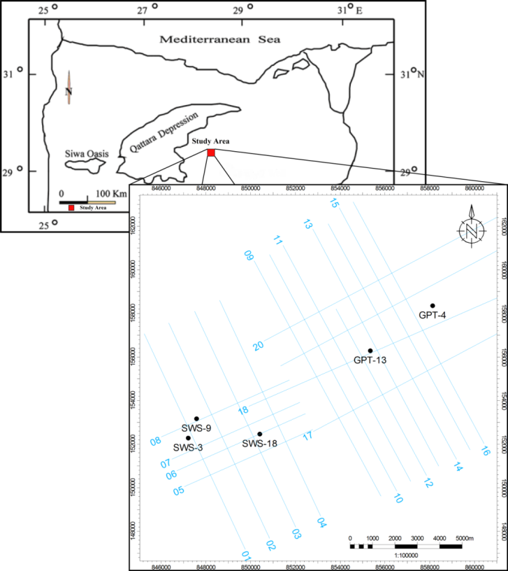
Fig. (1): Location map of Abu Sennan Area, showing the location of the selected wells and the alignment of the investigated seismic lines.
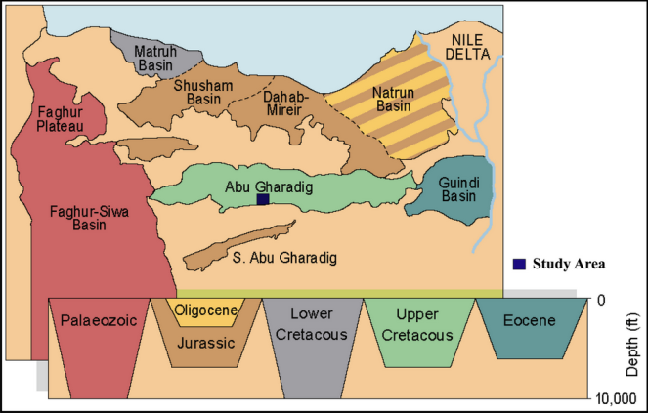
Fig. (2): Sedimentary Basins in the North Western Desert, and the location of the study area in relation to the sedimentary basins (Schlumberger, 1995).

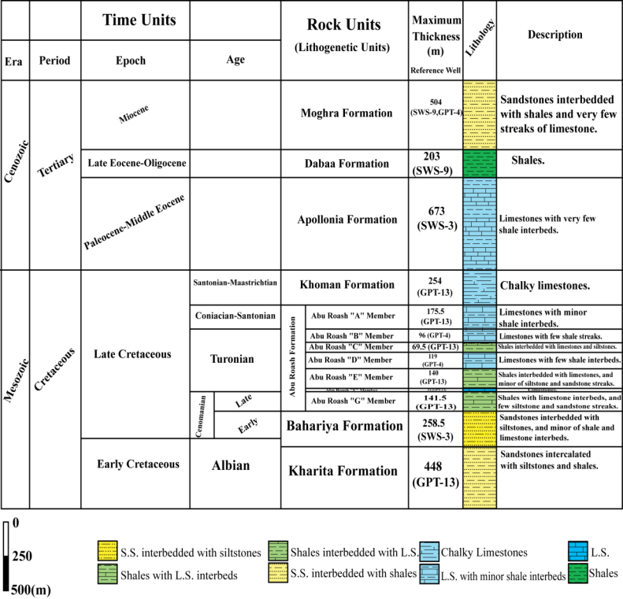
Fig. (3) Ideal stratigraphic column of Abu Sennan Area, showing the penetrated stratigraphic succession ranging from Kharita Formation (Albian) to Moghra Formation (Miocene).

In the study area, Abu Roash “G” Member is well represented in all the studied wells. Its thickness ranges from 110.5 m in GPT-4 well to 141.5 m in GPT-13 well. It is mainly composed of shale interbeded with limestone, and few siltstone and sandstone streaks.
The NE-SW aligned lithostratigraphic cross section constructed in the study area is shown in figure 4. It covers the central part of the study area. It passes through SWS-3, SWS-9, SWS-18, GPT-13 and GPT-4 wells. It generally shows that Abu Roash “G” Member is encountered with relatively the same thickness. It also shows that Abu Roah “G” Member is lithologically characterized by an increase in thickness of sandstone and siltstone intervals in GPT-13 well.
The isochore map of Abu Roash "G" Member (figure 5) shows an obvious increase in thickness towards the southeastern part of the study area with a maximum thickness of 141.5 m in GPT-13 well, where the main depocenter of deposition of this member exists. On the other hand there is a remarkable decrease in thickness towards the northeastern and southwestern parts of the study area with a minimum thickness of 110.5 m in GPT-4 well. The big thickness of Abu Roash “G” Member at the southeastern part of the study area reflects a continuous subsidence of this area during the deposition of this member.
The lithofacies map of Abu Roash “G” Member is constructed (figure 7) and interpreted, using the limits and characteristics of lithologic groups (Moody, 1961) (table 1 and figure 6). The clastic/non-clastic ratio, and sand/shale ratio of Abu Roash “G” Member are calculated and tabulated in table 2.
The Abu Roash "G" Member lithofacies map is characterized by the presence of one lithologic group, which is Shale-lime. The sand/shale ratio ranges from 0 % in GPT-4 well to 0.2 % in GPT-13 well, while the clastic/non-clastic ratio ranges from 1.86 % in SWS-18 well to 2.66 % in SWS-3 well. The area was under deep marine condition.
b. Structural Setting
The aim of this part is to highlight on the structural pattern of the study area. For this purpose, seismic cross sections, geologic structural cross sections, and structure contour maps are constructed using the geological and geophysical data.
To delineate the subsurface structure, two geologic structural cross sections are constructed. The interpretation of these sections is done by inferring the continuity of surfaces and making correlation between wells, and also by the support from the interpreted seismic sections.
The NE-SW structural cross section (figure 8) is characterized by the presence of a normal fault (SWS-F2). SWS-F2 fault is a major fault which has the downthrown side towards the NNW direction. It affects the Upper Cretaceous to Middle Eocene rock units, and diminutes in the upper rock units.

Table (1): Limits and characteristics of lithologic groups (Moody, 1961).
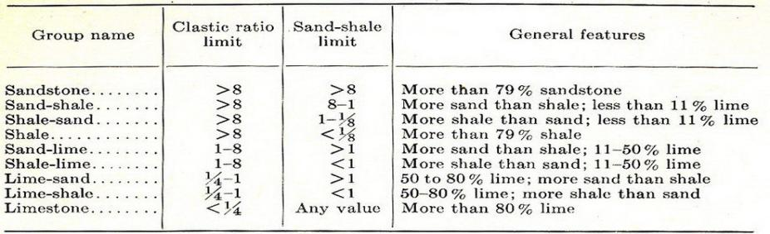

Table (2): Abu Roash “G” Member lithofacies calculations.
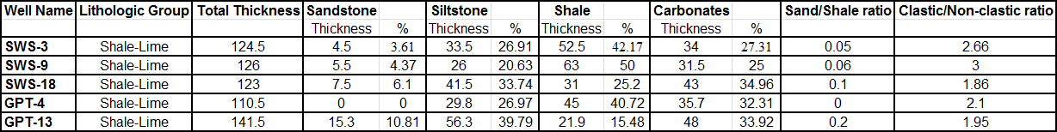

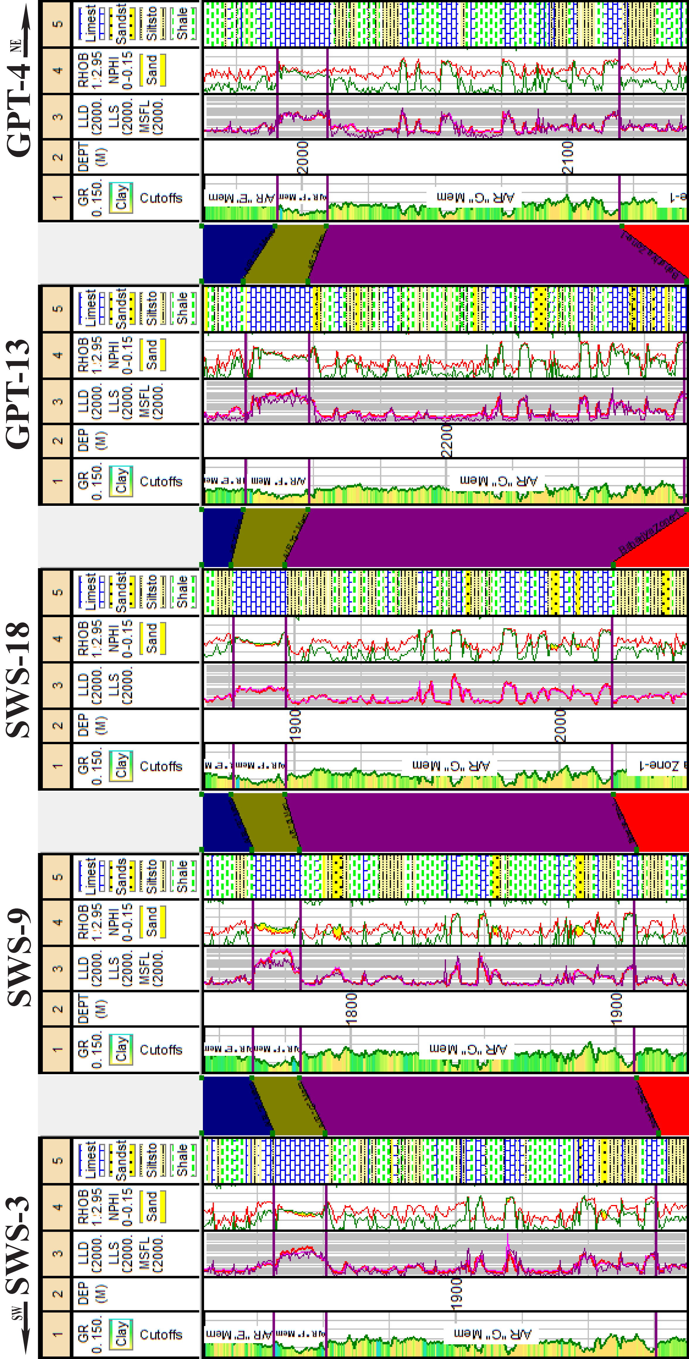
Fig. (4): NE-SW Lithostratigraphic cross section.

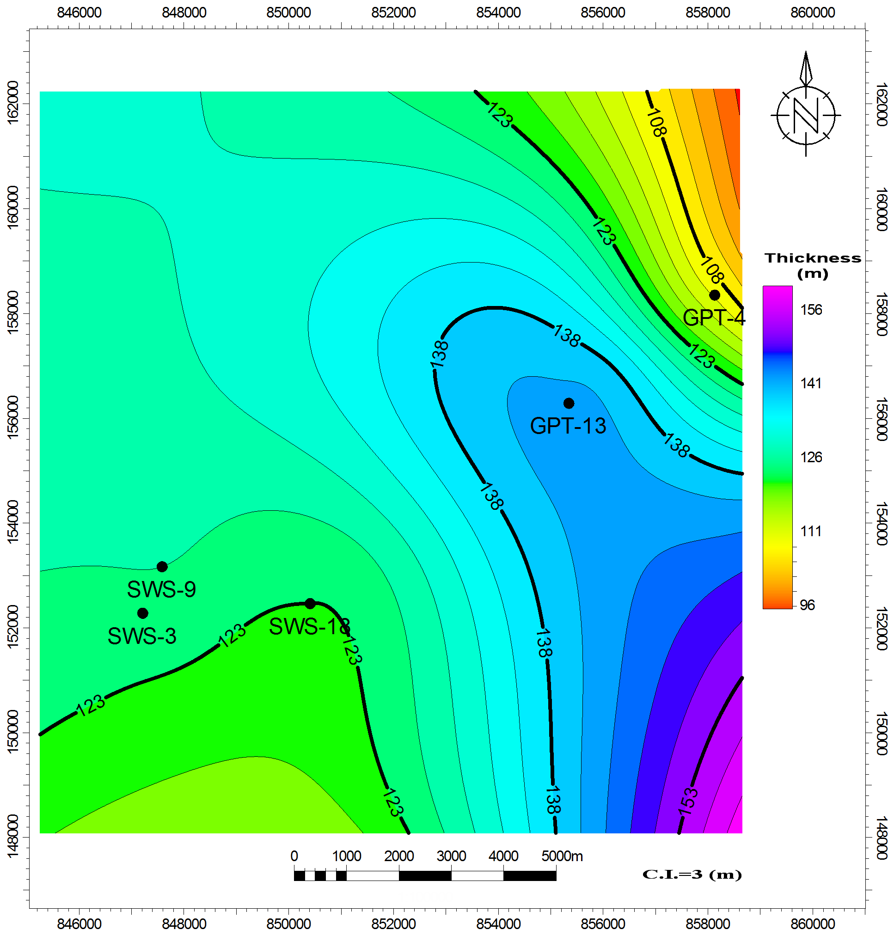
Fig. (5): Isochore map of Abu Roash "G" Member (Late Cenomanian), showing an increase in thickness towards the southeastern part of the study area.

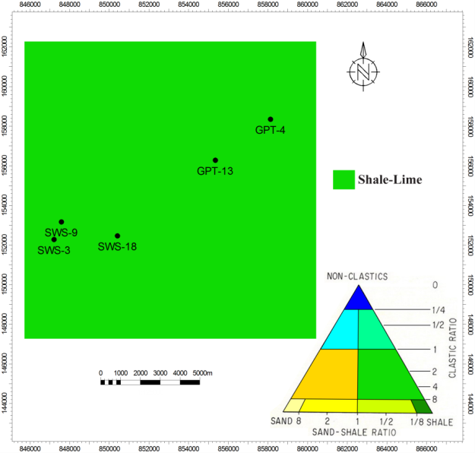
Fig. (7): Lithofacies map of Abu Roash “G” Member, showing the presence of a single lithologic group which is Shale-Lime.

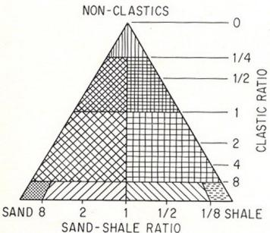
Fig. (6): Lithologic triangle used for mapping the composite lithologic aspects (Moody, 1961).

Well to Seismic Tie
According to Tearpock & Bischke (2003), once the well position is annotated on the seismic section, the information from the well data, in the form of geologic tops, must be located and marked on the seismic section. So the checkshot data is used to tie well data to seismic. Table 3 shows the time–depth values from well log and checkshot data. Figure 9 shows a cross-plot of the reflection two-way time (TWT) versus depth for all the formations that are penetrated by two wells, that are having a checkshot information. This cross-plot reveals that the two-way time tends to generally increase with the depth along the entire sections of the studied wells.

Table (3): Formation Time-Depth value from well log and checkshot data.
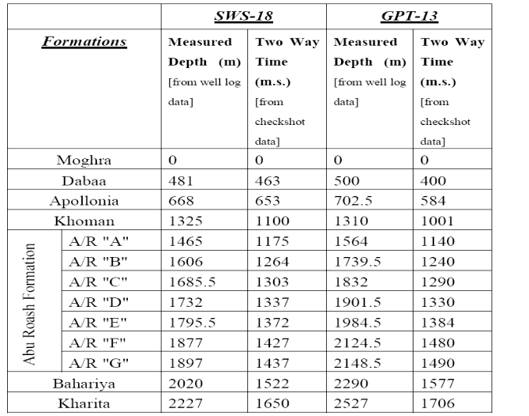

The delineation of the subsurface structure of the study area is based on twelve dip seismic sections aligned NNW-SSE and eight strike seismic sections aligned ENE-WSW. These cross sections show that the study area is affected by a set of normal faults (SWS-F1, SWS-F2, SWS-F3, SWS-F4, SWS-F5, GPT-F1, GPT-F2, GPT-F3, GPT-F4, GPT-F5 and GPT-F6), and also a domal structure at the northeastern part adjacent to GPT-4 well. The selected studied rock units are cut by these faults. SWS-F1, SWS-F2, and GPT-F3 faults have the downthrown side towards the NNW direction. SWS-F3, GPT-F1, GPT-F2, and GPT-F4 faults have the downthrown side towards the NW direction. SWS-F4 and SWS-F5 faults have the downthrown side towards the ENE and WSW directions respectively. GPT-F5 and GPT-F6 faults have the downthrown side towards the NNE and SSE directions respectively. SWS-F1, SWS-F2, SWS-F3, GPT-F1, GPT-F2, and GPT-F3 faults are forming a step fault pattern that would be an attractive area for oil and gas accumulations.
The interpreted seismic section – (01) is shown in figure 10. It is a dip section and takes the NNW-SSE trend. It is located at the southwestern part of the study area and passes adjacent to SWS-3 well. The interpretation of this section is done by tracing the continuity of the selected stratigraphic horizons at the intersection points with the other interpreted seismic sections, 03 and 13, that are interpreted by using the time-depth chart which is constructed using the checkshot data of SWS-18 and GPT-13 wells respectively, so detection of the TWT of the selected stratigraphic horizons is easily done.
This section passes through the selected studied rock units. The Bahariya Formation, Abu Roash “G” Member, Abu Roash “F” Member, Abu Roash “E” Member, Abu Roash “D” Member, Khoman Formation, and Apolloina Formation reflectors are picked at the proper time on this section.
This section shows a set of normal faults (SWS-F1, SWS-F2, and SWS-F3). The selected studied rock units are cut by these faults, except SWS-F3 fault which does not cut Apollonia Formation. SWS-F1 fault has the downthrown side towards the NNW direction with approximately 70 ms TWT vertical separation. SWS-F2 fault also has the downthrown side towards the NNW direction with approximately 66 ms TWT vertical separation. SWS-F3 fault has the downthrown side towards the NW direction with approximately 30 ms TWT vertical separation. SWS-F1, SWS-F2, and SWS-F3 faults are forming a step fault that would be an attractive area for oil and gas accumulations.

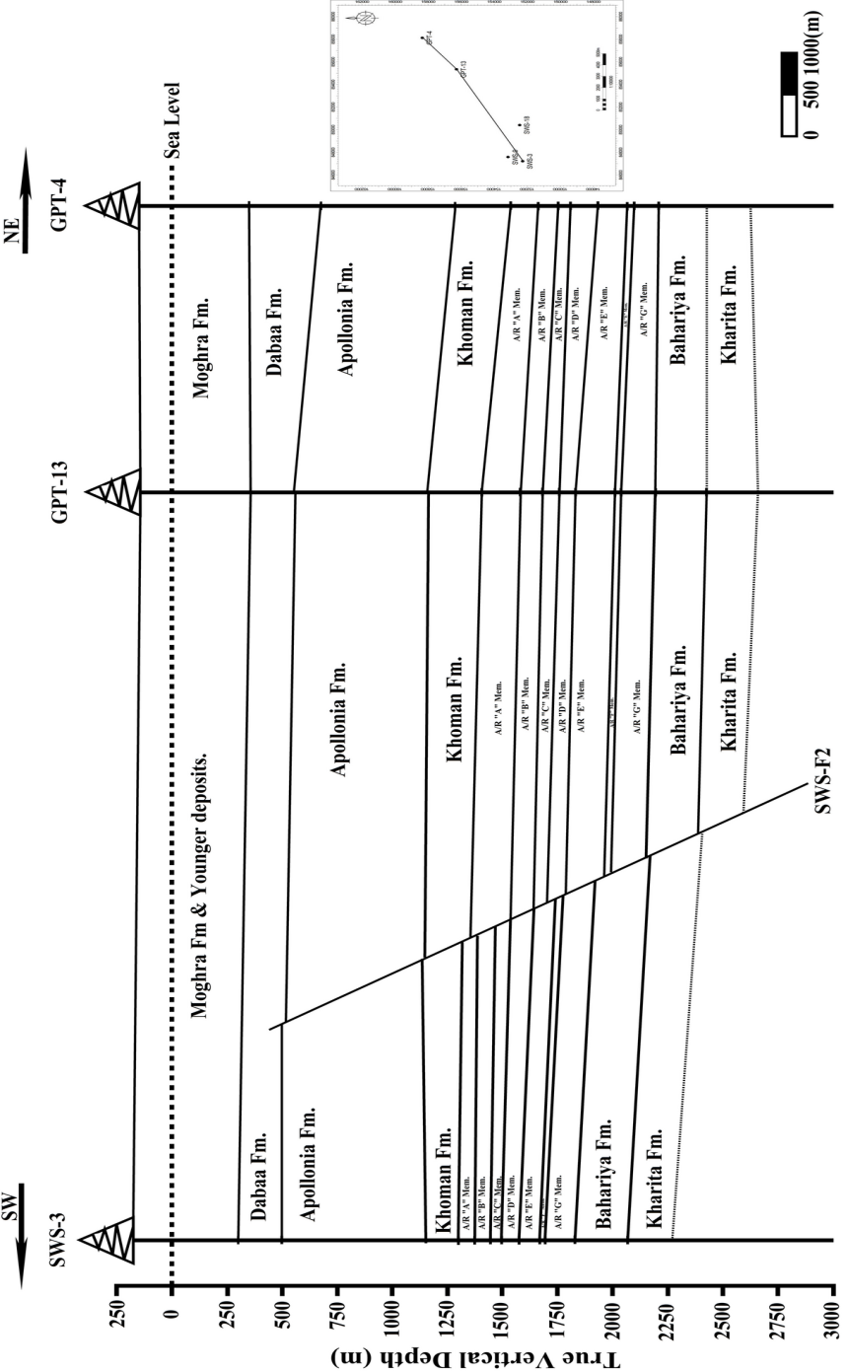
Fig. (8): NE-SW Structural cross section, showing the SWS-F2 normal fault.

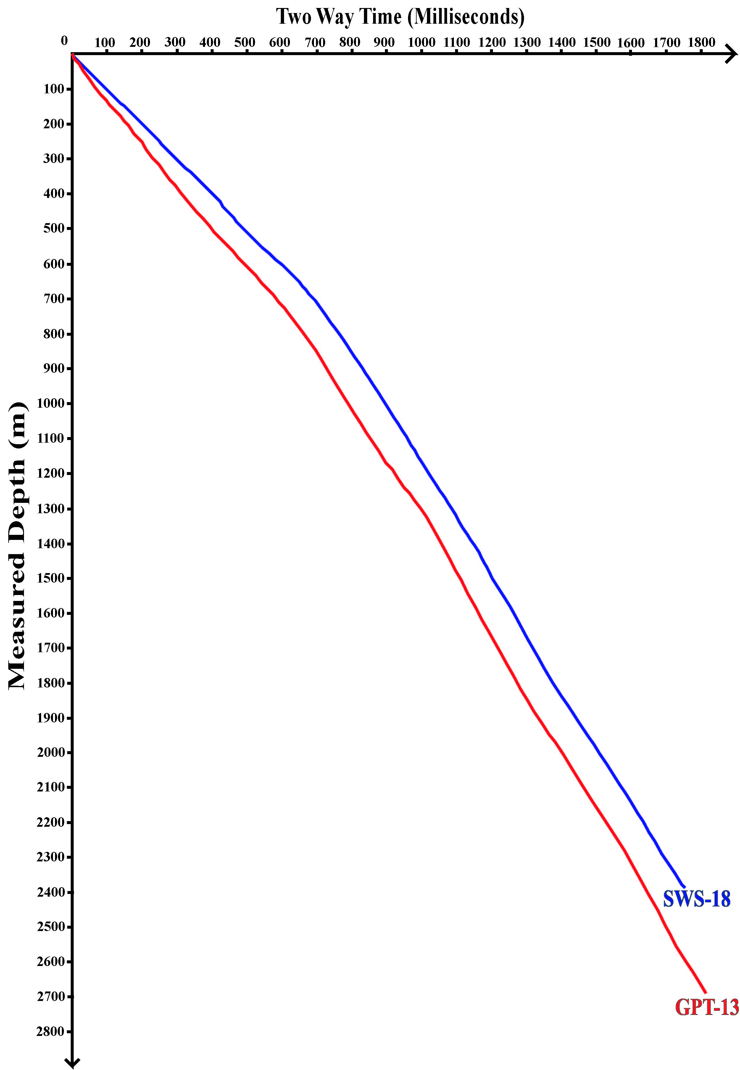
Fig. (9): Time vs Depth chart of SWS-18 & GPT-13 wells.

The interpreted seismic section – 9 is shown in figure 11. It is a dip section and takes the NNW-SSE trend. It is nearly located at the central part of the study area and does not pass through any of the studied wells. The interpretation of this section is done by tracing the continuity of the selected stratigraphic horizons at the intersection points with the other interpreted seismic sections, 03 and 13, that are interpreted by using the time-depth chart which is constructed using the checkshot data of SWS-18 and GPT-13 wells respectively, so detection of the TWT of the selected stratigraphic horizons is easily done.
This section passes through the selected studied rock units. The Bahariya Formation, Abu Roash “G” Member, Abu Roash “F” Member, Abu Roash “E” Member, Abu Roash “D” Member, Khoman Formation, and Apolloina Formation reflectors are picked at the proper time on this section.
This section shows a set of normal faults (GPT-F1, GPT-F2, and GPT-F3). The selected studied rock units are cut by these faults, except GPT-F3 fault which does not cut Apollonia Formation. GPT-F1 fault has the downthrown side towards the NW direction with approximately 50 ms TWT vertical separation. GPT-F2 fault also has the downthrown side towards the NW direction with approximately 42 ms TWT vertical separation. GPT-F3 fault has the downthrown side towards the NNW direction with approximately 27 ms TWT vertical separation. GPT-F1, GPT-F2, and GPT-F3 faults are forming a step fault pattern that would be an attractive area for oil and gas accumulations.

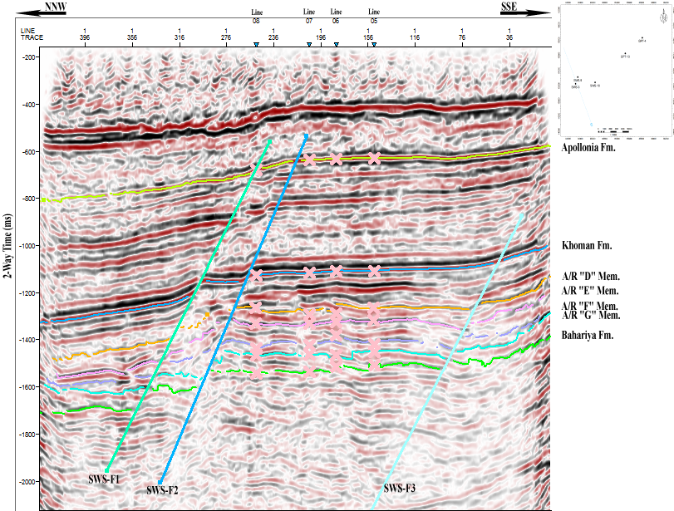
Fig. (10): NNW-SSE interpreted seismic section (01), showing the picked stratigraphic horizons cut by a set of normal faults (SWS-F1, SWS-F2, and SWS-F3). These faults are forming a step fault pattern that would be an attractive area for oil and gas accumulations.

To illustrate the subsurface structural configuration of the study area, a time structure contour map is constructed with the aid of the interpreted seismic sections.
The TWT structure contour map of the top of Abu Roash “G” Member is shown in figure 12. It shows a set of normal faults, six major normal faults (SWS-F1, SWS-F2, SWS-F3, GPT-F1, GPT-F2, and GPT-F3), and five minor normal faults (SWS-F4, SWS-F5, GPT-F4, GPT-F5, and GPT-F6), and also domal structure at the northeastern part adjacent to GPT-4 well, as is gained from the interpreted seismic sections. SWS-F1, SWS-F2, GPT-F3 and GPT-F6 faults are taking the ENE-WSW trend, with the downthrown side towards the NNW direction, except GPT-F6 which has the downthrown side towards the SSE direction. SWS-F3, GPT-F1, GPT-F2, and GPT-F4 faults are taking the NE-SW trend, with the downthrown side towards the NW direction. SWS-F4 and SWS-F5 faults are aligned to the NNW-SSE direction, with the downthrown side towards the ENE and WSW directions respectively. GPT-F5 fault is aligned to the ESE-WNW trend, with the downthrown side towards the NNE direction. SWS-F1, SWS-F2, SWS-F3, GPT-F1, GPT-F2, and GPT-F3 faults are forming a step fault pattern.
These faults (SWS-F1, SWS-F2, SWS-F3, GPT-F1, GPT-F2, and GPT-F3) are a result of the tectonic event, that occurred during the Late Cretaceous – Early Tertiary time, that was probably related to the movement of the north African plate toward Europe (Sultan and Abdel Halim, 1988 and Said, 1990).
All the studied wells, which are a good producing wells, are located on the second step of the step fault, which is bounded by SWS-F2, SWS-F3, GPT-F2, and GPT-F3 faults, although it is much better to be located on the third step of the step fault where the hydrocarbon accumulations prefer to be located on such the highest three-way dip clouser that is more beneficial to accumulation than the lower second step of the step fault. So it is may be possible to drill other wells in the third step of the step fault for more hydrocarbon production.

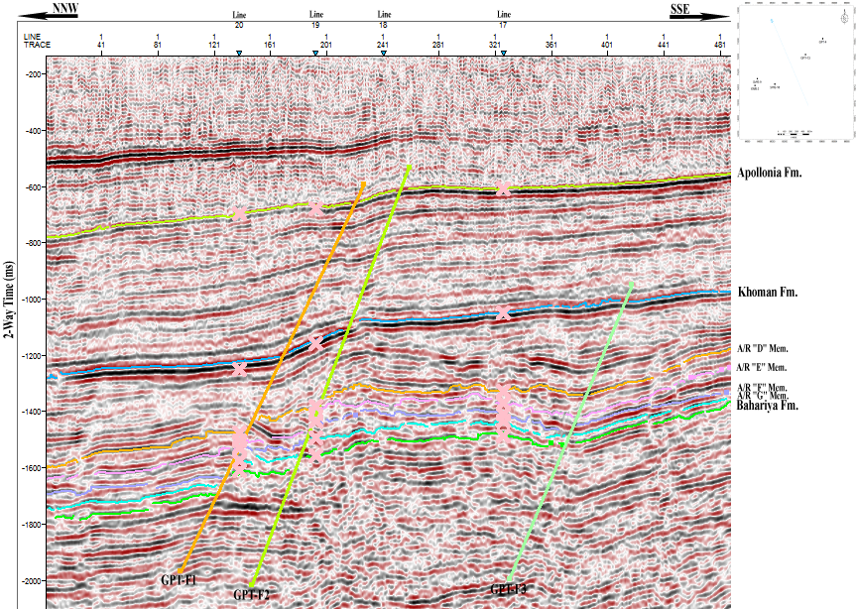
Fig. (11): NNW-SSE interpreted seismic section (9), showing the picked stratigraphic horizons cut by a set of normal faults (GPT-F1, GPT-F2, and GPT-F3). These faults are forming a step fault pattern that would be an attractive area for oil and gas accumulations.

To illustrate the subsurface structural setting of the study area in a 3D view, 3D structural view is constructed (figure 13) for Bahariya Formation, Abu Roash “G”, Abu Roash “F”, Abu
Roash “E”, and Abu Roash “D” members, Khoman and Apollonia formations with the aid of the interpreted seismic sections. It shows the horizon elevation of these rock units (1 is the highest elevation, and 0 is the lowest elevation), the selected wells drilled within these rock units, and the faults affected on them. It is obvious that it may be possible to drill many wells in the third step of this step fault (towards the southeastern part of the study area).

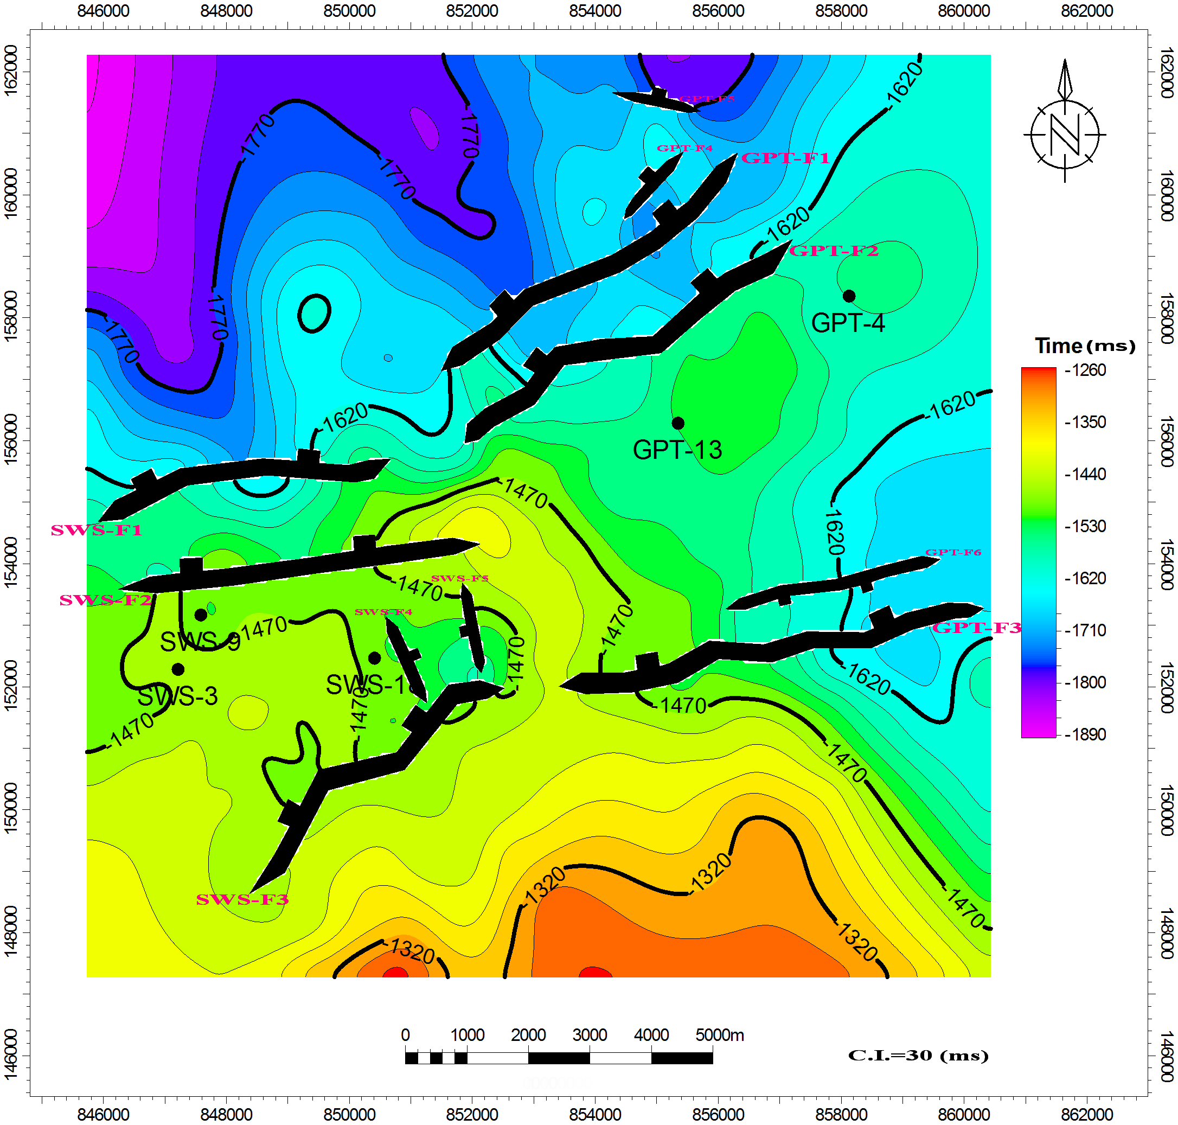
Fig. (12): Time structure contour map on top Abu Roash “G” Member, showing a set of normal faults (SWS-F1, SWS-F2, SWS-F3, SWS-F4, SWS-F5, GPT-F1, GPT-F2, GPT-F3, GPT-F4, GPT-F5 and GPT-F6) and also a domal structure at the northeastern part adjacent to GPT-4 well. SWS-F1, SWS-F2, SWS-F3, GPT-F1, GPT-F2, and GPT-F3 faults are forming a step fault pattern that would be an attractive area for oil and gas accumulations.

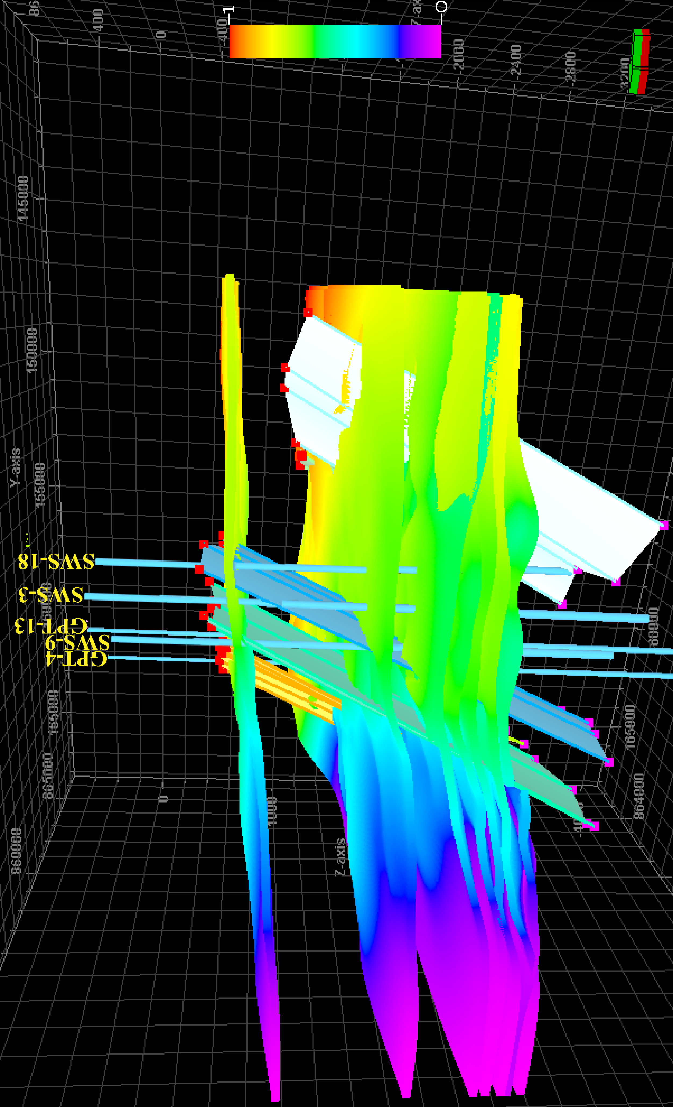
Fig. (13): 3D structural view of the studied rock units, showing that the rock units are affected by a set of ENE-WSW and the NE-SW normal faults.

2. Petrophysical Evaluation
The Petrophysical evaluation, in terms of evaluating the petrophyical characteristics (effective porosity (ϕ_{eff}), shale content (V_{sh}), water saturation (S_{w}), and hydrocarbon saturation (S_{h})) of Abu Roash “G” Member, is gained through the computer processed interpretation that passes through the quantitative interpretation technique. The petrophysical characteristics are illustrated laterally (in the form of iso-parametric maps) and vertically (in the form of litho-saturation cross-plots).
a. Computer Processed Interpretation
In this investigation, the computer processed interpretation process passes through the quantitative interpretation techniques by using Interactive Petrophysics version 3.5 software program (® Schlumberger, 2008).
Figure 14 represents the lithological identification cross-plot (neutron-density and the neutron-sonic) of Abu Roash “G” Member. Abu Roash “G” Member is characterized by the predominance of shale and limestone, and little of siltstone and sandstone.
Figure 15 represents the mono-porosity cross-plot of Abu Roash “G” Member. As shown in this figure, the value of water saturation ranges from 11.42 % to 100 %. It indicates the probability of presence of hydrocarbon sub-reservoir intervals as the mean value is 72.58 %, and there are some intervals which have a hydrocarbon saturation value up to 90 %.
Once we see that the mean value of water saturation is 72.58 %, we think that the hydrocarbon saturation is very low and the water saturation is very high and exceeds the limit of the cutoff which is 50 % for the water saturation. The probability of presence of hydrocarbon sub-reservoir intervals is very low, but considering that this high value of water saturation is the mean value in the whole interval of Abu Roash “G” Member in all the studied wells (including high productive and low productive wells), however there are a lot of sub-reservoir intervals where the hydrocarbon saturation reaches up to 90 % in these intervals within Abu Roash “G” Member and the litho-saturation cross-plots clarify this point.
Figure 16 represents the dia-porosity cross-plot for determining the shale volume (V_{sh}) of Abu Roash “G” Member. The value of shale content ranges from 0 % to 100 %. It indicates the probability of presence of hydrocarbon sub-reservoir intervals as the mean value is 20.43 %.
Figure 17 represents the dia-porosity cross-plot for determining the effective porosity (ϕ_{eff}) of Abu Roash “G” Member. The value of effective porosity ranges from 0 % to 45 %. It indicates the probability of presence of hydrocarbon sub-reservoir intervals as the mean value is 18.72 %.
The petrophysical characteristics are illustrated laterally (in the form of iso-parametric maps) and vertically (in the form of litho-saturation cross-plots).
Lateral Variation of Petrophysical Characteristics
The lateral variation of petrophysical charactriestics could be studied through a number of gradient and saturation maps (iso-parametric maps); that include net pay (m), effective porosity (Φeff %), shale content (Vsh %), water saturation (Sw %), and hydrocarbon saturation (Sh %).
Figure 18 represents the iso-parametric maps of Abu Roash “G” Member, and reveals the following:
The net pay of Abu Roash “G” Member ranges from 7.75 m in GPT-4 well to 17.17 m in GPT-13 well. It is clear that the net pay increases towards the southeastern part of the study area. The structural element of the area under investigation does affect the net pay distribution, as the southeastern part is structurally high area, and also lithologically characterized by an increase in thickness of the sandstone and siltstone intervals.
The effective porosity increases towards the southern and southeastern parts of the study area with a maximum value of 21.37 % in SWS-18 well.
The shale content increases towards the northwestern and northeastern parts of the area under investigation, where the shale content recorded its maximum value of 32.12 % in SWS-9 well. On the other hand there is a remarkable decrease in the value of shale content towards the southeastern part of the study area.
The water saturation increases towards the northwestern and northeastern parts of the study area with a maximum value of 78.26 % in SWS-9 well. On the other hand there is an obvious decrease in the value of water saturation towards the southeastern part of the area under investigation, where the hydrocarbon saturation increases.

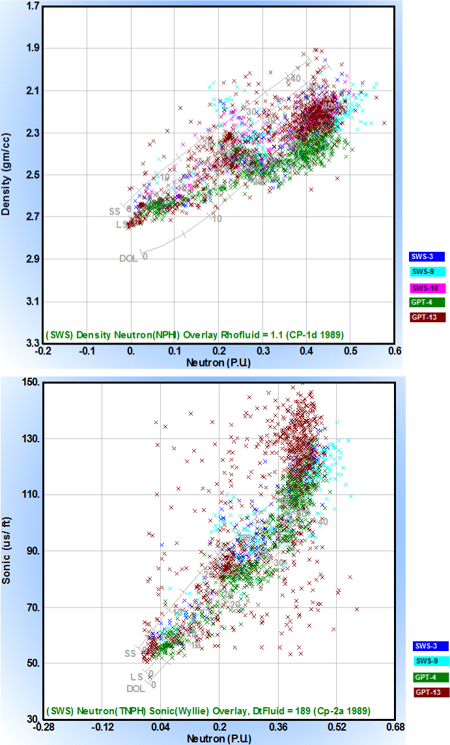
Fig. (14): Lithological identification cross-plot of Abu Roash “G” Member.

All maps show an accurate matching between the petrophysical characteristics. As the net pay and effective porosity increase towards the southeastern part, while the shale content and water saturation decrease towards this part.
It should be taken in consideration that the effective porosity in the reservoir intervals of Abu Roash "G" Member ranges from 19.4 % in GPT-4 well to 25.3 % in SWS-3 well. Moreover, the shale content in the reservoir intervals of Abu Roash "G" Member ranges from 8.8 % in SWS-3 well to 17.3 % in GPT-4 well. Moreover, the water saturation in the reservoir intervals of Abu Roash "G" Member ranges from 55.7 % in SWS-9 well to 64.5 % in SWS-3 well.

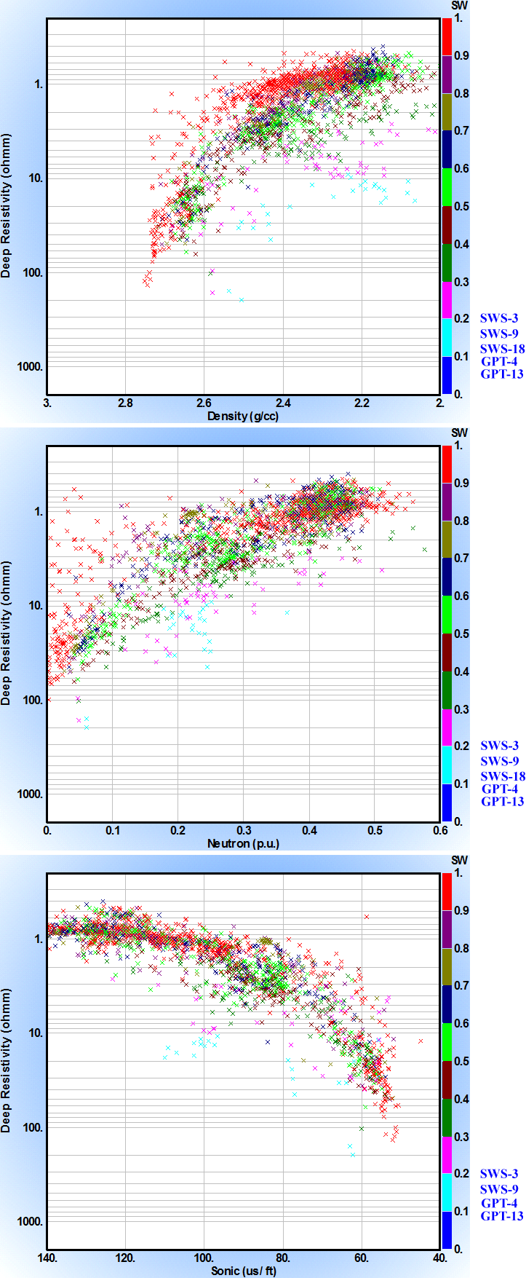
Fig. (15): Mono-porosity cross-plot of Abu Roash “G” Member.

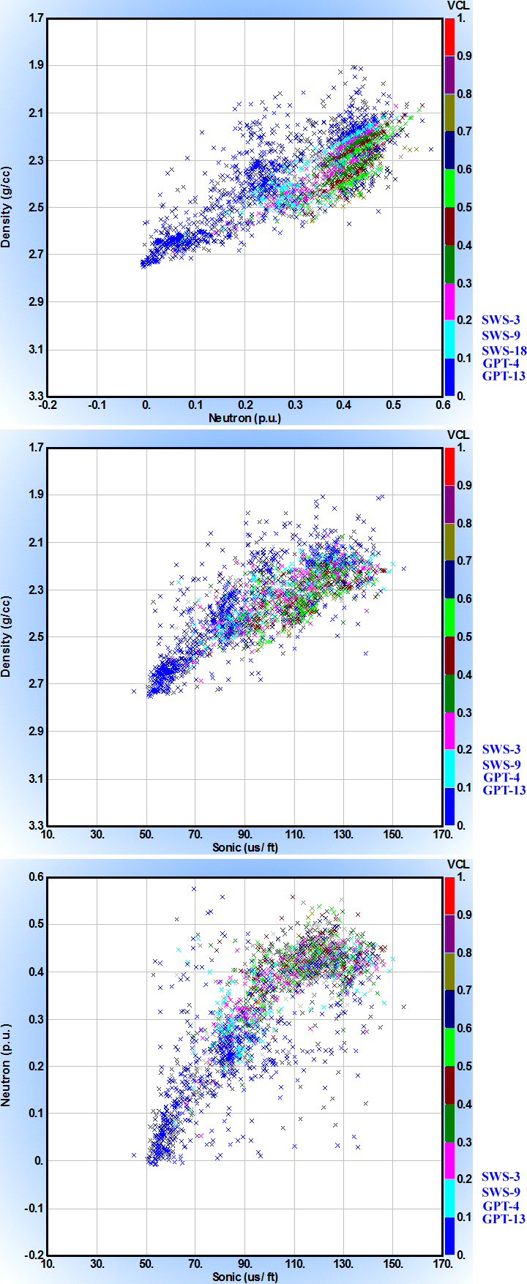
Fig. (16): Dia-porosity cross-plot for determining the shale volume (Vsh) of Abu Roash “G” Member, showing that the mean value is 20.43 %.

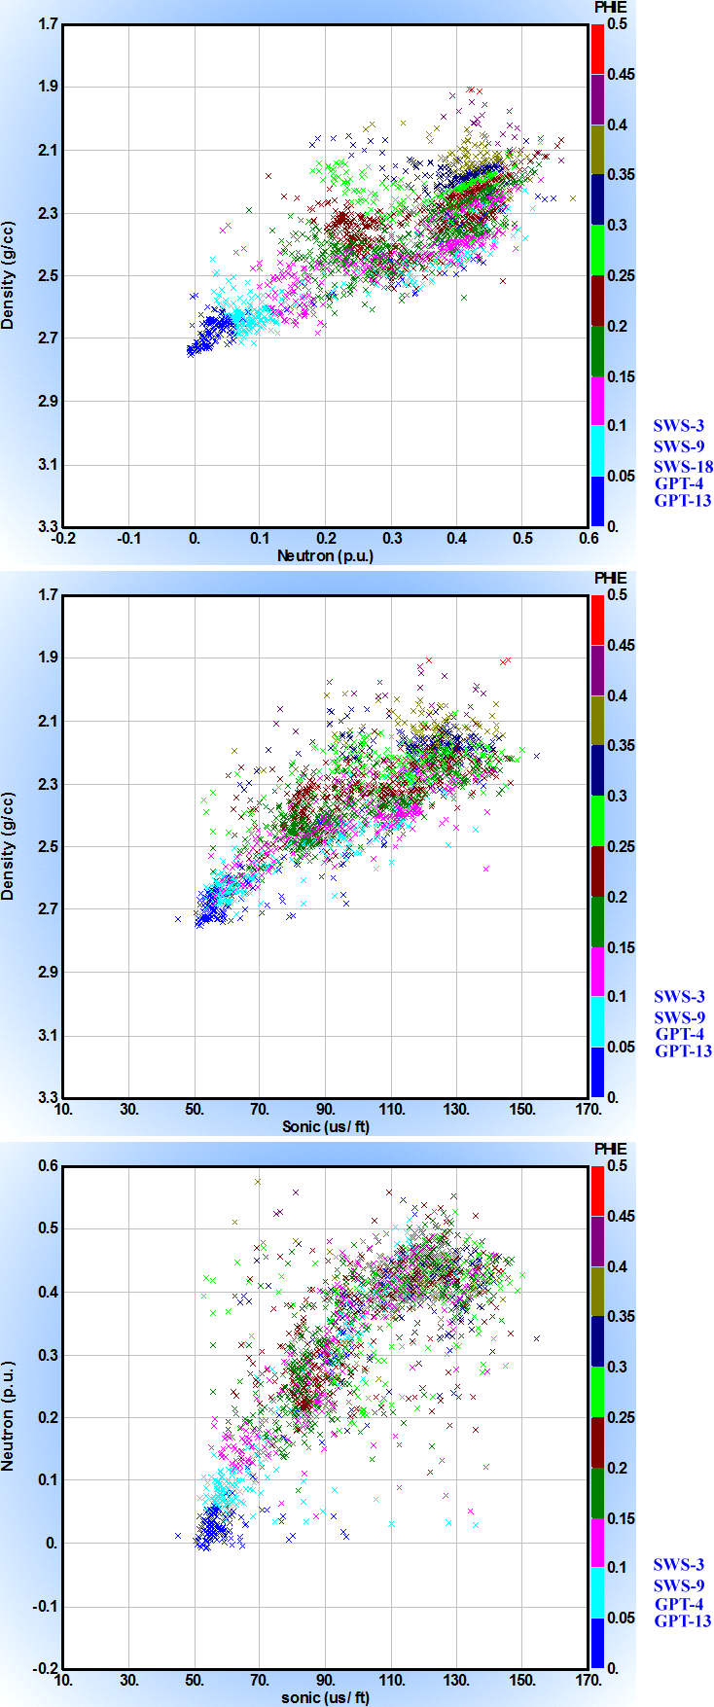
Fig. (17): Dia-porosity cross-plot for determining the effective porosity (ϕeff) of Abu Roash “G” Member, showing that the mean value is 18.72 %.

b. Illustration of Results
Vertical Variation of Petrophysical Characteristics
The vertical distribution of petroleum occurrences can be explained and presented through the construction of the litho-saturation cross-plots. Litho-saturation cross-plot is a representation, zone-wise, for the content of fluids and rocks with depth through the studied well. The contents of rocks include shale and matrix, while the contents of fluids include water and hydrocarbon saturation.
The litho-saturation cross-plots of Abu Roash “G” Member show the predominance of shale and limestone. They also show that Abu Roash “G” Member reveals a lot of intervals that are considered as sub-reservoirs where the hydrocarbon saturation reaches up to 90%.
Figure 19 represents the litho-saturation cross-plot of Abu Roash “G” Member in GPT-13 well. As shown in this figure the Abu Roash “G” Member is encountered at the depth of 2148.5 m to 2290 m. The gross interval of Abu Roash “G” Member is 141.5 m. It is mainly characterized by the predominance of shale and limestone. It is also characterized by the presence of little of siltstone and sandstone intervals. In this well, the mean value of shale content is 14.93 %. The mean value of effective porosity is 21.30 %. Abu Roash “G” Member reveals a lot of intervals that are considered as a sub-reservoir intervals, where the mean value of water saturation is 70.15 %. The net pay is 17.17 m.

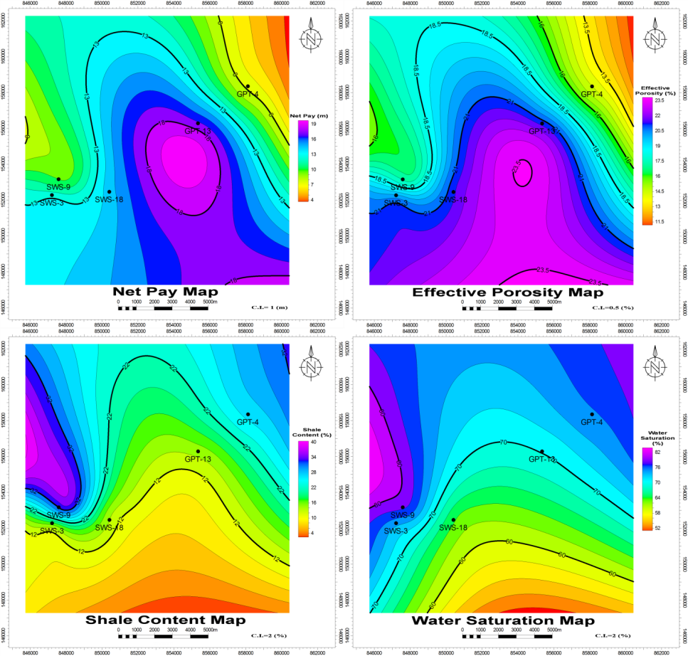
Fig. (18): Iso-parametric maps of Abu Roash “G” Member.

3. Petroleum Potentials
According to Magoon and Dow (1994), investigations of sedimentary basins, petroleum systems, plays, and prospects can be viewed as separate levels of hydrocarbon investigation, all of which are needed to better understand the genesis and habits of hydrocarbons. Sedimentary basins investigations emphasize the stratigraphic sequence and structural style of sedimentary rocks. Petroleum system studies describe the genetic relationship between a pod of active source rock and the resulting oil and gas accumulations. Investigation of plays describe the present-day geologic similarity of a series of present-day traps, and studies of prospects describe the individual present-day trap, and determine whether they have economic value and are exploitable with available technology and tools.
Gaining the petroleum potentialities are done by using the results of this study (subsurface and petrophysical), and the information of the previous studies on the study area.
According to Hamed (1999), the source rocks in Abu Sennan area are represented by the shales of Bahariya Formation. Also, the shales and carbonates that act as a source rock potentials are found within; Abu Roash "G", "F", and "E" Members. The Bahariya shales are of fair source rock potentials since the TOC (Total Organic Carbon content) varies from 0.7 % to 1.0 % (figure 20). Abu Roash "G" shales are of fair source rocks (07 to 1.4 TOC%). Abu Roash "F" limestone is of fair to excellent source rock (1.3 to 3.0 TOC%). Abu Roash "E" shale is of fair to good source rock (0.75 to 1.3 TOC%). Accordingly, the shales and carbonates of Abu Roash "G" Member act as a source rock for the siltstone and sandstone reservoirs of this rock unit itself.
In the area of study, the siltstones and sandstones of the Late Cenomanian Abu Roash “G” Member are considered as reservoir rocks.
Based on the petrophysical evaluation of Abu Roash “G” Member, it is mainly characterized by the predominance of shale and limestone, and little siltstone and sandstone. The mean value of effective porosity is 18.72 %. The mean value of shale content is 20.43 %. The mean value of water saturation is 72.58 %.
In the area of study, the carbonates of the Turonian Abu Roash “F” Member and the shales and carbonates of the Late Cenomanian Abu Roash “G” Member are considered to be the seal rocks, that prevent the upward migration of petroleum accumulated within Abu Roash “G” Member. Based on the petrophysical evaluation of Abu Roash "F" Member, it is composed of limestone.
In the area of study, the structural traps are represented by tilted fault blocks. A set of normal faults are present. Moreover a domal structure (4-way dip closure) is present in the northeastern part adjacent to GPT-4 well.
The structural traps caused by normal faults play a major role in the entrapment of hydrocarbons in the study area, also in making the Abu Roash "F" Member a seal rock that prevents petroleum accumulated in Abu Roash “G” Member from the lateral movement and holds it in place.

Fig. (20): TOC vs depth crossplot of GPT-3 well (Hamed, 1999).
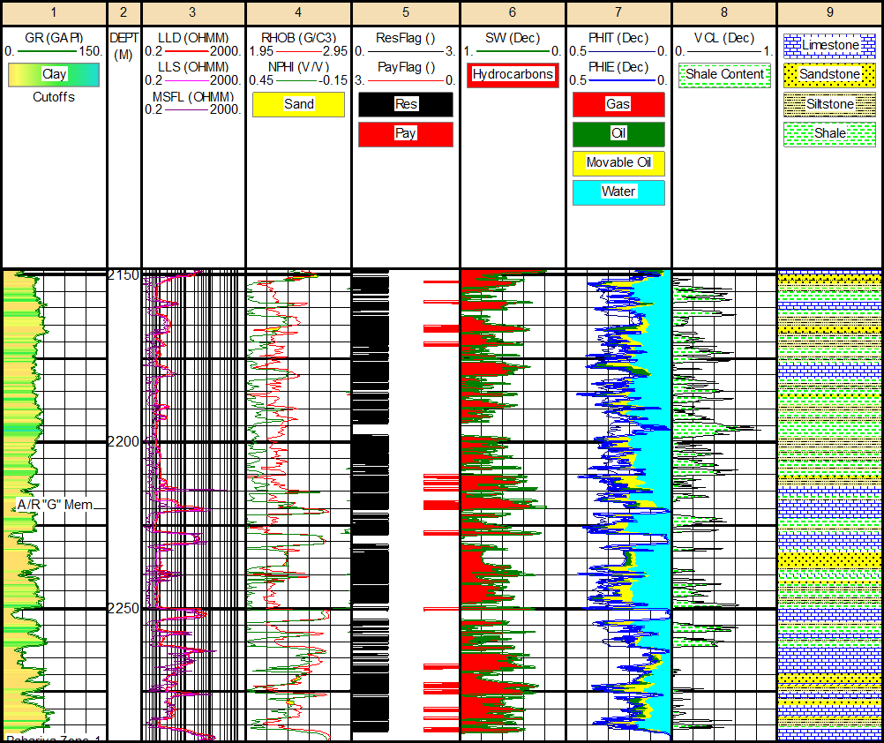
Fig. (19): Litho-saturation cross-plot of Abu Roash "G" Member in GPT-13 well (2148.5 m – 2290 m), showing that Abu Roash "G" Member reveals a lot of hydrocarbon sub-reservoir intervals, where the mean value of water saturation is 70.15 %. The net pay is 17.17 m.

All the studied wells, which are a good producing wells, are located on the second step of the step fault, although it is much better to be located on the third step of the step fault where the hydrocarbon accumulations prefer to be located on such the highest three-way dip closure that is more beneficial to accumulation than the lower second step of the step fault. So it is recommended to drill many wells in the third step of the step fault for more hydrocarbon production.
Prospect evaluation
According to Magoon and Dow (1994), prospects were first used by exploration geologists to describe present-day structural or stratigraphic features that could be mapped and drilled. A series of related prospects is a play.
According to Hyne (2001), a prospect is the exact location where the geological and economic conditions are favorable for drilling an exploratory well. A prospect can be presented by using prospect maps that illustrate the reasoning for selecting that drilling location. The maps include at least a structure and isopach map of the drilling target and a map of test results and fluid recoveries from wells in the area.
As a result of this study, using the subsurface and petrophysical evaluation, 2 new locations are proposed to be prospective areas, as is shown in figure 21. Prospect-1 is positioned as being located on a 3-way dip closure that would be an attractive area for oil and gas accumulations. Prospect-2 is positioned as being located on a structurally high area that could be a 3-way dip closure or 4-way dip closure, but there is not sufficient data that confirms this point as this area is at the end of the used seismic data, so it may be possible area for drilling exploratory wells. Moreover, these two areas are characterized by an increase in net pay and effective porosity of the target (Abu Roash “G” Member), and decrease in shale content and water saturation (figure 18).
Once the distribution of the reservoir characteristics in these prospects is understood, such prospective areas would be drilled, during the later stages of development in this area, particularly after this subsurface and petrophysical study, for more favorable economic conditions.

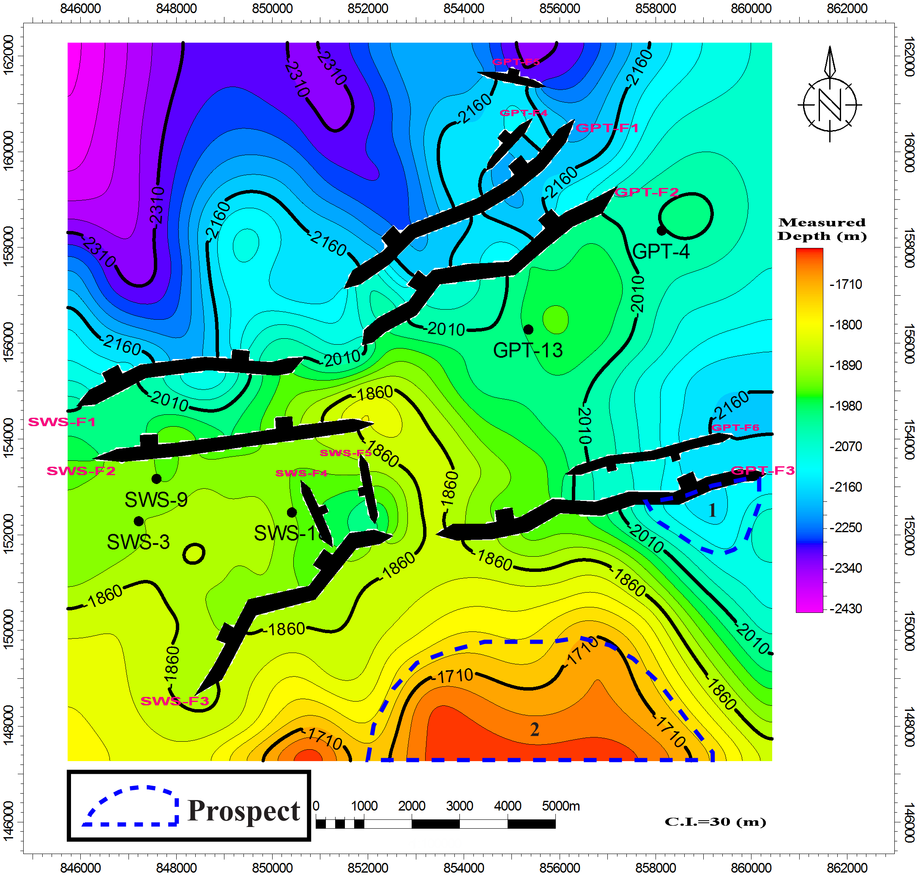
Fig. (21): Depth structure contour map on top Abu Roash “G” Member, showing the location of the proposed prospects.

Conclusions
The subsurface geologic setting is gained through the construction of lithostratigraphic cross sections, isochore maps, lithofacies maps, seismic sections, geologic structural cross sections and structure contour maps. The stratigraphic succession penetrated by the wells drilled in Abu Sennan area ranges from Kharita Formation (Albian) to Moghra Formation (Miocene).
Abu Roash "G" Member is mainly composed of shale interbeded with limestone, and few siltstone and sandstone streaks.
The study area is affected by a set of normal faults, six relatively major normal faults (SWS-F1, SWS-F2, SWS-F3, GPT-F1, GPT-F2, and GPT-F3), and five minor normal faults (SWS-F4, SWS-F5, GPT-F4, GPT-F5, and GPT-F6), and also a domal structure at the northeastern part adjacent to GPT-4 well, as is gained from the interpreted seismic sections, structural cross sctions, and structure contour maps. SWS-F1, SWS-F2, GPT-F3 and GPT-F6 faults are taking the ENE-WSW trend, with the downthrown side towards the NNW direction, except GPT-F6 which has the downthrown side towards the SSE direction. SWS-F3, GPT-F1, GPT-F2, and GPT-F4 faults are taking the NE-SW trend, with the downthrown side towards the NW direction. SWS-F4 and SWS-F5 faults are taking the NNW-SSE direction, with the downthrown side towards the ENE and WSW directions respectively. GPT-F5 fault is aligned to the ESE-WNW trend, with the downthrown side towards the NNE direction. SWS-F1, SWS-F2, SWS-F3, GPT-F1, GPT-F2, and GPT-F3 faults are forming a step fault that would be an attractive area for oil and gas accumulations. These faults (SWS-F1, SWS-F2, SWS-F3, GPT-F1, GPT-F2, and GPT-F3) are a result of the tectonic event, that was occurred during the Late Cretaceous – Early Tertiary time, that was probably related to the movement of the north African plate toward Europe.
The petrophysical evaluation, in terms of evaluating the petrophyical characteristics (effective porosity (ϕ_{eff}), shale content (V_{sh}), water saturation (S_{w}), and hydrocarbon saturation (S_{h})) of Abu Roash “G” Member, is gained through the computer processed interpretation that passes through the quantitative interpretation technique. The petrophysical characteristics are illustrated laterally (in the form of iso-parametric maps) and vertically (in the form of litho-saturation cross-plots).
Gaining the petroleum potentialities are done using the results of this study (subsurface and petrophysical), and the information of the previous studies on the study area. The shales and carbonates of Abu Roash "G" Member act as a source rock for the siltstone and sandstone reservoirs of this rock unit itself. In the area of study, the siltstones and sandstones of the Late Cenomanian Abu Roash “G” Member are considered as reservoir rocks. In the area of study, the carbonates of the Turonian Abu Roash “F” Member and the shales and carbonates of the Late Cenomanian Abu Roash “G” Member are considered to be the seal rocks, that prevent the upward migration of petroleum accumulated within Abu Roash “G” Member. The structural traps are represented in the form of tilted fault blocks, and a domal structure (4-way dip closure) in the northeastern part. A set of normal faults (SWS-F1, SWS-F2, SWS-F3, GPT-F1, GPT-F2, GPT-F3) are present and forming a step fault pattern.
As a result of this study, 2 new locations are proposed to be prospective areas that are positioned as being located on a suitable trap, that is very convenient for petroleum accumulations. Also these locations have an increase in the net pay and effective porosity of Abu Roash “G” Member, and decrease in shale content and water saturation.

Recommendations
As a result of this study, the proposed prospective area would be conveniently drilled, to develop this area, for more favorable economic conditions. The proper depth with the aid of the depth structure contour map is constructed for the top of Abu Roash “G” Member.

Acknowledgements
The authors gratefully would like to thank the Egyptian General Petroleum Corporation (E.G.P.C.) and the General Petroleum Company (GPC) for providing the raw data used in this study.

References
- E.G.P.C. (Egyptian General Petroleum Corporation) (1992): "Western Desert, oil and gas fields, A comprehensive overview", 431p.
- Hamed, T. A. (1999): “Geology and hydrocarbon potentialities of the Upper Cretaceous sequence in Abu Sennan Area, North Western Desert, Egypt.”, PhD thesis, Geology Department Fauclty of Science, Cairo University, 176p.
- Hyne, N. J. (2001): "Petroelum Geology, Exploration, Drilling, and Production", 2nd ed. Penn Well Corporation, 598 p.
- Magoon, L. B. and Dow, W. G. (1994): "The petroleum system-from source to trap", AAPG, Tulsa, Oklahoma, U.S.A. 637 p.
- Moody, G. B. (1961): "Petroleum Exploration Handbook", McGraw-Hill Book Company, Inc.
- Said, R. (1990): "The geology of Egypt", A.A., Balkema, Rotterdam, Brookfield, 734 p.
- Schlumberger (1995): "Well Evaluation Conference, Egypt", pp. 57-71.
- Sultan, N. and Abdel Halim, M. (1988): "Tectonic framework of northern Western Desert, Egypt and its effect on hydrocarbon accumulations", E.G.P.C., 9th Petrol. Explor. and Prod. Conf. Cairo, 31 p.
- Tearpock, D. J. and Bischke, R. E. (2003): "Applied subsurface geological mapping", Pearson Education, Inc. Publishing as Prentice Hall PTR, Upper Saddle River, New Jersey 07458, 822 p.

11/12/2014

