Potential Protective Effect of Curcumin on Acitretin - Induced Nephrotoxicity in Adult Albino Rat (Biochemical and Ultrastructure Studies)

Hala Hammed Mossalam and Asmaa Fathy Yousuf

Departments of Anatomy & Physiology, Faculty of Medicine for Girls Al-Azhar University – Cairo.
catandsod@yahoo.com

Abstract: Acitretin is an oral retinoid (Vitamin A- derivative) which widely used to treat severe psoriasis; however it can cause severe damage to the kidneys. The purpose of this study was to find out the effect of acitretin administration on rat kidney and the possible protective effect of curcumin against acitretin –induced nephrotoxicity. In this study four groups of rats (10 rats each) were used G1: control group. G2: animals received curcumin only (300 mg/kg/day) for three months. G3: animals received acitretin only (25mg/ kg /day) orally for three months. G4: animals received both curcumin the same dose of G 2 and acitretin the same dose of G 3 for three months. At the end of the experimental period the kidney function and markers of oxidative stress were investigated. Moreover, histopathological examination of the renal tissue was carried by light and electron microscopes. The result of the present study showed that the treatment with acitretin resulted in elevation in the levels of serum urea, creatinine, cystatin C and lipocalin in acitretin treated group indicating kidney dysfunction. Furthermore acitretin induced marked alteration in kidney tissue; these included glomerular tuft congestion, tubular degeneration and tissue necrosis. Acitretin administration also resulted in significant decrease in the activity of oxidative stress markers, renal superoxide dismutase (SOD) and reduced glutathione (GSH). However curcumin supplementation to acitretin treated rats resulted in improvement in kidney functions as shown by the significant decrease in serum urea and creatinine as well as cystatin C, and lipocalin. Furthermore there was significant improvement in the histological picture towards the normal when curcumin is used with acitretin. Moreover, the activity of oxidative stress markers, renal SOD and GSH, were also significantly elevated by curcumin administration when compared to acitretin treated rats. Conclusion the results of the current study showed that curcumin possess a potent protective effect from the oxidative stress induced by acitretin on the kidney.
[Hala Hammed Mossalam and Asmaa Fathy Yousuf. Potential Protective Effect of Curcumin on Acitretin - Induced Nephrotoxicity in Adult Albino Rat (Biochemical and Ultrastructure Studies). Nat Sci 2014;12(11):17-30]. (ISSN: 1545-0740). http://www.sciencepub.net/nature. 4

Keywords: kidney, Acitretin, Curcumin, ultra structure, anti oxidant protective effect

1.Introduction
Acitretin, second generation retinoid, is the pharmacologically active metabolite of etretinate. It replaced etretinate in late 1980s because of its more favorable pharmacokinetics profile in treating psoriasis (McNamara et al., 1988). Psoriasis is a chronic inflammatory skin disorder affecting 1-3 % of population. It is associated with impairments in health related quality of life even in mild cases and excess mortality in severe cases (Gelfand et al., 2007 (. Acitretin is approved by the Food and Drug Administration (FDA) for the treatment of severe psoriasis .It is useful as monotherapy and has increased efficacy when used in combination with other topical and systemic therapies, as well as phototherapy. Acitretin has also been used in treatment of severe keratinization disorders and other dermatoses (Blanchet-Bardon et al., 1991)
There is no safe minimal dose of acitretin for use. Small amounts of acitretin can converted into etretinate which is 50 times more lipophilic and has slower elimination half life (from 80 to 175days) (Saurat, 1999). Acitretin is rapidly and extensively distributed throughout the body without unexpected accumulation in any tissue. It is extensively bound to plasma proteins (95%) (Nguyen and Wolverton 2001). The metabolism of acitretin occurs mainly in the liver (Pilkigton and Brogden, 1992). After oral administration, acitretin absorption may vary between individuals (from 36 to 95%) and elimination occurs by hepatic and renal paths (Berbis, 2001). The concern about long term toxicity of oral retinoid has developed because many patients may require life - long therapy. Several organs are at risk especially hepatic, skeletal, and cardiovascular even atherosclerosis may develop in many patients who receive long term –retinoid therapy (Vahlquist, 1992). The most serious side effect of acitretin is teratogenicity (Yamauchi et al., 2003). While, its long-term treatment caused side effects on vital body organs and fetus (Macleod et al., 2001) and may cause hepatitis, nephritis and hepatic histopathological alterations (Berbis, 2001). Another major adverse effect is serum lipid elevation, also ocular, gastrointestinal, musculoskeletal, neurological and hematological disturbances have been reported (Katz et al., 1999).
The mechanism of acitretin – induced nephrotoxicity is not completely known, however studies have implicated reactive oxygen species (ROS) generation particularly hydroxyl radicals (Bohne et al., 1997). Also retinoids have the most potent activity on increasing the levels of triglycerides, total cholesterol, LDL cholesterol, and VLDL cholesterol and simultaneously decreasing the HDL fraction (Corbetta et al., 2006). HDL is a very important factor in reverse cholesterol transport (RCT). It takes part in the transport of cholesterol produced or accumulated in the peripheral tissues to the liver or other steroidogenic tissues and exerts the antioxidant, anti-inflammatory, antithrombotic and fibrinolytic action ( Kuliszkiewicz-Janus et al., 2006).
Plant and plant products are being used as a source of medicine since long. Plants used as food and in traditional medicine are more likely to yield pharmacologically active compounds. The medicinal properties of plants have been investigated in the recent scientific developments throughout the world, due to their potent antioxidant activities (without side effects) and for their economic viability.
Curcumin is a major yellow pigment in turmeric ground rhizome of Curcuma longa which is used widely as a spice and colouring agent in several foods such as curry, mustard and potato chips as well as in cosmetics and drugs (Okada et al., 2001). Curcumin represents a class of anti-inflammatory and antioxidants reported to be a scavenger of formed ROS (Biswas et al., 2005). Curcumin exhibited antioxidant activity in a renal cell line (Cohly et al., 1998).
So in this study curcumin is used as a protective against the effect of acitretin in the kidney. It has been shown to exhibit a variety of biological activities including antioxidative activity (Wei et al., 2006, Kumar et al., 2007) anti-inflammatory (Jacob et al., 2007), anticancer, antimicrobial (Goel et al., 2008), hepatoprotective (Farombi et al., 2008) and antihyperlipidemic effects (Arafa, 2005). Additionally thrombosis suppressing effect (Srivastava et al., 1989), hypoglycemic (Arun and Nalini 2002), antirheumatic effects (Deodhar et al., 1980) are well established. Various animal models (Shankar et al., 1980 and Qureshi et al., 1992) or human studies (Shoba et al., 1998 and Lao et al., 2.2006) proved that curcumin is extremely safe even at very high doses. The present study was undertaken to test if administration of curcumin could protect rats from acitretin –induced nephrotoxicity.

2. Materials and Methods
Animals:
Male albino rats weighting 150-200g were obtained from Theodor Bilharz-Institute (Giza, Egypt). The animals were housed in the animal facility of the Faculty of Medicine For Girls, Al-Azhar University. The animals were fed a standard diet (El-Nasr Company, Abou-Zaabal, Cairo, Egypt) and allowed free access to water. The rats were kept under standard conditions of temperature (21±0.5º) and relative humidity (55±5) with 12-h light/12-h dark cycle
Drugs and chemicals:
Acitretin was purchased from Sabaa international company for pharmaceutical and chemical industries (Egypt). Curcumin was purchased from Fluka Chemical CO. (GmbH, Steinhem, Germany).
Experimental design:
Animals were divided into four equal groups, 10 rats /each: Group 1: control rats, they were orally given distilled water during the period of the experiment. Group 2: animals received only curcumin single morning daily dose of (300 mg/kg/day) according to (Bruck et al., 2007) for three months. Group 3: animals received only acitretin a single morning daily dose of (25mg/ kg /day) single oral dose according to (Goodman and Gilmans, 2006) for three months. Group 4: animals received both curcumin as the same dose as group 2 and acitretin as the same dose of group 3 for three months.
At the end of the experiment blood samples were collected from 12-14 hours fasting rats, from retro-orbital sinus by capillary tubes under light ether anesthesia. The collected blood was centrifuged then sera were separated and stored at -20°C until the time of use. Then, all studied animals were sacrificed; the two kidneys of each rat were excised, one kidney for estimation of oxidative stress markers and light microscope and the other one prepared for transmission electron microscopic study.
Renal homogenate preparation:
The left kidney was perfused in ice-cold saline (0.9 sodium chloride) and then homogenized in potassium chloride (1.17%) to make 10% homogenate after which the homogenates were centrifuged at 2000 rpm for 5 minutes at 4°c. The supernatant obtained was centrifuged at 12,000 rpm for 20 minutes at 4°c to get the postmitochondrial supernatant. This supernatant was stored at -80°c until the time of use (Tirkey et al., 2005).
Histopathological preparation for light microscopic examination:
At the end of the experiment the animals were anaesthetized by ether inhalation and the abdomen was opened to expose the kidneys both kidneys were collected from all groups. The kidneys were halved sagittaly and preserved in 10% neutral buffered formalin (Kiernan, 2001) then dehydrated in alcohols, cleared in benzene and embedded in paraffin wax, 5 microns thick sections were cut stained with hematoxylin and eosin (H&E) stains for light microscopic examination (Bancroft and Stevens, 1996)
Preparation for Transmission Electron Microscopy (TEM):
For electron microscopy (EM), very small cortical parts of both kidneys were taken from all animal groups. The samples were fixed in 3% glutaraldehyde in phosphate buffer for 24 hours, washed in phosphate buffer for 20 minutes (3 changes) then a second fixation was performed in 1% buffered osmium tetraoxide for 1.5 hours. Specimens were washed again in phosphate buffer dehydrated in ascending grades of alcohol and embedded in pure fresh resin. Ultrathin sections (80-90nm) were cut on Leica ultramicrotome, stained with uranyl acetate and lead citrate and examined by Joel jem transmission electron microscope in the Regional center for Mycology and Biotechnology (RCMB)- Al-Azhar University.
Biochemical analysis
1- Serum urea and creatinine:
Serum urea and creatinine were estimated spectrophtometrically, at 520nm, by Quanti ChromTM Assay Kits (DIUR-500) supplied by Biodiagnostic (Jung et al., 1975 and Jaffe et al., 1980).
2- Serum cystatin C:
Serum levels of Cystatin C were quantitated with Enzo Cystatin C ELISA kits (Haves-Zburof, 2011). Standards, quality controls and samples are incubated in microplate wells pre‐coated with polyclonal anti‐rat cystatin C antibody. After incubation and washing, biotin labeled polyclonal anti‐rat cystatin antibody is added and after another washing, streptavidin‐HRP conjugate is also added. After incubation and the last washing step, the remaining conjugate is allowed to react with the substrate solution and the reaction is stopped by addition of acidic solution. The absorbance of the resulting yellow product is measured which is proportional to the concentration of cystatin C.
3- Serum lipocalin:
Immunoassay kit allows for the in vitro quantitative determination of lipocalin concentrations in serum from Sigma (Bolignano et al., 2008). The microtiter plate provided in the kit has been precoated with an antibody specific to NGAL. Standards or samples are then added to the appropriate microtiter plate wells with a biotin-conjugated polyclonal antibody preparation specific for NGAL and avidin conjugated to Horseradish peroxidase is added to each microplate well and incubated. Then TMB substrate solution is added to each well. Only those wells that contain NGAL, biotin-conjugated antibody and enzyme conjugated avidin will exhibit a change in colour. The colour change is measured spectrophotometrically at a wave length of 450 nm ± 2 nm.
4-Biochemical estimation of markers of oxidative stress:
Renal SOD was determined according to Mark - Lund (1985) method through inhibition of pyrogallol auto-oxidation by cytosolic fraction that contains SOD. The protein present in the cytosolic fraction used for final calculation of renal SOD and is determined by Lowry et al. (1951) method.
Renal GSH was determined by estimating free-SH groups, using 5-5′ dithiobis 2-nitrobenzoic acid (DTNB) method of Sedlak and Lindsay (1968). 10% tissue homogenate was made in 0.02 M EDTA for estimation of GSH level.
Statistical analysis:
Quantitative data were expressed by mean and standard deviation (S.D.) of mean. Student's ''T-test'' was done for quantitative data of 2 independent samples. The level of significance was taken at P value of < 0.05.

3. Results:
1-light microscopic findings:
Light microscopic examination of the kidney of the control albino rat and curcumin treated rat revealed a normal corpuscular and tubular histological structure (Figures 1 &2). The normal renal corpuscle consisted of glomerulus (capillary tuft) and Bowman’s capsule. The glomerulus was a globular network of densely packed anastmosing capillaries. The numerous nuclei in the glomerulus were those of the capillary endothelial cells, mesangial cells and podocytes which can be identified by EM. The Bowman’s capsule was formed of the parietal layer characterized by its flat nuclei of the squamous cells lining it, while the visceral layer was closely applied to the glomerular capillaries. The Bowman’s space (glomerular space) was the space between the parietal layer and the glomerular tuft (Figures 1&2). The proximal convoluted tubules (PCT) appeared rounded, and were lined by a single layer of short columnar cells with spherical nuclei. The free ends of these cells had well-developed brush borders that almost fill most of the lumen (Figures 1&2).The distal convoluted tubules (DCT) were lined with simple cuboidal epithelial cells with centrally located nuclei. The lumen of distal convoluted tubule was wider with more defined lumen (Figures 1&2).
In acitretin- treated rats, degenerative changes were markedly apparent within the renal corpuscles, proximal tubules and distal tubules (Figure 3). The renal corpuscles showed dilated capsular space with condensed irregular glomerular capillary tuft probably due to their congestion. Tubular affection was more evident, some proximal tubules can identified however the remaining convoluted tubules not identified either proximal or distal due to luminal dilatation with shedding of its lining cells in the dilated lumen with loss of brush border. Also there was decrease in the height of its epithelial cell lining with vacuolated cytoplasm and pyknotic nuclei. Vascular congestion and focal hemorrhagic areas were noticed within the renal cortex as well (Figure3).
In the combined acitretin and curcumin treated rats, the renal corpuscle, proximal and distal tubules were nearly similar to the control group except slight presence of vacuolated tubular epithelial lining in some tubules with some congestion (Figure 4).

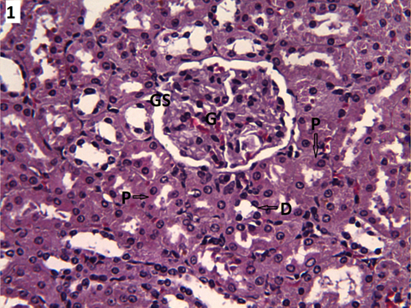 |  | 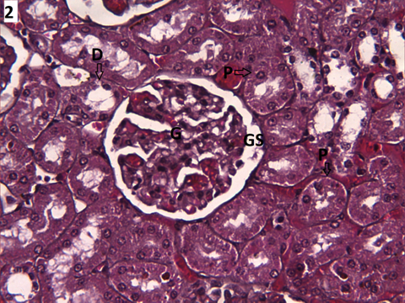
Figure-1 Light photomicrograph of the kidney of control rat shows the normal structure of the glomerulus (G), glomerular space (GS), proximal convoluted tubule (P) and distal convoluted tubule (D). (H&EX200) |  | Figure-2 Light photomicrograph of the kidney of curcumin - treated rat shows the normal structure of the glomerulus (G), glomerular space (GS), proximal convoluted tubule (P) and distal convoluted tubule (D). (H&EX200)
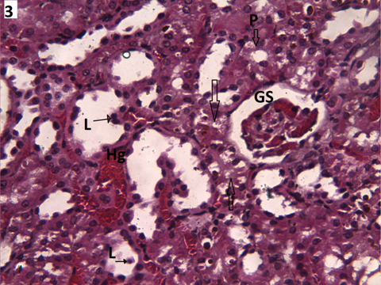 |  | 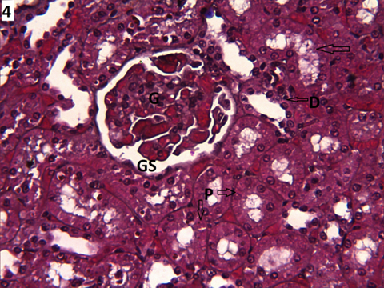
Figure-3 Light photomicrograph of the kidney of acitretin -treated rat shows wide glomerular space (GS) proximal convoluted tubule (P). Luminal dilatation with shedding of lining cells (L arrow).Vacuolated tubular epithelial lining (arrow) and areas of hemorrhage (Hg). (H&EX200). |  | Figure-4 Light photomicrograph of the kidney of combined acitretin -curcumin -treated rat shows the normal structure of the glomerulus (G), glomerular space (GS), proximal convoluted tubule (P) and distal convoluted tubule (D). Notice presence of vacuolated tubular epithelial lining (arrows). (H&EX200)

2-Electron microscopy findings:
Examination of ultrathin section of the kidney of control group revealed the usual component of glomeruli which is formed of anastmosing capillary loops. The glomerular capillary wall formed of endothelial inner layer, thin glomerular basement membrane and an outer layer of large podocytes (Figure 5). The podocyte has a large nucleus, abundant cytoplasm, thick primary cytoplasmic processes and many secondary foot processes rests on the glomerular basement membrane of the capillary loop. The lumen of the capillary loop may contain RBCs (red blood cells). The glomerular basement membrane is uniform in thickness. Fenestrations were seen between the foot processes (Figure 6). In between the loops the mesangial cells were seen. These mesangial cells were characterized by darkly-stained nuclei surrounded by little electron-dense cytoplasm (Figure 5).

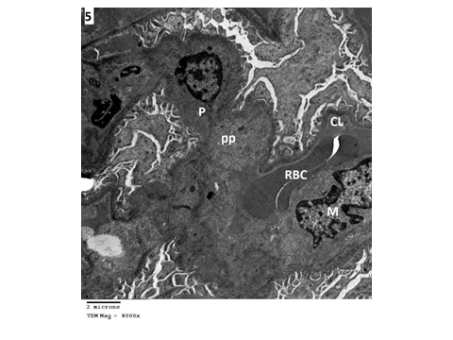 | 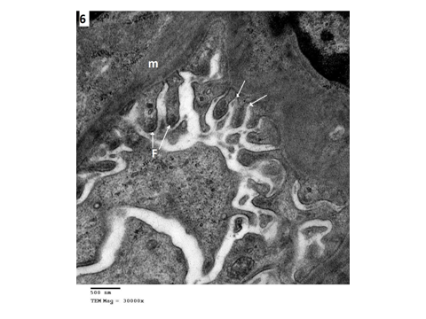
Figure-5 Electron photomicrograph of the kidney of control rat shows part of capillary lumen (CL) containing red blood cell (RBC), Mesangial cell (M), Podocyte (P) and its primary processes (pp). (TEM.MagX8000). | Figure-6 Higher magnification of the part of the previous figure shows basement membrane (m), fenestrations (arrows) and foot processes (F). (TEM.MagX30000).

Acitretin-treated rats revealed dilation and congestion of the glomerular capillary lumen with thickening of the basement membrane. The nucleus of the podocyte appeared irregular with dark nuclear condensation adjacent to the nuclear envelop in addition to the fusion of the secondary foot processes of the podocytes in (Figure 7& 8). Multiple electron lucent vacuoles of different sizes, shape were seen within and in-between the podocytes.

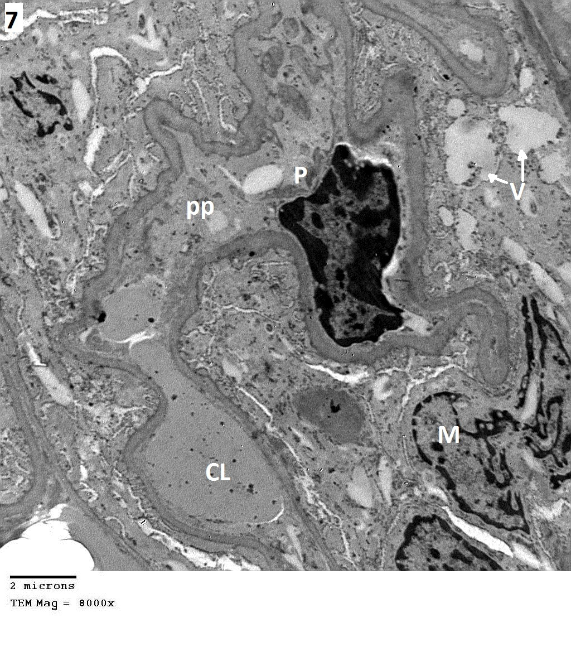 | 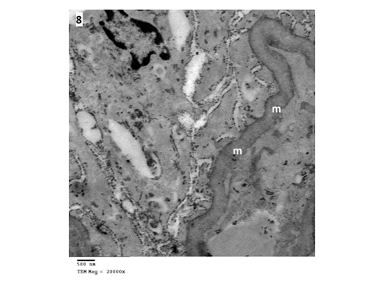
Figure-7 Electron photomicrograph of the kidney acitretin - treated rat shows part of congested capillary lumen (CL) Mesangial cell (M), Podocy te (P) and its primary processes (pp) and electron lucent vacuoles (V arrows) (TEM. Mag X8000). | Figure-8 Higher magnification of the part of the previous figure shows thickned basement membrane (m) with fusion of foot processes. (TEM. Mag X20000).

In combined acitretin and curcumin treated rats, showed improvement in the structure of podocytes, regular distribution of the secondary foot processes of podocytes which rests on uniform capillary basement membrane with almost normal capillary lumen were noticed in the renal corpuscle (Figures 9 &10).
The ultrastructure of the P.C.T cells in control rats appeared with normal structure, having a brush border of numerous microvilli projecting within the tubular lumen and intense cytoplasm due to high content of organelles. The nucleus is spherical, euchromatic, surrounded by numerous mitochondria and apical vacuoles (Figure 11).

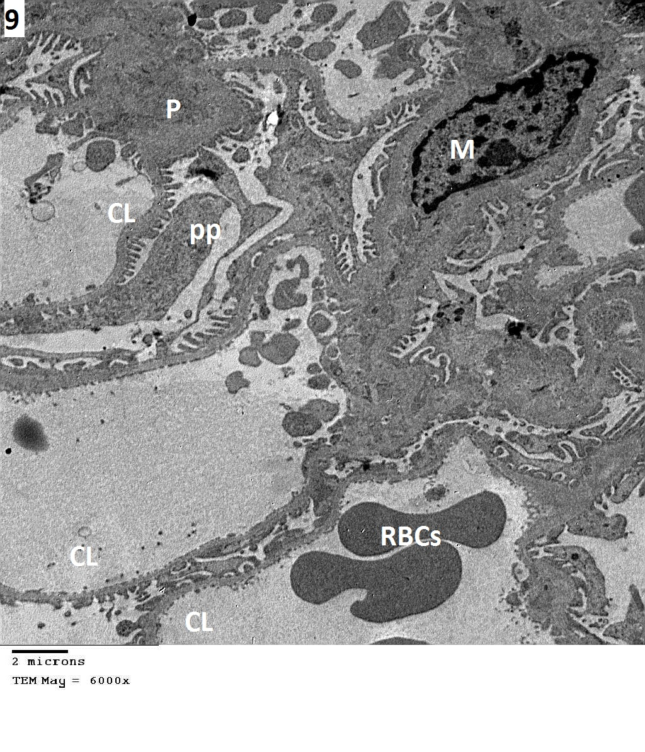 | 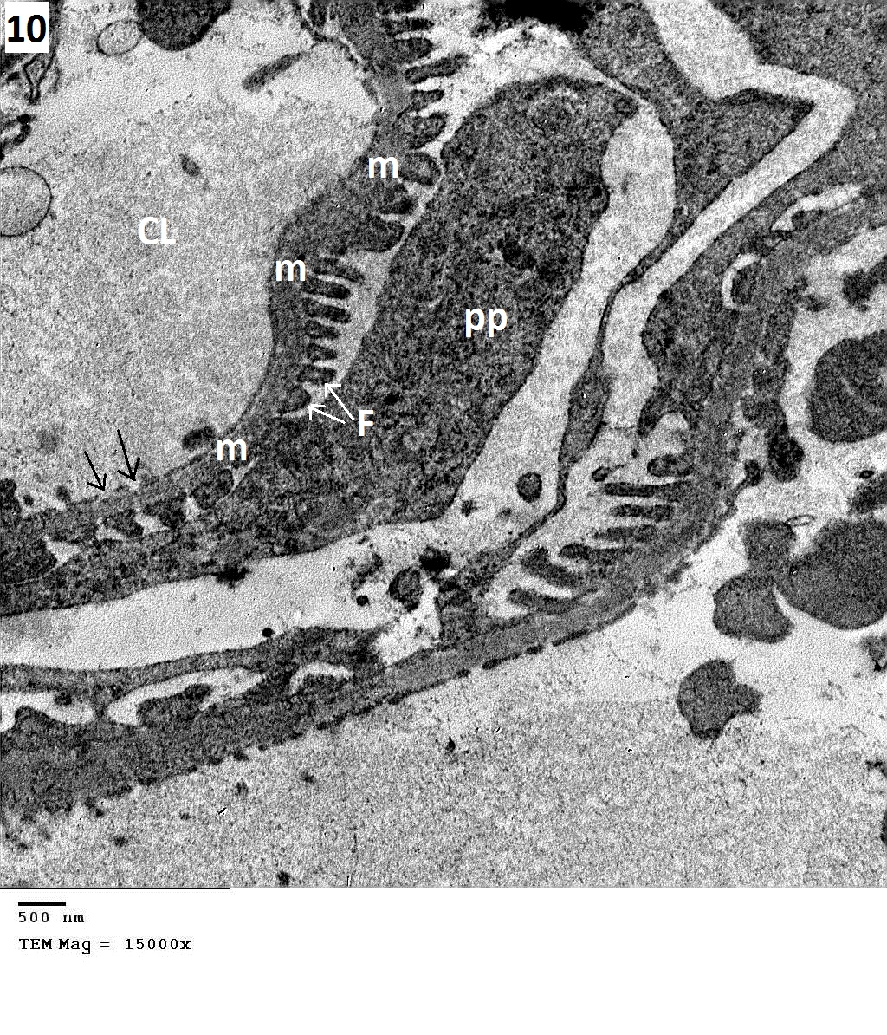
Figure-9 Electron photomicrograph of the kidney combined acitretin – curcumin treated rat shows part of normal capillary lumen (CL) containing red blood cell (RBC), Mesangial cell (M), Podocyte (P) and its primary processes (pp) (TEM. Mag X6000). | Figure-10 Higher magnification of the part of the previous figure shows basement membrane (m), primary processes (pp) of podocyte, foot processes (F) fenestration (arrows) (TEM. Mag X15000).

P.C.T in acitretin -treated rats showed focal lesions of necrotic tubular cells. The boundaries between epithelial cells of the proximal tubule wall were blurred. Some cells were flattened, with reduced volume, partially, or completely destroyed. The tubular lumen was widened. The brush border in the proximal tubules was focally destroyed. The mitochondria showed abnormal structure. They were edematous with brightened matrix. The cells had only a nucleus and only few organelles, and brightened structure of the cytoplasm. The nucleus of damaged cells was most commonly located in one of the cell poles; its shape was changed and markedly smaller than the nuclei of normal cells. Condensation and peripherally located chromatin were observed (Figure 12).

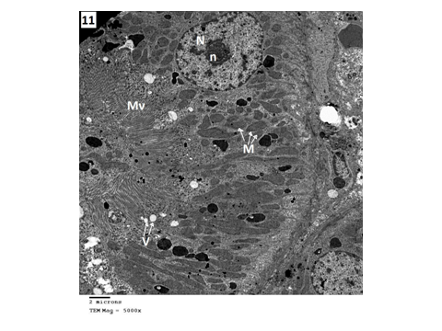 | 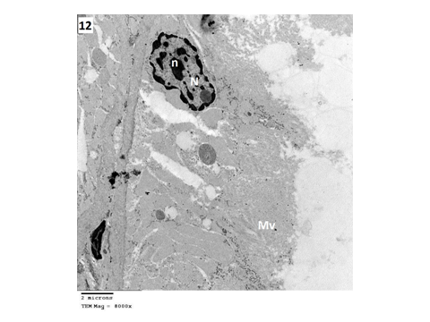
Figure-11 Electron photomicrograph of part of proximal convoluted tubule of control albino rat. The cell has large spherical nucleus (N) with central nucleolus (n). The cytoplasm containing many mitochondria (M), apical vacuoles (V arrows) and numerous microvilli (Mv) at the luminal side (TEM. Mag X5000). | Figure-12 Electron photomicrograph of part of proximal convoluted tubule of acitretin -treated rat the cell has irregular small sized nuclei (N) with irregular nucleolus (n) short microvilli (Mv). (TEM. Mag X 8000).

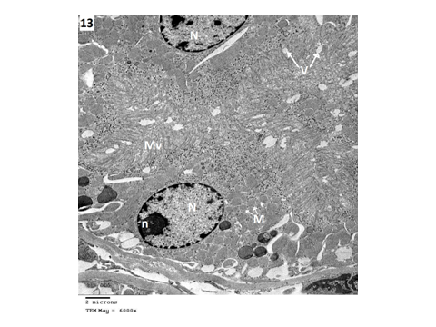
Figure-13 Electron photomicrograph of part of proximal convoluted tubule of combined acitretin-curcumin treated rat shows part of proximal convoluted tubule shows the cell has nuclei (N) nucleolus (n) long microvilli (Mv) and mitochondria (M) apical vacuoles (v). (TEM. Mag X 6000).

P.C.T in combined acitretin- curcumin treated rats, the proximal tubular cells revealed marked amelioration compared to those of acitretin group .The nucleus appeared spherical with normal pattern of chromatin distribution, numerous elongated mitochondria, a few apical vacuoles and long microvilli (Figure 13).
D.C.T of the control rats revealed regular basement membrane, sharp luminal outline and wide lumen few microvilli. Moreover, numerous, elongated and round-shaped mitochondria were seen within their cytoplasm. The cells showed spherical basal nuclei with a central or peripheral electron-dense nucleoli (Figure 14).

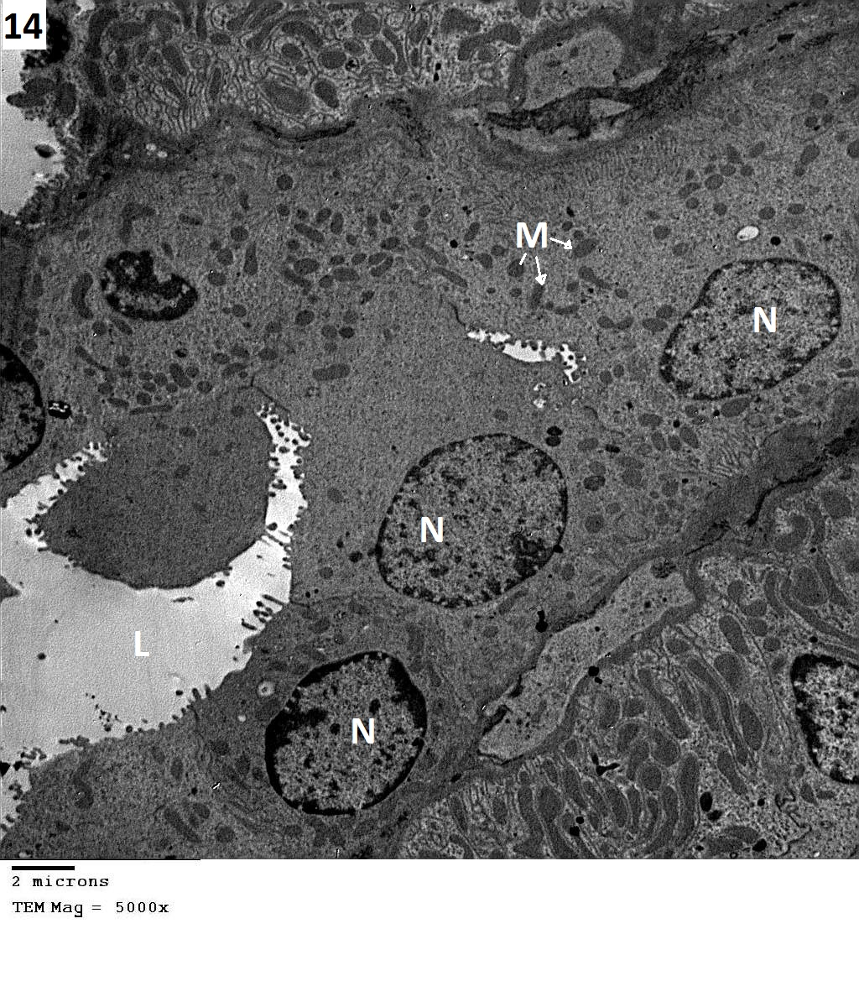 | 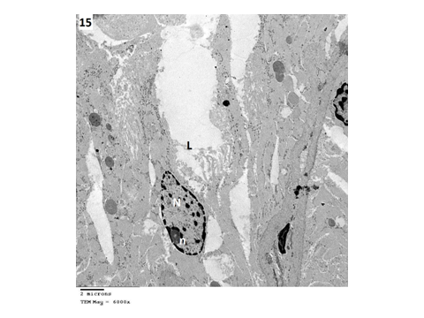
Figure-14 Electron photomicrograph of part of DCT of control albino rat shows wide lumen (L) the cells has large oval nucleus (N), many mitochondria (M). (TEM. Mag X5000). | Figure-15 Electron photomicrograph of part of DCT of Acitretin treated rat shows irrgular narrow lumen (L) The cells has irrgular nucleus (N) and nucleolus (TEM. Mag X6000).

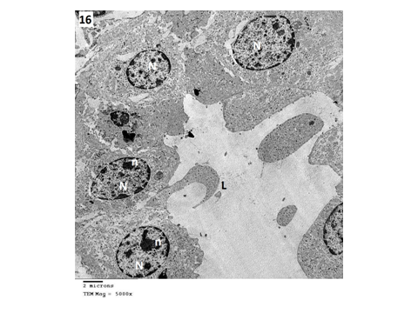
Figure-16 Electron photomicrograph of part of D.C.T of combined Acitretin- curcumin treated rat shows regular nucleus (N) nucleolus (n) and wide lumen (L) (TEM. Mag X5000).

D.C.T in acitretin-treated rats, the cells was disorganized, disintegrated. The cytoplasmic organelles cannot be identified with irregular shaped nuclei, nucleolus with condensation and peripherally located chromatin with loss of luminal outlines (Figure 15).
D.C.T cells of combined acitretin and curcumin -treated rats showed regular shaped cells with spherical nucleus with central or peripherally located nucleolus with wide lumen with regular luminal out lines (Figure 16). In spite of these signs of improvement cytoplasmic organelles still not identified.
4- Evaluation of Biochemical Results:
1-The Urea and creatinine levels:
Administration of daily acitretin for three months resulted in deterioration of renal functions as manifested by the significant elevation in serum urea and creatinine as well as the marker of glomerular functions, cystatin C, and the marker of tubular functions, lipocalin, when compared to normal (Table 1).
2-Results of the oxidative stress markers:
Acitretin administration also resulted in significant decreases in the activity of oxidative stress markers, renal SOD and GSH, when compared to normal levels (Table 1).
Interestingly, daily curcumin supplementation to acitretin treated rats resulted in improvement in kidney functions as shown by the significant decrease in serum urea and creatinine as well as the marker of glomerular functions, cystatin C, and the marker of tubular functions, lipocalin, when compared to acitretin treated rats. Moreover, the activity of oxidative stress markers, renal SOD and GSH, were also singnificantly elevated when compared to acitretin treated rats. Even cystatin C can reach to normal levels from all the above parameters by curcumin supplementation (Table 1).

Table (1): Effect of curcumin administration on some kidney parameters in acitretin treated rats.
Groups  Parameters | Control  Group (I)  Mean ±  S.D. | Curcumin Group (II) |  | Acitretin Group (III) |  | Acitretin + curcumin treated Group (IV)
 |  | Mean ± S.D. | P- value  Vs control | Mean ± S.D. | P- value  Vs control | Mean ± S.D. | P- value Vs  Acetretin G. | P- value  Vs control
Serum urea (mg/dl) | 45.6± 4.7 | 48.9±3.8 | P˃0.05 | 87.1± 6.1 ª | P˂0.05 | 58.9 ±1.7 ^{a,b} | P˂0.05 | P˂0.05
Serum creatinine (mg/dl) | 0.1± 0.01 | 0.15±0.01 | P˃0.05 | 0.7 ± 0.1 ª | P˂0.05 | 0.23 ±0.05 ^{a,b} | P˂0.05 | P˂0.05
Serum lipocalin (ng/ml) | 23.7± 2.2 | 26.4±1.9 | P˃0.05 | 113.9 ±4.5 ª | P˂0.05 | 57.9 ±6.8 ^{a,b} | P˂0.05 | P˂0.05
Serum Cystatin C (mg/l) | 0.41± 0.08 | 0.48±0.5 | P˃0.05 | 0.96 ±0.14 ª | P˂0.05 | 0.39 ±0.09 ^{b} | P˂0.05 | P˃0.05
Tissue SOD (u/mg ptn.) | 1.6± 0.3 | 1.8±0.02 | P˃0.05 | 0.3 ±0.06 ª | P˂0.05 | 0.86 ±0.04 ^{a,b} | P˂0.05 | P˂0.05
Tissue GSH (nmol/mg) | 47.8± 2.7 | 50.2±4.1 | P˃0.05 | 24.8 ± 3.2 ª | P˂0.05 | 38.2 ±1.9 ^{a,b} | P˂0.05 | P˂0.05
a: significant values vs..control b:significant values vs. acitretin

4. Discussion:
Many compounds, including clinically useful drugs, can cause cellular damage after metabolic activation to highly reactive compounds. Acitretin is a vitamin A derivative, is the only systemic retionid that is FDA –approved therapy for treatment of psoriasis. But it is also cost effective treatment option for keratinization disorders and the prevention of cutaneous malignancies (Magis et al., 2000).The mechanism of acitretin nephrotoxicity is still under analysis. This work was conducted to study the effect of acitretin on renal cortical tissue in albino rat by both light and electron microscopy.
In the present work by light microscopy the renal corpuscles was affected markedly by acitretin treatment. They lost their normal circular appearance with relatively wide glomerular space. Moreover, by the electron microscopic examination revealed changes that observed in the glomeruli as disturbance of podocyte architecture resulting in fusion of foot processes. This finding was explained by Pavenstädt et al. (2003) who reported that foot processes of podocyte with filtration slits in between play a major rule in selective permeability of glomeruli, injury to podocytes resulting in retraction of foot processes leading to proteinuria. Katz et al. (1999) mentioned that proteinuria is evident urinary side effect in patient under acitretin treatment.
In this study vacuolation seen within and in-between the podocytes most probably lipid vacuoles. Vahlquist et al. (1988) reported that, hypercholesterolemia and hyperlipidemia associated with elevated very low density lipoproteins and parallel decrease in high density lipoproteins were a major side effects of patients under acitretin use. Similar vacuolation were reported by as small and large lipid vacuolization in intracapillary lumina and mesangial cells were seen in cholesterol fed rats (Gonca et al., 2000).
In this work acitretin induced significant degree of damage on the architecture of tubular epithelium such as widening of lumen, focal destruction of brush border of proximal convoluted tubules, cell swelling, and cytoplasm lysis with loss of most of the cytoplasmic electron density, mitochondrial swelling, irregular shaped nuclei and chromatin. These results were similar to changes present in tubular necrosis induced by different toxins as reported by (Racusen et al., 1991). Moreover this finding were in agreement with Gupta et al. (1989) who find that acitretin is a cytotoxic drug produced interstitial nephritis is manifested by increase urea, creatinine, uric acid elevation , acetonuria and hematuria. Furthermore several factors may play a role in acitretin tubular injury such as decrease in glomerular capillary permeability leading to back leaking of glomerular filtrate through tubular wall (Alden and Frith, 1992). Damage to the brush border of the proximal tubules could have been as a result of toxin binding to the brush border leading to back leakage of alkaline phosphatase into urine this enzyme is associated with damage of the brush border of the renal tubules and the urinary concentration of alkaline phosphatase used as early marker of toxic tubular insult (Porter, 1994). Acitretin causes elevation in alkaline phosphatase as reported by (Pearce et al., 2006). Swelling of the mitochondria observed in this study could have been as a result of inhibited mitochondrial respiration. Many of the common nephrotoxic substances appeared to act by means of alteration in the renal perfusion (Rosen et al., 1994). Pathological changes in mitochondria as swollen are indications of cellular damage leading to less functional efficacy (Robbins, 1995).
This histological view was confirmed by serum and tissue studies. The light and electron microscopic examination can explain the manifested impairment in renal functions after acitretin treatment. The observed degeneration of the glomeruli, thickening of the basement membrane and the vacuoles around podocytes in acitretin treated rats could decrease the glomerular filtration rate and cause retention of toxins in the circulation and hence elevation of serum urea and creatinine (Marieb, 2006).
The altered glomerular filtration rate also detected by the elevated serum cystatin C as it is an early marker of kidney affection than ordinary markers (e.g. creatinine) and can detect mild to moderate kidney affection. Cystatin C is one of the major protectors of the intact glomerular basement membrane from damage by cysteine proteinases. It is isolated from urine in cases of tubular dysfunction while its serum level is increased in cases of impaired glomerular filtration rate (Parikh and Devarajan, 2008).
The manifested tubular necrosis and inflammation observed after acitretin treatment (which resembles that induced by many nephrotoxic drugs) was in consistence with the resulted high levels of serum lipocalin. Lipocalin was recently identified as one of the earliest and most robustly induced proteins in the kidney after toxic kidney injury in both animals and human and can be easily detected in blood and urine (Devarajan , 2006). Neutrophil gelatinase-associated lipocalin (NGAL) is highly accumulated in the human kidney cortical tubules, blood and urine after renal injury and it can display a greater than 10 fold increase in plasma and a greater than 100 fold increase in urine compared to the doubling of serum creatinine in less than 5 days of the insult. Thus, NAGL might represent an early, sensitive and non invasive biomarker for acute renal injury (Mori et al., 2005).
The apparent deterioration in renal functions by acitretin in this study could be attributed to oxidative stress. This opinion was suggested also by Silva et al. (2013) who reported that mitochondrial dysfunctions may play an important role in cellular injury and apoptosis induced by this acitretin. This was explained by the impaired mitochondrial phosphorylation efficiency as demonstrated by the decrease in the state 3 respiration and ATP levels. This was confirmed by the observed swelling of mitochondria which could be a manifestation of mitochondrial functions impairment, as mitochondria are the main sites for antioxidant enzymes (Arslantas, 2002). This was in line with the resulted low levels of oxidative stress markers, renal SOD and GSH.
One of the major adverse effects of acitretin is nephrotoxicity which is the major complication of its administration. Thus amelioration of nephrotoxicity would enhance its clinical use. On other hand, little or no attention has been paid on using of naturally occurring substances with potent antioxidant properties to protect against nephrotoxic damage induced by acitretin. In the light of this, we have explored the possible protective role of curcumin, a natural antioxidant substance on nephrotoxic damage induced by acitretin. In this study combined administration of curcumin with acitretin resulted in marked improvement of the biochemical and the histopathological picture towards normal.
Fortunately, curcumin supplementation to acitretin treated rats resulted in alleviation of kidney injury as showed by the significant reduction in serum urea and creatinine as well as lipocalin and cystatin C if compared to acitretin treated rats. Also, the significant elevation in oxidative stress markers, SOD and GSH in the current study is an indicator for the attributed role of curcumin as antioxidant factor.
Curcumin treatment significantly improved the levels of urea and creatinine. Earlier studies have also shown that curcumin treatment decreased serum creatinine and urea concentrations in cyclosporine induced renal injury in rats in dose dependent manner (Tirkey et al., 2005). This effect may be related to the antioxidant properties of curcumin since it has been found that ROS may be involved in the impairment of glomerular filtration rate (Farombi and Ekor, 2006).
In this study it is evidenced elevation in the activities of SOD and GSH in the kidney tissue by curcumin. These results were in agreement with earlier findings of Zhou et al. (2011) who reported that curcumin is suggested to have anticancer, antiviral, antioxidant and anti-inflammatory properties. The underlying mechanisms of these effects are diverse and appear to involve the regulation of various molecular targets, including transcription factors (e.g. nuclear factor-κB), growth factors (such as vascular endothelial cell growth factor), inflammatory cytokines (e.g. tumor necrosis factor, interleukin 1 and interleukin 6) and other enzymes (e.g. cyclooxygenase 2 and 5 lipoxygenase).
Similar results were reported by Zhang et al. (2014) who described a significant decrease in reactive oxygen species concentration, lower mitochondrial malondialdehyde (MDA) concentration and higher mitochondrial membrane potential in curcumin treated group. These results suggested that curcumin protects cellular damage by the enhancing antioxidant defense system, attenuating mitochondrial dysfunction and inhibiting apoptosis.
The results of the current study go in hand with Zeng et al. (2014) results that described a significant increase in the activity of SOD, GSH-Px and decrease in the content of MDA indicating that Curcumin can improve the antioxidant activity.
In this research administration of curcumin combined with acitretin resulted in significant improvement of histopathological changes induced by acitretin. The mesangial cells, podocyte foot processes, glomerular basement membrane were nearly similar to the control .In addition the cytolysis in proximal and distal convoluted tubules showed some improvement. This improvement explained by Cohly et al. (1998) who stated that curcumin offer a promise as therapeutic agent against renal cell injury because plasma cellular membranes are rich in lipid so it the target for cell injury by lipid peroxidation inducing cytolysis, curcumin inhibit lipid peroxidation at the plasma membrane level preventing cytolysis.
This is supported by the data from the current study and the findings Venkatesan et al. (2000) who found that curcumin treatment influences the integrity of glomerular basement membrane and retard the abnormal passage of high molecular weight macromolecules from blood to urinary space and suppress lipid peroxidation in kidney mitochondria thus prevent mitochondrial damage. In addition curcumin had potent anti-inflammatory and membrane stabilizing properties and thus prevent heavy proteinuria induced by damage of tubular epithelial cells.
The histological finding in this study showed that congestion and hemorrhage was greatly improved by curcumin this finding is supported by the work of Bayrak et al. (2008) who found that on histological examination, the rats treated with curcumin had nearly normal morphology of the kidney following ischemia reperfusion injury. In addition curcumin significantly ameliorate the rise in the serum level of urea in rat kidney via its antioxidant effect. Also Ghosh et al. (2009) in their experiment in which removal of 5/6 of the renal mass associated with proteinuria, hypertension, arteriolopathy, glomerulosclerosis, hemorrhage and inflammation. After curcumin administration all systemic and glomerular alteration are attenuated. The protective mechanism achieved by curcumin due to the increase in the antioxidant enzymes and decreases the oxidative stress. Shoskes (1998) examined the effect of curcumin on in ischemic renal injury produced in rats, pretreatment with curcumin resulted in preservation of histological integrity, with a decrease in tubular damage and interstitial inflammation and reversal of changes in creatinine levels.
In spite of improvement induced by curcumin use in this study is evident in the tubules either proximal or distal ,some cellular organelles were still affected which could be explained by, in this study the combined use of curcumin with acitretin is not protective enough if compared with the pretreatment with curcumin in the study of Surawat et al. (2009) who found degenerative changes and tubular necrosis in mice treated with cisplatin, which were improved by pretreatment with curcumin. They explained that curcumin has a direct cytoprotective, antiapoptotic effects. In addition cisplatin raised urea, creatinine, and kidney lipid peroxidation levels. All these parameters could be restored to normal values by pretreatment with curcumin. They suggested that the curcumin exhibits effective protection against cisplatin-induced nephrotoxicity mediated through direct anti-inflammatory and strong antioxidant activity.
In this experiment curcumin improve the cytotoxic effect induced by acitretin similar to the results of Farombi and Ekor (2006) found that curcumin treatment significantly attenuated gentamycin induced nephropathy and tubular necrosis and also decrease proteinuria, serum urea and creatinine urinary protein, glucose. This protective effect might be related to antioxidant properties of curcumin and the ability of curcumin to neutralize the increase in the free radicals cause by gentamycin. In another study in which curcumin decreased the tubular damage, attenuate renal inflammation, decreased serum creatinine and inhibited apoptosis after ureteral obstruction via its antioxidant effects (Shahed et al., 2001). In the present study the protective effect of curcumin on the kidney was supported by the work of (Greggi et al., 2001; Kuhad et al., 2007) demonstrated cisplatin-induced experimental nephrotoxicity, which assessed by measuring serum creatinine, blood urea nitrogen, creatinine, urea clearance, and serum nitrite levels.
In the present study curcumin reduced vacuolation induced by acitretin which were most probably lipid vacuoles this may be due to the hypolipidemic activity of curcumin. These results were in harmony with Babu and Srinivasan (1995) who showed that curcumin improves the metabolic status in diabetic conditions. The mechanism by which curcumin improves this situation is through hypolipidemic, hypocholesterolemic, hypoglycemic action, antioxidant nature, and free-radical scavenging property. In addition Babu and Srinivasan (1997) explained that curcumin exhibits hypolipidemic activity in rats with streptozotocin -induced diabetes. The decrease in cholesterol level was due exclusively to the decrease in low density lipoproteins (LDL)-very LDL (VLDL) fraction. A significant decrease in blood triglyceride and phospholipids was also brought about by dietary curcumin in diabetic rats.
The mechanism of hypocholesterolemic induced by curcumin may be due to that curcumin increases rate of cholesterol catabolism in the liver in these animals. Moreover curcumin caused a significant reduction in the blood glucose levels and a significant increase in the plasma insulin levels in diabetic rats and a significant reduction in serum and liver cholesterol, triglycerides, free fatty acids, phospholipids, VLDL, and LDL cholesterol levels. The decreased serum high-density lipoprotein (HDL) cholesterol in diabetic rats was also reversed toward normalization after the treatment (Murugan and Pari, 2006). In these studies administration of curcumin to acitretin- treated rats was found to ameliorate the renal toxicity.

Conclusion
Results of the present study suggests that combined administration of curcumin attenuated the development of acitretin- nephrotoxicity by mechanisms related to its ability to decrease lipid peroxidation and potentiating the antioxidant defense system. In addition, its renoprotective effects were also attributed to its anti-inflammatory and hypolipidemic efficacies

References
- Alden, C. L. and Frith, C. H. (1992): Urinary system. In: Hand book of Toxicologic Pathology. Haschek WM and Rousseaux CG 1st ed Academic press, San Diego. pp: 316- 379.
- Arafa, H.M. (2005): Curcumin attenuates diet-induced hypercholesterolemia in rats. Med. Sci. Monit. 11 (7): 228-34.
- Arslantas, A. (2002): development of functional models for SOD. Met. Based Drugs; 9(1-2): 9-18.
- Arun, N. and Nalini, N. (2002): Efficacy of turmeric on blood sugar and polyol pathway in diabetic albino rats. Plant. Foods. Hum. Nutr. 57 (1): 41-52.
- Babu, P.S. and Srinivasan K. (1995): Influence of dietary curcumin and cholesterol on the progression of experimentally induced diabetes in albino rat. Mol. Cell. Biochem. 152:13 - 21.
- Babu, P.S. and Srinivasan K. (1997): Hypolipidemic action of curcumin, the active principle of turmeric (Curcuma longa) in streptozotocin induced diabetic rats. Mol. Cell. Biochem. 166: 169-75.
- Bancroft, J. D. and Stevens, A. (1996): Theory and practice of Histological Techniques. 4th ed. Churchill Livingstone. Edinburg and London. P. 100.
- Bayrak, O.; Uz, E.; Bayrak, R.; Turgut, F.; Atmaca, A.F.; Sahin, S.; Yildirim, M.E.; Kaya, A.; Cimentepe, E. and Akcay, A. (2008): Curcumin protects against ischemia/reperfusion injury in rat kidneys.World. J. Urol. 26: 285-291.
- Berbis, P. (2001): Acitretin. Ann. Dermatol. Venereol. 128: 737-745.
- Biswas, S.K.; Mc Clure, D; Jimenez, L.A; Megson, I.L and Rahman, I. (2005): Curcumin induces glutathione biosynthesis and inhibits NF kappaB activation and interleukin-8 release in alveolar epithelial cells: mechanism of free radical scavenging activity. Antioxidant Redox Signaling 7:32-41.
- Blanchet –Bardon, C.; Nazzaro, V; Rognin, C. (1991) Acitretin in the treatment of severe disorders of keratinzation .Result of an open study .J. Am. Acad. Dermatol. 24 (6 pt 1 ):982-986.
- Bohne, M.; Struy, H.; Gerber, A. and Gollnick, H. (1997): Effect of retinoids on the generation of neutrophil –derived reactive oxgen species studied by EPR spin trapping techniques. Inflamm. Res. 46(10):423-4.
- Bolignano, D.; Lacquaniti, A.; Coppolino, G.; Campo, S.; Arena, A. and Buemi, M. (2008): Neutrophl gelatinase-associated lipocalin reflects the severity of renal impairment in subjects affected by chronic kidney disease, Kidney Blood Press., Res;31:255-258.
- Bruck, R.; Ashkenazi, M.; Weiss, S.; Goldiner, I.; Shapiro, H.; Aeed, H.; Genina, O.; Helpern, Z.; and Pines, M. (2007) : Prevention of liver cirrhosis in rats by curcumin. Liver. Int. 27(3):373-83.
- Cohly, H.H.P.; Taylor, A.; Angel, M.F. and Salahudeen, A.K. (1998) : Effect of turmeric, turmerin and curcumin on H₂O₂-induced renal epithelial (LLC-PK1) cell injury. Free Rad. Biol.Med., 24, 49 ± 54.
- Corbetta, S; Angioni, R; Cattaneo, A; Becke-Peccoz, P. and Spada, A. (2006): “Effects of retinoid therapy on insulin sensitivity, lipid profile and circulating adipocytokines,” European Journal of Endocrinology, vol. 154, no. 1, pp. 83–86.
- Deodhar, S.D.; Sethi, R. and Srimal, R.C. (1980): Preliminary study on antirheumatic activity of curcumin (diferuloyl methane). Indian J. Med. Res. 71: 632–4.
- Devarajan, P. (2006): Update on Mechanisms of Ischemic Acute Kidney Injury. J. Am. Soc. Nephrol. 17: 1503-1520.
- Farombi, E. and Ekor, M. (2006): Curcumin attenuates gentamycin-induced renal oxidative damage in rats. Food. Chem. Toxicol. 44:1443–8.
- Farombi, E.O.; Shrotriya, S.; Na, H.K.; Kim, S.H. and Surh, Y.J. (2008): Curcumin attenuates dimethylnitrosamine-induced liver injury in rats through Nrf 2-mediated induction of heme oxygenase-1. Food. Chem. Toxicol. 46:1279-87.
- Gelfand, J.M.; Lewis, J.D.; Kurd, S.K.; Shin D.B.; Wang, X.; Margolis, D. J. and Strom, B. L. (2007): The Risk of mortality in patients with psoriasis :Results from a population-based study. Archives of Dermatology.143:1493-1498.
- Ghosh, S.S.; Massey, H.D.; Kriege, R.; Fazelbhoy, Z.A.; Ghosh, S.; Sica, D.A.; Fakhry, I. and Gehr, T.W. (2009): Curcumin ameliorates renal failure in 5/6 nephrectomized rats: role of inflammation. Am. J. Physiol. 296: F1146-F1157.
- Goel, A.; Kunnumakkara, A.B. and Aggarwal, B.B. (2008): Curcumin as ''Curecumin'': from Kitchen to clinic. Biochem. Pharmacol., 75: 787-809.
- Gonca, S.; Ceylan, S.; Yardimoğlu, M.; Dalçik, H.; Yumbul, Z.; Köktürk, S. and Filiz, S. (2000): Protective effects of vitamin E and selenium on the renal morphology in rats fed high-cholesterol diets. Pathobiology. 68(6):258-63.
- Goodman, A. and Gilmans, G. (2006): The Pharmacological Basis of Therapeutics (10th ed.) Medical Publishing Division. 2147.
- Greggi, A.L.; Darin, J. and Bianchi, M.L. (2001): Effects of the antioxidants curcumin or selenium on cisplatin-induced nephrotoxicity and lipid peroxidation in rats. Pharmacological Research .43:145-50.
- Gupta, A. K.; Goldfarb, M.T.; Ellis, C.N. and Voohees, J. J. (1989): Side effect profile of acitretin therapy in psoriasis. J. Am. Acad.Dermatol.20:1088-93.
- Haves-Zburof, D. (2011): Cathepsins and their endogenous inhibitors cystatins: expression and modulation in multiple sclerosis.; J. Cell. Mol. Med. 15, 2421.
- Jacob, A.; Wu, R.; Zhou, M. and Wang, P. (2007): Mechanism of the anti-inflammatory effect of curcumin: PPAR-gamma activation. PPAR. Res., 89369.
- Jaffe, M.; Bergman, A. and Ohman, G. (1980): Effect of detergent on kinetic Jaffe-method assay of creatinine .Clin.Chem.; 26:1729-1732.
- Jung, D.; Briggs, N.; Erickson, J. and Ledyard, P. (1975): New colorimetric reaction for end point continues flow and kinetic measurement of urea .Clin.Chem.; 21:11-36.
- Katz, H.I.; Waalen, J. and Leach, E.E. (1999): Acitretin in Psoriasis: An overview of adverse effects .J. Am. Acad. Dermtol . 41 - S 7 -S12
- Kiernan, J.A (2001): Histological and Histochemical methods, Theory and practice 3rd ed. Arnold . London. New York and New Delhi. .P 30
- Kuhad, A.; Pilkhwal, S.; Sharma, S.; Tirkey, N. and Chopra, K. (2007): Effect of curcumin on inflammation and oxidative stress in cisplatin –induced experimental nephrotoxicity . J. of Agriculture and Food Chemistry 55:10150-5.
- Kuliszkiewicz-Janus, M.; Mohamed, A. S. and Abod N.: (2006 ) :The biology of HDL lipoprotein and its antisclerotic activity, Postepy Higieny i Medycyny Do´swiadczalnej, vol. 60, pp. 307–315.
- Kumar, P.; Padi, S.S.; Naidu, P.S. and Kumar, A. (2007): Possible neuroprotective mechanisms of curcumin in attenuating 3-nitropropionic acid-induced neurotoxicity. Methods Find. Exp. Clin. Pharmacol. 29: 19-25.
- Lao, C. D.; Demierre, M. F. and Sondak, V. K. (2006): Targeting events in melanoma carcinogenesis for the prevention of melanoma. Expert Rev. Anticancer Ther. 6 (11), 1559–68.
- Lowry, O.; Roseberough, N.; Farr, A. and Randall, R. (1951): Estimation of protein in tissue. J.Biol.Chem.;193, 265-75.
- Macleod, J.; Edwards, C. and Bouchier, I. (2001): Davidson’s Principles and Practice of Medicine. Fifteenth Ed. Livingstone Churchill New York: 348.
- Magis, N.L.; Blummel, J.J.; Kerkhof, P.C. (2000): The treatment of psoriasis with etretinate and acitretin : A follow up of actual use. Eur. J. Dermatol .10 (7):517- 521.
- Marieb, E.N. (2006): Essentials of human anatomy and physiology. 8th edition. Benjamin Cummings. P (502-525).
- Mark-Lund, S. (1985): Pyrogallol antioxidation. In: handbook of method for oxygen radical research. Green Wald, R.A. (ed), Boca Raton, Florida: CRC. Press, USA, 243-247.
- McNamara, P.J.; Jewell, R.C. and Jensen, B.K. (1988): Food increases the bioavailability of acitretin. J. Clin. Pharmacol., 28:1051–5.
- Mori, K.; Lee, H.T.; Rapoport, D. and Barasch, J. (2005):Endocyctic delivery of lipocalin-sidero phore-iron complex rescues the kidney from ischemia-reperfusion injury. J. Clin.Invest.; 115:610-621.
- Murugan, P. and Pari, L. (2006): Effect of tetrahydrocurcumin on lipid peroxidation and lipids in streptozotocin - nicotinamide-induced diabetic rats. Basic .Clin. Pharmacol. Toxicol. 99:122-7.
- Nguyen, E.H and Wolverton, S. (2001): Systemic retinoids. In : Wolverton S, editors. Textbook of comprehensive dermatologic drug therapy. WB Saunders Co: Philadelphia. p. 269-302.
- Okada, K.; Wangpoentrakul, C.; Tanaka, T.; Toyokuni, S.; Uchida, K. and Osawa, T. (2001): Curcumin and especially tetrahydrocurcumin ameliorate oxidative stress-induced renal injury in mice. J Nutr 131:2090–5.
- Parikh, C.R. and Devarajan, P. (2008): New biomarkers of acute kidney injury, Crit. Care med.; 36 (4supp1):S159-65.
- Pavenstädt, H; Kriz, W. and Kretzler, M. (2003): Cell biology of the glomerular podocyte. Physiol. Rev. 83(1):253-307.
- Pearce, D. J.; Klinger, S.; Ziel, K.K. (2006): Low dose acitretin is associated with fewer adverse events than high dose acitretin in the treatment of psoriasis. Arch. Dermatol.:142(8):1000-4.
- Pilkigton, T. and Brogden, R.N. (1992): Acitretin: A review of its pharmacology and therapeutic use. Drugs. 43:597-627.
- Porter, G.A.(1994):Urinary biomarkers and nephrotoxicity. Miner. Electrolytes. Metab. 20:181-186.
- Qureshi, S.; Shah, A. H. and Ageel, A. M. (1992): Toxicity studies on Alpinia galanga and Curcuma longa. Planta Med. 58: (2): 124–7.
- Racusen, L.C.; Fivush, B.A.; Li, Y.L.; Slatnik, I.; Solez, K. (1991): Dissociation of tubular cell detachment and tubular cell death in clinical and experimental "acute tubular necrosis". Lab Invest. 64 :(4):546-56.
- Robbins, C. (1995): Pathological Basis of Disease 5th .ed International edition W B Sounders pp: 1750.
- Rosen, S.; Brezis, M. and Stillman, I. (1994): The pathology of nephrotoxic injury :a reappraisal.Miner .Electrolyte Metab. 20:174-180.
- Saurat, J.H. (1999): Retinoids and psoriasis: novel issues in retinoid pharmacology and implications for psoriasis treatment. J. Am. Acad. Dermatol., 41: S2-6.
- Sedlak, J. and Lindsay, R. H. (1968): “Estimation of total, protein-bound, and nonprotein sulfhydryl groups in tissue with Ellman's reagent,” Analytical Biochemistry, vol. 25, pp. 192–205.
- Shahed, A.R.; Jones, E.; and Shoskes, D. (2001): Quercetin and curcumin up-regulate antioxidant gene expression in rat kidney after ureteral obstruction or ischemia reperfusion injury .Transplant Proc :33 : 2988.
- Shankar, T. N.; Shantha, N. V.; Ramesh, H. P.; Murthy, I. A. and Murthy, V. S. (1980): Toxicity studies on turmeric (Curcuma longa): acute toxicity studies in rats, guineapigs and monkeys. Indian J. Exp.Biol. 1980, 18 (1), 73–5.
- Shoba, G.; Joy, D.; Joseph, T.; Majeed, M.; Rajendran, R. and Srinivas, P. S. (1998): Influence of piperine on the pharmacokinetics of curcumin in animals and human volunteers. Planta. Med. 64 (4), 353–6.
- Shoskes, D.A. (1998): Effect of bioflavonoids quercetin and curcumin on ischemic renal injury: a new class of renoprotective agents. Transplantation .66:147–52.
- Silva, F.S.1.; Ribeiro, M.P.; Santos, M.S.; Rocha-Pereira, P.; Santos-Silva, A. and Custódio, J.B. (2013): Acitretin affects bioenergetics of liver mitochondria and promotes mitochondrial permeability transition: potential mechanisms of hepatotoxicity. Toxicology. 5; 306:93-100.
- Srivastava, R.; Dikshit, M.; Srimal, R. C. and Dhawan, B. N. (1989): Antithrombotic effect of curcumin. Thromb. Res. 40 (3): 413–7.
- Surawat, J.; Pranida, K.; Kanoknetr, S.; Aporn, C.; Arusa, C. and Pawinee, P. (2009): Protection against cisplatin-induced nephrotoxicity in mice by curcuma comosa Roxb ethanol extract . J. Natural medicine. 63:430-6
- Tirkey, N.; Kaur, G.; Vij, G. and Chopra, K. (2005): Curcumin, a diferuloylmethane, attenuates cyclosporine-induced renal dysfunction and oxidative stress in rat kidneys. BMC Pharmacol.; 15:5-15.
- Vahlquist, A. (1992): Long- term safety of retinoid therapy. J. Am. Acad. Dermatol. 27 (6 pt 2) S29-33.
- Vahlquist, C.; Selinus, I. and Vessby, B. (1988): Serum-lipid changes during acitretin (etretin) treatment of psoriasis and palmoplanter pustulosis . Acta. Derm.Venerol (Stochh) 66:300-5
- Venkatesan, N.; Punithavathi, D. and Arumugam, V. (2000): Curcumin prevents adriamycin nephrotoxicity in rats. Br. J. Pharmcol. 129 (2):231-4.
- Wei, Q.Y.; Chen, W.F.; Zhou, B.; Yang, L. and Liu, Z.L. (2006): Inhibition of lipid peroxidation and protein oxidation in rat liver mitochondria by curcumin and its analogues . Biochimica Biophysica Acta., 1: 70–77.
- Yamauchi, P.S.; Rizk, D.; Kormeili, T.; Patnaik, R. and Lowe, N.J. (2003): Current systemic therapies for psoriasis: where are we now? J. Am. Acad. Dermatol. 49: S66-77.
- Zeng, Y.; Liu, J.; Huang, Z.; Pan, X. and Zhang, L. (2014): Effect of curcumin on antioxidant function in the mice with acute alcoholic liver injury. Wei Sheng Yan Jiu. Mar; 43(2):282-5.
- Zhang, J.; Xu, L.; Zhang, L.; Ying, Z.; Su, W. and Wang, T. (2014): Curcumin Attenuates d-Galactosamine/Lipopolysaccharide-Induced Liver Injury and Mitochondrial Dysfunction in Mice. J Nutr. Jun 4. pii: jn.114.193573.
- Zhou, H.1.; Beevers, C.S. and Huang, S. (2011): The targets of curcumin. Curr Drug Targets. 1;12(3):332-47.

9/21/2014

