Phenotypic Identification and Molecular Characterization of Shigella sp from Diarrhoeal Patients’ Stool
Samples in Nigeria

Isawumi Abiola1, Oluduro Anthonia Olufunke1, Moses Ikechukwu Benjamin¹ and Ariyo Adenike Bosede 2

1Department of Microbiology, Obafemi Awolowo University, Ile-Ife, Nigeria, 220005
2 Biological Science, faculty of Science, Federal University, Otuoke
E-mail: aoluduro2003@yahoo.co.uk.
Telephone: +2348069379885.

Abstract: Shigellosis is a worldwide health concern especially in developing countries with poor sanitation and has contributed to the increase in the mortality rate of infants. The study reports the antibiotic resistance profiles and characterization of resistance (gyrA, blaCTX) and virulence (Stx1) genes in Shigella sp recovered from stool samples of diarrhoeal patients in Nigeria. One hundred and forty-eight diarrhoeal patients’ stool samples collected from various health institutions in Ile-Ife, Osun State, Nigeria were examined for the presence of Shigella sp Isolation was done on Salmonella-Shigella agar plates at 37oC and isolates identity confirmed by conventional biochemical tests. Antibiotic susceptibility of isolates was by Kirby-Bauer’s disc diffusion technique and isolation of plasmid DNA in the multiple antibiotic resistant (MAR) isolates was carried out. Molecular detection of resistance (gyrA) and virulence (Stx) genes was by polymerase chain reaction. A total of 58 Shigella sp comprising S. sonnei (37.9%), S. boydii (37.9%), S. flexneri (13.8%) and S. dysenteriae (10.3%) were recovered. Susceptibility to antibiotics was in varying proportions. All isolates were resistant to ceftriazone and resistance was mostly to nitrofurantoin (96.5%), augmentin (94.8%) and amoxicillin 82.2%). Generally, 80% of the Shigella sp were multiple antibiotic resistant (MAR) types, displaying 22 various MAR patterns. Plasmid DNA bands of varying sizes (1.17-
23.13 kb) and fluoroquinolone resistance (GyrA -270bp) genes were harboured by all the representatives MAR
isolates. None of the representative MAR isolates contained the beta-lactam resistance (BlaCTX) gene. Shiga toxin (Stx-400bp) was detected in only one of the isolates. The recovery of multiple antibiotic resistant Shigella sp harbouring large size plasmid DNA and fluoroquinolone resistance gene is of great health consequence.

[Isawumi Abiola, Oluduro Anthonia Olufunke, Moses Ikechukwu Benjamin and Ariyo Adenike Bosede. Phenotypic Identification and Molecular Characterization of Shigella sp from Diarrhoeal Patients’ Stool Samples in Nigeria. Nat Sci 2014; 12(10):169-175]. (ISSN: 1545-0740). http://www.sciencepub.net/nature. 22

Keywords: Shigella, diarrhoea, multiple antibiotic resistance, plasmid, resistance gene

Introduction
Shigella was recognized as the etiologic agent of
Shigellosis in 1898 by Kiyoshi Shiga, a Japanese scientist and was adopted as a genus in the 1950 (Kim et al., 2002). Shigella exists as a single organism and causes disease in primates (Ryan et al, 2004). It is only naturally found in humans and apes (Potter, 2006). During infection, it typically causes bacillary dysentery with diarrhoea as one of the major symptoms (Mims et al., 1993).
Shigellosis is a worldwide health concern especially in developing countries with poor sanitation, lack of personal hygiene and use of contaminated water supplies. Its effects have contributed to the increase in the mortality rate of infants (WHO, 2004). Estimation by the World Health Organization (WHO, 2004) indicates that the world population suffered from 4.5 billion incidences of diarrhoea causing 1.8 million deaths annually. Approximately 99% of the cases occurred in developing countries, where poor hygiene and limited access to clean drinking water promote the spread of enteric diseases. Malnutrition and the lack of
appropriate medical intervention contribute to the high mortality rate, especially for young children.
It has been reported that species of the genus Shigella are among the bacterial pathogens most frequently isolated from patients with diarrhoea. A total of 5 to 15% of all diarrhoeal episodes worldwide can be attributed to an infection with Shigella (Kotlof et al., 1999). The emergence of multidrug-resistant
Shigella stains and a continuous high disease
incidence imply that shigellosis is an unsolved global health problem (Sansonetti, 2005). Since it is an acute intestinal infection, the symptoms can range from mild watery diarrhoea to severe inflammatory bacillary dysentery characterized by strong abdominal cramps, fever, and stools containing blood and mucus. According to Venkatesan et al. (2006), the disease is usually self-limiting but may become life-threatening if patients are immune compromised or if adequate medical care is not available.
The four species of the genus Shigella that is
Responsible for Shigellosis include Shigella dysenteriae, S. flexneri, S. boydii and S. sonnei. The low infectious inoculum, (as few as 10 organisms)

render Shigella sp highly contagious. The predominant serogroups of Shigella sp occurring in a region also appears to be related to the socio- economic development; and evidence also indicates that the severity of shigellosis is related to the infecting serogroup. Shigella dysenteriae known as Shiga bacillus has been recognized as the most virulent, because it can produce Shiga Toxin with 12 serotypes and the major cause of epidemic dysentery for nearly 100 years (WHO, 2004). Diarrhoeal infections are caused by ingesting certain bacteria, viruses or parasites that may be spread by water, food, utensils, hands, flies; which eventually leads to passage of watery stools usually at least three times in
24 h period. Generally, Shigella invades the host through the M-cells in the gut epithelial of the large intestine using a Type III secretion system acting as a biological syringe to injects protein into cells which triggers bacterial invasion and the subsequent lysis of vacuolar membranes resulting in Shigellosis and the emergence of multidrug-resistant Shigella strains and a continuous high disease incidence imply that shigellosis is an unsolved global health problem (Sansonneti, 2005).
The progressive increase in antibiotic resistance among enteric pathogens in developing countries has been reported (Egah et al., 2003). This might be due to environmental factors, geographic differences or different patterns of antibiotic usage (Farshad et al.,
2006).The present study was therefore, designed to
isolate and characterize Shigella sp in diarrhoeal patients’ stool samples in Ile-Ife, Nigeria, and provide relevant information in the choice of antibiotics for the treatment of shigellosis in the study area.

Materials and Methods
Collection of Samples
One hundred and forty-eight (148) diarrhoeal
patients’stool samples were collected between April,
2011 and March, 2012 at Obafemi Awolowo University Teaching Hospitals Complex (OAUTHC), Ile-Ife and in some other Health Institutions within Ile-Ife, Nigeria. Samples collected in clean universal sampling bottles were immediately transported to the laboratory for bacteriological analysis. The stool samples were enriched in Selenite F broth, incubated at 37oC for 24 hours and streaked on Salmonella- Shigellaagar plates, and incubated at 37 oC for 48 h. Pure colonies were obtained by successive streaking on Salmonella-Shigella agar plates. The identity of isolates was confirmed by conventional biochemical tests with reference to Bergey’s Manual of Determinative Bacteriology.
Antibiotic Susceptibility Test
Antibiotic susceptibility of the Shigella isolates
was done by the Kirby-Bauer’s antibiotic disc
diffusion method. The disc containing the antibiotics augmentin (30μg), amoxycillin (25μg), nitrofuranton (200μg) pefloxacin (5 μg), tetracycline (30 μg), ciprofloxacin (10μg), ofloxacin (5μg), ceftriazone (30 μg), gentamicin (10 µg) and cotrimoxazole(25 μg) were firmly placed on Mueller-Hinton agar (HIMEDIA lab. Ltd Vadhani) plates previously seeded with standardized inoculums (106cfu/ml). The plates were then incubated at 370C for 24 h. The diameter of the zones of inhibition were measured to the nearest millimeter and interpreted according to the guidelines of Clinical Laboratory Standards Institute (CLSI, 2009).
Isolation of Plasmid DNA
Plasmid DNA extraction was carried out on the
representative MAR isolates using TENS buffer (Tris
25mM, EDTA 10mM, NaOH O.1N and SDS 0.5%) and separated by 0.8% (w/v) agarose gel in Tris- acetate-EDTA buffer containing ethidium bromide (20 ml of 50 X TAE and 6.0 μl of 10 μg/ml ethidium bromide per litre). Plasmid DNA bands were visualized by UV light illuminator and photographed with a Leicaflex SL-camera.
Molecular detection of resistance (gyrA and blaCTX) genes
Twenty isolates that were resistant to two major
classes of antibiotics (Fluoroquinolones and Beta- lactams) were selected for the molecular detection of gyrA and blaCTX genes respectively. Primers (gyrA-
1) 5’-CGT TGG TGA CGT AAT CGG-3’, (gyrA-2)
5’-CCG TAC CGT CAT AGT TAT-3’ and (blaCTX-
1) 5’-ATG TGC AGY ACC AGT AAR GTK ATG GC-3’ and (blaCTX-2) 5’-TGG GTR AAR TAR GTS ACC AGA AYC AGC GG-3’ (R, Y, K, S are wobbles base pairs) were used
The Polymerase Chain Reaction (PCR) composed of the following: 2.5μl of PCR buffer, 1.5μl of MgCl2, 0.1 unit of Taq DNA Polymerase, 0.2μl of Primers (both forward and reverse), 1.5μl of Template DNA, and 0.5μl of dNTPs was employed. Sterile water was added to make a final volume of 25μl. All the samples were amplified in a programmable thermocycler (Eppendorf AG 2233, Hamburg, Germany) and was programmed with the following parameters: denaturation at 95oC for 3 min, 95oC for
30 s for 30 cycles, annealing at 42oC for 60 s for gyrA and 62 oC for 60 s, extension at 72oC for 1 minute and final extension at 72oC for 10 min for molecular detection of the blaCTX gene. A volume of 10 µl of amplified PCR products was subjected to electrophoresis at 80 V in horizontal gel containing
1.2 % agarose with Tris-borate buffer (45 mMTris borate, 1 mM EDTA) for about 1h 30 min. A 100 base
pair marker was used as reference. The gel was stained with ethidium bromide and photographed in an Ultraviolet-transilluminator.

Molecular detection of virulence Shiga Toxin (stx
1) gene
The primers employed for the detection of the
virulence factor Shiga Toxin are (stx1-1) 5’-GTG GCA TTA ATA CTG AAT TGT CAT CA- 3’ and (stx1-2)
5’-GCG TAA TCC CAC GGA CTC TTC-3’.
The Polymerase Chain Reaction (PCR)
composed of 2.5μl of PCR buffer, 1.5μl of MgCl2, 0.1 unit of Taq DNA Polymerase, 0.2μl of Primers (both forward and reverse), 1.5μl of Template DNA, and
0.5μl of dNTPs. Sterile water was added to make a final volume of 25μl. The reaction conditions were
95ºC for 3 min, followed by 30 cycles at 95oC for 30 s, 51oC for 60 s, 72oC for 60 s and the last cycle at
72oC for 10 min.
Ten microliter (10μl) of the PCR products was analyzed by 1.2% of agarose gel after which the reaction in TE buffer was allowed to run at 80 V for
1h 30 min. The gel was stained with ethidium bromide
and photographed in an Ultra violet-transilluminator.

Results
Shigella sp were recovered from 58 of the 148
diarrhoeal patients’ stool samples analysed (Table 1). The isolates were identified as S. sonnei 22 (37.9%), S. boydii 22 (37.9%), S. flexneri 8 (13.8%) and S. dysenteriae 6 (10.3%). The antibiotic susceptibility profile of the isolates is presented in table 2. Susceptibility to antibiotics varied, 84.5% were sensitive to ofloxacin, pefloxacin (75.9%) and gentamicin (72.5%). Resistance to ceftriazone, nitrofurantoin, augumentin and amoxicillin was high.

Table 1. Occurrence of Shigella isolates in the faecal samples of the diarrhoeal patients
Isolates | Frequency (%)
S. sonnei | 22 (37.9%)
S. boydii | 22 (37.9%)
S. flexneri | 8 (13.8%)
S. dysenteriae | 6 (10.3%)

Table 2. Antibiotic susceptibility profile of Shigella isolates
Isolates
 | Frequency (%)
Antibiotics | resistance | Susceptible
Nitrofuratoin (200µg) | 96.5 | 3.5
Tetracycline (30 µg) | 44.9 | 55.1
Ceftriazone (30µg) | 100 | 0
Gentamicin (10µg) | 27.5 | 72.5
Cotrimoxazole (25µg) | 34.4 | 65.6
Ofloxacin (5µg) | 15.5 | 84.5
Amoxicillin (25µg) | 82.8 | 17.2
Ciprofloxacin (10µg) | 36.3 | 63.7
Augmentin (30µg) | 94.8 | 5.2
Pefloxacin (5µg) | 24.1 | 75.9

Forty-six (79.3%) of the isolates were MAR types and exhibited 22 multiple antibiotic resistance patterns. Resistance to four different antibiotics (30.9%) was the most frequent (Table 3). Antibiotic phenotype ‘AUG, CRO, NIT’ was the prominent resistance pattern observed.

Table 3. Multiple antibiotic resistance patterns of the Isolates
NUMBER OF ANTIBIOTICS | ANTIBIOTIC RESISTANCE PATTERNS | FREQUENCY (%) | TOTAL NUMBER OF ISOLATES (%)
2 | AMX, CRO  CRO, NIT AUG, CRO | 1(1.72)  1(1.72)  1(1. 72) | 3 (5.16)
3 | CRO, NIT, COT,  AUG, CRO, NIT | 1(1.72)  9(15.51) | 10 (17.23)
4 | AUG, CRO,NIT, PFX  AUG, CRO, NIT, TET  AUG, CRO, NIT, OFL AUG, CRO, NIT, COT AUG, CRO, NIT, CPX CRO, NIT, AMX, TET | 1(1.72)  1(1.72)  2 (3.44)  2(3.44)  4(6.89)  6(10.34) | 18 (30.99)
5 | AUG, CRO, NIT, GEN, CPX  CRO, NIT, COT, AMX, CPX  AUG, CRO, NIT, CPX, TET CRO, NIT,COT, AMX, TET AUG, CRO, NIT, COT,CPX CRO, NIT, GEN, OFL, AMX | 1(1. 72)  1(1.72)  2(3.44)  2(3.44)  2(3.44)  1(1. 72) | 9 (15.48)
6 | AUG, CRO, NIT, COT, CPX, TET  CRO, NIT, GEN AMX, TET, PFX AUG CRO, NIT, GEN, COT, CPX AUG, CRO, NIT, COT, OFL, TET | 1(1. 72)  1(1. 72)  1(1. 72)  2(3.44) | 5(8. 60)
7 | CRO, NIT, GEN,COT, AMX, CPX, TET | 1(1.72) | 1 (1.72)
 | TOTAL | 46 | 79.31

Table 4. Plasmid Profile of the MAR Shigella Isolates
Isolate  Code | Number of plasmid  haboured by the isolates | Estimated Molecular  Sizes of Plasmid (kb)
SH1  SH2  SH3  SH4  SH5  SH6  SH7  SH8  SH9  SH10  SH11  SH12  SH13  SH14  SH15  SH16  SH16  SH17  SH18  SH19  SH20 | 3  3  3  3  1  3  3  3  3  3  3  3  3  3  3  3  3  3  3  3  3 | 23.13, 1.46, 1.17  23.13, 1.46, 1.17  23.13, 1.46, 1.17  23.13, 1.46, 1.17  23.13  23.13, 1.46, 1.17  23.13, 1.46, 1.17  23.13, 1.46, 1.17  23.13, 1.46, 1.17  23.13, 1.46, 1.17  23.13, 1.46, 1.17  23.13, 1.46, 1.17  23.13, 1.46, 1.17  23.13, 1.46, 1.17  23.13, 1.46, 1.17  23.13, 1.46, 1.17  23.13, 1.46, 1.17  23.13, 1.46, 1.17  23.13, 1.46, 1.17  23.13, 1.46, 1.17  23.13, 1.46, 1.17

AUG- Augmentin, CRO- Ceftriazone, NIT- Nitrofuratoin, GEN- Gentamicin, OFL- Ofloxacin, COT-Cotrimoxazole, AMX- Amoxicillin, CPX- Ciprofloxacin, TET- Tetracycline, PFX- Pefloxacin
The molecular weights of plasmid DNA haboured by the multiple antibiotic resistant isolates are presented in Table 4. All but one of the representative MAR Shigellaisolates profiled for plasmid DNA showed multiple plasmid bands of molecular weights ranging from 1.171 to 23.130 kb. The gel electrophoresis showing the plasmid DNA fragments is depicted by figure 1.
Figure 2 shows the fluoroquinolone determinant resistance gene in the MAR Shigella isolates. The GyrA (270bp) gene were detected in all the 20 representatives’ fluoroquinolone (ciprofloxacin and ofloxacin) resistant isolates meanwhile, only one of the isolates haboured shiga-toxin (stx) gene (Figure 3). All the twenty beta-lactam (amoxicillin and augmentin) resistant Shigella isolates screened did not harbour BlaCTX gene.

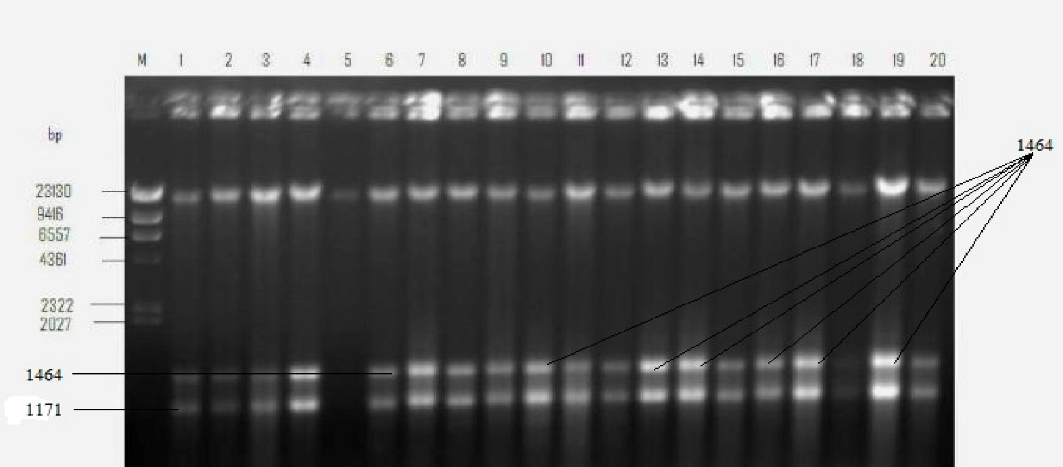
Figure 1: The gel electrophoresis of the plasmid DNA fragments. Lane M: DNA marker (Hind III digest) 23.1 Kb, Lanes 1-20- Shigellaisolates.

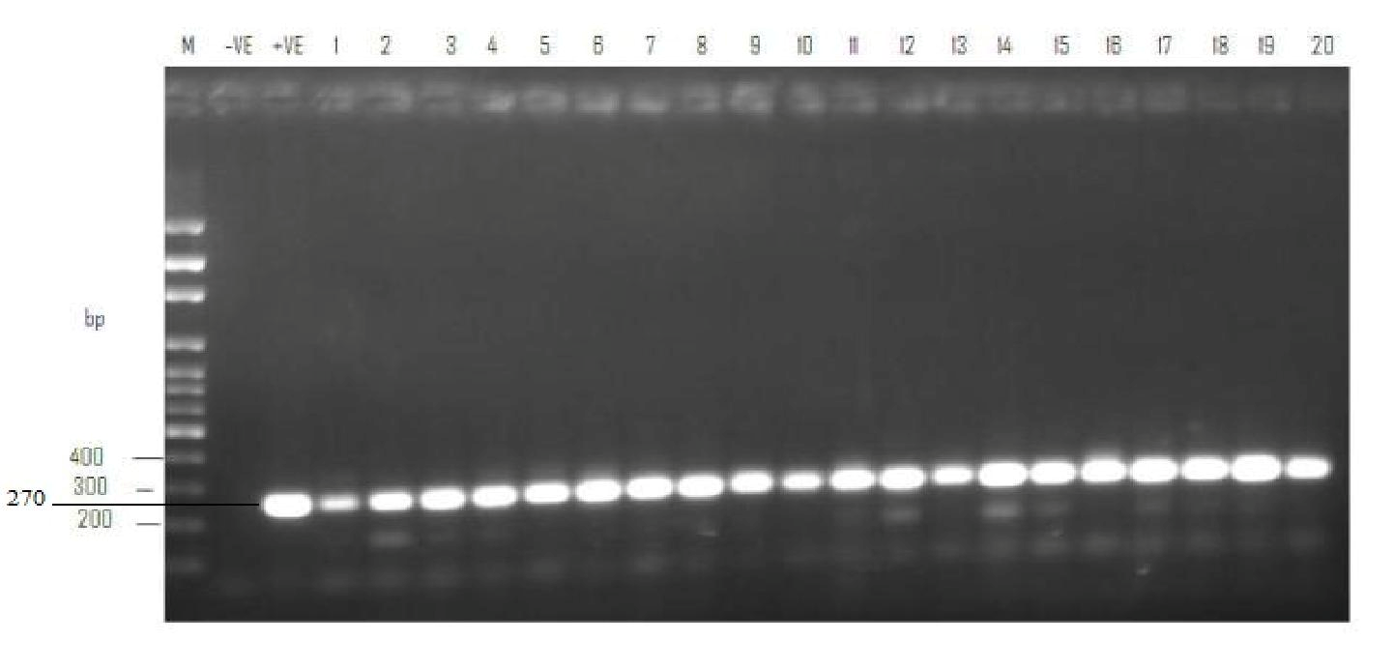Figure 2: The detection of the gyrA gene in Shigellaisolates obtained from stool samples of diarrhoeal patients. Lane M (100 bp DNA marker), Lane = – (PCR supermix without DNA), Lane = + (Shigelladysenteriae) and Lanes 1-20 are gyrA gene of the Shigellaisolates.

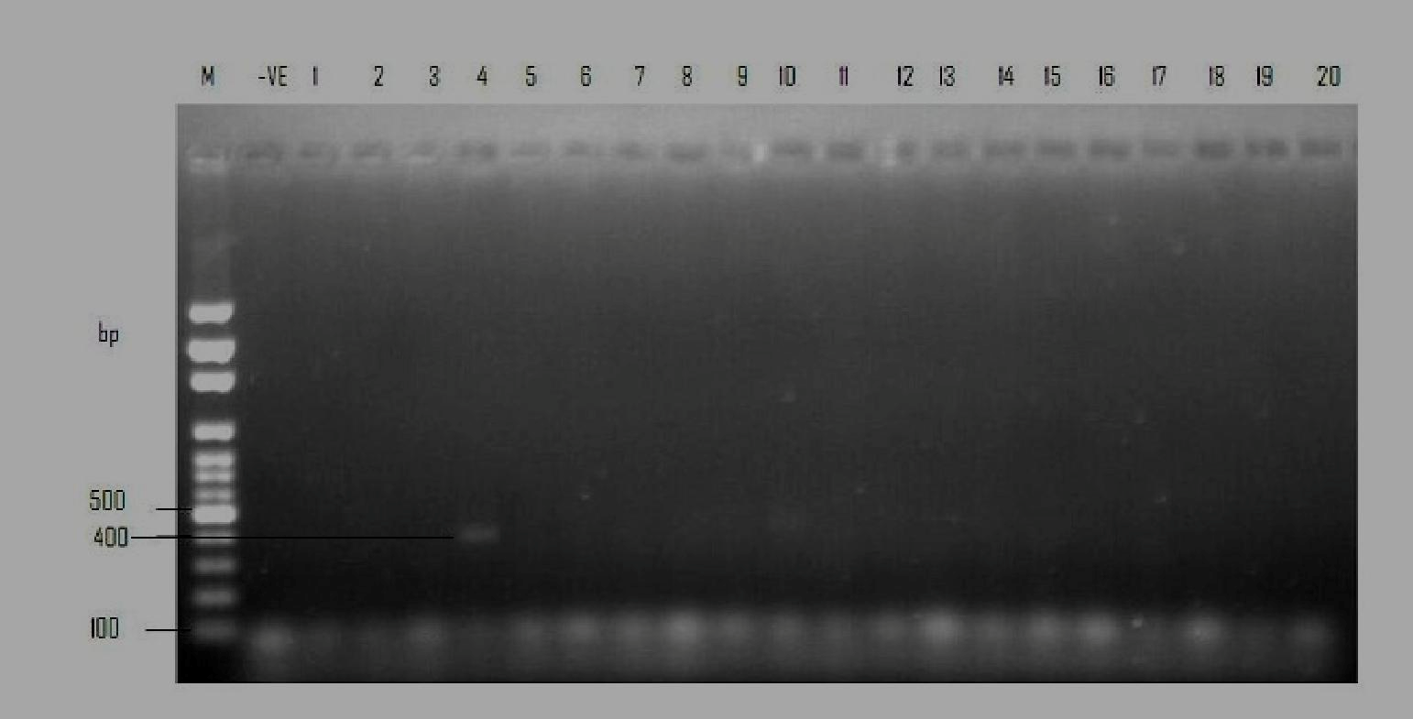
Figure 3. The detection of Shiga-Toxin (stx) gene in multiple antibiotic resistant Shigella isolate obtained from stool
samples of diarrhoeal patients.
Lane M-100 bp DNA marker, Lane –ve (PCR supermix without DNA), Lanes 1-20 - the Shigellaisolates, Lane 4 (Presence of stx gene of size 400bp)

Discussion
The recovery of Shigella sp from the stool
samples analysed indicates that the organism is one of the etiological agents implicated in diarhoeal in the study area. This corroborates studies by Moez et al. (2003), Delappe et al. (2003) and Fulla et al. (2005) who reported the isolation of Shigella sp from stool samples of diarrhoeal patients.
This study revealed high susceptibility rate of the Shigellaisolates to ofloxacin (79.3%) and pefloxacin (75.8%).This finding is in agreement with the result of the study done by Lee et al. (2001) who reported similar antibiotic susceptibility trend in Korea during the last two decades. This present investigation showed that the Shigellaisolates tested with various antibiotics were resistant to more than one class of antibiotic used The high rate of resistance to amoxicillin, nitrofuratoin, ceftriazone and augmentin is suggestive of misuse of these antibiotics.
The level of resistance to the commonly used antibiotics, tetracycline and amoxicillin was similar to studies conducted elsewhere in the world (Subekti et al., 2001; Voogd et al., 1992). Tetracycline and amoxicillin are widely used in the study area to treat shigellosis, but in the present study, 44.9% of the Shigella isolates developed resistance to tetracycline and 82.8% to amoxicillin, and in such cases, ciprofloxacin and ofloxacin should serve as suitable alternative. In other studies, overall resistance to tetracycline, amoxicillin and pefloxacin was quite low (Voogd et al., 1992). The results of the present study suggest a reconsideration of the empiric use of some commonly prescribed antibiotics for the treatment of Shigellosis.
The management of shigellosis is therefore a major economic and health problem due to globally emerging antibiotic resistant strains of Shigella(Replogle et al., 2000; Lee et al., 2001; McIver et al.,
2002). The high susceptibility of Shigellaisolates to
ofloxacin and pefloxacin as reported in this study is an advantage for practioners in the treatment of shigellosis in the study area.
About 80% of the isolates were multiple antibiotic resistant types, which is in consonance with the detection of multiple-resistant strains of Shigellasp in Africa (Egah et al., 2003), Asia (Lee et al.,
2001), England and Wales (Cheasty et al., 1998).
In this study, ninety-five percent (95%) of the isolates were found to have multiple plasmids DNA with similar band patterns. Tacket et al. (1984) and Litwin et al. (1991) also reported multiple plasmid bands in Shigella sp with similarities in band patterns. In this study, it can be suggested that antibiotic resistance determinants are carried by plasmids even though blaCTX gene that encodes the beta-lactamse enzyme was not found in the representatives beta lactam antibiotic resistant isolates screened. The genes encoding these enzymes may be inherently present on the bacterial chromosome or may be acquired via plasmid transfer (plasmid mediated resistance), and β-lactamase gene expression may be induced by exposure to β-lactams (Drawz and Bonono, 2010). The determination of plasmid profile has been shown to be a powerful tool in epidemiological studies Plasmid profile may aid in differentiation of strains, identifying a source of infection, or evaluating the efficiency control measures (Litwin and Ryan, 1991).

Resistance to ciprofloxacin and ofloxacin (fluoroquinolones) in the Shigella sp isolated in this study can be explained by the presence of a gyrA gene. Gyrase A gene was detected in the entire representative isolates screened which is in consonance with the reports of Taneja (2007) and Dhodapkar et al. (2008) which reported the presence of gyrA gene in Shigella sp isolated from stool samples. The presence of shiga toxin (stx1) gene, though in only one of the representative isolates screened is worth noting because it’s an index of virulence. The essential mechanism of virulence of Shigella sp resides in its ability to enter susceptible epithelial cells, induce apoptosis in infected macrophages and this virulence factor inhibits protein synthesis, ultimately causing cell death (Clerc et al.,
1986).

Conclusion
Shigella species may be considered as one of the
important etiological agents of diarrhoea with a high rate of antibiotic resistance profile in the study area. The high prevalence of multiple antibiotic resistant Shigella isolates is highly consequential in terms of therapeutic management of shigellosis There is a need for greater attention to the appropriate use of antibiotics, health education of food handlers, the establishment of hygienic measures to prevent or decrease transmission, and the development of new effective drugs that can be safely use to combating Shigellosis.

Acknowledgments
Authors wish to thank the genetics unit, Nigeria
Institute of Medical Research, Lagos State, for providing the bench space for the molecular characterization of isolates.

References
1. Bergey's Manual of Systematic Bacteriology. 2B
(2nd ed.). New York: Springer. pp. 1108. ISBN978-0-387-24144-9.
2. Cheasty T, Skinner JA, Rowe B and Threlfall EJ. “Increasing incidence of antibiotic resistance in Shigellafrom humans in England and Wales: Recommendations for therapy”. Microbial Drug Resistance. (1998): 4: 57-60.
3. Clerc P, Ryter A., Mounier J. and Sansonetti PJ (1986). “Plasmid-mediated intracellular multiplication of Shigellaflexneri”. Annales De L Institute Pasteur Microbiology, 137 (3): 315-
320.
4. Clinical and Laboratory Standards Institute
(CLSI). Performance standards for antimicrobial susceptibility testing: 20th informational
supplement M100–S20. Clinical and Laboratory
Standards Institute, (2009). Wayne, PA.
5. Delappe N, Halloran F. and Fanning S. “Antimicrobial resistance and genetic diversity of Shigellasonnei isolates from western Ireland, an area of low incidence of infection”. Journal of Clinical Microbiology. (2003): 41
6. Dhodapkar R., Acharya SN, Harish BN and Parija SC. “Shigellosis in Punducherry”.Indian Journal of Medical Research. (2008): 127: 621-
2.
7. Drawz SM. and Bonomo RA. "Three Decades of β-Lactamase Inhibitors". Clinical Microbiology Reviews. (2010): 23 (1): 160–201.
8. Egah DZ, Banwat EB, Audu ES, Allanana JA, Danung ML, Damen JG and Badung BP. “Multiple drug resistant strains of Shigellaisolated in Jos, central Nigeria”. Nigeria Postgraduate Medical Journal. (2003): 10: 154-
156.
9. Farshad S, Sheikhi R, Japoni A. “Characterization of Shigella strains in Iran by plasmid profile analysis and PCR amplification of Ipa genes”. Journal of Clinical Microbiology. (2006): 44 (8):2879-83
10. Fulla N, Prado V and Duran C. Surveillance for antimicrobial resistance profiles among Shigellaspecies isolated from a semi-rural community in the northern administrative area of Santiago, Chile. American Journal of Tropical Medicine. (2005):72 (6):851-854.
11. Kim D, Lenzen WG, Page AL, Legrain P, Sansonetti PJ and Parsot C. “The Shigellaflexneri effector OspG interferes with innate immune responses by targeting ubiquitin-conjugating enzymes”. Proc. National Academic Science USA (2005): 102: 14046-14051.
12. Kotloff KL, Winickoff JP, Ivanoff B, Clemens JD, Swerdlaw DL, Sansonetti PS, Adak GK and Levine MM. “Global burden of Shigellainfection: Identification for vaccine development and implementation of control strategies”. Bulletin of the WHO. (1999): 77 (8): 651-666.
13. Lee Chul J, Young O, Ki Sung K, Yong WJ, Jae WC, Jong CP, Sung Y et al. “Antimicrobial resistance of Shigellasonnei in Korea during the last two decades”. Article first published online,
109 (2): 228-234.
14. Litwin, C. M. and Ryan, K. J. (1991). “Molecular epidemiology of Shigella infections: Plasmid profiles, serotype correlation, and restriction endonuclease analysis”. Journal of Microbiology. (2001): 29 (1): 104-108.
15. McIver CJ, White PA., Jones LA., Karagiannis T, Harkness J, Marriott D and Rawlinson WD. “Epidemic strains of Shigella sonnei biotype g

carrying integrons”. Journal of Clinical
Microbiology. (2002): 40: 1538–1540.
16. Mims P, Roitt W, Williams. Medical
Microbiology (1st ed.). Mosby. (1993): p. A.24.
17. Moez Ardalan K, Zali MR., SoltanDallal MM. et al. “Prevalence and pattern of antimicrobial resistance of Shigella species among patients with acute diarrhoea in Karaj, Tehran, Iran”. Journal Health Population Nutrition. (2003): 21 (2):96-102.
18. Potter JF. "Water recreation and disease: Plausibility of associated infections: Acute effects, sequelae and mortality. The Environmentalist. (2006): 26: 329–329.
19. Replogle ML, Fleming DW and Cieslak. PR. “Emergence of antimicrobial-resistant shigellosis in Oregon”. Clinical Infectious Diseases. (2000):
30: 515-519.
20. Ryan KJ, Ray C and George C. “An Introduction
to Infectious Diseases” Sherris medical microbiology. (2004): (4 ed.) McGraw-Hill Professional Med/Tech. ISBN978-0-8385-8529-
0.
21. Sansonetti PJ. “War and peace at mucosal surfaces”. Nature Review Immunology: (2004):
4:953-964.
22. Subekti D, Oyofo BA, Tjaniadi P, Corwin AL, Larasati W, Putri M. et al. “Shigella sp Surveillance in Indonesia: the emergence or reemergence of dysenteriae”. Emerging Infectious Diseases. (2001): 7: 137-40.
23. Tacket CO, Shahed N and Huq MI. “Use fullness of plasmid profiles for differentiation of Shigella isolates in Bangladesh”. Journal of Clinical Microbiology. (1984): 20: 300-301.
24. Taneja N. “Changing epidemiology of shigellosis and emergence of ciprofloxacin resistant Shigella in India”. Journal of Clinical Microbiology. (2007): 45:678-9.
25. Venkatesan MM and Ranallo RT. “Live- attenuated Shigella vaccines”. Expert Reviews on Vaccines. (2006): 5: 669-686.
26. Voogd CE, Schot CS, Van Leeuwen WJ and Van Klingeren B. “Monitoring of antibiotic resistance in Shigellae isolated in the Netherlands”. Journal of Clinical Microbiology of Infectious Diseases. (1992): 11: 164-165.
27. World Health Organization. “Global burden of disease (GBD) 2002 estimates”. World Health Organization, Geneva, Switzerland. (2004).

1/21/2014

