Bioaccumulation of Heavy Metals using Selected Heavy Metal Tolerant organisms Isolated from Dumpsite Leachate

Adebisi Musbaudeen Sulaimon ¹, Adebowale Toba Odeyemi ², Adeniyi Adewale Ogunjobi ¹, Ismail Olasunkanmi Ibrahim ²

^{1.} Department of Microbiology, University of Ibadan
^{2.} Department of Microbiology, Ekiti State University, P.M.B 5363, Ado Ekiti, Ekiti State, Nigeria
busymindsulaimon11@gmail.com

Abstract: Potentials of some selected isolated microbes from Orita-aperin and Awotan dumpsites leachate to bio-accumulate heavy metal were investigated. Heavy metal content of the samples was determined by atomic absorption spectrophotometer. Microbial enumeration and isolation of the leachate samples were carried out using pour plate technique. Tolerance ability of the microbial isolates to heavy metals was determined by cultivating the isolates at concentrations ranging from 1mM to 5mM on nutrient broth and potato dextrose agar for bacteria and fungi respectively. Based on the result of heavy metal resistant assay, two bacteria and one fungus were then selected to determine their potential to bio-accumulate heavy metal from the leachate under the agitated condition in shaker incubator at 37ºC and 200rpm and non-agitation for a period of 10 to 15 days for bacteria and fungi respectively. The total bacteria count of the leachate ranged from 1.9 x 10⁸ to 3.77 x 10⁹CFU/ml while the heavy metal content ranged from 0.001mg/l for chromium and silver to 1.56mg/l for copper. The ability of Bacillus subtilis, Micrococcus luteus and Trichoderma harzianum to tolerate heavy metals at high concentration of 5mM was their basis for selection. Out of the three selected organism Bacillus subtilis was most efficient in the removal of copper with 90.49% and arsenic with 57.7% accumulation under agitated condition, whereas, the values dropped to 37.16% and 7.00% accumulation respectively when left un-agitated. Also the combination of the two bacteria (Bacillus subtilis and Micrococcus luteus) in the experimental set-up when left un-agitated showed relatively high accumulation ability for copper and nickel with 86.71% and 83.3% respectively. The microorganisms used in this study have the potential role in the bioremediation of heavy metals in contaminated aquatic environment by heavy metal containing leachate.
[Sulaimon AM, Odeyemi AT, Ogunjobi AA, Ibrahim IO. Bioaccumulation of Heavy Metals using Selected Heavy Metal Tolerant organisms Isolated from Dumpsite Leachate. Nat Sci 2014;12(10):101-106]. (ISSN: 1545-0740). http://www.sciencepub.net/nature. 13

Keywords: Bioaccumulation; leachate; Orita-aperin and Awotan dumpsites; heavy metal tolerant organisms

1. Introduction
Municipal and industrial activities led to substantial release of toxic metals into the environment. Heavy metals constitute a major hazard for the ecosystem and especially human health (Boopathy, 2000). The dumped solid wastes gradually release its initial water and some of its decomposition by-products get into water moving through the waste deposit called leachate. Leachate being a mixture of organic, inorganic and many unidentified toxicants may pose risk of unknown magnitude to aquatic life (Mohamed, 2009).
Microbes play a key role in the biosphere, particularly in the areas of metals transformation, decomposition and bioaccumulation. Although in higher concentration, heavy metal ions react to form toxic compound in cells (Nies, 1999). Meanwhile microbes have variety of properties that can affect changes in metals, For example, their ability in converting toxic metals into insoluble substances, for easy mobility as well as dissolution in the dump-sites (Rodriguez, 1993). To survive under metal-stressed conditions, microbes have evolved several types of mechanism to tolerate the uptake of heavy metal ions (Schmidt, 2003). The mechanisms include the efflux of metal ions outside the cell, accumulation and complexation of the metals inside the cell, and reduction of the heavy metal into a less toxic state (Nies, 1999).
Microbial metal accumulation has received much attention in the last years due to the potential of microorganism for cleaning metal in polluted water. However, considerably less attention has been paid to the role if microorganism for metal conversion in leachate even though the same process may occur there as it occurs in soil (Kathirvale et al., 2003).
Chemical methods such as precipitation, oxidation or reduction have been widely used to remove metal ions from industrial waste water. Those methods are ineffective and expensive (Volesky, 1990). The activity of microorganisms is extended to environmental management, and microbes have superseded the conventional techniques for remediation. (Vidali, 2001). Biological methods such as biosorption and bioaccumulation provide promising alternative to chemical methods. Biological processes are typically implemented at low cost. Contaminants are destroyed or accumulated and little or no residual treatment is required, however, some compounds may be broken down into more toxic by-products during the bioremediation process (e.g., TCE to vinyl chloride ) an advantage over the in-situ is that ex-situ applications, these by-products are contained in the treatment unit until non-hazardous end-products are produced. The rate at which microorganisms accumulate contaminants is influenced by the specific contaminants present, the environmental factors such as temperature, oxygen supply, nutrient supply, pH, the availability of the contaminants to the microorganism, and the concentration of the contaminants (high concentrations may be toxic to the microorganism) (Robinsin et al. 2000).
Bioaccumulation is the uptake and removal of inorganic and organic pollutants from substances by microorganisms, with bacteria and fungi being the most common organism for reclamation, immobilization, and detoxification of metallic and radionuclide pollutants. The aim of this study is to isolates and characterized organisms from sites receiving heavy metals pollutants, to study the heavy metals resistance pattern and the bioaccumulation potential of the selected organisms.

2. Material and Methods
Sample Collection and Total Bacterial Count
Leachate samples from Orita-aperin and Awotan dump sites, Ibadan were collected, and two replicates from each dumpsite were considered. Samples were kept in ice and transported to the laboratory for microbial characterization and heavy metals analysis. Using the pour plate and spread plate method for bacteria and fungi respectively, one millilitre (1ml) from 10⁻⁸ dilution of the leachate sample was taken and introduced aseptically into nutrient agar plates for bacterial and potato dextrose agar plates for fungi. Plates were incubated at 30⁰C for 24 hours and 72 hours for bacteria and fungi respectively following the procedure of Chen et al. (2003).
Microbial Characterization
The most tolerable bacterial and fungal isolates were characterized using series of biochemical tests and Bergey’s Manual of Systemic Bacteriology (Buchanan and Gibbons 1974; Sneath et al., 1986).
Heavy Metals Analysis
The heavy metal content of the samples was determined according to Cunningham and Lundie (1993); where 1ml nitric acid was added and Pb²⁺, Cu²⁺, Cr⁺, Ni⁺, Ag^{+,} Ar²⁺ were analyzed using atomic adsorption spectrophotometer.
Determination of MICs (Minimum inhibitory concentrations)
To test the heavy metals resistance pattern, the heavy metals Cu⁺², Pb⁺², Ni⁺, Cr⁺², Ag⁺, As⁺ used as Copper sulphate, Lead acetate, Nickel chloride, Potassium heptaoxodi-chromate VII, Silver nitrate, Arsenate were added to nutrient agar media at concentrations covering the range from 0.1mM to 5.0 mM. Plates were spot inoculated and incubated at room temperature for 24hrs. The minimum inhibitory concentration (MIC) of the heavy metals was designated as the highest concentration the organism was able to tolerate within 24hrs (Schmiatt and Schlegel, 1994). These were compared with the growth on agar plate and the most tolerable isolate were then selected.
Heavy Metal Reduction
Bacteria isolates were grown in 100ml nutrient broth for 24 hours. Cells were harvested by centrifugation and suspended in 1ml, 0.08 percent normal saline solution. Cells pellet were transferred into nutrient broth media containing a mixture of the different heavy metals (Mergeay et al., 1985). The mixture contained 0.026grammM Cu⁺², 0.16gram mM Pb²⁺, 0.02gram mM Ni⁺, 0.02gram mM Ar⁺. At time intervals of 24hours and 72hours, the metal content were determine in a free supernatant using atomic absorption spectroscopy(Gainji and Page, 1974).
For the fungi isolates, the inocula were taken from the actively growing margin of 4 days culture, grown on PDA. The inocula were inoculated in the middle of the plate containing the mixtures of PDA and heavy metals at different concentrations using cork borer. All micro-morphological data were examined on cultured plate for growth for about 7 days at 28⁰C and zone of clearance was measured to determine their minimum inhibitory concentrations.
Bioaccumulation Procedure
Experimentation was done in a flask containing leachate samples from the two dumpsites and the same inoculum size was used for the bacteria to ensure equilibrium (Hughes and Christy, 2003). The samples from each dump sites were divided into ten and dispensed into sterile conical flasks, each containing 40ml. Eight Conical flasks containing the samples from each sample sites were sterilized and the remaining two were left un-sterilized.
The three organisms were inoculated aseptically into the un-sterilized medium containing the indigenous organisms.
To the sterilized samples, the first four conical flasks containing the sterilized medium were inoculated separately and in mixed culture into each conical flasks and were put into the agitated/rotary shaker during the accumulation process, While the resistant fungus were left un-agitated (Ray, 2009).
The other sterilized samples were also inoculated and left un-agitated at room temperature. The samples inoculated with bacteria were incubated for a period of 7 days, while the samples inoculated with fungus were left for 15 days (Robinson et al., 2003). One millilitre (1ml) each from the samples was taken every 3days to ensure the survival of the organisms if probably the remediation process is actually accumulation or adsorption.
After the remediation process, cultured samples were centrifuged at 12000 (rpm). The supernatant contains the heavy metals that were left un-accumulated while the residual samples contain the organisms. The organisms were then lysed immediately so that heavy metals contents that have been accumulated over the period of days will be released out. Atomic absorption spectrometer was used to analyze the amount of heavy metals present in both organisms and the supernatants. The agitated and non-agitated samples were analyzed for heavy metals and the amount accumulated was recorded.

3. Results
The mean value of the total bacterial counts of the leachate sample ranged from 1.9 x 10⁸ to 3.77 x 10⁹CFU/ml from the two dumpsites (Table 1). Based on the colonial morphology, twelve distinct colonies were isolated, characterized and subjected to metal tolerance assay. The bacteria isolated includes Escherichia coli, Pseudomonas spp, Proteus sp, Bacillus spp, Arthrobacter sp, Klebsiella pneumonia, Enterobacter cloacae and Staphylococcus spp according to the cell morphology, Gram staining and biochemical characterisation while the fungi isolated include Aspergillus spp, Penicillum spp, Fusarium oxysporum, and Trichoderma harzianum.
The mean value of the bacteria isolate obtained was higher in the samples collected from Awotan compare to that of Orita-aperin. In the samples collected, bacteria isolated includes species of Bacillus, Escherichia, Micrococcus, Klebsiella, Proteus, Pseudomonas, Enterobacter, Flavobacterium known to be involved in the degradation/utilization of organic matter. This is in agreement with the report of Lewis et al. (2002) and Odeyemi et al. (2011) which stated that Pseudomonas sp and enteric pathogens have high degradability ability for organic matter. The bacteria counts in leachate indicated that the leachates were generally rich in organic matter which allows the growth of microorganisms as observed by Wade et al. (2006). They also went further that increase in moisture content most especially during raining season enhanced the degradability/utilization rate of the organic matter by the microbe in leachate (Wade et al., 2006).
From Orita-aperin dumpsite, the heavy metal content of the leachate samples from which the organisms were isolated were estimated as Cu²⁺ (0.475mg/l), Pb²⁺ (0.86mg/l), Ni⁺ (0.16mg/l), Ar⁺ (0.014mg/l). From Awotan dumpsite, the heavy metal content revealed Cu²⁺ (1.51 mg/l), Pb²⁺ (0.568mg/l), Ni⁺ (0.322 mg/l) and Ar⁺ (0.247 mg/l).
According to World Health Organization standard (WHO) heavy metal content of solid waste must not have value above the threshold of 3mg/l. Leachate samples obtained from wastes of Awotan and Orita-aperin dumpsite contained amount of heavy metals above the permitted values of lead and copper. Copper and lead has the highest concentration ranging from 1.53 mg/l to 0.86 mg/l while chromium has the least concentration of 0.001mg/l. This is in agreement with the work of Malik and Jaiswal, (2004) revealed lead to be found in high concentration in an environment because they are not bioavailable for microorganisms when present in low amount. Resistance of toxic metals in bacteria probably reflects the degree of environmental contamination with these metals (Malik and Jaiswal, 2000).
The result of screening of isolate for Minimum Inhibitory Concentration (MIC) revealed that, three bacteria were able to resist the mixtures of heavy metals at 300µg/100ml, of which at this concentration about three organisms were still able to tolerate the mixtures of the heavy metals. It was observed that the absorbance of Bacillus subtilis increased to 0.60nm at day 1 from the initial absorbance of 0.3nm while that of Micrococcus luteus increased to 0.512nm from the initial absorbance measurement. Bacillus subtilis still showed the highest absorbance of 0.76nm at day 5 while Pseudomonas aeruginosa had the lowest absorbance of 0.23nm. Also, the absorbance of Pseudomonas aeruginosa decreased to 0.167nm at day 1 from the same initial value, further decrease to 0.019nm and 0.005 at day 3 and day 4 respectively was observed (Fig 1).
The mixture of heavy metals concentration at 400µg/100ml was observed showing B. subtilis and M luteus as only two bacteria able to survive. The growth of the two bacteria varied considerably within the number of days. The absorbance measurement of B. subtilis reduced to 0.142nm within 24h from initial absorbance of 0.3nm. However, the growth of B. subtilis increased from 0.22nm on the 4th day of incubation to 0.35nm on the fifth day and eventually decreased to 0.23nm on the sixth day. While on the 4th day the growth rate of M. luteus increased from 0.13nm to 0.22nm after 24h of incubation and reduced to 0.12nm on the sixth day (Fig 2). Meanwhile, using concentration of 500µg/100ml, only two microbes; B. subtilis and M. luteus were able to tolerate the concentration (Fig 3).
Only three isolates (two bacteria and one fungus) that tolerated high concentration of heavy metals analyzed were selected and identified as Micrococcus luteus, Bacillus subtilis, and Trichoderma harzianum and were used for further studies.
Figure 4 and 5 showed the percentage accumulation of the heavy metals by the selected organisms in both agitated and non-agitated samples for the two sampling sites. The selected isolates (3) used for the bioaccumulation studies were found to completely accumulate lead (Pb). Bacillus subtilis had the highest percentage accumulation for copper (86.67% and 90.4%) for Orita-aperin and Awotan leachate respectively with agitated experiment. Also the combinations of the two organisms exhibited high accumulation rate of 86.71% and 78.4% accumulation when left un-agitated for both dumpsites. Micrococcus luteus had the highest percentage accumulation of 57.7% for Arsenic while the combination of the two bacteria performed best in the accumulation of Nickel.

Table 1: Total Bacterial count (CFU/ml x 10⁷) of the leachate sample from Orita-aperin and Awotan sampling site
Sampling point | Orita-Aperin | Awotan
LA₁ | 31 | 38
LA₂ | 51 | 54
LA₃ | 15 | 21
Mean Value | 32.5 | 37.6
LB₁ | 6 | 30
LB₂ | 27 | 17
LB₃ | 34 | 17
Mean Value | 19.0 | 37.7
Legend: A and B = Period of collection of sample (Where A
represent raining season, B represent Dry season)
1, 2, 3 = Sampling points

There was complete accumulation of lead by the three organisms in the experimental leachate samples. Bacillus subtilis was most efficient in the removal of copper and arsenic in the agitated leachate as reported by Pardo et al. (2003) which showed that the percentage of removal of copper in aqueous solution and supply of oxygen is high. Also, the combination of the two bacteria (Bacillus subtilis and Micrococcus luteus) when not agitated were able to accumulate copper and arsenic maximally. This agrees with the work of Ademola et al. (2013) who reported that Bacillus subtilis and Micrococcus luteus are not only resistant against copper and arsenic but also, had the extensive capability of accumulating these heavy metals on-site even when they are not agitated. Also Berg et al. (2001) reported aerobic organisms such as Bacillus spp having ability to accumulate arsenic from sediments which is as a result of arsenate reduction to arsenite by other anaerobic microbes. Micrococcus luteus highly accumulated nickel when left un-agitated (Sandrin and Maier, 2003).

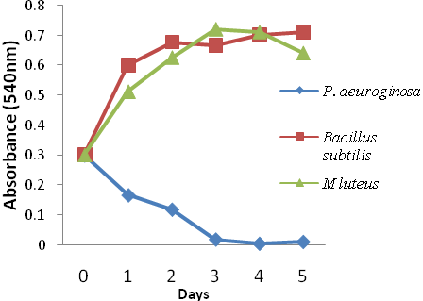
Fig 1: Growth rate of bacteria at mixtures of different concentration (Cu: 0.39mg/l, Nickel: 0.06mg/l, Cr: 0.168mg/l, Pb: 0.024mg/l) of heavy metals for five day

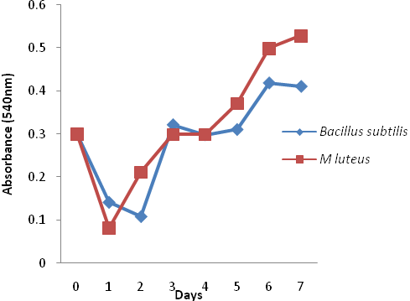
Fig 2: Growth rate of bacteria at mixtures of different concentration (Cu: 0.52mg/l, Nickel: 0.08mg/l, Cr: 0.224mg/l, Pb: 0.032mg/l) of heavy metals for seven days

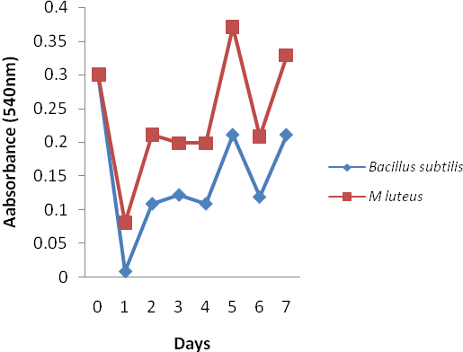
Fig 3: Growth rate of bacteria at mixtures of different concentration (Cu: 1.3mg/l, Nickel: 0.20mg/l, Cr: 0.56mg/l, Pb: 0.08mg/l) of heavy metals for seven days

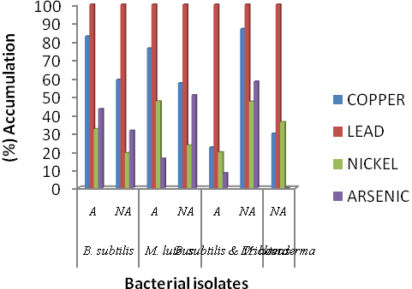
Fig 4: Percentage (%) accumulation of the heavy metals by the selected organisms from Orita-aperin dumpsite (A – Agitation, NA – Not agitated)

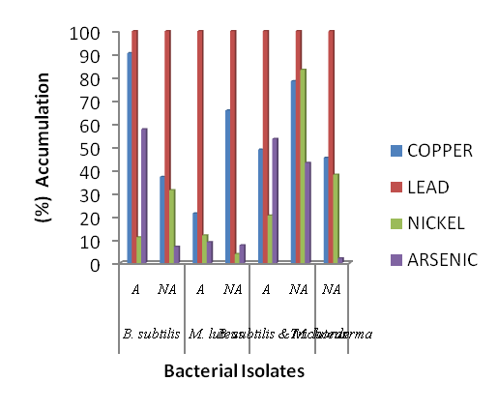 Fig 5: Percentage (%) accumulation of the heavy metals by the selected organisms from Awotan dumpsite (A – Agitation, NA – Not agitated)

Conclusion
In this study, the presence of high amount of coliform bacteria group indicated that the effluents from dumpsites are heavily contaminated with faeces. Hence there is need for proper treatment of effluents before they are discharged into the water bodies to prevent the risk of getting infected by waterborne diseases. There should be proper awareness among people by health workers that untreated sewage and refuse should not be dumped into the flowing water. Dumpsites should not be located around the source or the water bodies used for domestic and agricultural purposes in other not to increase the nutrient availability of the water which eventually might lead to the growth and spread of pathogenic infectious microbes in the community at large. Dumping of metals into the water bodies and on refuse dumpsites should be avoided, instead it is preferably to be incinerated or crushed for re-use industrially. This may prevent diseases associated with heavy metals such as lead poisoning.
It is evident from this work that Bacillus subtilis and Micrococcus luteus have potential roles in the bioremediation of heavy metals from the contaminated aquatic environment. Further work is ongoing to increase the viability and potential of these strains genetically to adsorb/accumulate into their system rapidly thereby bio-remediate the aquatic environment free of poisonous heavy metals.

Corresponding Author:
Adebisi Musbaudeen SULAIMON
Department of Microbiology
University of Ibadan
Oyo State, Nigeria.
E-mail: busymindsulaimon11@gmail.com

References
- Ademola OO, Adhika B, Balakrishna P. Bioavailability of Heavy Metals in Soil: Impact on Microbial Biodegradation of Organic Compounds and Possible Improvement Strategies. Int J Mol Sci. 2013; 14(5): 10197–10228.
- Berg M, Tran CH, Nguyen TC, Pham HV, Schertenleib R, Giger W. Arsenic contamination of groundwater and drinking water in Vietnam; a human health drinking threat. Environ Sci and Technol. 2001; 35(13): 2621-2626.
- Boopathy R. Factors limiting bioremediation technologies. Bioresource Technology. 2000; 74: 63-67.
- Buchana RE, Gibbons NE. Bergey’s Manual of determinative bacteriology 8thedition.The Williams and Williams company, Baltimore. 1974.
- Chen AC, lmachi H, Sekiguchi Y, Ohgashi A, Harada H. Archaeal community composition at different depth (up to 30m) of a Municipal Solid Waste Landfill in Taiwan as revealed by 16sr Rrna cloning analyses. Biotechnology Letters 2003; 5,719-722.
- Cunningham DP, Lundie LL. Precipitation of cadmium by Clostridium thermoaceticum. Appl Environ Microbiol. 1993; 59(1):7-14.
- Gainji TJ, Page AL. Rapid acid dissolution of plant tissue for cadmium determination by atomic absorption spectrophotometer. Atomic Absorption News. 1974; 13: 131-134.
- Hughes KL, Christy AD. Bioreactor landfills In Encyclopedia of Agricultural, Food, and biological Engineering. Marcel Dekker, New York. 2003; 104-107.
- Kathirvale S, MuhdYunus MN, Sopian K, Samsuddin AH. Energy potential from municipal solid waste in Malaysia.Renewable Energy. 2003; 39,559-567.1
- Lewis DL, Gattie DK. Environmental Science Technology Journal. 2002; 36: 28, 6A-293A.
- Malik A Jaiswal R. Lead accumulation by some resistant bacterial strains isolated from soil treated with industrial wastewater. World J. of Microbiology and Biotechnology. 2004; 16: 111-122.
- Mergeay M, Nies D, Schlegel HG, Geritis J, Charles PA, Gusegen F. Alcaligenes eutrophus CH34 is a facultative chemolithotroph plasmid-bound resistant to heavy metals. J. Bacteriol. 1985; 162: 328-333.
- Mohamed AF, Yaacob WMR, Taha MR, Samusdin AR. International Atomic Energy Agency, Technical report series 295 Vienna.Euro.J. of sci. Res., 2009; 27(4):628-635.
- Nies DH. Microbial heavy-metal resistance Appl Microbiol Biotechnol 1999; 51:730- 750.
- Odeyemi, A.T., Faweya, E.B., Agunbiade, O.R and Ayeni, S.K. (2011). Bacteriological, mineral and radioactive contents of leachate samples from dumpsite of Ekiti State Government Destitute Centre in Ado-Ekiti. Archives of Applied Science Research, 3 (4): 92-108.
- Pardo R, Herguedas M, Barrado E .Biosorption of cadmium, copper, lead and zinc by inactive biomass of Pseudomonas putida.Analytical and Bioanalytical chemistry. 2003; 376: 26-32.
- Ray SA, Ray MK. Bioremediation of heavy metal toxicity with special reference to chromium. Al Ameen Journal of Medical Sciences. 2009; 2(2): 57 63.
- Robinsin P, Enriquez, CE, Johnson D, Gerba CP. Environmental Microbiology. Academic Press.San Diego. 2000; 447-489.
- Robinson H, Farrow S, Lasts and Jones D. Remediation of leachate problems at Arpley landfill site, Washington, Cheshire, United Kingdom.CIWM Scientific and Technical Review, 2003; 18-26.
- Rodriguez Montelongo L, de la Cruz Rodriguez LC, Farias RN, Massa EM. Membrane-associated redox cycling of cop-per mediates hydroperoxide toxicity in Escherichia coli. Bio-chem BiophysActa. 1993; 1144: 77-84.
- Sandrin TR, Maier RM. Impact of metals on the biodegradation of organic pollutants. Environ. Health Perspect. 2003; 111:1093–1101.
- Schmiatt T, Schlegel HG. Combined Nickel-Cobalt-Cadmium resistance encoded by ncc locus of Alcaligenes xylose oxidans 31 A.J. Bacteriology. 1994; 176 (22): 7045-7054.
- Sneath PHA, Mair NS, Sharpe ME, Holt JG. Bergey’s Manual of Systematic Bacteriology. Williams Wilkins Co., Baltimore, 1986; p. 1123.
- Schmidt I, Sliekers O, Schmid MC, Bock E, Fuerst J, Kuenen JG, Jetten MS, Strous M. New concepts of microbial treatment processes for the nitrogen removal in wastewater FEMS Microbiol. Rev. 2003; 27: 481-492.
- Vidali MI, McCarthy AJ. Molecular biology detection and character of clostridium population in municipal landfill sites. Applied Environmental Microbiology. 2002; 68, 2049-2053.
- Volesky B. In: Volesky B. (Ed) Biosorption of heavy metals. CRC press Boca Raton. Florida. 1990.
- Wade A, Dave G. Acute toxicity of leachates from waste dumpsites in Malaysia. Chemosphere.2006; 64: 1777-1784.
- WHO. Guidelines for Soil and Drinking water Quality 3rd Edition (1): Recommendations. World Health Organisation, Geneva.

9/23/2014

