Preparation and characterization of biocomposite based on poly (L-lactide) and poly(ethylene glycol): in vitro bioactivity evaluation

M.I. El-Gohary¹, Gehan M. Kamal², Sahar M. Awad², Abeer M. El-Kadey³, Areg E. Omar²*

^{1.} Biophysics Department, Faculty of Science (Boys), Al-Azhar University, Nasr City, Cairo, Egypt
^{2.} Biophysics Department, Faculty of Science (Girls), Al-Azhar University, Nasr City Cairo, Egypt
^{3.} Biomaterials Department, National Research Center, Tahreer St., Dokki, Giza, Egypt.
*aregomar@yahoo.com

Abstract: The main objectives of the present study were to fabricate sodium calcium silicate ceramic /poly(L-lactide)/poly ethylene glycol composite membranes for bone engineering applications, by using liquid-liquid phase separation. The membranes were characterized by SEM, FT-IR, TGA and TF- XRD. Examination of the SEM microphotographs revealed that the membranes were porous and pore size was about 20µm. In vitro bioactivity evaluation showed that the composite membranes were able to induce the formation of hydroxyapaptite layer on their surfaces, demonstrating their potential application in bone engineering.
[El-Gohary MI, Kamal GM, Awad SM, El-Kadey AM, Omar AE. Preparation and characterization of biocomposite based on poly (L-lactide) and poly(ethylene glycol): in vitro bioactivity evaluation. Nat Sci 2014;12(10):95-100]. (ISSN: 1545-0740). http://www.sciencepub.net/nature. 12

Keywords: Composite biomaterial; Poly ( L-lactide ); poly(ethylene glycol); sodium calcium silicate ceramic

1. Introduction
Among the biodegradable polymers, poly L lactide (PLA) have been receiving a special interest as biomedical materials, PLA has widespread applications in sutures, drug delivery devices, prosthetics, scaffolds, vascular grafts, bone screws, pins, a bone reinforcement material and plates for temporary internal fixation [1].
PLA can be considered an eco-friendly biomaterial (It is biodegradable, recyclable, biocompatible and consume carbon dioxide in its production) with excellent properties but it has many drawbacks such as its hydrophobicity, slow degradation rate,acidity of its degradation products, in addition it is not bioactive material [2].
Hydrophilic properties could be achieved by the addition of another hydrophilic polymer to PLA such as Poly(ethylene glycol) (PEG). Poly ethylene glycol (PEG) is a water-soluble biocompatible polymer, readily eliminated from the body by kidney filtration provided molar masses are low enough [3]. Moreover PEG is neutral, flexible and known to decrease protein adsorption and cell interactions when present at the surface of a material [4].
By combining the hydrophilicity of polyether PEG with the biodegradability of polyester poly(L-lactide) (PLA), it is possible to enlarge the range of properties typical of PLA polymers in the field of temporary therapeutic applications.
Neither PLA nor PEG are bioactive and hence their blends will not be able to induce a bone like apatite on their surfaces in body fluids. This layer is known to be very essential for the integration of any bioactive materials with the surrounding bone tissue in vivo.
Bioactive material such as sodium calcium silicate ceramic was added to the prepared composite.

2. Material and Methods
2.1. Materials
Tetraethyl orthosilicate (TEOS), calcium nitrate tetrahydrate, Ca(NO₃)₂·4H₂O, were all ≥98% pure and purchased from Fluka (Buchs, Switzerland). Sodium nitrate (NaNO₃) was purchased from Sigma Aldrich Ammonia solution, 33%,and Nitric acid, 68%, were obtained from Merck, USA. Poly(L-lactide) (M. Wt. 152,000) was obtained from Fluka, USA. Chloroform was obtained from Acros (Acros Organics, Belgium). Both nitric acid and ammonia solutions were diluted to 2 M using distilled water.

2.2. Preparation of bioactive sodium calcium silicate ceramic (Na₄Ca₄Si₆O₁₈) by sol-gel method
Na₄Ca₄Si₆O₁₈ was prepared using the sol-gel technique and the preparation procedure was similar to the preparation of bioactive glass 58S [5]. The previous method was modified through a quick alkali mediated sol gel technique to obtain nano ceramic particles.

2.3. Preparation of biocomposites based on poly (L-lactide) and poly(ethylene glycol), and contain sodium calcium silicate ceramic particles as a filler
The composite membrane was formed of (PLA/ PEG /ceramic) in ratio of (70/30/40), respectively.
The composite membrane prepared by the liquid-liquid phase separation [6,7]. Briefly, poly(L-lactide) and poly ethylene glycol were dissolved in chloroform to form a polymer solution with a concentration of 10% (w/v). Bioactive ceramic powder was added and the mixture stirred for 3 h to ensure the complete dissolution of the polymer and the formation of a homogenous solution. Then the solution poured into a closed Petri dish and frozen at -20ºC for 2 days after that the dish was opened and still in freezing for 1 day to allow chloroform to evaporate. This lead to the formation of the porous membrane.
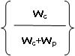
The code for this sample is CG30, The ceramic content 40 wt% was calculated according to Eq. (1):

ceramic content )wt%) = *100 Eq. (1)

where W_{c} was weight of the ceramic and Wp was weight of the polymer.

2.4. Characterization
The morphology and the porous structure of the composite membrane, as well as their elemental composition, were analyzed with Scanning Electron Microscopy coupled with Energy-Dispersive Spectroscopy, SEM/EDXA (JEOL JXA-840A, Electron probe micro-analyzer, Japan) at 30 kV. The scaffolds were cut with a razor blade and coated with carbon. The SEM analysis was carried out for the sample with different magnifications.
Thermogravimetric Analysis (TGA) of the prepared composite was obtained. Scans were performed in an air atmosphere in a temperature range 50–500 °C for the scaffolds at a rate of 10 °C/min using aluminum oxide powder as a reference. The phase analysis of samples was examined by an X-ray diffractometer model BRUKER axs, D8ADVANCE (Germany) employing Ni-filtered Cu Kα irradiation at 40 kV and 25mA.
The Fourier-Transform Infrared spectra, (FT-IR) of the prepared glass and the scaffolds were obtained using the FT/IR-6100 type A machine (The Netherlands) in the range of 400–4000 cm⁻¹.Disks were prepared by mixing powders of membrane with KBr. Pure KBr powder was used as a background.
2.5. Assessment of the in vitro bioactivity
The assessment of the in vitro bioactivity was carried out by soaking the composite in simulated body fluid (SBF) in sterilized polyethylene containers maintained at 37°C. The formation and growth of apatite layer on the ceramic and composite surfaces were verified by Scanning Electron Microscope coupled with Energy-Dispersive Spectroscopy, SEM/EDXA (JEOL JXA-840A, Electron probe micro-analyzer, Japan), Thin-Film X-ray Diffraction (TF-XRD) (Panalytical, X'Pert Pro, The Netherlands), and Fourier-Transform Infrared spectra, (FT-IR) (6100 type A machine) in the range of 400–4000 cm−1.

3. Results and Discussion
3.1. Thermal analysis
The thermogravimetric analysis (TGA) of CG30 is shown in Fig. 1. The TGA results showed that the thermal destruction of the polymer started at 121 and ended at 326 ºC, and the total weight loss recorded was 53.97%. The ceramic content in the fabricated composite membrane was calculated from the TGA data and from equation (1) for comparison.
The ceramic content from eq. 1 was 40% while that from TGA was 38.88%. The comparison showed a difference between the amount of the ceramic content calculated from TGA data and those calculated by Eq. (1). Such difference might be due to some partial sedimentation of the ceramic particles during fabrication of composites [8].

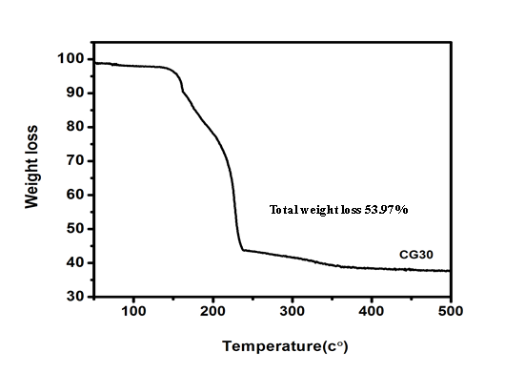
Figure 1. Thermogravimetric analysis (TGA) of CG30 composite membrane

3.2 SEM with EDX examination
Figures (2 & 3) presents the SEM micrographs of a cross-section of CG30 and its EDX analysis as well before and after 15 days of immersion in SBF, respectively.
Figure (2) shows porous structure ranging from few microns to about 20 μm, The EDX spectra of sample showed peaks of calcium, silica, and sodium which are the main components of the sol–gel bioactive ceramic. In addition to Carbone and oxygen peaks of poly l lactide.
In the preparation of the composites the polymer solution was frozen to -20ºC for two days, then allow chloroform to evaporate lest porous structure, the pores were affected by filler,. Many other results [9-11] showed the same observations.
Figure (3) indicates a layer of spherical particles fully covered the surfaces of Sample. The EDX analysis in this figure suggested that these spherical particles could be calcium-deficient and non-stoichiometric apatite with Ca/P ratio of 1.65.
Other studies have reported that the induced apatite layer on the surfaces of different bioactive materials during their incubation in SBF was also calcium-deficient [12, 13].
The formation of the hydroxyapatite layer on the surface of composite membrane, immersed in SBF, could be explained by the hydrolysis of ester bonds of the polymer, and the formation of carboxylate groups (COOH). These reactive groups have the ability to attract silica ions released from the composite due to the dissolution of the glass particles.
These ions could, in turn, act as nucleation sites for calcium and phosphorus ions, leading to the formation of hydroxyapatite layer on the surfaces of the composite membranes [14, 15].

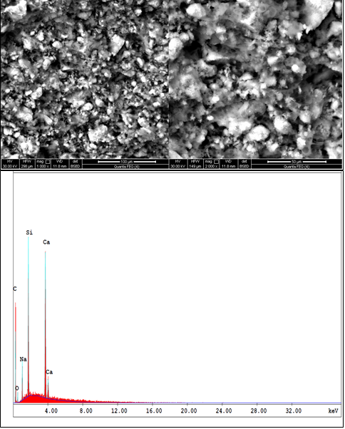

Figure 2. SEM micrograph showing a cross-section of the composite membrane CG30 and its EDX analysis plot. The figure shows a pore size varying from a few microns to about 20μm
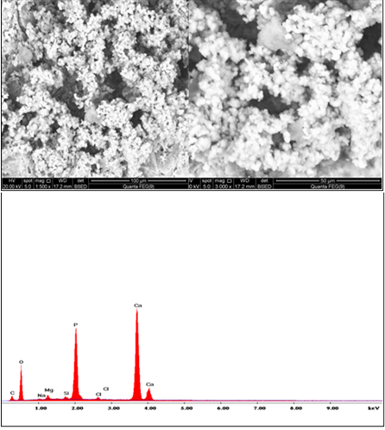

Figure 3. SEM micrograph and EDX analysis of the of CG30 composite membrane after immersion in the SBF for 15 days. A layer of spherical particles has fully covered the surface with Ca/P ratio of 1.65

3.3. X-ray diffraction analysis:
The TF-XRD patterns of the composite membrane CG30 before and after immersion in the SBF for 15 days were illustrated in Fig. (4).
For the composite membrane two XRD peaks of the crystalline poly(L-lactide) found at 2ө values of 16.63 and 18.86 corresponding to d-spacing of 5.34 A ° and 4.67 A ° respectively [16]. Also all peaks of sodium calcium silicate ceramic was noticed and it was identical to peaks of the standard PDF No.75-1687 quite well.
After 15 days of SBF immersion,the figures clearly indicate the formation of the apatite layer, on the surfaces of the sample, after 15 days of immersion in the SBF. The typical diffraction pattern of the crystalline apatite could be observed, which was associated with an evident peaks at d-spacing values of 2.81 A°, 2.72 A° and 2.78 A° [matched with the corresponding ICSD card no (82-1934)]. In addition, the appearance of other less intense peaks at d-spacing values of 2.44 A°, 2.28 A°, 1.94 A°, 1.84 A° and 1.72 A° [matched with the corresponding ICSD card no (82-1934)] was also noticed. Those results further confirmed the apatite formation and crystallization.
The diffraction peak of the formed apatite at d-spacing value of 8.27 A° was not appeared for thee samples, indicating the incomplete crystallization of the apatite layer. It may be observed when immersion time in SBF increased.
3.4. FT-IR analysis
FTIR spectra of the composite membrane CG30 before and after 15 days of immersion in SBF was indicated in Fig. (5)
FTIR spectra of the composite membrane CG30 before immersion illustrate all the characteristic absorption peaks of poly(L- lactide), poly ethylene glycol and sol–gel sodium calcium silicate ceramic.

Figure 4. Thin film X-ray of CG30, before and after immersion in SBF for 15 days

The main characteristic bands of poly(Llactide) as reported elsewhere (17, 18), these bands are ascribed to: carbonyl modes [C=O] at 1788 cm⁻¹, asymmetric CH₃ bending mode at 1470 cm⁻¹, symmetric CH₃ stretch at 1397 cm⁻¹, [C–O] stretching mode at 1150 cm⁻¹, and other methyl bands at 3018 cm⁻¹.
The sol–gel sodium calcium silicate ceramic characteristic bands was reported by El Batal et al. (2003) [19], these bands are ascribed to: Si-o-Si (b) in the range of 400-500 cm⁻¹, Si-O-Si (tetrahedral at 733 cm⁻¹, Si-O (stretch) at 922 cm⁻¹, Si-O-Si (Stretch) at 1042 cm⁻¹ and additional band at wavenumbers 627 cm⁻¹ which is due to presence of sodium calcium silicate [Na₂Ca₂ Si₃O₉] crystalline phase [20].
Polyethylene glycol exhibits absorptions of a primary alcohol. Hence, these absorptions, which are comprised of stretching and bending vibrations, are restricted to C-C stretching, C-O stretching, C-H stretching (methylene absorptions) and C-H bending.[ 21], strong hydroxyl bands for free alcohol (non bonded –OH stretching) and hydrogen bonded bands were found in the respective region between 3600-3650 cm⁻¹ and 3200-3500 cm⁻¹ [22].
The methylene group found in PEG has been found to vibrate in the stretching mode in the range of (2862-2952) cm⁻¹ [22, 23]. The absorption around 1465 cm⁻¹, 1385 cm⁻¹ is due to binding vibration of -CH₂. As in the case of a primary alcohol, the C-O-C stretching vibration, a strong bond around 1235 cm⁻¹ is also observed. A sharp, strong bond at 841 cm⁻¹ is due to the C-C stretching. [24].
The main characteristic band of the C–O vibration in the PEG chains, located around 1115 cm⁻¹ was superimposed with the strong absorption of the Si–O–Si vibration. Thus, it was difficult to distinguish the C-O vibration from the Si–O–Si vibration [ 24].
A slight shift was noticed for the main peaks of poly(L-lactide) to lower frequency which may be attributed to the interaction between the components of composite.

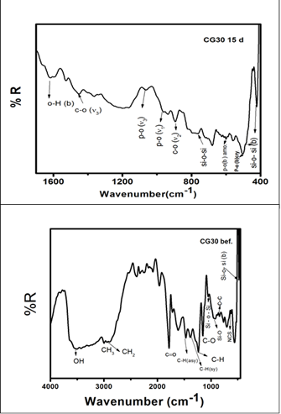

Figure 5. FTIR spectra of the composite membrane CG30 before and after 15 days SBF soaking

After immersion of CG30 in SBF for 15 days the figure showed all the characteristic absorption peaks of hydroxyapetite as illustrated elsewhere [25-27]. After SBF treatment the FTIR spectra peaks were noticed at 477, 529, 584, 741, 873, 1436, 1637 and 3485 cm⁻¹. After SBF treatment new peak was developed around at 529 cm⁻¹ (P-O Bend- Crystalline), 584 cm⁻¹ (P-O Bend- Amorphous), 1436 cm⁻¹ (C-O v₃), C - O stretching at 873 cm⁻¹ and 3485 cm⁻¹ (O-H stretching). Presence of C - O stretching at (890 - 800 cm⁻¹) bands shows the crystalline nature of HCA layer and P-O stretching (1040-910 cm⁻¹) bands are attributed due to HCA layer [20].

4. Conclusion
- The liquid-liquid phase separation used successfully in the fabrication of sodium calcium silicate ceramic/poly(L-lactide)/poly ethylene glycol composite membranes. The composite membrane showed porous structure with bore diameter of about 20 µm.
- In vitro bioactivity evaluation showed that the composite membranes were able toinduce the formation of hydroxyapaptite layer on their surfaces.The membranes were able to induce hydroxyapatite layer on their surface. So that this composite may improve bone bonding ability in vivo.

Corresponding Author:
Areg E. Omar
Faculty of Science (Girls)
Al-Azhar University, Nasr City Cairo, Egypt
E-mail: aregomar@yahoo.com

References
- A. H. Rohan & J. P. Darrin, Mrs Bulletin (2007), Vol. 32, pp. 354-358.
- D. Puppi, F.Chiel, A.M. Piras., E. Chiellini., Progress in Polymer Science, (2010), Vol. 35, pp. 403–440.
- K.E. Uhrich, S.M. Cannizarro, R.S. Langer, K.M.Shakesheff.. Chem Rev,(1999), vol.99, pp. 3181-98.
- J. M.Harris. New York: Plenum Press; 1992.
- D. Ruilin & c. jiang, Journal of Materials Science: Materials In Medicine, (2004), Vol. 15, pp. 1285 – 1289.
- X. M. Peter, materials today, (2004), Vol. 6, PP. 30-40.
- L. Budyanto, Y.Q Goh., C. P. Ooi., Journal of Materials Science: Materials in Medicine, (2009), Vol. 20, pp.105- 111.
- J.J. Blaker, V. Maquet, R. Je´roˆme, A.R. Boccaccini, S.N. Nazhat, Acta Biomater. 1, (2005), pp. 643–652.
- K. Zhang, Y. Wang, A. M. Hillmyer, F. Francis, Biomaterials, (2004), Vol. 25, pp. 2489–2500.
- A. M. El-Kady, A F. Ali, M M. Farag, Materials Science and Engineering C, (2010), Vol.30, pp. 120–131.
- X. Li, J. Shi, X. Dong, L. Zhang, H. Zeng, J. Biomed. Mater. Res. (2008), Vol. 84A pp. 84.
- S. Radin, P. Ducheyne, S. Falaize, A.Hammond, J. Biomed. Mater. Res., (2000),vol. 49, pp. 264.
- H.M. Kim, K. Kishimoto, F. Miyaji, T. Kokubo, T. Yao, Y. Suetsugu, J. Tanaka, T. Nakamura, J. Biomed. Mater. Res. (1999), Vol. 46, pp. 228.
- K. James, H. Levene, J. Parsons, J. Kohn, Biomaterials, (1999), Vol. 20, pp. 2203.
- T. Jaakkola, J. Rich, T. Tirri, T.N. Arhi, M. Jokinen, J. Seppälä, A. Yliurpo, Biomaterials, (2004),Vol. 25, pp. 575.
- Z. Zhou, J. Ruan, J. Zou, Trans. Nonferrous Met. Soc. China, (2007), Vol. 17, pp. 399–494.
- P Anurag, C. P. Girish, A. B. Pranesh, journal of the mechanical behavior o f biomedical materials 1, ( 2008 ), pp. 227 – 233.
- B. S. Ndazi1 &, S. Karlsson., Express Polymer Letters, (2011), Vol. 5(2 ), pp. 119–131.
- H. A. El Batal., M.A. Azooz., E.M.A Khalil., A. Soltan, Y.M. Hamdy., Materials Chemistry and Physics, (2003), Vol. 80, PP. 599–609.
- K. S Ankesh, and. P Ram, International Journal of Scientific & Technology Research, 2012, Vol. 1, pp. 2277-8616.
- A. P. Reddy and R. Kumar, Journal of the Korean Physical Society, (2011), Vol. 5 9 (1) PP.114-118.
- D. Joydeep, American Journal of Chemistry 2012, Vol. 2(2), PP. 6-11.
- Y. Djaoued, J. Robichaud, R. brüning, A. Andre-sebastien, V. A. Pandurang, Materials Science-Poland, (2005), Vol. 23 no.1, pp. 15-27.
- C. Jian,L. Jiding,C. Jinxun, L. Yangzheng, W. Xiaogong, Separation and Purification Technology 66, (2009), PP.606–612.
- W. Liu, W. Xiaohong, Z. Hongbing, Y. Fuhua, Materials Science and Engineering C 32 (2012), PP.707–711.
- A. Destainville, E. Champion, D. Bernache-Assollante, Materials Chemistry and Physics, (2003), Vol. 80, pp. 269 – 277.
- B Ratner, A. Hoffman, F. Schoen, “Biomaterials Scienc. An Introduction to Materials in Medicine”, Second Edition, Academic Press, (2004), pp. 851.
- S. Meejoo, W. Maneeprakorn, P. Winotai, Thermochimica Acta, (2006). Vol. 447, pp. 115–120.

9/23/2014

