**Structural Changes of Pathogenic Multiple Drug Resistance Bacteria Treated with *T. vulgaris* aqueous Extract**

Ahmed R. Sofy 1*, Ahmed A. Hmed 1, Abd El-Monem M.A. Sharaf 1 and Khalid A. El-Dougdoug 2

1. Botany and Microbiology Department, Faculty of Science, Al-Azhar University,11884 Nasr City, Cairo, Egypt

2. Agric. Microbiology Department, Faculty of Agriculture, Ain Shams University,11241 Cairo, Egypt

*[ahmd_sofy@yahoo.com](mailto:ahmd_sofy@yahoo.com)

**Abstract:** Most bacterial strains are becoming resistant to multiple antibiotics particularly, Methicillin Resistance *Staphylococcus aureus* (MRSA) and *Pseudomonas aeruginosa*. This study exhibited the strong antimicrobial activity of *T. vulgaris* total aqueous extract against Multiple drug resistance pathogenic bacteria including both Gram-positive (MRSA) and Gram-negative (*Ps. aeruginosa*) bacteria with low concentration of MIC and short time kill assay. Scanning Electron Microscopy (SEM) wasconducted to get the images of morphological damages in selected tested bacteria.The SEM images showed that, most cells present damage and observed to get clustered and stick to each other. Gram negative and the Gram positive cells appeared to be shrunk and even some were empty. Furthermore, most of the Gram-negative and Gram positivecells appeared to be stuck together and melted. These images confirm the loss of shape and integrity which was followed by the cell death.

[Sofy AR, Hmed AA, Sharaf AMA and El-DougdougKA. **Structural Changes of Pathogenic Multiple Drug Resistance Bacteria Treated with *T. vulgaris* aqueous Extract.** *Nat Sci* 2014;12(10):83-88]. (ISSN: 1545-0740). <http://www.sciencepub.net/nature>. 9

**Keywords:** *T. vulgaris*;Methicillin Resistance*Staphylococcus aureus*; (MRSA);*Pseudomonas aeruginosa*

**1. Introduction**

Resistance to antimicrobial agents has become an increasingly important and pressing global problem[1].

Bacteria that are resistant to current antibiotics have wreaked havoc in the clinic and are a primary cause of death in the intensive-care units of our hospitals worldwide[2,4].

The opportunistic pathogens *Staphylococcus aureus*, as well as *Pseudomonas aeruginosa*, rank among the clinically most significantorganisms that cause serious health problems, with antibiotic-resistance[5]. Now, a major cause for concern is methicillin-resistant *Staphylococcus aureus* (MRSA), which was at low levels a decade ago but now accounts for ca.50% of all *S. aureus* isolates[5].

In recent years, methicillin resistance in *Staph. aureus* is approaching an epidemic level and up to 50% are resistant to stronger drugs, such as methicillin causing deaths in a matter of weeks[5,6,7,8].

With antibiotic resistance, there is an urgent need to replenish our arsenal of anti-infective agents. Ideally, this should be in the form of new classes of antibacterial agent Inhibition of resistance mechanisms through the development of novel adjuncts also represents an important strategy. Natural products are a major source of chemical diversity and have provided important therapeutic agents for many bacterial diseases[9,10,11].

This study aimed to evaluate and confirm the antimicrobial activity of *T. vulgaris* aqueous extract which is a commercial herb and spice, to use in the form of new classes of antibacterial agent inhibition of multiple drug resistance bacteria.

**2. Material and Methods**

**2.1. Bacterial strains**

Methicillin resistant *S*. *aureus* (MRSA) bacterial strain was isolated from hospitalized patients from Al-Azhar University El-Hussein Hospital and approved by biochemical tests. A standard bacterial strain of *Ps*. *aeruginosa* ATCC 9027 obtained from Botany and Microbiology Department, Faculty of Science, Al-Azhar University, Cairo, Egypt.

**2.2. Plant material and extract preparation**

The leaves and flowers parts of*Thymus vulgaris*plant was brought to the laboratory and carefully washed separately under tap water to remove debris and dust particles. The dried materials were ground to fine powders by electric grinder. One hundred grams of powdered plant material were mixed with one liter of sterile distilled water for aqueous extraction and the mixture were kept at room temperature for 24 hours with continuous mixing by magnetic stirrer. This mixture was filtered through cloths and further extraction of the residue was repeated 3-5 times until a clear colorless supernatant extraction (aqueous extract). Aqueous extract were dried until a constant dry weight of each extract was obtained. The extracts were sterilized by 0.22μm Millipore filter. The residues were stored at 4°C for further use[12].

**2.3. Antibacterial activity by Disc diffusion assay**

Impregnated paper discs with *T. vulgaris*aqueous extract in concentrations 6.25 mg/ml and 1.562 mg/ml for *Ps. aeruginosa*and Methicillin Resistance *Staph. aureus* (MRSA) respectively were placed on the surface of inoculated agar plates for 24hrs, (~4 mm thickness agar layer). The Petri dishes were sealed using parafilm and left 1 hr in the refrigerator, in order to allow for the diffusion of the active compounds. Negative controls were done using sterile distilled water instead of active compounds. Then, plates were incubated at 37°C for 24hrs[13].

**2.4. Determination of Minimum Inhibitory Concentration (MIC)**

Determination of MIC was done using the broth micro-dilution technique. A 100μl of Mueller Hinton broth (MHB) was dispensed into the wells of U-shaped of microtiter plate except the first well of each row which contained 150 μl and the last row of wells contained distilled water. A 100μl of 100mg/ml of the tested plant extract was dispensed into the first well; a two-fold serial dilution was carried out up to well number 12 from which 100μl was discarded. Twenty microliters (20μl) of bacterial suspension (0.5 McFarland standards) was added to each of the wells except the control wells (control wells contained broth only and distilled water only). An automatic ELISA microplate reader (Sun Rise–TECAN, Inc. ®, USA) adjusted to 600 nm was used to measure the absorbance of the plates before and after incubation at 37°C after 24 hr. The absorbencies were compared to detect an increase or decrease in bacterial growth and the values plotted against concentration. The lowest concentration of the tested plant extract resulting in inhibition of tested was recorded as the MIC[14].

**2.5. Time kill assays**

Dialyzed tested extracts (6.25 and 1.562mg/mlof *Thymus vulgaris* aqueous extract) against *Ps. aeruginosa* and *S. aureus* (MRSA) diluted in sterile distilled water. Suspensions were mixed with bacteria harvested at late logarithmic phase and diluted to approximately 4.0-5.0 log CFU ml. A total volume of 25ml was used consisting of 12.5ml of trypticase soy broth (TSB), 10ml of filtered dialyzed extract and 2.5ml of inoculum. And incubated at 35-37oC and at regular intervals (0, 3, 6, 12 and 24 hrs) A bacterial suspension (1ml) was collected and the effect of the tested extract on the bacterial growth was evaluated at each previous times using the spectrophotometric assay at optical density of 620nm (O.D. 620nm). also (1ml or 0.1ml) from bacterial suspension was serially diluted in 0.1% peptone, and plated in triplicate using tryptic soy agar (TSA; TSB, Becton, Dickinson and Company, Sparks, MD and Agar, Fisher Scientific, USA), incubated for 24 hrs, at 35-37oC, and then CFU enumerated. All experiments were triplicated and average values were reported[15].

**2.6. Preparation of samples for Scanning Electron Microscope Examination**

Treated and non-treated samples were fixated by glutheraldhyde 2.5% and dehydrated by serial dilution of ethanol using automatic tissue processor (Leica EM TP).Then the samples drying using CO2 critical point drier (Tousimis Audosamdri-815). The samples coated by gold sputter coater (SPI-Module). Finally, the samples exanimated by scanning electron microscopy (JEOL-JSM-5500LV) by using high vaccum mode at the Regional Center of Mycology and Biotechnology, Al-Azahr University, Cairo, Egypt.

**3. Results**

The results of the clear zone diameter of inhibition and MIC values were summarized in table (1) these results clearly, showed the antimicrobial activity of used aqueous plant extract against both bacterial strain with average diameter and standard error of clear zones of inhibition 18.83±0.66mm against *Ps. aeruginosa* and 20.5±0.72 mm against (MRSA).

Table 1. Antibacterial activity and MICs values of *T. vulgaris* against *Ps. aeruginosa* and (MRSA)

|  |  |  |
| --- | --- | --- |
| Bacterial strain | Clear zone diameter (mm) | MIC (mg/ml) |
| *Ps. aeruginosa* | 18.83±0.66 | 6.25 |
| MRSA | 20.72±0.72 | 1.56 |

As well as, MIC values were 6.25 mg/ml and 1.56mg/ml against *Ps. aeruginosa* and MRSA respectively. On the other hands, time kill assay of plant aqueous extract against both bacterial strain at MICs displaying strong antimicrobial properties as shown in table (2).

Extract appeared to be particularly, effective, as bactericidal effects were observed between 0-3 hrs of exposure for MRSA and 0- 6 hrs of exposure for *Ps. aeruginosa*.

Cell densities were also confirmed by the "pour plate" method on plate count agar and colonies count expressed as (Log10 CFU /ml). The results tabulated in table (3) exhibited that, the viable count of (MRSA) and *Ps. aeruginosa* cultures after 3 and 6 hrs respectively not detected.

In respect to SEM results treated samples of pathogenic bacteria using relevant MICs for each, were incubated for 24 hrs, at appropriate incubation temperature and conditions. They were then, observed by SEM to investigate the morphological changes in the appearance of the cells. From all the SEM observations, the images illustrated in (Fig. 1; B1-B3 & Fig. 2; C1-C3) directly seemed that, the total aqueous extract of *T. vulgaris* caused severe damage to the tested bacteria. Non-treated cells (control) were intact and showed a smooth surface (Fig. 1; A1 & Fig. 2; A2). In treated bacteria most of the Gram negative cells and the Gram positive cells appeared to be shrunk and even some were empty, and the remains were flaccid. Furthermore, most of them appeared to be stuck together and melted. Treated *Ps. aeruginosa* showed plasmolysis, giant cells and showed appendages on cell surface. Pseudomucellium like structures appeared in MRSA SEM images. Generally, images SEM observations confirmed the physical damage and considerable morphological alteration to tested Gram-positive and Gram-negative pathogenic bacteria treated with *T. vulgaris* total crude extract.

Table 2. Optical densities of bactericidal effectiveness of *T. vulgaris* aqueous extract against against *Ps. aeruginosa* and (MRSA) held at 37 °C for (0, 3, 6, 12 and 24 hrs.)

|  |  |  |  |  |
| --- | --- | --- | --- | --- |
| Time kill assay of *T. vulgaris* total extract  O.D. (620nm) | | Bacterial growth  O.D. (620nm) | | Time (hrs.) |
| MRSA | *Ps. aeruginosa* | MRSA | *Ps. aeruginosa* |
| 0.011±0.43 | 0.013±0.36 | 0.041±0.63 | 0.012±0.55 | 0 |
| 0.281±0.66 | 0.455±0.22 | 0.140±0.62 | 0.341±0.62 | 3 |
| 0.000±0.00 | 0.030±0.72 | 0.522±0.71 | 0.637±0.41 | 6 |
| 0.000±0.00 | 0.000±0.00 | 0.784±0.85 | 0.911±0.55 | 12 |
| 0.000±0.00 | 0.000±0.00 | 1.479±0.67 | 2.181±0.47 | 24 |

Each reported value for optical density (O.D.) represents the mean (standard error) of three replications of the experiment.

Table 3. Viable count (Log10 CFU /ml) held at 37°C for (0, 3, 6, 12 and 24 hrs.) of *Ps. aeruginosa* and (MRSA)treated with total extract and Basic alkaloid fraction

|  |  |  |  |  |
| --- | --- | --- | --- | --- |
| Bacterial growth  Treated samples viable count with *T. vulgaris* (log CFU/ml) | | Bacterial growth  Viable count without treatment (log CFU/ml) | | Time (hrs.) |
| MRSA | *Ps. aeruginosa* | MRSA | *Ps. aeruginosa* |
| 00±00 | 00±00 | 00±00 | 00±00 | 0 |
| 0.33± 0.24 | 1.39± 0.94 | 2.14±0.62 | 2.15±0.88 | 3 |
| 00± 00 | 00± 00 | 2.95±0.71 | 3.12± 0.62 | 6 |
| 00±00 | 00±00 | 4.78 ±0.85 | 4.07± 0.57 | 12 |
| 00±00 | 00±00 | 5.79±0.67 | 6.46±1.54 | 24 |

Each reported value for viable count represents the mean (standard error) of three replications of the experiment.

**4. Discussion**

The onset of drug resistance in the 21st century has reached a critical stage. In an attempt to combat several resistant strains, multi-drug target therapy has gained popularity[16]. Plant extracts and their constituents are known to exhibit antimicrobial activity[17].

The aqueous extract from *Thymus vulgaris*, a common culinary aromatic herb, studied for its antimicrobial properties against *Ps. aeruginosa* and Methicillin Resistance *Staph. aureus* (MRSA). The results Cleary, exhibited the strong antimicrobial activity against to tested bacteria with inhibition growth zones 18.83mm and 20.5mm against *Ps. aeruginosa* and Methicillin Resistance *Staph. aureus* (MRSA) with MIC values 6.25mg/ml and 1.56, respectively. These results are in harmony with AL-Saghir[18] who found that, the antibacterial activity of *T. vulgaris* and *Cinnamomum cassia* against *Ps. aeruginosa* and *S. aureus* was strongamong five tested pathogens those results showed that, the extracts of both testedplants demonstrated antimicrobial activity against the tested organism, but the aqueous extract of *T. vulgaris* was the most active agents against the test organism. In addition this supports and confirmed the findings of Nevas *et al.*[19]; Takahashi *et al.*[20]; Fujita *et al.*[21].

The antimicrobial activity of the crude extract might be due to the presence of active compounds including alkaloid, quinines, tannins, flavonoides, saponins and iridoids[22].

Also, these results are in accordance with Fu *et al.*[23] who found that, the pure clove aqueous extract or mixes with rosemary (*Rosmarinus officinalis* spp.) aqueous extract were tested against *Staphylococcus epidermidis*, S*taphylococcus aureus, Bacillus subtilis, E. coli, Proteus vulgaris, Pseudomonas aeruginosa* and results showed minimum inhibitory concentrations between 0.062% and 0.500% (v/v).

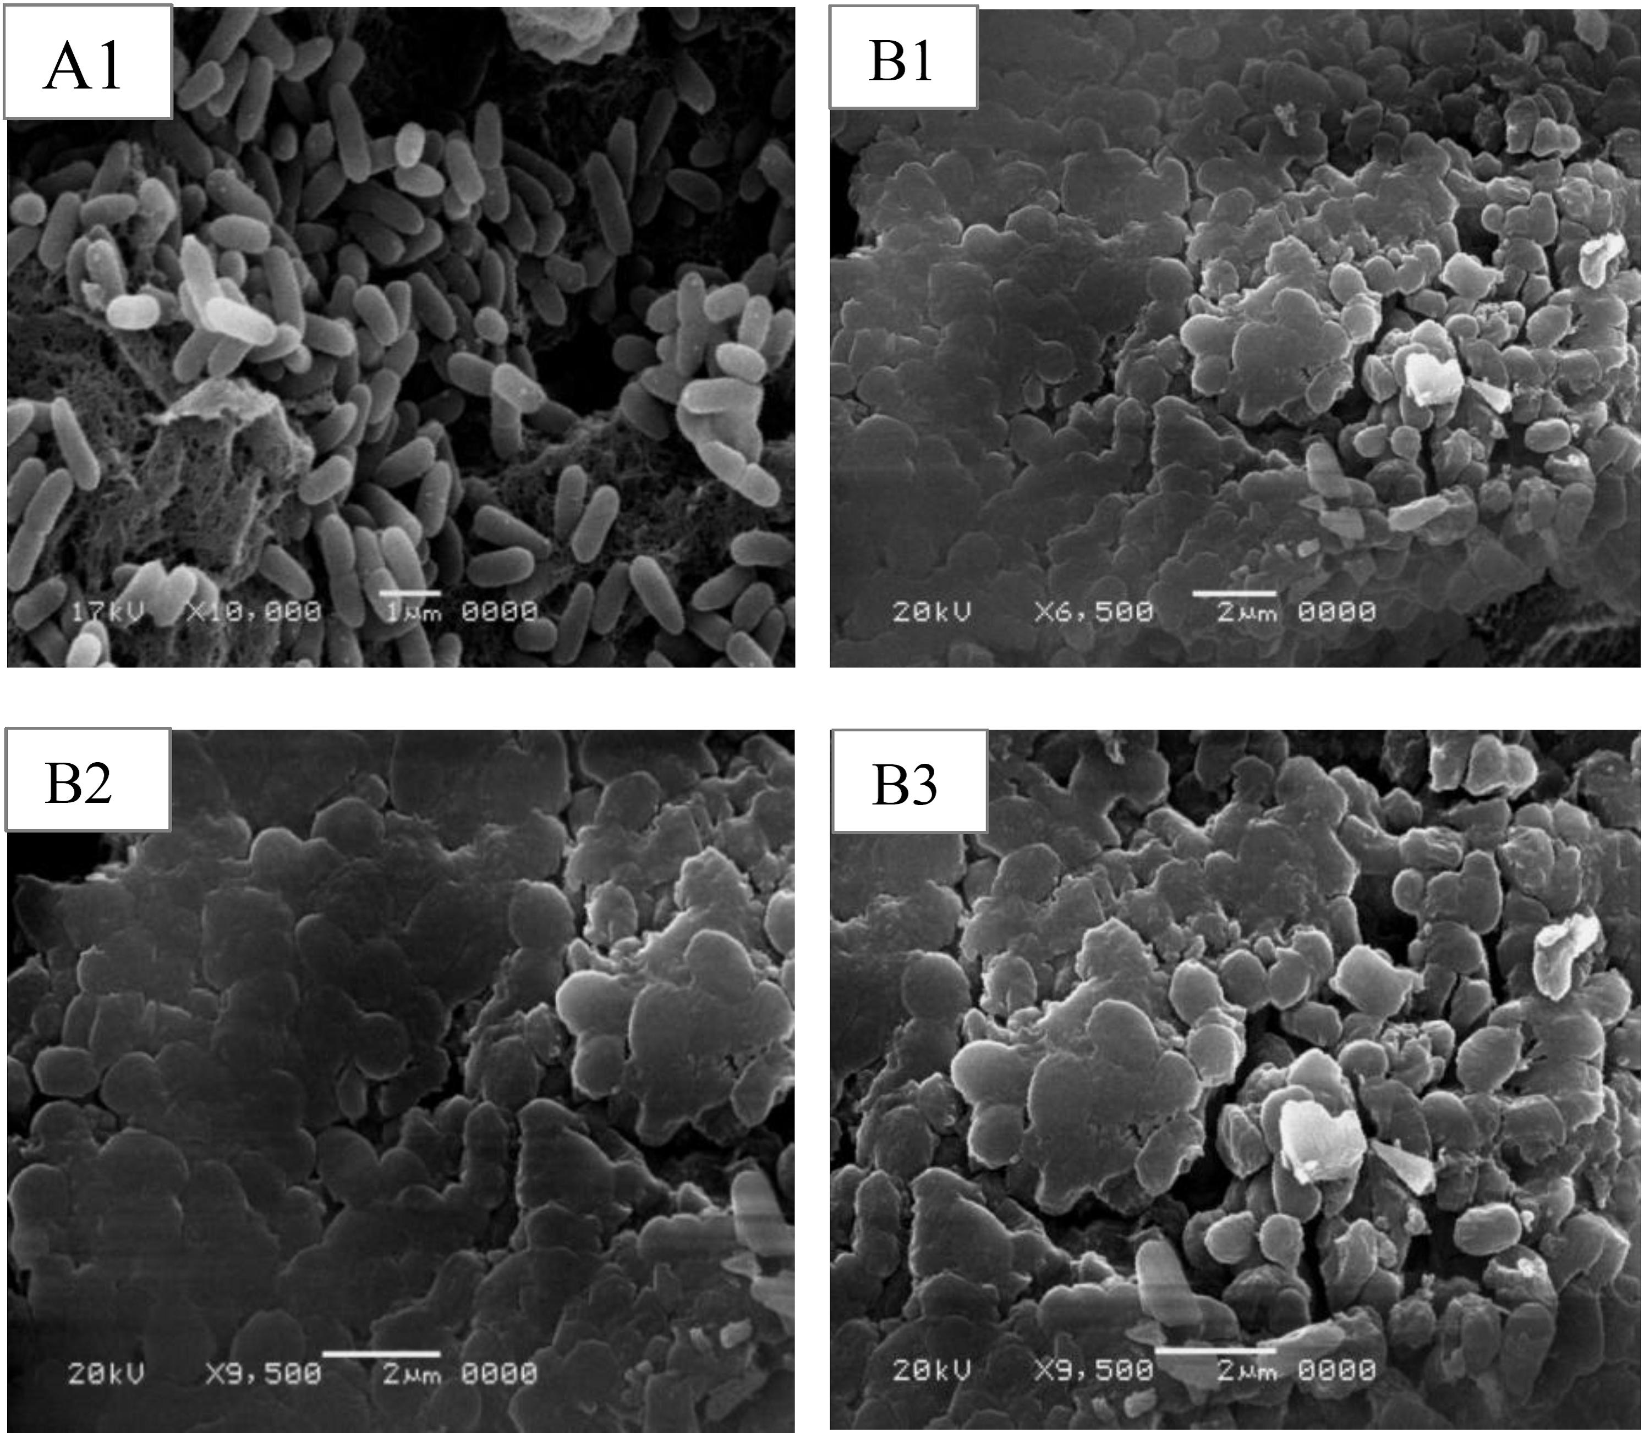

Figure 1. Scanning electron microscope observations of selected Gram-negative pathogenic bacteria (*Ps. aeruginosa*) treated with *T.vulgaris* aqueous extract (control; A1, Treated; B1-B3).

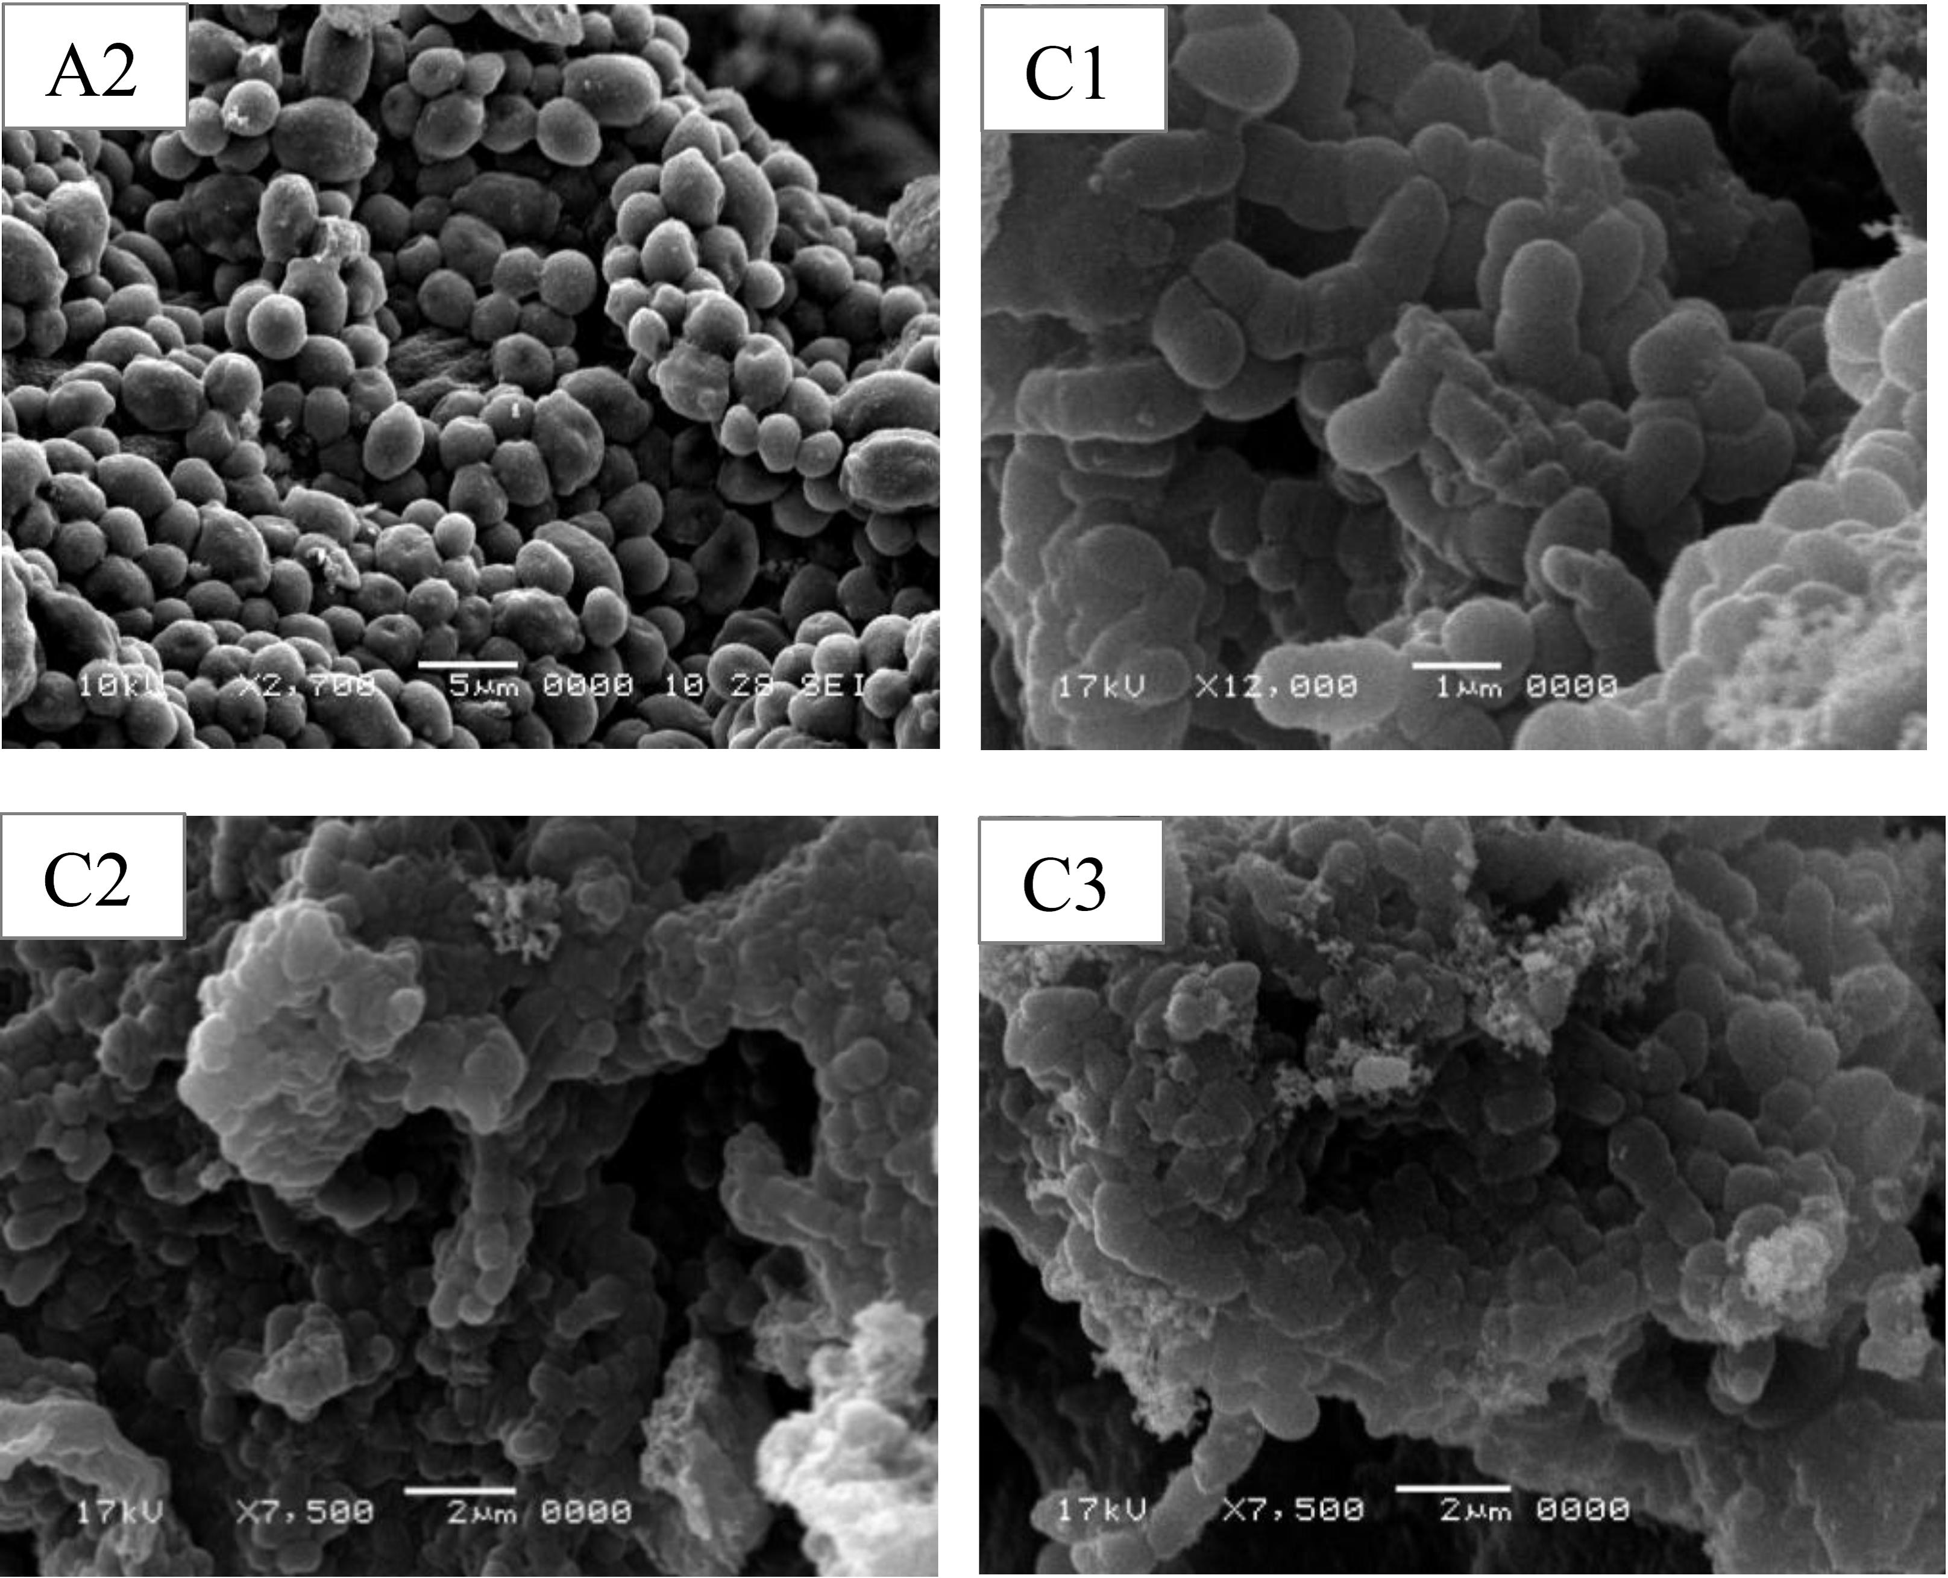

Figure 2. Scanning electron microscope observations of selected Gram-positive pathogenic bacteria Methicillin Resistance *Staph. aureus* (MRSA) treated with *T. vulgaris* aqueous extract (control; A2, Treated; C1-C3).

On the other hands, time kill assay results showed that, bactericidal effect against (MRSA) and the time kill assay were observed after 3hr and 6hr of exposure for *Ps. aeruginosa* these results are in agreement with Moreira *et al.*[24].

SEM images directly illustrate the destructive effects of the extract on the tested bacteria. There are many possible explanations for the observations. The literature suggests that the active components of the plant extracts might bind to the cell surface and then penetrate to the target sites, possibly the phospholipid bilayer of the cytoplasmic membrane and membrane-bound enzymes[25]. The SEM images show that some cells present damage as pores or deformity in the cell walls. Some authors have suggested that the damage to the cell wall and cytoplasmic membrane was the loss of structural integrity and the ability of the membrane to act as a permeability barrier[26,27,28]. Most of the cells were observed to get clustered and stick to each other. The distortion of the cell physical structure would cause the expansion and destabilization of the membrane and would increase membrane fluidity, which in turn, would increase passive permeability[29]. Most of the Gram negative cells and the Gram positive cells appeared to be shrunk and even some were empty, and the remains were flaccid. Furthermore, most of the Gram-negative and Gram positivecells appeared to be stuck together and melted .But the Gram positive cells were more affected, this study and many previous studies[30,31,32] indicated that the most bioactive compounds of plant extracts were more active against Gram-positive bacteria than Gram-negative bacteria. This is likely due to the significant differences in the outer layers of Gram-negative and Gram-positive bacteria. Gram-negative bacteria possess an outer membrane and a unique periplasmic space which is not found in Gram positive bacteria[33]. The resistance of Gram-negative bacteria toward antibacterial substances is related to the hydrophilic surface of their outer membrane which is rich in lipopolysaccharide molecules, presenting a barrier to the penetration of numerous antibiotic molecules, and is also associated with the enzymes in the periplasmic space, which are capable of breaking down the molecules introduced from outside[25]. Gram-positive bacteria do not have such an outer membrane and cell wall structure. Consequently, antibacterial substances can penetrate the bacterial cells and easily destroy the bacterial cell wall and cytoplasmic membrane and result in a leakage of the cytoplasm and its coagulation[34]. Eventually, these disruptions may cause the loss of cell integrity and death. These images confirm the loss of shape and integrity which was followed by the cell death. Cell death may have been the result of the extensive loss of cell contents, the exit of critical molecules and ions, or the initiation of autolytic processes.

**4. Conclusion**

Our work showed the antimicrobial activities of *T. vulgaris* aqueous extract against the multiple drug resistance tested bacteria and the cidal effect confirmed by the SEM.From all the SEM observations, it seemed that, the total *T. vulgaris* aqueous extract caused severe damage to the bacteria. In addition, the modes of action of bacterial agents depend on the type of microorganisms and are mainly related to their cell wall structure and to the outer membrane arrangement.

**Corresponding Author:**

Dr. Ahmed R. Sofy

Botany and Microbiology Department

Faculty of Science

Al-Azhar University,11884 Nasr City, Cairo, Egypt

E-mail: [ahmd_sofy@yahoo.com](mailto:ahmd_sofy@yahoo.com)

**References**

1. Infectious Diseases Society of America (2004). Statement of the (IDSA) concerning ‘Bioshield II: Responding to an ever-changing threat’. Alexandria, VA: IDSA.
2. Adcock H (2002). Pharmageddon: is it too late to tackle growing resistance to anti-infectives? Pharm J; 269: 599–600.
3. Alekshun MN, Levy SB (2007). Molecular mechanisms of antibacterial multidrug resistance. Cell; 128: 1037-1050.
4. Livermore DM (2005). Minimising antibiotic resistance. Lancet Infect Dis; 5: 450-459.
5. Tu¨mmler B, Bosshammer J, Breitenstein S, Brockhausen I, Gudowius P, Herrmann C, Hermann S, Heuer T, Kubesch P, *et al.* (1997). Infections with *Pseudomonas aeruginosa* in patients with cystic fibrosis. Behring Inst Mitt; 98: 249-255.
6. Palumbi SR (2001). Humans as the world’s greatest evolutionary force. Science; 293: 1786-1790.
7. Vicente M, *et al.* (2006). The fallacies of hope: will we discover new antibiotics to combat pathogenic bacteria in time? FEMS Microbiol Rev; 30: 841-852.
8. Levy SB, Marshall B (2004). Antibacterial resistance worldwide: causes, challenges and responses. Nature Med; 10: S122-S129.
9. Gould IM (2008). The epidemiology of antibiotic resistance. Int J Antimicrob Agents; 32(Suppl. 1): S2–9.
10. Moellering Jr RC (2006). The growing menace of community-acquired methicillinresistant *Staphylococcus aureus*. Ann Intern Med; 144: 368-370.
11. Payne DJ, Gwynn MN, Holmes DJ, Pompliano DL (2007). Drugs for bad bugs: confronting the challenges of antibacterial discovery. Nat Rev Drug Discov; 6: 29-40.
12. Woo WS, Chi HJ, Yun, Hye S (1977). Alkaloid screening of some Saudi Arabian plants. Saengyak Hakhoe Chi (Hanguk SaengyaK Hakhoe), 8(3): 109-113.
13. NARMS (2002). National Antimicrobial Resistance Monitoring System, Enteric Bacteria. CDC, USA.
14. CLSI (NCCLS), (2003). Methods for Dilution Antimicrobial Susceptibility Tests for Bacteria that Grow Aerobically: Approved Standard 23. National Committee for Clinical Laboratory Standards, Wayne, PA, USA.
15. Souza ELd, Stamford TLM, Lima EdO (2006). Sensitivity of spoiling and pathogen food-related bacteria to *Origanum vulgare* L. (Lamiaceae) essential oil. Brazilian Journal of Microbiology; 37: 527-532.
16. Wagner H (2006). Multitarget therapy-the future of treatment for more than just functional dyspepsia. Phytomedicine; 13: 122-129.
17. Bakkali F, Averbeck S, Averbeck D, Idaomar M (2008). Biological effects of essential oils-A review. Food Chem Toxicol; 46: 446-475.
18. AL-Saghir M (2009). Antibacterial assay of *Cinnamomum cassia* (Nees and Th. Nees) Nees ex blume bark and *Thymus vulgaris* L. leaf extracts against five pathogens. J Biolo Scien; 9(3): 280-282.
19. Nevas M, Korhonen AR, Lindstrom M, Turkki P, Korkeala H (2004). Antibacterial efficiency of finnish spice essential oils against pathogenic and spoilage bacteria*.* J Food Prot; 67: 199-202.
20. Takahashi T, Kokubo R, Sakaino M (2004). Antimicrobial activities of eucalyptus leaf extracts and flavonoids from *Eucalyptus* *maculate*. Lette Appl Microbiol; 39: 60-64.
21. Fujita M, Shiota S, Kuroda T, Hatano T, Yoshida T, Mizushima T, Tsuchiya T (2005). Remarkable synergies between baicalein and tetracycline, and baicalein and beta-lactams against methicillin-resistant *Staphylococcus* *aureus*. Microbiol Immunol 49(3): 391-396.
22. Nilforoushzadeha MA, Shirani-Bidabadia L, Zolfaghari-Baghbaderania A, Saberia S, Siadata AH, Mahmoudib M (2008). Comparison of *Thymus* *vulgaris* (Thyme)*, Achillea* *millefolium* (Yarrow) and Propolis hydroalcoholic extracts *versus* systemic glucantime in the treatment of cutaneous leishmaniasis in Balb/c mice. J Vector Borne Dis; 45: 301-306.
23. Fu Y, Zu Y, Chen L, Shi X, Wang Z, Sun S, (2007). Antimicrobial activity of clove and rosemary essential oils alone and in combination. Phytother Res; 21(10): 989-994.
24. Moreira MR, Ponce AG, del Valle CE, Roura SI (2005). Inhibitory parameters of essential oils to reduce a foodborne pathogen. LWT-Food Science and Technology; 38(5): 565-570.
25. Shan B, Cai Y, Brooks J, Corke H (2007). Antibacterial properties and major bioactive components of cinnamon stick (*Cinnamomum burmannii*): Activity against foodborne pathogenic bacteria. J Agric Food Chem 55(14): 5484-5490.
26. de Billerbeck V, Roques C, Bessiere J, Fonvieille J, Dargent R. (2001). Effects of *Cymbopogon nardus* (L.) W. Watson essential oil on the growth and morphogenesis of *Aspergillus niger*. Can J Microbiol; 47(1): 9-17.
27. Packiyasothy E, Kyle S (2002). Antimicrobial properties of some herb essential oils. Food Aust; 54(9): 384-387.
28. Filipowicz N, Kaminski M, Kurlenda J, Asztemborska M, Ochocka J (2003). Antibacterial and antifungal activity of juniper berry oil and its selected components. Phytother Res; 17(3): 227-231.
29. Ultee A, Bennik M, Moezelaar R (2002). The phenolic hydroxyl group of carvacrol is essential for action against the food-borne pathogen *Bacillus cereus*. Appl Environ Microbiol; 68(4): 1561-1568.
30. Ceylan E, Fung D, Sabah J (2004). Antimicrobial Activity and Synergistic Effect of Cinnamon with Sodium Benzoate or Potassium Sorbate in Controlling *Escherichia coli* O157:H7 in Apple Juice. J Food Sci; 69(4): FMS102-FMS106.
31. Lopez P, Sanchez C, Batlle R, Nerin C (2005). Solid- and Vapor-Phase Antimicrobial Activities of Six Essential Oils: Susceptibility of Selected Foodborne Bacterial and Fungal Strains. J Agric Food Chem; 53(17): 6939-6946.
32. Shan B, Cai Y, Sun M, Corke H (2005). Antioxidant capacity of 26 spice extracts and characterization of their phenolic constituents. J Agric Food Chem; 53(20): 7749-7759.
33. Duffy C, Power R (2001). Antioxidant and antimicrobial properties of some Chinese plant extracts. International journal of antimicrobial agents; 17(6): 527-529.
34. Shan B, Cai Y, Brooks J, Corke H (2007). The *in vitro* antibacterial activity of dietary spice and medicinal herb extracts. Int J Food Microbiol; 117(1): 112-119.

9/15/2014