**Potential impacts of seed bacterization or salix extract in faba bean for enhancing protection against bean yellow mosaic disease**

Ahmed R. Sofy 1*, Mohamed S. Attia 1, Abd El-Monem M.A. Sharaf 1 and Khalid A. El-Dougdoug 2

1. Botany and Microbiology Department, Faculty of Science, Al-Azhar University,11884 Nasr City, Cairo, Egypt

2. Agric. Microbiology Department, Faculty of Agriculture, Ain Shams University, 11241 Cairo, Egypt

*[ahmd_sofy@yahoo.com](mailto:ahmd_sofy@yahoo.com)

**Abstract:** In a greenhouse experiment, two strains of plant growth promoting rizobacteria (PGPR) mixture of (ICARDA-441 and ARC-202) as seed inoculants, and white willow **(***Salix alba*) extract as foliar and seed treatment were tested for induction systemic acquired resistance (SAR) in faba bean plants against *Bean yellow mosaic virus* (BYMV). The results demonstrated that BYMV challenged plants emerged from *Rhizobium* inoculants seeds and salix extract showed reduction in the level of disease severity of BYMV infection. Significant improvements in faba bean were obtained due to the used *Rhizobium leguminosarum* (PGPR) as well as salix extract. On contrary, considerable reductions in all tested parameters were occurred as a result of the viral disease. Both PGPR inoculants and soaking treatment with salix extract showed significant increase in abscisic acid (ABA), salicylic acid (SA) and jasmonic acid (JA) levels when being compared with other treatments. The beneficial effects of the used treatments were extended to increase not only total phenol and free proline but also the activities of peroxidase and polyphenoloxidase enzymes in comparison with control plants. PGPR inoculants and salix extract (especially soaking) improved plant health by increasing the pigment contents similar to control values.

[Sofy AR, Attia MS, Sharaf AMA and El-DougdougKA. **Potential impacts of seed bacterization or salix extract in faba bean for enhancing protection against bean yellow mosaic disease.** *Nat Sci* 2014;12(10):67-82]. (ISSN: 1545-0740). <http://www.sciencepub.net/nature>. 8

**Keywords:** Broad bean; Induced resistance;Phenolics; Indole acetic acid; Salicylic acid; Jasmonic acid

**1. Introduction**

Faba bean (*Vicia faba* L.)family Fabaceae considered the most important nutritive popular food crop in the world and Egypt. It plays a major role in the Egyptian diet as a source of protein. Faba bean crop rich in protein (protein content ranges from 26 to 41%) and the supply of essential amino acids (Fernández *et al*., 1996). Several investigators recorded that diseases found on faba bean considered the most destructive and cause considerable losses in yield (estimated at over 50%) (El-Bramawy and Shaban, 2010). Among these diseases constraints, virus diseases, can affect faba bean plants which considered a serious worldwide problem (El-Tahlawy *et al.,* 2005). Infection by certain viruses causes significant economic losses and yield reduction (estimated by 30% on susceptible cultivars of faba bean cultivars (Khalil and Erskine, 2001).

SAR against viral infection has been documented using biological and chemical inducing agents (Elbadry *et al.,* 2006). Management of viral disease can also be accomplished through the induction of plants natural defenses, e.g. systemic acquired resistance (Galal, 2006; Park *et al.,* 2007). In most cases, the biological agents consisted of plant pathogenic bacteria, fungi, or viruses as well as nonpathogenic rhizobacteria which have the ability to induce a state of systematic resistance in plants that provides protection against a broad spectrum of phytopathogenic microorganisms. Beneficial effects on plant biomass exerted by plant growth-promoting rhizobacteria (PGPR) often associated with increased rates of plant development and resistance against plant pest's e. g. biological control. Ghobrial, *et al* (2009) and Zehnder *et al*. (2000) identified PGPR strains that protected tomato against systemic infection by CMV under greenhouse and field conditions.

The major chemical constituents present in Salicicaceae species (*Salix alba*) were identified as phenolics (Salminen *et al*. 2001; Riipi *et al.,* 2002). Leaf tissues in *Salix alba* are mainly characterized by low molecular weight phenolic glucosides including salicin and related compounds, chlorogenic acid and condensed tannins (Osier and Lindroth, 2001).

The present study aims to evaluate the potential use of plant growth-promoting rhizobacteria (PGPR) inoculation and salix extract (either foliar or seed treatment) for induction of systemic acquired resistance and enhancing protection of faba bean against infection with *Bean yellow mosaic virus* (BYMV).

**2. Material and Methods**

**2.1. Plant material and growing conditions**

For the present investigation, seeds of (*Vicia faba* L) cv. Giza 3 were obtained from Legume Crops Research Centre, Institute of Crop Production, Agriculture Research Centre. Seeds were sowing in a mixture of sand and clay soil (1: 3 w/w) in pots (30 cm in diameter) in a separated growth chamber.

**2.2. *Rhizobium Leguminosarum***

*R. leguminosarum* bv. *viceae* (mixtures of ICARDA-441 and ARC-202) was kindly provided by Biofertelizer production unit, Soil, Water and Environment Research institute, Agriculture Research Center (ARC) Giza Egypt. It was streaked on slants of 100 ml yeast extract manitol agar bottles and incubated at 28ºC for 7 days. When the growth of rhizobia cover the entire surface of the slant agar, the growth was washed with saline solution (NaCl 0.85%). The suspension was shocked by magnetic stirrer for 15 min. The concentration of rhizobia in suspension was counted by most probable number (MPN).

**2.3. Preparation of the plant extract**

Dried leaves of the salix plant (*Salix alba*) were obtained from Botanical garden, Agriculture Research Centre (ARC) Giza Egypt. The dry leaves were crushed into powder. 0.5 gm of the powder was put in 50ºC boiled water and left for 1 hr then filtered into a conical flask. The aqueous infusion was serialized by bacterial filter. An equivalent of 10 mg dried material per ml of aqueous infusion was obtained (Adebolu and Oladimeji, 2005).

**2.4. Soaking of Seeds**

Faba bean seeds bacterization were carried out by the method of Dileep Kumar and Dube (1992) with some modification as follows: faba bean seeds (*Vicia faba* L., cv. Giza 3) were surface sterilized by placing seeds in 2.5% sodium hypochlorite for 5 min followed by rinsing in 1:29 mixture of hydrogen peroxide : distilled water for 30 min and dried under a sterile condition. Surface sterilized seeds were steeped in bacterial suspensions containing 109 CFU/ml culture (colony formation unit), using the rate of 2ml per one gram seeds mixed with 10% gum arabic for 1 h and dried overnight at room temperature in sterile Petri dishes. Seeds steeped in gum arabic solution only served as control. Also, surface sterilized seeds were steeped in *Salix alba* extract.

**2.5. BYMV inoculation**

A *Bean yellow mosaic potyvirus* Egyptian isolate was obtained from Virology Laboratory, Agricultural Microbiology Department, Faculty of Agriculture, Ain Shams University, Egypt. It was maintained on faba bean cultivar Giza 461. The virus was checked on *Chenopodium amaranticolor* L. and reisolated from a single lesion. Inoculum of the virus was prepared by grinding fresh leaves showing severe symptoms in 100 mM phosphate buffer (pH 7.5) using sterilized pestle and mortar. The pulp was squeezed through tow layer of cheesecloth and the filtrate was centrifuged at 5000 rpm for 10 min. The first two leaves of three leaves-old faba bean plants were lightly dusted with carborundum (600 mesh) where mechanically inoculated with the virus-inoculum. The supernatant containing virus was used after dilution 10-1 with the same buffer as a virus inoculum. As well as another plants inoculated with the same buffer as a positive control. The results were confirmed using specific polyclonal antibodies of BYMV by double antibody sandwich enzyme-linked immunosorbent assay (DAS-ELISA) according to Clark and Adams (1977).

**2*.*6.Pot experiment**

A pot experiment was carried out to evaluate *R. leguminosarum* bv. *viceae* (mixtures of ICARDA-441 and ARC-202) and salix for inducing systemic resistance (ISR) in faba bean plants against BYMV. Randomized complete block design was used with six treatments and two controls each consisted of eight replicate pots and four plants per pot. Treatments included *R. leguminosarum* bv. *viceae* (T1); T1 + BYMV (T2); plants were treated with *Salix alba* extract by spraying the whole leaves until run-off (T3); T3 + BYMV (T4); plants were pre-treated with *Salix alba* extract by spraying the whole leaves until run-off and then inoculated with BYMV three days later; surface sterilized seeds were steeped in *Salix alba* extract (T5); T5 + BYMV (T6); in addition to a virus challenged control (ChC) and an absolute control (AC) (no bacteria, no virus and was sprayed with water). Bacterized as well as nonbacterized healthy, surface sterilized faba bean seeds (*V. faba* L., cv. Giza 3) were sown in 40 cm earthen pots containing clayey soil (pH 7.5). The pots were maintained in greenhouse under natural lighting, day/night temperature of approx. 25/15°C and 55% mean relative humidity. The three leaves-old faba bean plants in T2, T4 and T6 treatments in addition to the challenged control (ChC) were challenge-inoculated with BYMV. At the beginning of flowering stage, after 45 days of planting, numbers of plants developed typical BYMV symptoms were recorded, ELISA test was performed, and plant height was measured. Thereafter, plants were carefully removed from soil to estimate the following parameters:

**2.6.1. Pathogenicity tests**

**2.6.1.1. Disease severity**

The disease severity induced by BYMV was recorded after 14 days of inoculation. The symptoms were recorded using the following rating scale:1= no symptoms, 2= Chlorotic local lesion, 3= vein clearing, 4= mosaic, 5= mottling, 6= Leaf narrow and 7= leaf rolling.

Disease severity values were calculated using the following formula according to Yang *et al*. (1996);



**2.7. Determination of phytochemicals**

Determination of endogenous hormones (abscisic acid, salicylic acid and jasmonic acid) in leaves of the treated plants as well as the control was carried out as described by Lee *et al*. (1989).

Determination of phenolic compounds (mg/100g of fresh w.t.) was carried out according to that method described by Daniel and George (1972). Contents of free proline (mg/100g of dry w.t.) were determined according to the method described by Bates *et al.*, (1973).

Peroxidase activity was assayed using solution containing 5.8 ml of 50 mM phosphate buffer pH 7.0, 0.2 ml of the enzyme extract and 2 ml of 20 mM H2O2 after addition of 2 ml of 20 mM pyrogallol, the rate of increase in absorbance as pyrogallol was determined spectrophotometric all by UV-spectrophotometer (Jenway) within 60 second at 470 nm and 25ᴼC (Srivastava, 1987).

The activity of polyphenol oxidase enzyme was determined according to the method adopted by Matta and Dimond (1963).

**2.8. Determination of pigments**

The method used for the quantitative determination of pigments was that of Vernon and Selly (1966).

**2.9. Electrophoresis analysis of protein by SDS-PAGE**

SDS-PAGE was used to detect the induction of systemic resistance (ISR) in faba bean plants against BYMV via quantitative and qualitative determination of the total proteins. This method was done according to Laemmli (1970) as modified by Studier (1973). In this protocol, electrophoresis is in a vertical slab gel between glass plates. Two gels consisted of two parts, the upper stacking gel (5%) and the lower resolving gel (15%). 80 µl of samples containing 1 mg/ml protein were denatured at 100ᴼC for 3 min in 1% SDS containing 100 mM β-mercaptoethanol and Tris-glycine buffer at pH 6.8. Electrophoresisi was conducted at 25 mA for 6-7 hr. The two gels were stained with solution (10% v/v methanol, 10% v/v acetic acid, 0.0125% w/v Coomassie Brilliant blue R-250) and shaken gently for 24 hr. The staining solution was replaced with destaining solution (5% v/v methanol, 7% v/v acetic acid) and shaken gently for 24 hr. The gels were viewed by transilluminator (Uvitec, UK) and the position of the bands was recorded by photographing the gel.

**2.10. Detection of Isozyme Markers**

Peroxidase (POD), Polyphenol oxidase (PPO) and Estrase isozymes: Native-polyacrylamide gel electrophoresis (Native-PAGE) was conducted to identify isozyme variations that related to the induction of systemic resistance (ISR) in faba bean plants according to Stegemann *et al*. (1985). 500 mg fresh leaves were homogenized in liquid N2 and 100 µl of 0.2 M Phosphate buffer was added (pH 7.0 was adjusted by potassium phosphate monobasic) and 10 µl of 2-mercaptoethanol before centrifugation at 14000 rpm for 15 min at 4ᴼC. The supernatant was stored at a temperature of -20ᴼC until isozyme analysis. Polyphenol oxidase isozymes were detected according to Baaziz *et al*. (1994), in which the gel was immersed in a solution containing 0.1% 1-dihydroxyphenyl alanine solubilized in 0.05 M phosphate buffer pH 7.5. For peroxidase, benzidine-dihydrochloride HCl of 0.125g and 2 ml glacial acetic acid and was completed with dsH2O up to 50 ml. Gel was placed into this solution and 5 drops of hydrogen peroxide was added. The gel was incubated at room temperature until bands appear (Brown, 1978). For visualisation of isoesterases the following solution was prepared. Forty mg of 1-naphthylacetate and 40 mg of 2-naphthylacetate were dissolved, together and also separately, in 16 ml of 50% (v/v) acetone and mixed with 100 ml of 50 mM Tris/HCl buffer (pH 7.1). The gels were incubated for 30 min in this solutions, rinsed in tap water, and stained 10 to 20 min in 0.2% Fast Blue RR salt (Sigma Chemical Co, NewYork) solution. The Fast Blue RR salt was dissolved in an appropriate volume of absolute methanol, and filtered into 50 mM Tris/HCl buffer (pH 7.1) (Cheliak and Pitel, 1985). The gel was rinsed in tap water and fixed in 30% (v/v) ethanol. Relative band mobility was measured in relation to the dye front and indicated by *Rf* values. The gel analysis was applied by AlphaEaseFCTM ver. 4 software.

**2.11. Statistical analyses**

Experimental data were subjected to one way analysis of variance (ANOVA) and the differences between means were separated by the least significant difference (L.S.D) at 5% level of probability using M-state software (Snedecor and Cochran, 1982).

**3. Results**

**3.1. Confirmation of BYMV**

*Bean yellow mosaic virus* Egyptian isolate was obtained from Virology Laboratory, Agricultural Microbiology Department, Faculty of Agriculture, Ain Shams University, Egypt. It was maintained on faba bean cultivar Giza 461.The BYMV was confirmed biologically by differential hosts which showed various symptoms; it was reacted with local infection on *Ch. amaranticolor* which gave chlorotic local lesion (12-15 days, O.D. of DAS-ELISA at 405nm= 0.325) (Fig. 1).As well as it was reacted with systemic infection (mosaic associated with vein yellow) with faba bean (15-20 days, O.D. of DAS-ELISA at 405nm= 0.427) (Fig. 2).

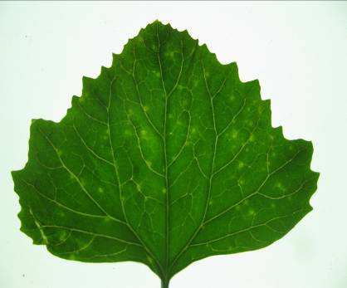

Figure 1.*Ch. amaranticolor* mechanically inoculated with BYMV isolate showing chlorotic local lesion

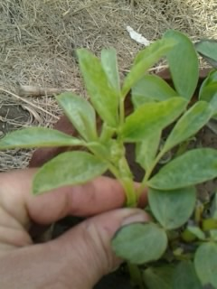

Figure 2. Faba bean plants showing systemic symptoms which inoculated BYMV.

**3.3. Virus infectivity and Disease severity**

The datain table (1) revealed that elicitors bioinducers were reduced BYMV infectivity whereas inhibition of virus infectivity with 55, 44 and 33% with T2, T4 and T6, respectively. In addition, these inducers due to reduction of disease severity with 36.6, 52.6 and 42.8%, respectively related to infected faba bean plants with ChC (82%). These results were confirmed by DAS-ELISA using polyclonal antibodies that 0.272, 0.375 and 0.325 optical density at 405nm, respectively.

The optical density of ELISA at 405nm revealed that virus titer was higher in severe symptoms (ChC) compared with moderate (T4 and T6) and mild (T2) symptoms (Table 1). In addition, it was found that virus titer was increased comparison of azure a staining procedure, ELISA and biological detection of BYMV infection in faba bean plants, positive results were achieved uniformly from all three comparison procedures.

**3.4. Physiological and metabolic changes**

It was noticed that, T4 and T6 in resulted in decreasing the contents of IAA compared with those of BYMV-infected plants (ChC). Significantly higher ABA, SA and JA, levels were observed in leaves of T2 in comparison with T6, T4, ChC), and absolute control (AC) plants, respectively (Table 2).

Data generated in table (3) showed that, BYMV (ChC), cause significant increase in total phenols as well as free proline contents of shoots in the infected plants compared to control plants (AC). Concerning the effect of *R. leguminosarum* inoculation (T2) and foliar (T4) or seed treatment (T6) with *Salix alba* extract on the challenged plants with BYMV, it was found that T2 show significant increase in total phenols as well as free proline content of faba bean shoots compared to T4 and T6, respectively.

For peroxidase and polyphenoloxidase activities, data describing increasing of their activities of all treatments (T2, T4 and T6) in relative to controls (AC, ChC, T1, T3, T5) (Table 3). It is quite evidence that, the greatest activities were achieved by using *Rhizobium* inoculation on the viral infected plants (T2) followed by salix treatment (T6 and T4) more than on the healthy plants (AC), indicating induction of systemic acquire resistant (SAR).

The effect of *Rhizobium* inoculation (T2) and salix extract (either foliar (T4) or seed treatment (T6) on vegetative growth parameters and photosynthetic pigments content (Table 4), illustrate significant increases of those parameters compared to challenged control. Concerning, shoot length, number of leaves and photosynthetic pigments data were severe reduced for the challenged control (ChC), but further enhancements of these data were obtained due to *Rhizobium* inoculation and treatment seeds with salix extract.

Results in table (4) indicated that, contents of carotenoids were significantly increased in broad bean plants in response to BYMV infection (ChC). Also, the obtained results (Table 4) illustrated that contents of carotenoids in T2, T4 and T6 were

decreased compared to challenged control (ChC). The observed decreases were found to be statistically, mostly, significant.

Table 1. Effect of bioinducers on BYMV infectivity on faba bean plants

|  |  |  |  |  |
| --- | --- | --- | --- | --- |
| *Treatments | Virus infectivity | Virus inhibition | Disease severity | *O.D. |
| ChC | 9/10 | 0 | 82% | 0.475 |
| T2 | 4/10 | 55% | 36.6% | 0.272 |
| T4 | 5/10 | 44% | 52.6% | 0.375 |
| T6 | 3/10 | 33% | 42.8% | 0.325 |

\**R. leguminosarum* bv. *viceae* + BYMV (T2); *Salix alba* foliar + BYMV (T4); seeds were steeped in *Salix alba* extract + BYMV (T6); challenged control (ChC)

**O.D= optical density at 405nm by DAS-ELISA, O.D. of +ve ELISA= 0.525, O.D. of -ve ELISA= 0.127

Table 2. Quantification of (PGPR) and salix extract-mediated induced systemic resistance to BYMV in 45-day old faba bean plants

|  |  |  |  |  |
| --- | --- | --- | --- | --- |
| JA  (mg/100g F.wt.) | SA  (mg/100g F.wt.) | ABA  (mg/100g F.wt.) | IAA  (mg/100g F.wt.) | *Treatment |
| 0.25 c | 0.01 f | 0.01 c | 0.81 d | AC |
| 0.39 b | 0.27 e | 0.13 b | 0.95 c | ChC |
| 0.48 b | 0.64 c | 0.02 c | 1.20 b | T1 |
| 0.89 a | 1.40 a | 0.53 a | 2.50 a | T2 |
| 0.19 c | 0.07 f | 0.03 c | 0.61 e | T3 |
| 0.43 b | 0.37 d | 0.15 b | 0.43 f | T4 |
| 0.23 c | 0.08 f | 0.03 c | 0.66 e | T5 |
| 0.81 a | 0.9 b | 0.18 b | 0.86 cd | T6 |
| 0.096 | 0.078 | 0.078 | 0.095 | LSD at %5 |

*R. leguminosarum* bv. *viceae* (T1); T1 + BYMV (T2); *Salix alba* foliar (T3); T3 + BYMV (T4); seeds were steeped in *Salix alba* extract (T5); T5 + BYMV (T6); challenged control (ChC); absolute control (AC)

Table 3. Effect of induced resistance elicitors (PGPR and Salix extract) on total phenols, free proline contents, peroxidase and polyphenoloxidase activities of faba bean healthy and infected with virus.

|  |  |  |  |  |
| --- | --- | --- | --- | --- |
| Polyphenoloxidaseg  (µg/g F.wt.) | Peroxidase  (µg/g F.wt.) | Proline  (mg/100g D.wt.) | Phenolic  (mg/100g D.wt.) | Treatment |
| 0.25 b | 0.10 e | 0.34 h | 0.81 e | AC |
| 0.27 b | 0.36 b | 0.71 e | 1.85 c | ChC |
| 0.26 b | 0.14 de | 0.66 f | 1.35 d | T1 |
| 0.35 a | 0.67 a | 2.26 a | 2.12 a | T2 |
| 0.23 c | 0.17 d | 0.80 d | 0.87 e | T3 |
| 0.36a | 0.38 b | 1.32 b | 1.95 b | T4 |
| 0.24 b | 0.25 c | 0.54 g | 0.88 e | T5 |
| 0.29 b | 0.39 b | 0.87 c | 1.86 c | T6 |
| 0.055 | 0.055 | 0.055 | 0.078 | LSD at %5 |

Table 4. Response of faba bean previously subjected to (PGPR) and salix extract to infection by BYMV in 45-day old faba bean plants

|  |  |  |  |  |  |
| --- | --- | --- | --- | --- | --- |
| Carotenoids (mg/g F.Wt) | Chl. b  (mg/g F.wt) | Chl. a  (mg/g F.Wt) | No. of leaves | Shoot length  (cm) | Treatment |
| 0.69 e | 3.61 a | 6.20 b | 37.37 a | 59.88 ab | AC |
| 1.26 a | 2.67 c | 3.47 g | 26.25 d | 45.50 c | ChC |
| 0.57 f | 3.38 b | 6.29 a | 34.87 ab | 60.63 a | T1 |
| 0.92 b | 2.40 d | 4.63 c | 30.50 c | 56.63 b | T2 |
| 0.36 g | 1.43 e | 4.92 d | 32.25 b | 56.62 b | T3 |
| 0.92 b | 2.39 d | 4.63 f | 26.75 d | 46.00 c | T4 |
| 0.84 c | 2.49 d | 5.88 c | 36.37 a | 61.50 a | T5 |
| 0.78 d | 2.42 d | 4.87 e | 35.75 a | 44.37 c | T6 |
| 0.055 | 0.123 | 0.050 | 3.32 | 3.98 | LSD at %5 |

*R. leguminosarum* bv. *viceae* (T1); T1 + BYMV (T2); *Salix alba* foliar (T3); T3 + BYMV (T4); seeds were steeped in *Salix alba* extract (T5); T5 + BYMV (T6); challenged control (ChC); absolute control (AC)

**3.5. Biochemical marker as indicators for SAR**

**3.5.1. Expressed protein as response to induction SAR in leaf**

The faba bean plants treatments (T1, T2, T3, T4, T5, T6, AC and ChC) showed variation in number, molecular weight and density of protein bands (Fig. 3). The variability analysis among three inducers appeared 95 protein bands. It was found that T1 gave 15 protein bands compared to T3 (11 protein bands) and T5 (9 protein bands), and ChC gave 8 protein bands, as well as AC gave 16 protein bands (Tables 5 & 6).

Concerning the effect *R. leguminosarum* inoculation (T2) and foliar or seed treatment with *Salix alba* extract (T4 and T6, respectively) on the challenged plants with BYMV, it was found that T6 gave highest number of bands (12 bands) followed by T2 (12 bands) and T4 (11 bands), respectively(Tables 5 & 6).

The molecular weight of polypeptides were determined related to protein markers ranged from 568.798 to 7.641 KDa. The polypeptide number of polymorphism was 53 with percentage 55.78%. The most prominent specific polypeptide alteration (polymorphic bands) ranged molecular weight from 285.020 to 10.794 KDa with percentage 7.36%. These bands may be related to biotic inducers. The prominent polypeptide bands in all inducers (monomorphic or common polypeptide) were ranged molecular weight from 65.737 to 16.789 kDa with percentage 5.26%. These bands may be related to faba bean plant. The unique (polypeptide markers) were appeared in faba bean infected with BYMV plants treated with biotic inducers ranged from 525.439 to 9.803 kDa with percentage 43.15%. These bands may be related to polypeptide markers (Tables 5 & 6).

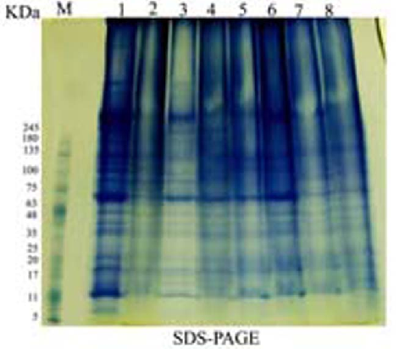

Figure 3. Protein fractions of the leaves of faba bean plants treated with biotic inducers using SDS-PAGE.

M): Marker. 1): absolute control (AC). 2): challenged control (ChC). 3): *R. leguminosarum* bv. *viceae* (T1). 4): T1 + BYMV (T2). 5): *Salix alba* foliar (T3). 6): T3 + BYMV (T4). 7): seeds were steeped in *Salix alba* extract (T5). 8): T5 + BYMV (T6).

**3.5.2. Detection of the elicited antiviral protein as response to induction SAR in seeds**

The faba bean plants treated with *R. leguminosarum* inoculation and foliar or seed treatment with *Salix alba* extract and inoculated with BYMV showed variation in number, molecular weight and density of protein bands compared with healthy ones (Fig. 4). The variability analysis among three inducers appeared 211 protein bands. It was found that T1 gave 25 protein bands compared to T3 (24 protein bands) and T5 (30 protein bands), and ChC gave 28 protein bands, as well as AC gave 23 protein bands.

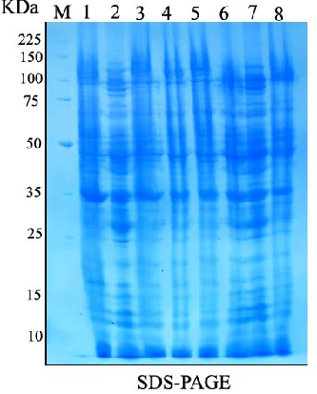

Figure 4. Protein fractions of the seeds of faba bean plants treated with biotic inducers using SDS-PAGE.

M): Marker. 1): absolute control (AC). 2): challenged control (ChC). 3): *R. leguminosarum* bv. *viceae* (T1). 4): T1 + BYMV (T2). 5): *Salix alba* foliar (T3). 6): T3 + BYMV (T4). 7): seeds were steeped in *Salix alba* extract (T5). 8): T5 + BYMV (T6)

Table 5.Protein bands of the leaves of faba bean plants treated with biotic inducers using SDS-PAGE

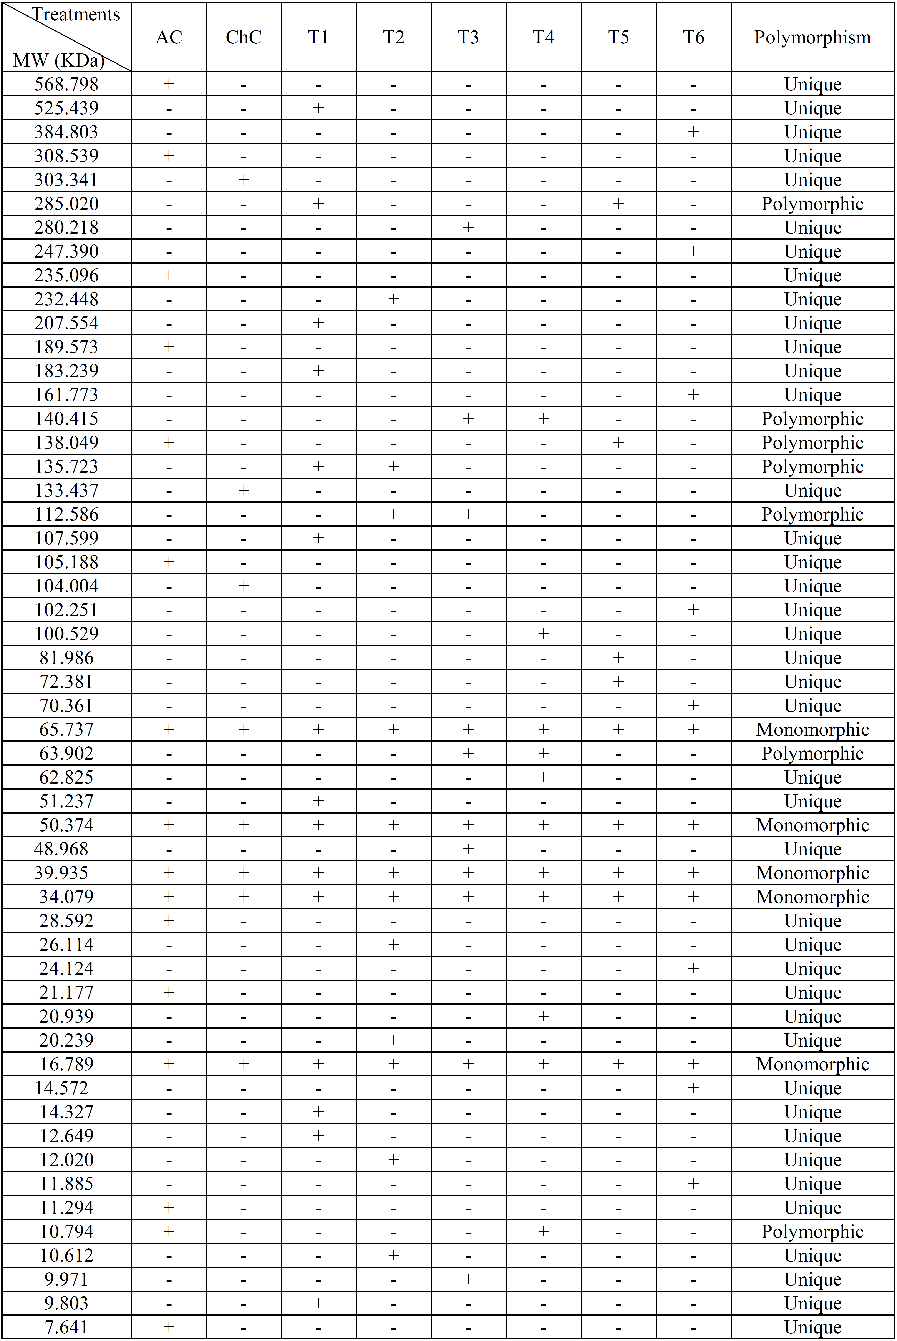

Table 6. Polymorphism and genetic markers of the leaves of faba bean plants treated with biotic inducers using SDS-PAGE

|  |  |  |  |  |  |  |  |  |  |
| --- | --- | --- | --- | --- | --- | --- | --- | --- | --- |
| Treatments  Bands | lanes polymorphism | | | | | | | | Gel polymorphism |
| AC | ChC | T1 | T2 | T3 | T4 | T5 | T6 |
| Mono | 5 | 5 | 5 | 5 | 5 | 5 | 5 | 5 | 5 |
| Poly | 2 | 0 | 2 | 2 | 3 | 3 | 2 | 0 | 7 |
| Unique | 9 | 3 | 8 | 5 | 3 | 3 | 2 | 8 | 41 |
| Total bands | 16 | 8 | 15 | 12 | 11 | 11 | 9 | 13 | 53 |

Table 7. Protein bands of the seeds of faba bean plants treated with biotic inducers using SDS-PAGE

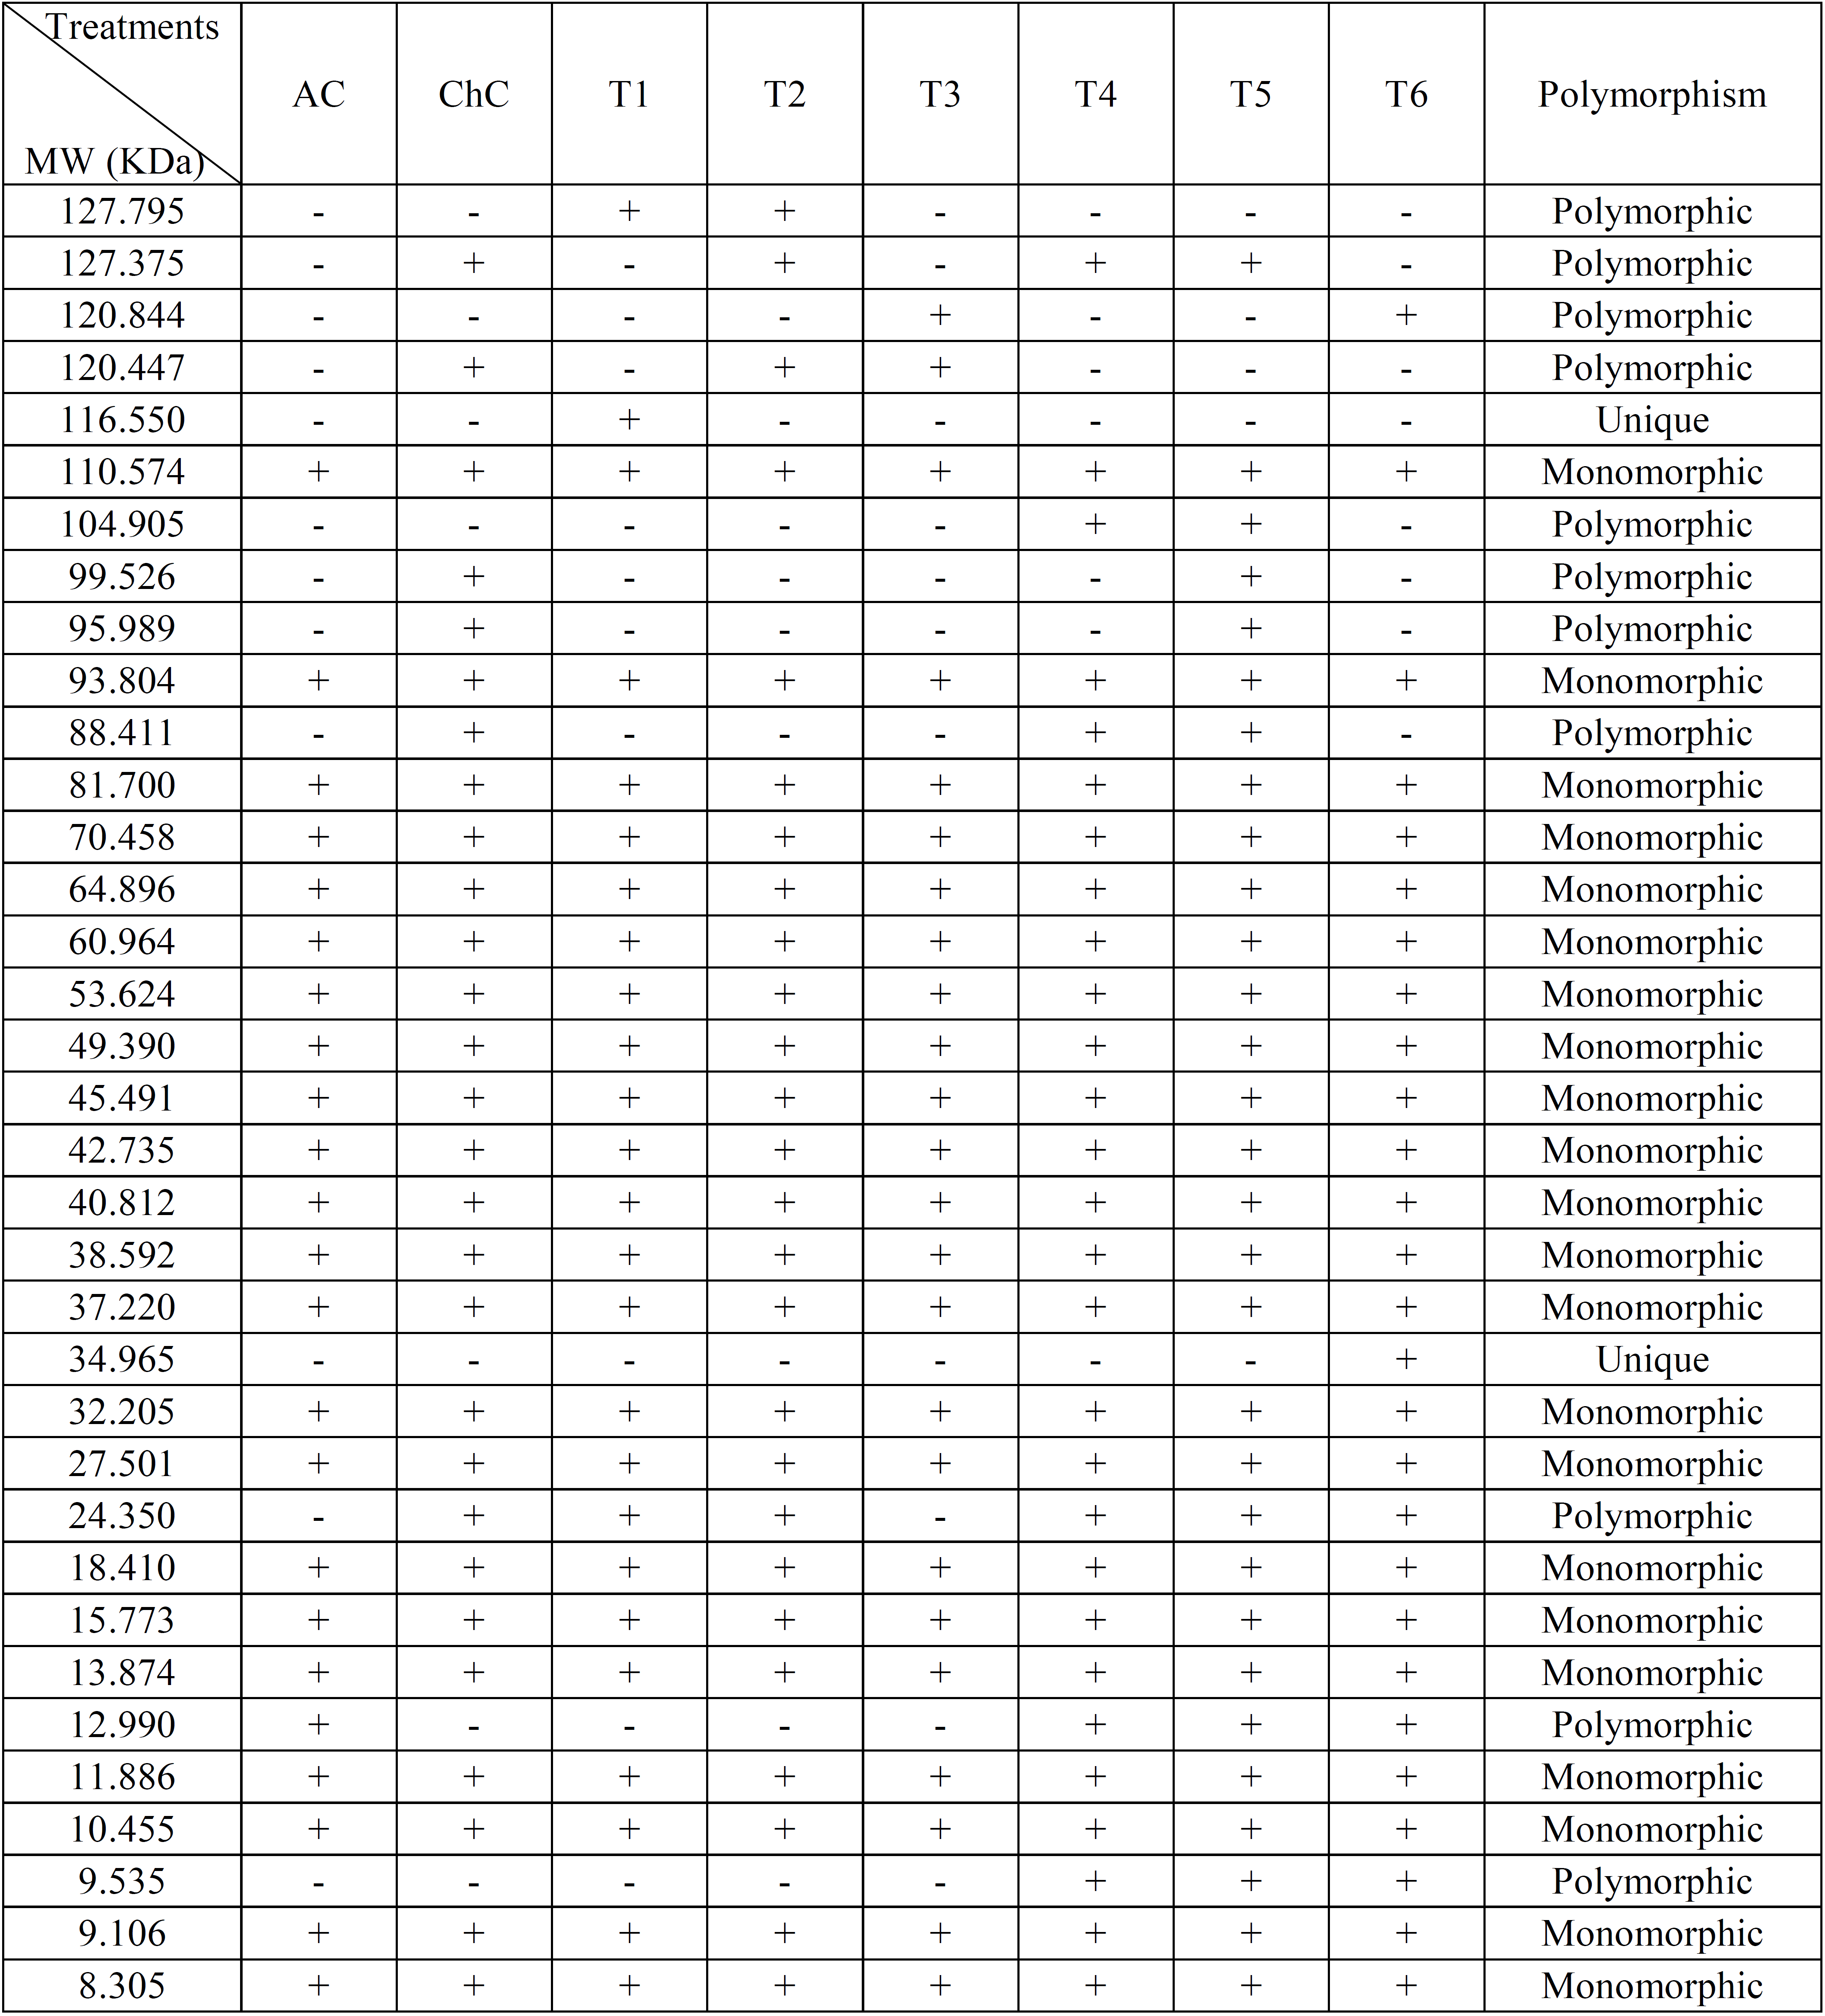

Concerning the effect *R. leguminosarum* inoculation (T2) and seed or foliar treatment with *Salix alba* extract (T4 and T6, respectively) on the challenged plants with BYMV, it was found that (T4) gave highest number of bands (28 bands) followed by T6 (27 bands) and T2 (26 bands), respectively (Tables 7 & 8).

The molecular weight of polypeptides were determined related to protein markers ranged from 127.795 to 8.305 KDa. The polypeptide number of polymorphism was 35 with percentage 16.58%. The most prominent specific polypeptide alteration (polymorphic bands) ranged molecular weight from 127.795 to 9.535 KDa with percentage 5.21%. These bands may be related to biotic inducers. The prominent polypeptide bands in all inducers (monomorphic or common polypeptide) were ranged molecular weight from 110.574, to 8.305 kDa with percentage 10.43%. These bands may be related to faba bean plant. The unique (polypeptide markers) were appeared in faba bean infected with BYMV plants treated with biotic inducers (116.550 and 34.965) kDa with percentage 0.94%. These bands may be related to polypeptide markers (Tables 7 & 8).

**3.5.3. Biochemical isozyme markers**

Faba bean plants treated with biotic inducers show variability in number, relative mobility and density of polypeptide peroxidase, polyphenol oxidase and Esterase isozymes in the leaf post-BYMV infection.

* + - 1. **Peroxidase isozymes**

The total numbers of peroxidase isozymes were 6 bands appeared in faba bean healthy in table (9) and Fig (5). The bioinducers and virus-infection treatments showed variation in number, relative mobility and density polypeptide bands compared with healthy ones. BYMV (ChC) gave 3 isozymes, while *R. leguminosarum* (T1) increased the number of isozymes (5 isozymes), and salix foliar (T3) gave 6 isozymes, as well as salix soaked (T5) gave (5 isozymes).

In addition infected plants and treated with *R. leguminosarum* inoculation (T2) and foliar or seed treatment with *Salix alba* extract (T4 and T6, respectively) increased number and density of isozymes. T6 gave 6 isozymes and T2 gave 5 isozymes, as well as T4 gave 5 isozymes.

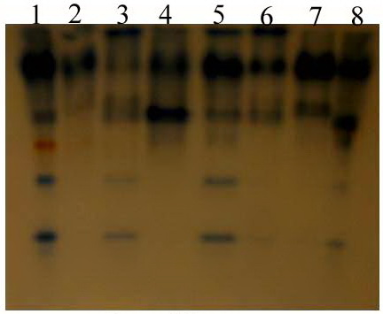

(B)

Figure 5.Native acrylamide gel (10%) electrophoresis (A) and dendogram (B) of POD isozymes produced in the leaves of faba bean plants treated with biotic inducers. 1): absolute control (AC). 2): challenged control (ChC). 3): *R. leguminosarum* bv. *viceae* (T1). 4): T1 + BYMV (T2). 5): *Salix alba* foliar (T3). 6): T3 + BYMV (T4). 7): seeds were steeped in *Salix alba* extract (T5). 8): T5 + BYMV (T6).

Table 8. Polymorphism and genetic markers of the seeds of faba bean plants treated with biotic inducers using SDS-PAGE

|  |  |  |  |  |  |  |  |  |  |
| --- | --- | --- | --- | --- | --- | --- | --- | --- | --- |
| Treatments  Bands | lanes polymorphism | | | | | | | | Gel polymorphism |
| AC |  | AC |  | AC |  | AC |  |
| **Mono** | 22 | 22 | 22 | 22 | 22 | 22 | 22 | 22 | 22 |
| **Poly** | 1 | 6 | 2 | 4 | 2 | 6 | 8 | 4 | 11 |
| **Unique** | 0 | 0 | 1 | 0 | 0 | 0 | 0 | 1 | 2 |
| **Poly + Uni** | 1 | 6 | 3 | 4 | 2 | 6 | 8 | 5 | 13 |
| **Total bands** | 23 | 28 | 25 | 26 | 24 | 28 | 30 | 27 | 35 |

Table 9.Disc-PAGE banding patterns of peroxidase isozymes the leaves of faba bean plants treated with biotic inducers

|  |  |  |  |  |  |  |  |  |  |
| --- | --- | --- | --- | --- | --- | --- | --- | --- | --- |
| Peroxidase Groups | *Rf* | AC | ChC | T1 | T2 | T3 | T4 | T5 | T6 |
| PX1 | 0.1 | 1++ | 1+ | 1++ | 1+ | 1++ | 1++ | 1- | 1+ |
| PX2 | 0.2 | 1++ | 1++ | 1- | 1+ | 1++ | 1+ | 1++ | 1++ |
| PX3 | 0.4 | 1+ | 1- | 1+ | 1++ | 1+ | 1+ | 1+ | 1++ |
| PX4 | 0.5 | 1++ | 0 | 0 | 1- | 1- | 0 | 1- | 1++ |
| PX5 | 0.7 | 1++ | 0 | 1- | 0 | 1+ | 1- | 0 | 1+ |
| PX6 | 0.8 | 1++ | 0 | 1+ | 0 | 1+ | 1- | 1- | 1+ |

*Rf* = Relative Mobility. 1+++ = strong density. 1++ = high density. 1+ = moderate density. 1- = low density. 0 = absence of band

**3.5.3.2. Polyphenol oxidase isozymes**

The total numbers of polyphenol oxidase isozymes were 7 bands in table (10) and Fig. (6). The isozyme bands of treatments showed variation in number, relative mobility and density polypeptide bands. BYMV (ChC) infected faba bean plant was decreased number of isozymes as well as T2 and T6 gave 6 Isozymes .While *R. leguminosarum* (T1) increased the density of isozymes (7 isozymes), and salix foliar (T3) gave (7 isozymes). In addition, T2 (6 isozymes), T4 (7 isozymes) and T6 (6 isozymes) increased in density of isozymes.

* + - 1. **Esterase isozymes**

The total numbers of estrase isozymes were 6 bands in table (11) and Fig. (7). The isozyme bands of treatments showed variation in density polypeptide bands. All treatments appeared 6 isozyme bands.

AC, ChC, T1, T2 and T3 were increased the density of isozyme Est5 at *Rf* 0.7. On the other hand, T4 was were increased the density of isozyme Est3 at *Rf* 0.5.

We can conclude that, the biotic inducers were improved on induction of SAR and reveal reproducibility different levels of acquired resistance according to the number of protein genetic markers.

**4. Discussion**

The objectives of this study were induction systemic acquired resistance in faba bean against virus infection with BYMV. No strategies are currently available to completely protect these plants against the virus. We try to realize this purpose, many experiments were successively to deducing if induction of systemic acquired resistance was successfully achieved could also protect faba bean against infection by BYMV.

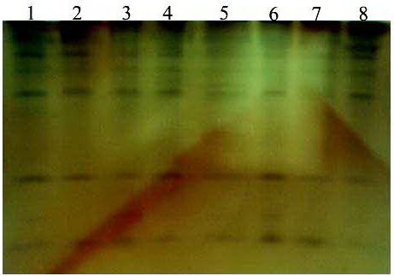

(A)

(B)

Figure 6.Native acrylamide gel (10%) electrophoresis (A) and dendogram (B) of PPO isozymes produced in the leaves of faba bean plants treated with biotic inducers. 1): absolute control (AC). 2): challenged control (ChC). 3): *R. leguminosarum* bv. *viceae* (T1). 4): T1 + BYMV (T2). 5): *Salix alba* foliar (T3). 6): T3 + BYMV (T4). 7): seeds were steeped in *Salix alba* extract (T5). 8): T5 + BYMV (T6).

Table 10.Disc-PAGE banding patterns of polyphenol oxidase isozymes the leaves of faba bean plants treated with biotic inducers

|  |  |  |  |  |  |  |  |  |  |
| --- | --- | --- | --- | --- | --- | --- | --- | --- | --- |
| Polyphenyl oxidase Groups | *Rf* | AC | ChC | T1 | T2 | T3 | T4 | T5 | T6 |
| PPO1 | 0.1 | 1++ | 1++ | 1- | 1+ | 1+ | 1+ | 1- | 1++ |
| PPO2 | 0.2 | 1++ | 1++ | 1+ | 1+ | 1+ | 1+ | 1- | 1++ |
| PPO3 | 0.3 | 1+ | 1+ | 1+ | 1+ | 1+ | 1- | 1+ | 1++ |
| PPO4 | 0.4 | 1++ | 1++ | 1++ | 1++ | 1+ | 1++ | 1- | 1++ |
| PPO5 | 0.65 | 1++ | 1++ | 1++ | 1++ | 1+ | 1++ | 1+ | 1+ |
| PPO6 | 0.8 | 1+ | 0 | 1+ | 0 | 1- | 1+ | 1- | 0 |
| PPO7 | 0.9 | 1+ | 1+ | 1+ | 1+ | 1+ | 1++ | 1+ | 1- |

*Rf* = Relative Mobility. 1+++ = strong density. 1++ = high density. 1+ = moderate density. 1- = low density. 0 = absence of band

Table 11.Disc-PAGE banding patterns of estrase isozymes the leaves of faba bean plants treated with biotic inducers

|  |  |  |  |  |  |  |  |  |  |
| --- | --- | --- | --- | --- | --- | --- | --- | --- | --- |
| Estrase Groups | *Rf* | AC | ChC | T1 | T2 | T3 | T4 | T5 | T6 |
| Est1 | 0.1 | 1- | 1- | 1- | 1- | 1+ | 1+ | 1+ | 1- |
| Est2 | 0.3 | 1+ | 1- | 1- | 1- | 1+ | 1- | 1- | 1+ |
| Est3 | 0.5 | 1+ | 1- | 1- | 1- | 1- | 1++ | 1- | 1- |
| Est4 | 0.6 | 1+ | 1+ | 1+ | 1+ | 1- | 1+ | 1- | 1- |
| Est5 | 0.7 | 1++ | 1++ | 1++ | 1++ | 1++ | 1+ | 1+ | 1- |
| Est6 | 0.85 | 1+ | 1- | 1+ | 1- | 1- | 1+ | 1- | 1+ |

*Rf* = Relative Mobility. 1+++ = strong density. 1++ = high density. 1+ = moderate density. 1- = low density. 0 = absence of band

The first criterion to judge the occurrence of SAR in faba bean plants treated with biotic inducers. The reduction of percentage of infection, tested inducers were able to reduce number of BYMV infected broad bean plants. The obtained results showed that biotic inducers reduce the level of disease severity of BYMV infection at range 52.6-36.6% by percentage, related to *R. leguminosarum* (36.6%), salix extract both foliar and seed treatment (36.6% and 52.6%, respectively). The same results were obtained by many authors (El-Badry *et al*., 2006; Megahed, 2008; Megahed *et al.,* 2013).

It has been suggested induced resistance is a state of enhanced defensive capacity developed by a plant when appropriately stimulated (Kuc, 1995).

Our results demonstrated that, T4 and T6 in resulted in decreasing the contents of IAA compared with those of BYMV-infected plants (ChC). In this respect, El-Tayeb *et al.* (2006); Gravel *et al.* (2007) and Mandal *et al.* (2009) they reported that, Indole acetic acid (IAA) is endogenous plant growth regulator and plays an important role in many physiological processes under different biotic and abiotic stresses. Exogenous application of SA and IAA has been demonstrated to enhance plant resistance against pathogens by acting as potent inducer of systemic resistance (Ueno *et al.*, 2011).

Because inoculation with *Rhizobium* and salix extract (especially seed treatment) on the challenged plants with BYMV, caused a significant increase in ABA and SA as well as JA level in plant leaves, it is reasonable to assume that several plant hormones either individually or in combinations modulate the complex processes involved in plant defense signaling pathways. The first hormones to be marked as central players in defense against plant pathogens were salicylic acid (SA), jasmonic acid (JA), and ethylene (ET) (Glazebrook, 2005), with roles more recently attributed to abscisic acid (ABA), gibberellins, and auxin (Navarro *et al*., 2006; 2008).

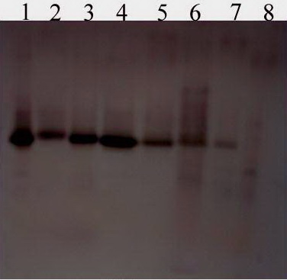

(A)(A)

(B)

Figure 7.Native acrylamide gel (10%) electrophoresis (A) and dendogram (B) of estrase isozymes produced in the leaves of faba bean plants treated with biotic inducers. 1): absolute control (AC). 2): challenged control (ChC). 3): *R. leguminosarum* bv. *viceae* (T1). 4): T1 + BYMV (T2). 5): *Salix alba* foliar (T3). 6): T3 + BYMV (T4). 7): seeds were steeped in *Salix alba* extract (T5). 8): T5 + BYMV (T6).

Salicylic acid (SA, 2-hydroxybenzoic acid) was first discovered as one of the main components from bark extracts of the willow tree (*Salix*). SA can trigger the SAR pathway as well as ISR in some plant species. SA induction is often linked with pathogenesis-related (PR) protein accumulation, mainly PR-1. Studies have demonstrated that JA is the major defense-signaling molecule associated with the wound response (Dong, 1998). The natural resistance of plants to pathogens and parasitic weeds is based on the combined effects induced mechanisms among which the systemic acquired resistance (SAR) that controlled by signaling pathway and depends on endogenous accumulation of salicylic acid (Yang *et al*., 2010). ABA also plays a major role in signaling due to biotic and abiotic stress, but disease resistance may differ with the type of pathogen and timing of applications (Ton *et al.*, 2005). ABA promotes resistance in some plant–pathogen interactions, whereas it increases susceptibility in others (Forcat *et al*., 2008).

In the present study, total phenols, free proline and defense enzymes such as peroxidase and polyphenol oxidase activities were increased in *R. leguminosarum* bv. *viceae* + BYMV (T2), *Salix alba* foliar + BYMV and seeds were steeped in *Salix alba* + BYMV (T6). Since Salicicaceae species (*Salix alba*) were identified as phenolic (Salminen *et al*., 2001; Riipi *et al*., 2002). *Salix* spp contained high constitutive concentrations of (+)-catechin seemed to be linked to expression of rust resistance (Hakulinen et al. 1999). Proline accumulation is a common metabolic response to both abiotic and biotic stress and when higher plants are exposed to stress; many plants accumulate high amounts of proline in tissues (Mansour, 2000; Mazid *et al.*, 2011). In our experiment, a higher amount of proline in diseased material was observed compared to the respec­tive controls in treatments with PGPR and salix extract (either foliar or soaking). The results are sup­ported by Chatterjee and Ghosh (2008), Mohamed (2011) and Al-Wakeel *et al*. (2013), they reported that infected plants showed a pronounced increase in the levels of proline as compared with the non-infected control plant. It appeared from our results that biotic inducers treatment induced faba bean plants for increasing free proline content. When plants are exposed to microbial pathogens, they may be produce reactive oxygen species (ROS) that induce programmed cell death in the plant cells surrounding the infection site to effectively wall off the pathogen and ter­minate the disease process (Apel and Hirt, 2004; Adi *et al.,* 2012). The amino acid proline may act as a potent scaven­ger of ROS and this property of proline might prevent the induction of programmed cell death by ROS (Chen and Dickman, 2005). For peroxidase and polyphenol oxidase, data describing increasing of its activity of all treatments in relative to controls. It is quite evidence that, the greatest activities were achieved by using rhizobium inoculation on the viral infected plants more than on the healthy plants, indicating induction of systemic acquire resistant (SAR). It indicates that the PGPR treatment was more effective to induce peroxidase and polyphenoloxidase activities than the treatments of *Salix alba* extract. These are in accordance with Saravanakumar *et al*. (2007), who stated that induction of peroxidase activity was significantly higher of about two-fold increase in enzyme activity in tea plants treated with *Pseudomonas fluorescens* Pf1 compared to the untreated control. On contrary, lowest peroxidase activities were achieved in the viral infected untreated plants, indicating suppression of the defense mechanism strongly due to viral infection.

Vegetative growth and photosynthetic pigments content were positive markedly affected as result to using the tested bioelicitors and became one of visible evidence of sufficient of treatments. Photosynthesis is one of the main physiological processes important for plant growth (Arfan *et al.,* 2007), and it is highly affected by viral infection (Radwan *et al.,* 2007a; b). In our results, cleary that contents of chlorophyll a and b were highly significantly decreased in BBMV-infected plants. This suggests that BYMV infection reduced Chla and b by the same amount, i.e., there is no specific target among photosynthetic pigment fractions for BYMV. On the other hand, it was found that salix treatment (especially soaking) enhanced the photosynthetic process in BBMV infected plants. These results are in harmony with the study carried by Elbadry *et al*. (2006) found that broad bean plants infected with *Broad bean yellow virus* (BBYV), significantly decreased shoot length, dry shoot weight, and number of nodules and dry weight of nodules as compared with healthy broad bean plants. Farouk *et al.* (2008) recorded that, the application of salicylic acid increased vegetative growth and the chlorophyll content of the cucumber plants.

Induction of SAR by biotic inducers treatment is due to the accumulation of pathogenesis-related proteins (PRS). In this study, total protein including biosynthesis proteins (free, conjugate, pathogenesis-related enzymes, their isozymes and antiviral) was determined with different techniques and many types of proteins were found as response to induction treatments. Proteins have a distinguish role in the resistance to many phytopathogens either healthy or challenged leaves. The quantitative, qualitative and activity of antiviral proteins as protein content patterns using SDS-PAGE, isozymes of peroxidase, polyphenol oxidase and esterase were determined as response to treatment faba bean plants with tested electors on healthy and infected plants with BYMV. Quantitative proteins of induced faba bean plants were determined using SDS-PAGE, the results indicated that, a new pattern of proteins were produced, as well as, different increasing in the density of bands among biotic inducers treatments. It has been suggested that, the induced proteins may help to limit virus spread or multiplication (Mahmoud, 2000; Chen *et* *al.,* 2006; Shahwan, 2010).

Electrophoratic studies using sodium dodecyl suiphate polyacrylamid gel electrophorasis indicated that seeds were treated with two inducers to study their effect on the induced resistance against BYMVresulted in including newproteins, which were not found in the healthy plants orinfected plants with the pathogen.

Furthermore, new protein with molecular weight 116.550 and 34.965 KD was found in plants treated with *Rhzobium* and *Salix alba* extract (seed treatment). These induced proteins have been defined as pathogenesis related proteins, they implicated in plant defense because of their anti-pathogenic activities (Van-Loon *et al*., 1994). The continuous accumulations of newly-induced proteins may help in the localization of viral infection; the reverse is not true, since the presence of a non-significant amount of induced proteins is a necessary condition to the observed systemic infection. Based on current knowledge of the biochemistry of resistance, it can be concluded that SAR results from the expression of several parameters, including changes in cell wall composition and *de novo* synthesis of phytoalexins and PR (pathogenesis related) proteins.Moreover, the local *de novo* synthesis of phytoalexins is often relatedto the induced resistance stage (Walter *et al.*, 2007).

SAR in cucumber is correlated with increasing in peroxidase activity, as well as polyphenol oxidase (PPO) in *N. glutinosa* (Ali *et* *al.,* 2006). In addition, proteins and isozyme polymorphisms are good indicators of response to biotic and abiotic stresses (Doebley, 1989). Variation in isozyme reveals the information in biochemistry entity of resistant genes to physiological changes, genetic characteristics and development of different organisms (Sosa and Garcia-Reina, 1992; Wang, 1998). Moreover, their relative contents and activities could be used as biochemical indicator to identify whether a strain had resistant ability to an external stress (Luo, 1999). In this study, clear differences existed not only in enzymatic activity but also in enzymatic composition between challenged plants without biotic inducers and challenged plants treated with biotic inducers*.* In general, activities of tested isozymes in challenged plants treated with biotic inducerswere higher than that in challenged plants without biotic inducers, which might be the potential factor for induction of SAR against BYMV according to previous findings. Also, biotic inducers increased many PR-proteins such as isozymes of peroxidase, β-1, 3 glucanase and chitinase, (Neetu *et al*., 2008; Anand *et al*., 2009).

**Corresponding Author:**

Dr. Ahmed R. Sofy

Botany and Microbiology Department

Faculty of Science

Al-Azhar University,11884 Nasr City, Cairo, Egypt

E-mail: [ahmd_sofy@yahoo.com](mailto:ahmd_sofy@yahoo.com)

**References**

1. Adebolu TT, Oladimeji SA (2005). Antimicrobial activity of leaf extracts of *Ocimum gratissimum* on selected diarrhea causing bacteria in south western Nigria. African Journal of Biotechnology; 6(1): 13-14.
2. Adi M, Jens P, Brotman Y, Mikhail K, Iris S, Henryk C, Renal G (2012). Stress responses to *Tomato yellow leaf curl virus* (TYLCV) infection of resistant and susceptible tomato plants are different. Metabolomics S1.
3. Ali SH, Eisa SS, El-Dougdoug KA (2006): Role of reactive oxygen species and anti-oxidants in hypersensitive local virus infected plants. J. Agric. Sci. Mansoura Univ.; 31(11): 6465-6480.
4. Al-Wakeel SAM, Moubasher H, Gabr MM, Madany MMY (2013). Induced systemic resistance: an innovative control method to manage branched broomrape (*Orobanche ramosa* L.) in tomato, IUFS J Biol.; 72(1): 9-21.
5. Anand R, Kulothungan S, Karthika S, Sentila R, Bhuvaneswari K (2009). Assay of chitinase and beta -1,3 glucanase in *Gossypium* *hirsutum* seedlings by *Trichoderma* spp. against *Fusarium* *oxysporum.* International J. Plant Sci.; 4(1): 255-258.
6. Apel K, Hirt H (2004). Reactive oxygen species: metabolism, oxidative stress and signal transduction. Plant Biology; 55: 373-399.
7. Arfan M, Athar HR, Ashraf M (2007). Does exogenous application of salicylic acid through the rooting medium modulate growth and photosynthetic capacity in two differently adapted spring wheat cultivars under salt stress?. J Plant Physiol.; 164: 685-94.
8. Baaziz M, Aissam F, Brakez Z, Bendiab K, El-Hadrami, Cheikh R (1994). Electrophoretic patterns of acid soluble proteins and active isoforms of peroxidase and polyphenol oxidase typifying calli and somatic embryos of two reputed date palm cultivars in Morocco. Euphytica, 76: 159-168.
9. Bates LS, Waldren RP, Teare ID (1973). Rapid Determination of Free Proline for Water Stress Studies. Plant Soil; 39: 205-207.
10. Brown AHD (1978). Isozymes, plant population genetic structure and genetic conservation. Theoretical and Applied Genetics, 52(4): 145-157.
11. Chatterjee A, Ghosh SK. (2008). Alterations in biochemical components in mesta plants infected with yellow vein mo­saic disease. Brazilian Journal of Plant Physiology; 20(4): 267-275.
12. Cheliak, WM, Pitel JA (1985): Techniques d’électrophorèse sur gel d’amidon des enzymes d’essences d’arbres forestiers. Institut forestier national de Petawawa, Service anadien des forêts. Rapp. Inf. PI – X – 42F, 47.
13. Chen C, Dickman MB (2005). Proline suppresses apoptosis in the fungal pathogen *Colletotrichum trifolii*. Plant Pathology; 102(9): 3459-3464.
14. Chen M, Qiu DW, Liu Z, Yang XF, Cao KQ (2006). Inhibition of RNA replication and coat protein synthesis in *Tobacco mosaic virus* by a plant activator protein. Chinese Journal of Biological Control; 22 (1): 63-66.
15. Clark MF, Adams A (1977). Characteristics of the microplate method of enzyme linked immunosorbent assay for the detection of plant viruses. J. of Gen. Virology; 34: 475-483.
16. Daniel HD, George CM (1972). Peach seed dormancy in relation to indogenous inhibitors and applied growth substances. J. Amer. Soc. Hort. Sci.; 97(5): 651-654.
17. Doebley J (1989). Isozymic evidence and the evolution of crop plants, In: Isozymes in Plant Biology, D. Soltis, and P. Soltis, eds. (Portl and, Oregon: Dioscorides Press), pp. 165-191.
18. Dong X (1998). SA, JA, ethylene, and disease resistance in plants. Current Opinion in Plant Biol.;1: 316-329.
19. Elbadry M, Taha RM, El-Dougdoug KA and Gamal Eldin H (2006). Induction of systemic resistance in faba bean (*Vicia faba* L.) to *Bean yellow mosaic potyvirus* (BYMV) via seed bacterization with plant growth promoting rhizobacteria. Journal of Plant Diseases and Protection; 113(6): 247-251.
20. El-Bramawy MAS, Shaban WI (2010). Effects of potassium fertilization on agronomic characters and resistance to chocolate spot and rust diseases in faba bean*.* Tunisian Journal of Plant Protection; 5(2): 131-150.
21. El-Tahlawy M, Rizkallah LR, Abdelkader HS (2005). Field Evaluation of different faba bean genotypes for seed transmission ability of some viruses using serological techniques. Egyptian J. Virol.; 2: 225-237.
22. El-Tayeb MA, El-Enany AE, Ahmed NL (2006). Salicylic acid-induced adaptive response to copper stress in sunflower (*Helianthus annuus* L.). Plant Growth Regulators;50: 191-199.
23. Farouk S, Ghoneem KM, Ali AA (2008). Induction and expression of systemic resistance to downy mildew disease in cucumber by elicitors. Egypt. J. Phytopathol., 36(1-2): 95-111..
24. Fernández MM, López-Jurado M, Aranda P, Urbano G (1996). Nutritional assessment of raw and processed faba bean (*Vicia faba* L.) cultivar major in growing rats. J. Agric. Food Chem.; 44(9): 2766-2772.
25. Forcat S, Bennett MH, Mansfield JW, Grant MR (2008). A rapid and robust method for simultaneously measuring changes in the phytohormones ABA, JA and SA in plants following biotic and abiotic stress. Plant Methods; 4: 16.
26. Galal AMM (2006). Induction of systemic acquired resistance in cucumber plant against *Cucumber mosaic cucumovirus*by local *Streptomyces* strains. Plant Pathology Journal Faisalabad; 5(3): 343-349.
27. Ghobrial WN, Mehesen AA, Abass JM, Shalaby ME, Omar AF (2009). Potential impacts of rhizobium and compost tea enriched with rhizobzcteria for enhancing protection of faba bean against *Bean yellow mosaic virus* (BBMV)*.* J. Agric. Res. Kafer El-Sheikh Univ.; 35.
28. Glazebrook J (2005). Contrasting mechanisms of defense against biotrophic and necrotrophic pathogens. Annu. Rev, Phytopathol.; 43: 205-227.
29. Gravel V, Antoun H, Tweddell RJ (2007). Effect of indole-acetic acid (IAA) on the development of symptoms caused by *Pythium ultimum* on tomato plants. European Journal of Plant Pathology;119: 457-462.
30. Hakulinen J, Sorjonen S, Julkunen-Tiitto R (1999). Leaf phenolics of willow clones differing in resistance to *Melampsora* rust. Physiol. Plant.; 105: 662-669.
31. Khalil SA, Erskine W (2001). Combating disease problems of grain legumes in Egypt. Grain Legumes; a32 (2): 24-26.
32. Kuc J (1995). Induced systemic resistance-an overview. Developments in Plant Pathology; 4: 169-175.
33. Laemmli UK (1970). Cleavage of structural head of bacteriphage. Nature; 227: 680-685.
34. Lee B, Martin P, Bangerth F (1989). The effect of sucrose on the levels of abscisic acid, indoleacetic acid and zeatin/zeatin riboside in wheat ears growing in liquid culture. Physiol. Plant.; 77: 73-80.
35. Luo LX, Cui KM, Li ZL (1999). Periodicity of cambial activity and variability of peroxidase and esterase isozymes in *Eucommia ulmoides* Oliv. Acta Sci. Nat. Univ. Pek.;35: 209-216..
36. Mahmoud SYM (2000). Antiviral substances induced in plants as a result of virus infection. Ph.D. Thesis. Faculty of Agriculture, Ain Shams University, Cairo, Egypt, 171 p.
37. Mandal S, Mallick N, Mitra A (2009). Salicylic acid-induced resistance to *Fusarium oxysporum* f. sp. *Lycopersici* in tomato. Plant Physiology and Biochemistry;47: 642-649.
38. Mansour MMF (2000). Nitrogen containing compounds and adaptation of plants to salinity stress. Biology Plantarum; 43: 491-500.
39. Matta A, Dimond AE (1963). Symptoms of Fusarium wilt in relation to quantity of fungus and enzyme activity in tomato stems. Phytopathol.; 53: 574-575.
40. Mazid M, Khan TA, Mohammad F (2011). Role of secondary metabolites in defense mechanisms of plants. Biology and Medicine; 3(2): 232-249.
41. Megahed AA (2008). Effect of antiviral proteins produced bybacterial and fungal isolates on some viruses infecting vegetable crops. M.Sc. Thesis, Faculty of Agriculture, Ain Shams University, Cairo, Egypt. 193p.
42. Megahed AA, El-Dougdoug KA, Othman BA, Lashin SM, Ibrahim MA, Sofy AR (2013). Induction of resistance in tomato plants against tomato mosaic tobamovirus using beneficial microbial isolates. Pak. J. Biol. Sci.; 16(8): 385-390.
43. Mohamed EF (2011). Changes in protein, amino acids compo­sition and leaf cells of beet plants (*Beta vulgaris* L.) due to *Beet mosaic virus* (BtMV) infection. Journal of American Science; 7(12): 845-854.
44. Navarro L, Bari R, Achard P, Lison P, Nemri A, Harberd NP, Jones JD (2008). DELLAs control plant immune responses by modulating the balance of jasmonic acid and salicylic acid signaling. Curr Biol. 18(9): 650-655.
45. Navarro L, Dunoyer P, Jay F, Arnold B, Dharmasiri N, Estelle M, Voinnet O, Jones JD (2006). A plant miRNA contributes to antibacterial resistance by repressing auxin signaling. Science; 312: 436-439.
46. Neetu S, Piyush P, Dubey RC, Maheshwari DK (2008). Biological control of root rot fungus *Macrophomina phaseolina* and growth enhancement of *Pinus roxburghii* (Sarg.) by rhizosphere competent *Bacillus subtilis* BN1. World J. Microbiol. Biotechnol., 24(9): 1669-1679.
47. Osier TL, Lindroth RL (2001). Effects of genotype, nutrient availability, and defoliation on aspen phytochemistry and insect performance. J. Chem. Ecol.; 27: 1289–1313.
48. Park SW, Kaimoyo E, Kumar D, Mosher S, KIcssig DF (2007). Methyl salicylate is a critical mobile signal for plant systemic acquired resistance. Science Washington; 318(5847): 113-116.
49. Radwan DEM, Fayez KA, Mahmoud SY, Hamad A, Lu G (2007a). Physiological and metabolic changes of *Cucurbita pepo* leaves in response to *Zucchini yellow mosaic virus* (ZYMV) infection and salicylic acid treatments. Plant Physiol. Biochem.; 45: 480–489.
50. Radwan DEM, Fayez KA, Mahmoud SY, Hamad A, Lu G (2007b). Salicylic acid alleviates growth inhibition and oxidative stress caused by *Zucchini yellow mosaic virus* infection in *Cucurbita pepo* leaves. Physiol. Mol. Plant Pathol. 69(4-6): 172-181.
51. Riipi M, Ossipov V, Lempa K, Haukioja E, Koricheva J, Ossipova S, Pihlaja K (2002). Seasonal changes in birch leaf chemistry: are there trade-offs between leaf growth and accumulation of phenolics?. Oecologia (Berlin); 130: 380-390.
52. Salminen JP, Ossipov V, Haukioja E, Pihlaja K (2001). Seasonal variation in the content of hydrolysable tannins in leaves of *Betula pubescens*. Phytochemistry; 57: 15-22.
53. Saravanakumar DC, Vijayakumar N, Kumar R, Samiyappan (2007). PGPR-induced defense responses in the tea plant against blister blight disease. Crop Prot.; 26: 556-565.
54. Shahwan ESM (2010). Inducing systemic resistance against some tomato virus diseases. ph.D., Thesis, Agricultural Botany Department Faculty of Agriculture, Moshtohor Banha University.
55. Snedecor GW, Chochran WG (1982). Statistical Methods. 7th ed. Iowa State Univ. Press. Iowa, USA.
56. Sosa PA, Garcia-Reina G, (1992). Genetic variability and differentiation of sporophytes and gametophytes in populations of *Gelidium arbuscula* determined by isozyme eletrophoresis. Mar. Biol.;113: 679-688.
57. Srivastava SK (1987). Peroxidase and polyphenoloxidase in *Brassica juncea* plants infected with *Macrophomina phaseolina* (Tassi. Goid.) and their implication in disease resistance. Phytopathol.; 120: 249-254.
58. Stegemann H, Afify AMR, Hussein KRF, (1985). Cultivar identification of dates (*Phoenix* *dactylifera*) by protein patterns. Second International Symposium of Biochemical Approaches to Identification of Cultivars. Braunschweing, West Germany, pp: 44.
59. Studier FW (1973). Analysis of bacteriophage T, early RNAs and proteins of slab gel. Journal of molecular Biology; 79: 237-248.
60. Ton J, Jakab G, Toquin V, Flors V, Iavicoli A, Maeder MN, Metraux JP, Mauch-Mani B (2005). Dissecting the {beta}-aminobutyric acid-induced priming phenomenon in *Arabidopsis*. Plant Cell; 17: 987-999.
61. Ueno M, Kumura Y, Ueda K, Kihara J, Arase S (2011): Indole derivatives enhance resistance against the rice blast fungus *Magnaporthe oryzae*. Journal of General Plant Pathology;77: 209-213.
62. Van Loon LC, Pierpoint WS, Boller T, Conejero V (1994). Recommendations for naming plant pathogenesis related proteins. Plant Molecular Biology Reporter; 12: 245-264.
63. Vernon LP, Selly GR (1966). The chlorophylls. Academic press.New York and London.
64. Walter D, Newton A, Lyon GD (2007). Induced Resistance for Plant Defence: A Sustainable Approach to Crop Protection. 1st. ed., Blackwell Publishing Ltd, Oxford, UK, 272pp.
65. Wang ZR (1998). Vegetable Allozyme Analysis. Science Press.
66. Yang B, Rahman MH, Liang Y (2010). Characterization of defense signaling pathways of *Brassica napus* and *Brassica carinata* in response to *Sclerotinia sclerotiorum* challenge. Plant Molecular Biology Reporter;28: 253-263.
67. Yang X, Liangyi K, Tien P 1996. Resistance of tomato infected with *Cucumber mosaic virus* satellite RNA to *Potato spindle tuber viroid*. Ann. Appl. Biol.; 129: 543-551.
68. Zehnder GW, Yao CB, Murphy JF, Sikora ER, Kloepper JW (2000). Induction of resistance in tomato against *Cucumber mosaic cucumovirus* by plant growth promoting rhizobacteria. Biocontrol; 45 (1): 127-137.

9/15/2014