**Transcutaneous Levator plication: is it an effective procedure for blepharoptosis correction?**

Mohamed AlTaher A.A., FRCS, MD, Ihab El-Sheikh, MD, Mahmoud M. Saleh, MD, Abdelghany Ib. Abdelghany, MD, Mohamed Elmoddather ,MD .

Ophthalmology departments Faculty of Medicine AlAzhar University, Cairo, Egypt

[drmaltaher75@yahoo.com](mailto:drmaltaher75@yahoo.com)

**Abstract**: **Introduction**: Blepharoptosis is a common functional and/or aesthetic ophthalmic problem. Many surgical techniques have been reported to manage this problem. Our aim of this work is to evaluate the effectiveness of the levator apponeurosis plication through cutaneous approach in mild-moderate blepharoptosis with levator function (LF) 5mm or more. **Methods**: Prospective clinical study was performed on 23 eyelids (18 patients, 5 bilateral and 13 unilateral). All patients underwent transcutaneous plication of the levator apponeurosis. After a follow up period of 18 months, functional, cosmetic results and complications were evaluated. **Results**: Functional and cosmetic results were successful in19 out of 23 eyelids with overall success rate of 83.6%. **Conclusion**:Transcutaneous Levator plication approach proves to be simple, safe, effective and versatile procedure for correction of mild-moderate blepharoptosis with levator function 5mm or more.

[Mohamed AlTaher A.A., FRCS, Ihab El-Sheikh, Mahmoud M. Saleh, Abdelghany Ib. Abdelghany, Mohamed Elmoddather. **Transcutaneous Levator plication: is it an effective procedure for blepharoptosis correction?** *Nat Sci* 2014;12(10):61-66]. (ISSN: 1545-0740). <http://www.sciencepub.net/nature>. 7

**Keywords**: Blepharoptosis, Transcutaneous, Levator, Plication, Repair

**1. Introduction**

Blepharoptosis surgery is one of the most popular operations in the field of ophthalmic plastic and reconstructive surgery. The specific surgical method for repairing blepharoptosis is determined by the measurements of eyelid vital signs which are Margin Reflex Distance 1 (MRD1) and Levator function ( LF) [1]. The majority of patients with blepharoptosis have either congenital blepharoptosis caused by dystrophy in the levator muscle or involutional blepharoptosis related to aging changes in the levator apponeurosis or muscle. [2] High skin crease is the result of the upward dragging of the levator fibers to the skin with the disinserted apponeurosis [3].The aim of history taking and clinical examination is to obtain three important points: type of blepharoptosis, treatment plan and factors that modify treatment options. [4]Simple congenital blepharoptosis is always associated with reduced levator function, if child with blepharoptosis and normal LF, something doesn't make sense, and another diagnosis should be considered, on the other hand, involutional blepharoptosis is associated with normal or near normal LF, so if adult with blepharoptosis and reduced LF is found, also something doesn't make sense [3].

There are 3 modalities of surgical approaches for blepharoptosis correction ; transcutaneous [5], transconjunctival [6] and sling surgery. [7] For blepharoptosis with LF < 4mm, several corrective techniques are available which are done through skin or cojnunctival route.

Transconjunctival approach for blepharoptosis correction can be carried out by Muller's muscle conjunctival resection or levator apponeurosis repair. The Müller’s muscle-conjunctival resection is a conventional, simple and yields a successful correction of the eyelid height in patients with apponeurotic blepharoptosis [8]. However, it does not address the primary cause of apponeurotic blepharoptosis which is a dehiscence in the attachment of the levator apponeurosis to the tarsal plate. Therefore, resecting a normal Müller’s muscle and ignoring the levator apponeurosis would seem as an illogical solution for correcting apponeurotic blepharoptosis. It has also a disadvantage that the operation is generally advocated for only mild and minimal blepharoptosis [9].

One of the main issues in transconjunctival levator apponeurosis repair

In blepharoptosis surgery is the difficulty in determining the amount of apponeurosis that should be advanced and fixated to the tarsal plate, based on the height and contour of the eyelid during surgery. There is no universal method to quantify the amount of the levator apponeurosis advancement in apponeurotic blepharoptosis repair [10].Furthermore; it is sometimes quite difficult to create the desired height and shape of the upper eyelid crease [11]. Ichinose and Tahara reported that the manipulation of soft tissues, such as the orbicularis oculi muscle and several fat pads, is the key to fashioning a natural and beautiful eyelid with an aesthetic upper eyelid crease in patients with thick eyelids which is limited in transconjunctival apponeurotic repair, especially the dissection of the preseptal and the retro-orbicularis oculi fat (ROOF) [12]

Transcutaneous approach for blepharoptosis correction can be accomplished by simultaneous advancement of the levator apponeurosis and Müller’s muscle (levator resection) [13], advancement of the apponeurosis only (lavatory advancement) [5] and pliacation of the levator apponeurosis [14]. As the aforementioned transcutaneous techniques are widely performed, from our point of view they are selected based on surgeons’ preferences and not based on the pathophysiology of blepharoptosis or factors like LF, degree of blepharoptosis, or type of blepharoptosis and we believe that levator plication is synonymous to levator resection, but it carries two points of superiority over resection, first being less time consuming and second, no muscle is excised allowing for easier revision if needed.

**2. Patients and Methods**

23 eyelids of 18 patients with mild-moderate blepharoptosis with LF ≥5mm were included in our prospective clinical study.14 lids of 10 patients were female(60%), 5 patients had bilateral blepharoptosis (27.8%),Of the study cases 11 eyelids were congenital (47.8%), 12 eyelids were involutional (52.2%). All the patients were submitted to eyelid examination with special concern to MRD1, levator function and height and shape of lid crease. All patients were counseled about procedure, expectations, drawbacks and possible complications.

**Surgical procedure**

Anesthesia used was determined by patients age, general anesthesia

(GA) in 7 patients with 10 eyelids (age >14 yrs.), and Local anesthesia (LA) in 11 patients. While the patient is in the sitting position on the operating table looking in primary position, upper eyelid skin crease is marked (if evident), marking with the same measures of the fellow eyelid crease (if absent in unilateral cases) or measured at its highest point 8-9 mm in males or 9-10mm in females and slopes down both medially and laterally (if absent in bilateral cases). Local infiltration anesthesia (Mebivicaine HCl 2 %+Levonordorphin 1/20000) is injected subcutaneously along previous marked crease with maximum amount of 1.5 cc to maintain hemostasis even in GA patients, Upper eyelid grey line traction suture with Silk4/0,introduction of McCallan eyelid spatula for ocular protection as well as hemostasis, with the use of no. 15 Beard-Barker blade, skin is incised along the whole mark length without passing deep through the orbicularis muscle, with the use of Wistcott scissors, the orbicularis muscle is incised across the wound and dissected off the orbital septum, with the use of Desmarre's retractor the upper edge of the wound(skin and underlying orbicularis) is retracted up providing better visualization of the orbital septum(Figure 1), the septum is incised with the Wistcott scissors allowing the yellowish preapponeurotic fat pads to bulge through. The fat pads are pulled gently and retracted up with simultaneous blunt dissection of them off the underlying white looking levator apponeurosis. With the use of Wistcott scissors, the anterior surface of the tarsus is dissected off the overlying skin and orbicularis oculi muscle. Double armed 5/0 non-absorbable braided polyester suture with 13mm needle is passed horizontally in a lamellar fashion about 3 mm inferior to the superior tarsal border (Figure 2). The arms of the suture are passed superiorly and slightly laterally through the back of the levator apponeurosis to emerge through its anterior surface (Figure 3) at a point depending on how much lift is needed. In cases under GA, this exit point is about 10-13 mm. In the patients under LA he sutures are tied with a temporary knot, asking the patients to sit down to evaluate eyelid position and contour. On trial and error bases, the exit site of the needle can be modified to achieve satisfactory lid height and contour, then, sutures are tied permanently (Figure 4). Another two sutures are taken in the same mattress manner medial and lateral to the first central one in order to augment it and maintain regular lid contour.

Three interrupted simple sutures, central, medial and lateral, with vicryl 5/0 are passed from the skin edge to the apponeurosis at the superior margin of the tarsus to the opposite skin side in a vertical manner to create skin crease. Skin is closed in continuous manner with vicryl 5/0.

Combined antibiotic-steroid eye ointment is applied over the wound. Traction suture is removed; frost suture is taken through the lower eyelid to be removed after 1-3 days. Ice packs are applied over the operated lids for the first 6 hours.Systemic broad spectrum antibiotics and Non-Steroidal Anti-Inflammatory Drugs (NSAIDs) are prescribed for the first 5 days; also topical lubricants are frequently prescribed on demand.

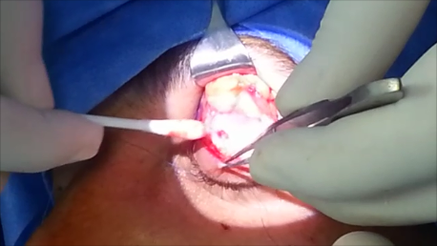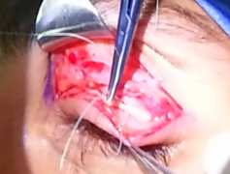

Figure 1 Figure 2

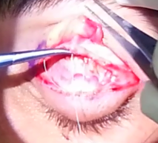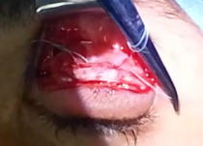

Figure 3 Figure 4

**Postoperative follow up**

Every patient was examined postoperatively in the first three days, at two weeks, one month, three months, six months, twelve months and eighteen months after surgery. At each visit, the Patients were evaluated for

1. MRD1
2. Amount of blepharoptosis correction (postoreative MRD1 -preoperative MRD1)
3. Symmetry of both sides regarding eylid position (interlid MRD1 difference) and contour (normal, nothcing and flatening)
4. Interlid crease difference
5. Lid margin (normal, ectropion, entropion and lash ptosis)
6. Complications

**3. Results**

The British Oculoplastic Surgery Society (BOPSS) National Blepharoptosis Survey defined an operation as successful only if all of the following criteria were met:

1- Upper MRD1 between 3 and 5 mm

2- Interlid MRD1 difference 1mm or less

3- Interlid crease difference 2 mm or less

4- The presence of symmetrical lid contour. [15]

According to the previous criteria we encountered the following results: 19 out of 23 eyelids fulfilled the previous criteria with success rate of83.6%, the improvement of the MRD1 was significant with mean of 2.04mm. Only 4 lids did not fulfill the above-mentioned criteria. One lid (case no. 9) showed MRD1 > 3mm, one lid had asymmetry of lid contour with a temporal flare (case no.7), and two cases (no 5 and 16) had shown bilateral asymmetry with interlid MRD1 difference more than 1mm. Taking into consideration the anesthesia used, we achieved success rate 70% in patients operated upon under GA (7/10 eyelids), while patients done under LA showed much higher success rate 92.3% (12/13 eyelids).

In only one case, severe lid edema developed from the first postoperative day and lasted for two weeks despite proper management and improved slowly over another two weeks with systemic steroids (Table 1).

**Table 1: Demographic aspects of the patients and the results**

|  |  |  |  |  |  |  |  |
| --- | --- | --- | --- | --- | --- | --- | --- |
| **Case no.** | **Laterality** | **Age** | **sex** | **AE** | **MRD1 pre** | **MRD1 post** | **complications** |
| **1** | Bi | 4 | F | C | 2-1.5 | 3.5-3 |  |
| **2** | Bi | 53 | F | S | 2-2 | 4-4 |  |
| **3** | U | 55 | F | S | 1 | 3.5 |  |
| **4** | U | 35 | M | C | 1 | 3 |  |
| **5** | U | 63 | F | S | 1.5 | 3.5 | asymmetry bil. |
| **6** | U | 67 | M | S | 2 | 4 |  |
| **7** | U | 9 | M | C | 2.5 | 3.5 | temporal flare |
| **8** | U | 72 | M | S | 2 | 4 |  |
| **9** | Bi | 10 | M | C | 2-2 | 3.5-2.5 | undercorrection |
| **10** | U | 54 | M | S | 1 | 4 |  |
| **11** | U | 59 | M | S | 2 | 3.5 |  |
| **12** | U | 66 | F | S | 2 | 4 |  |
| **13** | Bi | 5 | F | C | 2-3 | 4-4 |  |
| **14** | U | 13 | F | C | 2 | 3.5. |  |
| **15** | U | 60 | F | S | 2 | 5. |  |
| **16** | U | 8 | M | C | 2.5 | 3.5 | asymmetry bil. |
| **17** | U | 5 | F | C | 1.5 | 3.5mm | lid oedema |
| **18** | Bi | 65 | F | S | 1.5-2 | 3.5-4 |  |

Bi. Bilateral, U. Unilateral, F. Female, M. Male, AE. Aetiology, MRD1pre. preoperative upper Margin Reflex Distance, MRD1 post. Postoperative upper Margin Reflex Distance, S. Senile, C. Congenital, bil. Bilateral.

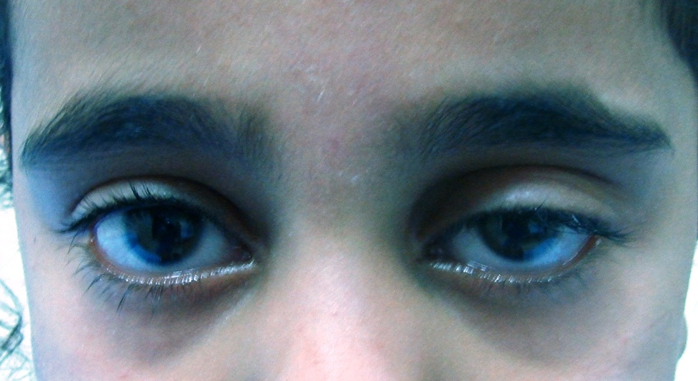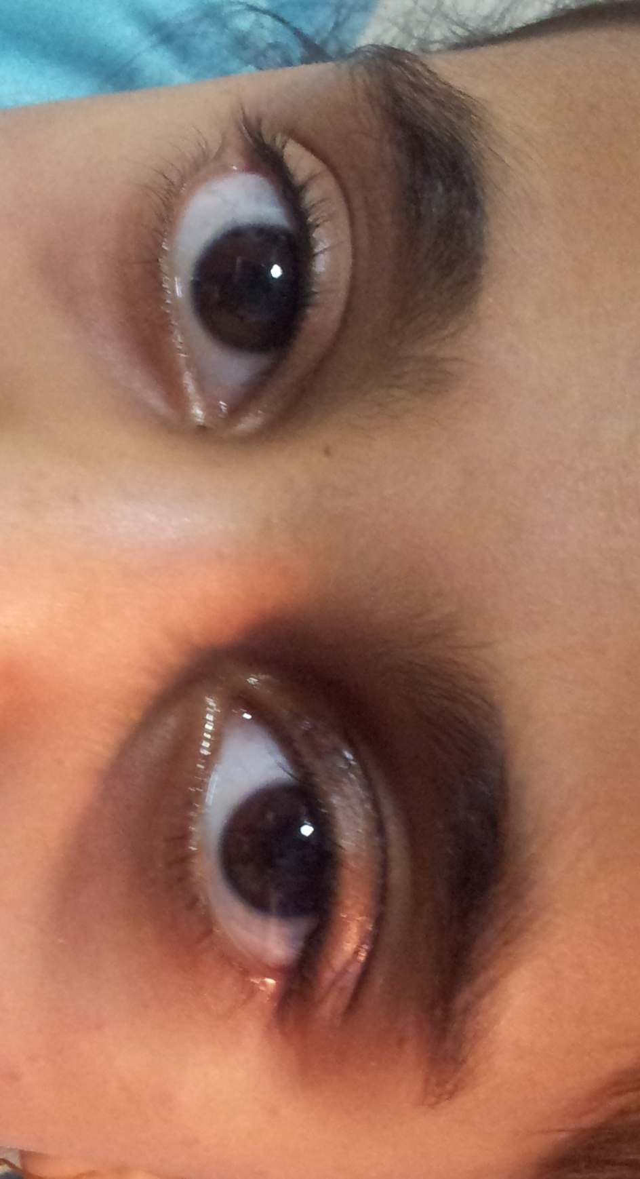

**Case no.17 preoperative and postoperative**

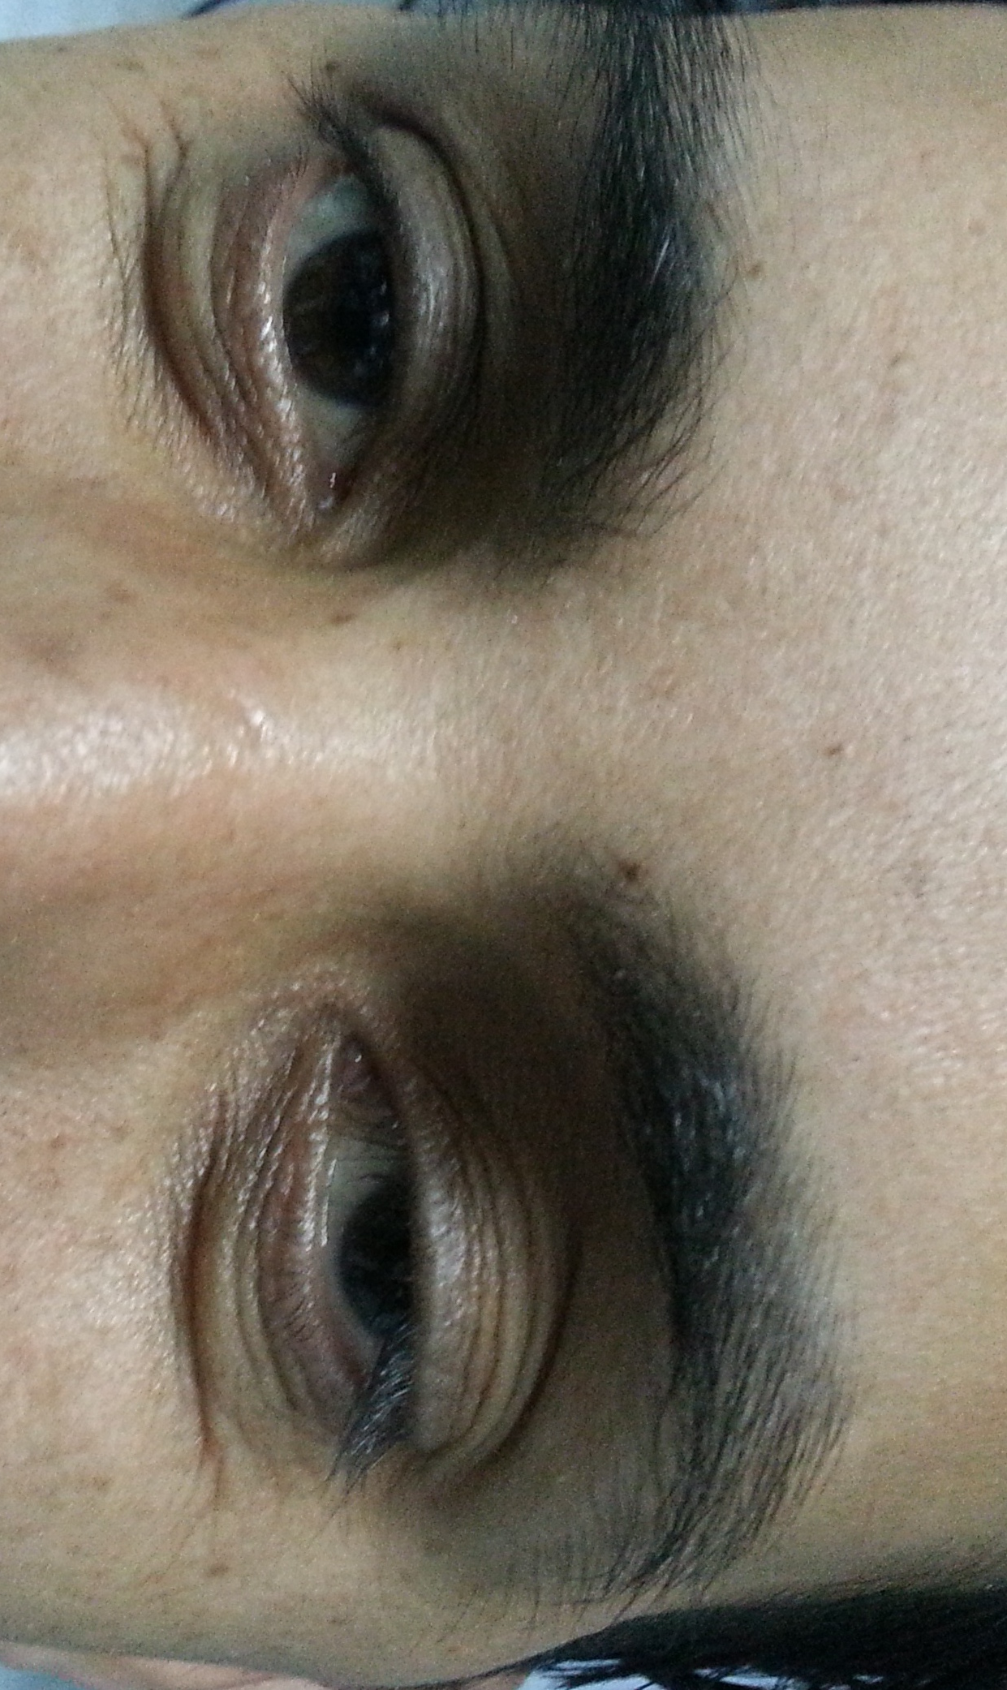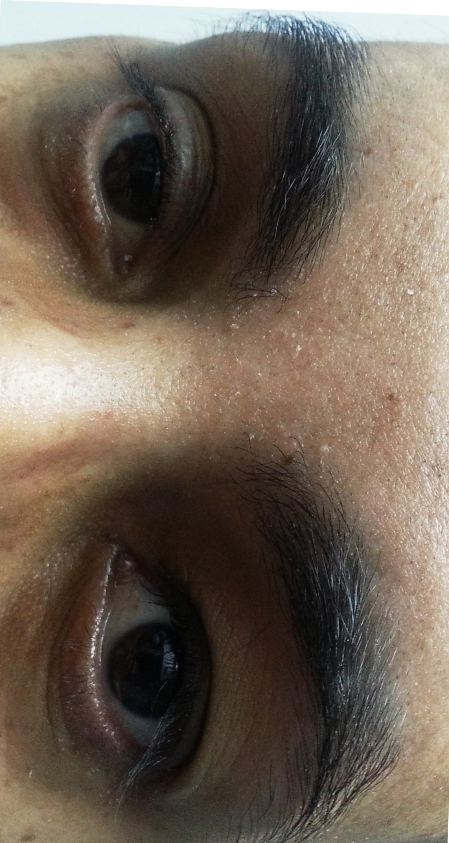

**Case no. 4 preoperative and postoperative**

**4. Discussion:**

Everbusch was first described the apponeurotic repair approach in blepharoptosis surgery, however, it did not gain popularity until 1975 when Jones et al. [16] reintroduced it. Their technique primarily involved tucking or resecting the levator apponeurosis. [17]

Apponeurotic tucking is simple, effective, and versatile. It can be used in the correction of involutional, postcataract, traumatic, and congenital types of blepharoptosis. Although local anesthesia is preferred, consistent results also can be obtained in those cases where general anesthesia is indicated. The complications that occurred were minimal and easily corrected. [18] Levator plication is a modified technique of the apponeurotic approach in the management of blepharoptosis surgery. We believe that, the technique has been suggested in an attempt to make the operative time shorter and to simplify the difficult operative techniques often encountered especially by the beginner oculoplastic surgeons.

In our study 19/23 (83.06%) had achieved successful outcome with a median amount of correction mm, comparably verdahan etal in their study documented median amount of improvement 2±1.28mm[19].

Li Bin et al in the study conducted on 18 eyelids of 13 patients with transcutaneous levator plication recorded that the mean difference of MRD1 was 3.1 mm with one year follow up, and he found only one case of under correction. [20]

At 2 weeks postoperatively, when operative lid edema, if any, had resolved and muscle tone of both orbicularis and levator muscles had returned, the lid level was always maintained thereafter, as the only case of under correction was seen in the early first weeks after surgery and no recurrence of ptosis occurred in the follow up period. The cause of undercorrection in this case was due to inadequate lid height at time of surgery. Cotroversely, Kumar et al had reported that levator plication procedure had a greater chance of drooping from the fourth week onwards and they supposed that levator placation failed to correct dystrophic muscle in congenital ptosis. [21]

We had only one case of under correction (case no.9) in which postoperative MRD1 was 2.5mm , two cases of interlid asymmetry (cases no.5 and no.16), in both of them the interlid MRD1 difference was 1.5mm and one case of irregular lid contour with temporal flare (case no.7)

In our work we had achieved bilateral symmetrical lid crease of normal height and shape of the all cases.

Most surgeons prefer doing levator repair under local anesthesia; this offers the benefit of a “monitored” levator advancement whereby dynamic adjustment of the lid height with voluntary patient cooperation can be done intra-operatively. This advantage is lost while operating under general anesthesia [16].

The work of Scoppettulol [16] go in favor with our study results as we found a significant difference of success between patients done under LA and those done under GA (success rates were 92.3 % and 70% respectively),

However McCord et al. [22] described a solution to overcome this problem by using three step technique, but his technique was advocated to the bilateral cases to ascertain symmetrical palpebral fissure height regardless final upper eyelid position.

Although voluntary co-operation of the patient in the operating room to ascertain intra-operative adjustment of lid height can be affected by a variety of factors. Variations in sedation can certainly affect patient co-operation. Local anesthetic can affect levator function and epinephrine may cause contraction of the Muller’s muscle obscuring the true resting lid level.[16] In our study we didn't face this problem, as we don't inject more than 1.5 cc of LA and the haemostatic medication used (levonordorphin1/20000) has a very minimal stimulating effect on the Muller's muscle.

Vardhan et al. [19] in their study found that the median amount of blepharoptosis correction achieved was 2±1.28mm in the transcutaneous group whom median age was 22±9.22 years; we find these results are also comparable with our results which showed median amount of blepharoptosis correction to be 2mm.

In fact, we aren't certain weather the difference in success rate between patients done under GA and those done under LA is attributed to either anesthesia limitation (difficult intraoperative assessment under GA) or pathogenesis difference between congenital and involutional blepharoptosis, as almost all congenital cases (10/11 eyelids) were done under GA or both.

Vardhan et al. [19] in their work comparing transcutaneous versus transconjunctival levator plication for blepharoptosis correction found that the median amount of correction achieved was 2±1.28 mm in transcutaneous group,and 2± 1.25 mm in transconjunctival group. The difference between the two groups is statistically non significant.

Although conjunctival approach surgery is an excellent approach for mild to moderate blepharoptosis as it has the advantage of avoiding a lid scar, thereby giving a better cosmoses, It has a disadvantage of technically difficult exposure of the superior orbit which is mainly required in cases of severe blepharoptosis. So it may not be possible to correct completely the patients with severe blepharoptosis. The other problem with this approach is that it may be difficult for the beginners to appreciate the anatomy as the lid is everted. In addition, it is sometimes quite difficult to create the desired height and shape of the superior palpebral crease[11].

To our knowledge, there is no severe and long lasting lid oedema following apponeurotic repair in the literature as we had in case no. 17, 5yr. old girl who is medically free, and we assume that it was allergic in nature to either the sterilizing material (Betadine 5%) or the suturing materials(Braided Polyester or Vicryl) or both as the edema started to resolve in response to systemic steroids which was started two weeks after the operation and edema disappeared completely after two-weeks course of steroid.

In our study, no cases of lid notching, entropion, ectropion, flattening or irregularity of lid margin was found. Also we encountered no case of keratopathy as frequent instillation of lubricants helped to maintain clear healthy cornea.

**Conclusion:**

Transcutaneous Levator plication approach proves to be simple, safe, effective and versatile procedure for correction of mild-moderate blepharoptosis with levator function more than 4mm with better results in patients suffering involutional blepharoptosis and in those operated upon under LA

**References**

1. Finsterer J. Ptosis: causes, presentation, and management. Aesth Plast Surg 2003; 27: 193-204.
2. Wong CY; Fan DS; Gohty; Lam DS : Long term results of Palmaris longus frontalis sling in children with congenital ptosis. Eye;2005; 18(5): 546-8.
3. Nerad J; Evaluation and treatment of patients with ptosis. In: Nerad JA (Ed.); The Requisities; Oculoplastic surgery, 2005. C.V.Mosby-St. Luis; chapter 7, 157-62.
4. McCord CD, Evaluation of Ptosis Patients, In: McCord CD. Eyelid surgery Principles and Techniques 1995. Lippincot-Ravan, Philadelphia; (7):99-112.
5. Anderson RL, Dixon RS. Apponeurotic ptosis surgery. Arch Ophthalmol 1979; 97: 1123-8.
6. Putterman AM, Fett DR. Müller's muscle in the treatment of upper eyelid ptosis: a ten-year study. Ophthalmic Surg 1986; 17: 354-60.
7. Crawford JS. Repair of ptosis using frontalis muscles and fascia lata: a 20-year review. Ophthalmic Surg 1977; 8: 31-40.
8. Putterman AM, Urist MJ. Müller's muscle-conjunctival resection ptosis procedure. Ophthalmic Surg 1978; 9: 27-32.
9. Callahan MA, Beard CB, Callahan M, Beard C. Beard's ptosis, 4th ed. Birmingam: Aesculapius Publishing Company 1990.
10. Matsuo K. Stretching of the Mueller muscle results in involuntary contraction of the levator muscle. Ophthal Plast Reconstr Surg 2002; 18: 5-10.
11. Liao WC, Tung TC, Tsai TR, Wang CY, Lin CH. Celebrity arcade suture blepharoplasty for double eyelid. Aesthetic Plast Surg 2005; 29: 540-5.
12. Ichinose A, Tahara S. Transconjunctival levator apponeurotic repair without resection of Müller's muscle. Aesthetic Plast Surg 2007; 31: 279-84.
13. Older JJ. Upper lid blepharoplasty and ptosis repair using a transcutaneous approach. Ophthal Plast Reconstr Surg 1994; 10: 146-9.
14. d, [Martin SA](http://www.ncbi.nlm.nih.gov/pubmed?term=Martin%20SA%5BAuthor%5D&cauthor=true&cauthor_uid=12900629), [De Cordier BC](http://www.ncbi.nlm.nih.gov/pubmed?term=De%20Cordier%20BC%5BAuthor%5D&cauthor=true&cauthor_uid=12900629), [Al-Hakeem MS](http://www.ncbi.nlm.nih.gov/pubmed?term=Al-Hakeem%20MS%5BAuthor%5D&cauthor=true&cauthor_uid=12900629), [Collawn SS](http://www.ncbi.nlm.nih.gov/pubmed?term=Collawn%20SS%5BAuthor%5D&cauthor=true&cauthor_uid=12900629), [Vásconez LO](http://www.ncbi.nlm.nih.gov/pubmed?term=V%C3%A1sconez%20LO%5BAuthor%5D&cauthor=true&cauthor_uid=12900629). Aesthetic eyelid ptosis correction: a review of technique and cases. [Plast Reconstr Surg.](http://www.ncbi.nlm.nih.gov/pubmed/12900629) 2003 Aug; 112(2):655-60; discussion 661-2.
15. Scoppettulol E, Chadha V, Bunce C, Olver JM, Wright M. British Oculoplastic Surgery Society (BOPSS) National Ptosis Survery. Br J Ophthalmol 2008; 92: 1134-8.
16. Jones LT, Quickert MH, Wobig JL. The cure of ptosis by apponeurotic repair. Arch Ophthalmol 1975; 93: 629-34.
17. Salman Waqar, Catherine McMurray and Simon N. Madge; Transcutaneous Blepharoptosis Surgery - Advancement of Levator Apponeurosis. The Open Ophthalmology Journal, 2010, 4, 76-80.
18. Liu D. Ptosis repair by single suture apponeurotic tuck. Surgical technique and long-term results. Ophthalmology 1993;100:251-9.
19. Prem Vardahan: Evaluation of Ptosis Correction by Levator Plication Through Skin Approach Vs Conjunctival Approach: A Comparative Study, AIOC PROCEEDINGS; ORBIT/ PLASTIC SURGERY SESSION-I; 2009; 405-40 (Internet course).
20. Li Bin, Gui Li, Wang Cui-qing, Li Jun-Yi, LiRui-guo. Treatment of apponeurotic ptosis by placation of levator apponeurosis. [Acta Academiae Medicinae CPAF, 2009-12](http://en.cnki.com.cn/Journal_en/E-E000-WUXB-2009-12.htm).
21. K, [Kamal S](http://www.ncbi.nlm.nih.gov/pubmed?term=Kamal%20S%5BAuthor%5D&cauthor=true&cauthor_uid=20302407), [Kohli V](http://www.ncbi.nlm.nih.gov/pubmed?term=Kohli%20V%5BAuthor%5D&cauthor=true&cauthor_uid=20302407). Levator plication versus resection in congenital ptosis - a prospective comparative study. [Orbit.](http://www.ncbi.nlm.nih.gov/pubmed/?term=levator+plication+versus+resection) 2010 Feb;29(1):29-34.
22. Mc Cord CD, Seify H, Codner MA. Transblepharoplasty ptosis repair: three-step technique. Plast Reconstr Surg 2007; 120: 1037-44.

9/10/2014