Assessment of Microbial Contamination of Groundwater Near Solid Waste Dumpsites in Basement Complex Formation, using Total Plate Count Method

Badmus B.S, Ozebo V.C, Idowu O.A.,Ganiyu S.A ,Olurin O.T and Atayese A.O

Department of Physics, Federal University of Agriculture Abeokuta, Ogun State Nigeria
Department of Water Resources and Agrometeorology, Federal University of Agriculture Abeokuta, Ogun State Nigeria
Department of Microbiology, Federal University of Agriculture Abeokuta, Ogun State Nigeria
Corresponding Author
Department of Physics, Federal University of Agriculture Abeokuta, Ogun State Nigeria
Email: olurin@physics.unaab.edu, +234 -806 – 660 - 0703

Abstract: Microbial analysis of water samples collected from two selected dumpsites within Ibadan metropolis were carried out in order to ascertain the effects of leachates generated by dumpsite on groundwater quality. Water samples were collected from surrounding wells and stream near Aba-Eku and Ajakanga solid waste landfill sites in Southwestern part of Nigeria. The samples were analysed for coliform count and Escherichia Coli through total plate count method. The result of the microbial analysis reveals high presence of coliform in all the water samples while two wells around Aba Eku dumpsite have E. Coli presence and none is detected in wells and stream around Ajakanga landfill. High values of microbial counts are principal indicators of suitability of water for domestic purpose and also sign of groundwater contamination in the surrounding wells. The sign of groundwater contamination was noticed in many surrounding wells around the two dumpsites resulting in high number of coliform bacteria. The presence of E. coli in wells 2 and 7 in Aba Eku requires control measures before consumption.
[Badmus B.S, Ozebo V.C, Idowu O.A., Ganiyu S.A, Olurin O.T and Atayese A.O. Assessment of Microbial Contamination of Groundwater Near Solid Waste Dumpsites in Basement Complex Formation, using Total Plate Count Method. Nat Sci 2014;12(9):113-118]. (ISSN: 1545-0740). http://www.sciencepub.net/nature. 19

Keywords: landfill, contamination, solid waste, coliform, E.coli, groundwater.

Introduction
Solid wastes are produced everyday in urban societies as a result of human activities and in an attempt to dispose off these materials; man has carelessly polluted the environment. Classical unlined sanitary landfills and open dumps are well known to release large amount of hazardous and otherwise deleterious chemicals to nearby groundwater, surface water, soil and air through leachate and landfill gases respectively. Leachate generated as a result of solid waste anaerobic decomposition may seep from the landfill site into underground aquifers thereby polluting water resources (Bhuiya et al., 2002, Tesfaye, 2007). Besides the effect of leachate on groundwater, solid wastes dumped on landfill causes various aesthetic and public health problems by attracting insects, rodents and various disease vectors (Egunjobi, 1986, Olayinka and Olayiwola, 2001). This is especially the case in developing countries.
Solid waste disposal in Ibadan city located in southwestern part of Nigeria has become a growing problem in the area of groundwater resources and this requires environmental impact assessment of the area. Ibadan city currently generate about 1,618,293kg of solid waste daily with high probability of increase in the volume of these wastes as years come by (CPE, 2010). Waste management in Ibadan is characterized by inefficient collection, insufficient coverage of the collection system and improper disposal of solid waste. Ibadan however, suffers serious water supply problems, because of inadequate supply of pipe borne water and cases of dry taps are common virtually in every part of the city (Ifabiyi, 2008). Hence, many homes have hand-dug wells as alternative source of potable water. Siting of dumpsite near the residential area have high chances of polluting the surrounding wells through the migration of leachate into the underground aquifer. Therefore, there is need to protect these alternative sources from adverse effects of landfill wastes.
McGraw-Hill (1992) reported that various bacteria, protozoa, algae, fungi viruses and animal parasites, some of which are potentially pathogenic may be found in potable water. Microbial faecal contamination indicators are Escherichia coli, Salmonella spp. Shigella, Streptococii, Clostridia spp (Binni et al., 2002, Scott et al, 2002) and other class of bacteria that could be of human or non human origin. E-coli especially those possessing haemolysin, vero cytotoxin and those belonging to entero pathogenic serotypes have been responsible for gastroenteritis in human (Bell et al., 1994; Griffin and Tanxen, 1991).
This study therefore seeks to assess the bacteriological quality of groundwater and surface water near Aba-Eku and Ajakanga landfills through the use of Total Plate count method.
Study Area
The study areas were two active landfill sites situated within Ibadan metropolis. These are Aba-Eku and Ajankanga landfills. Aba Eku landfill is located along Akanran road in Ona Ara Local Government area. This landfill was established in 1998 and located approximately on Latitude 3⁰ 59 009 N and 30⁰ 59 973N and longitude 7⁰ 19 270 E and 7⁰ 19 843 E. Ajakanga landfill is located along Odo Ona Elewe road in Oluyole Local Government Area between latitude 3⁰ 50 187 N and 3⁰ 50 696 N and longitude 7⁰ 18 021 E and 7⁰ 18 997 E,. established in 1996. The two study area falls within the humid and sub humid tropical climate of South western Nigeria with a mean annual rainfall of about 1230mm and mean maximum temperature of 32⁰C.
The basement complex rocks in Ibadan area are mainly the metamorphic rocks of Precambrian age with few intrusions of granites and porphyries of Jurrasic age.
The dominant rock types are quartizites of the meta-sedimentary series and banded gneisses, augen gneisses and migmatites, which constitute the gneiss-migmatite complex. Other minor rock types include pegmatites, quartz, aplites, dolerite dykes, amphibolites and xenoliths (Aizebeokhai, 2010). In most parts of Ibadan, the rocks are overlain by the weathered regolith, thus, outcrops are correspondingly few (as shown in Figure 1). Banded gneiss constitutes over 75% of the rocks in and around Ibadan while augen gneisses and quartzites share the remaining in about equal percentages (Okunlola et al., 2009).
The area is within the humid tropics with a mean rainfall of 1,237 mm (Akintola, 1986). The climate is characterized by two seasons, namely, the rainy season (April – October) and the dry season (November – March). Most of the precipitation is received during the rainy season.

Figure 1: Generalized geological map of Ibadan (after Okunlola et al., 2009)

Materials And Method

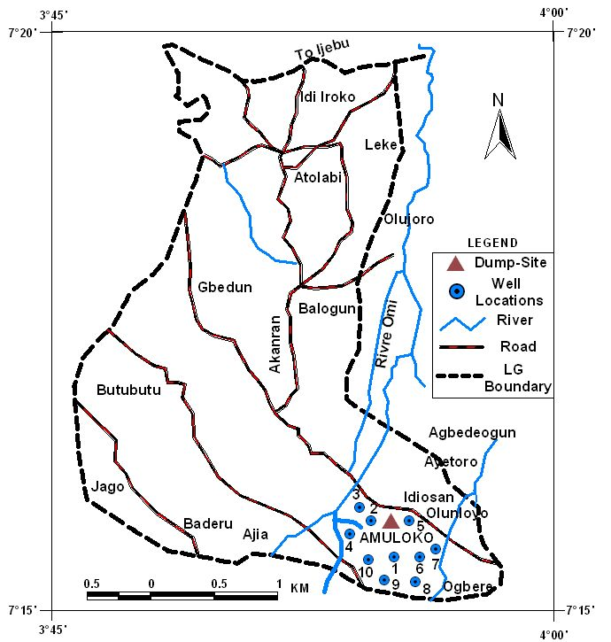
Figure 2: Map of Aba Eku Dumpsite and water samples locations

In each study area, Ten groundwater samples were collected from hand-dug wells around each landfill site making twenty samples for the two sites in March, 2013. Sample 1- 10 were collected from hand-dug wells around Aba-Eku dumpsite while samples 11- 20 were collected within Ajakanga dumpsite. Each water sample was collected inside a sterile 20ml bottle. After collection, they were transported to the laboratory on Ice in order to maintain the microbial population for proper microbial analysis. A hand held Garmin Etrex GPS was used to record the geographic location of the sampling points. The locations of sampling points in each dumpsite are shown in Figure 2 and 3 respectively. The samples collected were taken to the microbiology laboratory of the Department of Microbiology, Federal University of Agriculture, Abeokuta (FUNAAB), Ogun State, Nigeria for microbial analysis. Coliform and E.Coli were microbial parameters analysed for this study. The Mac Conkey Agar was used for the detection of Coliform while Eosine methylenes Blue Agar (EMBA) were used for E-coli count. The total plate count method was used in the counting of microbial organism. The samples were serially diluted to 10⁻². Using the standard plate method, 0.5ml of each of the dilution water sample was placed into separate and properly labelled petri dishes. The prepared media of Mc Conkey Agar and EMBA were separately poured over the samples in petri dishes. This was then swirled for proper mixing before incubated at 37⁰C for 24hrs. For the coliform count, only lactose fermenters (pink colonies) were counted by counting the colonies directly (Olutiola et al., 1991).

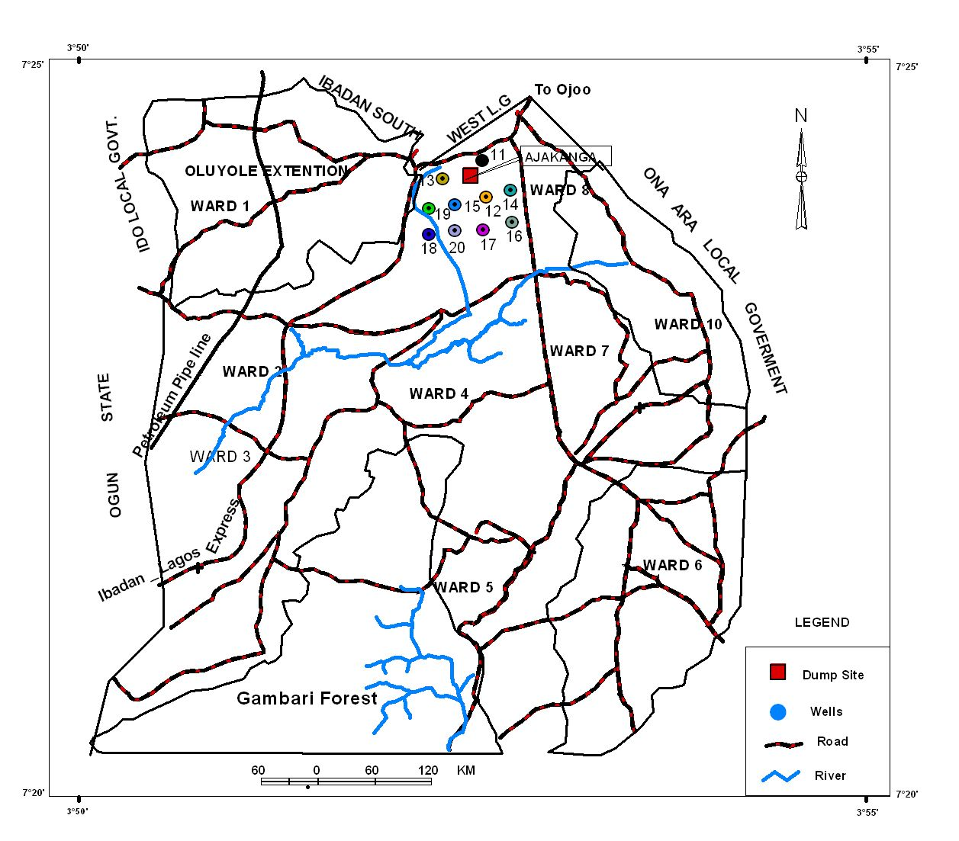
Figure 3: Map of Ajakanga Dumpsite and Water sampling locations

Results And Discussions
The results of microbial analysis of all the samples in the two landfill sites were as shown in Table i. It was observed that all the water samples from the two study areas were contaminated with coliforms while two wells (wells 2 and 7) in Aba-Eku area have E.coli presence. There is no presence of E.coli in all wells and stream around Ajakanga landfill. All the values obtained were far above the World Health Organisation (WHO) and United State Environmental Protection Agency (USEPA) standards. Presence of E-coli is an indication of fecal contamination and associated with water borne epidermic thereby rendering the water samples unfit for human consumption (Mackenzie et al., 1995).
The presence of E.coli in wells 2 and 7 of Aba-Eku area may be due to unhygienic practices of inhabitants using these two wells. For instance, E-coli presence in well 2 which is about 30m from the landfill may not be primarily due to leachate migration but also due to human activities such as open defeacation and bathing . This is consistent with the findings of (Shimizu et al. 1980) that more microbial activities were found in wells close to organic wastes in Japan. Besides the distance of well 2 to Aba-Eku landfill, there is an open defeacation practice, bathing and washing of clothes near the well by people living around it during sampling period. These poor sanitary practices around the well may also introduce bacteria into the water. The major diseases that could arise from bacteriolocally contaminated groundwater include typhoid, diarrhea and cholera (Victoria and Ismail, 2011). The presence of E.coli in well 7, about 200m from the dumpsite, may be due to unhygienic condition of the well as rearing of goats and hens, animal faeces were noticed close to this well during the sampling period. These two wells need to be taken care of by adopting proper control measures such as chlorination, disinfection of well, boiling the water, proper hygienic practice and good sewage treatment (Ogedengbe and Akinbile, 2007) before use for domestic consumption.
It was observed that out of all the twenty water samples analysed for this research work, none of the samples was able to satisfy the minimum required condition for potability of water meant for public consumption according to WHO specification of 100cfu per ml of drinking water. These high values of coliform count obtained in all the samples are similar to values on earlier work conducted by Fabiyi (2008), Akinbile and Yusoff (2011). Adejuwon and Mbuk (2011) in basement complex terrain.
Other factors such as the geology of the area where the well was sited, level of hygiene of the well, absence of protective embankment thereby making the well prone to bacterial contamination due to run-off and the population of people the well is serving could be considered as possible sources of contamination apart from dumpsite leachate (Ifabiyi, 2008, Victoria and Ismail, 2011). Also high level of coliform count and presence of E.coli in two wells around Aba-Eku dumpsite over that of Ajakanga area may follows from the lithological results obtained from Vertical Electrical Sounding (VES) data interpretations of the two sites (Aba Eku and Ajakanga) done earlier by (Ibitola et. al. 2011) where groundwater percolation at Aba Eku landfill site travels faster through the vadoze zone than that of Ajakanga landfill

Conclusion
The study reveals high values of coliform counts in all samples collected around the selected landfills.The values obtained were far above WHO and USEPA standard. This indicates poor human waste management system of the inhabitants around the two study areas, such as bathing, shallow pit toilet and open defeacation. These high values of coliform count and presence of E.coli in few wells in Aba-Eku area should be of great concern to inhabitants living around these two dumpsites. This is because E.coli and coliform in water indicate recent fecal contamination and may indicate possible presence of disease causing pathogens such as bacteria, viruses and parasites. Remedial measures suggested should be adopted to reduce groundwater contamination through leachate percolation and unhygienic practices.
Acknowledgement
The authors are grateful to the Institute of Food Security, Environmental Resources and Agricultural Research (IFSERAR), Federal University of Agriculture Abeokuta, Nigeria for funding part of this research work.

Table 1: Result of total microbial counts of the water samples
Sample code | Coliform (cfu/ml) | E-Coli
S₁ | 1.36 x 10⁴ | 0
S₂ | 1.52 x 10⁴ | 1
S₃ | 1.96 x 10⁴ | 0
S₄ | 2.4 x 10^{3.} | 0
S₅ | 1.92 x 10⁴ | 0
S₆ | 2.98 x 10⁴ | 0
S₇ | 2.00 x 10⁴ | 2
S₈ | 1.36 x 10⁴ | 0
S₉ | 1.72 x 10⁴ | 0
S₁₀ | 1.84 x 10⁴ | 0
S₁₁ | 1.14 x 10⁴ | 0
S₁₂ | 9.2 x 10³ | 0
S₁₃ | 5.2 x 10³ | 0
S₁₄ | 2.2 x 10³ | 0
S₁₅ | 1.24 x 10⁴ | 0
S₁₆ | 1.42 x 10⁴ | 0
S₁₇ | 1.68 x 10⁴ | 0
S₁₈ | 7.6 x 10³ | 0
S₁₉ | 1.38 x 10⁴ | 0
S₂₀ | 1.72 x 10⁴ | 0

References
1. Adejuwon, J.O. and Mbuk, C.J. (2011): Biological and Physiochemical properties of shallow wells in Ikorodu Town, Lagos, Nigeria. Journal of Geology and Mining Research, 3(6) 161-168.
2 Akinbile, C.O. and Yusoff, M.S. (2011). Environmental Impact of leachate pollution on roundwater supplies in Akure, Nigeria. Int. J. of Environmental Science and Development 2(1) 81-86.
3 Bell, B.P. Goldoft, M. Griffin, P.M. and Davis, M.A. (1994). A multistate outbreak of E.coli0157: H7 associated bloody diarrhea and haemolytic urenic syndrome from hamburgers. The Washington experience JAMA 272 (17) 389-408.
4 Binnnie C, Kimber, M and Smethrust, G. (2002) Basic water treatment. Royal Society of Chemistry, Cambridge, UK.
5 Bhuiya, M.A.H; Huq, N.E. and Hossain, M.M. (2002).unplanned waste disposal and itspossible impacts on subsurface environment of Dhaka City, Bangladesh. In BangladeshEnvironment. Vol 2(ed) pp 7231-7331.
6 CPE (2010). Final Report on landfill recovery and use in Nigeria (Pre-feasibility studies ofusing LFGE).
7 Egunjobi, T.O. (1986). Problem of solid waste management in Nigeria urban centre. Proceedings of the National Conference on Development and the Environment (NCDE’ 86). Nigeria Institute for Social and Economic Research Ibadan. Pp 303-312
8 Griffin, P.M. and Tauxe, R.V. (1991). The epidemiology of infections caused by E.coli 0157:H7, other enterohemorrhogic E.coli and the associated haemolytic uremic syndrome. Epidemiologic Reviews 13: 60-98.
9 Ibitola, M.P, Ehinola, O.A. and Akinnigbagbe, A.E. (2011). Electrical resistivity method indelineating vadose and saturated zone in some selected dumpsites in Ibadan part of South-western Nigeria. Int. J. of Geomatics and Geosciences vol. 2(1) 164-178.
10 Ifabiyi, I.P. (2008). Depth of hand-dug wells and water chemistry. Example from Ibadan North East Local Government Area, Oyo State, Nigeria. Journal of Social Sciences 17 (3) 261-266.
11 McGraw Hill (1992)Wage Incentive wurtate. Encyclopedia of Science and Technology 19:333-334.
12 Mackenzie, W.R., Schell, W.L/ Blair, K.A. and Addis, D.G. (1995). Massive outbreak ofwater borne cryptosporidium infection in milwankeen wisconsion: recurrence of illness and risk of secondary transmission. Chemical infection diseases 1, 57-62.
13 Ogedengbe .K and Akinbile, C.O. (2007). Impact of Industrial pollutant on Quality of Groundand Surface waters at Oluyole Industrial Estate, Ibadan, Nigeria. Nigeria J. of Technol. Devt.4(2) 139-144.
14 Okunlola, O.A., Adeigbe, O.C. and Oluwatoke, O.O. (2009): Compositional and petrogenetic features of Schitose rocks of Ibadan area, Southwestern Nigeria. Earth Sciences Research Journals. 13(2). Pg 29-43.
15 Olayinka, A.I, and M.A. Olayiwola, 2001. Integrated use of geoelectric imaging and hydrochemical methods in delineating limits of polluted surface and groundwater at a landfill site in Ibadan area, SW Nigeria. J. Mining Geol. 37:53-68.
16 Olutiola, P.O, Famurewa O., Sonntagi, H.G. (1991). A practical approach: Hygiene Institute der Universicit, Heilberg, Germany 112-114.
17 Rahaman, M.A. (1976). Review of Basement Geology of the Southwestern Nigeria. Elizaberthan Publishing Company, Nigeria. Pp 41-58.
18 Scott, T.M, Rose, J.B. Jenkins, T.M, Farrah, S.R. and Lukas K.J. (2002). Microbial source tracking: Current methodology and future directions. Applied Environmental Microbiology 68, 5796-5803.
19 Shimizu, T.T.M, Kigotake, T.M and Agatomo, H.N. (1980) Bacteria contamination of drinking water for wells in miyazaki, Japan. In: Bulleting for Agriculture. Miyakazi University pp 21-2820.
20. Victoria, O.A and Ismail, A.O (2011). Groundwater contamination in Agbowo Community, Ibadan, Nigeria: Impact of Septic tanks distance to wells. Malaysian J. of Microbiology vol 7(3) pp159-166.
21 Tesfaye Z. (2007): Groundwater pollution and public Health risk analysis in the vicinity of Reppi Solid Waste dumpsite. Addis Ababa City, Ethiopia. Unpublished M.Sc thesis. AddisAbaba University, Ethiopia.
22 USEPA (2009). National Primary Drinking Water Regulations. EPA 816-F-09-004. Washingtoon D.C.23 WHO (2008). Guidelines for drinking water quality. 3rd Edition incorporating the 1st and 2nd addenda vol.1, recommendation, WHO, Geneva.

8/3/2014

