Effect of Morinda citrifolia Supplementation on the Lactate levels of Athletes

Anugweje KC¹ and Willey-Abey B²

¹Department of Health Services, Lulu Briggs Health Centre, University of Port Harcourt, East-West Road, P.M.B. 5323, Choba, Port Harcourt, Rivers State, Nigeria;
²Department of Biochemistry, University of Port Harcourt, East-West Road, P.M.B. 5323, Choba, Port Harcourt, Rivers State, Nigeria
e-mail: kanugweje@hotmail.com; Tel: +2348033382154

Abstract: The influence of M. citrifolia on blood lactate levels of athletes was investigated in this study. Preliminary studies involving a 30 month-long exploratory monitoring of athletes consuming wide-ranging doses of M. citrifolia juice were carried out to establish dosage and toxicity. Administration of M. citrifolia and placebo juices were respectively performed on two groups of one hundred subjects each, comprising highly trained athletes and non-athletes randomly assigned. Both groups were subjected to a 6-week physical training programme prior to the commencement of a thirty (30) day assessment period. Substantial decrease in lactate level was obtained in the test subjects after M. citrifolia juice supplementation: 8.70 ± 0.30 mmol/L (Pre-supplementation) and 6.30 ± 0.30 mmol/L (Post-supplementation). There was significant difference (p=0.039) in lactate levels (mmol/L) after supplementation with M. citrifolia juice. Lactate concentrations in the control group before and after placebo juice supplementation however, did not show significant difference (p≤ 0.05): 11.10 ± 0.50 (Pre-supplementation) and 10.90 ± 0.50 (Post-supplementation). Further analysis showed that M. citrifolia juice does not contain any banned substance. These findings suggest that Morinda citrifolia juice juice may be acting positively on muscle tissues of athletes by enhancing their functional capacity through the promotion of cross-bridging, calcium binding and enzymatic activity.
[Anugweje KC and Willey-Abey B. Effect of Morinda citrifolia Supplementation on the Lactate levels of Athletes. Nature and Science. Nat Sci 2014;12(9):97-102]. (ISSN: 1545-0740). http://www.sciencepub.net/nature. 16

Key words: Morinda citrifolia, Lactate, Supplementation, Athletes

1. Introduction
During intense exercise especially of long duration, energy required for the activity is obtained through the tricarboxylic acid cycle. However, at some point in time, the rate of oxygen supply in the body can no longer keep pace with exercise physiological requirements. When this happens, most of the energy is now obtained through anaerobic glycolysis. When the rate of anaerobic glycolysis exceeds the capacity of the mitochondria for oxidative phosphorylation, lactic acid accumulates in the muscle cell.
In exercising skeletal muscle, reduced nicotinamide adenine dinucleotide (NADH) production by glyceraldehyde 3-phosphate dehydrogenase and by the three NAD⁺-linked dehydrogenases of the citric acid cycle exceeds the oxidative capacity of the respiratory chain. This results in elevated NADH/NAD+ ratio, favouring reduction of pyruvate to lactate (Champe et al., 1988). At physiologic pH, lactic acid is completely ionized and exists in the form of lactate, resulting to an increase in (H⁺) concentration in skeletal muscle and blood (Chase and Kushmerick, 1988).
Lactate is present in the blood at rest because of the activity of lactate dehydrogenase (LDH). However, with anaerobic glycolysis, lactate levels increase tremendously because the rate of ATP breakdown exceeds the rate of ATP synthesis by oxidative phosphorylation (Holloszy, 1982). Studies on skinned animal muscle fibre have shown that acidification reduces the isometric force and shortening velocity of skeletal muscles (Chase and Kushmerick, 1988).
In human skeletal muscles, early studies have shown a strong correlation between the lowering of muscle pH and the reduction of the contractile force of the muscle (Donaldson and Hermansen, 1978; Miller et al., 1988; Cady et al., 1989). Ranatunga (1987), however, found an increase in the contractile force with acidification in rat muscle studied at 35ºC. Lactate also increases the concentration of calcium ions in the cytoplasm by inhibiting the activity of the chemical pump responsible for the active transport of calcium out of the cell. The increased concentration of cytoplasmic calcium ions lowers the sensitivity of the contracting muscle to stimulation (Lamb et al., 2006).
Morinda citrifolia, commonly known as great morinda, Indian mulberry, nunaakai (Tamil Nadu, India), dog dumpling (Barbados), mengkudu (Indonesia and Malaysia), apatot (Philippines), Kumudu (Bali), pace (Java), beach mulberry, cheese fruit (Nelson, 2006) or Morinda citrifolia (from Hawaiian) is a tree in the coffee family, Rubiaceae. Originally native to Southeast Asia, the Carribeans and the Australasia, it is now widely cultivated as commercial crops in the tropics. It is a familiar plant in the northern parts of Nigeria, and is known to the local population as Kura. The leaves are 8-10 inches long, oval shaped, dark green and shiny, with deep veins (Rivera et al., 2011). When the Morinda citrifolia fruit is ground, analysis of the resultant powder shows that it contains moderate amounts of carbohydrate and fibre, embodied in the pulp of the fruit. The powder also contains micronutrient such as Niacin and Vitamin C, Potassium and Iron in significant amounts and Vitamin A, Calcium and Sodium in moderate amounts (Rivera et al., 2011).
Interestingly, the numbers of athletes who use M. citrifolia as part of their nutritional regimen are growing, and include reports of increases in recovery time and endurance. However the mechanisms responsible for these effects have not been elucidated. In this study, we report the effect of M. citrifolia fruit juice supplementation on blood lactate levels of atheletes.

2. Material and Methods
2.1. Population and sample
One hundred (100) student-athletes and 100 non-athletes of the University of Port Harcourt, Nigeria were randomly placed in each of two study groups. Samples of blood were collected from the antecubital veins of each participant. The training programmes of the participants during a 42-day period were similar and properly designed. All participants consumed the same meals as provided in the University of Port Harcourt athletes training camp. Food records were monitored during the study. The participants were all treated for malaria prior to the commencement of the study. The use of prescription drugs, vitamins, mineral supplements and other sports nutritional supplements was forbidden during the study. Written informed consent was obtained from participants after detailed explanations of the risks involved in the study. Detailed physical examination was carried out on all the participants to exclude any heart or musculoskeletal disease.
2.2. Endurance clinical trial
One hundred volunteers (50 males and 50 females), who were training for the Nigerian University Games (NUGA) were enrolled in the study with one hundred (100) non-athletes (50 males and 50 females). The volunteers were divided into 2 groups of 50 males and 50 females each: a Morinda citrifolia (the experimental) group, ages 18 – 25 years; and a placebo (the control) group, ages 19 – 25 years. Participants assigned to the experimental group consumed 100 ml of Morinda citrifolia twice daily, 30 min before meals, for 30 days. Those in the placebo group consumed a placebo blackcurrant juice, following the same dose and consumption schedule as the Morinda citrifolia group. The endurance of each participant was measured by a treadmill run with increasing workload (stepwise every minute), until muscle fatigue (time-to-fatigue). The time-to-fatigue which was adopted as the fatigue threshold was measured pre-study. At day 30, each participant was made to stop the exercise activity at his fatigue threshold. Lactate levels were assayed at the same interval using Lactate proTM test strip and lactate pro test meter (test meter) ( procured from Arkray, USA Inc. 5198 West 76th Street, Edina, MN, 55439, United States).
2.3. Data Analysis
The data generated were analyzed by using SPSS software (version 20.0, Chicago, USA), the paired t test and independent samples-test were used to compare values of the experimental treatment and control group. A comparison was considered statistically significant if the P value was < 0.05.

3. Results
Paired t-test results showed that there was significant difference (p=0.039) in lactate levels (mmol/L) after supplementation with M. citrifolia juice. There was no significant difference (p=0.705) in lactate levels (mmol/L) after placebo juice supplementation. Independent t-test showed that there was significant difference (p=0.007) in lactate levels (mmol/L) between males and females in both groups pre- and post-training. Correlation analysis (Figures 1-9) showed significant differences in the rise in lactate levels of both males and females in the experimental group after supplementation. Thus, this supplement can delay the onset of fatigue. It showed no significant difference in the rise in lactate levels of both males and females in the control group after supplementation. Thus, control drink has no effect on the onset of fatigue.
3.1. Lactate reduction in female athletes post-supplementation (Experimental group)
Figure 1 shows the lactate reduction in female athletes’ post-supplementation (experimental group).
It shows significant reduction of lactate levels in all the female athletes after supplementation and the R² values (Table 1) for all the models show strong correlation before and after taking the supplement. Based on the degree of correlation, the power law model is selected as the equation of best fit.

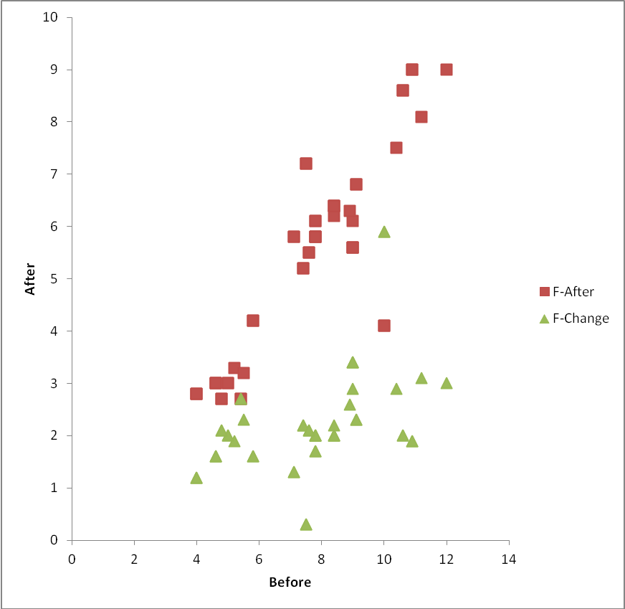
Figure 1: Lactate reduction in female athletes’ post-supplementation (Experimental group)

Table 1: Correlation of lactate reduction in female athletes post-supplementation (Experimental group)
Model name | Model | R² | Choice
Linear | y = 0.787x - 0.591 | 0.784
Exponential | y = 1.504e^{0.158x} | 0.784
Polynomial | y = -0.017x² + 1.044x - 1.484 | 0.785
Power | y = 0.52x^{1.144} | 0.815 | SELECTED

3.2. Lactate reduction in male athletes (Experimental group) after supplementation

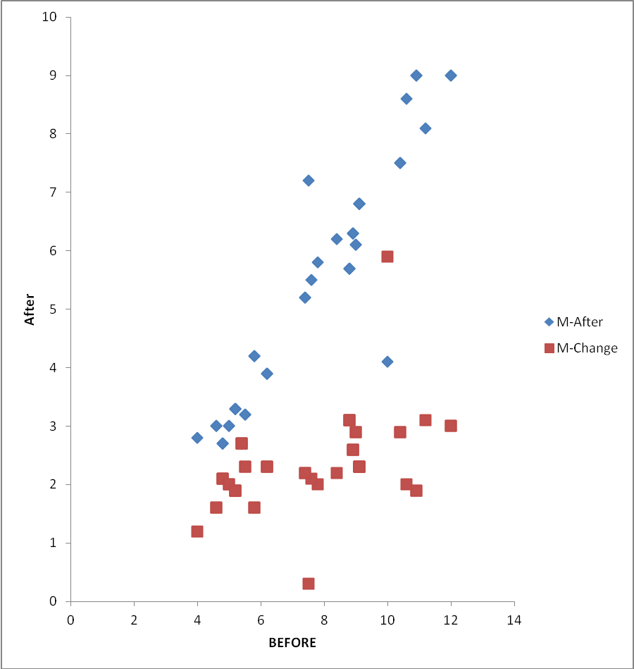
Figure 2: Lactate reduction in male athletes (Experimental group) after supplementation

Figure 2 shows lactate reduction in male athletes (experimental group) after supplementation. It shows higher lactate level reduction among male athletes after supplementation compared to that of the females in Figure 1.
And the correlation of lactate levels before and after the experiment shows stronger correlation on the effects of the supplement. Based on the degree of correlation, the power law model is selected as the equation of best fit (Table 2).

Table 2: Correlation of lactate reduction in male athletes post-supplementation (Experimental group)
Model name | Model | R² | Choice
Linear | y = 0.849x - 1.205 | 0.895
Exponential | y = 1.349e^{0.168x} | 0.887
Polynomial | y = 0.005x² + 0.761x - 0.89 | 0.892
Power | y = 0.410x^{1.246} | 0.901 | Selected

3.3. Lactate reduction in female athletes (Control)
Figure 3 shows lactate reduction in female athletes (control). The change in lactate levels in the female athletes as shown in Figure 3 shows no significant difference in the lactate levels post- supplementation in the control group.

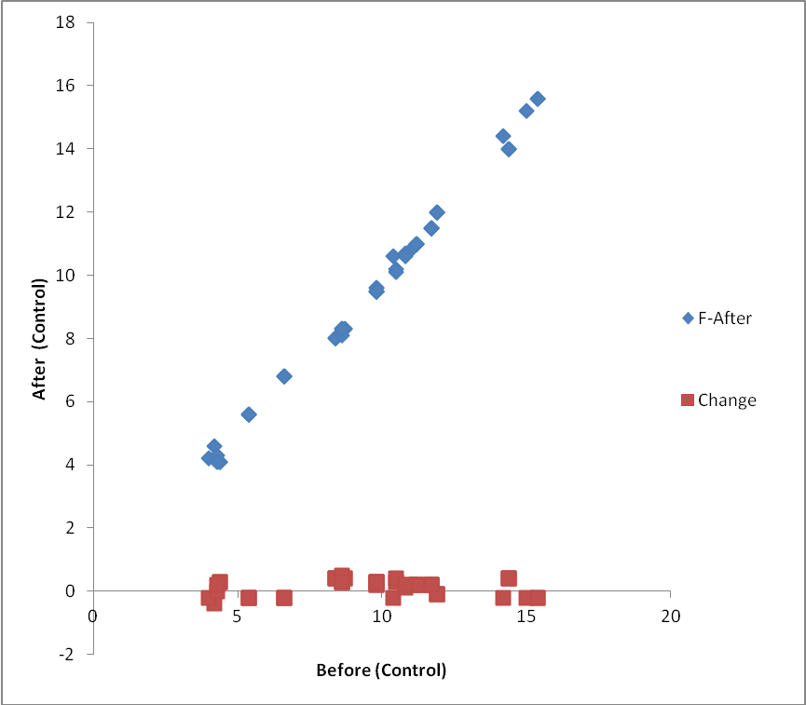
Figure 3: Lactate reduction in female athletes (Control)

3.4. Lactate reduction in male athletes (Control)
Figure 4 shows lactate reduction in male athletes (control). Figure 4 is identical to Figure 3 as no significant difference in lactate level reduction among the male athletes.
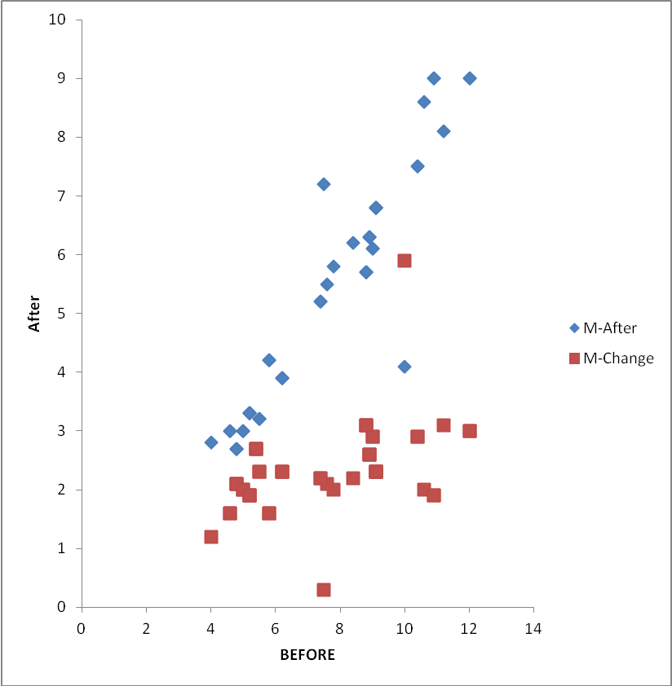
Figure 4: Lactate reduction in male athletes (Control)

3.5. Comparison of lactate level reduction between the experimental and control groups
Figure 5 shows comparison of lactate level reduction between the experimental and control groups of the female athletes.

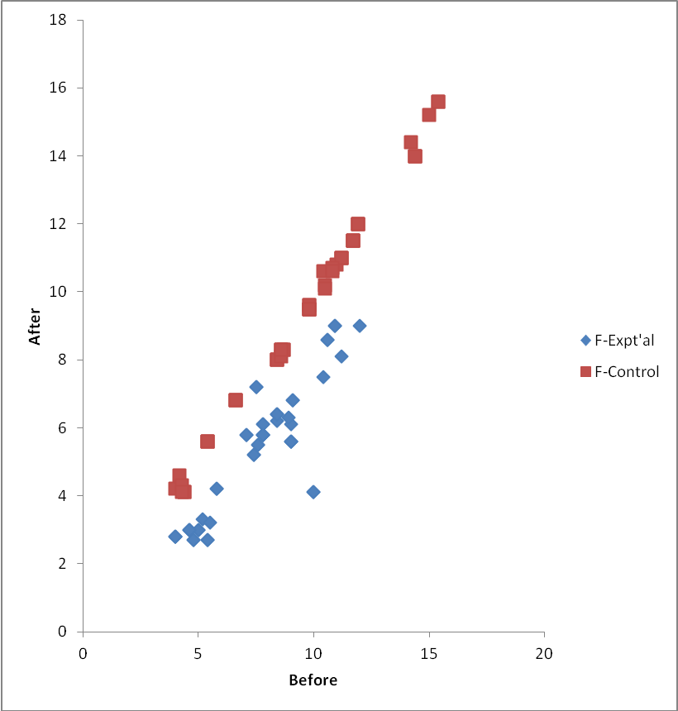
Figure 5: Comparison of lactate level reduction between the experimental and control groups of the female Athletes

Figure 6 shows comparison of lactate level reduction between the experimental and control groups of the male athletes. The best fit trend lines for the control and experimental groups are indicated.

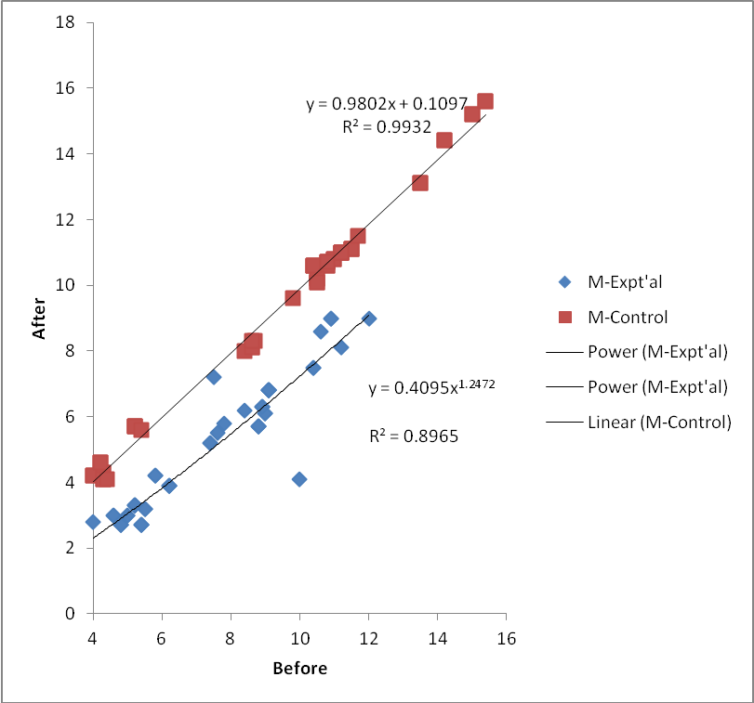
Figure 6: Comparison of lactate level reduction between the experimental and control groups of the male athletes

Figure 7 shows comparison of the change in LL between the experimental and control groups of the male athletes.

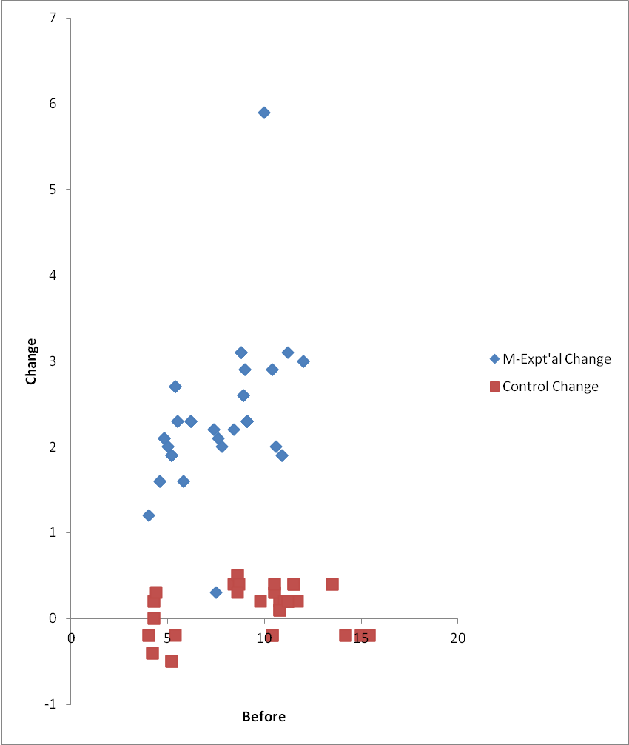Figure 7: Comparison of the change in LL between the experimental and control groups of the male athletes

Figure 8 shows comparison of lactate level reduction for the experimental group between the male and female athletes. The comparison of the female and male athletes as shown in Figure 8 indicates no significant difference in the impact on gender after supplementation.

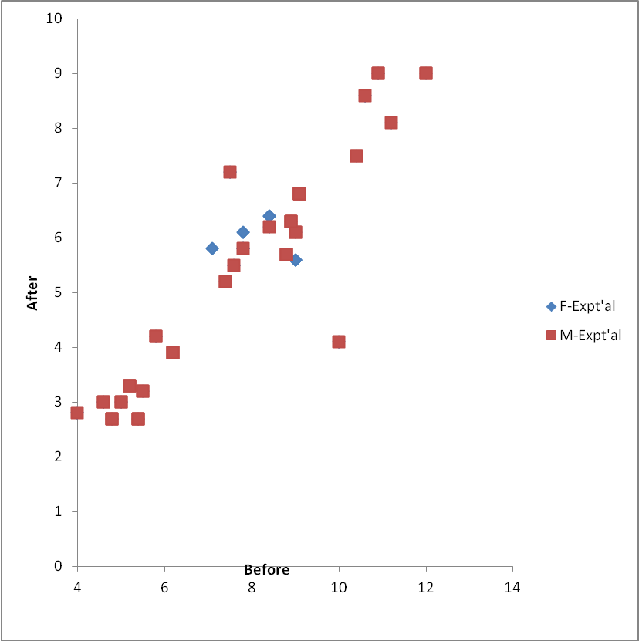
Figure 8: Comparison of lactate level reduction for the experimental group between the male and female athletes.

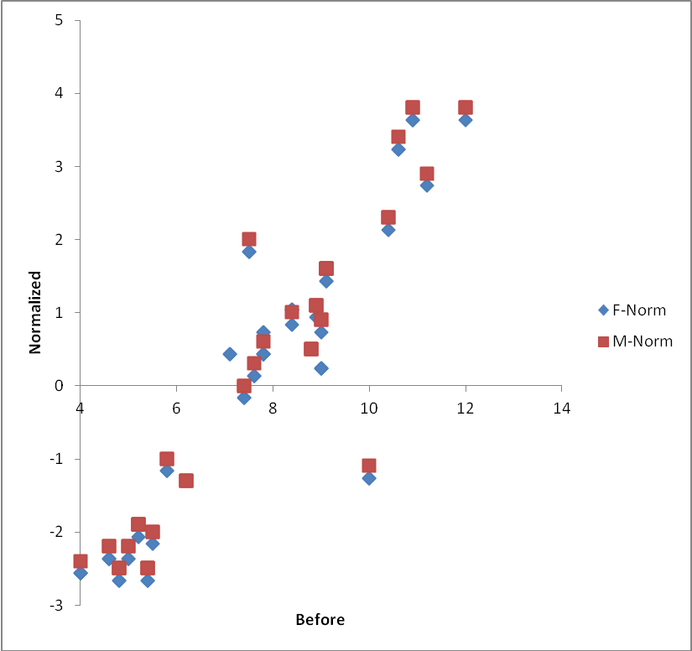
Figure 9: Comparison of normalized lactate level reduction for the experimental group between the male and female athletes

Figure 9 shows comparison of normalized lactate level reduction for the experimental group between the male and female athletes. The normalized plot of lactate level reduction indicates a slight difference in the reduction levels between the males and females. The male athletes show higher levels of reduction than the female athletes. The normalized data is obtained by subtracting the average of the post-supplementation results from the post-supplementation result of each athlete. The average is seen as the minimum acceptable reduction level below which the impact will not improve the performance of the athlete even if there is a change between the pre and post supplementation results.

4. Discussion
In this study, post-supplementation values for lactate levels were significantly lower in the experimental groups than in their controls. In other words, over the study period, Morinda citrifolia reduced the magnitude of exercise-induced elevation in lactate levels. The results obtained are consistent with the observations of Coombes and McNaughton (2000), Brancaccio et al. (2007), Palu et al. (2008a,b, 2010) and Tsai et al. (2009).
A highly probable explanation for this the reduction of blood lactate levels after Morinda citrifolia supplementation is that the supplement increases the oxygenation of muscle cells. With this increase in oxygen supply to the exercising skeletal muscles, ATP required to sustain activity is produced via the electron transport chain of the mitochondria rather than the conversion of pyruvate to lactate. Palu et al. (2008a,b, 2010) reported that Morinda citrifolia has ergogenic effect in mice and indicated that Morinda citrifolia increased the swimming time of mice (36 to 45%) before becoming fatigued, and increased their endurance time (59 to 128%) on a rotarod test, compared to their control. Further, the older mice in the Morinda citrifolia group performed similarly to the younger ones in the control group, with respect to swimming time and endurance.
Morinda citrifolia is reported to possess beneficial properties on the immune system, prevention of inflammation, cancers and numerous other health problems (Clafshenkel et al., 2012), but little is known about its ability to enhance performance. More recently, an array of commercial Morinda citrifolia fruit juice products are gaining popularity as dietary supplements, with claims of anti-cancer and immunostimulant activities (Samoylenko et al., 2006). The biologically active principles of Morinda citrifolia are not fully known (Samoylenko et al., 2006).
The limiting factors to exercise have been enumerated: accumulation of lactate; accumulation of phosphate ions; the activities of reactive oxygen species, and the depletion of glycogen stores. The ergogenic effects of Morinda citrifolia as confirmed by this study can be attributed to the multifarious mechanisms of action of the constituents of Morinda citrifolia.

Reference
- Brancaccio, P., N. Maffulli and F.M. Limongelli. (2007). Creatine kinase monitoring in sport medicine. British Medical Bulletin; 81 and 82: 209–230.
- Cady, E.B., Jones, D.A, Lynn, J. and Newhan, D.J. (1989). Change in force and intracellular metabolite, during fatigue of human skeletal muscle. Journal of Physiology 418:311-325.
- Champe, P.C., Harvey, R.A. and Ferrier, D.R. (2008). Reaction of glycolysis, Lippincott’s Illustrated Biochemistry Reviews (4th edition).
- Chase, P.B. and Kushmerick, M.J. (1988). Effects of pH on contraction of rabbit fast and slow skeletal muscle fibre. Biophysical Journal 53: 935 – 946.
- Clafshenkel, W.P., T.L. King, M.P. Kotlarczyk, J.M. Cline, W.G. Foster, V.L. Davis, and Witt-Enderby, P.A. (2012). Morinda citrifolia (NONI) Juice augments mammary gland differentiation and reduces mammary tumor growth in mice expressing the unactivated c-erbB2 transgene. Evidence-Based Complementary and Alternative Medicine.: 487423:1-15.
- Coombes, J.S., and McNaughton, L.R. (2000). Effects of branched-chain amino acid supplementation on serum creatine kinase and lactate dehydrogenase after prolonged exercise. Journal of Sports Medicine and Physical Fitness; 40: 240–246.
- Donaldson, S.K.B. and Hermanaen, L. (1978). Differential, Direct Effect Effects of H⁺ on Ca ²⁺- Activated Force of Skinned Fibres from the Soleus, Cardiac and Adductor Magnus Muscles of Rabbits. Pfluger Archive 376: 55-65.
- Holloszy, J.O. (1982). Muscle metabolism during exercise. Archives of Physical Medicine and Rehab. 63:231-234.
- Lamb, G.D., Stephen, D.G., and Bangsbo, J.C. (2006). Point counterpoint: lactic acid accumulation is an advantage/disadvantage during muscle activity. Journal of Applied Physiology, 100:1410-1412.
- Miller, R.G, Boska, M.D, Moussavi, R.S and Weiner, M.W. (1988). ³¹P nuclear magnetic resonance studies of high energy phosphate and pH in human muscle fatigue. Journal of Clinical Investigation 81: 1190 – 1196.
- Nelson, S.C. (2006). Nutritional analysis of Hawaiian Morinda citrifolia (Pure Noni Fruit Juice) The Noni Website. Retrieved 15-06-2009.
- Palu, A., Su, C., Zhou, B.N., West, B., and Jensen, J. (2010). Wound Healing Effects of Morinda citrifolia (Noni) Leaves: A Mechanism Involving its PDGF/A2A Receptor Ligand Binding and Promotion of Wound Closure. Phytotherapy Research, 24(10):1437-1441.
- Palu, A.K., Kim, A.H., West, B.J., Deng, S., Jensen, J., White, L. (2008a). The Effects of Morinda citrifolia L. (Noni) on the Immune System: Its Molecular Mechanisms of Action. Journal of Ethnopharmacolgy. 15(3):502-506.
- Palu, A.K., R.D. Seifulla and B.J. West. (2008b). Morinda citrifolia L. (Noni) Improves Athlete Endurance: Its Mechanisms of Action. Journal of Medicinal Plants Research 2(7): 154-158.
- Ranatunga, K.W. (1987). Effects of Acidosis on Tension Development in Mammalian Skeletal Muscle. Muscle and Nerve 10:439-445.
- Rivera, A., Giono, S., Gonzalez, M., Rodríguez, N. and Cedillo, L. (2011). Antibacterial Effect of Morinda citrifolia Fruit Juice against Mycoplasmas. Annals of Biological Research, 2 (3) :491-497.
- Samoylenko, V., Zhao, J., Dunbar, D.C., Khan, I.A., Rushing, J.W., and Muhammad, I. (2006). New Constituents from Morinda citrifolia (Morinda citrifolia) Fruit Juice. Journal of Agricultural and Food Chemistry, 54 (17): 6398–6402. DOI: 10.1021/jf060672u.
- Tsai, P.H., T-K.,Tang, C-L., Juang, K., W-C., Chen, C-A., Chi, and M-C., Hsu. (2009). Effects of Arginine Supplementation on Post-Exercise Metabolic Responses. Chinese Journal of Physiology 52(3): 136-142.

8/28/2014

