**Evaluation of some biochemical parameters in differentiation between Tuberculosis and non-Tuberculosis ascites patients**

Abeer A. Khayal 1 and S.A. Eissa2

1. Chemistry Department, Faculty of Science and Arts, Al Jouf University, Kingdom of Saudi Arabia

2. Clinical Pathology, Faculty of medicine, Cairo University, Egypt.

[E-mail: Abeerkhaial@yahoo.com.](E-mail:%20Abeerkhaial@yahoo.com.%0c)

**Abstract:** Cytology is an essential part in diagnosing malignancy. However not all malignant ascites could be detected by cytology. Other biochemical parameters should be included in ascetic fluid analysis to differentiate tuberculosis ascetic fluid and malignant (non tuberculosis ascetic fluid). The study included 70 patients with ascites. These patients were divided into three groups, (30) malignant patients HCC, (25) patients with liver cirrhosis and (15) patients tuberculosis peritonitis besides 20 healthy persons to serve as controls. The following parameters were carried out in serum and ascitic fluid: Total protein, Albumin, Lactate Dehydrogenase, (LDH), Alkaline phosphatase (ALP), tumor markers as Alpha-fetoprotein(AFT) and Carcinoembrionic antigen (CEA) in both serum and ascitic fluid, besides Tuberculosis detection by Poly Chain Reaction (PCR) technique, bacterial and cytological examination in ascetic fluid. The results showed some alternation in the studied parameters in both serum and ascetic fluid. The values of some biochemical parameters i.e SAAG, total ALP, total LDH, LD isoenzymes, AFP could be used to point out to the diagnosis of malignant cases. Adenosine deaminase activity (ADA) proved to be good parameter to point out the presence of tuberculosis TB in ascetic fluid. Also, the combined use of ascites ADA and PCR achieve the highest sensitivity making them useful tools for screening patients with tuberculosis TB.

**[**Abeer A.Khayal and S.A. Eissa. **Evaluation of some biochemical parameters in differentiation between Tuberculosis and non-Tuberculosis ascites patients.** *Nat Sci* 2014;12(9):30-35]. (ISSN: 1545-0740). <http://www.sciencepub.net/nature>. 6

**Key words:** ascetic fluid, tuberculosis, malignant

**1. Introduction:**

Ascites is a collection of extracellular fluid in peritoneal cavity resulting from imbalance between inflow and out flow through the peritoneal membrane (Karoo et al., 2003). The fluid is not a sequestrated static collection. There is continuous movement of solutes into and out of the peritoneal cavity (Sherlock, 1989& Runyon, 2013). Ascites can have many causes. In about 80 % of cases, it occurs during decomposition of chronic hepatic cirrhosis, but tumors account for 10 % of cases (Gulyas et al., 2001).

Cirrhosis is a premalignant condition irrespective of the etiology. The nodular hyperplasia progresses to carcinoma. In cirrhotic patients, it is independent risk factors for hepatocellular carcinoma. Dysplasia is found in 60% of cirrhotic livers harboring hepatocellular carcinoma and in only 10 % of non-cirrhotic liver. In terms of incidence of tuberculosis, Egypt is ranked among the mid-level incidence countries. Tuberculosis in Egypt is considered the second most important public health problem after Bilharziasis (WHO, 2002 & Kocaman, 2014).

Tuberculosis peritonitis can occur at any age but appears most common in young adults, principally in their third and fourth decades of life (Shetty and Kane, 1999). Labroscopic examination, supplemented by biopsy confirms tuberculosis peritonitis in 85 % to 90 % of cases. No laboratory tests completely distinguish malignant ascites from ascites associated with cirrhosis or tuberculosis. The diagnosis of TB ascites was accomplished by a sputum microscopic examination was performed of two serial sputum samples that had been stained with Ziehl-Neelsen Stain.

Ascitic fluid cytology appears to be very important for the detection of malignant ascites. However cytology does not detect all patients with malignancy related ascites because usually the cytology detects the cases with peritoneal carcinoma i.e. tumor cells lining the peritoneal cavity (Runyon, 1998).

Cytology should not be expected to detect tumor when peritoneum is not involved (e.g. hepatoma, massive liver metastasis, malignant lymphoma because hepatoma rarely metastasize to peritoneum; so, cytology is almost never positive (Runyon et al; 1988 & Shikha, 2014). Colli et al; (1993) found positive ascetic cytology in 12 % of patients with hepatocellular carcinoma.Also, some investigators found 17 % of ascitic fluid aspirates proved positive for malignant cells (Karoo et al., 2003 & Sadek et al., 1997).

Earlier studies tried to approach the differential diagnosis of ascites based on the estimation of ascitic fluid and concentration of total protein (Hoefs, 1981).serum ascites albumin gradient (SAAG) was found to be superior over ascites total protein concentration in the separation of "transudative ascites" (portal hypertension) and "exudative ascites "(non-portal hypertension) (Runyon et al., 1992 & Leksrisakul et al., 2001). Lactate dehydrogenase enzyme and LDH isoenzymes my be useful in differential diagnosis since tissue damage release isoenzymes contained therein, leading to a change in their pattern (Moss and Henderson, 1996 & Paavonen et al., 1991).

Alkaline phosphates ALP of liver origin can be increased in serum during liver disease. As general rule, the degree of ALP elevation reflects the severity of obstruction and the amount of biliary tissue involved.

Other non-invasive diagnostic test (ADA) have been recently introduced, the measurment of ADA in ascitic fluid could be used as a useful screening test for TB (Viot et al., 1989 and Gupta et al., 1992).

A great requirement exists for the specific and sensitive identification of M. tuberculosis by using PCR. PCR technique has the potential to be useful in the detection of very low number of microorganisms as occur in samples from patients with tuberculosis (Villegas et al., 2000 & Byrnes and Chopra, 2014): however it is expensive and relies on sophisticated equipment.

The aim of the present work is to study some biochemical parameters namely protein, albumin gradient, Lactate dehydrogenase (LDH), Alkaline Phosphatase (ALP) and their isoenzymes, Adenosine Deaminase activity ADA, turmor markers Alpha-fetoprotein (AFP), Carcinoembryonic antigen (CEA), DNA determination, besides bacterial and cytological examination to evaluate these parameters in both serum and ascitic fluid to differentiate between tuberculosis and non- tuberculosis patients (liver cirrhosis and malignant).

**2.Patients & methods**

Seventy The study was performed on 70 patients with ascites (30 patients with malignant ascites and 40 patients with non-malignant ascites). Patients with malignant ascites were presenting to the outpatient clinic of Medical Oncology Unit of the National Cancer Institute, Cairo University. While patients with liver cirrhosis and tuberculosis peritonitis were recruited from Hepatology unit, Kaser El Ani, Cairo University and their ages range (30–60 years). Besides 20 healthy individuals were included as healthy control group. their ages ranged (27-50 years).

The following investigations were carried out in the serum and ascitic fluid samples:-

Total Protein (T.P). Albumin (Alb). The serum-ascites albumin concentration gradient (SAAG). Cholesterol concentrations, Adenosine deaminase (ADA) activities. Alpha Fetoprotein (AFP) concentrations Carcinoembryonic antigen (CEA) concentrations. Alkaline phosphatase and its isoenzyme activities. Total Lactate dehydrogenase and its isoenzyme activities. Polymerase chain reaction (PCR) to detect tuberculosis in ascitic fluid only.

Statistical analysis: The results of clinical evaluations, diagnostic tests, ADA activity, and PCR were analyzed using computer software (SPSS, version 7.5; SPSS; Chicago, IL) (Metz, 1978 and Henderson 1993). The sensitivity, specificity, Positive Predictive Value (PPV), and Negative Predictive Value (NPV) of ADA activity and PCR results were compared to each of the conventional methods. The results of the ascitic fluid cultures and histopathological testing were used as the “gold standard.”

Sensitivity = true positive/ (true positive + false negative) x 100;

Specificity =: true negative/ (true negative + false positive) x 100.

The sensitivity and specificity of the diagnostic methods were determined using the result of each of the diagnostic methods for each patient. Therefore, the unit of analysis was the patient, not the clinical specimen or test. Comparisons between the diagnostic methods were performed using a McNemar x2 test (P > 0.05). Student’s t test and analysis of variance were used to compare the mean production of ALP and LDH enzyme and its isoenzyme activities among groups. PPVs and NPVs were estimated using Bayesian analysis (Hulley, et al., 1988) with a TB prevalence range of 1 to 50% for the patient population with ascetic fluid

Cut off limits for the chemical analyses were calculated on the basis of receiver operating characteristics (ROC) (Galen & Gambino, 1977).

**3. Results & Discussion**

Total protein concentration of 2.5 g/dl has traditionally been used to separate "transudative" ascites due to cirrhosis or HCC from "exudative" ascites due to tuberculosis. However, in our study, ascitic fluid total protein level was greater than 2.5 g/dl in 23 % (7/30) in patients with HCC, 28 % (7/25) in patients with liver cirrhosis and 86 % (13/15) in patients with tuberculosis.

Our findings confirmed that the superiority serum ascites albumin difference over ascites total protein concentration in the separation of transudative ascites (e.g. cirrhotic and HCC patients) and exudative ascites (e.g. tuberculosis). This gradient reflects the hydrostatic pressure difference between the portal capillaries and peritoneal cavity serum total protein and albumin levels were significantly lower in all studied groups compared to control. The significant decrease in albumin in cirrhotic groups may be attributed to the dysfunction of the liver cells, so they were unable to synthesize albumin at normal rate.

Our study suggested that the determination of ascitc fluid cholesterol was of limited value for the diagnosis malignant ascites.



Figure 1. Mean value for Ascitic fluid TP, ALB and SAAG concentration (g/dl) in different studied groups

Ascitic fluid ADA showed elevated levels in patients with tuberculous peritonitis more than liver cirrhosis and malignant groups. This is due to the stimulation of T-lymphocyte in response to cell-mediated immunity to mycobacterial antigens. Our results showed that the determination of ADA activity in ascitic fluid has a high sensitivity 86.7 % and specificity 98.2 % for the diagnosis of active peritoneal tuberculosis. Thus, the present study suggests that the detection of adenosine deaminase activity (ADA) is a useful test for the diagnosis of ascitic TB and in differentiating it from other causes of ascites ( Byrnes and Chopra,2014)

PCR assays have been devised for the rapid identification of mycobacterium in clinical samples. The technique has been shown to be highly specific and sensitive for the diagnosis of tuberculosis. According to our data, the sensitivity of this PCR for the detection of M. tuberculosis DNA is very high (14/15) 93%. Therefore, this PCR technique has the potential to be useful in the detection of very low number of microorganisms as occur in samples from patients with tuberculosis.

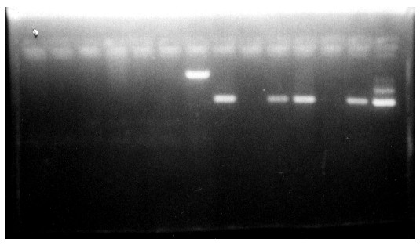

**Picture** (1): Electrophoresis separation of Amplified DNA M. tuberculosis isolated from Ascitic Fluid by PCR in Different Studied Groups.

The measurement of ADA activity when combined with PCR method yielded higher sensitivity (100 %) making them useful tools for screening patients with TB.

**Table (1**): Overall combined sensitivity, specificity, positive predictive value (PPV), negative predictive value (NPV) and accuracy of ADA and PCR when tested independently or in combinations

|  |  |  |  |  |  |
| --- | --- | --- | --- | --- | --- |
| **Marker** | **Sensitivity%** | **Specificity%** | **PPV%** | **NPV %** | **Accurcy%** |
| **ADA** | 86.7 | 98.2 | 86.7 | 982 | 943 |
| **PCR** | 93.3 | 98.2 | 93.3 | 982 | 971 |
| **ADA**  **+ PCR** | 100 | 96.4 | 88.2 | 100 | 971 |

There was good relationship between the ADA activity and total protein level in ascitic fluid in tuberculosis peritonitis (r=0.68)(Fig 5 ).But there was no correlation of ADA activity in the malignant and liver cirrhotic group with their ascitic fluid total protein (r=0.31, r=0.30 respectively ).

In this study, AFP in serum and ascitic fluid showed significantly higher levels in malignant group HCC compared to non malignant group, and there was a highly significant direct positive correlation between the level of AFP in serum and ascitic fluid in patients HCC where they run parallel to each other with correlation coefficient r=0.74.

Sensitivity of in AFP in serum was 56.7% and in ascitic fluid was (76.6%), this suggests that in HCC with elevated AFP in ascitic fluid, there is an active process of secretion of AFP in ascitic fluid from the tumor into the peritoneal cavity and not simple transudation of AFP from serum to ascitic fluid.

Our study revealed significant higher levels of serum T.LDH in malignant group compared to non- malignant groups. Due to LD production from anaerobic metabolism as well as from damage caused by the expansive growth of the tumor, all LD fractions (LD1, LD2, LD3, LD4 and LD5) were usually elevated in malignancies involving the liver This constellation may be considered characteristic of malignant liver disease. Also, high percentage of LD5 in malignant group were observed than those of non- malignant groups, this is due to predominance LD5 in hepatocytes and therefore the activity of this fraction in serum is abnormally high in liver damage our study revealed significant higher levels of ascitic T.LDH in malignant group compared to non malignant groups (liver cirrhosis & tuberculosis peritonitis).Also, ascitic total LDH demonstrated high diagnostic sensitivity 70 % and specificity 95 % than serum total LDH which showed sensitivity and specificity 53 %, 92 % respectively in malignant group.

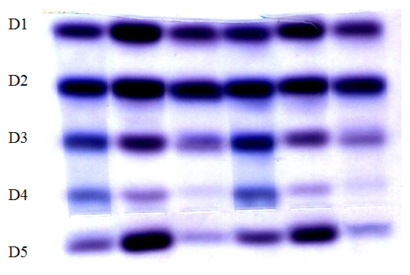

**Picture (2):** Serum Lactate Dehydrogenase Isoenzyme Patterns Separated on 1% Agarose pH.8.6

A lower percentage of LD1 were detected in malignant ascites group (16.6%) than non-malignant ascites group (liver cirrhosis 24.8 % and tuberculosis peritonitis 22.3%). Also highest percentage of LD3 activity was detected in patients with tuberculosis peritonitis (29.8 %) when compared to malignant group (22.5 %), liver cirrhosis group (17.8 %). This could be due to LDH isoenzymes may be released from cells that have infiltrated the body fluid other than serum.For example, in viral and tuberculous meningitis causing lymphocytosis, it may creat an elevation of LD1 through LD3.

Alkaline phosphatas (ALP) is an important enzyme mainly derived from the liver, bones and minute amounts from intestines, placenta and kidneys. In our study, the serum alkaline phosphatase activity rises in many types of liver disease, the highest levels being seen in patients with obstruction to the flow of intra-hepatic space occupying lesions such as primary liver tumors.

In the present study, serum ALP activities increased in malignant patients HCC than the patients with non-malignant disease. The enzyme activities of ALP make useful and practical contribution to the diagnosis of malignant cases. Furthermore, isoenzyme pattern of ALP gave more accurate picture of the involved organ either the liver or the bone. Also, the isoenzyme pattern of ALP in the ascetic fluid is useful in the diagnosis of malignant patients.

However, this could be identified of the isoenzymes by means of PAGE, heat inactivation and chemical inhibition methods to determine the origin of the enzyme in serum, which in our studied groups was mainly from liver indicating that the liver is affected to certain extent in some cases (probably early stage of hepatocellular carcinoma) perhaps could be due to partial cholestasis.

Our results showed that I.ALP was not detected in healthy controls but was detected in 14 out of 25 (56 %) of patients with cirrhosis and in 3 out of 30 (10 %) of patients with malignant group HCC and 8 out of 15 (53 %) of TB patients by electrophoresis and confirmed by the high values of L-phenylalanine percent inhibition.

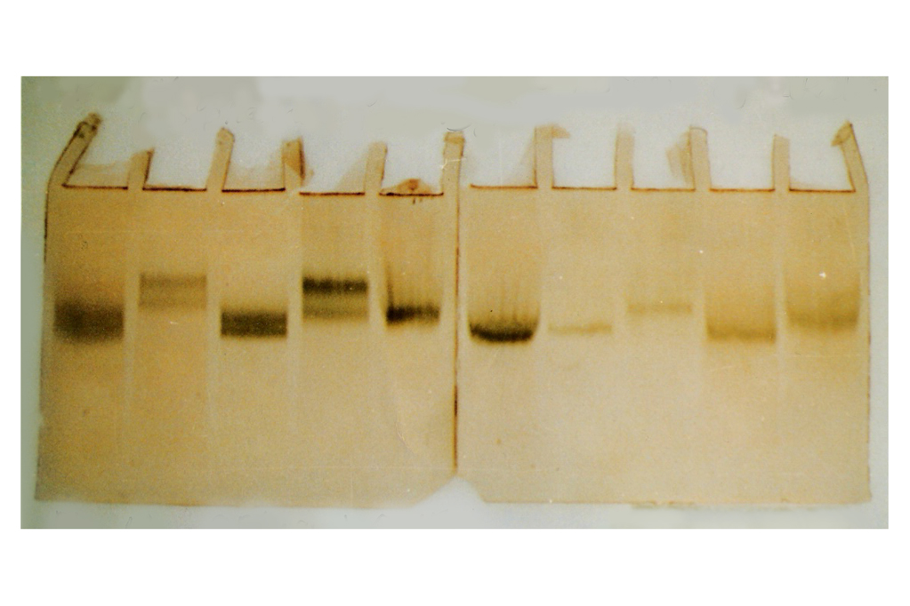

**Picture (3):** Polyacrylamide gel Electrophoresis of Alkaline Phosphatase isoforms in serum sample of healthy control, at pH 9.5 which showed the effect of partial digestion with neuramindase on Electrophoretic mobilities of bone and liver phosphatases.

Our study showed that ascitic T.ALP was elevated in malignant group than non malignant group. A level 91.1 U/L of ascitic alkaline phosphatase can be considered a cut off level separating patients with malignant ascites HCC from patients with non-malignant ascites (liver cirrhosis and TB) with a high sensitivity 100 % and specificity 97.5 %.

The electrophoretogram of the ascitic fluid showed one main band (liver isoenzyme) and in some cases the intestinal isoenzyme was found in (23.3% malignant, 52% cirrhosis and 73.3%TB),the presence of the intestinal isoenzyme was confirmed by the high values of L-phenylalanine percent inhibition.

Our results showed that all non-malignant cases (liver cirrhosis and TB peritonitis) were negative for malignant cells cytology (100%). A positive cytology for malignant cells were detected in 5/30 cases (16%), while 25/30 cases (84%) showed a negative cytology in malignant group HCC but proved by CT guided biopsy as malignancy. The low positively of ascitic fluid cytology reflects to the limited tendency of HCC to metastasize to the peritoneum.

ascitic total leukocyte count (TLC) showed no significant difference between the malignant and liver cirrhotic group where all cases of these groups showed ascitic TLC < 500 mm3 except two cases of the malignant HCC showed TLC > 500 mm3. These cases were probably due to the presence of malignant cells as their cytology gave positive results.

Ascitic total leukocyte count TLC in tuberculosis peritonitis group showed TLC > 500 mm3 in all cases of this group. The elevation of TLC is usually due to many lymphocytes and some polymorphs.

Finally, the study recommend that the values of some biochemical parameters could be used to point out to the diagnosis of the malignant and non malignant cases (i.e. SAAG, total ALP, total LDH, LDH isoenzymes, AFP) and proved to be the promising parameters in differentiating malignant and non malignant ascites.

Also, the combined use of ascites ADA (86.7%) as well as PCR (93.3%) achieve the highest sensitivity (100%) making them useful tools for screening patients with tuberculosis (TB).

**References:**

1. Byrnes V, Chopra S: Tuberculous peritonitis. In: UpToDate, Post, BA, ed. UpToDate, Waltham, MA; (2014) 25: 79-80
2. [Colli A, Cocciolo M, Riva C, Marcassoli L, Pirola M, Di Gregorio P, Buccino G.](http://www.ncbi.nlm.nih.gov/entrez/query.fcgi?cmd=Retrieve&db=pubmed&dopt=Abstract&list_uids=8392901&query_hl=3&itool=pubmed_docsum): Ascitic fluid analysis in hepatocellular carcinoma. Cancer., (1993)72(3):677-82
3. Galen R.S., Gambino S.R.: Sensitivity, specificity, prevalence and incidence: In Gambino SR, eds. Beyond normality: the predictive value and efficiency of medical diagnoses. New York.Wily Biomedical: 10-4,(1977).
4. [Gulyas M, Kaposi AD, Elek G, Szollar LG, Hjerpe A.](http://www.ncbi.nlm.nih.gov/entrez/query.fcgi?cmd=Retrieve&db=pubmed&dopt=Abstract&list_uids=11684715&query_hl=11&itool=pubmed_docsum) Value of carcinoembryonic antigen (CEA) and cholesterol assays of ascitic fluid in cases of inconclusive cytology. J Clin Pathol., (2001): 54(11):831-5.
5. [Gupta VK, Mukherjee S, Dutta SK, Mukherjee P.](http://www.ncbi.nlm.nih.gov/entrez/query.fcgi?cmd=Retrieve&db=pubmed&dopt=Abstract&list_uids=1452564&query_hl=9&itool=pubmed_docsum) Diagnostic evaluation of ascitic adenosine deaminase activity in tubercular peritonitis. J Assoc Physicians India, (1992): 40(6):387-9.
6. Hoefs, J.C. The mechanism of ascitic fluid protein concentration increase during diuresis in patients with chronic liver disease.Am. J. Gastroenterol, 76: 423-31.
7. Hully SB, Gove S, Borwner WS. In Hully SB, Cummings AND Sr, eds. Designing clinical research. Baltimore, MD: William &Wilkins. (1988).
8. [Karoo RO, Lloyd TD, Garcea G, Redway HD, Robertson GS.](http://www.ncbi.nlm.nih.gov/entrez/query.fcgi?cmd=Retrieve&db=pubmed&dopt=Abstract&list_uids=12782778&query_hl=16&itool=pubmed_docsum) How valuable is ascitic cytology in the detection and management of malignancy? Postgrad Med J., (2003): 79(931):292-4.
9. Kocaman O. Understanding tuberculous peritonitis Turk J Gastroenterol; (2014):25: 79-80.
10. Leksrisakul S, Juangpanich P, Riantawan P, Chantrasunthornkul V, Rojanarsweewong P. Adenosine deaminase levels in lymphocytic ascites of TB and non-TB peritonitis.Intern. Med. J. Thai, (2001) 17 (4): 304-310.
11. Metz CE: Basic principles of ROC analysis. Semin Nucl Med (1978.) 8: 283-5.
12. Moss DW, Henderson AR Enzymes. In: Burtis CA, Ashwood ER, ldrish JE. Tietz. Fundamentals of clinical chemistry. 4th edition ed. W.B. Saunders Copany. Philadilphia. pp. 308-311. (1996).
13. [Paavonen T, Liippo K, Aronen H, Kiistala U.](http://www.ncbi.nlm.nih.gov/entrez/query.fcgi?cmd=Retrieve&db=pubmed&dopt=Abstract&list_uids=1934463&query_hl=10&itool=pubmed_docsum) Lactate dehydrogenase, creatine kinase, and their isoenzymes in pleural effusions. Clin Chem., (1991): 37(11):1909-12.
14. Runyon BA, Introduction to the revised American Association for the Study of Liver Diseases Practice Guideline management of adult patients with ascites due to cirrhosis 2012. Hepatology; (2013): 57(4):1651.
15. [Runyon BA](http://www.ncbi.nlm.nih.gov/entrez/query.fcgi?cmd=Retrieve&db=pubmed&dopt=Abstract&list_uids=3417231&query_hl=16&itool=pubmed_docsum) Ascites and spontaneous bacterial peritonitis. In: Sleisenger MH, Fordtan JS. Eds. Gasterintestinl and liver disease. 6th ed. Philadelphia: Saunders, p. 1180. (1998).
16. [Runyon BA, Hoefs JC, Morgan TR.](http://www.ncbi.nlm.nih.gov/entrez/query.fcgi?cmd=Retrieve&db=pubmed&dopt=Abstract&list_uids=3417231&query_hl=16&itool=pubmed_docsum) Ascitic fluid analysis in malignancy-related ascites. Hepatology, (1988): 8(5):1104-. 1109.
17. [Runyon BA, Montano AA, Akriviadis EA, Antillon MR, Irving MA, McHutchison JG.](http://www.ncbi.nlm.nih.gov/entrez/query.fcgi?cmd=Retrieve&db=pubmed&dopt=Abstract&list_uids=1616215&query_hl=17&itool=pubmed_docsum) The serum ascites albumin gradient is superior to the exudates transudate concept in the differential diagnosis of ascitesAnn Intern Med; (1992):117:215-220.
18. Sadek, A.; Abdel-Hady, A; el-Ayyat-A; Hassan, M; Mostafa, I., Nouh-A. Alpha feto-protein and albumin in ascitic fluid in hepatocellular carcinoma patients. J. Egypt. Soc. Parasitol; Aug; (1997): 27(2): 455-64.
19. Sherlock, S. Diseases of the liver and biliary system. 8th edition. Blackwell Scientific Publications. Oxford, London, Edinburgh. (1989).
20. Shikha, NG A Cytological Study of Peritoneal Fluids and Its Clinicobiochemical Correlation. (2014):13, ( 2): 12-15.
21. [Villegas MV, Labrada LA, Saravia NG.](http://www.ncbi.nlm.nih.gov/entrez/query.fcgi?cmd=Retrieve&db=pubmed&dopt=Abstract&list_uids=11083686&query_hl=30&itool=pubmed_docsum) Evaluation of polymerase chain reaction, adenosine deaminase, and interferon-gamma in pleural fluid for the differential diagnosis of pleural tuberculosis. Chest, (2000): 118(5):1355-64.
22. World Health Organization (WHO) An expanded DOTS framework for effective tuberculosis control. Stop TB Communication disease, WHO, Geneva, Switzerland. (2002).

8/15/2014