Effect of compression on the electrical resistivity of EPDM/NBR rubber blends filled with different types of carbon black

H.N.M. Alsuhaiqi*, A.A. El-Gamel, S.A. Khairy and H.H. Hassan

Faculty of Science, Department of Physics, Cairo University, Giza, Egypt
*hezam.naji1986@gmail.com

Abstract: Blends of ethylene-propylene diene monomer/acrylonitrile butadiene (EPDM/NBR) loaded with different ratios of N-326(HAF):N-774(SRF) carbon black fillers were prepared. The mechanical properties of pure rubber blends and those loaded with different ratios of carbon black were investigated. The 75EPDM:25NBR blend was found to exhibit the highest values of tensile strength and elongation at break. The observed changes in the mechanical properties of blends were correlated to the morphology as observed by SEM. The changes of the electrical resistivity of the rubber blends during compression were investigated. Based on the shell structure theory, the experimental results were explained from the view that external pressure induces the creation and annihilation of effective conductive paths, leading to the changes in the resistivity of blends.
[Alsuhaiqi HNM, El-Gamel AA, Khairy SA and Hassan HH. Effect of compression on the electrical resistivity of EPDM/NBR rubber blends filled with different types of carbon black. Nat Sci 2014;12(8):154-161]. (ISSN: 1545-0740). http://www.sciencepub.net/nature. 21

Keywords: EPDM; NBR; tensile strength; elongation; SEM

1. Introduction
Blending two or more polymers to produce new materials with mixed properties has been extensively developed in several industries [1]. Polymer composites doped with carbon-based fillers have attracted growing interest due to their potential use in various applications [2]. The type, concentration, particle size, and structure of the filler are the key factors in determining the mechanical and electrical properties of the polymer [3, 4].
The incorporation of conductive additives, as carbon black, has been reported to form carrier path throw the insulating matrix [5]. It has been pointed out that, the interaction between polymer and carbon black has a significant impact on the electrical and mechanical properties [6, 7]. The mechanical properties of polymer blends are highly dependent on the blend ratio, characteristics of blend constituents, processing conditions, and phase morphology.
The reinforcement of rubber properties by the incorporation of carbon black is due to the presence of active polar groups such as phenol, carboxyl, quinine and lactones on the carbon black surfaces [8]. Sau et al [9] found that a higher elongation at break is observed for EPDM based composites. In addition, electrically conductive particle in polymer could produce flexible piezoelectric materials [10]. The correlation between the external pressure and the electrical resistivity of the composites has been intensively investigated [11-15]. Voet et al. [16] and Sircar et al [17] studied the electrical resistance of carbon black filled styrene butadiene rubber at constant shear strain.
The present work aims to study the effect of static pressure on the electrical resistivity of conductive blends of EPDM/NBR rubbers. We have also measured the changes in the electrical resistivity with time after the instantaneous static load was applied.

2. Experimental
2.1. Materials
Ethylene Propylene Diene Monomer (EPDM) with diene monomer content of 5 %, and Nitrile Butadiene Rubber (NBR) with nitrile content 34% have been blended together according to the recipe illustrated in Table (1). We have used two different types of carbon black namely, the High Abrasion Furnace black (HAF-LS or N-326) and the Semi Reinforcing Furnace black (SRF -HS or N-774). The physical and chemical properties of both blacks are listed in Table (2). All other ingredients such as sulfur, zinc oxide, stearic acid, dioctylphthalate and diphenyle guanidine are obtained from the commercial grades.

2.2 Samples preparation
All rubber compounds were mixed according to the ASTM D 3182 by using two-roll mill machine of 300 mm length, 150 mm diameter, and gear ratio 1.4. Different ratios of Ethylene Propylene Diene Monomer (EPDM)/Acrylonitrile Butadiene (NBR) rubber blends were prepared with {(0:100), (25:75), (50:50), (75:25), and (100:0)} respectively. Each blend was reinforced with different ratios of [N-326: N-774] as {(0:100), (25:75), (50:50), (75:25), and (100:0)}. Other

ingredients were used and compounded according to the recipe listed in Table (1). The compounded rubbers were molded into discs of 1 x 10⁻⁴ m² area and 0.01 m thick.
The vulcanization process was carried out by using an electrically heated platen press at 153±2ºC and 4 MPa for 30 min.

2.3. Experimental techniques
Scanning Electron Micrographs were carried out using a JEOL electron microscope model JSM-T 20, Japan. The experimental set-up for measuring the electrical resistivity of the investigated samples is shown in Fig. (1). Two iron plats were attached to the sample during the vulcanization process with good ohmic contacts and were used as electrodes. The electrical resistance was recorded by using a digital multimeter of accuracy 1%.
The electrode area is a little less than that of the sample to keep the transverse size invariant during the compression. The sample was compressed instantaneously to a certain pressure (P) by using a hydraulic press up to 15 MPa. Then the pressure was kept invariant for 1.5 hrs.

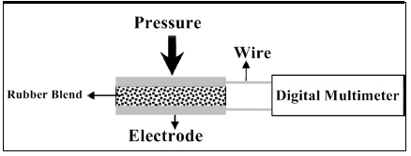

Figure 1. Sketch of experimental set-up for measuring resistance of the rubber blends

Table 1. The compositions of EPDM /NBR rubber blends loaded with different types of carbon black

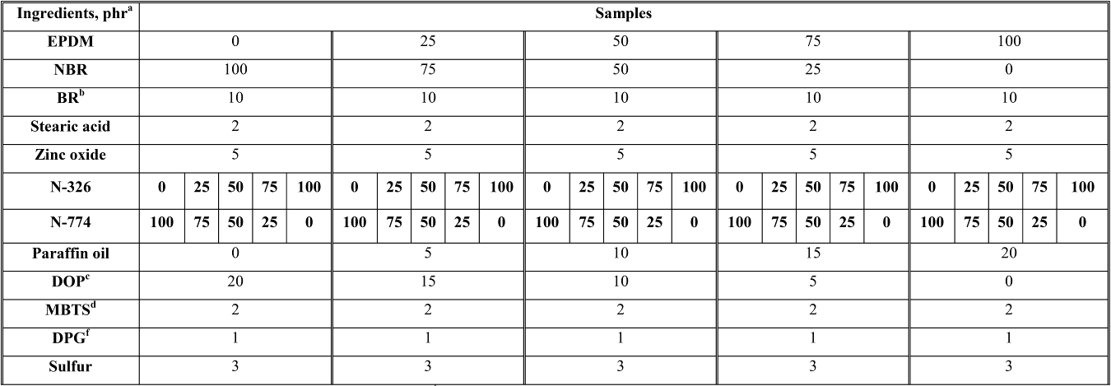

ª Part per hundred parts of rubber by weight
^{b} Butadiene rubber
^{c} Dioctyl phythalate
^{d} Dibenzthiazyl disulphide
^{f} Diphenyl Guanidine

Table 2. Physical and chemical properties of the different types of black used [18]
Properties | Particle size, nm | Surface area, m²/g | PH
N-326 (HAF-LS) | 29 | 80.0 | 7.0
N-774 (SRF-HS) | 70 | 28.0 | 9.0

3. Results and Discussion
3.1. Stress-Strain Curves

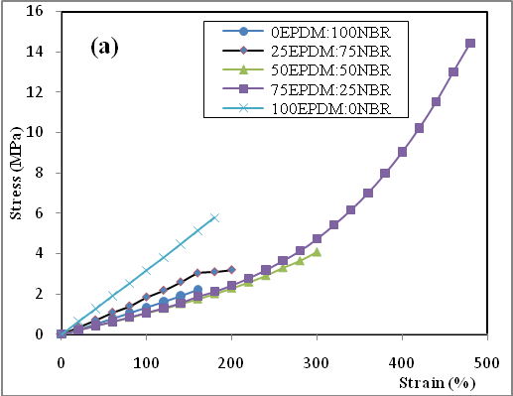
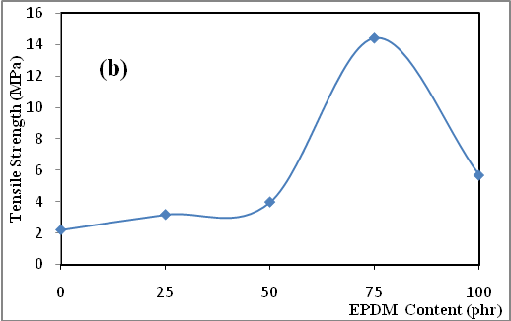
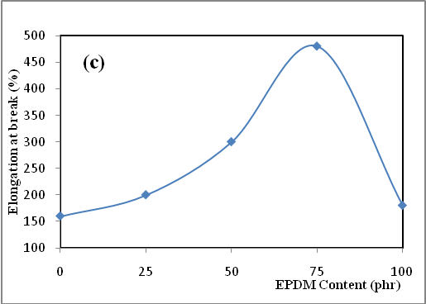

Figure 2:a-c. stress-strain curves, tensile strength, and elongation at break versus the blend ratio of EPDM/NBR without carbon black

Figure (2:a) shows the stress-strain curves of EPDM/NBR rubber blends. It is noticed that, as the EPDM content increases the tensile strain increase. This may be attributed to the expected orientation of crystalline regions of EPDM upon extension [9]. It also observed that, as the content of EPDM increases the tensile strength increases up to a certain maximum value at (75EPDM:25NBR) blend as shown in Fig. (2:b). Beyond this ratio, the tensile strength decreases. This could be due to phase change taking place in the blend systems, where the EPDM in this region of the phase tends to be in a continuous phase.
The relationship between elongation at break and rubber blend ratio (EPDM/NBR) is presented in Fig. (2:c). The elongation at break increases also with increasing EPDM content [19]. Thereafter it shows a marked decrease so from these figures, the blend (75EPDM:25NBR) exhibits the good mechanical properties compared with other blends.
Some mechanical properties such as tensile strength, and elongation at break of rubber blends filled with different carbon black types like N-326, and N-774 with different ratios {(0:100), (25:75), (50:50), (75:25), and (100:0)} have been also studied. The tensile strength versus the blends ratio (EPDM/NBR) was shown in Fig. (3:a). The degree of reinforcement is found to be at its highest for pure EPDM rubber followed by pure NBR [9, 19]. EPDM rubber and NBR, because of their difference in polarities are incompatible with each other and therefore the degree of reinforcement in each blend is relatively lower than the level of reinforcement that can be achieved in the pure components [9]. It was clear that, the blend ratio (75EPDM:25NBR) has the highest value of the tensile strength than other blends. Both EPDM rubber and NBR are considered as non-self-reinforcing rubbers and carbon black is regarded as being reinforcing fillers [19]. Also, the highest value of tensile strength appears in the blend which has high content of N-326 carbon black due to its small particle size (higher surface area)which can produce good reinforcement.
Fig. (3:b) shows the elongation at break with rubber blends EPDM/NBR loaded with different ratios of carbon blacks. The higher values of the elongation at break are observed for EPDM followed by NBR rubber. This is because the EPDM matrix has greater chain mobility than that of the NBR matrix, since the Tg of EPDM is -80 ºC whereas for NBR it is -40ºC [20].
Based on the Stress-Strain studies for the rubber blends (EPDM/NBR) unfilled and filled with different types and ratios of carbon black filler, it was observed that, the rubber blend (75EPDM:25NBR) was the optimum blend which gives good mechanical properties.

3.2. Morphology analysis
Figure (4:a-e) shows the scanning electron micrographs (SEM) of rubber blends of different ratios (EPDM/NBR) without carbon black filler. The morphology analysis of the blends shows that the

blend (75EPDM:25NBR) is the effective blend formation via continuous phase formation, i.e. the components are found homogenized, and excellent structure arrangement than the other blends as shown in Fig. (4:d). As NBR content increases, miscibility of the blend decreases and the crack propagation increases in the other samples which have shown pullouts at its fractured. Also, the depth of the cracks in these samples was increased. A careful examination of the sample morphologies shows that with increasing concentration of EPDM, the blend morphology becomes better and better and this performance also was matched with the mechanical properties.

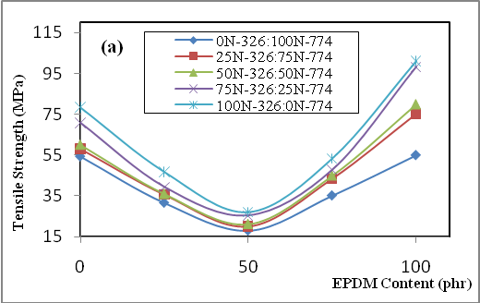
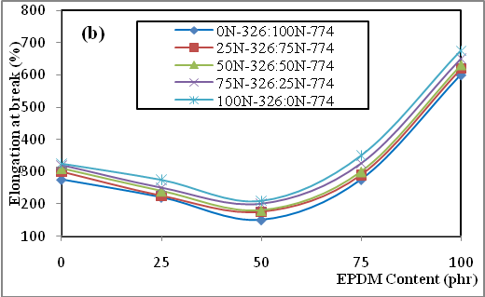

Figure 3:a, b. The tensile strength and the elongation at break versus the blend ratio of EPDM/NBR with different ratios of carbon black fillers

3.3. Effect of pressure on the electrical resistivity
From the previous parts, we found that blend (75EPDM:25NBR) is the best blend, so we choose it to study the effect of pressure on its electrical resistivity. Fig. (5:a-c) show the time dependence of the electrical resistivites of the optimum rubber blend (75EPDM:25NBR) loaded with different ratios of carbon black filler (75N-326:25N-774), (50N-326:50N-774), and (25N-326:75N-774) respectively after loading with different static pressure values; P = 5 MPa, 10 MPa, and 15 MPa. The electrical resistivities of the rubber blend increases instantaneously at the moment and immediately after the sample is loaded from 0MPa to a certain pressure P. After which the electrical resistivity decreases exponentially with time under the constant pressure P. It is noticed that, as the compressive pressure P increases the electrical resistivity increases. It is clear also from the figure that, as carbon black N-326 content increases the resistivites decrease. This can be explained due to the smaller particle size (29 nm) of N-326 black than that of N-774 (70 nm) which enables it to form aggregations which increases the conduction paths through the insulating rubber matrix.
To analyze the changes in the electrical resistivity of rubber blend (75EPDM:25NBR) several variables are defined; ρ_{i}(o⁻) which represents the electrical resistivity of the rubber blend before the compression process. ρ_{i}(o⁺) represents the electrical resistivity at the moment immediately after the compression. ∆ρ_{i} represents the instantaneous increment of the resistivity at the moment immediately after the sample loaded from 0 MPa to pressure P, and it can be expressed by ∆ρ_{i =} ρ_{i}(o⁺) - ρ_{i}(o⁻). ∆U_{i} represents the total decrement of the resistivity for the rubber blend under compression, and it can be expressed by ∆U_{i =} ρ_{i}(o⁺) - ρ_{i}(t), where ρ_{i}(t) represent the resistivity after time t.
The instantaneous increment of the electrical resistivity ∆ρ_{i}, increases slightly with the increase of the instantaneous loading pressure (5 MPa, 10 MPa, and 15 MPa), for rubber blend (75EPDM:25NBR) at different carbon black ratios (N-326:N-774) as shown in Fig. (6). The total resistivity decrement ∆U_{i} increases also with the increase of the instantaneous loading pressure, as in Fig. (7). From Fig.s (6, 7) it was shown that, as N-326 increases the instantaneous increment of the electrical resistivity (∆ρ_{i}) and the total resistivity decrement (∆U_{i}) decrease.
The experimental phenomena can be explained and described by analyzing the changes in the conductive network of the rubber blend as follows. It was pointed out that, the blend is a three dimensional conductive network composed of rubber macromolecule and carbon black [21]. The electrical resistivity of the blend is decided by the changes in the conductive carbon black network. When the gap between carbon black particles is small enough, the tunneling effect occurs, inducing the formation of local conductive path (LCP). If LCP penetrates insulating matrix, an effective conductive path (ECP) is formed, thus contributing to the conductivity of the blend, the external pressure changes ECP, leading to the changes in the resistivity of the blend.

Figure 4:a-e. SEM of unfilled EPDM/NBR rubber blends: (a) (0:100), (b) (25:75), (c) (50:50), (d) (75:25), and (e) (100:0).

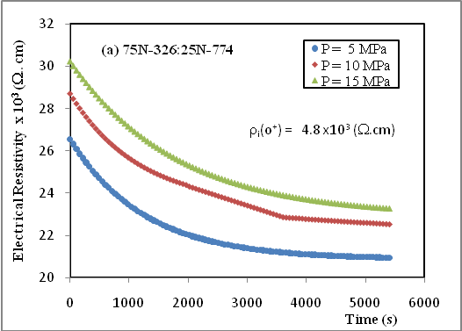
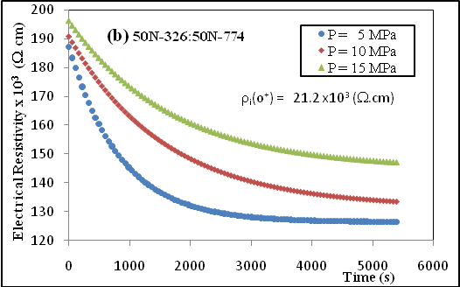
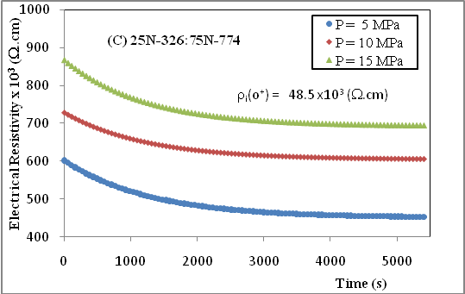

Figure 5:a-c. the electrical resistivites versus time for the rubber blend (75EPDM:25NBR) with different ratios of carbon black types at different compression pressure 5 MPa, 10 MPa, and 15 MPa

During the process of instantaneous compression the conductive network is changed by the movement of the polymer segments and the changes in the uniaxial size of the blend, leading to the change in the electrical resistivity of the blend. The electrical resistivity of carbon black is far less than that of the rubber; therefore, the electrical resistivity of the blend loaded with carbon black is decided by the electrical resistivity of the insulating films between adjacent conductive particles, which are related to the changes in ECPs under the compression process.
There are three kinds of changes in the ECPs. Change A: in the existing ECPs, the gaps between adjacent conductive particles changes, whereas the number of conductive particles does not change. Change B: carbon black particles are extruded out or added into the existing ECPs, leading to the change in the gaps between adjacent conductive particles and its number. Change C: the existing ECPs are destructed or new ECPs are formed, leading to the changes in the number of ECPs.
The three kinds of the changes in ECPs mentioned cause six factors affecting the change of the resistivity. Factor 1: the decrease of the gap between adjacent conductive particles contributes to the decrease of the electrical resistivity of existing ECPs. Factor 2: the increase of the gap between adjacent conductive particles contributes to the increase of the electrical resistivity. Factor 3: the decrease of the number of the insulating films contributes to the decrease of the resistivity of existing ECPs. Factor 4: the increase of the insulating films contributes to the increase of the resistivity of existing ECPs. Factor 5: the increase of the number of ECPs contributes to the decrease of the electrical resistivity of the blend. Factor 6: the decrease of the number of ECPs contributes to the increase of the electrical resistivity of the blend. So the factors 1, 3, and 5 contribute to decrease the electrical resistivity, whereas, factors 2, 4, and 6 contribute to increase it.
The schematic diagram of the three kinds of the changes in ECPs and the six factors that affecting the resistivity is shown in Fig. (8). The relations between them are discussed as follows: during the compression process, change A decreases the gaps between adjacent conductive particles (factor 1), as shown in Fig. (8). For change B there are two kinds of scenarios, first, carbon black particles are extruded out of the existing ECPs, leading to the decrease of the number of insulating films (factor 3). As both the uniaxial size of the blend and the number of the insulating films decrease, the gaps between adjacent conductive particles may decrease (factor 1), or increase (factor 2), as shown in change B1. Second, carbon black particles are added into the existing ECPs, leading to the increase of the number of the insulating films (factor 4) and the decrease of the gaps between adjacent conductive particles (factor 1), as shown in change B2. The two kinds of scenarios aforementioned may concur in the same existing ECPs, as shown in (change B3). For change C, on the one hand, the gaps between carbon black particles get smaller, leading to the formation of new ECPs. This effect contributes to the increase of the number of ECPs (factor 5) as shown in change C1. On the other hand, the transverse slippage of carbon black leads to the destruction of ECPs. This effect contributes to the decrease in the number of ECPs (factor 6), as shown in change C2.

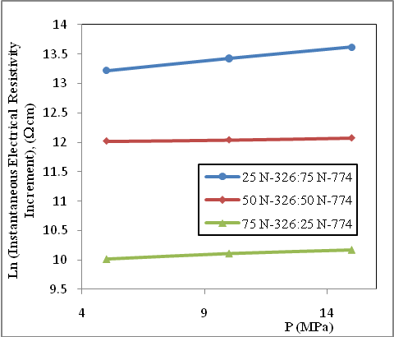

Figure 6. Ln the instantaneous electrical resistivity increment versus P for the rubber blend (75EPDM:25NBR) at different ratios of carbon black types

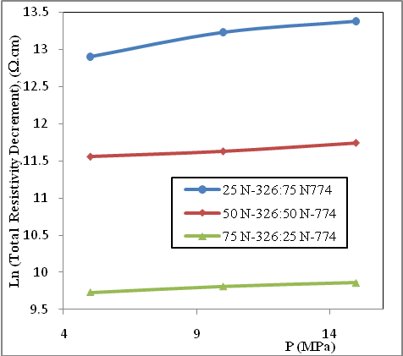

Figure 7. Ln of the total electrical resistivity decrement versus P for the rubber blend (75EPDM:25NBR) at different ratios of carbon black types

As shown in Fig. (5:a-c), the electrical resistivity increases instantaneously when the sample is compressed. This experimental phenomenon indicates that the effect of factors 2, 4, and 6 is dominant at the moment of compression. It is noticed also that, the electrical resistivity decreases with time after the rubber blend is loaded. This result indicates that the effect of factors 1, 3, and 5 is dominant. The conductive network gets more and more unstable with time under the constant pressure. As shown in Fig. (6), the instantaneous increment of the resistivity increases with the increase of the instantaneous pressure. This result indicates that the extent of the changes in the conductive network increases with the increase of the instantaneous loading pressure. According to the theory of viscoelasticity, the external compression causes the movement of the polymer segments. The retardation times correspond to the different movement elements composed of polymer segments.

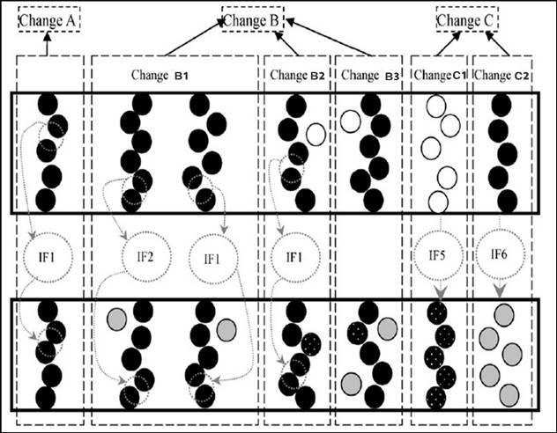

Figure 8. Schematic diagrams for the changes in ECP during loading of pressure

4. Conclusion
Results presented in this paper point to the presence of EPDM and carbon black type N-326 enhances the mechanical properties obtained from stress-strain data measurements. The degree of reinforcement achieved through incorporation of N-326 carbon black to pure EPDM followed by blend enriched with EPDM like rubber blend. SEM observation shows that with increasing EPDM content, the blend (75EPDM:25NBR) morphology becomes better and better and this performance also was reflected to the mechanical properties. The electrical resistivity of the pressure sensitive rubber blend (75EPDM:25NBR) filled with different ratios of carbon blacks increases suddenly when compressed and then decreases with time. As carbon black N-326 content increases the electrical resistivity decreases owing to its small particle size. The instantaneous increment of the resistivity increases with the increase of the instantaneous pressure. The electrical phenomena aforementioned are caused by changes in the effective conductive paths.

Corresponding Author:
Hezam Naji Musaed Al-suhaiqi
Department of Physics,
Faculty of Science,
Cairo University,
Giza, Egypt.
E-mail: hezam.naji1986@gmail.com

References
- T.M. Nair, M.G. Kumaran, and G. Unnikrishnan, J.Appl. Polym. Sci., 93, 2606 (2004).
- J.E. An, and Y. G. Jeong, Eur. Polym. J., 49, 1322 (2013).
- W. Hopark, J. Polym., 28 (5), 672 (1996).
- S. Isaji, Y.Z. Bin, and M. Matsuo, Polymer, 50 (4), 1046 (2009).
- T.A. Ezquerra, J. M. Salazar. and F.J. Calleja, J. Mater. Sci. Lett., 5, 1065 (1986).
- J.K. W. Sandler, J. E. Kirk, I. A. Kinloch, M. S. P. Shaffer, and A. H. Windle, Polymer, 44 (19), 5893 (2003).
- L.E. Nielsen, “Mechanical Properties of Polymer and Composites“, Marcel Dekker Press, New York (1994).
- S. Wolf, M.J. Wang, and E.H. Tan, Rubber Chem. Technol., 66, 163 (1993).
- K.P. Sau, T.K. Chaki, and D. Khastgir, J. Mater. Sci., 32, 5717 (1997).
- N. Hu, Y. Karube, C. Yan, Z. Masuda, and H. Fukunaga, Acta. Mater., 56, 2929 (2008).
- X. Wang, and D.L. Chung, Compos., 29 B, 63 (1998)
- J.N. Aneli, G.E. Zaikov, and L.M. Khananashvili, J.Appl. Polym. Sci., 74, 601 (1999).
- X.S. Wen, Y. C. Xu, and X.S. Yi, National Defense Industry Press, Beijing, (2004)
- X.L. Tao, Y. Pan, and Q. Zheng, J.Appl. Polym. Sci., 79, 2258 (2001).
- A. M. Y. El-Lawindy, W.E. Mahmoud, and H.H.Hassan, Egypt. J. Sol., 26, 43 (2003).
- A. Voet, F.R. Cook, and A.K. Sircar, Rubber Chem. Technol., 44, 175 (1971).
- A.K. Sircar, A. Voet, and F.R. Cook, Rubber Chem. Technol., 44, 185 (1971).
- C. M. B low, “Rubber Technology and Manufacture” Butterworth and Co., Ltd, London (1971).
- S.A. Al-Gahtani, J. Amer. Sci., 7 (8), 13 (2011).
- K.P. Sau, T.K. Chaki, and D. Khastgir, J. Appl. Polym. Sci., 71, 887 (1999).
- L.H.Wang, T.H. Ding, and P. Wang, Carbon, 47, 3151 (2009).

8/5/2014

