Occurrence and Severity of Ganoderma lucidum (Fr.) P. Karst. on Azadirachta indica Trees in University of Port Harcourt, Nigeria: Implications for Sustainable Harvesting and Replacement

Adedeji, G. A., A. A. Aiyeloja and G. E. Omokhua

Department of Forestry and Wildlife Management, University of Port Harcourt, Nigeria
adedapo.aiyeloja@uniport.edu.ng

Abstract: More than 40% mortality of the 35 years old Neem trees (Azardirachta indica) used as avenue tree in University of Port Harcourt (UNIPORT) has been observed. This phenomenon is strongly believed to have been caused by Ganoderma lucidum – a fungus which causes root rots, cracking of the root and stem barks, heartwood rots, die-back of the branches, deformation of crown and eventually death. Therefore, occurrence and severity of Ganoderma lucidum on the Neem trees from Delta axis road to Ofrima/Senate roundabout were examined for 3 years. Epidemiological observations showed that two genera of Ganoderma appeared early in the years when there was rain and gradually reduce with decreasing rainfall intensity. High occurrences of G.lucidum were observed between April and July for the 3 years of study. Over the years, there were progressive increase in the damaging impact of G.lucidum in all trees and the total mortality associated with its occurrence was greater than 40% at the end of 2013. Occurrence-severity indicated that A. indica trees were affected mostly by decays of roots and stem butts that were associated with tree age (old), soil contact and moisture. Occurrence of Ganoderma lucidum in living trees is recognized as a distinct disease and is strongly associated with declining of A. indica among ornamental trees in University of Port Harcourt, Nigeria. A disk obtained from one of the dying tree was still hard enough without any visible xylem decay, stain, tunnel and discolouration to produce furniture and other indoor wood products for the University community. This study suggests that the trees could be selectively harvested for furniture while replacement with non-vulnerable and fast growing tree like Gmelina arborea is advised before complete harvesting is carried out.
[Adedeji, G. A., A. A. Aiyeloja and G. E. Omokhua. Occurrence and Severity of Ganoderma lucidum (Fr.) P. Karst. on Azadirachta indica Tree in University of Port Harcourt, Nigeria: Implications for Sustainable Harvesting and Replacement. Nat Sci 2014;12(8):123-128]. (ISSN: 1545-0740). http://www.sciencepub.net/nature. 17

Keywords: Azardirachta indica, Ganoderma lucidum, indoor wood products, Pathogens, Diseases, wood fungus.

1. Introduction
The genus Ganoderma includes several wood decaying fungi on living trees as well as dead trunks and stumps and has been recorded mostly in tropical and temperate countries (Fernando, 2008). Ganoderma lucidum is a major fungus pest of many woody live trees in Nigeria. It is a primary fungus pest that attacks healthy living trees, dead woods and woods under service when expose to external environmental conditions as its host. Many investigations have examined the economic damage, prevalence, severity and host range of G.lucidum in many regions largely in America, Asia, the middle East and Europe (Fernando, 2008; Paterson, 2006; Luna, et al., 2004; Adaskaveg, et al., 1993; Farr, et al., 1989) though its medicinal values in Asia has also been extensively studied, reported (Ahmadi and Riazi, 2008) and its cultivation encouraged (Poomsing, et al., 2013; Wasser, 2005). A decline in productivity and death of trees are the reported main economic impacts due to Ganoderma diseases and the fungus has been identified as a serious pathogen of cash crops, forest plantations and trees in natural forests (Hennessy and Daly, 2007; Sankaran, et al., 2005).
Neem (Azadirachta indica) known as Dongoyaro is one of the popular trees grown for landscaping purposes in Nigeria. Despite the widely reported antimicrobial and insecticidal properties of its parts, Neem is still vulnerable to fungus (G. lucidum) attack which causes decline in productivity and high mortality in Rivers State. Reports on its occurrence, severity and economic damage caused to forest plantations in Nigeria are rare. Few available information oriented towards its potential medicinal values despite its wood destructive mechanism; In Vivo evaluation of antimalarial and cytotoxic properties of crude aqueous extract of the G.lucidum in plasmodium berghei-infested mice (Oluba, et al., 2013); effect of grower feed diet supplemented with G.lucidum against enteric zoonotic parasites of pigeon (Osemwegie, et al., 2012); proximate composition, phytochemical and elemental analysis of some organic solvent extract of the G.lucidum (Shamaki, et al., 2012); effect of pulverized Ganoderma spp. on Sclerotium rolfsii Sacc and post-harvest tomatoe fruits preservation (Osemwegie, et al., 2010); diversity of macrofungi oil palm agroforests of Edo State (Osemwegie and Okhuoya, 2009). The study, therefore examined the trend of occurrence and severity of Ganoderma lucidum on the Neem used as avenue trees from Delta axis road to Ofrima/Senate roundabout for 3 years and offered suggestions for sustainable harvesting and replacement with non-vulnerable tree species.

2. Materials and Methods
2.1. Study Area
The study was carried outbetween January, 2011 and December, 2013 within theUniversity of Port Harcourt which is located on a land area of about 400 hectares in Obio/Akpor Local Government Area of Rivers State. Delta axis main road to Ofrima/Senate roundabout lie between Latitude 4⁰ 54’ 6.14’’ and 4⁰ 54’ 23.26’’N and longitude 6⁰ 54’ 24.63’’ and 6⁰ 55’ 8.98’’ E. The area is tropical climate in Mangrove/swamp freshwater forest zone characterized with two seasons, the dry season (November to March) and wet season (April to October). The rainfall distribution is nearly all year round though its intensity is seasonal and variable. The monthly mean maximum temperature ranges from 28⁰C to 33⁰C while the monthly minimum temperature ranges from 17⁰C to 24⁰C (Ogbonna, et al., 2007). The vegetation is a mixture of disturbed fallow land and secondary forest growth with grown Azadirachta indica, Delonix regia, Gmelina arborea, Mangifera indica, Casuarina equisetifolia, Terminalia catappa, Elaeis guineensis, Pinus caribae and Anacardium occidentale as dominant landscaping trees.

2.2. Examination of G. lucidum occurrence
Field record and observations were made on emergence, occurrence, severity and subsequent impacts of G. lucidum on the two rows of 35 year- old Azadirachta indicaplanted at 7m apart with diameter at breast height (DBH) ranging from 40. 90cm to 73.18cm used as avenue trees for 3 consecutive years. A total number of 358 trees were enumerated: 144 dead stumpswere recorded as mortality at the beginning of the study while the remaining 214 live trees were monitored fortnightly. In the course of the study, 2 more mortalities were recorded reducing the experimental trees to 212. The study emphasized on superficial observations of the morphological characteristics of G. lucidum. At the end the study, the number of missing stand as mortality was 146 against 212 live trees given mortality rate of 40.78%.

3. Results
3.1. Occurrence and severity of G. lucidum
The study showed that 146 or 40.78% of the initial total number of 358 trees were killed by occurrence of G. lucidum. Two types of Ganoderma were recognized: G. lucidum attacked live and dead woods; and G. applanatum attacked only dead stump/wood. The fungus is a soil and air-borne pathogen whose pronounced occurrence and wide spread were observed in rainy months of April to July. Occurrences were severe in March, August, September, October and November with less severity in December, January and February. The trends were similar for the 3 years of study as shown in table 1. In all the years, there were progressive increases in the damaging impact of G. lucidum in all trees and the total mortality associated with its occurrence was greater than 40% as at end of 2013. Other ornamental trees attacked by G. lucidum in the University premises include Casuarina equisetifolia, Delonix regia, Terminalia catappa, Terminalia superba and Mangifera indica.

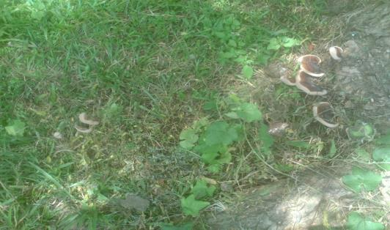
Fig.1: G. lucidumon roots of living Azadirachta indica tree
Source: Authors’s fieldwork, 2013

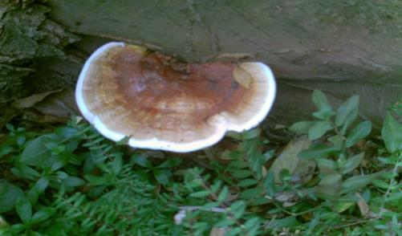
Fig.2: G. lucidum on trunk of dead Azadirachta indica tree
Source: Authors’s fieldwork, 2013

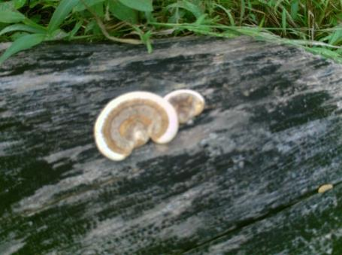
Fig.3: G. applanatum on dead trunk of Azadirachta indica tree
Source: Authors’s fieldwork, 2013

Table 1: Occurrence severity of G. lucidum
Months | Severity of occurrence
 | 2011 | 2002 | 2013
January | NS | NS | NS
February | NS | NS | NS
March | S | S | S
April | MS | MS | MS
May | MS | MS | MS
June | MS | MS | MS
July | MS | MS | MS
August | S | S | S
September | S | S | S
October | S | S | S
November | S | S | S
December | NS | NS | NS
Source: Authors’s fieldwork, 2011- 2013
NS: Not severe
S: Severe
MS: More severe

3.2. Impacts of G. lucidum on hosts (trees)
All the remaining 212 live trees were infected by G. lucidum but its occurrence varied among the trees. The trees with exposed lateral roots were more susceptible to attack. However, the occurrences of G.lucidum were more severe in all trees in months of April, May, June and July than other months of the year. The trees have blemishes, shown no good adaptability to the area climatic conditions with non-satisfactory foliage production. The impacts of G. lucidum on the trees have caused cracking and rotting of the roots, cracking of the stem/trunk bark, sparse foliage and deformation of crown, and die-back of individual branches as shown in Fig. 4, 5 and 6 making them susceptible to wind damage. The impacts of G. lucidum also rendered the trees vulnerable to termite attack as shown in fig. 7 as well as many epiphytic plants such as Angel fire and Aerangis biloba. Generally, occurrence of G. lucidum has both significant ecological and economical impacts in the loss of Ornamental trees and maintenance expenses for replacement respectively.

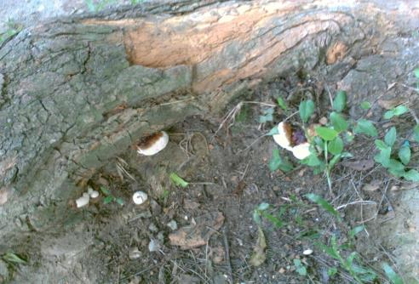
Fig.4: G. lucidum causing roots cracking and rotting of living Azadirachta indica tree
Source: Authors’s fieldwork, 2013

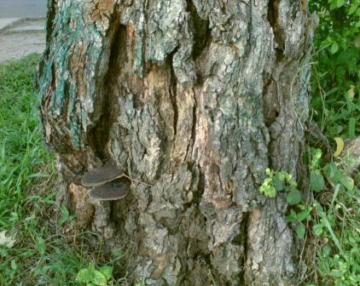
Fig.5: Cracking of trunk bark of a dying Azadirachta indica tree with dead fruiting bodies of G. lucidum
Source: Authors’s fieldwork, 2013

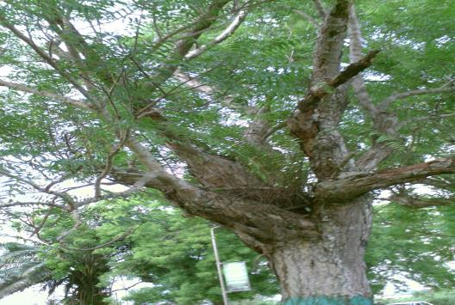
Fig.6: Die-back of individual branches on liveAzadirachta indica tree
Source: Authors’s fieldwork, 2013

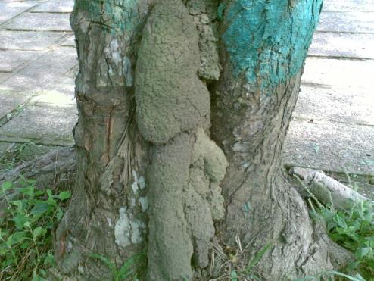
Fig. 7: Secondary pest termite attacking heartwood of live tree
Source: Authors’s fieldwork, 2013

4. Discussion
Epidemiological observations showed that G. lucidum appeared at the floor and base of the trees early in the years when there was rain in months of April, May, June and July and gradually reduced with decreasing rainfall. There were significantly higher proportion occurrences of G.lucidum on live trees in rainy season than dry season. This is an indication to suggest that occurrence and severity of G. lucidum on live Azadirachta indica trees has a strong positive relationship with soil moisture.G. lucidum appeared to be particularly severe on the trees in UNIPORT because of the higher annual rainfall in the area. The result corroborated the submission of Hennessy and Daly (2007) that advancement of G. lucidum on Palm trees in Australia is dependent on the environmental conditions such as water availability and temperature. The occurrence of G. lucidum on live trees and dead stumps/horizontally oriented woods indicated that G. lucidum is a facultative fungus living as parasitic pathogen on live trees and saprophyte on dead stumps/woods as shown in fig. 1 and 2. This observation was in agreement with what Luna, et al., (2004) reported that G. lucidum caused white rot in both living and felled Poplar trees in Argentina, Loguercio-leite, et al., (2005) that Ganoderma employed wood as saprotrophs as well as parasites in Southern Brazil and Futch, et al., 2013 that some Ganoderma species are saprophytic while others are wound pathogens causing heart and butt rots on citrus in Florida, America. The proportion of G.lucidum occurrence on the live Azadirachta indica trees in the study area was used as criterion for the classification of severity. The higher proportion was observed in the months of April, May, June and July and thus, classified as “more severe”. While high proportion was observed in March, August, September, October and November, thus classified as “severe”. However, the occurrence of G.lucidum was restricted to only dead stumps/woods in January, February and December including other months of the year in the study area, thus classified as “not severe” as shown in table 1. G.lucidum thrived well on dead woods even with little amount of soil moisture. The observed current state of severity is an indicative of decreasing order of occurrence with decreasing rainfall in the area. It could also be explained as growth habit having parent mother growth lapsed for four months and its secondary growth or first filial (Fi) generation growth of five months in the presence of appreciable amount of soil moisture. Therefore, the proportion variation could be attributed partly to soil moisture influence and partly to growth habit. The four months (120days) of more severity was nearly as the same 110 days reported by Poomsing, et al., (2013) for optimum growth of lucidum cultivated in Thailand. Another genus of Ganoderma, G. applanatum was strictly encountered on dead stumps and horizontally oriented dead woods throughout the years in the study area as shown in fig. 3. This observation corroborated the reported G. applanatum on dead stumps of citrus in Florida, America (Futch, et al., 2013). This obligate genus thrived well on dead woods with increasing amount of rainfall. The two species of Ganoderma (G. lucidum and G. applanatum) encountered in this study were the same as reported by Farr, et al., (1989) on Citrus in US and were among the seven types of Ganoderma reported by Loguercio-leite, et al., (2005) in tropical Forest of Santa Catarina State, Southern Brazil.
Due to the impacts of G. lucidum, the current situation of the rows of avenue trees does not fully fulfill the practical purposes as well as its aesthetic value or impulse. Cracking of the roots and stem bark, rotting of the roots, heartwood rots, further vulnerability of trees to secondary termite pest attack, die-back of the individual branches, dying and death of trees were evidences of the impacts of Ganoderma. This current state of appearance is an indicative of increasing decline in vigour. The killing impact of Ganoderma lucidum could be described as low because it attacked olderAzadirachta indica trees in the study area. This trend of killing impact is similar to what Hennessy and Daly, (2007) reported on Oil palm trees in Australia, Department of Crop Science (1999) on wood rots and decay in Illinois, US and not in agreement with what Fernando, (2008) reported as fast killing impact on Cassia nodosa, C. fistula and Delonix regia at younger age in Sri Lanka.

4.1. Implications
Because G. lucidum attacked older Azadirachta indica trees, the killing impact seemed to be rather moderate or slow. However, the projection death of the remaining 59.22% or 212 trees could be fast as a result of poor condition of the trees. There is urgent need to interplant non-vulnerable trees like Gmelina arborea and harvest the avenue trees for production of furniture and other indoor wood products for the University community. A disk (Fig. 8) obtained from one of the dying tree was still hard enough without any visible xylem decay, stain, tunnel and discolouration to produce indoor wood products. The replacement of few missing stand with Delonix regia is not appropriate because D. regia is more susceptible to G. lucidum in UNIPORT and it could be attacked at tender age. More so, D. regia has undesirable buttress and lateral root pattern that could easily destroy the walk ways and even the main road.

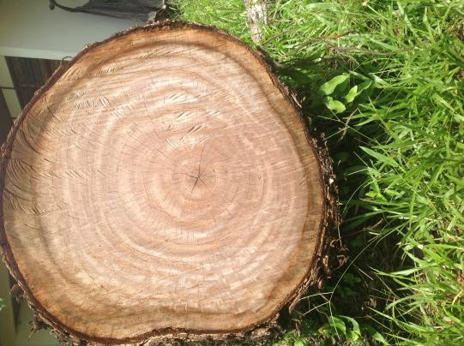
Fig. 8: A disk obtained from wind prone felled dying tree
Source: Authors’s fieldwork, 2013.

5. Conclusion
The result revealed that G. lucidum is a major wood-decay fungus pest of Azadirachta indica used as avenue trees in UNIPORT. It infested the trees at older age causing considerable damages such as rotting of roots, cracking of roots and stem bark, heartwood rot, die-back of the individual branches and eventually death. Its destructive mechanism facilitated the secondary infestation of heartwood by termite. The avenue trees are in a rather poor condition and the foresters as tree care specialist must decide their future. This is an important information value to UNIPORT management, and Forestry and Wildlife Management Department. There is need for further study to compare the wood density and mechanical properties of G. lucidum infested wood and sound wood so as to recommend suitable utilization the wood could put to. There is also need for comparative soil analyses of UNIPORT and other Institution(s) in high rainforest zone, Nigeria where occurrence of Ganoderma is strictly found on dead woods. The result clearly showed that there were ecological factors effects on occurrence of G. lucidum in A. indica trees. However, it was less clear whether the innoculum arrival was through soil or air as the disease is generally accepted as air and soil borne disease. The study was limited to A. indica trees because the trees could no longer achieve its original object of management as avenue tree.

Corresponding Author
Dr. A. A. Aiyeloja
Department of Forestry and Wildlife Management, University of Port Harcourt,
P.M.B. 5323, Choba,
Port Harcourt, Nigeria
adedapo.aiyeloja@uniport.edu.ng

References
- Adaskaveg, J. E., R. W. Miller, and R. L. Gilbertson, 1993. Wood decay, lignicolous fungi and decline of peach trees in South Carolina. Plant Dis., 77: 707-711.
- Ahmadi, K. and M. Riazipour, 2008. T-2 Toxin Regulated Ganoderma lucidum Induced Cytokine Release. American Journal of Immunology, 4(1):8-13. Doi: 10.3844/ajisp.2008.8.13.
- Department of Crop Science, 1999. Wood rots and Decays. Report on plant diseases, RPD NO. 642, College of Agricultural, Consumers and Environmental Sciences, University of Illinois Extension, 1-9.
- Farr, D. F., G. F. Bills, G. P. Chamuris and A. Y. Rossman, 1989. Fungi on plant and plant products in the United States. APS Press, St. Paul, MN. P 496.
- Fernando, K. M. E. P. 2008. The host preference of a Ganoderma lucidum strain for three tree species of Fabaceae families; Cassia nodosa, Cassia fistula and Delonix regia. J Natn. Sci. Foundation Sri Lanka, 36 (4): 323-326.
- Futch, S. H., J. H. Graham, L. W. Duncan and L. W. Timmer, 2013. Ganoderma. Wood-rotting Fungi on Citrus Stumps. IFAS Extension, HS1019, University of Florida, 2pp.
- Hennessy, C. and A. Daly, 2007. Ganoderma diseases. Agnote, No:167, 2pp.
- Loguercio-leite, C., C. Groposo and M. A. Halmenschlager, 2005. Species of GanodermaKarsten in Subtropical area (Santa Catarina State, Southern Brazil). IHERINGIA, Ser. Bot., Porto Alegre, 60(2): 135-139.
- Luna, M. L., M. A. Murace, G. D. Keil, and M. E. Otano, 2004. Pattern of decay caused by Pycnoporus sanguineus and Ganoderma lucidum (Aphkllophorales) in Poplar wood. IAWA Journal, 25(4):425-433. ISSN: 0928-1541.
- Ogbonna, D. A., G. T. Amangabara, and T. O. Ekere, 2007. Urban solid waste generation in Port Harcourt metropolis and its implications for waste management. Management of Environmental Quality, 18 (1): 71-88. DOI: 10.1108/14777830710717730.
- Oluba, O. M., Eidangbe, G. O., Adebisi, K. E., Odutuga, A. A. and Onyeneke, E. C. 2013. In vivo evaluation of antimalarial and cytotoxic properties of crude aqueous extract of the fruiting body of medicinal mushroom, Ganoderma lucidum (W. Curt.: Fr) P. Karst in plasmodium berghei-infested mice. J Immunol Tech Infect Dis., 2(4):1-6. DOI:10.4172/2329-9541.1000116.
- Osemwegie, O. O. and J. A. Okhuoya, 2009. Diversity of macrofungi in oil palm agroforests of Edo State, Nigeria. Journal of Biological Sciences, 9(6):584-593. DOI: 10.3923/jbs.2009.584.593.
- Osemwegie, O. O., Ekaye, S., and Ntekume, I. C. (2012): The effect of grower feed diet supplemented with Ganodermalucidum against enteric zoonotic parasites of pigeon. Biokemistri, 24(3):129-135. ISSN: 0795-8080.
- Osemwegie, O. O., Oghenekaro, A. O. and Owolo, L. O. (2010): Effect of pulverized Ganoderma Spp. on Sclerotium rolfsii Sacc and post-harvest tomatoe fruits preservation. Journal of Applied Sciences Research, 6(11)1794-1800
- Paterson, R. R. M., 2006. Ganoderma disease of oil palm – A white rot perspective necessary for integrated control. Crop protection, 26 (2007): 1369-1376.
- Poomsing, P., K. Pattanapanyasat, P. Wongsinkongman, and N. Soonthornchareonnon, 2013. Research and development of Ganoderma lucidum cultivated in Thailand. Mahidol University Journal of Pharmaceutical Sciences, 40(3):1-7.
- Sankaran, K. V., P. D. Bridge and C. Gokulapalan, 2005. Ganoderma diseases of perennial crops in India-an overview. Mycopathologia, 159 (1):143-152.
- Shamaki, B. U., U. K. Sandabe, I. A. Fanna and M. S. Adamu, 2012. Proximate composition, phytochemical and elemental analysis of some organic solvent extract of the wild mushroom Ganoderma lucidum. Journal of Natural Sciences Research, 2(4):24-35. ISSN 2225-0921.
- Wasser, P. S., 2005. Reishi or Ling Zhi (Ganoderma lucidum). Encyclopedia of Dietary Supplements. DOI:10.1081/E-EDS-120022119, 603-622.

8/3/2014

