Effect of Seasons on Colonisation and Suitability of Triplochiton scleroxylon K. Schum.Wood for Beekeeping in Rivers State, Nigeria

Adedeji, G. A., Aiyeloja, A. A., Larinde, S. L. and Omokhua, G. E.

Department of Forestry and Wildlife Management, University of Port Harcourt, Nigeria
adedapo.aiyeloja@uniport.edu.ng

Abstract: Season has been observed as a major factor influencing hives’ colonisation in Nigeria. However, information on the influence of seasons on colonisation is rare. This study therefore explored the effect of seasons on colonisation of hives constructed from local Triplochiton scleroxylon wood in Port Harcourt. Experimental Apiary was established with fifteen Kenyan top bar hives and placed within 50 metres radius in the departmental arboretum in April, 2012 which marked the beginning of the raining season. The apiary was inspected fortnightly. Three hives were colonised in October, 2012 and the remaining twelve in October, 2013. Result indicated that colonisation behaviour was influenced by seasons. Colonisation in the month of October is recognised as a distinct transition month from raining to dry season and is strongly associated with swarming of honeybees colonies, setting and fruiting of trees which provide nutrition for honeybees. The honeybees showed excellent adaptability to the Triplochiton scleroxylon wood hives without any absconding case. The best period for hives placement in the Niger Delta region is between August and September since colonisation usually occur around October. Keeping hives in most sanitary conditions and withdrawal of non-colonized hives in raining season are good preventive measures against deterioration and attack.
[Adedeji, G. A., Aiyeloja, A. A., Larinde, S. L. and Omokhua, G. E. Effect of Seasons on Colonisation and Suitability of Triplochiton Scleroxylon K. Schum.Wood for Beekeeping in Rivers State, Nigeria. Nat Sci 2014;12(8):117-122]. (ISSN: 1545-0740). http://www.sciencepub.net/nature. 16

Keywords: Colonisation, hives, honeybees, seasons, T. scleroxylon wood

1. Introduction
The Nigerian beekeeping economy has a very poor history which is not well documented in literature. The reason for this could be partly because of death cases associated with bee stings or dearth of political support to actualise honeybees’ potentials. The potential contributions of honeybees to the nation’s economic development are vast and have not been fully harnessed and reported. In terms of plants pollination, no single group of insects has earned distinction more than honeybees. In America and European member countries, the value of pollination attributed to honeybees is estimated to billions of US dollars annually (Malcolm, 1998; Morse and Calderon, 2000; and Breeze, et al., 2011). The honeybee industry in United State, which is well developed from the introduced Africanized bee, generated about US$15-20 billion annually from commercial pollination (Malcolm, 1998; Morse and Calderone, 2000; Johnson, 2010; Honey Traveler, 2012). Visitation of honeybees to perform this vital function of pollination has not been acknowledged in Nigeria. Yet, honeybees visit agricultural crops like citrus, cacao, cashew, oil palm, mango, coconut, Irvingia sp., Musa sp., melons, onion, cucumber, tomatoes as well as many forest trees which include Rhizophora racemosa, Pycnanthus angolensis, Vitex doniana, Bombax spp., Eucalyptus camaldulensis,etc. without pay. Indeed, it is a forgotten and neglected input (Malcolm, 1998). With regard to rural livelihood, honey hunting and harvesting still offer quite a sizeable number of people their means of livelihood. More so, it is an important source of honey and other raw materials for varied medicinal purposes, drum leather quality control and preservation. Nigeria is abundantly blessed with genetic honeybee’s resources which can be found in all the ecological zones of the country. Obviously, utilisation of this resource in the production of the globally much needed organic honey and other products especially beewax and probolis will constitute a strategic effort at diversifying the economy. Beekeeping, if properly developed and managed, can add immense value to the economic, education and scientific research, social, health and cultural life of the country because it does not require special skill to appreciate the enormous beekeeping resources that Nigeria is endowed. The opportunities are enormous: total land mass of diverse forage flora is ideal, diverse naturally occurring cavity materials, a wide range of vegetation zones with attendant surplus human and material resources and associated activities that can earn us both local and foreign earnings.
Evidences abound that pollination service is threatened on a global level (Thomas and Telfa, 2004; MEA, 2005b; FAO, 2008; EEA, 2010; Potts, et al., 2010; UNEP, 2010). This is as a result of; habitat loss and fragmentation, use of agrochemicals, pathogens, invasive species, climate change and interactions between and among them (IRGC, 2009). Habitat loss and fragmentation and the use of agrochemicals for weeding have been identified as drivers threatening genetic honeybees’ resources in Nigeria (Adedeji and Aiyeloja, 2012; Popo-ola, et al.,2013). In spite of this vital function to reproductive and regenerative capacity of nature honeybees population has been on the decline worldwide which call for urgent conservation effort.
Few available impact studies reported on hives colonisation by honey bees in Africa are on hive types (Ande, et al., 2008a), hive types and tree shade management (Kugonza, et al., 2009), distribution and impact of pests (Oyerinde and Ande, 2009), polythene and lime applications to top bars (Babarinde, et al., 2010), apiary management (Okwee-Acai, et al., 2010), shade tree species types (Babarinde, et al., 2011), hive dimension and flight entrance (Babarinde, et al., 2012) and hive wood colours (Adedeji and Aiyeloja, 2014). Seventy five percent of these articles reported low rate of colonisation and high absconding rate without any information on the impact of seasons on colonisation and the colours of wood species used for bees’ hives constructions. Deforestation without replacement and scarcity of preferred and moderately durable species like Gmelina arborea had placed a price premium on these species necessitating the use of alternative white wood species. This study investigated the effect of seasons on colonisation and suitability of Triplochiton scleroxylon wood hives for beekeeping in the Niger Delta region of Nigeria.

2. Material and Methods
Study Area
Effect of seasons on colonisation and suitability of Triplochiton scleroxylon wooden hives for conservation of genetic native honeybees’ resources were investigated between April, 2012 and March, 2014 in the Department of Forestry and Wildlife Management Arboretum, University of Port Harcourt, Rivers State. The University is located on a land area of about 400 hectares in Obio/Akpor Local Government Area of Rivers State. The hives were placed between Latitude 4.90794 and 4.90809 N and longitude 6.92413 and 6.92432 E within the Department of Forestry and Wildlife Management Arboretum. The area is within the Mangrove/swamp freshwater forest zone characterised with two seasons, the dry season (November to March) and wet season (April to October). The rainfall distribution is nearly all year round though its intensity is seasonal and variable. The monthly mean maximum temperature ranges from 28⁰C to 33⁰C while the monthly minimum temperature ranges from 17⁰C to 24⁰C (Ogbonna, et al., 2007). The vegetation is a mixture of disturbed fallow land and secondary forest growth with planted Gmelina arborea, Tectona grandis and Nauclea diderrichii trees dominating. The dominant foraging/pollinating plants in the area include Aspillia africana, Tridax procumbens,cassava in disturbed fallow land and Pycnantus angolensis, Elaeis guineensis in secondary forest.
Triplochiton scleroxylon Wood and Construction of Hives
Triplochiton scleroxylon is a tropical tree known as Obeche in Nigeria, Wawa in Ghana, Ayous in Cameroon and Samba in Ivory Coast. Its wood has a white colour and moderate texture that permits nailing both in green (wet) and dry conditions without causing pronounced split. One of the biggest T. scleroxylon encountered as shown in Fig. 1 during preliminary survey of wood species cavities preferred by honeybees in Nigeria was not vulnerable to hollowness and even at DBH of 1.47m while living unlike other white woods like Adansonia digitata, Bombax buonopozenze, Ceiba pentandra, Gmelina arborea, Vitex donianaetc which provide cavities and preferred by honeybees for nesting (Aiyeloja and Adedeji, 2014). Its non-proneness to hollowness might be an inherent genetic attribute and its selection as a suitable wood was based on colour, texture and availability in the lumber markets. Sound lumbers of 1x12x12 and 2x6x12 sizes were purchased from Ilabuchi lumber market in Port Harcourt. Fifteen Kenyan hives samples of 80cm length by 30cm in depth with 22 top bars (40cm length by 3.3cm in width) were constructed with used corrugated aluminium roofing sheets as covers. The hives were allowed to air-dry well because the wood has unpleasant odour in wet condition but disappeared as it seasoned.

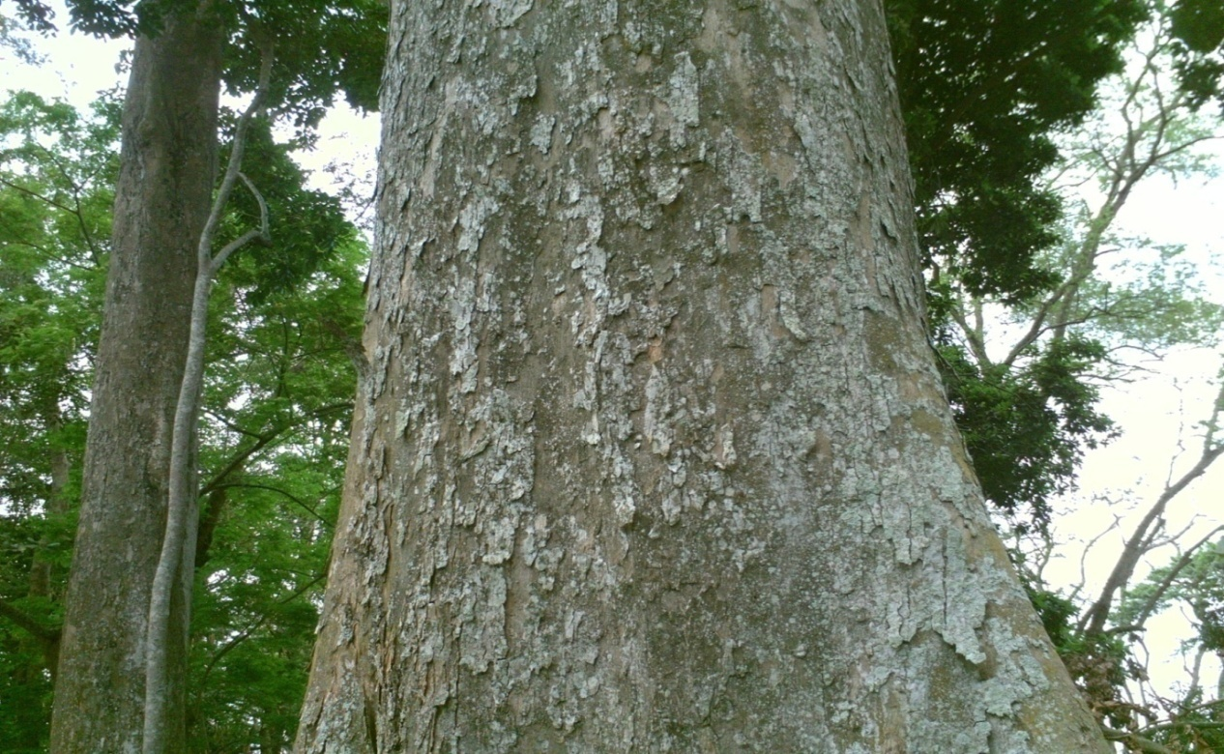
Figure 1: Sound Triplochiton scleroxylontree of 1.47m DBH without hollow
Source: Authors Fieldwork

Baiting and mounting of hives
The baited hives were mounted on metal stands under tree shades at different strategic locations within the site in the month of April, 2012. Internal inspections were carried out every forth night while hives environments were discretionally kept in desirable sanitary condition before and after colonisation. Complete colonisation of all the hives was actualised in the month of October, 2013.

3. Results
Evaluation of effect of seasons on colonisation
No colonisation was observed from the month of April, 2012 which marked the beginning of rainy season until October, 2012 when three were colonised and no colonisation again until October, 2013 when the remaining twelve were colonised as shown in table 1. Fig. 2 showed one of the hives colonised in the month of October, 2013. The result indicated that October was the only colonisation month for the two years of the study. Classification of climatic seasons in Nigeria put rainy season months as April to October and dry season from November to March. Based on our evaluation, we put or adjudged the month of October as a transition month from rainy season to dry season rather than completely seeing it as rainy month. This amphoteric phenomenon of the month of October might have a positive relationship with nesting behaviour of the honeybees. The result suggested that seasons play a role in the colonisation.

Table 1: Colonisation and absconding month(s) and rate
Year | Colonisation |  | Absconding
 | Month | Rate % | Month | Rate %
2012 | October | 25 | Nil | 0.0
2013 | October | 75 | Nil | 0.0

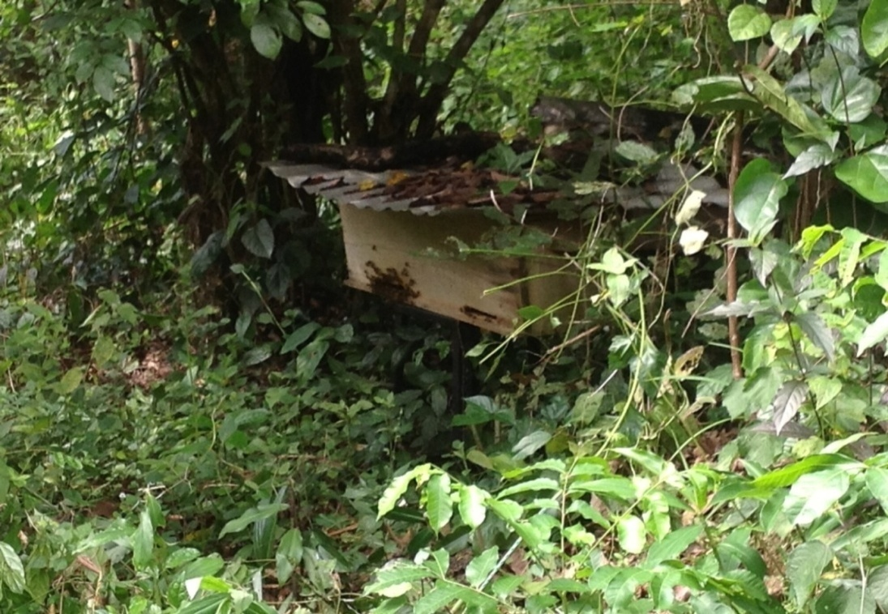
Figure 2: One of the colonised Triplochiton scleroxylon wood hives in the study area.
Source: Authors Fieldwork

Predisposing factors influencing colonisation
Human disturbance was first observed as predisposing factor influencing colonisation in the first year of mounting the hives. The human pest situation was reduced in the second year (2013) when the remaining hives were completely colonised as a result of education and awareness given on the need to conserve honeybees. Other pre-colonisation pests observed included cavities boring/nesting organisms such as Monomorium minimum (black ants), Lyctus africanus (Powder-post beetle), Polistes fuscatus (Wasp) mound and small brown rats bedding as indicated in Fig. 4.

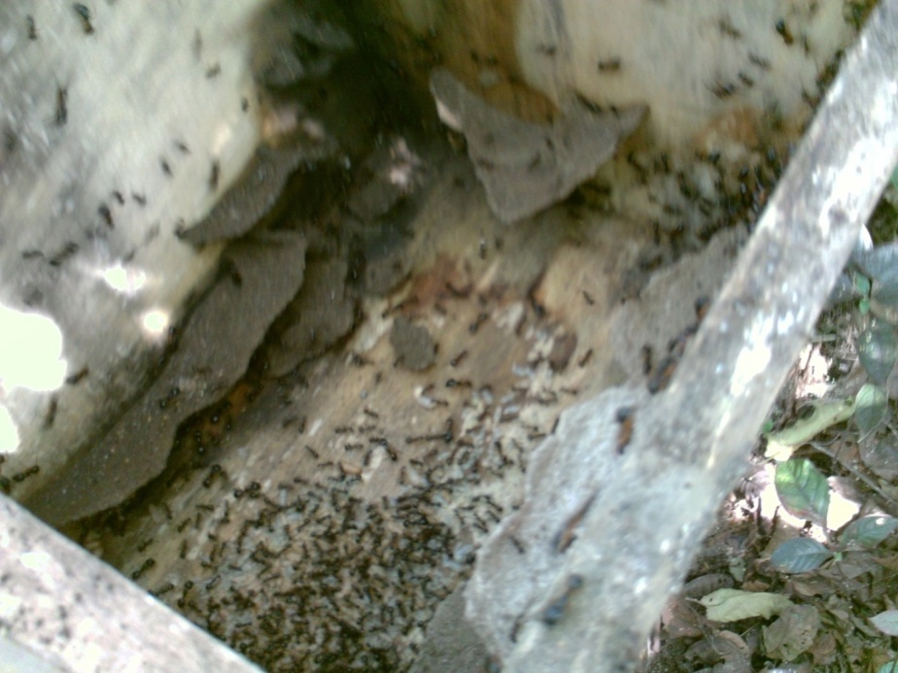
Figure 3: Hive infested with colony of Monomorium minimum before colonisation
Source: Authors Fieldwork

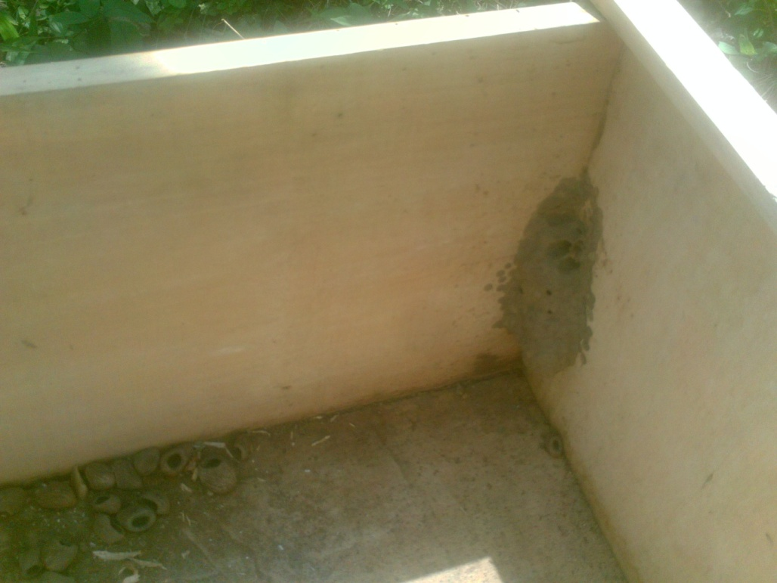
Figure 4: Small rats bedding materials and Wasp mound before colonisation
Source: Authors Fieldwork

Assessment of suitability of Triplochiton scleroxylon wood for beekeeping
Honeybees in all the hives were remarkably stable and agile in their activities and operations with 0% absconding rate after five months of complete colonisation. This current evidence demonstrates and justifies the traditional claim that Nigerian native honeybees have special preference for white wood cavities. The colonies were large and strong with high defensive characteristic.
Post colonisation pest
Small black hive beetles (Aethina tumida) were scantly observed in all hives during harvesting and one of the hives was partially infested with termites as shown in Fig. 5.

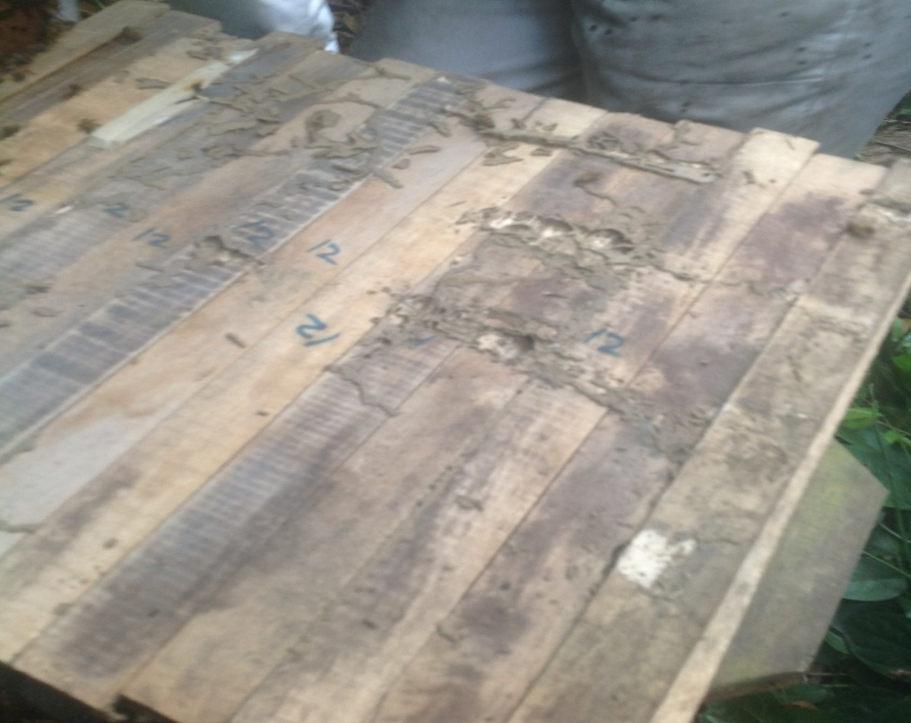
Figure 5: Termites’ partially infested colonised hive
Source: Authors Fieldwork

4. Discussion
This study which further confirms honeybees’ preference for white wood investigated the effect of seasons on colonisation and suitability of Triplochiton scleroxylon wood as a ready alternative to Gmelina arborea. The prevailing ecological type to a large extent dictates the honeybees nesting behaviour in terms of colonisation period. The colonisation of hives by the honeybees in the month of October for the two years of study suggests that seasons significantly played a role in colonisation. The non-colonisation of the hives before and after October could not be linked with incidence of pre-colonisation pests but strongly on seasons. This trend of observations was also made at Ebubu Egbalor in Eleme local government Rivers State, where apiary was established and managed for a farmer.
October, being a transition month between raining and dry seasons in Nigeria is observed as the beginning of swarming activities of honeybees. It may also have some strong association with setting and fruiting of some crops like Cashew, Mango, Cacao, citrus, Neem, Irvingia sp., etc which provide nectars and pollens for honeybees’ nutrition. It is safe to submit that, bees have chosen this month in preparation for on-season of food flow to prepare and store food against off-season. Colonisation month(s) differed in various derived savannah communities of western Nigeria as reported by (Babarinde, et al., 2010) – January, (Babarinde, et al., 2011) – March - April, (Babarinde, et al., 2012) –April and (Adedeji and Aiyeloja, 2014) – February - April. This is however not at variance with our observations in the Niger Delta region because, colonisation of Gmelina arborea wood made hives occurred in the month of October at Imeko, Ogun State in 2013 but colonisation extended to February, 2014 when all hives were fully colonised. All these months of colonisation in Nigeria are within dry season. Therefore, season has a significant impact on colonisation. Since honeybees in Rivers State are associated to a specific month for habitats colonisation, their chances of colonising habitats in other months are rather limited.
As regard the suitability of T. scleroxylon wood, all the colonies showed good adaptability and were remarkably stable without any absconding incidence. This result is in agreement with the traditional claim that Nigerian native honeybees have preference for white wood cavities (Aiyeloja and Adedeji, 2014). The result indicated that T. scleroxylon wood is suitable for beekeeping but highly vulnerable to insect attacks before colonisation and perhaps partially after colonisation. Lyctus africanus (Powder-post beetle) was the most destructive boring insect attacking the top bars before colonisation both at internal and external environmental conditions. The evidences of attack stopped after colonisation. This cessation could be attributed to honeybees’ activities and the presence of inhibines (hydrogen peroxide, flavonoids and phenolic acids) in honey and probolis (Wahdan, H. A. L., 1998; Kacaniova, et al., 2009). Most of their daily activities are top bars centred because top bars anchor the combs that house the eggs and food. Monomorium minimum (black ants) are wood destructive and aggressive cavity nesting social ants that attacked the hives before colonisation as shown in Fig. 3. Monomorium minimum (black ants) colonised one of the hives, concealed and partially degraded the hive before it was checked. The ant’s colony infestation was observed as pre-colonisation pest situation. This pest was reported as post-colonisation insect that caused 29% absconding rate in Central Uganda (Kugonza, et al., 2009). The ants are wood eaters and can compete favourably with honeybees for cavities nesting.
The presence of few numbers of A. tumida without bees absconding suggested that their relationship posed no threat. This could be because the pest is endemic insect in Africa. This result is in conformity with reported findings of Cosoroaba, et al., (2008) in South Africa, Kugonza, et al., (2009) in Central Uganda and Adedeji and Aiyeloja, 2014) in Western Nigeria that Aethina tumida prefers warmer micro-climate. Though the presence of the beetles was reported to have implication on the stressful workers to become more housekeepers because of the likelihood of the beetles attacking the queen (Fell, 1999). Termites attacked one of the colonised hives and the level of attack has not posed dangers to bee-colony before inspection as shown in Fig.. 5. The attack could be attributable to nearness of the hive to several termite mounds in the site, though the prevalence of termites in the area is high. Generally, pest situation in beekeeping can be reduced and cannot be totally eliminated because obviously termites used to interact with honeybees trees in the wild. It seemed A. tumida has a good long standing relationship with honeybees colonies in the wild as well because its presence in artificial cavities has not been reported as posing serious threat or causing absconding. To reduce the risk of insect attacks, hives should be mounted in September, a month prior colonisation month.

5. Conclusion
The results revealed that seasons play a crucial role in the colonisation and T. scleroxylon wood was suitable but vulnerable to insect attacks. The activities of honeybees and their products halted further decay caused by powder-post beetles immediately after colonisation. The wood can be medium term sustainably managed if a calendar is drawn to indicate the appropriate month(s) to prepare the hives, mount the hives, inspect the hives and keep the hives environments in most sanitary conditions. This study has generated a significant climatic and biological information required for sustainable development and management of genetic honeybees’ resources in Niger Delta, Nigeria.

6. Recommendations
The results have a numbers of policy implications
- Since honeybees in Rivers State are associated to a specific month for habitats colonisation, their chances of colonising habitats in other months are rather limited. A calendar should be drawn to indicate appropriate month(s) to construct and mount the hives.
- Because honeybees pollinate many plants in the zone and in Nigeria at large, honeybees should be kept for their ecological value rather than economical value and youth should be engaged and well paid.
- Because honeybees native to Nigeria have special preference for white woods cavities, government and private individuals should embark on massive plantation of Gmelina arborea in Niger Delta.
- Further research should be conducted in other ecological zones of Nigeria so as to be able to draw a national calendar for beekeeping that will reduce risks of pest attacks as well as low colonisation rate.

Corresponding Author:
Dr. A.A. Aiyeloja.
Department of Forestry and Wildlife Management,
University of Port Harcourt, Nigeria
E-mail: adedapo.aiyeloja@uniport.edu.ng

References
- Adedeji, G. A. and A. A. Aiyeloja, 2014. Preference and Suitability of Nigeria grown Gmelina arborea Linn. Roxb. And Vitex doniana Sweet woods for beekeeping in Imeko, Nigeria. International Journal of Scientific and Engineering Research (IJSER), 5(5): 1484-1494. ISSN: 2229-5518.
- Adedeji, G. A. and A. A. Aiyeloja, 2012. Challenges of Beekeeping in Nigeria: In Ijeomah, H. M. and Aiyeloja, A. A. (Eds.) Challenges to Sustainable Productions in Agriculture and the Environment: Nigeria in Perspective. TopBase Nigeria Limited, Lagos, in Conjunction with Green Canopy Consultants, Port Harcourt, Rivers State: 357-372. ISBN: 978-978-933-048-5.
- Aiyeloja, A. A. and Adedeji, G. A. 2014. Preliminary survey of wood species cavities preferred by honeybees in Nigeria. International Journal of Scientific and Engineering Research (IJSER), 5(2): 1313-1320. ISSN: 2229-5518.
- Ande, A. T., A. A. Oyerinde and M. N. Jibril, 2008. Comparative study of the influence of hive types on bee colony establishment. International Journal of Agriculture and Biology, 10: 517–520. ISSN: 1814-9596.
- Babarinde, S. A., M. O. Akanbi, T. A. Adebayo, J. I. Olaifa, A. F. Odewole and E. A. Alagbe, 2010. Effect of polythene and lime applied to top bars hive on colonization, weight gain and pest infestation. Annals of Biological Research, 1 (4): 61-66. ISSN 0976-1233.
- Babarinde, S. A., M. O. Akanbi, F. A. Akinpelu, B. G. Oyelade, and B. Oyelami, 2011. Impact of canopy type on honey Bee (Apis mellifera adansonii) (Hymenoptera: Apidae) colony performance and pest infestation. African Scientist, 11(3): 169-174. ISSN: 1595-6881.
- Babarinde, S. A., A. F. Odewole, O. O. Oyegoke, and O. B. Amao, 2012. Impact of hive dimension and flight entrance on hive colonization, pest infestation and hive weight gain in Apis mellifera adansonii (Hymenoptera: Apidae). Munis Entomology and Zoology, 7 (1): 634-641.
- Breeze, T. D., A. P. Bailey, K. G. Balcombe and A. G. Potts, 2011. Pollination Services in the UK: How important are honeybees? Agriculture, Ecosystems and Environment, 142 (3-4): 137-143. DOI: 10.1016/j.agee.2011.03.020.
- Cosoroaba, I., L. Chitimia and M. Ilie, 2008. The small hive beetle: A pest of honey bee colonies. LUCRĂRI STIINłIFICE MEDICINĂ VETERINARĂ VOL. XLI, 437-442 retrieved on 6 June, 2014 from http://www.usab-tm.ro/vol18MV/68_vol18.pdf.
- EEA (European Environmental Agency), 2010. EU 2010 Biodiversity Baseline: Post-2010-EU biodiversity policy. Copenhagen. Available online @ http://www.eea.europa.eu/publications/eu-2010-biodersity-baseline.
- FAO (Food and Agriculture Organisation), 2008. Rapid Assessment of Pollinators’ Status. 64Pp. FAO Article retrieved on 16 November, 2013 from http://www.bfn.de/fileadmin/MDB/images/themen/bestaeuber/rapid_assessment_polinator_status.pdf.
- Fell, R. D., 1999. The Small Hive Beetle: A new pest of honey bee colony. Department of Entomology, Virginia Tech, Blacksburg, VA. 10p.
- Honey traveler, 2012. Honey by Country Region. Honey traveler article retrieved on 29 September, 2012 from www.honeytraveler.com/honey-by-country-region/.
- IRGC, 2009. Concept note on risk governance of pollination services. International Risk Governance Council, Geneva. Concept note retrieved 14th December, 2013 from IRGC_Pollination_Concept_Note_2009PDF.
- Johnson, R., 2010. Honey Bee Colony Collapse Disorder. Congressional Research Service, 7-5700www.crs.govRL33938.
- Kacaniova, M., Melich, M., Knazovicka, V., Felsociava, S. and Sudzinova, J. 2009. The Antimicrobial activity of honey and probolis against yeasts Candida species. ZootehniesiBiotehnologii, 42(2): 167-173.
- Kugonza, D. R., Kamatara, K.B., Nabakabya, D., Kikonyogo, S. 2009. Effects of hive type and tree shade on colonization rate and pest prevalence of honeybee (Apis Mellifera) colonies in Central Uganda. Africa Journal of Animal and Biomedical Sciences, 4 (2): 87-92.
- Malcolm Sanford, 1998. Pollination, The Forgotten Agricultural Input: In J. Ferguson, et al., (eds.) Proceedings of the Florida Agricultural Conference and Trade Show. 29-30 September, 1998, Lakeland, FL: 45-47.
- MEA., 2005b. Ecosystem and human well-being: Biodiversity synthesis. Washington DC.
- Morse, R. A. and N. W. Calderone, 2000. The values of Honey Bees as Pollinators of US Crops.Cornell University,http://www.masterbeekeeper.org/pdf/pollination.pdf.
- Ogbonna, D. A., G. T. Amangabara, and T. O. Ekere, 2007. Urban solid waste generation in Port Harcourt metropolis and its implications for waste management. Management of Environmental Quality, 18 (1): 71-88. DOI: 10.1108/14777830710717730.
- Okwee-Acai, J., T. A. Anyanzo, J. Aroba, J. K. Vuchiri, T. Onzivua, and P. Okullo, 2010. Effects of apiary management on colonisation and colony performance of African honey bee (Apis mellifera) in the North-Western Agro-ecological zone of Uganda. Livestock Research for Rural Development. Volume 22, Article 86. Retrieved 13 August 2013, from http://www.lrrd.org/lrrd22/5/okwe22086.htm.
- Oyerinde, A. A. and A. T. Ande, 2009. Distribution and Impact of Honeybee Pests on Colony Development in Kwara State, Nigeria. Journal of Agriculture and Social Sciences, 5:85-88. ISSN: 1814-960X08-025/SAE/2009/5-3-85-88.
- Popo-ola, F. S., G. A. Adedeji, and A. A. Aiyeloja, 2013. Beekeeping in addressing green economy: Opportunities and threats: In Labode Popoola, O. Y. Ogunsanwo, V. A. J. Adekunle, I.O. Azeez and N. O. Adewole (Eds.) Proceedings of the 36th Annual Conference of Forestry Association of Nigeria. 04-09 November, 2013 Uyo, Akwa Ibom State, Nigeria. (1):88-97. ISBN 978-978-50793-7-1.
- Potts, S. G., J. C. Biesmeijer, C. Kremen, P. Neumann, O. Schweiger, and W. E. Kunin, 2010. Global pollinator declines: trends, impacts and drivers. Trend in ecology and evolution, 25 (6): 345-353. DOI: 10.1016/j.tree.2010.01.007.
- Thomas, J. A. and M. G. Telfer, 2004. Comparative Losses of British Butterflies, Birds, and Plants and the Global Extinction Crisis. Science: 303(5665): 1879 – 1881. DOI: 10.1126/science.1095046.
- UNEP, 2010. Global Honey Bee Colony Disorder and other Threats to Insect Pollinators. UNEP Emerging Issues retrieved on 16 November, 2013 from www.unep.org/dewa/Portals/67/pdf/Globalbee_colony_disorder_and_threats_insects_pollinators.pdf.
- Wahdan, H.A.L., 1998. Causes of the antimicrobial activity of honey. Infection, 26(1): 26-31.

8/3/2014

